**ACN Lab1**

**Name: Devansh Choudaha**

**ID: 202011030**

INTRODUCTION

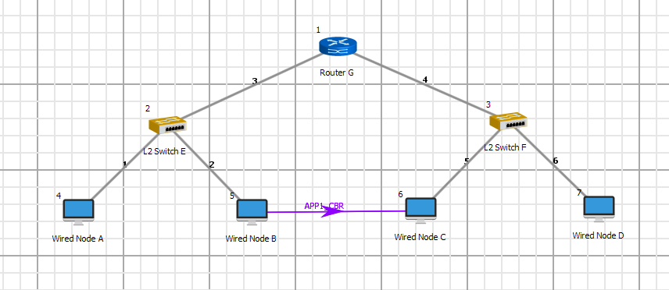

3 EXERCISE

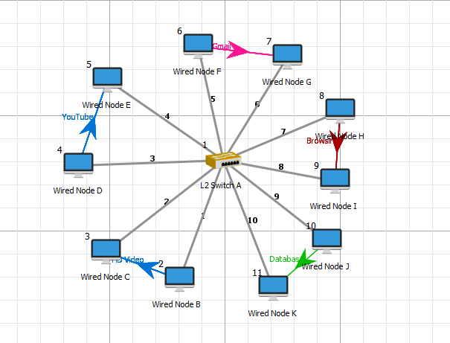

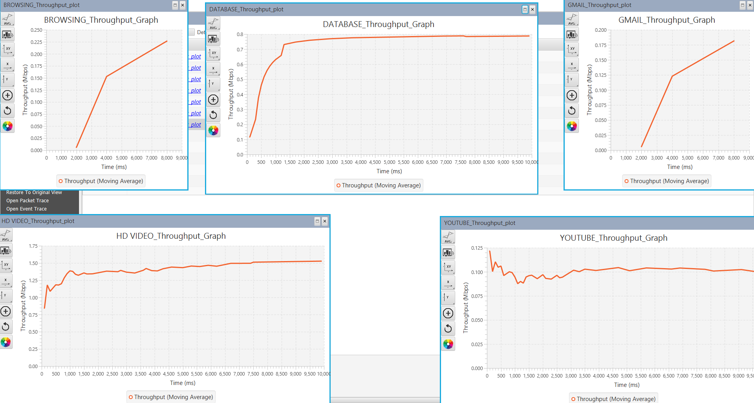

3.2 Perform analysis on the LAN performance

1. **Find throughput of every application.**

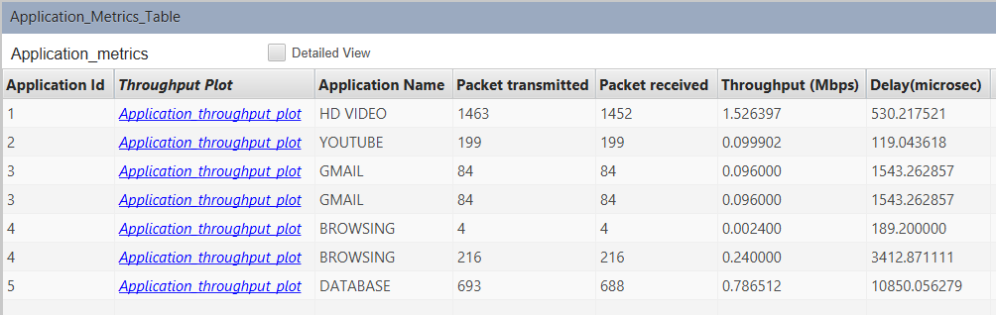

1. **Find average throughput of video applications**

**3. Find average throughput of all the applications**