**TESTCASES FOR THE BEYOND WEBSITE:**

1. If a user selects the option “Gender” in the outfit suggestions menu then a submenu will be popped out :

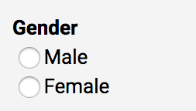

1. Now, if the option “Male” is selected by the user then following web page will be opened.

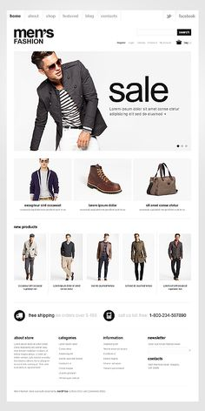

1. If the option “Female” is selected by the user then following web page will be opened:

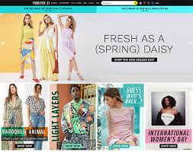

1. If a user selects the option “Accessories” in the outfit suggestions menu then then following web page will be opened:

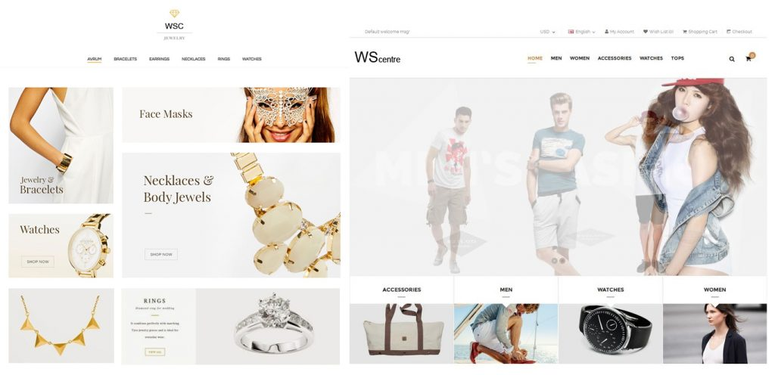

1. If a user selects any website from the provided “top websites”, that particular website will opened where our website’s recommended products will be available:
2. For example if the user selects myntra then the myntra website will be opened:

