Bharati Vidyapeeth College of Engineering, Pune
Cloud Computing
Project Based Learning (PBL), Project #16
Deployment to a Publicly Hosted Linux VM on Azure
CloudTasks: a task tracker with a live VM status panel
Submitted by
# | Name | Roll number
1 | Devansh Lamba
2
3
4

Subject: Cloud Computing
Guide: ______________________________
October 2026

Contents
1. Objective 3
2. Cloud concepts used 3
3. Architecture 5
4. Implementation steps 6
5. Security choices 6
6. Testing and measurements 8
7. Cost 8
8. Limitations 9
9. What I learned 10
10. Evidence 10
10.1 Live site with the address bar 10
10.2 Full-page views (light and dark) 14
10.3 Terminal evidence 17
10.4 Azure portal 18
10.5 Paused state 18

Project #16, Cloud Computing. Application: CloudTasks, a task tracker with a live VM status panel. Live URL during evaluation: http://20.205.122.152/ · Code: https://github.com/devanshlamba/azure-vm-deploy
PENDING (draft status). Still to be completed before submission:
1. Azure portal screenshots, Section 10.4 (being captured).
2. The paused state: pause.ps1 output and the portal's Stopped (deallocated) view, Section 10.5.
3. The billed cost from Cost Analysis, Section 7 (Azure reports usage 8–24 hours late).
4. Section 9, What I learned, rewritten in my own words.

1. Objective
Build a real, small web application and deploy it to a Linux virtual machine on Microsoft Azure that anyone on the internet can reach, while:
- using Infrastructure as a Service (IaaS) directly: I create and manage the VM, network and firewall myself rather than using a managed platform;
- automating the whole deployment with the Azure CLI in repeatable scripts (deploy, pause, start, destroy);
- packaging the application in containers behind an nginx reverse proxy, with data on a persistent volume;
- applying sensible security (key-only SSH, a minimal firewall, no secrets, a hardened container); and
- keeping it free: Azure for Students credit only, no credit card, with a clear cost model for running, paused and deleted states.

2. Cloud concepts used
Concept | What it means | Where it appears in this project
IaaS | The cloud provider runs the physical hardware; I manage the OS and everything above it. | I chose the OS image (Ubuntu 24.04), installed Docker, and run and patch the stack myself.
Virtual machine | A software-defined computer with a chosen number of vCPUs, amount of RAM and disk, billed per hour while it runs. | vm-cloudtasks, size Standard_B2pts_v2 (2 vCPU Arm64, 1 GiB RAM), a burstable B-series size suited to mostly idle web apps.
Region and policy | Data-centre location; organisations can restrict which regions may be used. | Azure for Students allows only five regions. The script reads that policy and picks East Asia (Section 4).
Public IP | An internet-routable address attached to the VM's network interface. | pip-cloudtasks, Standard SKU, static, so the URL survives stop/start.
NSG (network security group) | A stateful firewall of allow/deny rules attached to a NIC or subnet. | Allows 22 only from my IP /32 and 80 from anywhere; Azure's default rules deny all other inbound traffic.
SSH keys | Public-key authentication: the VM holds the public key, my laptop keeps the private key. | A new ed25519 key per project; password login disabled (verified: disablePasswordAuthentication = true).
cloud-init | A first-boot script that configures a fresh VM. | Installs Docker, adds swap, clones the repo, writes metadata and starts the containers, with no manual SSH steps.
Containers | An app packaged with its dependencies into an image that runs isolated on a shared kernel. | The app image (python:3.13-slim, non-root) and nginx:1.30-alpine, both run by Docker Compose.
Reverse proxy | A server in front of the app that receives client traffic and forwards it. | nginx is the only published service (port 80); it forwards to the app over an internal network and sets the client-IP headers.
Persistent volume | Storage that outlives the container. | Named volume taskdata holds the SQLite database; tasks survive rebuilds, restarts and VM stop/start.
Managed disk | The VM's virtual disk, billed per month by size and tier. | Standard SSD, 30 GB (billed as E4).
Cost model | Pay-as-you-go per resource; deallocating stops compute charges but not storage or IP charges. | Running / paused / destroyed costs in Section 7, with live prices pulled from the Azure Retail Prices API.
Auto-shutdown | A schedule that deallocates the VM at a fixed time. | 02:00 IST every day, a safety net against forgotten VMs.

3. Architecture
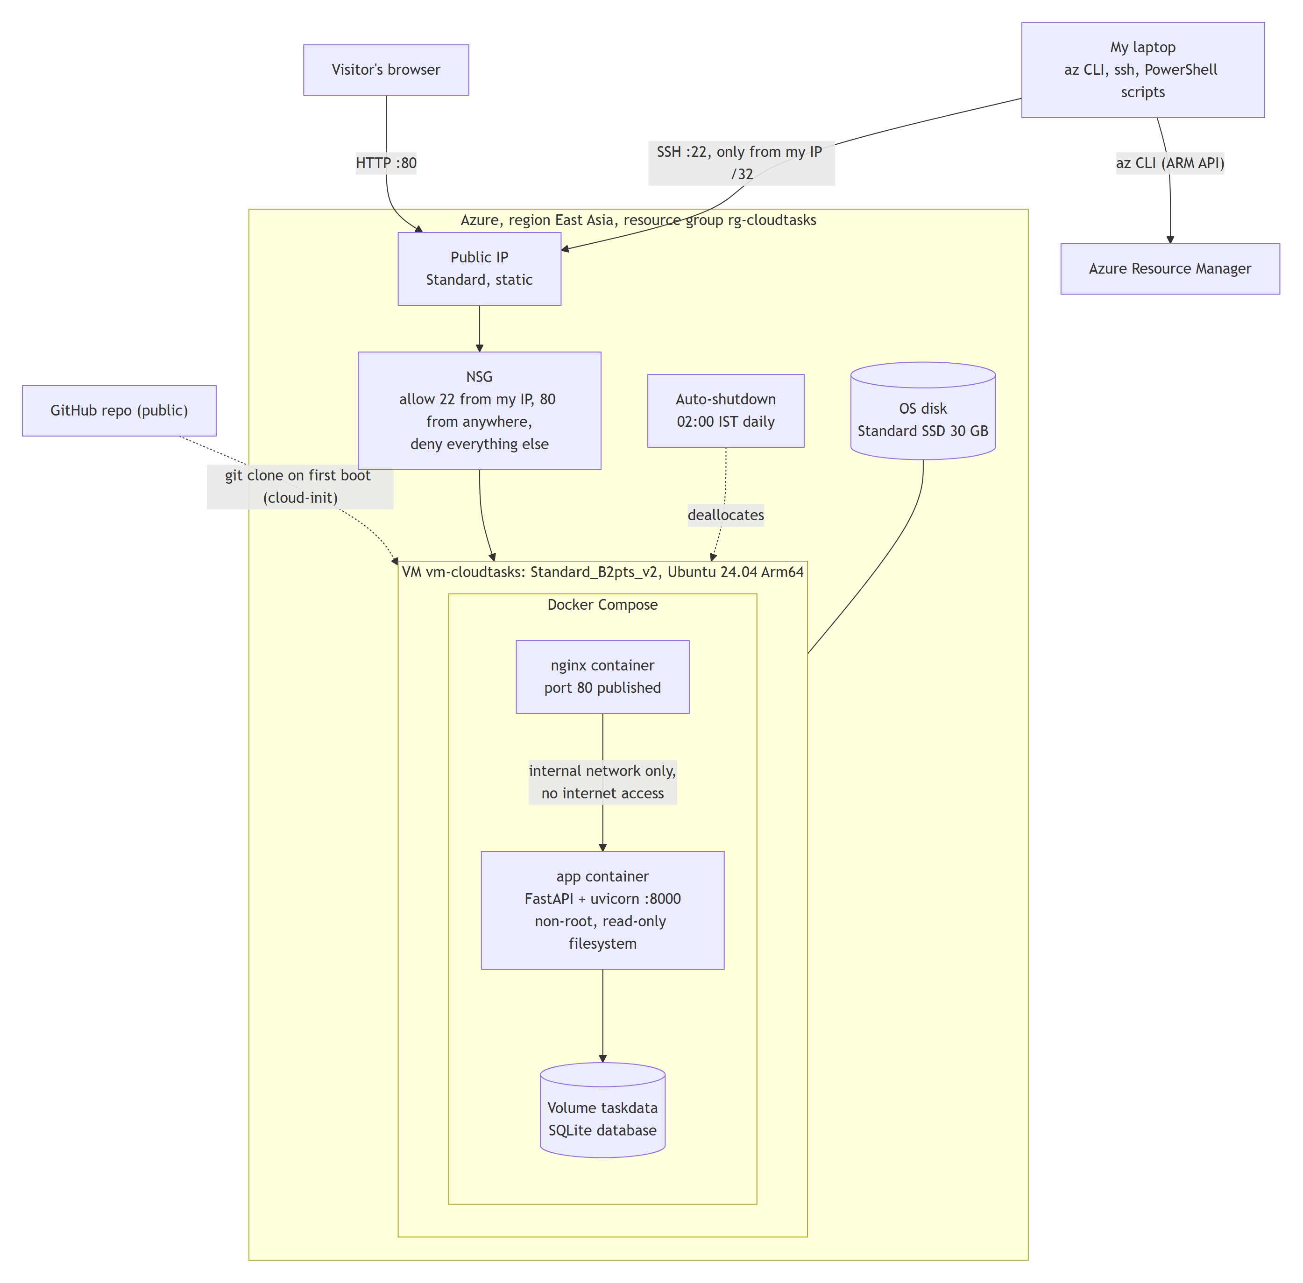
Figure: Architecture of the deployment (rendered from the Mermaid diagram).
Azure resources (all in rg-cloudtasks, so one command deletes everything): virtual machine, OS disk, NIC, public IP, NSG, VNet 10.20.0.0/24 with subnet 10.20.0.0/26, and the auto-shutdown schedule (Microsoft.DevTestLab/schedules). Seven resources in total, as listed by az resource list.
Application:
- Backend: FastAPI on uvicorn with SQLite. The task API supports create, list, edit, toggle and delete. The status API reports CPU, RAM, disk, load and uptime via psutil.
- Frontend: one HTML page in plain JavaScript and CSS, with self-hosted fonts and inline SVG gauges and sparklines. It loads nothing from external sites.
Request flow: browser → public IP → NSG (port 80 allowed) → nginx container → app container over a Docker network marked internal → SQLite on the taskdata volume.

4. Implementation steps
- Application and tests. Built the API with strict validation, the UI, and 18 automated API tests (pytest). Took screenshots with Playwright and refined the design based on them.
- Containers locally.
- Dockerfile: python:3.13-slim base, non-root user, healthcheck, plus a separate test stage so docker build --target test . runs the tests inside the image.
- Compose: nginx on port 80; the app on an internal network; read-only filesystems, memory/CPU/process limits, restart always.
- Local checks: verified the security properties (see Section 6).
- Choosing a region and size. The script reads the student policy instead of guessing:
Allowed region | Auto-shutdown supported | Cheap B-series sizes available to my subscription
East Asia | yes | yes: B2pts_v2, B2ats_v2, B2als_v2
UAE North | yes | no, all NotAvailableForSubscription
India South Central | no | yes
Malaysia West, Indonesia Central | no | no

East Asia is the only region that satisfies both requirements. Standard_B2pts_v2 is the cheapest size available there at 0.0116 USD/hour; the x86 B2ats_v2 costs 0.0131 USD/hour. Before choosing ARM, I confirmed that every component has an arm64 build: the Ubuntu image, both container base images and psutil.
- Deployment (scripts/deploy.ps1).
- Pre-flight checks, then the plan and cost per day; the script waits for an explicit yes.
- Creates the resources with the Azure CLI. cloud-init then installs Docker from Docker's apt repository, clones the repo and runs docker compose up -d --build.
- Total time from yes to a verified site: about 5 minutes.
- Verification from my laptop.
- http://20.205.122.152/ returned 200 with the page, and /health returned {"status":"ok","database":"ok"}.
- The VM status tab showed the real region, size, VM name and IP. Port 8000 was unreachable from outside.
- Operations.
- pause.ps1 (deallocate), start.ps1 (start, re-pin the SSH rule to my current IP, verify).
- update.ps1 (git pull on the VM and rebuild; used once to ship a fix).
- destroy.ps1 (delete the resource group after typing its name).

5. Security choices
Area | Choice | Why
Firewall | NSG: SSH only from my IP /32, HTTP from anywhere, default deny. start.ps1 updates the SSH rule if my IP changes. | Shrinks the attack surface; bots constantly scan port 22 on public IPs.
Login | SSH key only (ed25519); password authentication disabled. | Rules out password brute-force. The private key never leaves my laptop and is excluded by .gitignore.
Network isolation | App container on an internal: true Docker network: no published port, no internet access. | Only nginx is reachable. Without internet access, the app couldn't send data out even if it were compromised.
Container hardening | Non-root user (uid 10001), read-only filesystem (only the database volume writable), all Linux capabilities dropped, no-new-privileges, memory/CPU/process limits; nginx is also read-only with minimal capabilities; the Docker socket is never mounted. | Limits what an attacker could do inside a container.
Input validation | Pydantic models: title 1–120 characters, note ≤ 500, priority and colour from fixed lists, valid dates, unknown fields rejected, control characters stripped. | Bad input is rejected before it reaches the database.
SQL injection | Bound parameters only; the column names used in updates come from a fixed allowlist. | User input can never become SQL.
XSS | All user text is rendered with textContent, never innerHTML. A Content-Security-Policy allows scripts only from the site itself, with no inline scripts. Plus X-Frame-Options: DENY, nosniff, no-referrer. | Even a task titled <img src=x onerror=alert(1)> is shown as plain text (there is a test for this).
Rate limiting | 300 requests/min per visitor IP on /api. The X-Real-IP / X-Forwarded-For headers are trusted only from nginx's fixed address (172.28.0.10/32); nginx overwrites them. | Spoofed headers can't bypass the limit. Tested: 125 requests through nginx, each with a different fake IP header, gave exactly 120 allowed and 5 blocked (measured while the limit was 120).
Secrets | Nothing secret in code, image, git history or logs. Subscription and tenant IDs are never printed: every az query selects only the needed fields, and az rest fills in the subscription ID itself. | The repository is public.
Honest metadata | Region, size, VM name and IP are passed in as non-secret environment variables by the deploy script; /api/info reports metadata_source: "deploy" and the UI says "Set at deploy time from Azure". | The app has no internet access, so it can't call Azure's instance metadata service (IMDS), and IMDS doesn't return Standard-SKU public IPs anyway.

6. Testing and measurements
Check | Result
Automated API tests | 18 passed, locally and inside the Docker test stage. They cover validation, create/edit/toggle/delete, 404s, XSS and security headers, sample tasks, metrics/info, metadata source, rate limiting, and trusted-proxy handling.
Docker isolation (local) | App port 8000 not reachable from the host; app has no internet access (DNS fails); app runs as uid 10001; writing outside /data fails ("Read-only file system"); tasks survived docker compose down / up.
Images | App image 238 MB on the VM, of which about 190 MB is the Python slim base; nginx 93 MB.
Memory on the 1 GiB VM | App 43 MiB, nginx 11 MiB, about 540 MB still available. Building the image on the VM used at most 42 MB of swap, with no out-of-memory kills.
Polling load | One VM status tab sends 24 /api/metrics + 1 /api/info + 1 /api/tasks per minute = 26 of 300 (about 9%). /health (24/min) is not rate limited.
Compression | app.js is 41 KB uncompressed and 14.8 KB gzipped by nginx.
Response time | About 110–130 ms for /health from my laptop in India to East Asia.
Screenshots | Desktop and mobile, light and dark, both views, taken from the live site with Playwright (docs/screenshots/live-*.png), with no browser console errors.

7. Cost
Pay-as-you-go prices for East Asia, read from the Azure Retail Prices API on 2 October 2026:
Resource | Price | Per day
VM Standard_B2pts_v2 (Linux) | 0.0116 USD/hour | 0.278 USD
Public IP, Standard static | 0.005 USD/hour (also while the VM is stopped) | 0.120 USD
OS disk, Standard SSD E4 (30 GB) | 2.40 USD/month | 0.079 USD
NSG, VNet, NIC, auto-shutdown | free | 0

State | How to get there | USD/day | USD/month
Running | deploy.ps1 or start.ps1 | 0.477 | 14.51
Paused (deallocated) | pause.ps1 or auto-shutdown at 02:00 IST | 0.199 | 6.05
Destroyed | destroy.ps1 | 0 | 0

Real cost. The VM was created on 2 October 2026 at 10:04 UTC. By the time this report was written (about 1.5 hours later), the expected charge was about 0.03 USD: 1.5 h × (0.0116 + 0.005) USD/hour + 1.5 h of disk. Azure shows billed usage 8–24 hours late. The final figure comes from Cost Management → Cost analysis, filtered to rg-cloudtasks.
PENDING: billed cost for the project period, from Cost Management → Cost analysis: _____ USD, for the period _____ to _____.
All charges come out of the Azure for Students credit; no credit card is linked. With 100 USD of credit, this setup could run nonstop for roughly 200 days.

8. Limitations
- HTTP only, no HTTPS. There is no domain name, so no TLS certificate. Traffic, including task text, is unencrypted. Next step: a domain plus Let's Encrypt via certbot, or Azure Front Door.
- Single VM, single app process. No redundancy or load balancing. The rate limiter keeps its counters in one process's memory and loses them on restart. Restarts or VM maintenance cause downtime.
- Everyone shares one board. There are no user accounts, so anyone with the URL can edit or delete tasks. Abuse is limited by validation, a 300-task cap and the rate limit, not by authentication.
- SQLite on the VM's OS disk. Data is lost when the resource group is destroyed, and there are no backups. A managed database or disk snapshots would fix that.
- Shared IP addresses. Many people behind one NAT (for example a college network) share the 300-requests-per-minute budget. About 11 VM status tabs can poll at the same time from one IP.
- The paused state still costs money, because the Standard static IP is billed while the VM is stopped.
- The SSH rule depends on my IP. If my ISP changes my IP, SSH is blocked until start.ps1 (or a manual rule update) re-pins it.
- No Trusted Launch. The VM uses the Standard security type: the Azure CLI default didn't enable Trusted Launch for this Arm64 VM.
- The image is built on the VM. That takes a few minutes on a small burstable VM. A container registry with a prebuilt arm64 image would make deployments faster and more reproducible.

9. What I learned
PENDING: the points below are notes drafted from what happened during the build. Rewrite them in your own words before submitting.
- Student policies shape the architecture. The region I would have picked first (close to India) wasn't allowed. Of the allowed ones, only East Asia had both auto-shutdown support and VM sizes my subscription could use. Checking az vm list-skus restrictions per subscription, not just the region list, saved a failed deployment.
- "Stopped" is not "deallocated", and deallocated isn't free. Only deallocation stops VM billing. Disks and Standard static IPs keep costing money, which is why my paused state still costs 0.199 USD/day.
- ARM is a real option for small workloads. It was the cheapest size available; the only extra work was checking that every image and Python package had an arm64 build.
- Defence in depth works in layers. The NSG decides who reaches the VM, nginx is the only door into Docker, the internal network keeps the app off the internet, and the container itself is non-root and read-only. Each layer still helps if another one fails.
- Trusting proxy headers is a trap. Accepting X-Forwarded-For from anyone would let attackers bypass the rate limit just by changing a header. Trusting it only from nginx's fixed IP, and testing that, closed the gap.
- Hardening has side effects. Cutting the app off from the internet also cut it off from Azure's metadata service. I solved that by passing non-secret values in from the deploy script and labelling their source honestly in the UI.
- Windows tooling quirks matter for automation. az on Windows runs through cmd.exe, which cut a URL at its &, and PowerShell 5.1 stripped quotes inside SSH commands. Running the scripts for real, not just writing them, exposed both bugs.
- Automation makes the cloud cheap to experiment with. One command deploys, one pauses, one destroys, and every step is verified from outside the VM.

10. Evidence
All evidence comes from the real deployment on 2 October 2026. Images were checked one by one: no subscription ID, tenant ID, password or home IP address appears in any of them. In terminal output, the deployer's home IP is replaced with <home-ip-masked>; nothing else was changed.

10.1 Live site with the address bar
Captured from a real Chromium window with the Win32 PrintWindow API (scripts/window_screenshots.py), so the address bar is included.
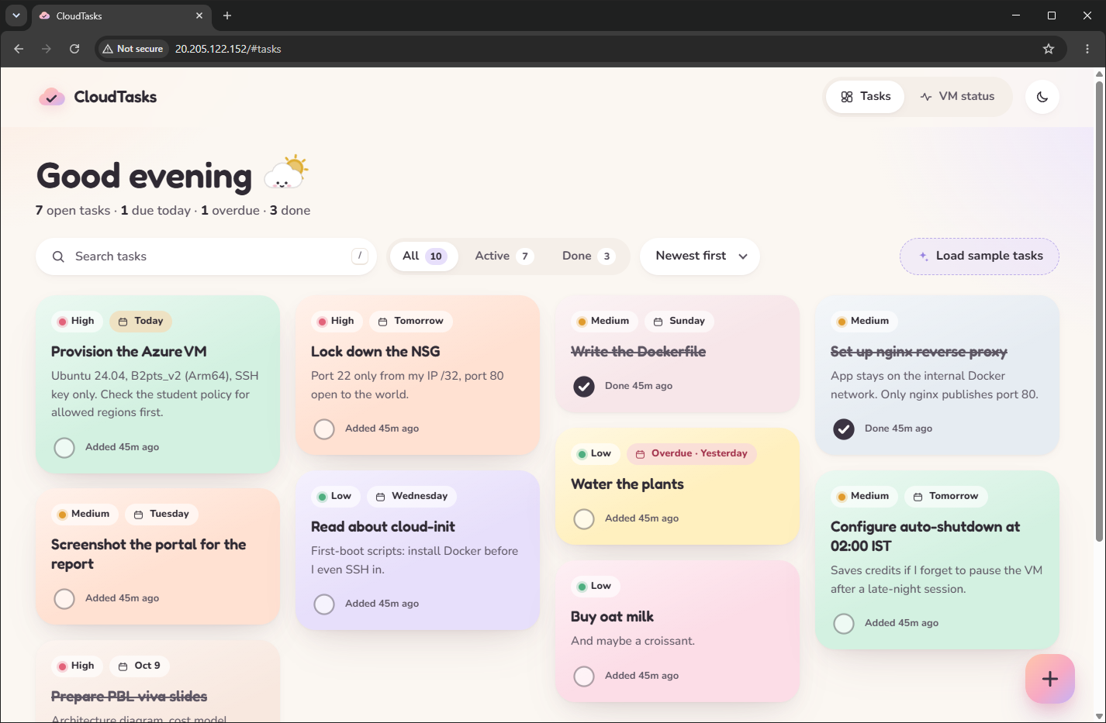
Figure 1: Tasks view on the live VM, address bar showing 20.205.122.152/#tasks ("Not secure" because the site is HTTP only, see Section 8).
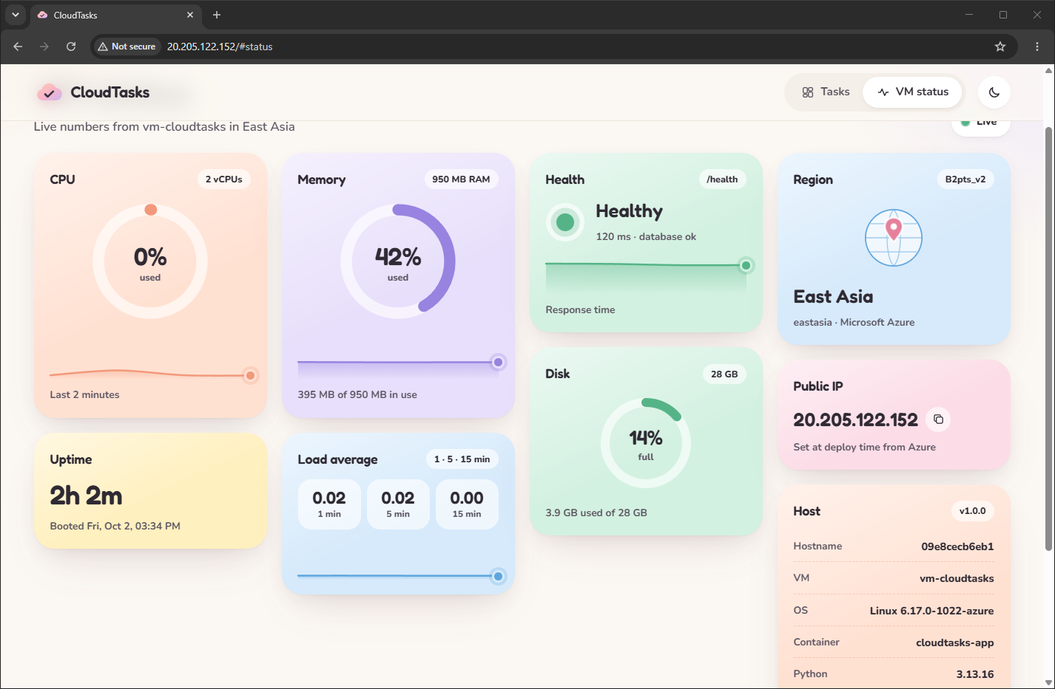
Figure 2: VM status panel (heading scrolled under the top bar)
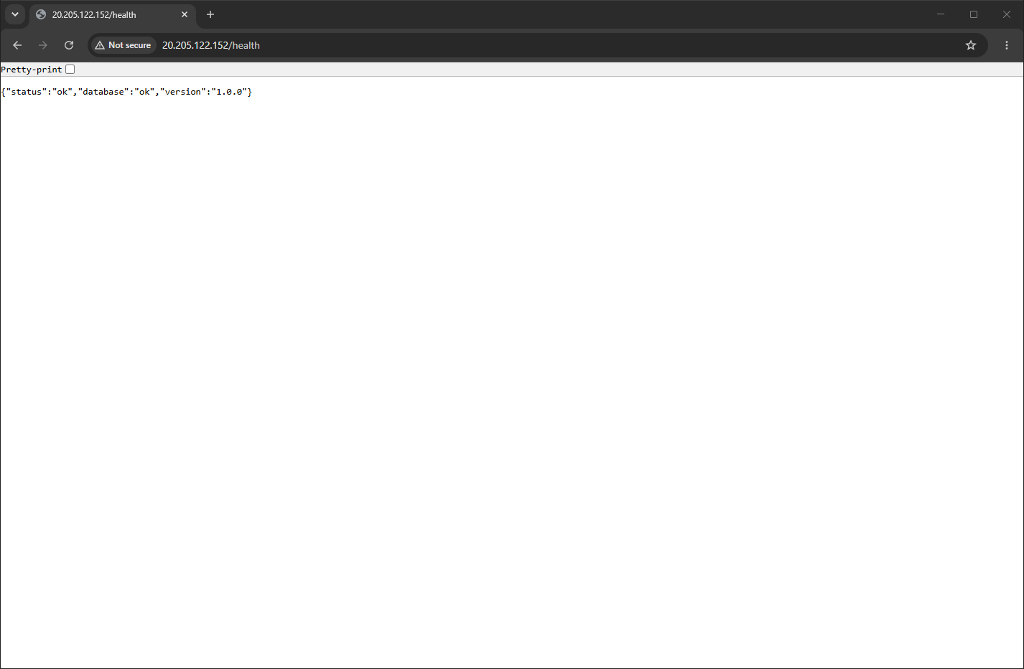
Figure 3: The public /health endpoint returning {"status":"ok","database":"ok","version":"1.0.0"}.
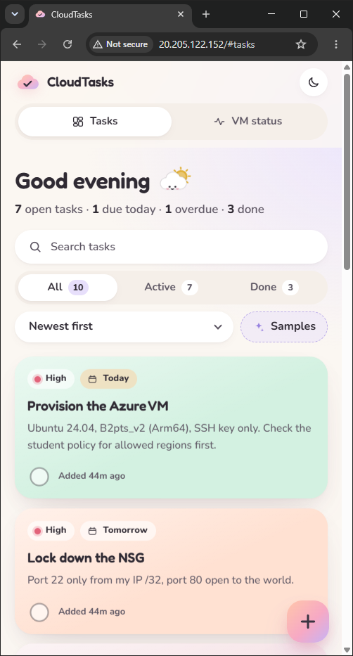
Figure 4: Mobile layout in a narrow (about 500 px) browser window, the smallest width Chromium allows: one column of cards.
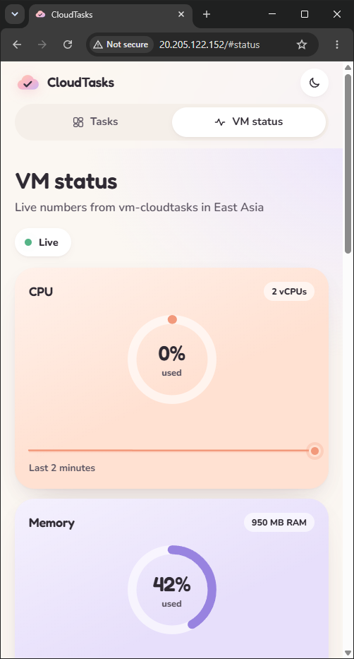
Figure 5: VM status in the same narrow window.

10.2 Full-page views (light and dark)
Captured with Playwright from the live site (scripts/screenshots.py), with no browser console errors.
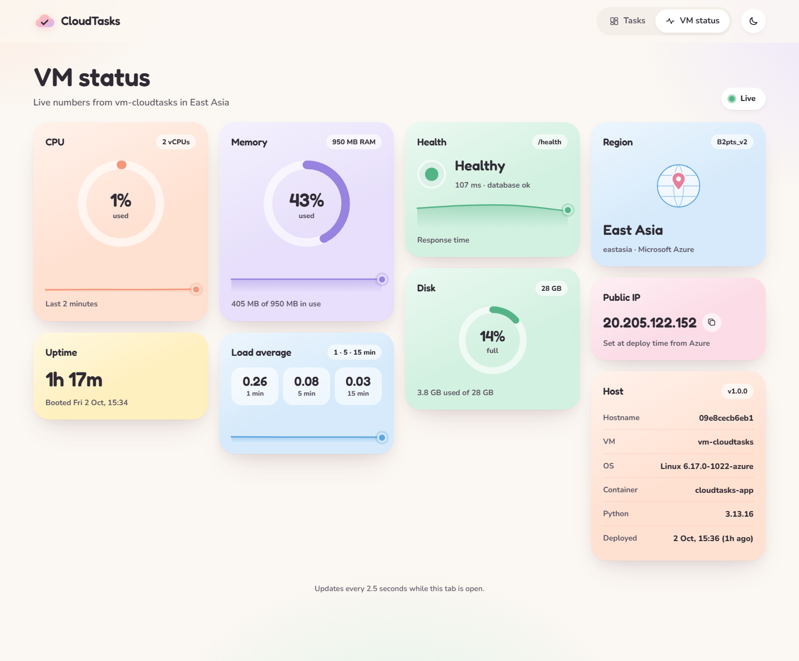
Figure 6: VM status, light theme: real region (East Asia), VM size (B2pts_v2) and public IP, labelled "Set at deploy time from Azure".
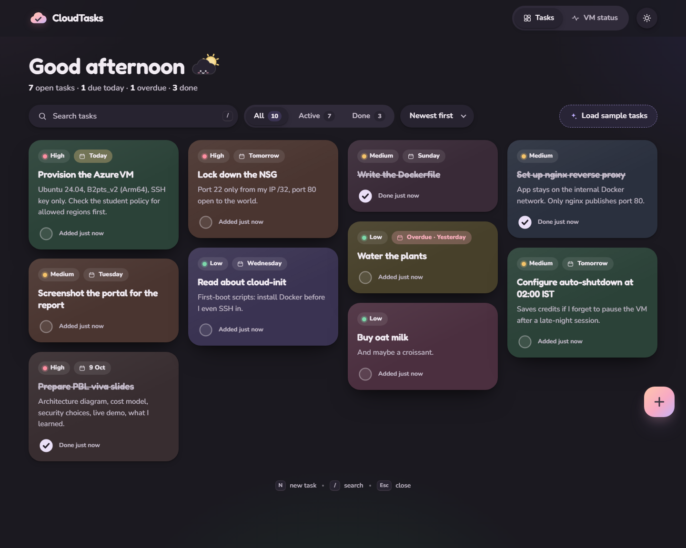
Figure 7: Task board, dark theme: masonry grid, priorities, due-date chips, done tasks with strike-through.
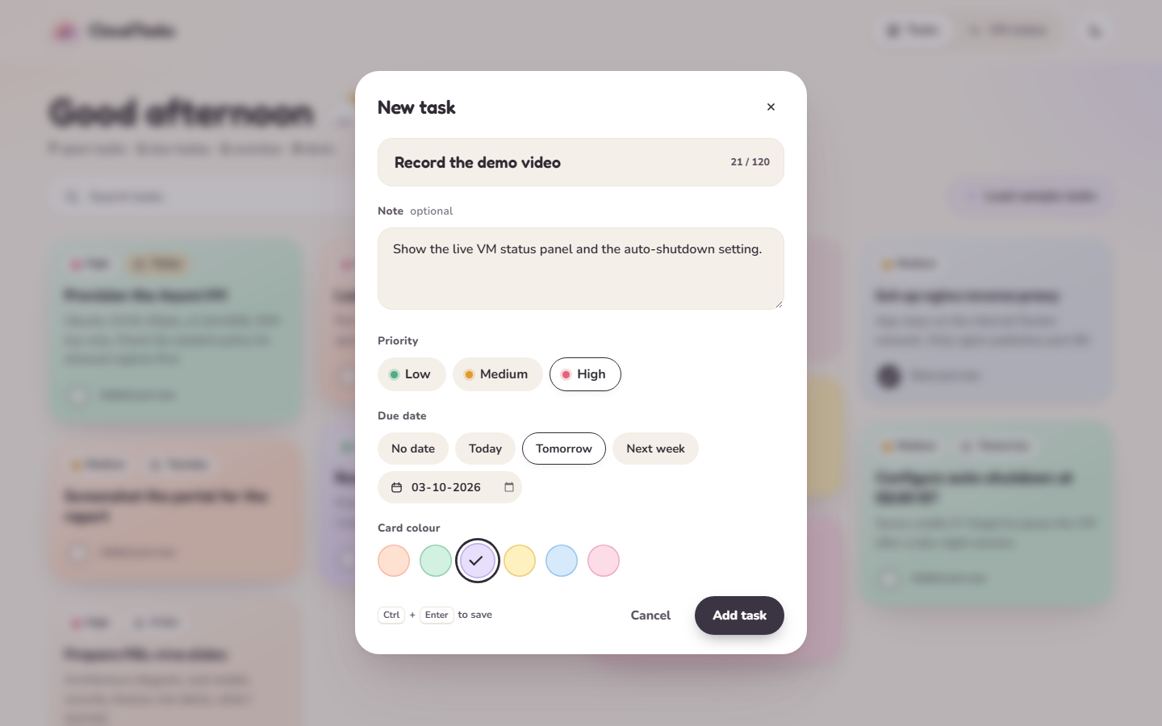
Figure 8: The add-task dialog with priority, due date and card colour.
Other captures in docs/screenshots/ | Shows
live-desktop-light-tasks.png, live-desktop-dark-status.png | The two views in the other theme
live-mobile-{light,dark}-{tasks,status}.png | Mobile, both views, both themes
live-desktop-light-empty.png | Empty state before the sample tasks were loaded
live-mobile-light-composer.png | Add-task bottom sheet on mobile

10.3 Terminal evidence
Listing 1: ./scripts/deploy.ps1 -PlanOnly, run against the existing deployment on 2 October 2026 at 11:38 UTC (home IP masked).
==> Checking Azure login
OK Logged in, subscription: Azure for Students
Note: 'rg-cloudtasks' already exists (deployed). Showing the plan for reference only.

==> Checking the subscription policy (allowed regions)
Allowed regions: eastasia, malaysiawest, uaenorth, indonesiacentral, indiasouthcentral
OK eastasia is allowed

==> Checking that auto-shutdown works in this region
OK Auto-shutdown is supported in East Asia

==> Checking that Standard_B2pts_v2 is available to this subscription in eastasia
OK Standard_B2pts_v2 is available (no restrictions)

==> Finding your current public IP (for the SSH rule)
OK SSH (22) will be allowed only from <home-ip-masked>/32

==> Fetching live prices (Azure Retail Prices API)

PLANNED RESOURCES (region: eastasia / East Asia)

Resource Name Details USD/day
-------- ---- ------- -------
Resource group rg-cloudtasks container for everything below 0
Virtual machine vm-cloudtasks Standard_B2pts_v2, Ubuntu 24.04 Arm64, SSH key only 0.278
OS disk vm-cloudtasks-osdisk StandardSSD_LRS 30 GB (E4) 0.079
Public IP pip-cloudtasks Standard SKU, static IPv4 0.120
NSG nsg-cloudtasks 22 from <home-ip-masked>/32, 80 from anywhere, rest denied 0
VNet + subnet vnet-cloudtasks 10.20.0.0/24, subnet 10.20.0.0/26 0
NIC vm-cloudtasksVMNic attached to VM, NSG and public IP 0
Auto-shutdown shutdown-computevm-vm-cloudtasks 02:00 IST (20:30 UTC) every day 0

State USD / day USD / month
Running (VM + disk + IP) 0.477 14.51
Paused / deallocated (disk + IP) 0.199 6.05
Destroyed (resource group deleted) 0.000 0.00

Prices: VM 0.0116 USD/h, public IP 0.005 USD/h, disk 2.4 USD/month. Billed to your Azure for Students credit (no card).
Outbound data: first 100 GB/month free. Auto-shutdown deallocates the VM at 02:00 IST, so the VM part stops being billed overnight.

Plan only: nothing was created.

Listing 2: sudo docker ps on the VM over SSH, 2 October 2026, 11:38 UTC.
azureuser@vm-cloudtasks:~$ sudo docker ps
CONTAINER ID IMAGE COMMAND CREATED STATUS PORTS NAMES
09e8cecb6eb1 cloudtasks-app:1.0.0 "uvicorn app.main:ap…" 16 minutes ago Up 16 minutes (healthy) 8000/tcp cloudtasks-app
d048df130e2f nginx:1.30-alpine "/docker-entrypoint.…" 2 hours ago Up 2 hours (healthy) 0.0.0.0:80->80/tcp, [::]:80->80/tcp cloudtasks-nginx

Listing 3: sudo docker compose ps in /opt/cloudtasks on the VM, 2 October 2026, 11:38 UTC. Both containers healthy; only nginx publishes a port (80); the app's 8000 is internal.
azureuser@vm-cloudtasks:/opt/cloudtasks$ sudo docker compose ps
NAME IMAGE COMMAND SERVICE CREATED STATUS PORTS
cloudtasks-app cloudtasks-app:1.0.0 "uvicorn app.main:ap…" app 16 minutes ago Up 16 minutes (healthy) 8000/tcp
cloudtasks-nginx nginx:1.30-alpine "/docker-entrypoint.…" nginx 2 hours ago Up 2 hours (healthy) 0.0.0.0:80->80/tcp, [::]:80->80/tcp

10.4 Azure portal
Captured from the Azure portal in a browser window. Subscription ID, tenant ID, email address and home IP are masked before every capture.
PENDING: screenshot (a): Resource group rg-cloudtasks → Overview, showing all 7 resources in East Asia.
Figure 9: (a) Resource group rg-cloudtasks → Overview.
PENDING: screenshot (b): Virtual machine vm-cloudtasks → Overview, showing status Running, size Standard B2pts v2, Ubuntu 24.04, public IP.
Figure 10: (b) Virtual machine vm-cloudtasks → Overview.
PENDING: screenshot (c): Network security group nsg-cloudtasks → Inbound security rules, showing AllowSshFromMyIp (22, home IP masked), AllowHttp (80), default deny rules.
Figure 11: (c) Network security group nsg-cloudtasks → Inbound security rules.
PENDING: screenshot (d): VM → Operations → Auto-shutdown, showing enabled daily at 02:00 IST.
Figure 12: (d) VM → Operations → Auto-shutdown.
PENDING: screenshot (e): OS disk vm-cloudtasks-osdisk → Overview, showing Standard SSD, 30 GiB.
Figure 13: (e) OS disk vm-cloudtasks-osdisk → Overview.
PENDING: screenshot (f): Public IP pip-cloudtasks → Overview, showing SKU Standard, static, 20.205.122.152.
Figure 14: (f) Public IP pip-cloudtasks → Overview.
PENDING: screenshot (g): VM → Monitoring → Metrics, showing Percentage CPU chart.
Figure 15: (g) VM → Monitoring → Metrics.
PENDING: screenshot (h): Azure Policy → Assignments, showing Allowed resource deployment regions with the five allowed regions.
Figure 16: (h) Azure Policy → Assignments.
PENDING: screenshot (i): Cost Management → Cost analysis (scope rg-cloudtasks), showing accumulated cost; may still be empty until Azure reports usage.
Figure 17: (i) Cost Management → Cost analysis (scope rg-cloudtasks).

10.5 Paused state
PENDING: real output of ./scripts/pause.ps1, with its cost line.
PENDING: screenshot (j): VM Overview showing status Stopped (deallocated).
Figure 18: (j) VM Overview after pause.ps1.

