Browser Compatibility Testing Information:

1) Platform Windows 11.

- Tested in: Mozilla Firefox (Version 132) on Windows 11 (Desktop)

- Tested in: Google Chrome (Version 130) on Windows 11 (Desktop)

- Tested in: Opera (Version 114) on Windows 11 (Desktop)

2) Platforms: Mobile (Samsung Galaxy S23)

- Tested on mobile browsers: Chrome and Firefox on Samsung Galaxy s23 (works perfect)

- Tested on tablet browsers: Safari and Chrome on iPad Mini (works perfect)

- No horizontal overflow, broken grid layouts, or other layout issues observed. (In all devices)

Layout verified on the latest versions of Firefox, Chrome, and Opera for Windows 11, as well as mobile browsers for Galaxy and iPad Mini. No layout issues detected on any of the platforms. The layout is responsive and functions correctly across all screen sizes. The layout is fully responsive and works as intended across desktop and mobile devices.

--------------------------------  
HTML & CSS validation:  
1) Homepage: (index.html)  
No errors:

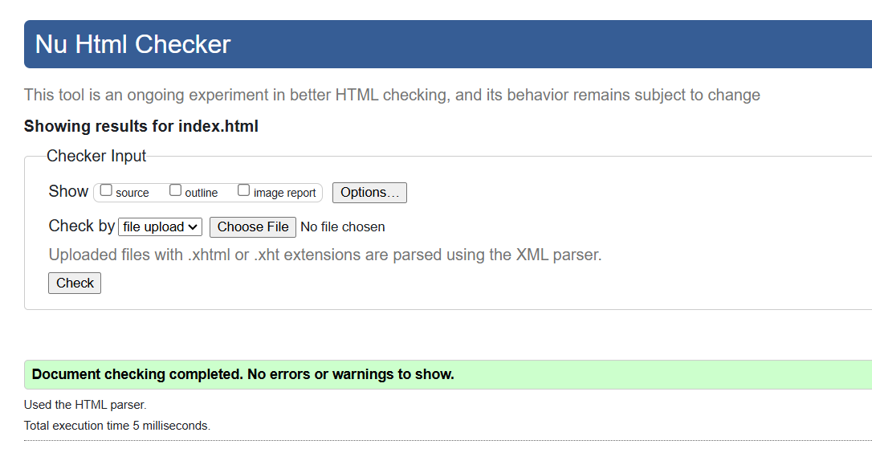

2) style.css:  
10 warning, due to static nature cannot check variables. (not applicable)

WebAIM color contrast checker and Accessibility Checker:

No errors found.

3) About Page: (about.html)

4) Services Page: (services.html)

No errors:

