HaatSetu
A Voice-First Digital Market Bridge for Rural Producers
Theme: Digital Empowerment for Rural Communities | Team Luminescence | [College name]
1. Problem Description
India’s rural economy runs on micro-producers: handicraft artisans, handloom weavers, women’s self-help groups (SHGs) and forest-produce collectors. They make goods the market wants, but they cannot reach that market on fair terms. Selling online assumes literacy, English, product photography, pricing knowledge and marketplace know-how that most of them lack. We start with handicraft artisans, where the gap between the value of the craft and the maker’s income is widest.
- Scale: an estimated 64.66 lakh handloom and handicraft artisans (Ministry of Textiles, 2025), about 64% of them women. An IHD–Crafts Council of India study puts the craft workforce at 1.13 crore.
- Low earnings: gross value added is about ₹270 per worker per day, below prescribed minimum wages (IHD–CCI study).
- Middlemen and pricing: a source-to-retail price ratio of 1:10 is “not at all rare” in Indian craft markets (Dilli Haat study). Artisans price by guesswork, often below the cost of materials plus a fair wage.
- Digital access without digital tools: rural India has 548 million of India’s 958 million active internet users (IAMAI–Kantar, 2025). Phones are present, but selling tools assume typing, English and forms.
- Presentation and trust: cluttered phone photos make products look cheap online, and buyers cannot tell genuine handmade or GI goods from factory copies.
2. Problem Validation
Each pain point above is backed by government and research data. Government programmes already invest in artisan identity (Pehchan cards), market channels (GeM, ONDC, TRIFED) and SHG livelihoods (DAY-NRLM: 10 crore women in 90 lakh+ SHGs). However, none of them help a producer create a sellable listing. Primary validation: [Add: we interviewed N artisans at <location>; X% had never listed online, Y% priced by guesswork. Add one direct quote.]
3. Existing Solutions and Their Limitations
Existing solution | What it offers | Limitation
Amazon Karigar, Flipkart Samarth | Seller programmes on large marketplaces | Artisan must still shoot photos, write English listings and set prices
iTokri, Jaypore | Curated handmade stores | Curator-led, small intake; not a tool the artisan controls
TRIFED / Tribes India, GeM | Government sales channels | One channel each; no help creating the listing
ONDC seller apps | Open-network access | Assume a digitally confident, literate seller
Common gap: every option is a place to sell. None turns a rural producer’s voice and phone photo into a finished, fairly priced, verified listing.
4. Our Solution and Its Uniqueness
HaatSetu (“bridge from the village haat”) is a voice-first companion app for the producer, plus a programme console for government and NGOs. The artisan records one voice note and takes one photo; HaatSetu returns a ready-to-publish listing.
- Speak, don’t type: a voice note in the artisan’s own language becomes a bilingual listing (title, story, attributes). It is generated natively in each language, not machine-translated.
- AI photo studio: one phone photo becomes a clean, e-commerce-ready product image.
- Fair-price floor: materials + hours × fair wage + overhead, combined with a market band (P10–P90). The system never suggests a price below the maker’s wage, and the server enforces this rule.
- Signed Craft Passport: a QR/NFC tag carrying an Ed25519 signature proves the artisan, region and technique. Buyers verify it, not just read a claim.
- List once, sell everywhere: one listing reaches the HaatSetu storefront, ONDC, social commerce and B2B/GeM leads. The programme console tracks verification, beneficiaries by scheme and income lift against income at intake.
Built to generalise: voice-to-listing, photo studio, price floor and provenance work for any rural product. Adding SHG food products, handloom or forest produce is a configuration change (vocabulary, categories, price features), not a rewrite.
5. Technical Description and Feasibility
- App: Flutter for low-end Android; offline drafts with idempotent sync (no duplicates on retry).
- Backend: FastAPI + PostgreSQL/pgvector on Supabase. All AI runs server-side, so models can change without an app update.
- Language: Gemini (audio to listing in one call), with Bhashini (MeitY, AI4Bharat models) and Sarvam behind the same interface as fallbacks.
- Pricing: rule-based wage floor + LightGBM quantile regression (P10/P50/P90), evaluated on pinball loss and interval coverage.
- Provenance & search: Ed25519-signed passports; CLIP embeddings in pgvector for text and image search.
Feasibility: a working prototype exists. The backend passes 70 automated tests (pricing rules, passport tamper checks, degraded modes), and the Next.js programme console is built. Only a smartphone is needed, with no special hardware.
6. Prototype and Workflow
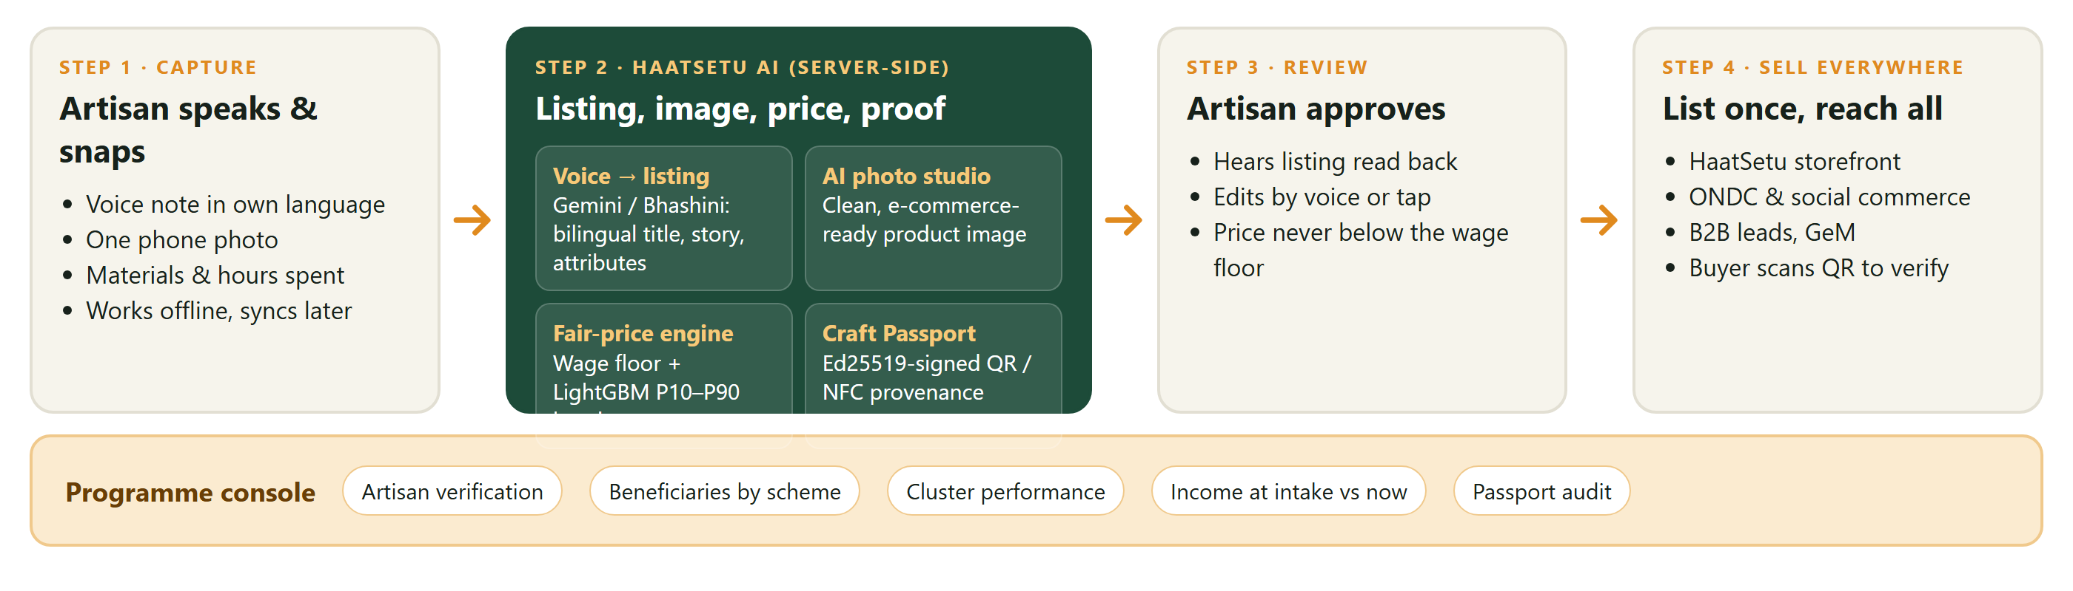
Figure 1. HaatSetu workflow: from one voice note and one photo to a verified listing on every channel.
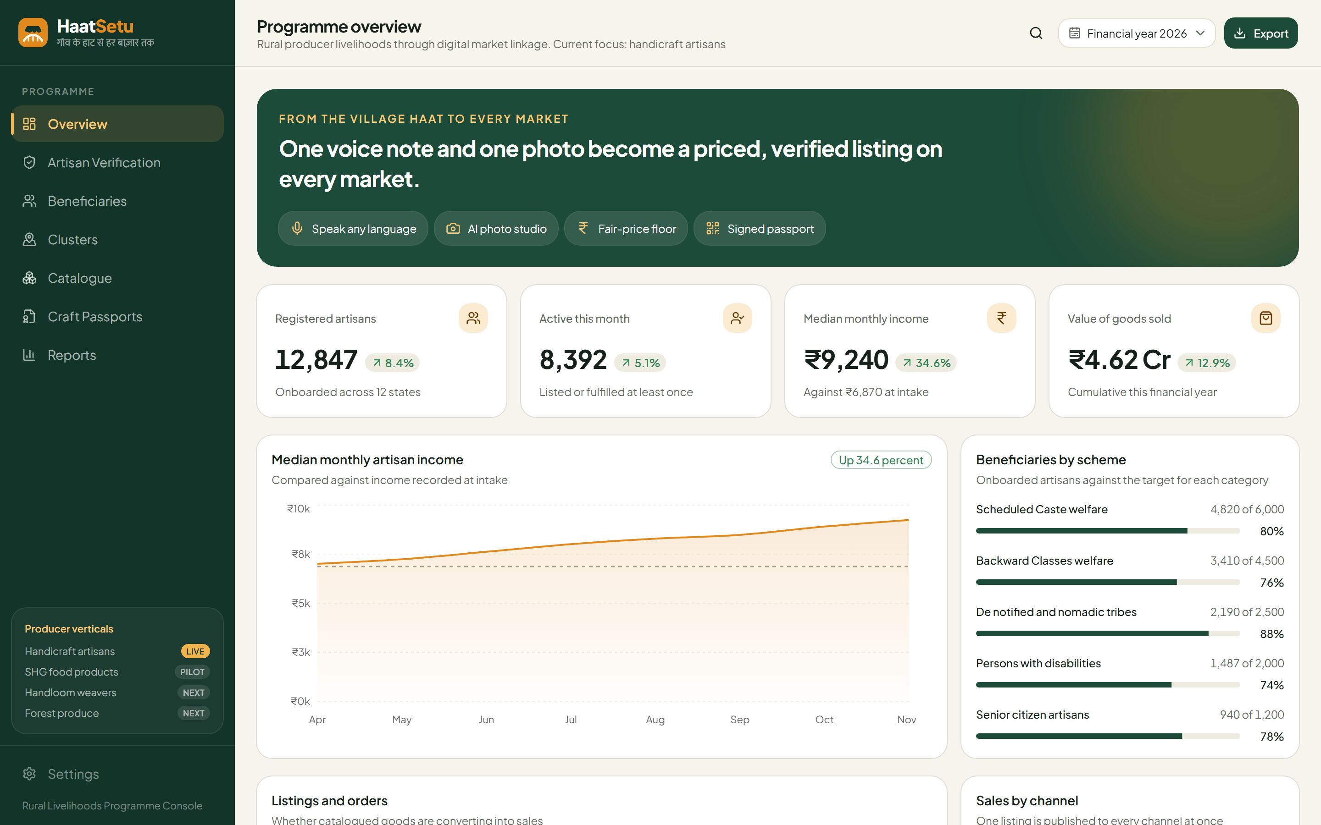
Figure 2. Programme console prototype (sample data): income lift, scheme coverage and producer verticals.
References
[1] Ministry of Textiles, PIB backgrounder on handloom and handicraft artisans, Dec 2025.
[2] Institute for Human Development & Crafts Council of India, craft-sector workforce and earnings study, 2025.
[3] IAMAI & Kantar, Internet in India Report 2025 (Jan 2026).
[4] Ministry of Rural Development, DAY-NRLM progress (10 crore women, 90 lakh+ SHGs), 2025.
[5] Dilli Haat caselet on artisan pricing and middlemen.

