**Worksheet 1.3.2**

**Student Name: Devansh Pandey UID: 21MCA2604**

**Branch: MCA Section/Group MCA5-B**

**Semester: 4 DateofPerformance: 20-03-2023**

**Subject Name: Embedded Programming Subject Code: 21CAH-752**

**1. Aim/Overview of the practical: (For EVEN UIDs)**

Interface an Arduino Uno with LCD to print Week Days (from Monday to Sunday) in Row 1. Row 2 will display the Date from 1st March to 15th March.

**Note:**

1. **Paste the Screenshots of Every Circuit as per the mentioned case.**
2. **Screenshot should have your Name and UID (21MCI1234_XYZ)**
3. **Mention the comments in the programming.**

**2. Apparatus (For applied/experimental sciences/materials based labs):**

**Hardware Requirements**

**Software requirements**

**3. Circuit Diagram(TinkerCad):**

1. **Coding:**

**#include<LiquidCrystal.h>**

**const int rs = 12,**

**en = 11,**

**d4 = 5,**

**d5 = 4,**

**d6 = 3,**

**d7 = 2;**

**LiquidCrystal lcd(rs, en, d4, d5, d6, d7);**

**void setup() {**

**lcd.begin(16, 2);**

**//lcd.print("Hello World");**

**}**

**void loop() {**

**lcd.setCursor(0, 0);**

**lcd.print("Mon Tue Wed Thu Fri Sat Sun");**

**lcd.setCursor(0, 1);**

**lcd.print("1 2 3 4 5 6 7 8 9 10 11 12 13 14 15"); {**

**for (int positionCounter = 1; positionCounter++;) {**

**lcd.scrollDisplayLeft();**

**delay(100);**

**}delay(5000);}**

**}**

**OUTPUT**

**Screenshort-1**

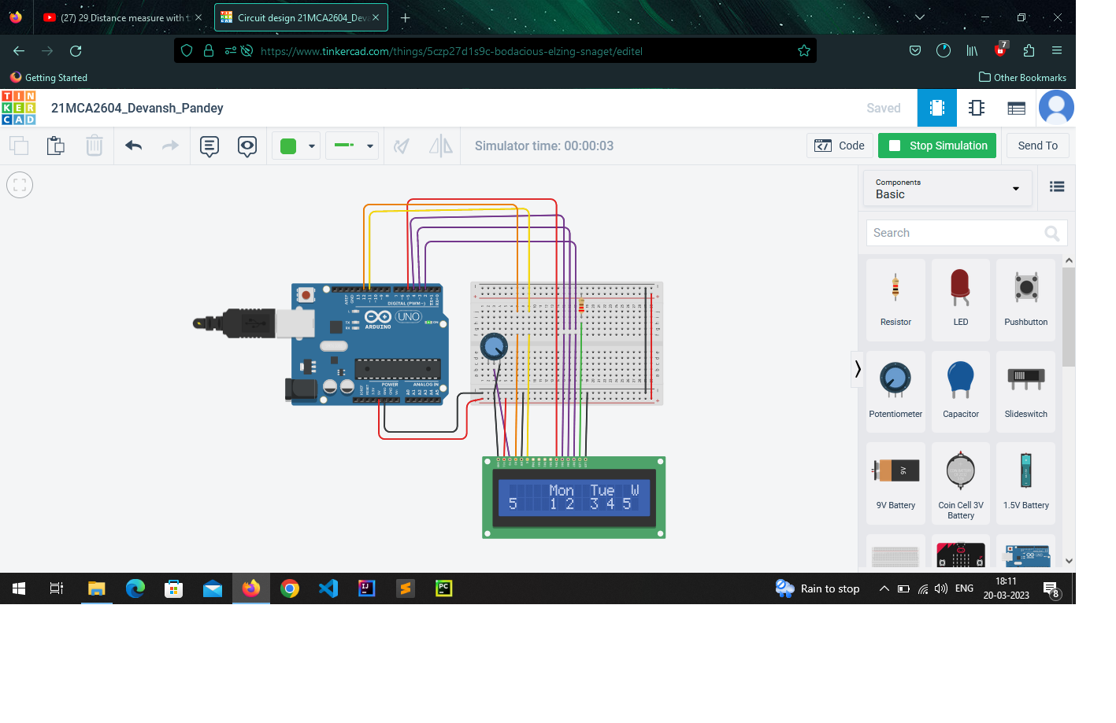

**Screenshort-2**

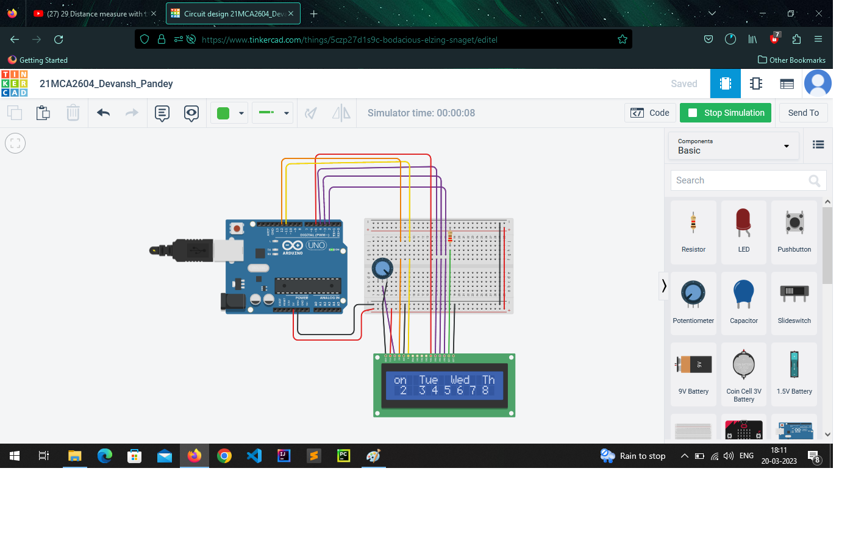

**Screenshort-3**

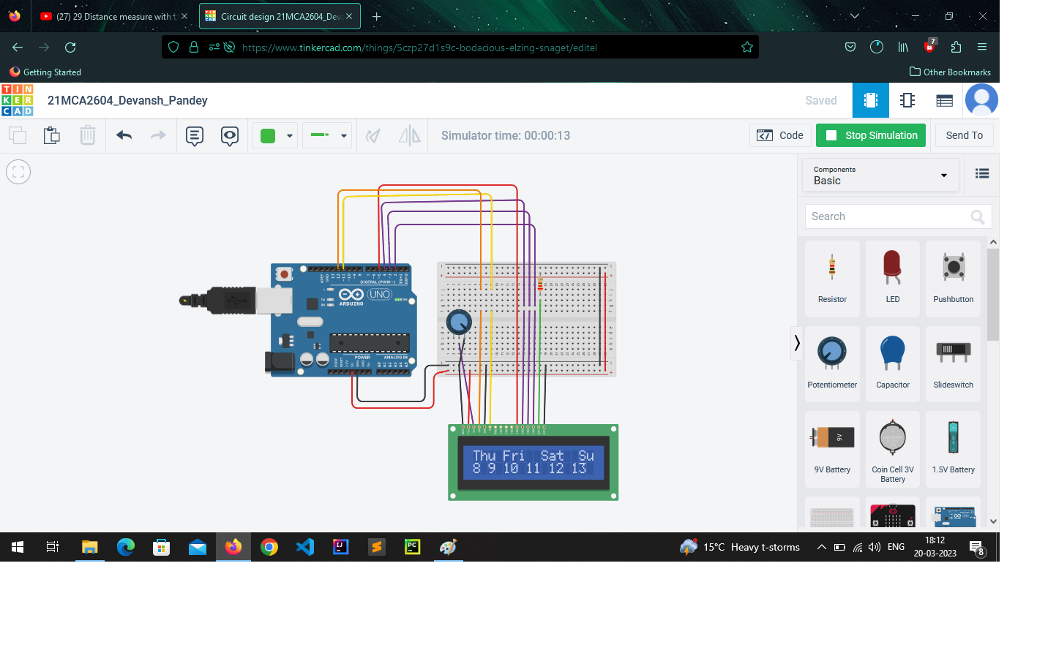

**Screenshort-4**

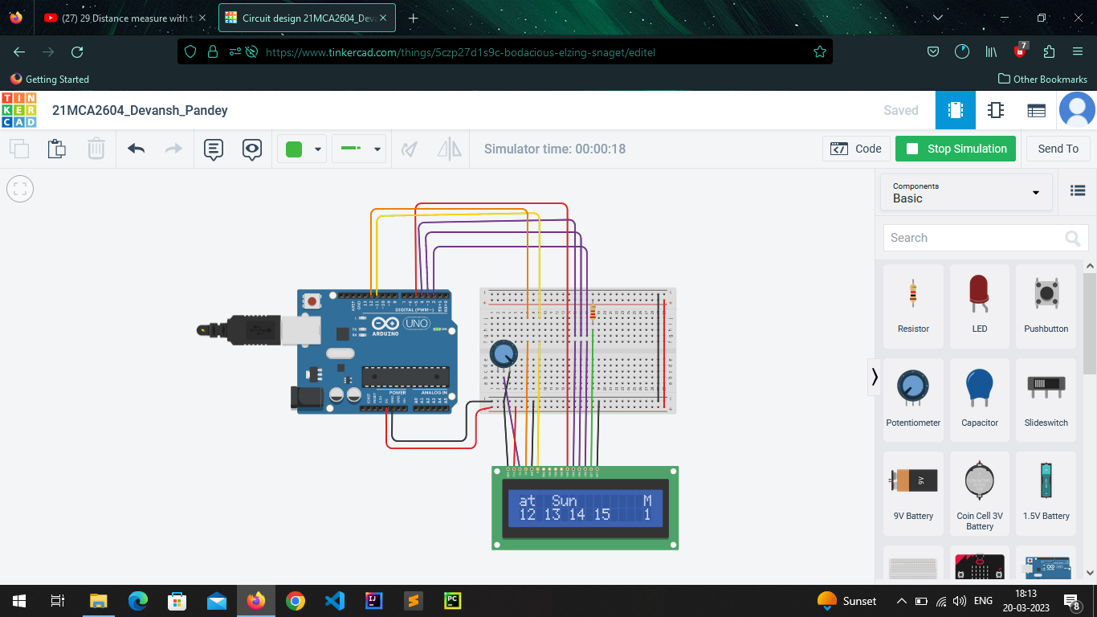

**Evaluation Grid (To be created as per the SOP and Assessment guidelines by the faculty):**

|  |  |  |  |
| --- | --- | --- | --- |
| Sr. No. | Parameters | Marks Obtained | Maximum Marks |
| 1. | Worksheet Completion |  | 10 marks |
| 2. | Post Lab Quiz Result |  | 5 marks |
| 3. | Student Engagement  (Simulation/ Demonstrate/Performance and Pre-Lab Questions)) |  | 5 marks |
|  | Total |  | 20 marks |