**Worksheet 2.2.2**

**Student Name: Devansh Pandey UID: 21MCA2604**

**Branch: MCA Section/Group MCA5-B**

**Semester: 4 DateofPerformance: 10-04-2023**

**Subject Name: Embedded Programming Subject Code: 21CAH-752**

**1. Aim/Overview of the practical: (For EVEN UIDs)**

Interface an Arduino Uno with Gas Sensor and seven segments to calculate the concentration of gas and print on a Serial monitor.

1. If the gas concentration is > 550 print F on seven segments.
2. If the gas concentration is < 550 and gas concentration is> 300 print E on seven segment display
3. If the distance is < 300 turn on the green light and 0 display on seven segment display.

**Note:**

1. **Paste the Screenshots of Every Circuit as per the mentioned case.**
2. **Screenshot should have your Name and UID (21MCI1234_XYZ)**
3. **Mention the comments in the programming.**

**2. Apparatus (For applied/experimental sciences/materials based labs):**

**Hardware Requirements**

**Software requirements**

**3. Circuit Diagram(TinkerCad):**

1. **Coding:**

int gas_snsr = A1;

int gas_val;

int dist_snsr = A0;

int dist_val;

int a = 11;

int b = 12;

int c = 2;

int d = 3;

int e = 6;

int f = 9;

int g = 10;

int green_led = 7;

void setup()

{

pinMode(gas_snsr, INPUT);

pinMode(dist_snsr, INPUT);

Serial.begin(9600);

pinMode(a, OUTPUT);

pinMode(b, OUTPUT);

pinMode(c, OUTPUT);

pinMode(d, OUTPUT);

pinMode(e, OUTPUT);

pinMode(f, OUTPUT);

pinMode(g, OUTPUT);

pinMode(green_led, OUTPUT);

}

void displayF() {

digitalWrite(a,HIGH);

digitalWrite(b, LOW);

digitalWrite(c, LOW); //a g f e

digitalWrite(d, LOW);

digitalWrite(e, HIGH);

digitalWrite(f, HIGH);

digitalWrite(g, HIGH);

}

void displayE() {

digitalWrite(a, HIGH);

digitalWrite(b, LOW);

digitalWrite(c, LOW);

digitalWrite(d, HIGH);

digitalWrite(e, HIGH);

digitalWrite(f, HIGH);

digitalWrite(g, HIGH);

}

void display0() {

digitalWrite(a, HIGH);

digitalWrite(b, HIGH);

digitalWrite(c, HIGH);

digitalWrite(d, HIGH);

digitalWrite(e, HIGH);

digitalWrite(f, HIGH);

digitalWrite(g, LOW);

}

void loop()

{

gas_val = analogRead(gas_snsr);

dist_val = analogRead(dist_snsr);

Serial.println("**GAS**");

Serial.println(gas_val);

if (gas_val > 550) {

displayF();

} else if (gas_val < 550 && gas_val > 300) {

displayE();

} else {

display0();

}

if (dist_val < 300) {

digitalWrite(green_led, HIGH);

display0();

} else {

digitalWrite(green_led, LOW);

}

delay(1000);

}

**OUTPUT**

1. **If the gas concentration is > 550 print F on seven segments**

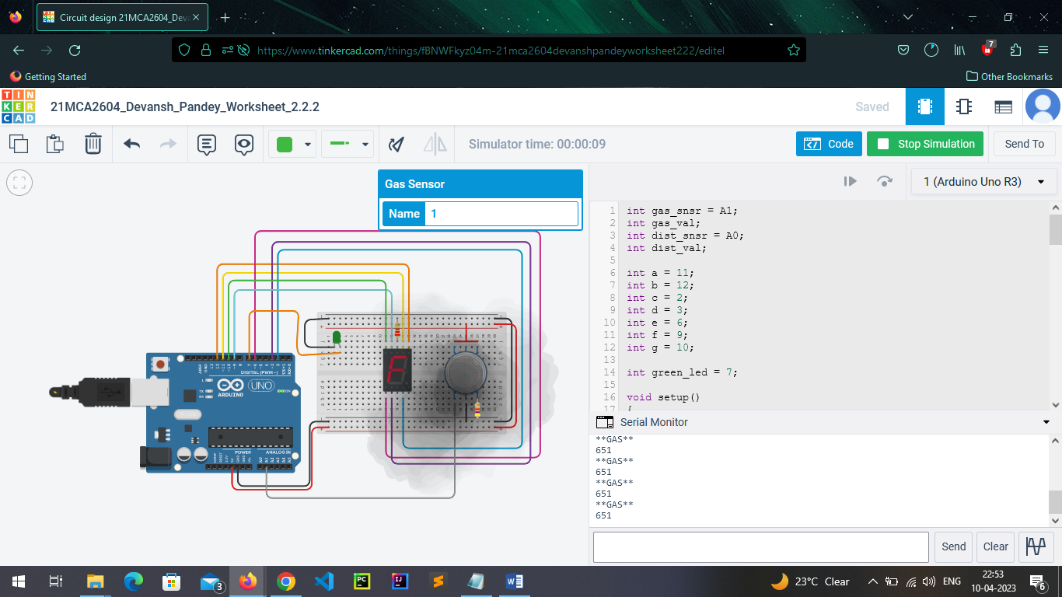

1. **If the gas concentration is < 550 and gas concentration is> 300 print E on seven segment display**

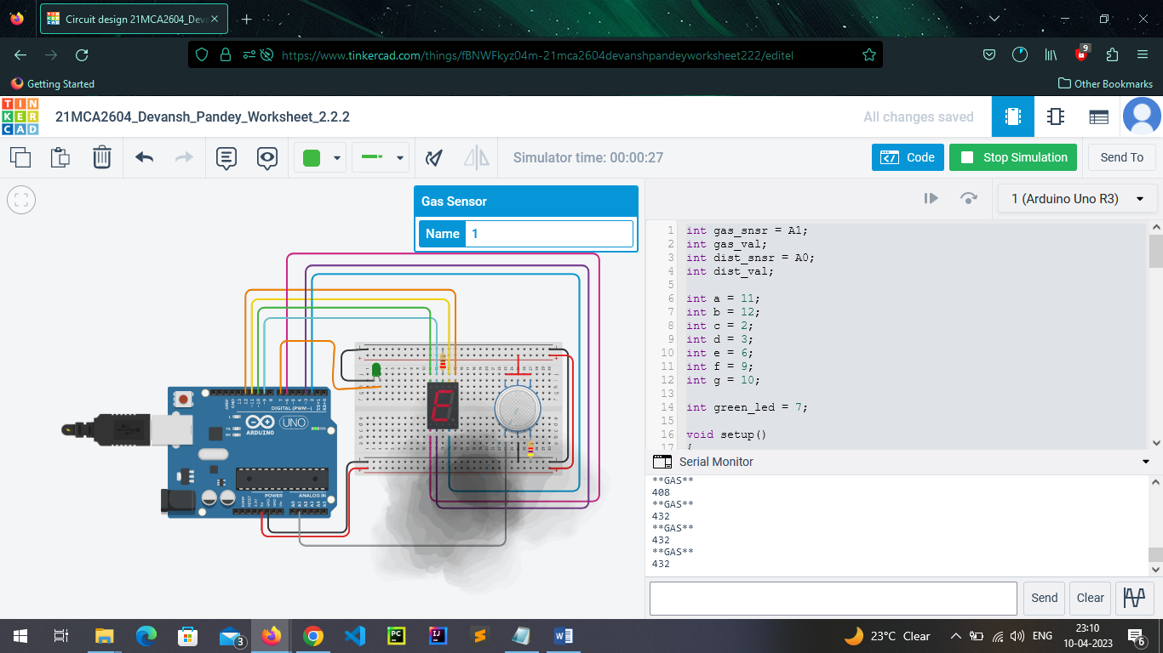

1. **If the distance is < 300 turn on the green light and 0 display on seven segment display.**

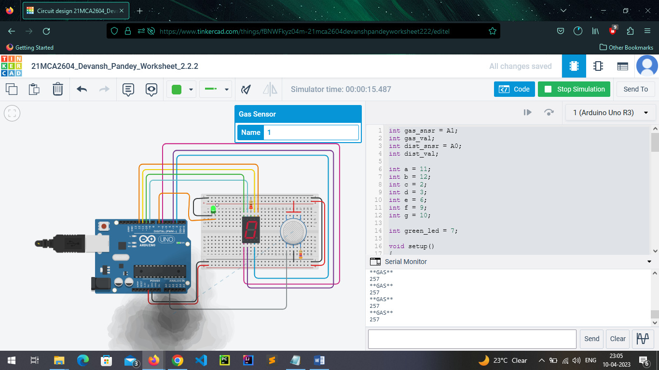

**Evaluation Grid (To be created as per the SOP and Assessment guidelines by the faculty):**

|  |  |  |  |
| --- | --- | --- | --- |
| Sr. No. | Parameters | Marks Obtained | Maximum Marks |
| 1. | Worksheet Completion |  | 10 marks |
| 2. | Post Lab Quiz Result |  | 5 marks |
| 3. | Student Engagement  (Simulation/ Demonstrate/Performance and Pre-Lab Questions)) |  | 5 marks |
|  | Total |  | 20 marks |