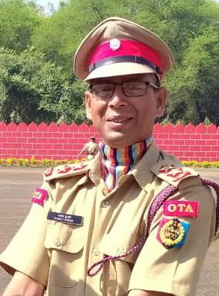 ***Name:* Lt. Manoj Kumar Bijalwan**

***Post In Teaching:*  Lecturer In English**

***Home District:* Uttarkashi**

***Age :* year**

***His 3 Mo. Training Experience***

**I did my ANO training from OTA Kamptee in Maharashtra.**

**It was a great experience for me to do the training of NCC Leiutenant.**