Name: Devansh Upadhyay

Roll No. 55, TYCSBS

Practical No. 1

Program:

#include <iostream>

using namespace std;

string encrypt(string text,int s)

{

    string result="";

    for(int i=0;i<text.length();i++)

    {

        if(isupper(text[i]))

        result+=char(int(text[i]+s-65) % 26+65);

        else

        result+=char(int(text[i]+s-97) % 26+97);

    }

    return result;

}

int main()

{

    string text;

    int s;

    cout<<"\nEnter The text: ";

    cin>>text;

    cout<<"\nText: "<<text;

    cout<<"\nEnter the number of shift to do: ";

    cin>>s;

    cout<<"\nShift: "<<s;

    cout<<"\nCipher: "<<encrypt(text,s);

    return 0;

}

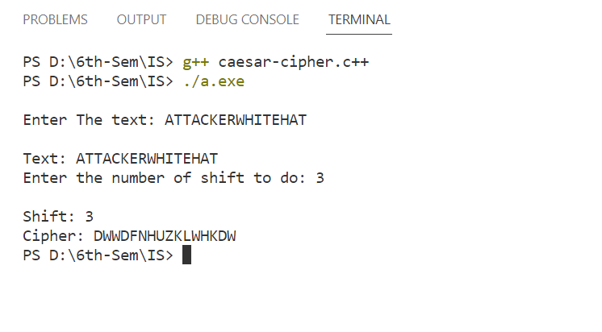Output: