Name: Devansh Upadhyay

Roll No 52

CSBS Final Year

**Practical No. 1**

**Title: Introduction to ERP system and ERP packages**

**Theory:**

1. ERP stands for enterprise resource planning. The simplest way to define ERP is to think about all the core business processes needed to run a company: finance, HR, manufacturing, supply chain, services, procurement, and others. At its most basic level, ERP helps to efficiently manage all these processes in an integrated system. It is often referred to as the system of record of the organization.
2. Finance requires an ERP to quickly close the books. Sales needs ERP to manage all customer orders. Logistics relies on well-running ERP software to deliver the right products and services to customers on time. Accounts payable needs ERP to pay suppliers correctly and on time. Management needs instant visibility into the company’s performance to make timely decisions. And banks and shareholders require accurate financial records, so they count on reliable data and analysis made possible by the ERP system.

**Benefits of ERP:**

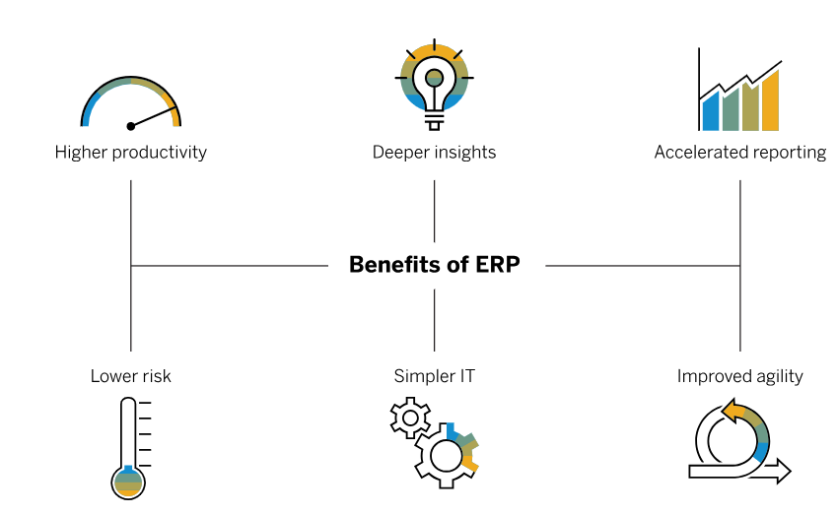

1. **Higher productivity:** Streamline and automate your core business processes to help everyone in your organization do more with fewer resources.
2. **Deeper insights:** Eliminate information silos, gain a single source of truth, and get fast answers to mission-critical business questions.
3. **Accelerated reporting:** Fast-track business and financial reporting and easily share results. Act on insights and improve performance in real time.
4. **Lower risk:**Maximize business visibility and control, ensure compliance with regulatory requirements, and predict and prevent risk.
5. **Simpler IT:** By using integrated ERP applications that share a database, you can simplify IT and give everyone an easier way to work.
6. **Improved agility:**With efficient operations and ready access to real-time data, you can quickly identify and react to new opportunities.

**Working of ERP System:**

1. An [ERP system](https://www.sap.com/products/erp.html) – also called an ERP suite – is made up of integrated modules or business applications that talk to each other and share common a database.
2. Each ERP module typically focuses on one business area, but they work together using the same data to meet the company’s needs. [Finance](https://www.sap.com/insights/erp-finance.html), accounting, [human resources](https://www.sap.com/insights/employee-experience.html), sales, [procurement](https://www.sap.com/insights/procurement-business-networks.html), [logistics](https://www.sap.com/insights/viewpoints/sustainable-logistics-on-the-move.html), and [supply chain](https://www.sap.com/insights/viewpoints/key-supply-chain-issues-tech-strategies.html) are popular starting points. Companies can pick and choose the module they want and can add on and scale as needed.
3. ERP systems also support industry-specific requirements, either as part of the system’s core functionality or through application extensions that seamlessly integrate with the suite.
4. ERP software can be bought using a cloud subscription model (software-as-a-service) or a licensing model (on premise).

**Types of ERP**:

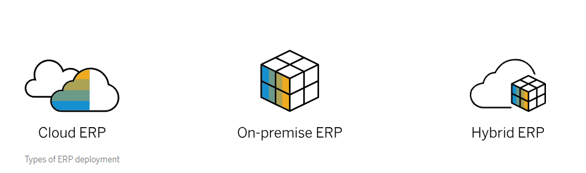

1. **Cloud ERP**: With cloud ERP, the software is hosted in the cloud and delivered over the Internet as a service that you subscribe to. The software provider generally takes care of regular maintenance, updates, and security on your behalf.
2. **On-premise ERP**: This is the traditional model for deploying software where you control everything. The ERP software is typically installed in your data center at the locations of your choice. The installation and maintenance of the hardware and software is your staff’s responsibility.
3. **Hybrid ERP**: For companies that want a mixture of both to meet their business requirements, there is the hybrid cloud ERP model. This is where some of your ERP applications and data will be in the cloud and some on premise. Sometimes this is referred to as two-tier ERP.

**ERP Packages**:

1. **Microsoft Dynamics 365**
   1. It is ERP software that belongs to Microsoft corporation, and which provides the CRM functions, ERP package features, or even businesses can customize more functions to support business processes include:
2. Sales
3. Service
4. Customers’ service
5. Operation
6. Finance
7. Maintenance
8. Project management
9. Marketing

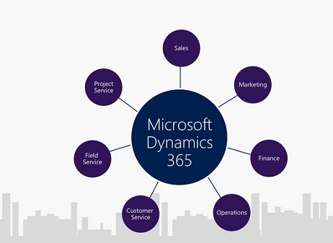

1. **ERP Oracle**
   1. ERP Oracle is a cloud platform that provides applications including finance, FMCG, Human resources, distribution, and production. It serves for various targets from small enterprises, SME to major companies. The main features of this include:
2. Finance management
3. Project management
4. Ordering management
5. CRM
6. Production
7. Planning logistic
8. Report
9. Smart business

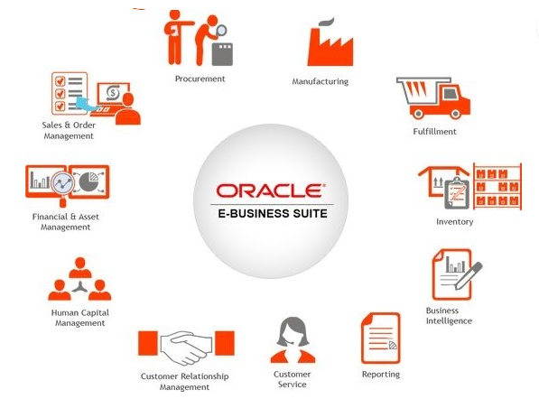

1. **ERP SAP Business One**
   1. SAP Business One is suitable for many modules, and accounting, productions, retailing, distribution. Furthermore, this software is based on integrated cloud, so it is able to be applied for various sectors:
      1. Finance
      2. CRM
      3. Inventory management
      4. Sales
   2. And all functions are operated in a system. Moreover, SAP Business One supports multi-currency transactions, and various languages for businesses over the world. In addition, the system provides a remote support platform that can perform many functions

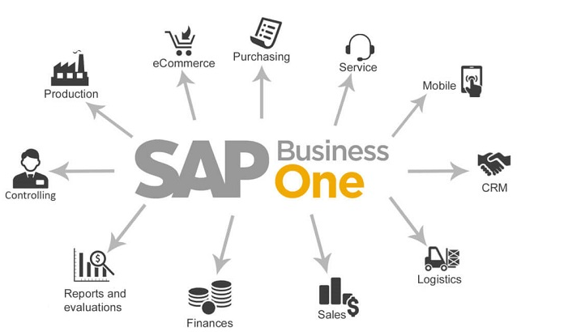

**Conclusion:** ERP systems have become a crucial aspect of modern business operations. The benefits they bring to organizations are numerous and can lead to increased efficiencies, better decision-making processes, and ultimately higher profits. However, it’s essential to be aware of the challenges that come with implementing an ERP system.