Name: Devansh Upadhyay

Roll No 52

CSBS Final Year

**Practical No. 2**

**Title: Open Source and Cloud ERP**

**Theory:**

1. Open source software is software with source code that anyone can inspect, modify, and enhance.
2. "Source code" is the part of software that most computer users don't ever see; it's the code computer programmers can manipulate to change how a piece of software—a "program" or "application"—works. Programmers who have access to a computer program's source code can improve that program by adding features to it or fixing parts that don't always work correctly
3. Some software has source code that only the person, team, or organization who created it—and maintains exclusive control over it—can modify. People call this kind of software "proprietary" or "closed source" software.

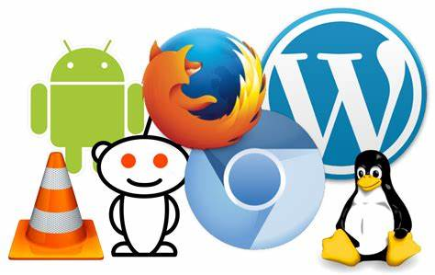

1. Only the original authors of proprietary software can legally copy, inspect, and alter that software. And in order to use proprietary software, computer users must agree (usually by signing a license displayed the first time they run this software) that they will not do anything with the software that the software's authors have not expressly permitted. Microsoft Office and Adobe Photoshop are examples of proprietary software.
2. Open source software is different. Its authors make its source code available to others who would like to view that code, copy it, learn from it, alter it, or share it. LibreOffice and the GNU Image Manipulation Program are examples of open source software.
3. As they do with proprietary software, users must accept the terms of a license when they use open source software—but the legal terms of open source licenses differ dramatically from those of proprietary licenses.

Open Source ERP Software:

1. Open-source ERP is software with a source code that anyone can inspect, modify or enhance. These tools are publicly accessible, commonly managed, and maintained by organizations with a specific mission in mind. The open-source ERP solutions included in this list are surprisingly full-featured, offering various users an expansive list of capabilities.
2. It’s important to remember that some of the open-source offers included in this list require some development skills, making them less than ideal fits for your use case.
3. Some of Open Source ERP Softwares:
   1. Apache OFBiz
      1. Apache OFBiz's suite of related business tools is built on a common architecture that enables organizations to customize the ERP to their needs. As a result, it's best suited for midsize or large enterprises that have the internal development resources to adapt and integrate it within their existing IT and business processes.
      2. [Apache OFBiz®](https://www.crunchbase.com/organization/apache-ofbiz) uses 29 technology products and services including HTML5, jQuery, and Google Analytics, according to [G2 Stack](https://stack.g2.com/).
      3. OFBiz is a mature open source ERP system; its website says it's been a top-level Apache project for a decade. Modules are available for accounting, manufacturing, HR, inventory management, catalog management, CRM, and e-commerce. You can also try out its e-commerce web store and backend ERP applications on its demo page.

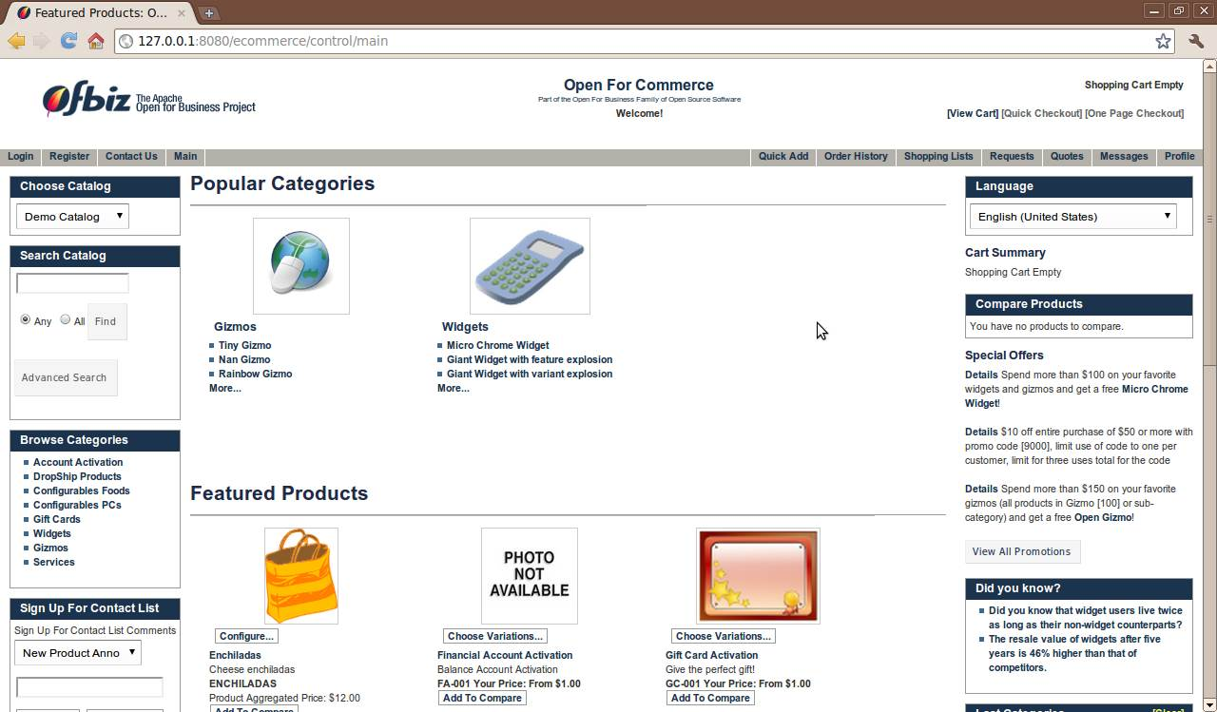

* 1. ERPNext
     1. ERPNext is one of those classic open source projects; in fact, it was featured on Opensource.com way back in 2014. It was designed to scratch a particular itch, in this case replacing a creaky and expensive proprietary ERP implementation.
     2. ERPNext was built for small and midsized businesses. It includes modules for accounting, managing inventory, sales, purchase, and project management. The applications that make up ERPNext are form-driven—you fill information in a set of fields and let the application do the rest. The whole suite is easy to use.
     3. ERPNext uses 11 technology products and services including HTML5, jQuery, and Google Analytics, according to G2 Stack.

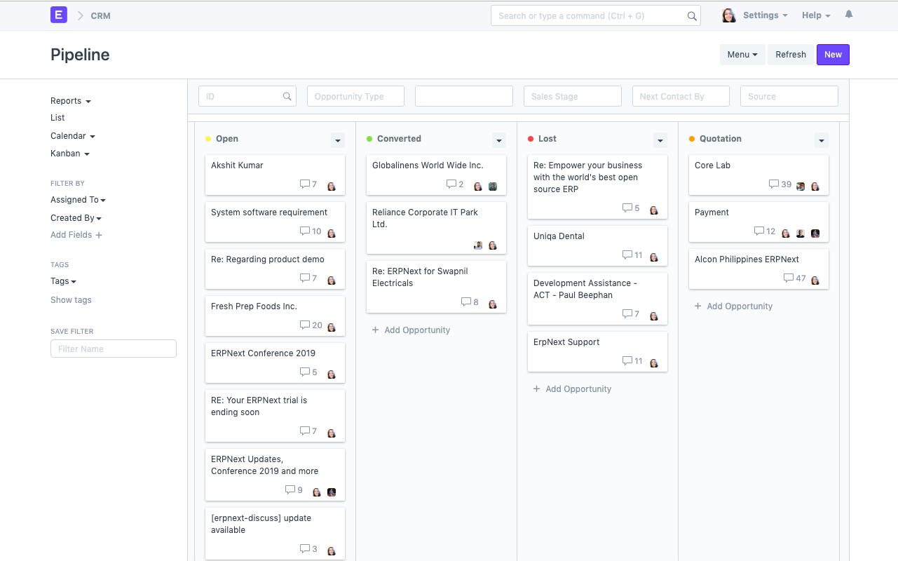

* 1. Metasfresh
     1. Metasfresh's name reflects its commitment to keeping its code "fresh." It's released weekly updates since late 2015, when its founders forked the code from the ADempiere project. Like ADempiere, it's an open source ERP based on Java targeted at the small and midsize business market.
     2. While it's a younger project than most of the other software described here, it's attracted some early, positive attention, such as being named a finalist for the Initiative Mittelstand "best of open source" IT innovation award.
     3. metasfresh uses 19 technology products and services including HTML5, jQuery, and Google Analytics, according to G2 Stack.

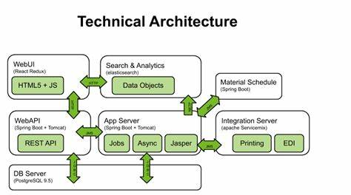

* 1. Odoo
     1. Odoo is an integrated suite of applications that includes modules for project management, billing, accounting, inventory management, manufacturing, and purchasing. Those modules can communicate with each other to efficiently and seamlessly exchange information.
     2. While ERP can be complex, Odoo makes it friendlier with a simple, almost spartan interface. The interface is reminiscent of Google Drive, with just the functions you need visible. You can give Odoo a try before you decide to sign up.
     3. Odoo uses 25 technology products and services including HTML5, Google Analytics, and Google Fonts, according to G2 Stack.

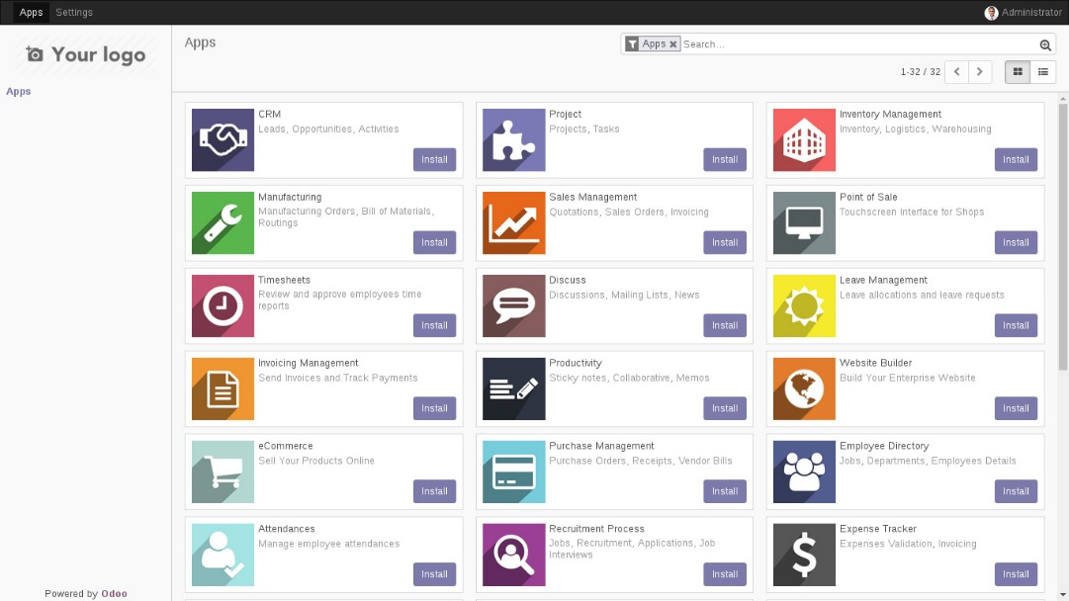

* 1. Tryton
     1. Tryton's based on a EPR system called TinyERP and has been around since 2008. Over its lifetime, Tryton has grown both in popularity and flexibility.
     2. Tryton is aimed at businesses of all sizes, and has a range of modules. Those include accounting, sales, invoicing, project management, shipping, analytics, and inventory management. Tryton's not all or not, though. The system is modular, so you can install only the modules your business needs. While the system is web based, there are desktop clients for Windows and MacOS.
     3. The online demo will give you an idea of what Tryton can do. When you're ready, you can install it using a Docker image, download the source code or get the code from the project's Mercurial repository. The source code, in case you're wondering, is licensed under GPLv3 or later.
     4. Tryton uses 4 technology products and services including HTML5, F5 NGINX, and Lighttpd, according to G2 Stack.  
        