Name: Devansh Upadhyay

Roll No 52

CSBS Final Year

**Practical No. 3**

**Title: ERP Implementation Life Cycle**

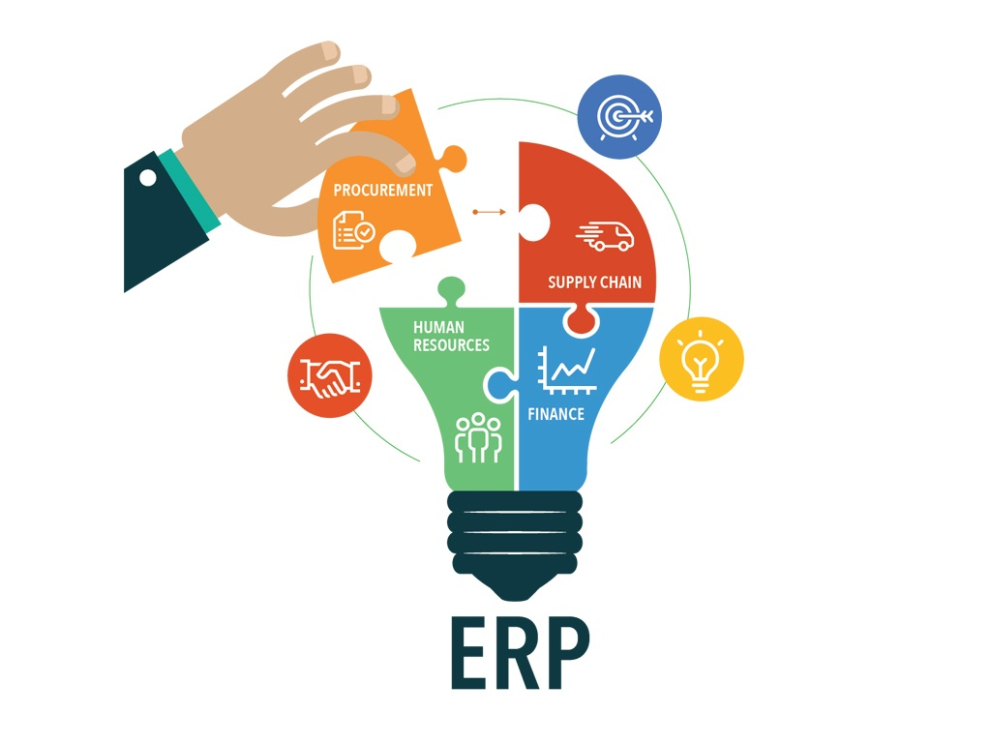

**Enterprise Resource Planning (ERP)** is made to automate any task. With ERP, it is easy to manage every department under one single database. This consumes not much time and is easy and fast way to do work with. Developed in 1990s, Enterprise Resource Planning is foundation system for domestic and global operations, supporting most or all functional areas in their daily operations. Is one of the more common categories of business software, especially with large-scale businesses.

It is business strategy and set of industry-domain-specific applications that build customer and shareholder communities value network system by enabling and optimizing enterprise and inter-enterprise collaborative operational and financial processes. ERP at its core is an effective way of centralizing information and workflow processes through data management. Because ERP keeps all of your workflow data in one place.

**Example :**

Any enterprise’s planning, manufacturing, sales and marketing efforts are put under one management system and then it combines to one single database system.

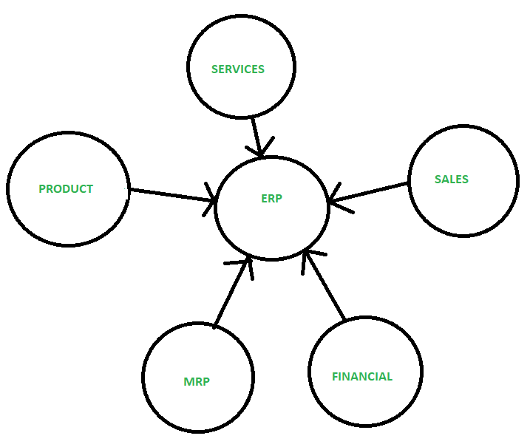

**Different phases of ERP Implementation** :

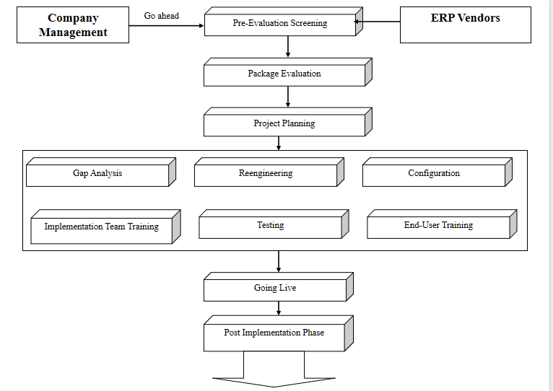

1. **Pre-Evaluation Screening**: Pre-Evaluation Screening is the phase which starts when company decides to go for a ERP System, the search for perfect solution starts.It is very time consuming process to select few where all claims be the best, it is just external study of package.Each package has its own weakness and strength.
2. **Package Evaluation**:Package Evaluation process is one of the most important phase of the ERP implementation , because the package you select will decide failure or success of project.There is little room for error in this as ERP packages are so expensive once purchased can not switch to another.While making the analysis the important point is nothing is perfect , important here is whether it is a perfect fit or good fit.
3. **Project Planning Phase** This is the phase which plans and designs the implementation process.Details of how to go about implementation ,Time schedules and deadlines are decided.Roles and responsibilities are identified and assigned.This phase will decide when to begin, how to do it and when the project is supposed to be completed and what to do in emergency.
4. **Gap Analysis**: Gap analysis is a phase in the ERP implementation, where the organization tries to find out the gaps between the company’s existing business practices & those supported by the ERP package.This is the process through which companies create a complete model of where they are now & where they want to head in the future.
5. **Re-engineering**: It is in this phase that the human factors are taken into account.Two different connotations (association or suggestion )1st one is the controversial, involving the use of ERP to aid in downsizing efforts. The 2nd use of the word re-engineering in the ERP field refers to an ERP implementation model initially designed & used to.
6. **Customization**: This is the main functional area of the ERP implementation. Business processes have to be understood & mapped in such a way that the arrived solution matches with the overall goals of the company.
7. **Implementation Team Training**: Implementation team is being trained not how to use the system, but how to implement it.This is the phase where the company trains its employees to implement & later run the system.The ERP vendors & the hired consultants will leave after the implementation is over.
8. **Testing**: This is the phase where you try to break the system.Here we reach a point where we are testing real case scenarios.The system is configured & now we must come up with extreme case scenarios- system overloads, multiple users logging on at the same time with the same query, users entering invalid data, hackers trying to access restricted areas & so on.The test case must be designed specifically to find the weak links in the system & these bugs should be fixed before going live.
9. **End-User Training** On the technical side, the work is almost complete- data conversions is done, databases are up & running, & on the functional side, the prototype is fully configured & tested & ready to go operational.The system is officially proclaimed operational, even though the implementation team must have been testing it & running successfully for some time.But once the system is ‘live’, the old system is removed & the new system is used for doing business.
10. **Going Live** On the technical side, the work is almost complete- data conversions is done, databases are up & running, & on the functional side, the prototype is fully configured & tested & ready to go operational.The system is officially proclaimed operational, even though the implementation team must have been testing it & running successfully for some time.
11. **Post Implementation Phase**

