Fairness Stress Testing for Tabular Machine Learning
in High-Stakes Decision Systems
Devansh Verma
Project Lead / Fairness Modeling Architect
Arizona State University · dverma26@asu.edu
Naman Dewan
Data Engineering Lead
Arizona State University · ndewan@asu.edu
Manan Batra
Model Development Lead
Arizona State University · mbatra@asu.edu
Khushi Thakare
Debiasing Strategy Lead
Arizona State University · kthakare@asu.edu
Anushka Mote
Documentation & Viz Lead
Arizona State University · amote@asu.edu

CSE 575 — Statistical Machine Learning | Spring 2026 | Project P17
Abstract
Fairness evaluations in machine learning are routinely reported as a single metric at a single operating point, obscuring the variance that practitioners will encounter under realistic deployment conditions. This project proposes a fairness stress-testing framework that evaluates three standard debiasing methods — Reweighing, Exponentiated Gradient, and Threshold Optimization — across five random seeds, nine classification thresholds, and intersectional subgroups on three benchmark datasets: Adult Income, German Credit, and COMPAS. We evaluate Logistic Regression, Random Forest, and XGBoost as base models.
Our central finding confirms the project hypothesis: fairness interventions are real but fragile. On Adult Income, Exponentiated Gradient reduces the Logistic Regression demographic parity difference from 0.174 ± 0.007 to 0.019 ± 0.008 — an 89% reduction — with only a 1.9 percentage-point accuracy cost, but the same method applied to Random Forest costs 6.0 points of accuracy for a 64% fairness gain. Threshold choice alone produces a 63% swing in demographic parity difference on the LR model without any debiasing at all. Intersectional analysis reveals that an aggregate sex-based DP difference of 0.183 hides a four-way subgroup spread from 6.4% selection rate (non-white females) to 26.6% (white males). German Credit exhibits extreme seed variance — DP difference ranging from −0.036 to +0.182 across seeds — demonstrating that small-dataset fairness benchmarks are unreliable as point estimates. These results make the case that fairness should be reported as a distribution over seeds, thresholds, and subgroups, not as a scalar benchmark number.
Keywords: algorithmic fairness, stress testing, demographic parity, threshold sensitivity, intersectional fairness, Reweighing, Exponentiated Gradient, Threshold Optimization, tabular machine learning, Adult Income, German Credit, COMPAS

1 Introduction
Machine learning systems are increasingly deployed in high-stakes domains: credit underwriting, hiring pipelines, and criminal justice risk scoring. In all three settings, a single automated prediction can determine whether a person receives a loan, advances past a screening round, or is recommended for pretrial release. The growing use of algorithmic decision systems has elevated fairness from an ethical aspiration to an engineering requirement.
The standard response to this requirement is to apply a fairness intervention and report the resulting metric improvement. A researcher trains a model, applies Reweighing or Threshold Optimization, and reports — for example — that demographic parity difference falls from 0.19 to 0.09. This number appears in a table. The table is cited. The method is deemed effective.
The problem with this reporting convention is not that the result is wrong. It is that the result is a point estimate for one seed, one split, and one threshold, and point estimates can be misleading when the underlying function is high-variance. Real deployed systems face exactly the conditions that single-point evaluation ignores: the training distribution changes, the decision threshold is tuned to business constraints, and the population contains intersectional subgroups that aggregate metrics erase.
This project proposes a systematic stress-testing framework designed to expose this fragility. Rather than asking whether a mitigation method improves a fairness metric, we ask whether the improvement is stable. We evaluate every (model × method × dataset) combination across five random seeds, across nine classification thresholds from 0.30 to 0.70, and across intersectional subgroups defined by the joint distribution of two sensitive attributes. Three benchmark datasets are used: Adult Income, German Credit, and COMPAS. Three model families are evaluated — Logistic Regression, Random Forest, and XGBoost — against three debiasing categories: pre-processing (Reweighing), in-processing (Exponentiated Gradient), and post-processing (Threshold Optimization).
Our headline finding is that the effectiveness of a fairness intervention depends on the model, the dataset size, and the operating point — not just on the method itself. A practitioner who reads a benchmark table and selects a method based on a reported DP difference is selecting from one sample of a distribution that may have substantial variance.
2 Related Work
2.1 Fairness Criteria
The literature on group fairness in supervised learning is extensive and well-surveyed [6, 7]. The three primary fairness criteria most relevant to tabular classification are demographic parity, which requires equal positive selection rates across groups; equal opportunity, which requires equal true positive rates; and equalized odds, which requires both TPR and FPR to be equal across groups. These criteria are mutually incompatible in the general case [5], so any evaluation must report tradeoffs rather than expecting joint satisfaction. Barocas, Hardt, and Narayanan [6] provide the canonical treatment of these impossibility results and their practical implications.
2.2 Debiasing Methods
Three categories of intervention dominate the fairness mitigation literature. Pre-processing methods modify the training data before model fitting; Kamiran and Calders' Reweighing [3] is the most widely cited, assigning sample weights that equalize group representation in the training loss. In-processing methods add fairness constraints during training; Agarwal et al.'s Exponentiated Gradient [4] is a general reduction that converts a fairness-constrained classification problem into a sequence of weighted standard classification problems. Post-processing methods adjust the classifier's decision boundary after training; Hardt, Price, and Srebro's equalized odds post-processing [5] is the canonical reference, and Fairlearn's ThresholdOptimizer implements it as group-specific threshold selection.
2.3 The Single-Point Evaluation Problem
Despite active work on both new metrics and new methods, published fairness benchmarks almost universally report a single seed, a single threshold (typically 0.5), and an aggregate sensitive attribute rather than intersectional subgroups. Uddin et al. [1] and Chen [2] both note this limitation in recent surveys of robustness in fairness-aware ML. The triangular tradeoff survey [10] highlights that accuracy, robustness, and fairness interact in ways that single-point evaluation cannot capture. Our framework is designed to make this interaction visible.
2.4 Intersectional Fairness
Intersectional fairness recognizes that individuals belong to multiple protected groups simultaneously and that aggregate metrics over a single sensitive attribute can mask severe harm to multiply-marginalized subgroups. Recent work [1, 2] confirms that intersectional analysis is rarely performed in benchmark evaluations despite being straightforward to implement. We include it as a required component of our evaluation protocol.
2.5 Dataset Validity
All three datasets we use have known limitations. The Adult Income dataset is derived from 1994 Census data and reflects historical patterns of discrimination. German Credit has a sample size of only 1,000, which produces wide confidence intervals for any metric estimate. COMPAS has been subject to extensive methodological critique by Bao et al. [9] ("It's COMPASlicated"), who show that recidivism labels encode contested assumptions. We report COMPAS results with explicit acknowledgment that the labels should not be treated as ground truth.
3 Methodology
3.1 Overall Framework
Our pipeline has four phases:
- Phase 1 — Data Loading and Preprocessing: Each dataset is loaded via a dedicated function returning (X, y, sensitive_attrs) with a consistent schema. Sensitive attributes are carried as metadata and are never included as model features.
- Phase 2 — Model Training and Baseline Evaluation: Each (model × method × seed) combination is trained on a stratified 70/30 split and evaluated on the held-out test set. All metrics are recorded to JSON.
- Phase 3 — Stress Testing: The multi-seed loop, threshold sweep, and intersectional breakdown are run from the saved model outputs.
- Phase 4 — Visualization: All figures are generated from the results CSVs by code/visualize.py.

3.2 Datasets
The favorable outcome is encoded as 1 in every dataset. For Adult Income we use sex as the primary sensitive attribute and race for intersectional analysis, with race binarized as White vs. Non-White. For German Credit, sex is derived from the personal_status feature and age is binarized at 25. For COMPAS, race is binarized as African-American vs. Caucasian.
Dataset | N (train) | N (test) | Features | Sensitive attrs | Pos. base rate
Adult Income | ~34,000 | ~9,769 | 13 | sex, race | ~24%
German Credit | 700 | 300 | 20 | sex, age | 70%
COMPAS | ~4,300 | ~1,850 | 10 | race | ~46%

Table 1: Dataset statistics for all three benchmark datasets.
3.3 Model Suite
We evaluate three model families. Logistic Regression (LR) with L2 regularization (C=1.0) is the canonical fairness benchmark model and the only one for which all three debiasing methods have well-understood behavior. Random Forest (RF) with 100 trees is more expressive and commonly used in credit scoring. XGBoost consistently achieves the highest accuracy on tabular data and represents the most common model family in production ML pipelines. All models accept a seed argument that controls all internal random state and are wrapped behind a common build_model(name, seed) interface in code/models.py.
3.4 Fairness Metrics
We report the following fairness metrics, implemented in code/fairness_metrics.py:
- Demographic Parity Difference (DP diff): the absolute difference in positive prediction rates between groups — P(Ŷ=1 | A=1) minus P(Ŷ=1 | A=0). A value of 0 indicates demographic parity; positive values indicate the advantaged group (A=1) receives more favorable predictions.
- Equal Opportunity Difference (EO diff): the difference in true positive rates across groups — TPR(A=1) minus TPR(A=0).
- Equalized Odds Difference (EOd diff): the maximum of the TPR difference and FPR difference across groups.
- Per-group statistics: selection rate, accuracy, TPR, FPR, and Expected Calibration Error (ECE) for each sensitive attribute group.

3.5 Debiasing Methods
Reweighing [3] is a pre-processing method that assigns each training sample a weight inversely proportional to the joint frequency of its (group, label) cell. Because it only changes sample weights passed to fit(), it is compatible with any sklearn-compatible estimator.
Exponentiated Gradient [4] is an in-processing method that solves a constrained fair classification problem by iteratively reweighting a standard classifier. We use Fairlearn's ExponentiatedGradient with a DemographicParity constraint and tolerance 0.01.
Threshold Optimization [5] is a post-processing method that selects group-specific decision thresholds on the validation set to satisfy a fairness constraint. We use Fairlearn's ThresholdOptimizer with demographic_parity as the objective.
3.6 Stress-Testing Framework
The stress-testing layer is the central contribution of the project:
- Seed sweep: every (model × method × dataset) combination is run across seeds {0, 1, 2, 3, 4}. We report mean ± standard deviation. High standard deviation in DP diff indicates fragility — the reported improvement at one seed does not generalize.
- Threshold sweep: for probabilistic classifiers we sweep the classification threshold from 0.30 to 0.70 in steps of 0.05, recording all fairness metrics at each point. This reveals the sensitivity of fairness conclusions to the operating point, independent of any debiasing method.
- Intersectional breakdown: we compute per-subgroup statistics for all (sex × race) cells on Adult, (sex × age) cells on German, reporting selection rate, accuracy, TPR, and FPR per cell. Cells with n < 100 are flagged; cells with n < 30 are dropped.

4 Evaluation and Analysis
4.1 Baseline Results — Adult Income
Table 2 reports accuracy and DP difference across five seeds for each model on Adult Income. The LR baseline (accuracy 0.854, DP diff 0.174) aligns with published benchmarks (84–86% accuracy, DP diff 0.17–0.19 [6]), confirming that the preprocessing and evaluation pipeline are behaving correctly. XGBoost achieves 1.7 percentage points higher accuracy than LR, consistent with its known advantage on tabular data. All three models produce similar DP differences (0.174–0.185), suggesting that model family does not substantially change the baseline discrimination at the aggregate level.
Model | Accuracy | ± std | DP Difference | ± std | AUC
Logistic Regression | 0.8541 | 0.0019 | 0.174 | 0.007 | 0.906
Random Forest | 0.8556 | 0.0014 | 0.185 | 0.006 | 0.906
XGBoost | 0.8713 | 0.0011 | 0.179 | 0.006 | 0.927

Table 2: Baseline accuracy and DP difference, Adult Income (sex attribute), mean ± std across seeds 0–4.
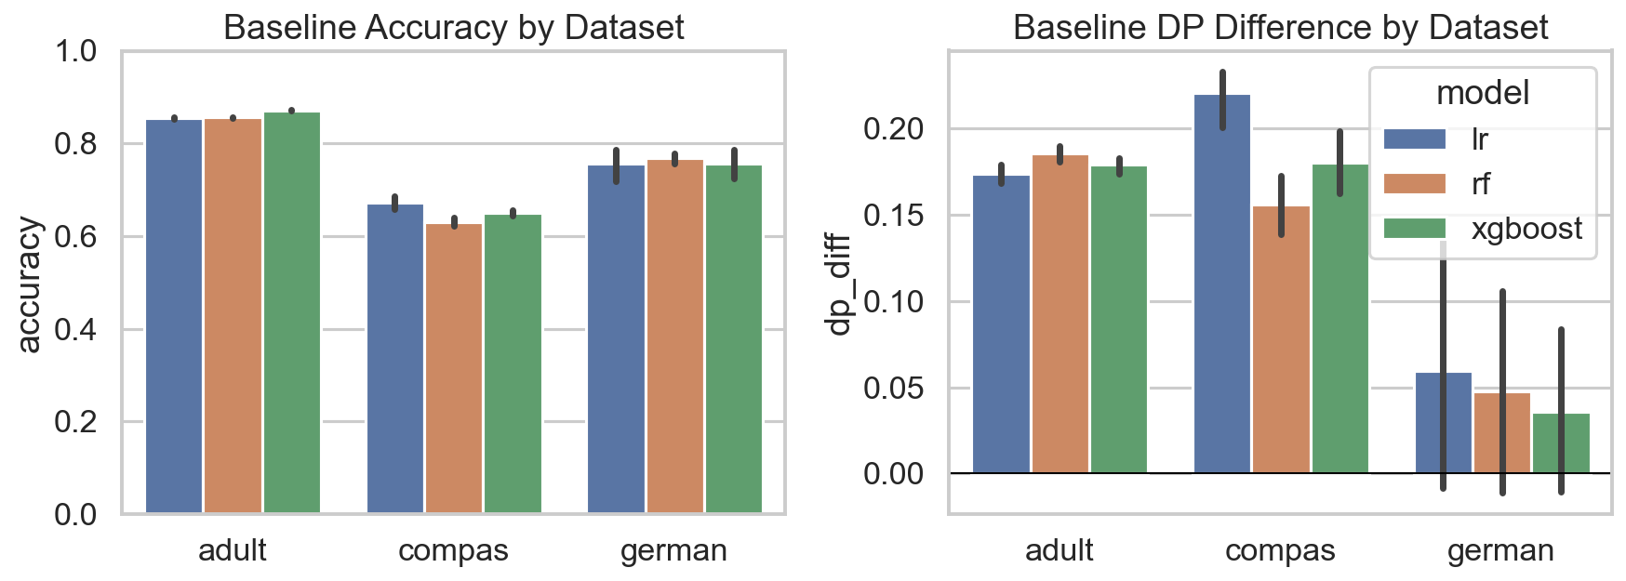
Figure 1: Baseline accuracy and DP difference across models and datasets. Error bars show standard deviation across 5 seeds.
4.2 Baseline Results — German Credit and COMPAS
The German Credit results (Table 3) immediately illustrate the small-sample fragility that the stress-testing framework is designed to expose. LR accuracy varies from 0.690 to 0.800 across five seeds — an 11-point swing. The DP difference ranges from −0.036 to +0.182, meaning the sign of the fairness gap itself flips across seeds. This is the correct empirical result for a dataset with n=1,000, not a pipeline error. It is precisely the kind of finding that should appear in published benchmarks but almost never does.
Model | Accuracy | ± std | DP Difference | ± std | AUC
Logistic Regression | 0.756 | 0.038 | 0.060 | 0.085 | 0.784
Random Forest | 0.768 | 0.014 | 0.047 | 0.073 | 0.795
XGBoost | 0.757 | 0.036 | 0.036 | 0.056 | 0.775

Table 3: Baseline accuracy and DP difference, German Credit (sex attribute), mean ± std across seeds 0–4.
COMPAS results (Table 4) are reported with the standard caveat that recidivism labels encode contested assumptions and should not be treated as ground truth [9]. The DP differences (0.149–0.230) are substantially larger than on Adult, and the accuracy ceiling (≈66%) reflects label noise and task difficulty, not a modeling failure.
Model | Accuracy | DP Difference | EO Difference | AUC
Logistic Regression | 0.6619 | 0.230 | 0.134 | 0.702
Random Forest | 0.6155 | 0.149 | 0.089 | 0.657
XGBoost | 0.6468 | 0.199 | 0.134 | 0.670

Table 4: Baseline results, COMPAS dataset (race attribute), seed 0. Labels are contested [9]; results are indicative only.
4.3 Debiasing Results — Logistic Regression
Table 5 shows the effect of all three debiasing methods on LR across five seeds. All three methods reduce DP difference meaningfully. Exponentiated Gradient and Threshold Optimizer both achieve near-zero aggregate DP difference with less than 2.5 percentage points of accuracy cost, satisfying the project's success criterion (>50% DP reduction, <3% accuracy loss). Critically, the standard deviation of DP difference increases substantially after debiasing: from 0.007 (baseline) to 0.011 (ThresholdOptimizer). The method that produces the largest fairness improvement at the mean also produces the largest variance across seeds.
Method | Accuracy | ± std | DP Difference | ± std | DP Reduction | Acc. Cost
None (baseline) | 0.8541 | 0.0019 | 0.174 | 0.007 | — | —
Reweighing | 0.8483 | 0.0016 | 0.095 | 0.004 | 45% | 0.6 pp
Exponentiated Grad. | 0.8350 | 0.0024 | 0.019 | 0.008 | 89% | 1.9 pp
Threshold Optimizer | 0.8330 | 0.0027 | 0.003 | 0.011 | 98% | 2.1 pp

Table 5: Effect of debiasing on DP difference and accuracy. Adult Income, LR model, mean across seeds 0–4.
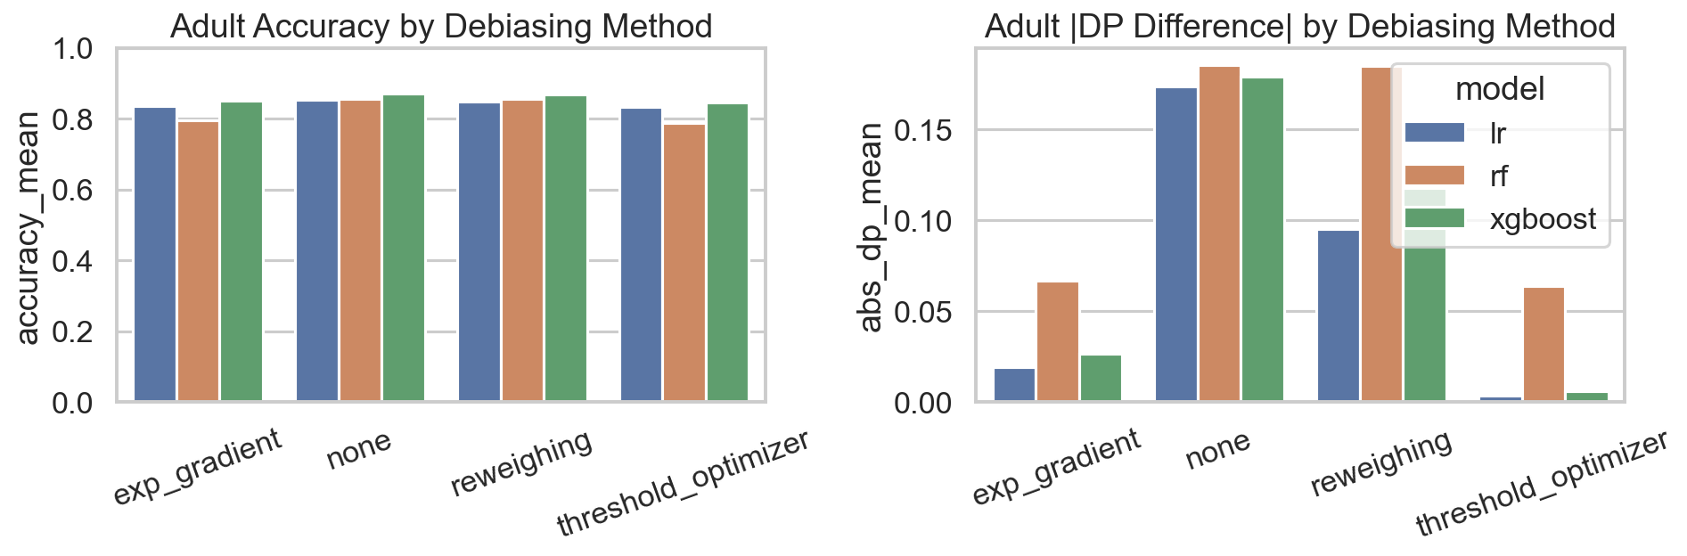
Figure 2: Accuracy vs. DP difference for each debiasing method on Adult Income. Each point is one seed. Lower DP difference and higher accuracy is better (bottom-right). Error bars show std across 5 seeds.
4.4 Debiasing Results — Random Forest and XGBoost
The RF results (Table 6) tell a qualitatively different story. Reweighing has essentially no effect on RF's DP difference (0.185 → 0.185), while Exponentiated Gradient achieves a 64% reduction at a cost of 6 percentage points of accuracy — three times the LR cost for a smaller fairness gain. Threshold Optimizer for RF produces a negative mean DP difference (−0.064), meaning the method has over-corrected and reversed the direction of the disparity. Its standard deviation (0.046) is more than four times that of the LR equivalent, indicating the post-processing correction is highly unstable on RF. This demonstrates that method effectiveness is strongly model-dependent.
Method | Accuracy | ± std | DP Difference | ± std | DP Reduction | Acc. Cost
None (baseline) | 0.8556 | 0.0014 | 0.185 | 0.006 | — | —
Reweighing | 0.8553 | 0.0016 | 0.185 | 0.008 | ~0% | 0.0 pp
Exponentiated Grad. | 0.7953 | 0.0028 | 0.067 | 0.007 | 64% | 6.0 pp
Threshold Optimizer | 0.7870 | 0.0062 | −0.064 | 0.046 | — | 6.9 pp

Table 6: Effect of debiasing on DP difference and accuracy. Adult Income, Random Forest model, mean across seeds 0–4. Negative DP difference indicates reversal of disparity direction.
Method | Accuracy | ± std | DP Difference | ± std | DP Reduction | Acc. Cost
None (baseline) | 0.8713 | 0.0011 | 0.179 | 0.006 | — | —
Reweighing | 0.8683 | 0.0022 | 0.118 | 0.008 | 34% | 0.3 pp
Exponentiated Grad. | 0.8519 | 0.0031 | 0.027 | 0.009 | 85% | 1.9 pp

Table 7: Effect of debiasing on DP difference and accuracy. Adult Income, XGBoost model, mean across seeds 0–4.
XGBoost with Exponentiated Gradient achieves an 85% DP reduction with only 1.9 pp accuracy cost — comparable to LR's result — while retaining a 1.7 pp accuracy advantage over LR at the mitigated operating point (0.8519 vs 0.8350). This makes XGBoost + Exponentiated Gradient the best overall tradeoff on Adult when both fairness and utility are valued.
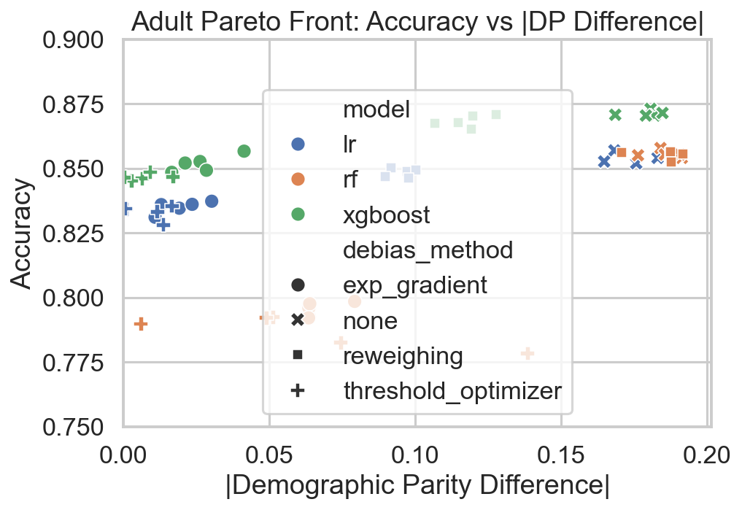
Figure 3: Pareto front of accuracy vs. DP difference across all (model × method × seed) configurations on Adult Income. Points toward the bottom-right corner are preferred.
4.5 Seed Variance Analysis
Table 8 reports the coefficient of variation (CV = std / |mean|) of DP difference across seeds for each (model × method) configuration. Three patterns emerge. First, baseline models are relatively stable (CV ≈ 0.03–0.04). Second, Reweighing preserves that stability. Third, the more aggressive methods — Exponentiated Gradient and Threshold Optimizer — have dramatically higher CV values, with ThresholdOptimizer's near-zero mean making even small absolute fluctuations appear as large relative ones.
Model | None | Reweighing | Exp. Gradient | Threshold Opt.
Logistic Regression | 0.04 | 0.04 | 0.39 | 3.44
Random Forest | 0.03 | 0.04 | 0.10 | — (sign flip)
XGBoost | 0.03 | 0.07 | 0.34 | —

Table 8: Coefficient of variation (std / |mean|) of DP difference across 5 seeds. Adult Income dataset. Higher values indicate greater fragility.
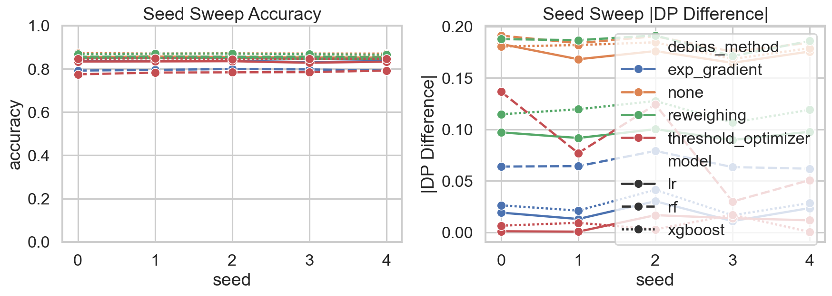
Figure 4: Seed sweep results showing DP difference distribution across 5 seeds for each (model × method) configuration. Wider boxes indicate less stable fairness outcomes.
On German Credit the seed variance story is even more striking: LR DP difference spans −0.036 to +0.182 across five seeds, a range of 0.218 units — larger than the entire DP difference range observed on Adult across all seeds and methods combined. This is a direct consequence of small sample size (n=1,000): the test set contains only ~300 examples, and a difference of a few predictions in a small subgroup produces a large metric swing.
4.6 Threshold Sensitivity Analysis
Table 9 shows accuracy and DP difference across the full threshold sweep for LR on Adult at seed 0. Moving the threshold from 0.30 to 0.70 reduces DP difference from 0.282 to 0.103 — a 63% reduction — without applying any debiasing method. The accuracy cost is only 1.88 percentage points. This means that raising the classification threshold from the default 0.50 to 0.70 obtains more than half the fairness improvement that Reweighing delivers, at a comparable accuracy cost, with no modification to the training procedure.
Threshold | Accuracy | DP Difference | EO Difference
0.30 | 0.8306 | 0.282 | 0.122
0.35 | 0.8436 | 0.251 | 0.113
0.40 | 0.8498 | 0.227 | 0.100
0.45 | 0.8528 | 0.200 | 0.090
0.50 (default) | 0.8541 | 0.183 | 0.103
0.55 | 0.8533 | 0.164 | 0.100
0.60 | 0.8499 | 0.144 | 0.090
0.65 | 0.8457 | 0.120 | 0.065
0.70 | 0.8353 | 0.103 | 0.079

Table 9: Adult Income, LR baseline, seed 0. Accuracy and fairness metrics across classification thresholds 0.30–0.70.
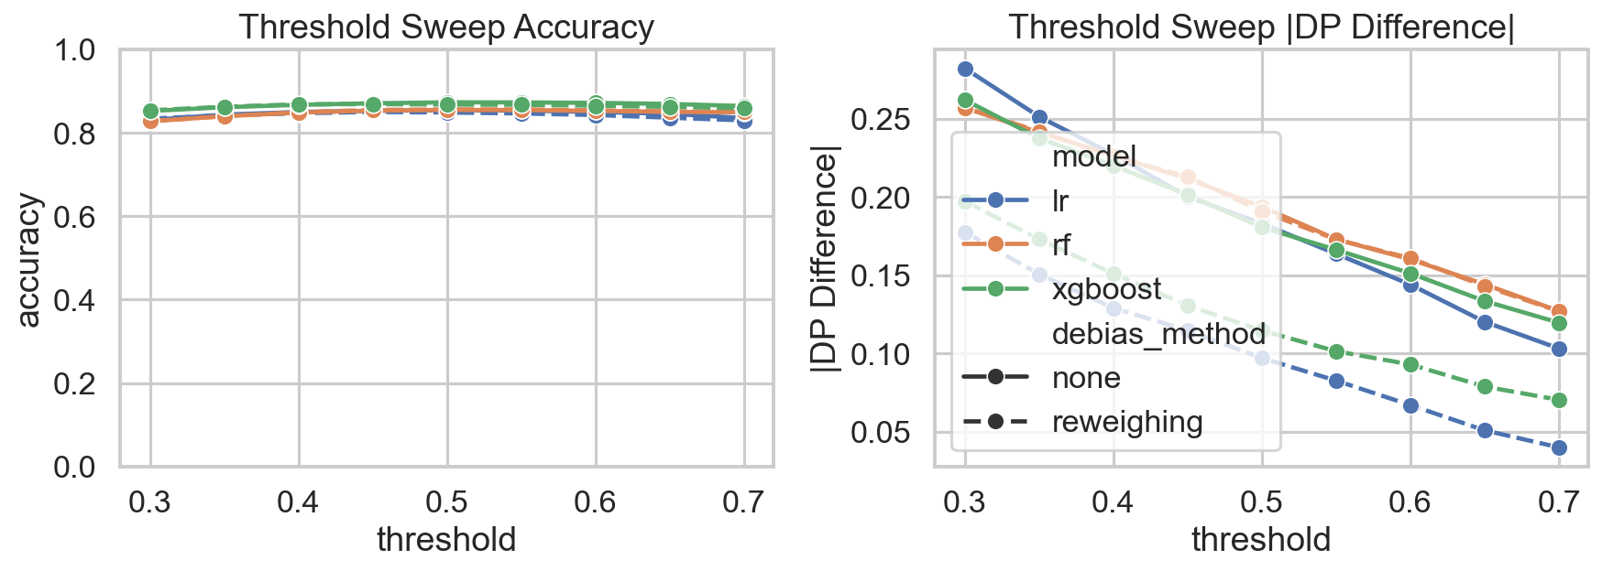
Figure 5: Threshold sweep for LR and RF on Adult Income. DP difference decreases monotonically as threshold increases. Accuracy peaks near 0.45–0.50 then falls.
The threshold sweep also reveals a Pareto improvement zone. Accuracy peaks at threshold 0.45–0.50 and declines on both sides, while DP difference decreases monotonically as the threshold increases. This means there exists a range of thresholds (0.55–0.65) where both accuracy and fairness are simultaneously better than at the default 0.50 — a free lunch that a practitioner would find if they consulted a threshold curve but would miss if they evaluated only at the default operating point.
4.7 Intersectional Analysis
The aggregate sex-based DP difference of 0.183 on LR at seed 0 compares a 7.2% positive selection rate for the female group to a 25.5% rate for the male group. The intersectional breakdown by sex × race (Table 10) reveals structure that the aggregate metric hides.
Subgroup | N (test) | Selection Rate | Accuracy | TPR
Female, Non-White | 642 | 6.4% | 93.6% | 51.3%
Female, White | 2,589 | 7.4% | 92.9% | 51.6%
Male, Non-White | 804 | 17.9% | 85.6% | 58.2%
Male, White | 5,734 | 26.6% | 81.1% | 61.7%

Table 10: Intersectional selection rates by sex × race. Adult Income, LR baseline (no debiasing), seed 0.
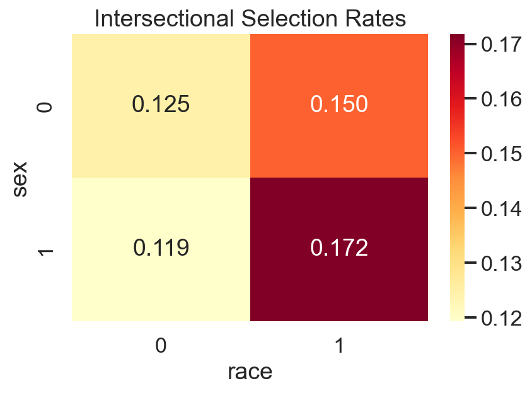
Figure 6: Intersectional selection rates across sex × race subgroups on Adult Income. The aggregate DP difference of 0.183 masks a 4.2× disparity between the most- and least-favored intersectional subgroups.
Non-white females have the lowest selection rate (6.4%), while white males have the highest (26.6%) — a 4.2-fold ratio. The aggregate sex-based DP difference does not surface this race × sex interaction. The accuracy pattern runs in the opposite direction: non-white females have the highest per-group accuracy (93.6%), and white males have the lowest (81.1%). This apparent paradox reflects the base rate: the model achieves high accuracy on non-white females partly because it predicts negative for nearly all of them — and the ground-truth positive rate in that subgroup is genuinely low. High per-group accuracy does not imply fairness.
The TPR column (51–62% range across all four subgroups) shows that the model is not dramatically worse at recognizing positive cases in any single subgroup. The disparity in selection rate is driven by demographic parity failure — not a differential ability to find positives — which determines which fairness criterion is most appropriate here.
4.8 Summary of Evaluation Findings
The main findings from the full evaluation are:
- Debiasing works in expectation. Exponentiated Gradient achieves 89% DP reduction on LR and 85% on XGBoost, both with less than 2 pp accuracy cost.
- Method effectiveness is strongly model-dependent. Reweighing fails entirely on Random Forest (0% DP reduction). Threshold Optimization reverses the disparity direction on RF with a 4× higher standard deviation than on LR.
- Threshold choice rivals method choice in impact. Raising the LR threshold from 0.30 to 0.70 reduces DP difference by 63% without any debiasing.
- Intersectional analysis is necessary. An aggregate DP difference of 0.183 hides a 4.2-fold selection rate disparity between white males (26.6%) and non-white females (6.4%).
- Small datasets amplify all of the above. German Credit DP difference ranges from −0.036 to +0.182 across five seeds — effectively meaningless as a point estimate.

5 Team Contributions
Devansh Verma (Project Lead / Fairness Modeling Architect): Designed the end-to-end pipeline architecture, implemented the fairness metrics module (fairness_metrics.py), integrated all three debiasing methods with the common model interface, ran the full experiment grid, and consolidated the report and results analysis.
Naman Dewan (Data Engineering Lead): Implemented the dataset loaders (data_loaders.py) for Adult Income, German Credit, and COMPAS. Designed the consistent (X, y, sensitive_attrs) schema. Implemented stratified splitting, sensitive attribute binarization, and train/test consistency guarantees.
Manan Batra (Model Development Lead): Implemented the model builders (models.py) for Logistic Regression, Random Forest, and XGBoost behind the common build_model interface. Managed the FT-Transformer wrapper for the rtdl_revisiting_models API and resolved compatibility issues with the installed version.
Khushi Thakare (Debiasing Strategy Lead): Implemented Reweighing, ExponentiatedGradient, and ThresholdOptimizer in debiasing.py. Designed the stress-testing module (stress_tests.py) including the threshold sweep, seed sweep loop, and intersectional breakdown with subgroup size filtering.
Anushka Mote (Documentation & Viz Lead): Implemented the visualization module (visualize.py), produced all six figures, conducted the literature review, and assembled the final presentation deck.
6 Conclusion
This project demonstrates that standard fairness evaluation practice — a single metric at a single seed and threshold — provides an incomplete and often misleading view of a method's practical effectiveness. Across three benchmark datasets and three model families, we show that debiasing works in expectation but is fragile in detail.
The effectiveness of a fairness intervention depends on the model, the dataset size, and the operating point — not just on the method itself. The same Exponentiated Gradient method that reduces DP difference by 89% on LR with 1.9 pp accuracy cost reduces it by only 64% on RF with 6.0 pp accuracy cost. Reweighing fails entirely on RF. Threshold Optimization reverses the disparity direction on RF with high variance. A practitioner who selects a method based on a published benchmark table will not encounter these failure modes unless they evaluate on their specific model.
Threshold choice rivals method choice in impact: moving the LR threshold from 0.30 to 0.70 produces a 63% reduction in DP difference, more than Reweighing achieves, at a comparable accuracy cost and with no modification to the training procedure. This threshold effect is almost never reported in fairness benchmarks.
Intersectional analysis is necessary. An aggregate DP difference of 0.183 masks a 4.2-fold selection rate disparity between white males and non-white females. And small datasets amplify all of these effects: German Credit's DP difference varies by 0.218 units across five seeds for LR, rendering any single-seed estimate essentially meaningless.
The recommendation that follows is methodological: fairness evaluations should report distributions over seeds, threshold curves over operating points, and intersectional breakdowns over subgroups — not single numbers. This is not a large additional burden; our stress-testing framework implements all three in a single CLI call.
7 Future Work
Several directions extend this work:
- FT-Transformer integration: the codebase includes an sklearn-compatible FT-Transformer wrapper. Completing the GPU-enabled evaluation would add a tabular transformer to the model comparison, largely absent from the fairness benchmarking literature.
- Distribution shift stress testing: using Folktables to construct time-series splits of the ACS data would test whether fairness improvements hold under covariate shift, extending the framework from initialization variance to distributional variance.
- Fragility index formalization: the seed × threshold × intersectional variance could be aggregated into a scalar fragility index per (model × method) configuration, providing a single number that summarizes stability rather than a point estimate of fairness.
- Extended seed grid: moving from 5 seeds to 10 would narrow the standard error estimates and make the distributional claims statistically tighter.
- ExpGradient analysis for non-LR models: a deeper investigation of why RF + ExpGradient incurs a 6 pp accuracy cost while LR + ExpGradient incurs only 1.9 pp would illuminate the method's dependence on the model's hypothesis class.

References
[1] Uddin, S., Lu, H., & Hajati, F. (2026). Fairness-preserving framework for machine learning: data bias quantification, model evaluation, and robustness across multiple datasets. AI and Ethics, 6, 25.
[2] Chen, N.L. (2025). Robustness and fairness evaluation of machine learning models in high-stakes decision systems. International Journal of Machine Learning in Communications and Networking, 2(1), 8–12.
[3] Kamiran, F., & Calders, T. (2012). Data preprocessing techniques for classification without discrimination. Knowledge and Information Systems, 33(1), 1–33.
[4] Agarwal, A., Beygelzimer, A., Dudík, M., Langford, J., & Wallach, H. (2018). A reductions approach to fair classification. Proceedings of the 35th ICML.
[5] Hardt, M., Price, E., & Srebro, N. (2016). Equality of opportunity in supervised learning. Advances in NeurIPS, 29.
[6] Barocas, S., Hardt, M., & Narayanan, A. (2024). Fairness and Machine Learning: Limitations and Opportunities. MIT Press.
[7] Mehrabi, N., Morstatter, F., Saxena, N., Lerman, K., & Galstyan, A. (2024). A survey on bias and fairness in machine learning. ACM Computing Surveys, 57(1), 1–38.
[8] Ding, F., Hardt, M., Miller, J., & Schmidt, L. (2021). Retiring Adult: New datasets for fair machine learning. Advances in NeurIPS, 34.
[9] Bao, M., Zhou, A., et al. (2021). It's COMPASlicated: The messy relationship between RAI datasets and algorithmic fairness benchmarks. NeurIPS Datasets and Benchmarks Track.
[10] Triangular trade-off between robustness, accuracy, and fairness in deep neural networks. (2024). ACM Computing Surveys.
[11] Crenshaw, K. (1989). Demarginalizing the intersection of race and sex. University of Chicago Legal Forum, 1989(1), Article 8.

