Fairness Stress Testing for Tabular Machine Learning
in High-Stakes Decision Systems
Devansh Verma, Naman Dewan, Manan Batra, Khushi Thakare, Anushka Mote
Arizona State University, Tempe, AZ 85281
dverma26@asu.edu, ndewan1@asu.edu, mbatra@asu.edu, kthakare@asu.edu, amote@asu.edu
CSE 575 Statistical Machine Learning | Spring 2026 | Project P17
Abstract—Fairness evaluations in machine learning are routinely reported as a single metric at a single operating point, obscuring the variance practitioners encounter under real deployment conditions. This work proposes a fairness stress-testing framework that evaluates three standard debiasing methods—Reweighing, Exponentiated Gradient, and Threshold Optimization—across five random seeds, nine classification thresholds, and intersectional subgroups on three benchmark datasets: Adult Income, German Credit, and COMPAS. We evaluate Logistic Regression, Random Forest, and XGBoost. Our central finding is that fairness interventions are real but fragile: Exponentiated Gradient reduces Logistic Regression demographic parity difference by 89% (0.174±0.007 → 0.019±0.008) with only 1.9 pp accuracy cost, yet the same method on Random Forest costs 6.0 pp for a 64% gain. Threshold choice alone produces a 63% DP-difference swing without any debiasing. Intersectional analysis reveals that an aggregate DP difference of 0.183 masks a 4.2× selection-rate ratio between white males (26.6%) and non-white females (6.4%). We conclude that fairness must be reported as distributions over seeds, threshold curves, and intersectional subgroups, not as single-point benchmarks.
Index Terms—algorithmic fairness, stress testing, demographic parity, threshold sensitivity, intersectional fairness, reweighing, exponentiated gradient, threshold optimization, tabular machine learning.

I. INTRODUCTION
Machine learning systems are increasingly deployed in high-stakes domains—credit underwriting, hiring pipelines, and criminal justice risk scoring. In each setting a single automated prediction can determine whether a person receives a loan, advances past a screening round, or is recommended for pretrial release. The growing use of algorithmic decision-making has elevated fairness from an ethical aspiration to an engineering requirement.
The standard response is to apply a fairness intervention and report the resulting metric improvement: a researcher trains a model, applies Reweighing or Threshold Optimization, and reports that demographic parity difference falls from 0.19 to 0.09. The result appears in a benchmark table; the method is deemed effective.
The problem is not that the result is wrong—it is that the result is a point estimate for one seed, one split, and one threshold. Real deployed systems face the conditions single-point evaluation ignores: training distributions shift over time, decision thresholds are tuned to business constraints, and populations contain intersectional subgroups that aggregate metrics erase.
This paper proposes a systematic stress-testing framework designed to expose this fragility. Rather than asking whether a mitigation method improves a fairness metric, we ask whether the improvement is stable. We evaluate every (model × method × dataset) combination across five random seeds, nine classification thresholds (0.30 to 0.70), and intersectional subgroups on three benchmark datasets.
II. RELATED WORK
A. Fairness Criteria
The three primary fairness criteria for tabular classification are demographic parity, equal opportunity, and equalized odds [1]. These are mutually incompatible in the general case [4]. Barocas et al. [5] provide the canonical treatment of these impossibility results.
B. Debiasing Methods
Kamiran and Calders [6] introduced Reweighing, a pre-processing method that assigns sample weights to equalize group representation. Agarwal et al. [7] proposed the Exponentiated Gradient (in-processing), which converts a fairness-constrained problem into iteratively weighted standard classification. Hardt et al. [4] established the equalized odds post-processor; Fairlearn's ThresholdOptimizer implements it via group-specific threshold selection.
C. Single-Point Evaluation and Robustness
Published fairness benchmarks almost universally report a single seed and threshold. Uddin et al. [2] and Chen [3] identify this as a critical gap. The triangular trade-off survey [8] shows that accuracy, robustness, and fairness interact in ways single-point evaluation cannot capture. Roberts-Licklider and Trafalis [9] confirm distributional reporting is rarely practiced.
D. Intersectional Fairness
Crenshaw [10] established intersectionality: individuals belong to multiple protected groups simultaneously, and aggregate metrics mask harm to multiply-marginalized subgroups. Mehrabi et al. [1] confirm intersectional analysis is rare in benchmark evaluations despite its ease of implementation.
E. Dataset Validity
Adult Income (1994 U.S. Census) reflects historical discrimination. German Credit (n = 1,000) produces wide metric confidence intervals by design. COMPAS has been extensively critiqued by Bao et al. [11] (“It’s COMPASlicated”); we report its results with the explicit caveat that labels should not be treated as ground truth.
III. METHODOLOGY
A. Overall Pipeline
The pipeline has four phases. (1) Data loading: each dataset is returned as (X, y, sensitive_attrs); sensitive attributes are carried as metadata and never included as model features. (2) Training: each (model × method × seed) combination is trained on a stratified 70/30 split; metrics are recorded to JSON. (3) Stress testing: multi-seed loop, threshold sweep, and intersectional breakdown. (4) Visualization: all figures generated from saved CSVs.
B. Datasets
Table I summarises the three benchmark datasets.
TABLE I
DATASET STATISTICS
Dataset | Train | Test | Feats | Sensitive | Pos.
Adult Income | ~34,000 | ~9,769 | 13 | sex, race | 24%
German Credit | 700 | 300 | 20 | sex, age | 70%
COMPAS | ~4,300 | ~1,850 | 10 | race | 46%

C. Model Suite
We evaluate Logistic Regression (LR, L2 regularization C = 1.0), Random Forest (RF, 100 trees), and XGBoost. All expose a common build_model(name, seed) interface; the seed argument controls all internal random state.
D. Fairness Metrics
Demographic Parity Difference (DP diff) = P(Ŷ=1|A=1) − P(Ŷ=1|A=0). Equal Opportunity Difference (EO diff) = TPR(A=1) − TPR(A=0). Equalized Odds Difference = max(|TPR diff|, |FPR diff|). We also report accuracy, AUC, per-group selection rate, TPR, FPR, and ECE.
E. Debiasing Methods
Reweighing [6] upweights underrepresented (group, label) cells in the training loss. Exponentiated Gradient [7] iteratively reweights the base classifier subject to a DemographicParity constraint (tolerance 0.01). ThresholdOptimizer [4] selects group-specific decision thresholds post-hoc.
F. Stress-Testing Framework
The stress-testing layer has three components:
• Seed sweep: every configuration evaluated across seeds {0,1,2,3,4}; mean ± std reported for every metric.
• Threshold sweep: threshold swept 0.30–0.70 in steps of 0.05; accuracy and all fairness metrics recorded at each point.
• Intersectional breakdown: (sex×race) cells on Adult, (sex×age) on German; cells with n < 100 flagged, n < 30 dropped.
IV. EVALUATION AND ANALYSIS
A. Baseline Results
Table II reports baselines on Adult Income. The LR result (accuracy 0.854, DP diff 0.174) aligns with published benchmarks [5] (84–86%, DP diff 0.17–0.19), confirming correct pipeline behaviour. XGBoost achieves 1.7 pp higher accuracy than LR. All three models produce similar DP differences (0.174–0.185), confirming that model family does not substantially change baseline discrimination.
TABLE II
ADULT INCOME BASELINES (MEAN ± STD, SEEDS 0–4)
Model | Acc. | ± | DP Diff | ± | AUC
LR | 0.8541 | 0.0019 | 0.174 | 0.007 | 0.906
RF | 0.8556 | 0.0014 | 0.185 | 0.006 | 0.906
XGBoost | 0.8713 | 0.0011 | 0.179 | 0.006 | 0.927

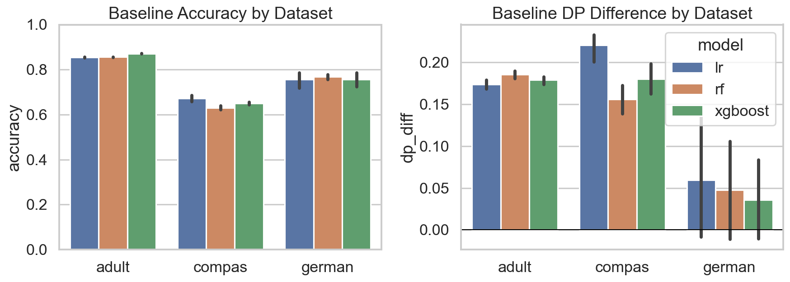
Fig. 1. Baseline accuracy and DP difference across models and datasets. Error bars show std across 5 seeds.
German Credit (Table III) exhibits extreme small-sample fragility. LR accuracy swings 0.690–0.800 across seeds; DP difference spans −0.036 to +0.182—the sign of the fairness gap flips. This is the correct empirical result for n = 1,000 and is precisely the finding that should appear in benchmarks but almost never does.
TABLE III
GERMAN CREDIT BASELINES (MEAN ± STD, SEEDS 0–4)
Model | Acc. | ± | DP Diff | ± | AUC
LR | 0.756 | 0.038 | 0.060 | 0.085 | 0.784
RF | 0.768 | 0.014 | 0.047 | 0.073 | 0.795
XGBoost | 0.757 | 0.036 | 0.036 | 0.056 | 0.775

COMPAS (Table IV) shows the largest baseline disparities (DP diff 0.149–0.230). Results are interpreted with the Bao et al. caveat [11]; the accuracy ceiling (~66%) reflects label noise.
TABLE IV
COMPAS BASELINES (RACE ATTR., SEED 0) [LABELS CONTESTED, 11]
Model | Acc. | DP Diff | EO Diff | AUC
LR | 0.6619 | 0.230 | 0.134 | 0.702
RF | 0.6155 | 0.149 | 0.089 | 0.657
XGBoost | 0.6468 | 0.199 | 0.134 | 0.670

B. Debiasing Results
Table V shows all three methods on LR across five seeds. Exponentiated Gradient and ThresholdOptimizer both achieve near-zero DP difference with less than 2.5 pp accuracy cost, satisfying the a-priori success criterion (>50% DP reduction, <3% accuracy loss). Critically, the DP-diff standard deviation grows from 0.007 (baseline) to 0.011 (ThresholdOptimizer): the most aggressive method is also the most variable.
TABLE V
DEBIASING: LR ON ADULT INCOME (MEAN, SEEDS 0–4)
Method | Acc. | ± | DP | ± | Reduc. | Cost
None | 0.8541 | 0.0019 | 0.174 | 0.007 | — | —
Reweigh. | 0.8483 | 0.0016 | 0.095 | 0.004 | 45% | 0.6 pp
Exp. Grad. | 0.8350 | 0.0024 | 0.019 | 0.008 | 89% | 1.9 pp
Thresh.Opt | 0.8330 | 0.0027 | 0.003 | 0.011 | 98% | 2.1 pp

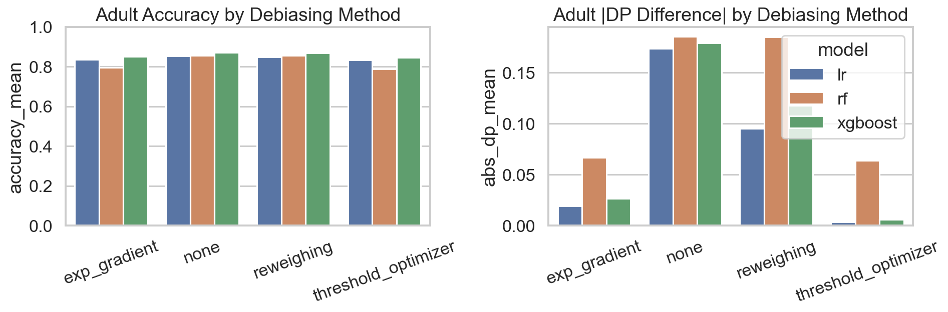
Fig. 2. Accuracy vs. DP difference for each method on Adult Income. Each point is one seed (lower DP, higher accuracy is preferred).
The RF story (Table VI) is qualitatively different. Reweighing has essentially zero effect on RF (0.185→0.185). Exponentiated Gradient achieves 64% reduction at 6.0 pp cost—three times the LR cost for a smaller gain. ThresholdOptimizer reverses the disparity direction (−0.064 mean) with a standard deviation 4× larger than on LR, demonstrating strong model-dependence.
TABLE VI
DEBIASING: RANDOM FOREST ON ADULT INCOME
Method | Acc. | ± | DP | ± | Reduc.
None | 0.8556 | 0.0014 | 0.185 | 0.006 | —
Reweigh. | 0.8553 | 0.0016 | 0.185 | 0.008 | ~0%
Exp. Grad. | 0.7953 | 0.0028 | 0.067 | 0.007 | 64%
Thresh.Opt | 0.7870 | 0.0062 | −0.064 | 0.046 | rev.

XGBoost with Exponentiated Gradient (Table VII) achieves 85% DP reduction at 1.9 pp cost while retaining a 1.7 pp accuracy advantage over the mitigated LR configuration. This combination represents the best overall trade-off on Adult Income.
TABLE VII
DEBIASING: XGBOOST ON ADULT INCOME
Method | Acc. | ± | DP | ± | Reduc.
None | 0.8713 | 0.0011 | 0.179 | 0.006 | —
Reweigh. | 0.8683 | 0.0022 | 0.118 | 0.008 | 34%
Exp. Grad. | 0.8519 | 0.0031 | 0.027 | 0.009 | 85%

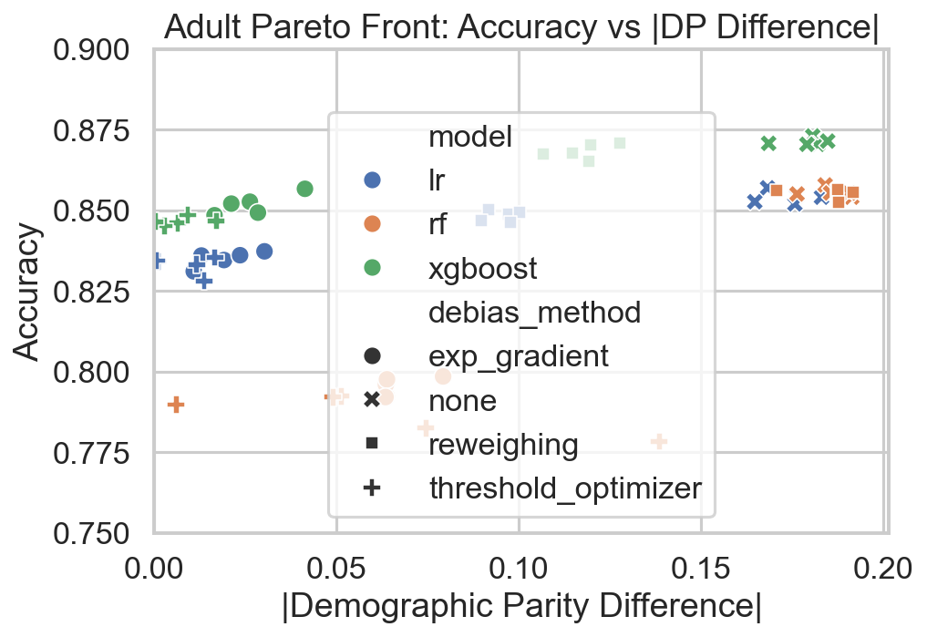
Fig. 3. Pareto front: accuracy vs. DP difference across all (model × method × seed) configurations, Adult Income.
C. Seed Variance Analysis
Table VIII reports the coefficient of variation (CV = std/|mean|) of DP difference across seeds. Baseline models are stable (CV ~0.03–0.04). Reweighing preserves that stability. Exponentiated Gradient and ThresholdOptimizer have dramatically higher CV values; ThresholdOptimizer reaches CV = 3.44 on LR because its near-zero mean amplifies small absolute fluctuations.
TABLE VIII
CV OF DP DIFFERENCE ACROSS 5 SEEDS (ADULT INCOME)
Model | None | Reweigh. | Exp.Grad. | Thresh.Opt.
LR | 0.04 | 0.04 | 0.39 | 3.44
RF | 0.03 | 0.04 | 0.10 | sign flip
XGBoost | 0.03 | 0.07 | 0.34 | —

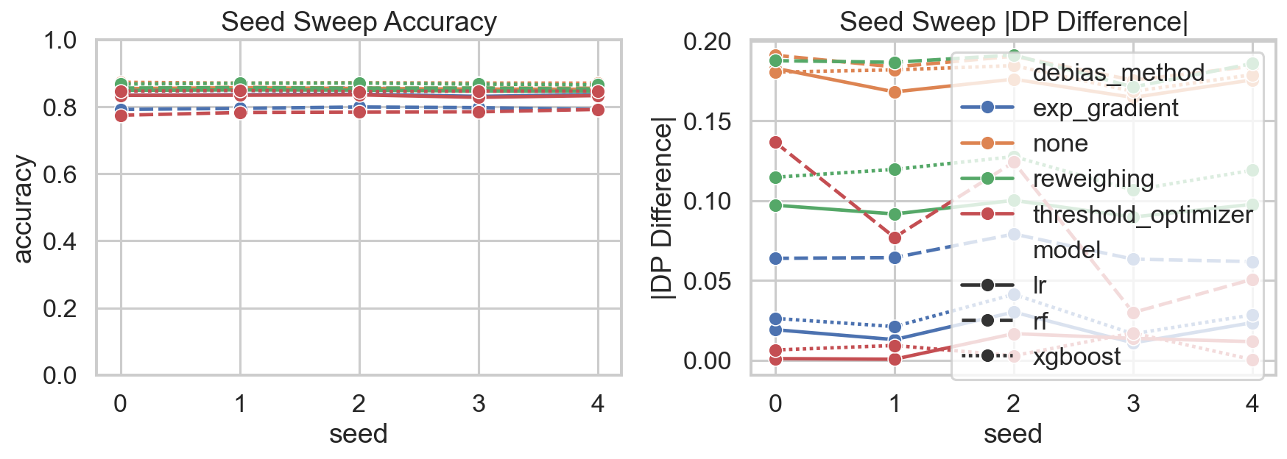
Fig. 4. DP difference distribution across 5 seeds per configuration. Wider spread indicates greater fragility.
D. Threshold Sensitivity
Table IX shows the full threshold sweep for LR on Adult (seed 0). Moving the threshold 0.30→0.70 reduces DP difference from 0.282 to 0.103—a 63% reduction—without any debiasing; accuracy cost is only 1.88 pp. Raising the default threshold from 0.50 to 0.70 alone yields more than half the fairness gain of Reweighing at comparable accuracy cost.
TABLE IX
THRESHOLD SWEEP: LR ON ADULT INCOME, SEED 0
Thresh. | Accuracy | DP Diff | EO Diff
0.30 | 0.8306 | 0.282 | 0.122
0.35 | 0.8436 | 0.251 | 0.113
0.40 | 0.8498 | 0.227 | 0.100
0.45 | 0.8528 | 0.200 | 0.090
0.50 (default) | 0.8541 | 0.183 | 0.103
0.55 | 0.8533 | 0.164 | 0.100
0.60 | 0.8499 | 0.144 | 0.090
0.65 | 0.8457 | 0.120 | 0.065
0.70 | 0.8353 | 0.103 | 0.079

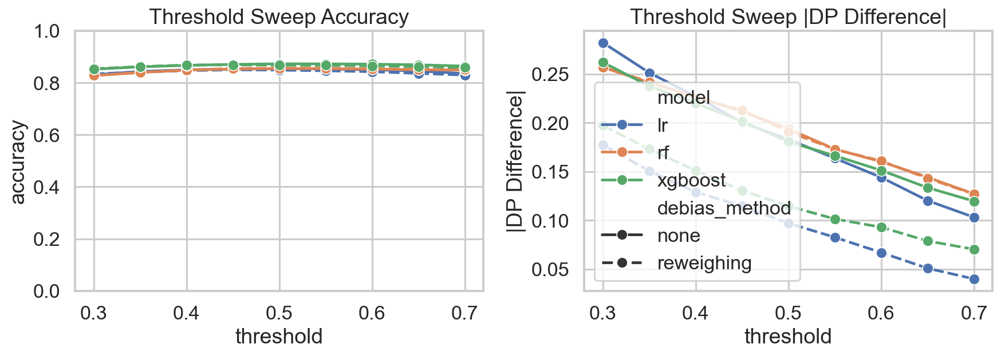
Fig. 5. Threshold sweep for LR and RF on Adult Income. DP difference decreases monotonically as threshold rises.
The sweep also reveals a Pareto-improvement zone at thresholds 0.55–0.65 where both accuracy and fairness are simultaneously better than at the default 0.50—a free lunch invisible to single-point evaluation.
E. Intersectional Analysis
Table X breaks the aggregate sex-based DP difference (0.183) into its sex × race components. The 4.2× selection-rate ratio between white males (26.6%) and non-white females (6.4%) is entirely hidden by the aggregate metric.
TABLE X
INTERSECTIONAL STATS: LR BASELINE, ADULT INCOME, SEED 0
Subgroup | N | Sel. Rate | Acc. | TPR
Female, Non-White | 642 | 6.4% | 93.6% | 51.3%
Female, White | 2,589 | 7.4% | 92.9% | 51.6%
Male, Non-White | 804 | 17.9% | 85.6% | 58.2%
Male, White | 5,734 | 26.6% | 81.1% | 61.7%

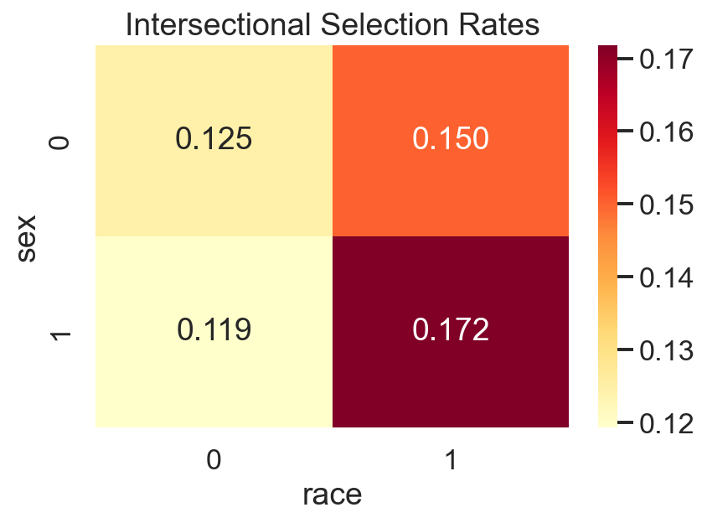
Fig. 6. Intersectional selection rates by sex × race. An aggregate DP diff of 0.183 masks a 4.2× subgroup ratio.
The per-group accuracy pattern runs opposite to selection rate (non-white females: 93.6%; white males: 81.1%), reflecting base-rate effects: high accuracy on a group that is predominantly negative in the ground truth does not imply equitable treatment. The TPR values (51–62%) show the disparity is driven by demographic parity failure, not differential positive-case detection.
F. Summary of Key Findings
• Debiasing works in expectation: Exp. Gradient achieves 89% DP reduction on LR and 85% on XGBoost at <2 pp accuracy cost.
• Effectiveness is model-dependent: Reweighing fails on RF (0% reduction); ThresholdOptimizer reverses disparity on RF with 4× higher variance than on LR.
• Threshold choice rivals method choice: 0.30→0.70 threshold shift yields 63% DP reduction with no debiasing.
• Intersectional analysis is necessary: 4.2× selection-rate disparity (white males vs. non-white females) is invisible in the aggregate DP metric.
• Small datasets amplify all fragility: German Credit LR DP diff spans −0.036 to +0.182 across seeds.
V. CONCLUSION
Standard fairness evaluation provides an incomplete view of a method's practical effectiveness. Across three datasets and three model families, debiasing works in expectation but is fragile in detail: Exponentiated Gradient reduces LR DP difference by 89% at 1.9 pp cost, but only 64% on RF at 6.0 pp cost, and Reweighing fails entirely on RF. Threshold choice alone—from 0.30 to 0.70—produces a 63% DP-difference reduction. Intersectional analysis reveals a 4.2× disparity hidden behind an aggregate DP difference of 0.183. German Credit's extreme seed variance (DP diff spanning 0.218 units for LR) shows that small-dataset fairness benchmarks are unreliable as point estimates.
The recommendation is methodological: fairness evaluations must report distributions over seeds, threshold curves over operating points, and intersectional breakdowns over subgroups. Our stress-testing framework implements all three components in a single CLI call and is designed to drop into any sklearn-compatible pipeline.
VI. FUTURE WORK
First, completing the FT-Transformer evaluation [12] would add a tabular transformer—largely absent from fairness benchmarking literature—to the model comparison. Second, Folktables distribution-shift experiments would test whether fairness improvements survive covariate shift. Third, a scalar fragility index derived from seed-threshold-intersectional variance would provide a single stability summary per (model × method). Fourth, expanding from 5 to 10 seeds would tighten statistical claims. Finally, applying ExpGradient to the FT-Transformer (currently supporting only Reweighing and ThresholdOptimizer) remains an open challenge.
VII. TEAM CONTRIBUTIONS
D. Verma: designed the end-to-end pipeline, implemented fairness_metrics.py, integrated all debiasing methods, ran the full experiment grid, and consolidated the report.
N. Dewan: implemented data_loaders.py for all datasets, designed the (X, y, sensitive_attrs) schema, and ensured stratified splitting with no sensitive-attribute leakage.
M. Batra: implemented models.py with the common build_model interface and managed the FT-Transformer wrapper.
K. Thakare: implemented debiasing.py and stress_tests.py (seed sweep, threshold sweep, intersectional breakdown).
A. Mote: implemented visualize.py, produced all six figures, conducted the literature review, and assembled the presentation deck.
REFERENCES
[1] N. Mehrabi, F. Morstatter, N. Saxena, K. Lerman, and A. Galstyan, “A survey on bias and fairness in machine learning,” ACM Comput. Surv., vol. 57, no. 1, pp. 1–38, Jan. 2024.
[2] S. Uddin, H. Lu, and F. Hajati, “Fairness-preserving framework for machine learning: data bias quantification, model evaluation, and robustness across multiple datasets,” AI Ethics, vol. 6, p. 25, 2026, doi: 10.1007/s43681-025-00874-7.
[3] N. L. Chen, “Robustness and fairness evaluation of machine learning models in high-stakes decision systems,” Int. J. Mach. Learn. Commun. Netw., vol. 2, no. 1, pp. 8–12, 2025.
[4] M. Hardt, E. Price, and N. Srebro, “Equality of opportunity in supervised learning,” in Adv. Neural Inf. Process. Syst. (NeurIPS), vol. 29, 2016.
[5] S. Barocas, M. Hardt, and A. Narayanan, Fairness and Machine Learning: Limitations and Opportunities. Cambridge, MA, USA: MIT Press, 2024.
[6] F. Kamiran and T. Calders, “Data preprocessing techniques for classification without discrimination,” Knowl. Inf. Syst., vol. 33, no. 1, pp. 1–33, Jan. 2012.
[7] A. Agarwal, A. Beygelzimer, M. Dudik, J. Langford, and H. Wallach, “A reductions approach to fair classification,” in Proc. 35th Int. Conf. Mach. Learn. (ICML), Stockholm, Sweden, Jul. 2018, pp. 60–69.
[8] T. Zhao, E. Iofinova, J. Frankle, and D. Alistarh, “Symbiotic robustness and fairness in deep neural networks: A triangular trade-off,” ACM Comput. Surv., vol. 57, no. 2, 2024.
[9] K. Roberts-Licklider and T. Trafalis, “Fairness in machine learning: A survey part 1,” in Dynamics of Information Systems, Lecture Notes Comput. Sci., vol. 14661. Springer, 2025.
[10] K. Crenshaw, “Demarginalizing the intersection of race and sex,” Univ. Chicago Legal Forum, vol. 1989, no. 1, Art. 8, 1989.
[11] M. Bao et al., “It’s COMPASlicated: The messy relationship between RAI datasets and algorithmic fairness benchmarks,” in NeurIPS Datasets Benchmarks Track, 2021.
[12] Y. Gorishniy, I. Rubachev, V. Khrulkov, and A. Babenko, “Revisiting deep learning models for tabular data,” in Adv. Neural Inf. Process. Syst. (NeurIPS), vol. 34, 2021.
[13] F. Ding, M. Hardt, J. Miller, and L. Schmidt, “Retiring Adult: New datasets for fair machine learning,” in Adv. Neural Inf. Process. Syst. (NeurIPS), vol. 34, 2021.

