BankEase: NextGen Net Banking
System Design Document | Project P_018 | Full Stack Development (Banking & Finance)

1. Introduction
BankEase is a secure net-banking web application that lets customers manage accounts, transfer funds, pay bills and use loan and investment services online, while giving bank staff tools for monitoring, compliance and audit. The stack is Java + Spring Boot (back end), Angular (front end) and MySQL (database). Security, data integrity and regulatory compliance (RBI guidelines, KYC/AML, PCI-style data protection) drive every design decision.

2. System Architecture
BankEase follows a layered, four-tier architecture so that each concern (UI, security, business rules, data) can be developed, tested and scaled independently.
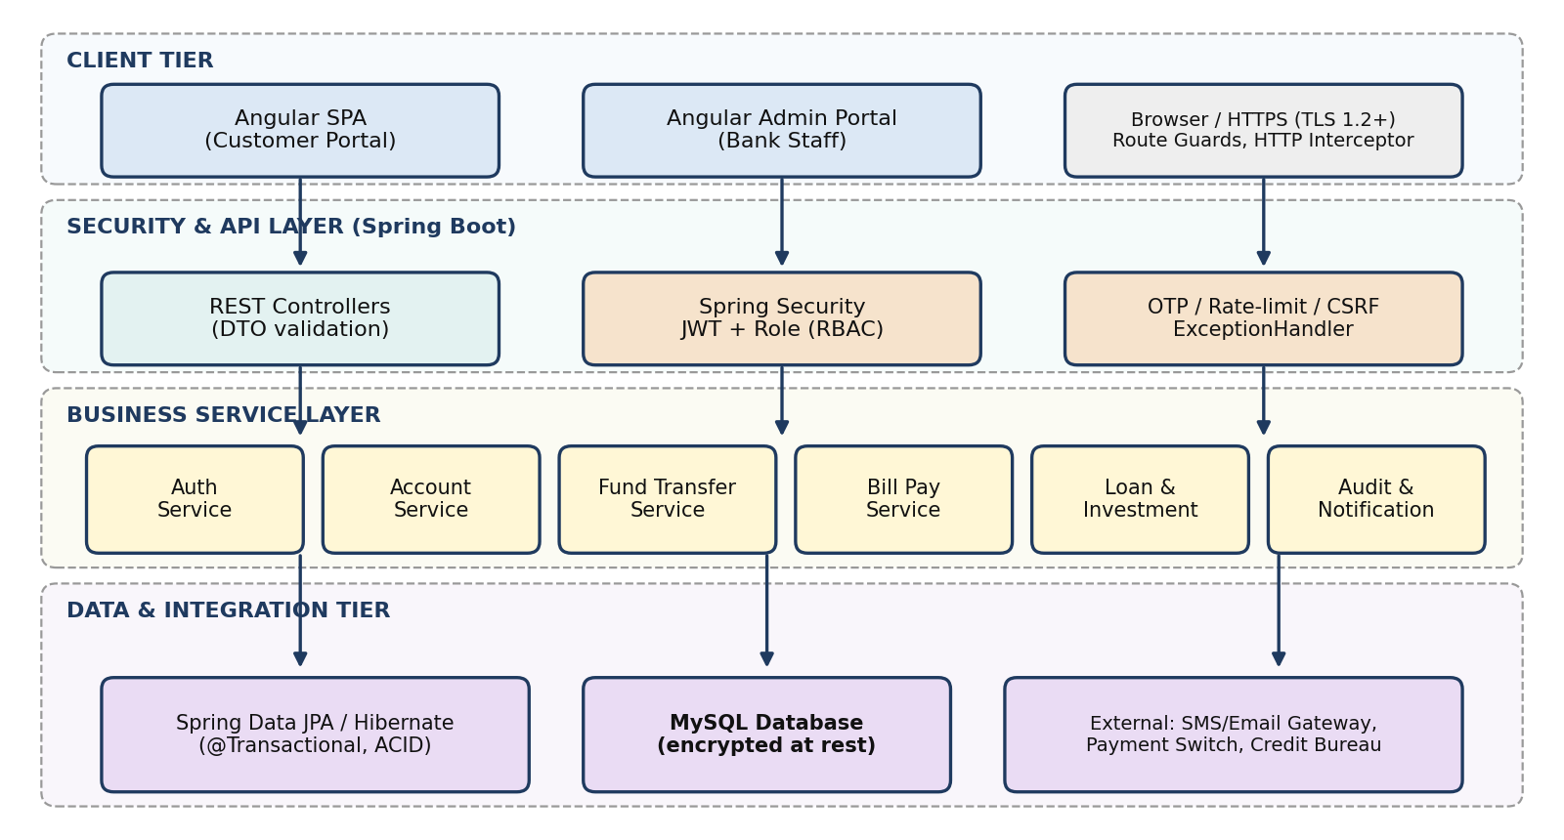
Figure 1: Layered system architecture of BankEase
- Client tier: Angular SPAs (customer and admin portals) use route guards and an HTTP interceptor that attaches the JWT to every call over HTTPS.
- Security/API tier: REST controllers validate DTOs; Spring Security enforces JWT and role-based access, with OTP, rate limiting and CSRF protection.
- Service tier: stateless services hold business rules; money movement runs inside @Transactional boundaries to guarantee ACID behaviour.
- Data tier: Spring Data JPA/Hibernate over MySQL (InnoDB) with encryption at rest, plus SMS/e-mail and payment-switch integrations.

3. Application Flow Diagram
The diagram shows the end-to-end flow for the most critical journey: secure login followed by a fund transfer, including failure paths.
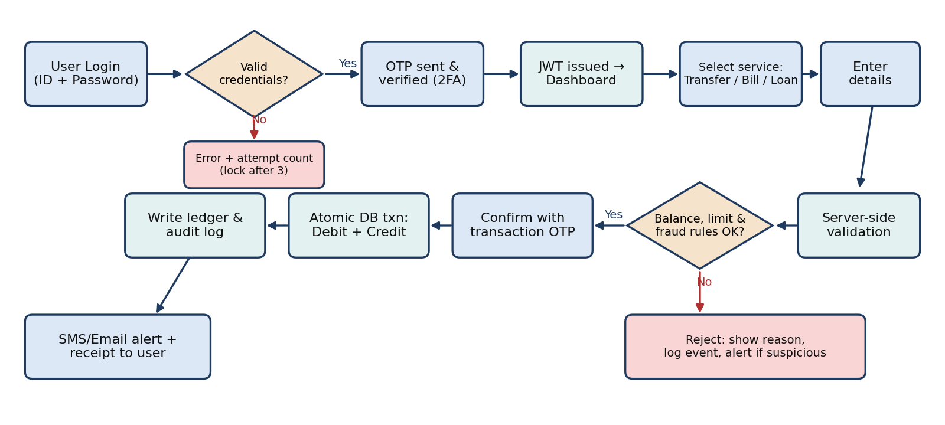
Figure 2: Login and fund-transfer flow with validation and rejection paths

4. Modules and Their Functionality
Module | Functionality
1. Authentication & Security | Registration, login, 2-factor OTP, JWT session, password reset, role-based access (Customer / Admin / Auditor), account lock after 3 failed attempts, session timeout.
2. Account Management | View balance and mini/full statements, download PDF/CSV statements, manage profile & KYC, set transaction limits, open or close accounts.
3. Fund Transfer | Add/verify beneficiaries; own-account, NEFT, RTGS and IMPS transfers; schedule or recurring transfers; ACID-safe debit-credit with unique reference number.
4. Bill Payment | Register billers (electricity, mobile, DTH, credit card), fetch dues, pay now or auto-pay, payment history and receipts.
5. Loan Services | Loan products, EMI calculator, online application with document upload, eligibility check, status tracking, repayment schedule and prepayment.
6. Investment Services | Open Fixed/Recurring Deposits and mutual-fund SIPs, view maturity value and interest, premature closure, portfolio summary.
7. Compliance, Audit & Notification | Immutable audit trail, AML/fraud rule engine (velocity, high-value alerts), regulatory reports (RBI/KYC), SMS/e-mail alerts, admin dashboard.

5. Use Cases: User Input and Application Response
Use Case | User Input | Application Response
Login with 2FA | Enters username + password, then 6-digit OTP. | Validates hash (BCrypt), sends OTP, verifies within 5 min, issues JWT and opens dashboard; wrong input shows error and counts attempts.
Check balance / statement | Selects account and date range. | Fetches transactions via JPA (paged), shows balance and running statement; offers PDF/CSV download.
Transfer funds (IMPS/NEFT) | Picks beneficiary, enters amount, remark, confirms with OTP. | Validates balance and daily limit, runs fraud rules, debits and credits in one transaction, returns reference no. and sends SMS/e-mail.
Add beneficiary | Enters name, account no., IFSC. | Validates IFSC format, applies cooling period + OTP verification, then activates beneficiary.
Pay utility bill | Chooses biller, enters consumer no. | Fetches due amount, user confirms, account is debited, biller is credited, receipt generated and stored.
Apply for a loan | Selects type, amount, tenure, uploads documents. | Computes EMI, checks eligibility (income, credit score), creates application ID and notifies of status changes.
Open a Fixed Deposit | Enters amount, tenure, payout option. | Checks balance, debits account, creates FD with maturity value and issues digital certificate.
Suspicious activity (Admin) | Admin reviews flagged transaction. | Shows rule triggered and history; admin can freeze account or clear the alert — every action is audit-logged.

6. Entity-Relationship (ER) Diagram
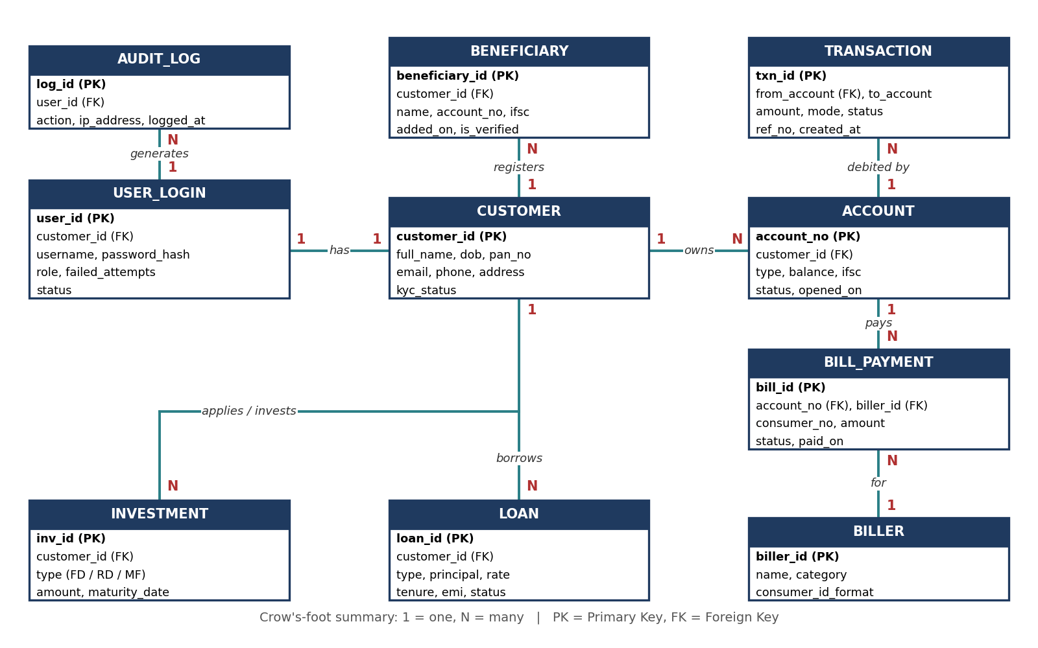
Figure 3: ER diagram of the BankEase database (MySQL)
Key relationships: one CUSTOMER has one USER_LOGIN and many ACCOUNTs, BENEFICIARYs, LOANs and INVESTMENTs; one ACCOUNT has many TRANSACTIONs and BILL_PAYMENTs; each BILL_PAYMENT is made to one BILLER; each USER_LOGIN generates many AUDIT_LOG records.
Design notes: balances use DECIMAL(15,2); TRANSACTION rows are insert-only (corrections are new reversal entries); passwords are stored as BCrypt hashes; indexes on account_no, customer_id and created_at keep statements fast.

