**Function For Youtube Link**

**1. Task Description**

The task is to ”Build a function that retrieves YouTube video links based on a user-provided search query.” The project uses the youtubesearchpython library to query YouTube and return a list of up to five video URLs. The workflow includes:

* **Query Input:** Accept a user-provided search string (e.g., ”Python tutorials”) via command-line input.
* **API Integration:** Query YouTube using the youtubesearchpython library to fetch video metadata in JSON format.
* **Data Extraction:** Extract the video URLs from the API response, ensuring compliance with YouTube’s API usage policies.
* **Output Display:** Print the retrieved URLs to the console in a numbered list format.

The task was implemented using a Python script (youtube_search.py), designed for simplicity and adaptability for integration into larger applications or standalone use.

**2. Task Output Screenshot**

The project generates a list of YouTube video links displayed in the console. No visualization (e.g., plots or UI) is produced, so a graphical screenshot is not applicable. Instead, the output is a text-based console printout. Below is a sample output for the query ”Python tutorials”:

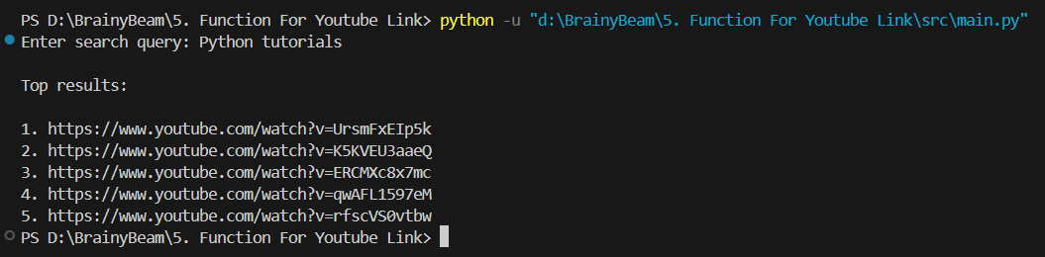

**3. Widget/Algorithm Used In Task**

The task uses Python for data retrieval and console output, with no UI widgets, as the project focuses on command-line interaction and API integration. The key algorithms and functions are:

* **VideosSearch (from youtubesearchpython):** Queries YouTube’s search API to retrieve video metadata in JSON format, specifying a limit of five results.
* **list comprehension:** Extracts the link field from the API response to create a list of video URLs.
* **print:** Formats and displays the URLs in a numbered list in the console.

These functions enabled efficient querying of YouTube’s search API and userfriendly output, addressing challenges such as API rate limits and ensuring robust data extraction.