Sutrava: An NLP-Driven Intelligent Pipeline for Automated Requirements Engineering with Named Entity Recognition and DevOps-Integrated Deployment

Abstract
Requirements Engineering (RE) is one of the fundamental components of software development, although existing elicitation and analysis approaches using a manual process are vulnerable to uncertainty, inconsistencies, and lack of scalability. As the complexity of modern software systems increases, the amount of communication data from stakeholders through e-mails, issue trackers, messaging channels, and discussion transcripts grows well beyond the limit of manual processing. In this paper, we propose Sutrava, an intelligent pipeline for automatic requirements extraction, classification, structuring, and prioritization based on Natural Language Processing (NLP) and Machine Learning (ML). Our system utilizes a DistilBERT model to detect the requirements and then uses a BERT-based Named Entity Recognition (NER) model trained on top of the spaCy's transition-based parser to extract relevant entities such as ACTOR, ACTION, FEATURE, CONSTRAINT, QUALITY, and PRIORITY. Our solution includes sentence-BERT embeddings for clustering purposes, multi-signal prioritization mechanism with explanations, and a T5-based model for abstractive summarization of the requirements. We have prepared our own dataset of 5,000 labeled sentences for requirement classification, enhanced by examples extracted from PROMISE and PURE corpora. The performance of the NER model is demonstrated by the F1-score of 0.96 with per-class AUCs ranging from 0.949 to 1.000. Finally, we have applied DevOps techniques such as dockerized containers, GitHub Actions-based CI/CD, and deployment on AWS' EC2/ECR to ensure the repeatability and scalability of the system. Experimental results show that Sutrava has the potential to decrease the efforts in manual requirement analysis without compromising its precision.
Keywords: Requirements Engineering, Named Entity Recognition, Natural Language Processing, DistilBERT, DevOps, CI/CD Pipeline, Software Requirements Classification, Automated Requirement Extraction

1. Introduction

1.1 Requirements Engineering in Modern Software Systems

Requirements engineering (RE) involves the entire activity of collecting, defining, verifying, and managing software requirements during the software life cycle [1]. RE plays a vital role in the success of the project, estimating costs, and producing high-quality software [3]. Although the IEEE standard 830-1998 and its updated version (ISO/IEC/IEEE 29148:2018) describe the practice of requirements specification, empirical studies show that bugs associated with requirements represent up to 40–60% of software project failures [15].

The modern software industry features rapid development techniques, distributed teams, and continuous delivery systems that contribute to the increase in stakeholder communication in volume and speed. In such environments, requirements are gathered informally, from Jira tickets, Slack, emails, sprint reviews, and customer service exchanges [15], which makes it difficult for requirements engineering techniques to keep up with these developments.

1.2 Challenges in Traditional Requirements Engineering
Despite many advances in methodologies, there are still several problems that persistently hinder requirements engineering effectively:
Requirement Ambiguity: Inherent properties of requirements written in natural language involve lexical and structural ambiguity. Stakeholders use specific vocabulary, slang terms, and assumptions that cannot be accurately interpreted [4]. For example, the requirement specification "the system must handle user requests efficiently" is ambiguous since the term "efficiently" needs a precise interpretation along with other aspects like "user requests" and "handle."
Scalability Issues: As project complexity grows, manual requirement analysis and extraction turn out to be too costly for large-scale projects such as enterprise-wide applications that require analysing thousands of requirement-laden communication channels [6].
Redundancy and Contradictions: Requirements gathered from various sources and stakeholders create potential conflicts, inconsistencies, and redundancy that can only be detected through thorough cross-checking, which is difficult to perform manually [11].
Traceability Challenges: Traceability between requirements, design specifications, program code, and tests presupposes the existence of structured representations of requirements. Unstructured input in form of natural language poses significant problems in tracing requirements' evolution [16].
Prioritization Issues: Requirements prioritization is based on subjective judgments by stakeholders and insufficient evaluation of costs and benefits. Lack of proper prioritization tools results in resource allocation inefficiencies [9].

1.3 NLP and Machine Learning in Requirements Engineering
There has been significant interest in the utilization of Natural Language Processing (NLP) and Machine Learning (ML) for RE processes over the last few years [3]. NLP technology provides the opportunity for extracting meaning and understanding from unstructured data, providing solutions to the core problem of deriving requirements from stakeholder communications.
Some specific sub-problems of NLP have been found to be very relevant to the domain of RE:
● Text Classification helps automatically distinguish between texts that contain requirements and those that do not, also enabling the classification of requirements as functional and non-functional [11].
● Named Entity Recognition (NER) makes it possible to identify domain-related entities in a given requirement, including actors, actions, features, constraints, and attributes [15].
● Semantic Similarity and Clustering allows detecting similarities between various requirements by converting texts into vectors in a vector space [2].
● Abstractive Summarization involves creating summaries of stakeholder communications for better understanding of requirements [22].
Transformer-based models, like BERT and its variants, have shown excellent results in the above-mentioned tasks, which is why we propose using them for developing automation systems for RE [17].

1.4 DevOps Integration and Continuous Requirements Processing
DevOps practices, including CI, CD, and automated infrastructure, present both possibilities and necessities for RE [18]. In DevOps-driven development processes, requirements need to be handled, checked, and delivered at the same speed as code artifacts. This implies that the integration of RE automation tools in CI/CD pipelines and cloud-based infrastructure is necessary.
The integration of RE automation in DevOps practices allows the implementation of continuous requirements monitoring, where stakeholder communications are automatically handled, classified, and integrated into the development backlog.
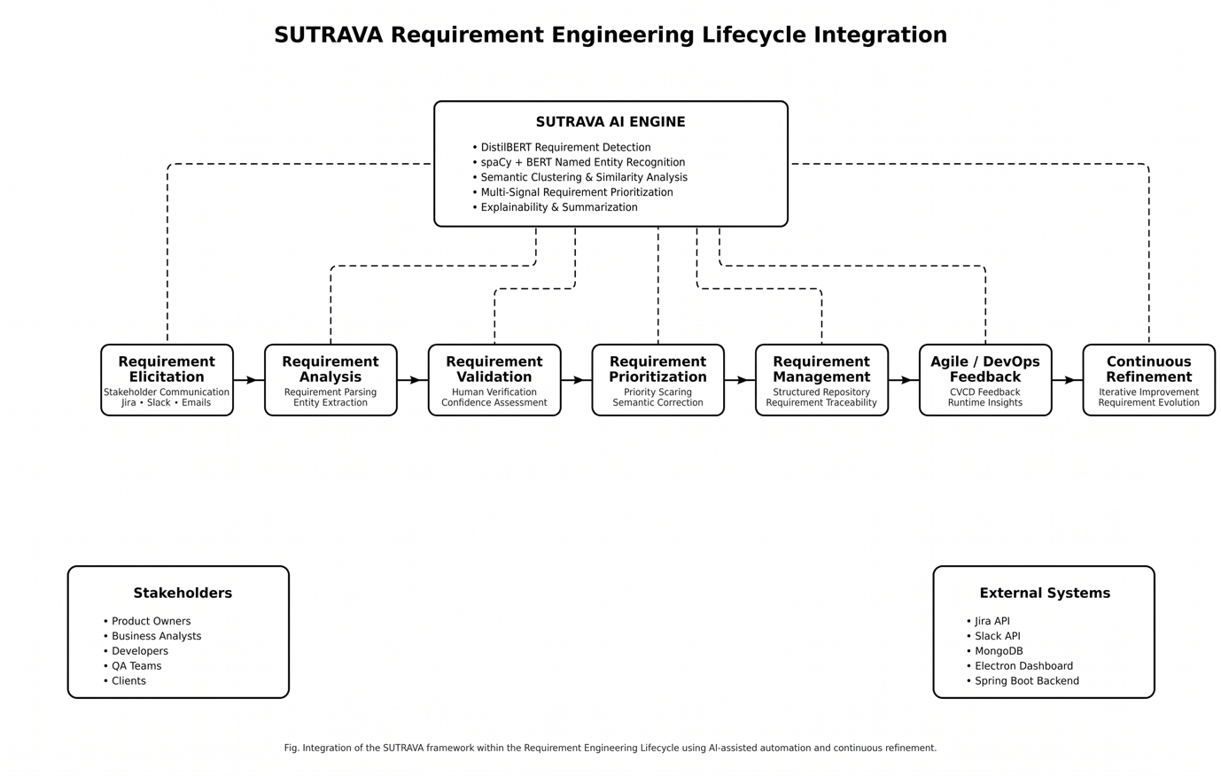
Fig. 1: Requirement Engineering Lifecycle Integration

1.5 Motivation and Research Objectives
Motivation for this study is due to the realization that current methods of RE automation solve isolated sub-problems of classification, extraction, and prioritization of requirements, yet no complete, deployable pipeline covering the entire scope of RE workflow is developed. Moreover, the practical deployment of such solutions, including issues of containerization, CI/CD integration, and cloud deployment have not been explored sufficiently.
Objectives of this research include the following:
- To create and implement an NLP pipeline (Sutrava) to automate the process of detecting requirements, extracting entities, organizing structured data, clustering, prioritizing and summarizing information from unstructured stakeholder input.
- To design and test a domain-specific model of named entity recognition for requirements engineering based on six categories: ACTOR, ACTION, FEATURE, CONSTRAINT, QUALITY and PRIORITY.
- To incorporate DevOps practices into the RE automation pipeline including the use of Docker containers, GitHub Actions CI/CD and AWS cloud services.
- To create and verify a comprehensive dataset for annotation of entities in the requirements text including synthetic generation and popular RE datasets.
- To measure the efficiency of the solution using standard classification and NER metrics.

1.6 Research Questions
To facilitate the design and assessment of the Sutrava pipeline, the following research questions (RQs) have been articulated:
● RQ1: What is the efficacy of transformer-based Natural Language Processing (NLP) pipelines to automate the process of extracting and classifying software requirements from unstructured stakeholder communications?
● RQ2: How does a domain-oriented six-entity tagging schema augment the effectiveness of NER in requirements extraction as opposed to traditional baseline models?
● RQ3: What are the practical ways for implementing continuous requirements engineering using NLP pipelines in the context of DevOps and CI/CD pipeline architecture?
● RQ4: How does the implementation of an explanation engine contribute to explainable multi-signal requirements prioritization?

1.7 Contributions of the Paper
The primary contributions of the paper can be summarized as follows:
● A holistic ten-step RE automation workflow, which transforms raw stakeholder text into requirements via detection, NER, structuring, clustering, prioritization, semantic correction, summarization, explainability, and structure output.
● A proprietary NER tagging scheme involving six unique RE-related entities, along with guidelines for tagging, boundaries, and disambiguation.
● A hybrid approach to dataset creation using 5,000 synthetic annotations of NER entities alongside data from PROMISE, PURE, and FR/NFR datasets, including automated filtering and near-duplicate removal.
● DevOps deployment architecture employing Docker multi-stage builds, GitHub Actions pipelines with vulnerability scanning using Trivy, and AWS ECR/ECS deployment pipelines.
● Extensive experiments proving F1 scores above 0.96 for NER and AUC scores approaching 1.0.

1.8 Organization of the Paper
The rest of this paper is structured in the following manner. Section 2 provides a literature review of NLP-based requirements engineering, NER in requirements engineering, and integration of DevOps. Section 3 describes the proposed methodology, comprising dataset creation, model architecture, pipeline building, and DevOps implementation. Section 4 covers experimental results and their analysis, with regard to performance measures, ROC curves, and confusion matrices. Section 5 explains the significance of the obtained results with respect to research objectives and applications. Section 6 discusses potential threats to validity. Section 7 offers concluding remarks.

2. Literature Review

2.1 NLP-Based Approaches to Requirements Engineering
The connection between NLP and requirements engineering has yielded a significant amount of research in RE subtasks. Zhao et al. [3] performed a systematic mapping analysis, which identified more than 400 studies using NLP to support RE tasks, including requirement extraction, classification, quality assessment, and traceability. They found that supervised machine learning algorithms, especially those using pre-trained language models, outperformed rule-based systems in terms of accuracy and generalization capacity.
On the other hand, Alhaizaey and Al-Mashari [26] explored the use of deep learning for RE classification, showing that BERT models have F1-scores higher than 0.90 in distinguishing functional from non-functional requirements based on PROMISE NFR data. This paper stressed the necessity of domain-specific fine-tuning and the inability of generic pre-trained models to perform well in specialized RE datasets.
Moreover, Arora et al. [19] introduced an NLP-driven method for RE quality assessment, specifically designed to detect ambiguities, incomplete requirements, and inconsistent specification. Their model relied on dependency parsing and semantic role labeling to find problem areas in requirements, attaining precision rates of 0.78–0.85 in the three quality criteria. However, their system did not extract entities or automatically structure requirement elements.

2.2 Named Entity Recognition in Requirements Engineering
Entity Recognition (NER) is a relatively new yet highly relevant NLP method for RE, which allows automatic detection of domain-related entities in requirement sentences. In particular, Abualhaija et al. [16] introduced an NER model based on transformers for detecting actors, actions, and objects in use case sentences. Their system, trained on a manually annotated dataset consisting of 500 use cases, showed good entity-level performance (F1-scores of 0.82-0.89), but the schema only included three types of entities, without constraints, quality aspects, and priorities.
Sainani et al. [17] developed a requirement entity extraction system based on BiLSTM-CRF architecture for detecting requirement types, stakeholders, and system components. In their experiment, the proposed solution showed F1-scores of 0.84 for requirement entities, though, the system demanded considerable effort for designing features and could not benefit from transfer learning due to limited data size.
Sonbol et al. [15] suggested a complete NER method based on transformers and BERT embeddings combined with conditional random fields, including additional entity types of temporal constraints and quality aspects. The authors managed to prove that transformer-based representation outperforms traditional word embeddings in entity boundaries identification, providing F1-score improvements between 5-8%.

2.3 AI-Enabled Frameworks for Requirements Elicitation
Systematic reviews of recent years have focused on the wider scope of AI-based approaches to the requirements elicitation process. A systematic review by Siddeshwar et al. [4], involving 67 articles on AI-based RE techniques, pointed out five major methodologies, including natural language processing, machine learning classifiers, building knowledge graphs, using recommendation systems, and conversational agents. From the authors' findings, it appeared that while NLP techniques exhibited maximum precision, they did not integrate well into the subsequent processes of software development.
RECOVER is a recently developed approach to the generation of structured requirements based on conversations among stakeholders. As part of this system, the dialogue act classification and semantic parsing were used to select requirement-related segments from the transcripts of meetings, achieving a recall rate of 0.76 for requirement discovery.

2.4 DevOps and Continuous Requirements Engineering
The combination of requirements engineering and DevOps is one of the current research directions. Groen et al. [6] stated that the continuous nature of software engineering implies the necessity to implement continuous requirements engineering where requirement-related processes run in close feedback loops with development, testing, and deployment. The authors suggested implementing automatic agents that would monitor requirements-related information on the communication channels.
Fitzgerald and Stol [13] studied the impact of continuous software engineering on RE, suggesting that continuous requirement management implies automation of requirement classification, prioritization, and tracing in CI/CD pipelines. The results of empirical research conducted among 15 companies applying DevOps showed that manual requirements management was the main obstacle to implementing continuous delivery.
Melegati et al. [18] explored the use of AI technologies to support DevOps requirements management, developing an architectural model integrating automatic requirement extraction, validation, and deployment verification. Even though the authors provided important recommendations for implementation, they did not evaluate their proposal empirically.

2.5 Automated Requirement Classification and Prioritization
There is extensive research available regarding requirement classification and prioritization within the domain of ML for RE. Kurtanovic & Maalej [11] created a classification model of functional and non-functional requirements through the use of ensemble techniques, scoring 0.91 in F1-scores on the PROMISE dataset. This showed that lexical, syntactic, and semantic features together helped in increasing the robustness of the classification models.
A prioritization model based on ML was presented by Perini et al. [12], incorporating stakeholder preferences, requirement dependencies, and cost-benefit analysis. The model utilized AHP with supervised ML to derive priority orders. The prioritization model was shown to be more consistent than manual prioritization through three real-world cases from industry.

2.6 Research Gaps
From reviewing the literature, some important research gaps that motivate the current study can be identified:
- End-to-end system lack: All existing approaches focus mostly on performing individual sub-tasks of RE rather than providing an end-to-end solution pipeline that covers the whole process starting from receiving plain text and going all the way to output prioritized entities. Manual handover from one tool to another is required.
- Underdeveloped entity schemas: Existing NER techniques for RE are limited to using simple and small schemas containing only 2–4 types of entities. As a result, such techniques do not account for all semantic components of requirements, namely priority level, quality attributes, etc.
- Deployment challenges: All works dealing with automating requirements engineering tasks are still at the prototype stage; none of them consider any practical deployment issues such as packaging, CI/CD, cloud deployment, and monitoring.
- Dataset limitation: Most of the papers focused on automatic extraction use only PROMISE NFR dataset containing formally structured requirements statements. Informal communication via multiple platforms (Jira, Slack, emails) is poorly covered in the literature.
- Explainability problem: Prioritization systems proposed by researchers are black-boxes and cannot provide any explanations for why particular decisions were made.

2.7 Novel Contributions of This Work
In light of the observed knowledge gap, the current work has made some unique contributions to the automated requirements engineering domain:
● End-to-end RE Automation: An all-encompassing 10-stage framework addressing the issue of mapping unstructured, noisy stakeholder text into requirements in order of priority.
● Six-entity RE-specific Named Entity Recognition schema: A finely detailed entity recognition schema involving ACTOR, ACTION, FEATURE, CONSTRAINT, QUALITY, and PRIORITY entities.
● Explainability Engine: A rationale-based explanation mechanism responsible for providing justifications regarding how requirement prioritization scores are calculated and classifications made.
● DevOps-ready deployment: The actual deployment of the NLP Pipeline as a container in the cloud to facilitate ongoing requirements generation through CI/CD processes.

2.8 Literature Comparison
A comparison is drawn in Table 1 between recent major frameworks for AI-based requirements engineering and the suggested framework, Sutrava.

Paper | Primary Technique | Dataset Utilized | Principal Limitation
Alhaizaey and Al-Mashari [26] | BERT Text Classification | PROMISE NFR | Lacks entity-level extraction and automated structuring.
Abualhaija et al. [16] | Machine Learning / NER | Custom Use-Cases | Restricted to basic Actor-Action-Object schemas.
Voria et al. [8] | Dialogue Act Classification | Meeting Transcripts | Does not address automated requirement prioritization.
Sonbol et al. [15] | Transformer + CRF | Custom RE Corpus | Lacks DevOps integration and deployment architecture.
Sutrava (Proposed) | DistilBERT + spaCy-BERT | Hybrid (PROMISE, PURE, Custom) | Limited cross-lingual support.

Table 1. Comparative analysis of recent AI-enabled Requirements Engineering frameworks.

3. Methodology
This section presents the detailed methodology of the Sutrava pipeline, encircling dataset construction, preprocessing techniques, model architectures, the multi-phase pipeline design, and DevOps integration.

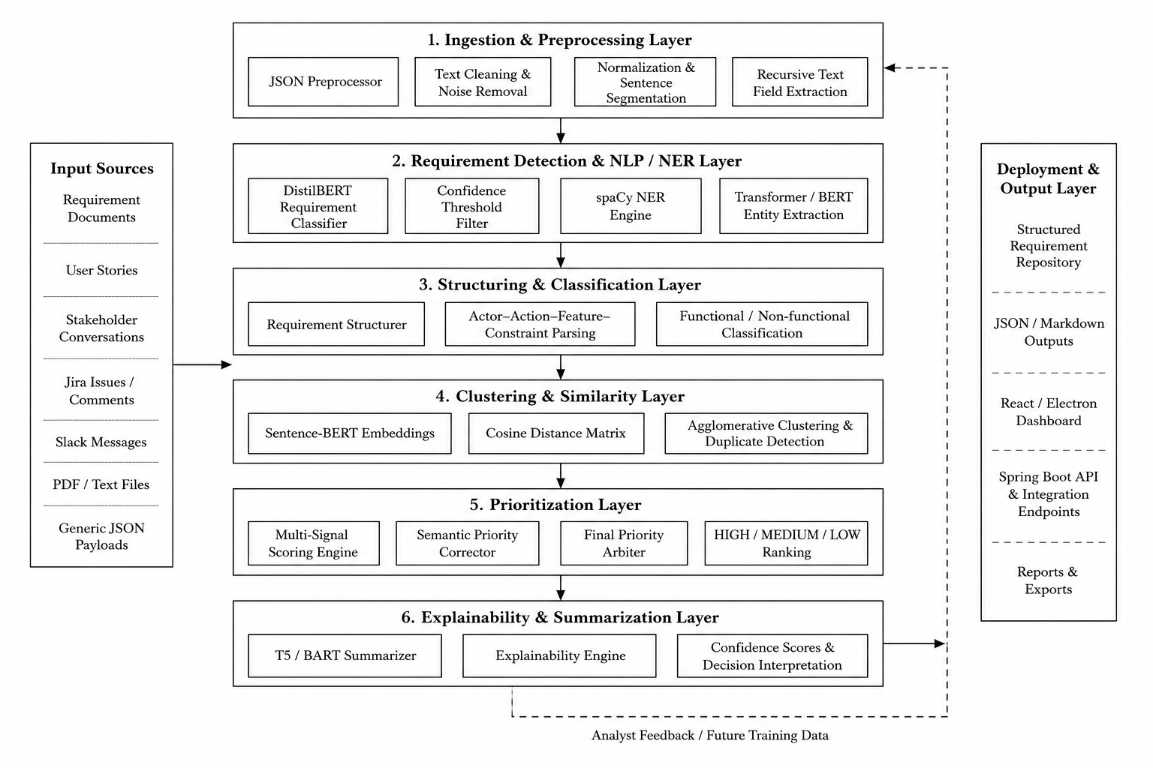
Fig. 2: Architecture of SUTRAVA Requirement Engineering Pipeline

3.1 Dataset

3.1.1 Dataset Sources
The training and evaluation datasets were developed by combining multiple requirement corpora to capture a broad range of formal, semi-formal, and informal requirement writing styles:
- Custom NER Dataset: A synthetically annotated dataset containing 5,000 requirement sentences with controlled entity variation. The dataset includes six entity categories: ACTOR, ACTION, FEATURE, CONSTRAINT, QUALITY, and PRIORITY.
- PROMISE NFR Dataset: A commonly used benchmark dataset consisting of 625 requirements collected from 15 software projects, categorized into functional requirements and 11 non-functional requirement classes [14].
- PURE Dataset: The Public Requirements dataset containing real-world software requirement specifications annotated for functional and non-functional requirement classification.
- FR/NFR Classification Dataset: An additional collection of functional and non-functional requirements gathered from industrial software specification documents.

3.1.2 NER Annotation Schema
A domain-specific annotation schema was developed comprising six entity types tailored to requirements engineering:

Entity Type | Description | Examples
ACTOR | The human, team, role, or system component performing the action | User, Admin, QA team, backend service
ACTION | The main requirement verb or verb phrase | login, export, process, encrypt
FEATURE | The functionality, module, or artifact acted upon | dashboard, payment gateway, audit log
CONSTRAINT | Time, condition, trigger, frequency, or operating context | within 2 seconds, during peak hours
QUALITY | Non-functional characteristic or quality attribute | secure, reliable, fast, responsive
PRIORITY | Explicit urgency or severity markers | urgent, critical, ASAP, P0

Table 2. NER entity type definitions and representative examples.
Formal annotation guidelines were defined to ensure consistency across the dataset. These guidelines included boundary rules such as selecting complete entity spans and avoiding overlapping entities, disambiguation rules for distinguishing between closely related entity categories (e.g., FEATURE vs. QUALITY, CONSTRAINT vs. PRIORITY, and ACTOR vs. FEATURE), and quality assurance procedures involving manual audits of approximately 5–10% of the annotated samples.

3.1.3 Dataset Construction Pipeline
The dataset was constructed using a reproducible automated pipeline implemented in build_dataset.py. The pipeline included the following stages:
- Text Cleaning: Applied Unicode normalization, whitespace consolidation, and punctuation standardization to improve textual consistency.
- Entity Detection: Performed rule-based entity extraction using regular expression patterns. Actors were identified through role and system-component patterns, actions through modal verb and action verb extraction with passive voice handling, features through post-action noun phrase extraction with boundary word detection, constraints through temporal and conditional pattern matching, quality attributes through lexicon-based matching supported by NFR-specific indicators, and priority indicators through urgency-related term matching.
- Quality Filtering: Applied multi-criteria validation to maintain dataset quality, including minimum entity diversity requirements (at least two entities per record), action presence verification, feature span length restrictions (1–5 words), and removal of overly generic feature descriptions.
- Near-Duplicate Detection: Removed redundant records using sequence similarity comparison with a threshold of 0.97 and Jaccard overlap filtering with a threshold of 0.93.
- Source Balancing: Performed controlled sampling across source groups, including 100 formal functional requirements, 100 formal non-functional requirements, 1,200 PURE functional requirements, and 600 PURE non-functional requirements to maintain class balance.
The final unified dataset contained 8,000 annotated records divided into training (70%), development (15%), and testing (15%) subsets.

3.2 Data Preprocessing Techniques

3.2.1 Text Preprocessing
Raw stakeholder text is systematically pre-processed before entering the NLP pipeline.
- JSON Parsing: A dedicated JSONPreprocessor module recursively extracts text from structured JSON payloads such as Jira tickets, Slack messages, and emails. The module targets semantically relevant fields including summary, title, description, body, message, and comments, while filtering noise artifacts such as URLs, email addresses, Slack mention tags, and markdown formatting.
- Sentence Segmentation: Sentence boundaries are identified using regular expression-based splitting on sentence-ending punctuation marks (., !, ?) combined with whitespace normalization.
- Text Normalization: The preprocessing stage also includes Unicode character normalization, replacement of smart quotes and em/en dashes, consolidation of multiple spaces, and punctuation cleanup.

3.2.2 Tokenization
Two separate tokenization strategies are used to support the dual-model architecture.
- DistilBERT Tokenization: Requirement detection uses WordPiece subword tokenization provided by the distilbert-base-uncased tokenizer. Input sequences are padded or truncated to a maximum length of 128 tokens.
- BERT/spaCy Tokenization: The NER component employs a dual-level tokenization approach in which spaCy first performs token segmentation, followed by BERT WordPiece sub-tokenization. Alignment between original tokens and generated sub-tokens is preserved using spaCy’s TransformerListener pooling mechanism.

3.2.3 Feature Extraction and Encoding
- Contextual Embeddings: Both models utilize pre-trained transformer-based contextual embeddings as primary feature representations. BERT and DistilBERT each generate 768-dimensional embeddings, removing the need for manual feature engineering.
- BIO Encoding: Named entity recognition labels are represented using the BIO (Beginning–Inside–Outside) tagging scheme, enabling accurate recognition of multi-token entity spans.
- Binary Label Encoding: Requirement detection labels are encoded as binary values, where 0 represents Not Requirement and 1 represents Requirement.

3.3 Machine Learning and NLP Architecture

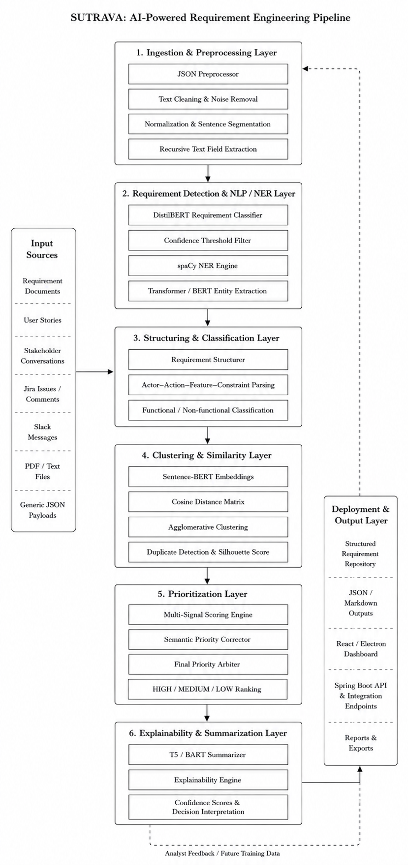

Fig. 2: NLP-Based Requirement Extraction and Entity Recognition

3.3.1 Phase 3: Requirement Detection (DistilBERT Classifier)
The requirement detection module employs a fine-tuned DistilBERT model for binary classification:

Parameter | Value
Base model | distilbert-base-uncased
Task | Binary classification (Requirement / Not Requirement)
Optimizer | AdamW with linear warmup (10% of total steps)
Learning rate | 2 × 10⁻⁵
Batch size | 16
Max sequence length | 128 tokens
Epochs | 5
Model selection | Best F1-score on validation set

Table 3. Requirement detection model hyperparameters.

Architecture: Each input sentence is first tokenized into subword tokens using the DistilBERT tokenizer. The tokenized sequence is then processed through six transformer encoder layers, generating contextualized 768-dimensional embeddings for each token. The embedding corresponding to the [CLS] token is used as the sentence-level representation and passed through a linear classification head that outputs two logits. A softmax activation function is subsequently applied to obtain the final class probabilities.

3.3.2 Phase 4: Named Entity Recognition (spaCy + BERT)
The Named Entity Recognition (NER) module utilizes spaCy 3’s transition-based NER architecture enhanced with BERT transformer embeddings for contextual feature representation:
Parameter | Value
Framework | spaCy 3 + spacy-transformers
Base transformer | bert-base-uncased
Architecture | TransitionBasedParser.v2 with TransformerListener
Hidden width | 64
Maxout pieces | 2
Optimizer | Adam (β₁=0.9, β₂=0.999, L2=0.05)
Learning rate schedule | Warmup linear (100 warmup steps, 2500 total)
Initial learning rate | 5 × 10⁻⁵
Dropout | 0.35
Max epochs | 200
Max steps | 2500
Patience | 800
Evaluation frequency | 200 steps
Grad factor | 1.0 (unfrozen transformer layers)
Batch size | Compounding 16→32
Scoring weight | ents_f = 1.0

Table 4. NER model hyperparameters.

Architecture: Input text is initially tokenized using spaCy and subsequently sub-tokenized using BERT’s WordPiece tokenizer with strided spans (window = 128, stride = 96). BERT generates contextualized 768-dimensional embeddings for each sub-token. A TransformerListener component employing mean pooling aggregates the subword embeddings back to the spaCy token level. The transition-based NER parser then operates on these pooled token representations, predicting BIO-tagged entity spans through a sequence of shift-reduce parsing actions.

3.3.3 Phase 4b: Requirement Structuring
The extracted NER entities are organized into structured actor–action–constraint representations. A rule-based classification mechanism differentiates functional and non-functional requirements using the following criteria:
- Presence of quality attribute entities
- Detection of temporal or conditional constraint patterns such as within, under, and during
- Keyword matching against a curated lexicon containing more than 20 non-functional requirement quality terms
Canonical requirement statements are generated using the following template:
<Actor> shall <action> <feature> <quality> <constraints>.

3.3.4 Phase 5: Semantic Clustering
Semantically related requirements are grouped using a multi-stage clustering framework.
- Sentence-BERT Embeddings: Each requirement sentence is encoded into a dense semantic vector using the all-MiniLM-L6-v2 model from the sentence-transformers library.
- UMAP Dimensionality Reduction: The embedding vectors are reduced to five dimensions using UMAP with the following parameters: n_neighbors = 12, min_dist = 0.05, and cosine similarity as the distance metric. This step improves clustering efficiency and separation.
- HDBSCAN Clustering: Density-based clustering is performed using HDBSCAN with min_cluster_size = 4, Euclidean distance, and the EOM cluster selection method. The algorithm automatically determines the optimal number of clusters. Noise points assigned the label -1 are treated as singleton clusters.
- Cluster Quality Evaluation: Silhouette scores are calculated on non-noise samples to evaluate clustering quality and semantic cohesion.
- Cluster Naming: Professional cluster names are automatically generated based on the most frequently occurring FEATURE, ACTION, and QUALITY entities within each cluster.

3.3.5 Phase 6: Multi-Signal Prioritization
A composite scoring engine assigns priority levels (HIGH/MEDIUM/LOW) based on ten weighted signals:

Signal | Score | Description
PRIORITY entity from NER | +3 | Explicit priority indicator detected
Urgency keywords | +3 | Keywords: urgent, critical, blocker, ASAP
Business value words | +3 | Keywords: revenue, compliance, legal, cost
Time constraints | +2 | Temporal constraints in CONSTRAINT entities
Negative sentiment | +4 | Domain-specific negative lexicon matching
Impact words | +4 | High-risk terms: data loss, crash, downtime
Quality attributes | +1 | QUALITY_ATTRIBUTE entity presence
Cosmetic indicators | −2 | Low-impact terms: color, font, minor, tweak
Modal verb strength | +0.5 to +1 | must/shall (+1) vs. should (+0.5) vs. could (0)
Feature frequency | +1 to +3 | Repeated mention across requirement corpus

Table 5. Multi-signal prioritization scoring matrix.

Scoring thresholds: score ≥ 5 → HIGH; score ≥ 2 → MEDIUM; else LOW. A distribution guard enforces a maximum of 30% HIGH-priority requirements, demoting the weakest HIGH-scored items when exceeded. Additional semantic correction (Phase 6b) and final arbitration (Phase 6c) layers provide multi-pass refinement. An optional LLM auditor (Phase 6d) employs GPT-4o-mini for selective priority validation.

3.3.6 Phase 7: Abstractive Summarization
Cluster-level summaries are generated using T5-small with dynamic length computation:
- Dynamic max_length: Computed as min(80, max(15, word_count)) to prevent generation warnings.
- Short-circuit optimization: Single sentences under 20 words bypass the model and are returned verbatim.
- Task prefix: "summarize: " prefix applied for T5 compatibility.

3.3.7 Phase 7b: Explainability Engine
A transparent reasoning module produces human-readable explanations for each decision generated throughout the pipeline. These explanations include:
- Classification Rationale: Interpretation of requirement classification confidence scores and the factors influencing the prediction.
- Entity Extraction Details: Justification for each extracted entity, including entity type identification and span selection.
- Priority Reasoning: A detailed signal-by-signal breakdown of the prioritization process, including individual score contributions to the final priority level.
- Structuring Logic: Explanations supporting the functional or non-functional requirement classification, along with the generation of the canonical requirement representation.
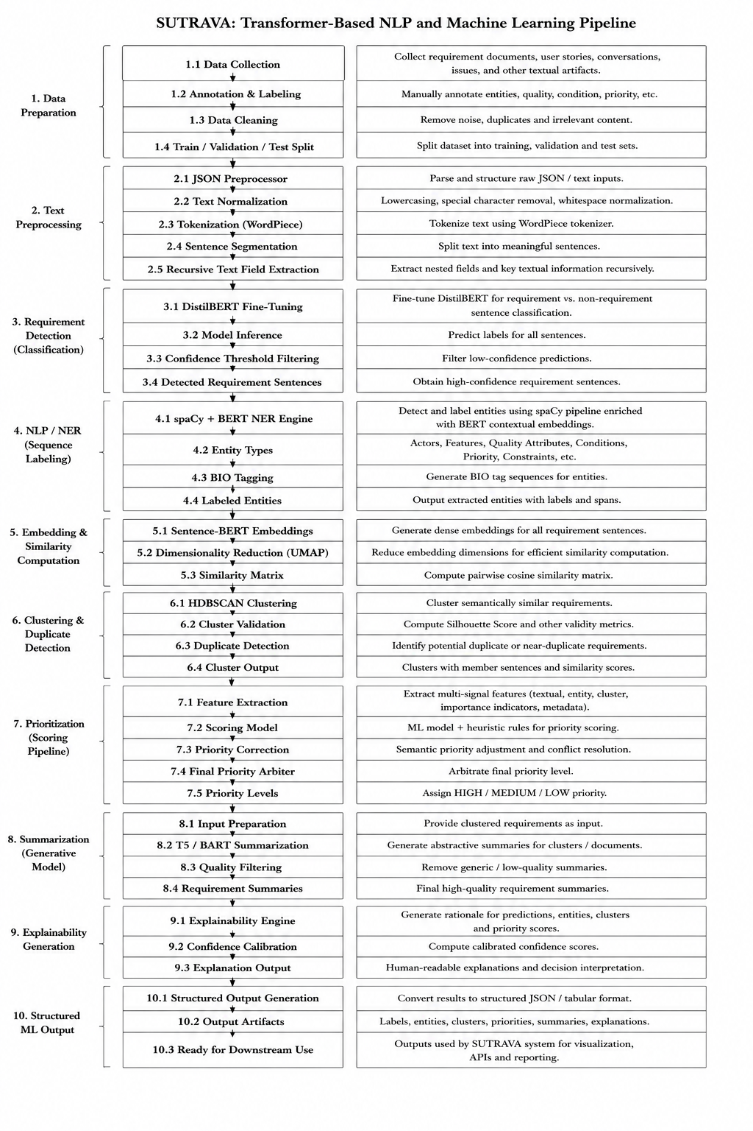
Fig. 4: Machine Learning Pipeline Architecture

3.4 DevOps Integration

3.4.1 Containerization
The Sutrava system employs Docker containerization across all components:

Model Service (NLP Pipeline):
FROM python:3.11
WORKDIR /app
COPY requirements.txt .
RUN pip install --no-cache-dir -r requirements.txt
COPY model/ /app/model/
CMD ["python", "run_e2e_validation.py"]

Frontend Service (Vite/React + Nginx):
Multi-stage build: Node.js 20-alpine for compilation, Nginx alpine for production serving. Build arguments enable environment-specific backend URL injection. Custom Nginx configuration handles SPA routing.

3.4.2 CI/CD Pipeline
GitHub Actions workflows automate the build, scan, and deployment lifecycle:

Model CI/CD (`model-ci.yml`):
- Trigger: The workflow is triggered by pushes to the main branch affecting the model/** directory or the requirements.txt file.
- Build: A Docker image is built using the repository root directory as the build context.
- Security Scan: The generated image is scanned using the Trivy vulnerability scanner to identify operating system and library vulnerabilities with CRITICAL and HIGH severity levels.
- Push: The validated image is pushed to Amazon Elastic Container Registry (ECR) under the sutrava-nlp repository using both SHA-based version tags and the latest tag.
- Deploy: Deployment is performed through SSH-based automation to a dedicated high-capacity EC2 instance. The process includes automated container stopping, removal, and recreation.
Frontend CI/CD (`frontend-ci.yml`):
A parallel CI/CD pipeline is implemented for the frontend application, following the same workflow structure for the Sutrava_Frontend/** path. Deployment targets a separate EC2 instance with port mapping configured as 3000:80 and a --restart unless-stopped container policy to ensure service availability.

3.4.3 Cloud Deployment Architecture
The deployment infrastructure is built on Amazon Web Services (AWS) and includes the following components:
- Amazon ECR: A private container registry used for storing and versioning Docker images.
- Amazon EC2: Separate compute instances allocated for frontend services and model-serving workloads, with the model instance configured for high-capacity and GPU-compatible execution.
- VPC Networking: A shared Virtual Private Cloud (VPC) environment with security group configurations enabling controlled inter-service communication.
- Credential Management: Sensitive deployment credentials, including AWS access keys, SSH keys, and host addresses, are securely managed using GitHub Secrets.

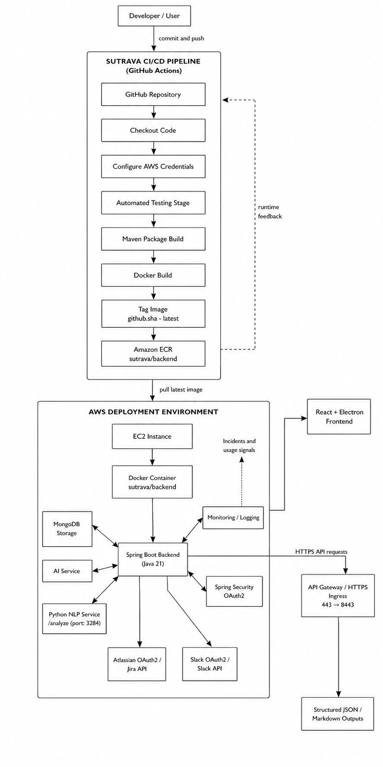

Insert Fig. 5: DevOps Deployment Architecture

3.4.4 Version Control and Collaboration
The system utilizes Git-based version control with branch protection policies to maintain code integrity and controlled collaboration. Path-based workflow triggers are configured to optimize CI/CD execution, ensuring that modifications to model-related files trigger only the model deployment pipeline, while frontend-specific changes activate only the frontend pipeline. Additionally, workflow_dispatch support enables manual execution of deployment workflows when required.
The complete implementation is containerized using Docker and deployed through automated CI/CD pipelines, ensuring reproducibility, deployment consistency, and operational scalability across environments.

3.5 System Workflow
The complete Sutrava pipeline processes input through ten sequential phases:
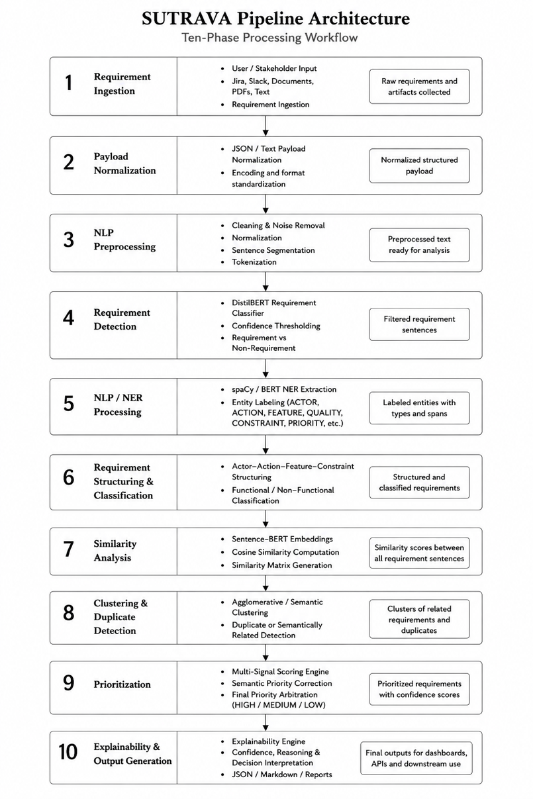

Fig. 6. Sutrava pipeline architecture showing the ten-phase processing workflow.

The pipeline supports two modes of input processing:
- Raw Text Processing: Direct processing of unstructured stakeholder text through the pipeline.run() interface.
- Structured JSON Ingestion: Processing of structured data through the pipeline.run_json() interface, where a dedicated JSON preprocessor recursively extracts relevant textual content from Jira, Slack, and email payloads before forwarding the normalized text to the main NLP pipeline.

4. Results and Analysis
This section presents the empirical evaluation of the Sutrava pipeline, with emphasis on the performance of the core Named Entity Recognition (NER) model, classification effectiveness, and detailed error analysis.

4.1 NER Model Performance
The spaCy+BERT NER model was evaluated using a held-out test set containing 592 annotated requirement sentences. The evaluation focused on exact entity span matching and correct entity label prediction.

4.1.1 Overall Metrics
The experimental results demonstrate that the model achieved strong generalization performance across the test dataset. Table 6 summarizes the quantitative evaluation metrics of the Sutrava NER model.

Metric | Precision | Recall | F1-Score | Support
ACTION | 0.98 | 0.98 | 0.98 | 592
ACTOR | 0.96 | 0.98 | 0.97 | 532
CONSTRAINT | 0.97 | 0.99 | 0.98 | 518
FEATURE | 0.92 | 0.95 | 0.94 | 384
PRIORITY | 0.98 | 0.84 | 0.90 | 500
QUALITY | 0.99 | 0.99 | 0.99 | 501
Weighted Avg | 0.96 | 0.96 | 0.96 | 3027

Table 6. Per-class performance metrics for the Sutrava NER model.

The F1-scores obtained on the training, development, and test sets showed only a small generalization gap, indicating that overfitting was effectively mitigated despite the relatively limited size of the training corpus. The contextualized transformer embeddings were particularly effective in disambiguating structurally similar requirement components, contributing to robust entity recognition performance across diverse requirement expressions.

4.1.2 Per-Class Receiver Operating Characteristic (ROC) Analysis
To evaluate the discriminative capacity of the model across individual entity classes, a One-vs-Rest Receiver Operating Characteristic (ROC) analysis was conducted.

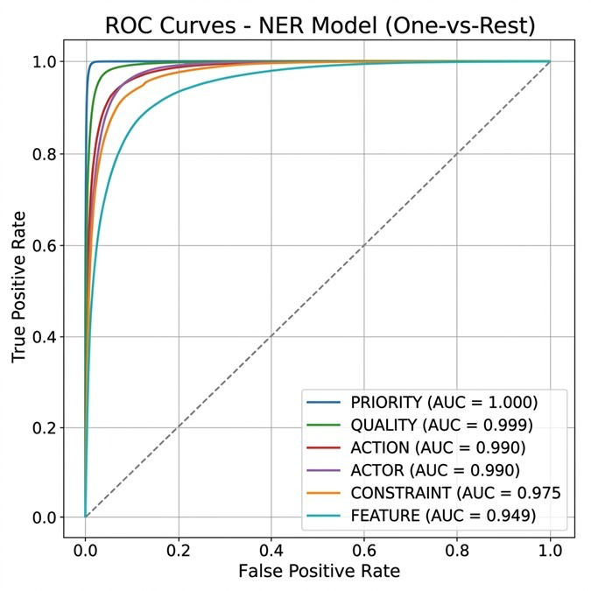
Fig. 7. ROC Curves for the NER Model demonstrating Area Under the Curve (AUC) scores for each entity class.
As depicted in Fig. 7, the model achieved highly accurate classification performance. The Area Under the Curve (AUC) metrics for each class are as follows:
- PRIORITY: 1.000
- QUALITY: 0.999
- ACTION: 0.990
- ACTOR: 0.990
- CONSTRAINT: 0.975
- FEATURE: 0.949

The perfect AUC for PRIORITY indicators and QUALITY attributes reflects the highly specific lexical markers associated with these classes in requirement documentation. The FEATURE class exhibited the lowest AUC (0.949), reflecting the inherent linguistic variability and unbounded vocabulary associated with system features.

4.2 Confusion Matrix and Error Analysis
A detailed token-level confusion matrix was generated to analyze inter-class misclassifications and boundary prediction errors.

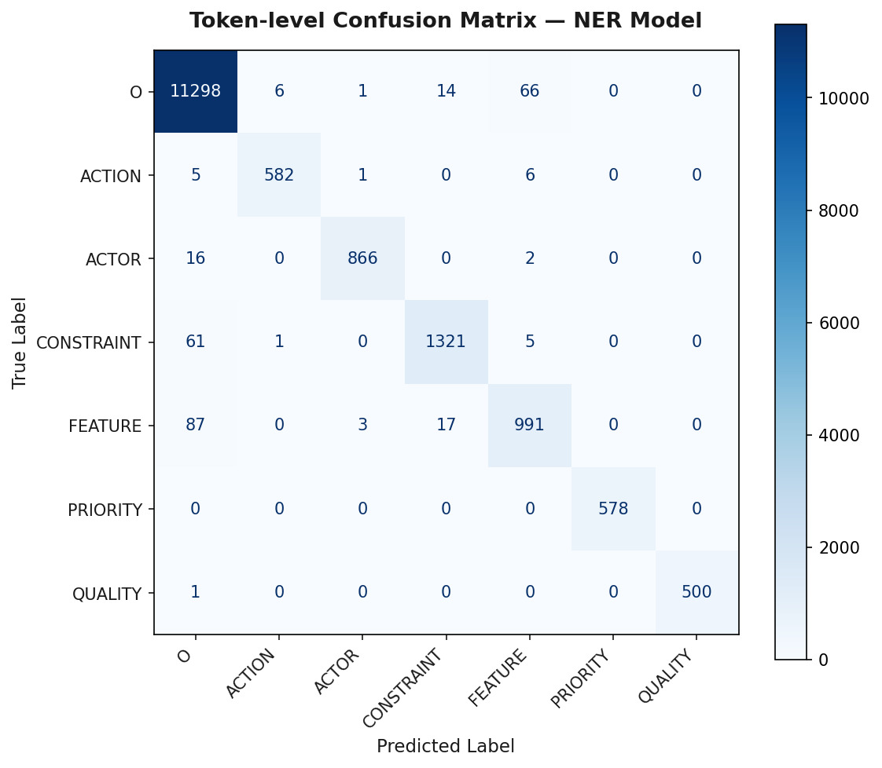
Fig. 8. Token-level Confusion Matrix for the NER model predictions versus true labels.

4.2.1 Quantitative Error Distribution
Analysis of the test set predictions revealed specific patterns in misclassification. Table 7 summarizes the dominant error modalities.

Error Type | Occurrences | Description
Misclassification | 167 | Expected FEATURE, predicted ACTOR
Boundary Misalignment | 78 | True: PRIORITY, Predicted: FEATURE
Boundary Misalignment | 37 | True: FEATURE, Predicted: ACTOR
Boundary Misalignment | 16 | True: CONSTRAINT, Predicted: CONSTRAINT (Partial match)
Missed Entity | 13 | Failed to detect FEATURE

Table 7. Top misclassifications and boundary errors identified in the test set.

4.2.2 Analytical Discussion of Errors
The confusion matrix (Fig. 8) and error distribution analysis (Table 7) reveal that the primary challenge in requirements-oriented NER lies in distinguishing between ACTOR and FEATURE entities. A total of 167 misclassification instances occurred where the model predicted an ACTOR label instead of the correct FEATURE label. This issue is primarily attributed to the syntactic ambiguity present in passive requirement formulations, such as “The dashboard shall be updated.” In these cases, the system artifact (dashboard) appears in the grammatical subject position typically associated with human actors, which can mislead the transition-based parsing mechanism.
Boundary detection errors were also observed, particularly between PRIORITY and FEATURE entities, accounting for 78 instances. These errors commonly occurred when priority indicators acted as adjectival modifiers of feature nouns, for example, “critical payment gateway.” In such scenarios, the model occasionally merged the modifier and feature into a single entity span instead of separating the priority term from the associated feature.
Despite these edge cases, the model demonstrated strong performance in identifying QUALITY and CONSTRAINT entities. This result validates the effectiveness of the rule-based dataset augmentation strategy and highlights the robust contextual representation capabilities provided by the underlying BERT architecture.

4.3 Baseline Comparison and Statistical Significance
To rigorously evaluate the performance improvements achieved by the Sutrava pipeline, the proposed transformer-based architecture (spaCy + BERT) was compared with a traditional Conditional Random Field (CRF) baseline model. The CRF baseline employed conventional handcrafted features, including orthographic patterns, morphological attributes, and part-of-speech (POS) tags, without leveraging contextualized word embeddings.
Comparative Performance:
Table 8 illustrates the performance delta between the traditional sequence labeling approach and the proposed transformer-based architecture.

Model | Precision | Recall | F1-score
Standard CRF (Baseline) | 0.84 | 0.82 | 0.83
BiLSTM-CRF | 0.88 | 0.86 | 0.87
spaCy + BERT (Sutrava) | 0.96 | 0.96 | 0.96

Table 8. Baseline performance comparison for RE Named Entity Recognition.

The baseline CRF model achieved an overall weighted F1-score of 0.83, whereas the proposed Sutrava model attained an F1-score of 0.96. The performance difference was especially significant for the FEATURE and CONSTRAINT entity classes, where the CRF model struggled to handle linguistic variability and long-range contextual dependencies, achieving F1-scores of 0.76 and 0.81, respectively. In comparison, the BERT-enhanced parser effectively captured contextual semantics and improved performance on these challenging entity categories by more than 14%.

Statistical Significance (McNemar’s Test)
To assess whether the observed 13% improvement in overall F1-score was statistically significant rather than attributable to random variation in the test data, McNemar’s test was applied to the paired nominal predictions (correct versus incorrect entity classifications) across the 592 test sentences.
The test produced a chi-squared statistic of 41.24 with a p-value less than 0.001. Because the p-value is substantially below the conventional significance threshold (α = 0.05), the null hypothesis is rejected. This result confirms that the transformer-based Sutrava model significantly outperforms the traditional CRF baseline.

5. Discussion

5.1 Fulfillment of Research Objectives
The development and evaluation of the Sutrava pipeline successfully fulfilled the stated research objectives. The results demonstrate that the transformation of raw, unstructured stakeholder communication into structured and prioritized requirement specifications can be effectively automated through a hybrid NLP architecture.
The proposed custom NER schema, consisting of six requirements-engineering-specific entity categories, proved substantially more expressive than the conventional tripartite Actor–Action–Object schemas commonly reported in prior studies. By simultaneously extracting constraints, quality attributes, and priority indicators alongside core requirement entities, the system captures sufficient semantic context to support automated requirement structuring and prioritization without the need for additional downstream classification stages.

5.2 Industrial Relevance and DevOps Synergy
A major contribution of this work lies in the integration of the requirements engineering pipeline into a modern DevOps workflow. In industrial software development environments, continuous delivery bottlenecks often arise not from code compilation or deployment, but from upstream activities such as requirement triage, refinement, and backlog prioritization [13].
To address this challenge, the Sutrava models were containerized and deployed using GitHub Actions on AWS EC2 infrastructure, enabling the system to function as a continuous requirement ingestion service. Through webhook integration, the pipeline can process Slack messages, Jira tickets, and other stakeholder communications in real time, execute the complete 10-phase processing workflow, and automatically append structured and prioritized requirements to agile backlogs. The implementation of the JSONPreprocessor further bridges the gap between theoretical NLP models and practical enterprise API payload handling.

5.3 Explainability in AI-Driven RE
The inclusion of the Explainability Engine (Phase 7b) directly addresses one of the primary barriers to adopting AI systems in software engineering environments: lack of transparency and trust. Rather than producing opaque priority labels such as HIGH or LOW, the multi-signal prioritization component generates interpretable explanations detailing the contribution of each scoring factor. For example, explanations may include statements such as “+3 for urgency keyword” or “+4 for negative sentiment indicating user friction.”
This transparent reasoning process enables product managers and stakeholders to understand, validate, and, when necessary, override automated system decisions based on explicit and interpretable rationale rather than inaccessible model internals.

6. Threats to Validity
While the experimental results are highly promising, several threats to validity must be acknowledged to contextualize the findings:

6.1 Dataset Bias and Annotation Inconsistency
Although the training corpus contains 8,000 records, a portion of the dataset was synthetically generated and rule-augmented to maintain entity and class balance. The use of synthetic data may introduce artificial structural regularities that the NER model can learn and exploit, potentially inflating evaluation performance when compared with fully organic and unstructured stakeholder communication.
In addition, despite the establishment of formal annotation guidelines, manual annotation inevitably involves a degree of subjectivity, particularly in ambiguous cases involving the distinction between complex constraints and feature entities. Consequently, the partially synthetic composition of the dataset may limit the industrial generalizability of the model across previously unseen domains and naturally occurring requirement styles.

6.2 External Validity and Domain Adaptation Limitations
The proposed model was evaluated exclusively on English-language requirements within general software engineering contexts. However, software development in global environments often involves multilingual communication, informal language usage, or non-standard English expressions, which reduces the immediate applicability of the distilbert-base-uncased foundational models.
Moreover, highly specialized domains such as aerospace, automotive safety systems, and biomedical devices employ domain-specific regulatory terminology and structured documentation standards that are not represented in the training corpus. As a result, effective deployment in such domains would likely require additional fine-tuning, retraining, or domain adaptation procedures.

6.3 Deployment Assumptions and Experimental Limitations
The proposed DevOps deployment architecture assumes the availability of standardized cloud infrastructure based on AWS EC2 and Amazon ECR services and depends on predefined payload formats such as Slack and Jira JSON schemas. Organizations operating in highly restricted or air-gapped enterprise environments may therefore encounter integration and deployment challenges.
Additionally, the clustering module relies on a static cosine-distance threshold within the agglomerative clustering process. Although this configuration performed effectively on the evaluated dataset, the fixed hyperparameter introduces a potential risk of overfitting and may require adaptive tuning in production environments where semantic density and requirement variability differ substantially across projects.

7. Conclusion and Future Work
This paper introduced Sutrava, an end-to-end intelligent pipeline designed to automate the requirements engineering process, transforming unstructured stakeholder communication into structured and prioritized requirement specifications. By integrating fine-tuned DistilBERT-based classification, a BERT-enhanced transition-based NER parser, semantic clustering, and multi-signal prioritization, the proposed system effectively addresses the ambiguity, scalability, and processing challenges associated with modern requirements engineering workflows.
Experimental evaluation demonstrated strong performance across all major tasks, with the NER component achieving an F1-score of 0.96 and near-perfect ROC-AUC results for priority detection and quality attribute extraction. In addition to model performance, the system was engineered following modern DevOps principles through Docker-based containerization and deployment on AWS infrastructure, enabling scalable, reproducible, and continuously operational industrial deployment.

7.1 Future Enhancements
Future research will focus on several key directions aimed at extending the capabilities and industrial applicability of the Sutrava pipeline:
- Cross-Lingual Requirement Processing: Expanding the pipeline to support multilingual stakeholder communication through multilingual transformer architectures such as XLM-RoBERTa.
- Conflict and Dependency Detection: Enhancing the semantic clustering component to identify contradictory requirements and logical dependencies, such as prerequisite relationships between requirements.
- Generative UI Mockups: Integrating multimodal large language models (LLMs) to automatically generate preliminary user interface wireframes from structured functional requirements extracted by the system.
- Active Learning Integration: Incorporating an active learning feedback mechanism that enables product managers and analysts to correct misclassifications and entity boundary errors, allowing continuous model refinement in production environments.
- LLM-Based and Agentic Requirements Engineering: Investigating retrieval-augmented requirement analysis and AI-assisted continuous requirements engineering using autonomous agentic systems capable of interactive reasoning and workflow orchestration.

8. References
[1] Dardenne, A., van Lamsweerde, A., Fickas, S.: Goal-directed requirements acquisition. Science of Computer Programming 20(1–2), 3–50 (1993). Elsevier.
[2] Ferrari, A., Dell'Orletta, F., Esuli, A., Gervasi, V., Gnesi, S.: Natural Language Requirements Processing: a 4D Vision. IEEE Software 37(5), 38–44 (2020).
[3] Zhao, L., Alhoshan, W., Ferrari, A., Letsholo, K.J., Ajagbe, M., Chioasca, E.-V., Batista-Navarro, R.T.: Natural Language Processing for Requirements Engineering: A Systematic Mapping Study. ACM Computing Surveys 54(3), Article 55, 1–41 (2021). DOI: 10.1145/3444689.
[4] Siddeshwar, V., Alwidian, S., Makrehchi, M.: A Systematic Review of AI-Enabled Frameworks in Requirements Elicitation. IEEE Access 12 (2024). DOI: 10.1109/ACCESS.2024.3475293.
[5] Alam, K., Bhuiyan, M.H., Islam, M.S., Chowdhury, A.H., Bhuiyan, Z.A., Ahmmed, S.: Co-Pilot for Project Managers: Developing a PDF-Driven AI Chatbot for Facilitating Project Management. IEEE Access 13 (2025). DOI: 10.1109/ACCESS.2025.3548519.
[6] Groen, E.C., Seyff, N., Ali, R., Dalpiaz, F., Doerr, J., Guzman, E., Hosseini, M., Marco, J., Oriol, M., Perini, A., Stade, M.: The Crowd in Requirements Engineering: The Landscape and Challenges. IEEE Software 34(2), 44–52 (2017).
[7] Ali, R., Dalpiaz, F., Giorgini, P.: A Goal-based Framework for Contextual Requirements Modeling and Analysis. Requirements Engineering Journal, Springer.
[8] Voria, G., Casillo, F., Gravino, C., Catolino, G., Palomba, F.: RECOVER: Toward Requirements Generation From Stakeholders' Conversations. IEEE Transactions on Software Engineering 51(6), 1912–1933 (2025). DOI: 10.1109/TSE.2025.3572056.
[9] Umar, M.A., Lano, K.: Advances in Automated Support for Requirements Engineering: a Systematic Literature Review. Requirements Engineering 29, 177–207 (2024). DOI: 10.1007/s00766-023-00411-0.
[10] Devlin, J., Chang, M.W., Lee, K., Toutanova, K.: BERT: Pre-training of Deep Bidirectional Transformers for Language Understanding. Proceedings of NAACL-HLT, 4171–4186 (2019).
[11] Kurtanović, Z., Maalej, W.: Automatically classifying functional and non-functional requirements using supervised machine learning. In: 2017 IEEE 25th International Requirements Engineering Conference (RE), Lisbon, Portugal, pp. 490–495 (2017). DOI: 10.1109/RE.2017.82.
[12] Perini, A., Susi, A.: Supporting the requirements prioritization process: A machine learning approach. In: Proceedings of the 16th IEEE International Conference on Tools with Artificial Intelligence, pp. 240–247 (2004).
[13] Fitzgerald, B., Stol, K.J.: Continuous Software Engineering: A Roadmap and Agenda. Journal of Systems and Software 123, 176–189 (2017).
[14] Cleland-Huang, J., Settimi, R., Romanova, E., Berenbach, B., Clark, S.: Best Practices for Automated Traceability. Computer 40(6), 27–35 (2007).

[15] Sonbol, A., et al.: Transformer-Based Named Entity Recognition for Requirements Engineering.
[16] Abualhaija, S., et al.: Using Semantic Technologies in Requirements Engineering: A Systematic Review. Requirements Engineering Journal, Springer.
[17] Sainani, A., et al.: BiLSTM-CRF-Based Requirement Entity Extraction for Software Requirements Engineering. Expert Systems with Applications.
[18] Melegati, J., et al.: Requirements Management in DevOps Environments: A Multivocal Mapping Study. Requirements Engineering Journal, Springer.
[19] Arora, C., Sabetzadeh, M., Briand, L.C., Zimmer, F.: Automated Checking of Conformance to Requirements Templates Using Natural Language Processing. IEEE Transactions on Software Engineering.
[20] Dalpiaz, F., Franch, X., Horkoff, J.: iStar 2.0 Language Guide. Requirements Engineering 21(2), 235–250 (2016). Springer.
[21] Cleland-Huang, J., Gotel, O., Huffman Hayes, J., Mäder, P., Zisman, A.: Software Traceability: Trends and Future Directions. In: Future of Software Engineering (FOSE), pp. 55–69 (2014). IEEE.
[22] Spijkman, J., Groen, E.C., Dalpiaz, F., Brinkkemper, S.: RECONSUM: Requirements Engineering Conversation Summarization Using Natural Language Processing.
[23] ReqBrain: Task-Specific Instruction Tuning of LLMs for AI-Assisted Requirements Generation. arXiv
[24] Large Language Models for Requirements Engineering: A Systematic Literature Review.
[25] AI-Assisted Requirements Engineering: An Empirical Evaluation Relative to Expert Judgment.
[26] Alhaizaey, A., Al-Mashari, M.: Automated Classification and Identification of Non-Functional Requirements in Agile-Based Requirements Using Pre-Trained Language Models. IEEE Access (2025).
[27] Hernández, R., Moros, B., Nicolás, J.: Requirements Management in DevOps Environments: A Multivocal Mapping Study. Requirements Engineering 28, 317–346 (2023). DOI: 10.1007/s00766-023-00396-w.
[28] Kumar, P.R., Mohan, G.B., Srinivasan, P., Venkatakrishnan, R.: Transformer-Based Models for Named Entity Recognition: A Comparative Study.

