UPES
UNIVERSITY OF THE FUTURE
Design and Analysis of Algorithms (DAA)
Lab File
Submitted to: Mr Sandeep Kumain
Name: Devansh Joshi
SAP ID: 590028189
Batch: Batch-19

Q1: Write a C program to implement Binary Search to search for an element in a sorted array
Source Code (BinarySearch.c):
#include <stdio.h>
#include <stdlib.h>
int binarySearch(int a[], int n, int key) {
int low = 0;
int high = n - 1;
while (low <= high) {
int mid = (low + high) / 2;
if (a[mid] == key)
return mid;
if (a[mid] < key)
low = mid + 1;
else
high = mid - 1;
}
return -1;
}
int main() {
int sizes[] = {100, 1000, 10000};
for (int s = 0; s < 3; s++) {
int n = sizes[s];
int *a = malloc(n * sizeof(int));
for (int i = 0; i < n; i++)
a[i] = i;
int key = n - 1;
binarySearch(a, n, key);
printf("Binary Search completed for n = %d\n", n);
free(a);
}
return 0;
}
Output:
Binary Search completed for n = 100
Binary Search completed for n = 1000
Binary Search completed for n = 10000
Graph:
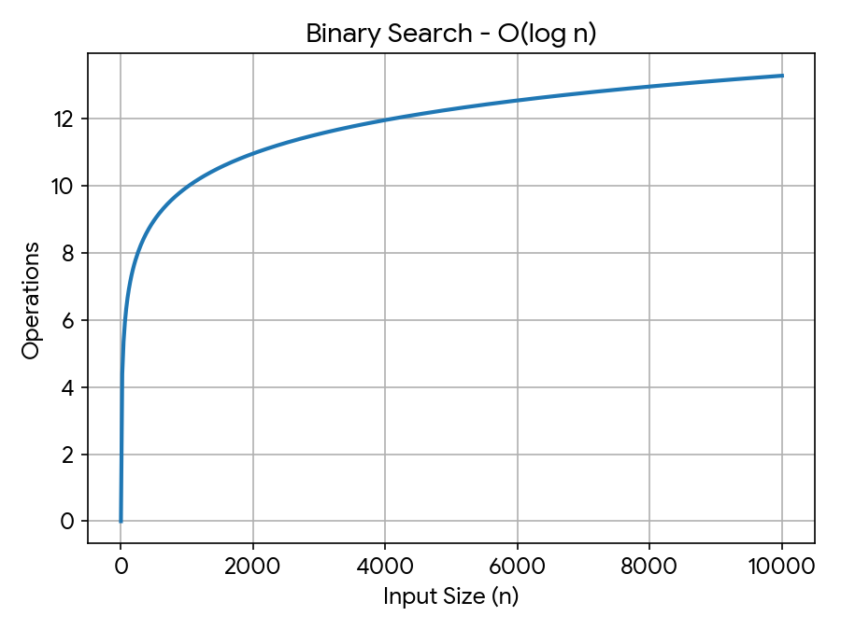
Learning outcomes:
After completing this experiment, students will be able to:
- Understand the concept of Binary Search
- Implement Binary Search using C programming
- Search for an element efficiently in a sorted array
- Analyze the time complexity of Binary Search, O(log n)
- Compare Binary Search with Linear Search

Q2: Write a C program to implement Bubble Sort to sort an array in ascending order
Source Code (BubbleSort.c):
#include <stdio.h>
#include <stdlib.h>
#include <time.h>
void bubbleSort(int a[], int n) {
for (int i = 0; i < n - 1; i++) {
for (int j = 0; j < n - i - 1; j++) {
if (a[j] > a[j + 1]) {
int temp = a[j];
a[j] = a[j + 1];
a[j + 1] = temp;
}
}
}
}
int main() {
int sizes[] = {100, 1000, 10000};
for (int s = 0; s < 3; s++) {
int n = sizes[s];
int *a = malloc(n * sizeof(int));
for (int i = 0; i < n; i++)
a[i] = rand() % 10000;
bubbleSort(a, n);
printf("Bubble Sort completed for n = %d\n", n);
free(a);
}
return 0;
}
Output:
Bubble Sort completed for n = 100
Bubble Sort completed for n = 1000
Bubble Sort completed for n = 10000
Graph:
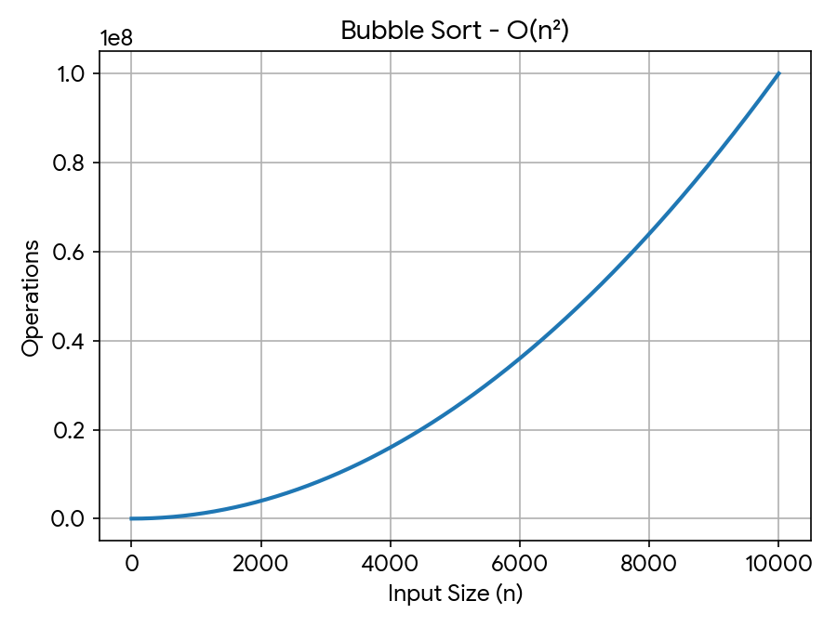
Learning outcomes:
After completing this experiment, students will be able to:
- Understand the concept of Bubble Sort
- Implement Bubble Sort using C programming
- Sort an array in ascending order using Bubble Sort
- Analyze the time complexity of Bubble Sort, O(n²)
- Understand the working and limitations of Bubble Sort

Q3: Write a C program to implement Linear Search to search for an element in an array
Source Code (LinearSearch.c):
#include <stdio.h>
#include <stdlib.h>
int linearSearch(int a[], int n, int key) {
for (int i = 0; i < n; i++) {
if (a[i] == key)
return i;
}
return -1;
}
int main() {
int sizes[] = {100, 1000, 10000};
for (int s = 0; s < 3; s++) {
int n = sizes[s];
int *a = malloc(n * sizeof(int));
for (int i = 0; i < n; i++)
a[i] = i;
int key = n - 1;
linearSearch(a, n, key);
printf("Linear Search completed for n = %d\n", n);
free(a);
}
return 0;
}
Output:
Linear Search completed for n = 100
Linear Search completed for n = 1000
Linear Search completed for n = 10000
Graph:
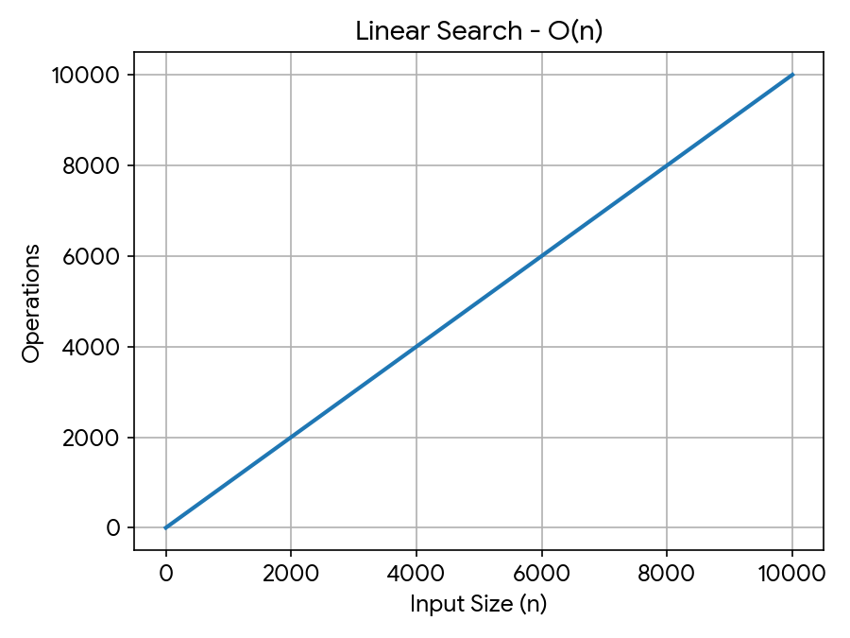
Learning outcomes:
After completing this experiment, students will be able to:
- Understand the concept of Linear Search
- Implement Linear Search using C programming
- Search for an element in an array
- Analyze the time complexity of Linear Search, O(n)
- Understand the advantages and limitations of Linear Search

Q4: Write a C program to implement Merge Sort to sort an array in ascending order
Source Code (MergeSort.c):
#include <stdio.h>
#include <stdlib.h>
void merge(int a[], int left, int mid, int right) {
int *temp = malloc((right - left + 1) * sizeof(int));
int i = left;
int j = mid + 1;
int k = 0;
while (i <= mid && j <= right) {
if (a[i] <= a[j])
temp[k++] = a[i++];
else
temp[k++] = a[j++];
}
while (i <= mid)
temp[k++] = a[i++];
while (j <= right)
temp[k++] = a[j++];
for (i = left, k = 0; i <= right; i++, k++)
a[i] = temp[k];
free(temp);
}
void mergeSort(int a[], int left, int right) {
if (left < right) {
int mid = (left + right) / 2;
mergeSort(a, left, mid);
mergeSort(a, mid + 1, right);
merge(a, left, mid, right);
}
}
int main() {
int sizes[] = {100, 1000, 10000};
for (int s = 0; s < 3; s++) {
int n = sizes[s];
int *a = malloc(n * sizeof(int));
for (int i = 0; i < n; i++)
a[i] = rand() % 10000;
mergeSort(a, 0, n - 1);
printf("Merge Sort completed for n = %d\n", n);
free(a);
}
return 0;
}
Output:
Merge Sort completed for n = 100
Merge Sort completed for n = 1000
Merge Sort completed for n = 10000
Graph:
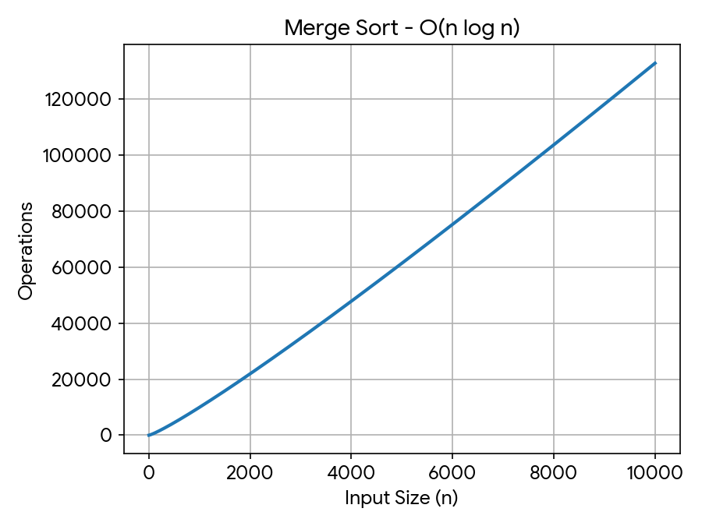
Learning outcomes:
After completing this experiment, students will be able to:
- Understand the concept of Merge Sort
- Implement Merge Sort using C programming
- Sort an array using the divide-and-conquer approach
- Analyze the time complexity of Merge Sort, O(n log n)
- Understand the advantages and limitations of Merge Sort

Q5: Write a C program to implement Quick Sort to sort an array in ascending order
Source Code (QuickSort.c):
#include <stdio.h>
#include <stdlib.h>
void quickSort(int a[], int low, int high) {
if (low < high) {
int pivot = a[high];
int i = low - 1;
for (int j = low; j < high; j++) {
if (a[j] < pivot) {
i++;
int temp = a[i];
a[i] = a[j];
a[j] = temp;
}
}
int temp = a[i + 1];
a[i + 1] = a[high];
a[high] = temp;
int p = i + 1;
quickSort(a, low, p - 1);
quickSort(a, p + 1, high);
}
}
int main() {
int sizes[] = {100, 1000, 10000};
for (int s = 0; s < 3; s++) {
int n = sizes[s];
int *a = malloc(n * sizeof(int));
for (int i = 0; i < n; i++)
a[i] = rand() % 10000;
quickSort(a, 0, n - 1);
printf("Quick Sort completed for n = %d\n", n);
free(a);
}
return 0;
}
Output:
Quick Sort completed for n = 100
Quick Sort completed for n = 1000
Quick Sort completed for n = 10000
Graph:
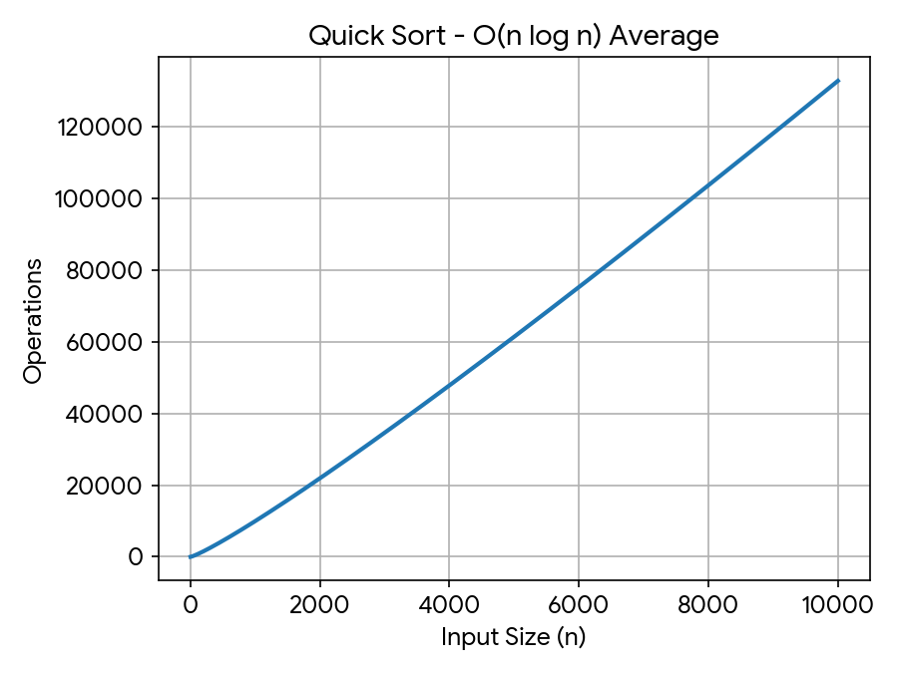
Learning outcomes:
After completing this experiment, students will be able to:
- Understand the concept of Quick Sort
- Implement Quick Sort using C programming
- Apply the divide-and-conquer approach to sorting
- Analyze the average and worst-case time complexity of Quick Sort
- Understand the advantages and limitations of Quick Sort

