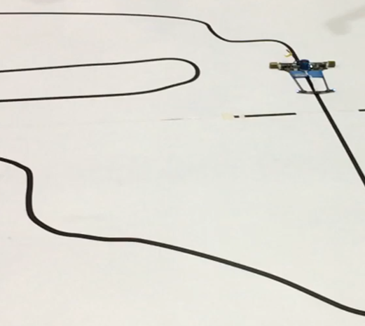

Project – Line follower robot with custom 16 channel IR-sensors PCB.

Name – Devansh Pundir
Course – BTech-CSE, JK Lakshmipat University
Competitive Club - Dyoraa Robotics

What is a line follower robot ?
A Line Follower Robot (LFR) is an autonomous mobile robot that can detect and follow a specific path, usually marked by a black or white line on the floor. It uses infrared (IR) sensors to sense the contrast between the line and the surface. The sensor readings are processed by a microcontroller, which controls the robot’s motors to keep it aligned with the path.
Line follower robots are widely used in industrial automation, warehouse transportation, and educational robotics, as they demonstrate the principles of sensor-based navigation, motor control, and feedback systems. In competitive robotics, advanced line followers implement PID control algorithms for precise movement and can handle complex tracks with curves, intersections, and mazes.

Components Used :
- Self Build custom 16 channel ir sensor array:
The robot is equipped with a custom-built 16-channel IR sensor array designed in a curved layout, which allows better detection of sharp turns and complex paths compared to a straight-line array. The PCB was designed using EasyEDA and fabricated through JLCPCB, ensuring precision and reliability.

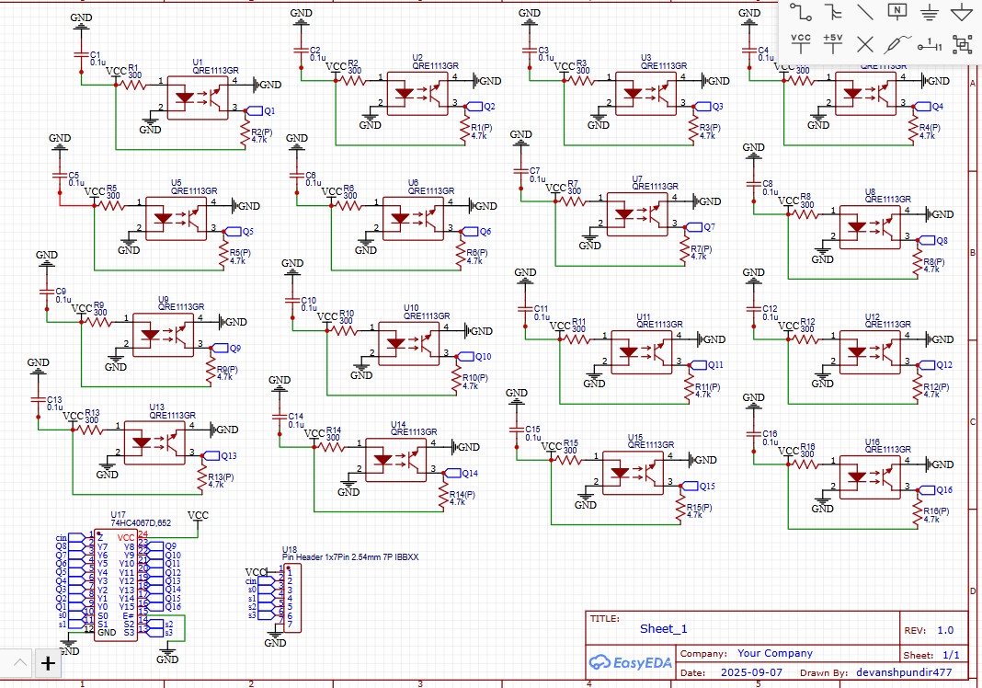
Image 1: Shows the Schematic of PCB

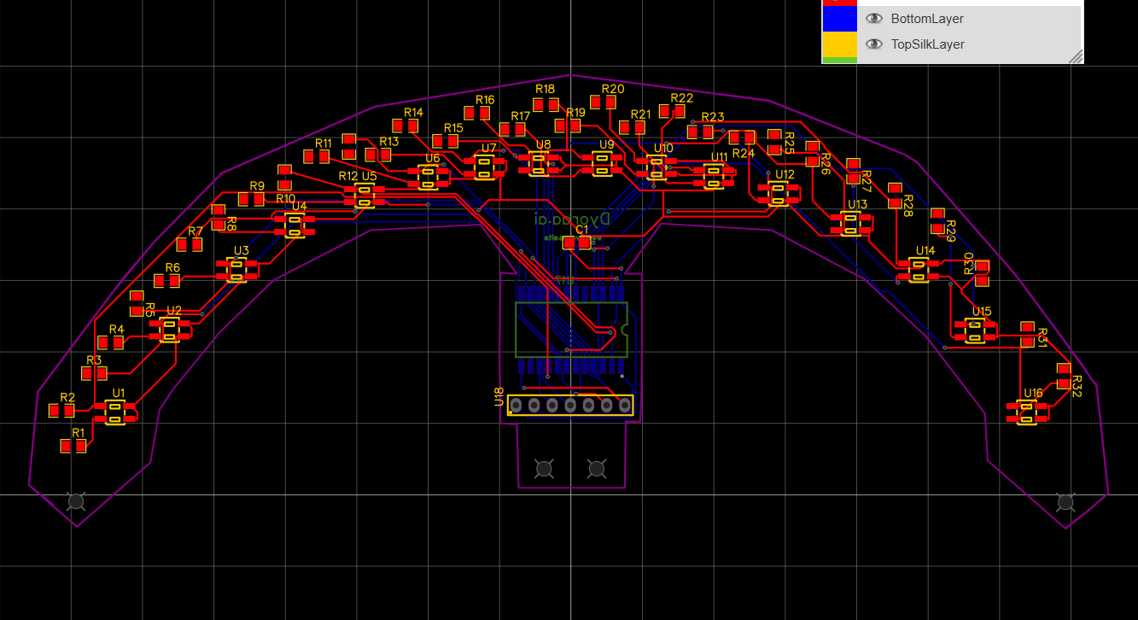
Image 2: Shows the PCB

The curved arrangement improves line detection by covering a wider area in front of the robot, allowing faster and more accurate decision-making when navigating tight corners, intersections, or curves. This design also reduces the chance of the robot losing the line during high-speed operation, making it ideal for competitive line following.

IR Sensor Specifications – QRE1113GR
- Type: Reflective Infrared Sensor with Phototransistor
- Output: Analog
- Supply Voltage: 2.7V – 5.5V
- Current Consumption: ~3 mA
- Wavelength: 940 nm (Infrared)
- Response Time:
  - Rise Time: 20 µs
  - Fall Time: 20 µs
- Detection Range: Up to 6 mm from surface
- Features: Fast response, high sensitivity, ideal for high-speed line detection
The phototransistor allows the sensor to detect reflectivity changes between black and white surfaces, enabling accurate line following even at sharp turns.
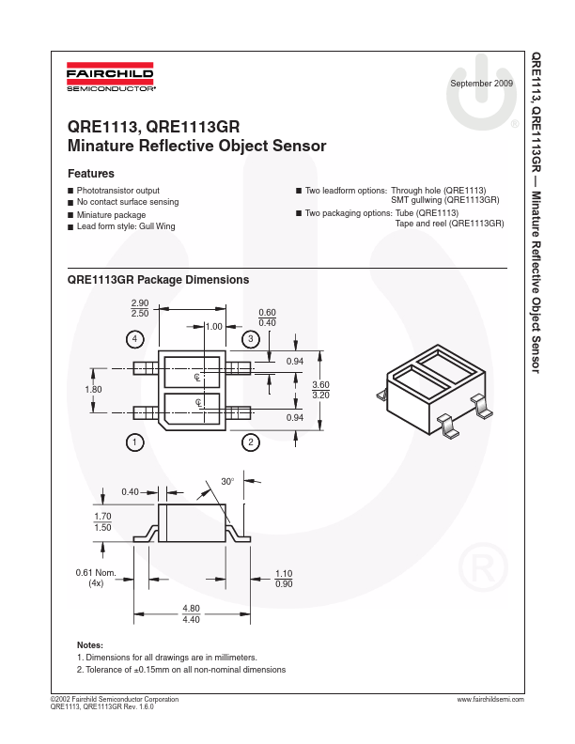
2)Micro-controller used:
The STM32F411 Black Pill is a high-performance 32-bit ARM Cortex-M4 microcontroller board. It features a compact design, fast processing speed, and multiple input/output options, making it ideal for robotics and embedded system applications.

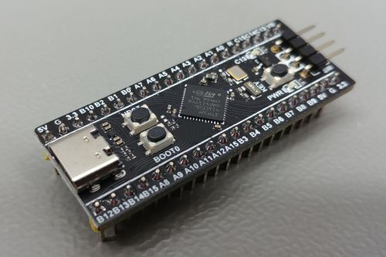
Image 3: STM32F411CEU

Specifications
- Core: ARM Cortex-M4, 32-bit
- Clock Speed: 100 MHz
- Flash Memory: 512 KB
- SRAM: 128 KB
- Operating Voltage: 3.3V
- Digital I/O Pins: 26+
- Analog Input Pins: 16 (12-bit ADC)
- Communication Interfaces: UART, I2C, SPI, CAN
- PWM Channels: Multiple for motor control
- USB Support: USB OTG Full-Speed

Why It’s Suitable for Our Robot
- High Processing Speed (100 MHz): Handles signals from 16 IR sensors in real-time for accurate line tracking.
- Multiple ADC Channels: Allows simultaneous reading of analog sensor values without external multiplexing.
- PWM Support: Drives motors precisely for PID-based control.
- Compact & Reliable: Fits easily on the robot chassis with low power consumption.
- Versatile Interfaces: Enables expansion for future upgrades like wireless control or additional sensors.

- Wheels used :
The robot uses custom 3D-modeled wheels with Silicon grips designed to meet specific requirements for high-speed line following. These wheels are:
- Small in diameter: Ensures compact design and better maneuverability on tight paths and curves.
- Broad surface: Provides increased friction with the ground, improving traction and stability during high-speed turns.
- Custom design: 3D-printed to perfectly fit the robot’s chassis and motor shaft, allowing precise control and minimal slippage.
These wheels, combined with accurate motor control, help the robot maintain speed and stability while following complex and curved lines.

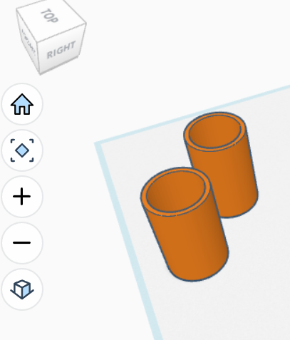
Image 4 : shows the structure of wheels

4) Chassis
The robot features a custom-built chassis made from 3mm acrylic sheet. Key features include:
- Motor Mounting Holes: Precisely positioned for secure attachment of motors.
- Space for Vacuum or Components: Designed to accommodate additional modules or electronics.

- Custom Design: Created in EasyEDA (for layout planning) to ensure proper alignment of sensors, motors, and wheels.
- Lightweight and Sturdy: Acrylic provides rigidity while keeping the robot light for high-speed operation.
The chassis provides a solid base for all components, ensuring stability and accurate movement during line-following tasks.

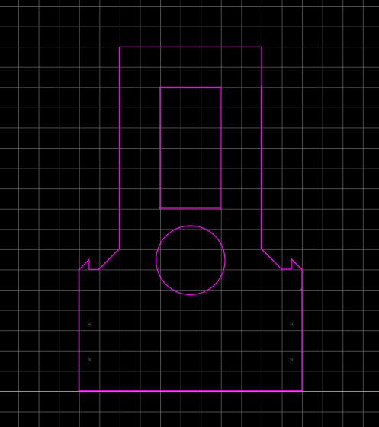
Image 5 : shows structure of chassis

5) Power Supply
The robot is powered by a 7.4V, 450mAh Bonka Li-ion battery with a 45C discharge rating, providing sufficient current for high-speed motors and sensors. To safely power the microcontroller and IR sensors, a buck converter is used to step down the voltage from 7.4V to 3.3V, ensuring stable operation without damaging sensitive components.
Key Features:
- High-Current Battery (45C): Supports rapid acceleration and high-speed movement.

Voltage Regulation: Buck converter delivers a consistent 3.3V to the STM32 Black Pill and IR sensors.
- Compact & Efficient: Combines battery and converter in a single module for neat wiring and minimal weight.
This power setup ensures reliable and stable operation for both the high-speed motors and precision electronics of the robot.

6) Motor Driver – TB6612FNG
The robot uses a TB6612FNG dual H-bridge motor driver to control the two DC motors. This driver allows precise speed and direction control, which is essential for accurate line following.
Key Specifications:
- Operating Voltage: 2.7V – 5.5V (logic), 4.5V – 13.5V (motor)
- Continuous Output Current: 1.2A per channel (3.2A peak)
- PWM Control: Supports speed regulation via PWM signals from the microcontroller
- Compact Size: Easy to mount on the custom chassis
- Overheat Protection: Built-in thermal shutdown for safety
Why Suitable:
- Enables smooth speed control for tight turns and sharp curves.
- Handles the current requirements of the robot’s motors.
- Integrates easily with STM32 Black Pill PWM outputs.
The TB6612FNG ensures the motors respond quickly to sensor inputs, allowing the robot to accurately follow lines and navigate curves.

7) Motors – N20 Metal Gear Motors
The robot uses N20 metal gear DC motors for precise and high-speed movement. These motors are ideal for small, fast robots like line followers.

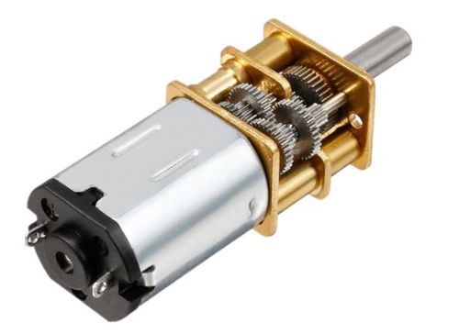
Image 6: Shows N20 gear motor

Key Specifications:
- Rated Voltage: 6V
- No-load Speed: 2000 RPM
- Torque: 300 g·cm (gram-centimeter)
- Type: Metal gear motor for durability and smooth operation
- Current Draw: Low, suitable for compact battery-powered robots
Why Suitable:
- High RPM: Enables the robot to move quickly along the track.
- Metal Gears: Provide durability and consistent performance.
- Torque: Sufficient to handle the robot’s weight and sharp turns without slipping.
- Compact Size: Fits perfectly on the custom chassis.
Combined with the TB6612FNG motor driver and STM32 Black Pill, these motors ensure precise speed and directional control, allowing the robot to accurately follow complex lines and curves.

8) Vacuum System
To enhance traction and stability at high speeds, the robot is equipped with a vacuum system using an impeller propeller. This system slightly pulls the robot toward the ground, increasing friction between the wheels and the surface.
Key Features:
- Purpose: Ensures the robot remains grounded at speeds up to ~1.6 m/s.
- Design: Compact impeller mounted within the chassis, creating a low-pressure zone under the robot.
- Effectiveness: Reduces the risk of wheel slip during sharp turns and rapid acceleration, improving line-following accuracy.
- Integration: Fits seamlessly with the custom chassis and power system.
This addition allows the robot to maintain high-speed performance without losing contact with the track, ensuring stable and precise line following.

9) Optic Encoders are also used for distance measuring in this bot.

Competition Participation and Achievements
This line follower robot has participated in multiple prestigious competitions and achieved remarkable results:
- Technoxian World Championship 2025
  - Event: Fastest Line Follower
  - Date: 29Augest - 2 September
  - Result: Ranked in Top 30 out of 440 teams worldwide
- IIIT Delhi Zonals 2025
  - Event: Line Follower Robotics Challenge
  - Result: Secured Top 5 position and qualified for IIT Bombay Meshmerize, a highly competitive (asia) national-level robotics event
These achievements highlight the robot’s high-speed performance, precise line tracking, and advanced design, demonstrating its competitiveness on both national and international platforms.

