FinX
Personalized Financial Planning & Investment Guidance
Product Specification — v1.0

The Problem We're Solving
Today, a person's financial life is scattered across a dozen different platforms. Stocks on one app. Mutual funds on another. A crypto wallet. An FD at the bank. A life insurance policy buried in email. Real estate valued by gut feel. Nobody has a single, true picture of their net worth — and nobody is giving them advice that accounts for all of it.

Existing solutions are either aggregators (they show you the picture but won't tell you what to do) or robo-advisors (they tell you what to do but only see what's on their own platform). There is no product that sits above all asset classes and combines a complete financial view with intelligent, personalized guidance.

Our thesis
A unified financial dashboard combined with an AI reasoning layer that knows your complete situation not just one slice of it is the most valuable product in personal finance that doesn't yet exist.

1. Project Overview & Core Architecture

1.1 What FinX Is
FinX is a two-layer product: a unified asset aggregation engine that pulls all financial holdings into one view, and an AI-powered advisory layer that reasons over that complete picture to deliver personalized, explainable guidance.

It is not a chatbot. It behaves like a private wealth advisor — one that builds a deep model of the user over time, challenges their assumptions, detects contradictions, and improves its advice as the user's life changes.

1.2 The Four Core Pillars
- Financial principles — sound reasoning grounded in return, risk, liquidity, diversification, and tax efficiency
- Risk profiling — behavioral, not just stated. Scenario-based probes surface the real tolerance, not the self-reported one
- Behavioral finance — the agent accounts for cognitive biases, emotional reactions, and irrational tendencies that affect real decisions
- Explainable reasoning — every recommendation includes a clear 'why', alternative scenarios, and the trade-offs involved

1.3 Asset Classes Aggregated
FinX consolidates the following into a single financial picture:
- Equity (direct stocks, listed shares)
- Mutual Funds & SIPs (ongoing and completed)
- Fixed Deposits & recurring deposits
- Cryptocurrency (wallets, exchange holdings)
- Real Estate (self-reported or linked to registry data)
- Life, health, and disability insurance policies
- Provident Fund (EPF, PPF) and pension accounts
- Loans, EMIs, and other liabilities

2. User Persona & Profiling Engine

2.1 Static Profile Variables
The agent builds a structured user profile on intake, covering:
- Demographics — age, country, tax residency vs. citizenship
- Income — annual income, monthly take-home, income stability, years at current job
- Capital — available investable capital, existing asset breakdown
- Liabilities — outstanding loans, EMI amounts, debt interest rates
- Dependents — number, ages, and financial dependency level
- Insurance coverage — life sum assured, health cover, disability cover
- Monthly running costs — fixed expenses, discretionary spend
- Emergency fund — current amount vs. recommended 6-month runway
- Investment knowledge baseline — beginner, intermediate, advanced

2.2 Goals Framework
Users define one or more financial goals with a timeline and priority weighting:
- Retirement planning — target corpus, expected retirement age
- Property — down payment target, timeline, location
- Child's education — institution type, years away, estimated cost
- General wealth growth — target net worth milestones
- Health contingency — medical emergency fund
- Side income / passive income — target monthly income from investments

2.3 Behavioral Risk Profiling
Why stated risk tolerance is not enough
Users consistently overstate their risk tolerance in calm markets and understate it during volatility. A questionnaire score is a starting point, not a fact.

The agent uses scenario-based behavioral anchoring to produce a behavioral risk score that is more predictive than stated preference:
- Loss tolerance probe: "If your ₹10L became ₹6L in 6 months, would you (a) panic sell, (b) hold, (c) buy more?"
- Opportunity cost probe: "Would you rather have a guaranteed 8% return or a 50% chance at 20%?"
- Liquidity stress probe: "If you needed ₹2L in cash next month, how easy would that be?"
- Time horizon probe: "If markets fell 30% tomorrow, at what point would you start worrying about your timeline?"

Contradiction detection is built in. If a user claims high risk tolerance but their behavioral responses indicate anxiety under loss, the agent surfaces the conflict explicitly and works with the user to resolve it rather than averaging the scores.

2.4 Persona Drift & Re-Profiling
User circumstances change. Income drops, goals shift, children are born, relationships end. The agent implements periodic re-profiling prompts triggered by:
- Time elapsed (every 6 months automatically)
- Detected life events (salary change, new loan, large withdrawal)
- User-initiated updates
- Contradictions detected between new inputs and stored profile

3. Conversational Intelligence & Reasoning

3.1 Advisor Behavior, Not Chatbot Behavior
The agent is designed to mirror the behavior of a high-quality human financial advisor — not a question-answering system. This means:
- It asks before it advises: "Before I say anything, I want to understand your cash flow."
- It probes incomplete answers: short responses to significant questions trigger follow-up, not acceptance
- It challenges inconsistencies: "You've said you have high risk tolerance, but you also said you can't sleep when markets fall — let's talk about that."
- It uses motivational interviewing (MI) techniques: "What would achieving this goal mean for you?" before "How much do you want to save?" — this surfaces emotional commitment, not just numbers

3.2 Advice Staging
The agent avoids cognitive overload by staging advice across sessions. A first-time user does not receive a full financial plan on day one:
- Session 1 — Profile building: income, goals, existing assets
- Session 2 — Emergency fund assessment and liquidity check
- Session 3 — Debt analysis: EMI burden, interest rate optimization
- Session 4 — Insurance gap analysis
- Session 5 — Investment strategy and asset allocation
- Session 6 — Tax optimization, goal tracking, portfolio rebalancing

3.3 Personality Model
Based on profiling data and behavioral signals, the agent constructs a personality model for the user that persists across sessions. This includes:
- Risk archetype — conservative, moderate, aggressive, or mixed
- Decision style — analytical (wants data) vs. intuitive (wants narrative)
- Engagement pattern — how frequently they check in, what they respond to
- Emotional triggers — what types of news or market events cause anxiety
- Learning pace — how much financial detail they want in explanations

3.4 Reasoning Agent Design
The LLM component functions as a structured reasoning agent, not a text generator. For every advisory output it:
- Reasons over structured user profile + market context simultaneously
- Applies relevant financial principles (e.g. debt avalanche vs. snowball, 50-30-20 rule, bucket strategy for retirement)
- Explains why a recommendation is made, not just what it is
- Offers multiple scenarios with trade-offs ("If you invest ₹10K/month in equity: here's the 5-year range. If you split 60/40 with debt: here's the range."
- Refuses to give advice when it lacks sufficient context, instead asking for the missing information

4. Unified Asset Dashboard

4.1 The Aggregation Layer
The dashboard is the foundation that makes the advisory layer meaningful. Without a complete financial picture, any advice is partial. The aggregation layer connects to or accepts data from:
- Brokerage APIs — for real-time equity and MF portfolio values
- Bank statement parsing — PDF or API import for FD, savings, RD data
- Exchange APIs — for crypto holdings (Binance, Coinbase, WazirX, etc.)
- Insurance portal integrations or manual policy entry
- Self-reported real estate with auto-market-value estimation by city/area
- Loan account APIs or manual EMI entry

4.2 Net Worth View
The primary dashboard surface shows:
- Total net worth (assets minus liabilities), updated in real time where possible
- Asset allocation breakdown by class (equity, debt, real estate, crypto, cash)
- Liquidity ratio — what percentage of net worth is accessible within 30 days
- Debt-to-income ratio
- Month-on-month net worth change
- Progress bars against each defined goal

4.3 Goal Tracking
Each goal has its own tracking view with:
- Current progress vs. target
- Monte Carlo probability of success at current savings rate
- Required monthly contribution to hit the goal on time
- Sensitivity analysis: "If markets return 8% vs. 12%, here's the difference"

5. Market Awareness Engine

5.1 What the Agent Knows About Markets
The agent maintains awareness of market conditions — not to forecast, but to contextualize advice. It distinguishes between what it knows and what it doesn't, never presenting probability estimates as certainties.

- Macro indicators — central bank rates (RBI, Fed, ECB), inflation data, currency movements
- Asset class characterization — current yield environment, equity valuations, credit spreads
- Historical market behavior — how asset classes have performed in similar macro regimes
- Volatility regimes — qualitative classification: risk-off, inflationary pressure, credit stress, recovery
- Cross-asset correlation awareness — "when US rates rise, EM equities and gold tend to move in specific ways"

5.2 News & Sentiment Intelligence
A dedicated NLP pipeline processes financial news and media with the following properties:
- Sentiment classification — headlines and articles labeled as highly positive, positive, neutral, negative, or highly negative
- Entity extraction — companies, people, and key events (M&A, regulatory fines, earnings, recalls) identified from unstructured text
- Source credibility weighting — an RBI Governor speech carries different weight than a Twitter rumor; each source has an authority score
- Temporal decay — signals from 48 hours ago are weighted less than signals from 2 hours ago
- Document processing — analyst reports, SEBI filings, earnings call transcripts processed and summarized

5.3 Regime Detection
Rather than just reporting "volatility is high", the agent classifies the current market regime and adjusts its framing accordingly:
- Risk-off / flight to safety — typically favor short-duration debt and gold
- Inflationary regime — real assets and floating-rate instruments tend to outperform
- Credit stress — reduce exposure to high-yield and leveraged instruments
- Recovery / risk-on — equities and growth assets typically reward longer positioning

Important principle
The agent never claims to predict markets. It uses regime awareness to contextualize recommendations and flag risks, not to time the market on the user's behalf.

6. Memory Architecture & External Tools

6.1 Memory Design
The agent maintains two distinct memory layers:
- Short-term memory — the active context window: the current conversation, recent messages, and any data loaded for this session
- Long-term memory — a vector database (VDB) storing the user's financial profile, past recommendations, emotional reactions, and life events. Each new query uses RAG to pull relevant user context alongside market data

User personal data (structured fields) lives in a relational database and is indexed into the vector DB for semantic retrieval. This means the agent can answer questions like "how has my risk appetite changed over the last year" by retrieving and comparing stored profile snapshots.

6.2 Multi-Session Continuity
Every session ends with an automatic session summary stored in long-term memory:
- What was discussed
- What advice was given and why
- What the user's emotional reaction appeared to be
- What to follow up on next session

This ensures the agent never treats a returning user as a new user. Context accumulates, trust builds, and advice sharpens.

6.3 External Data Tools
The agent integrates with external data sources for real-time grounding:
- Market data — Polygon.io, Bloomberg API, NSE/BSE feeds for real-time equity data
- Macroeconomic data — FRED, RBI data portal, World Bank APIs for rates and inflation
- Regulatory filings — SEC EDGAR API, SEBI filings for corporate events
- News aggregation — filtered financial news feeds with NLP pre-processing
- Real estate indices — NHB Residex, PropEquity, or similar for property valuation context

6.4 Quantitative Computation Tools
All financial calculations are handled by dedicated computation modules, never estimated by the LLM:
- Portfolio metrics — P&L, CAGR, XIRR, Sharpe ratio, drawdown analysis
- Retirement projections — SWP (systematic withdrawal plan) modeling, inflation-adjusted corpus targets
- Compound interest and SIP calculators — with variable rate scenarios
- Tax computation — LTCG, STCG, income tax slab optimization, indexation benefit calculations
- Debt optimization — EMI schedules, prepayment impact, debt avalanche vs. snowball comparison
- Monte Carlo simulation — probability of goal success across 10,000 randomized return scenarios

6.5 Risk & Portfolio Optimization
- Mean-variance optimization for asset allocation suggestions
- Efficient frontier visualization for risk-return trade-off
- Correlation matrix across the user's actual holdings
- Concentration risk alerts (e.g. >40% in a single stock or sector)

7. Output Design & Explainability

7.1 Every Recommendation Includes
- The recommendation itself, stated simply
- The reasoning chain: why this, given your profile and current conditions
- The trade-offs: what you give up by choosing this option
- Alternative scenarios: at least two other paths with their projected outcomes
- A confidence level: is this based on strong data or broad estimates?
- The next action: a specific, concrete step the user can take today

7.2 Handling Uncertainty
Design principle
The agent never pretends to know what it doesn't. Projections are presented as ranges with stated assumptions. Market-dependent outcomes include sensitivity analysis. Hallucinated data points are treated as a critical failure.

7.3 Tax Avoidance (Legal Optimization)
The agent actively identifies legal tax optimization opportunities within the user's jurisdiction:
- ELSS and 80C instruments for income tax reduction
- LTCG harvesting — crystallizing gains below the ₹1L exemption threshold annually
- Debt fund indexation benefits for inflation-adjusted cost base
- HRA structuring and home loan interest deductions where applicable
- NPS contribution optimization for additional 80CCD(1B) benefit
The agent is explicit that these are legal avoidance strategies, not evasion, and always recommends consulting a qualified CA for implementation.

8. Portfolio Rebalancing & Trigger System

8.1 When Rebalancing Is Triggered
The agent monitors the user's portfolio and flags rebalancing when:
- Asset allocation drifts more than 5% from target (e.g. equity runs from 60% to 67% due to market growth)
- A life event changes the risk profile (new dependent, job change, loan taken)
- The macro regime shifts significantly (e.g. entering a risk-off environment)
- A goal timeline shortens materially and the current portfolio is too aggressive
- 6-month re-profiling reveals changed preferences

8.2 What a Rebalancing Recommendation Contains
- Current allocation vs. target allocation
- Specific sell/reduce and buy/increase actions
- Tax implications of the rebalancing (which sales trigger LTCG vs. STCG)
- Cost of rebalancing vs. cost of staying misallocated

9. Phased Build Roadmap

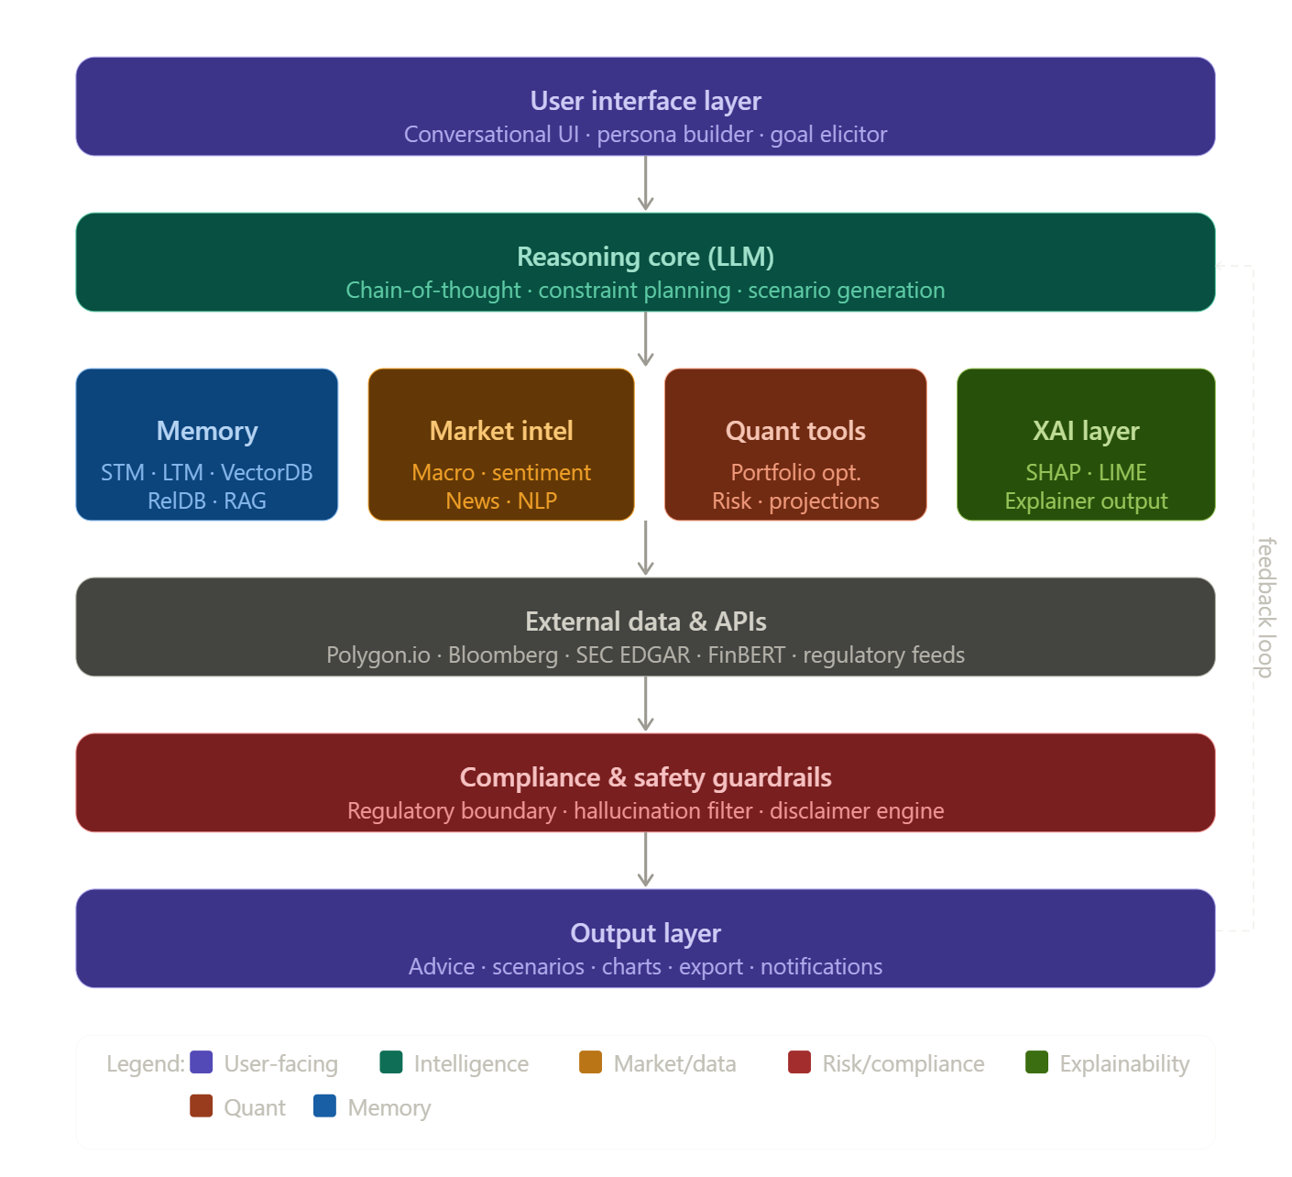

Phase 1 — Foundation (Months 1–3)
- User onboarding and profile engine
- Manual asset entry + PDF bank/demat statement parsing
- Net worth dashboard (static, no live feeds yet)
- Basic conversational advisor with profiling flow

Phase 2 — Intelligence (Months 4–6)
- Live market data integration (equity, MF NAV, crypto)
- Goal tracking with Monte Carlo projections
- Behavioral risk profiling and contradiction detection
- Long-term memory (vector DB) and session continuity

Phase 3 — Market Awareness (Months 7–9)
- News and sentiment NLP pipeline
- Macro regime detection
- Tax optimization module
- Portfolio rebalancing trigger system

Phase 4 — Scale & Compliance (Months 10–12)
- Regulatory review and licensing assessment per market
- Insurance and real estate API integrations
- Multi-language support
- Mobile app (iOS + Android)

FinX — Internal Product Specification
Confidential — Not for external distribution

