Case Study on Transport Management System

Database Schema for Transport Management System:

1. Vehicles table:

• VehicleID: INT, AUTO_INCREMENT, PRIMARY KEY

• Model: VARCHAR(255)

• Capacity: DECIMAL(10, 2)

• Type: VARCHAR(50) (e.g., Truck, Van, Bus)

• Status: VARCHAR(50) (e.g., Available, On Trip, Maintenance)

2. Routes table:

• RouteID: INT, AUTO_INCREMENT, PRIMARY KEY

• StartDestination: VARCHAR(255)

• EndDestination: VARCHAR(255)

• Distance: DECIMAL(10, 2)

3. Trips table:

• TripID: INT, AUTO_INCREMENT, PRIMARY KEY

• VehicleID: INT, FOREIGN KEY REFERENCES Vehicles(VehicleID)

• RouteID: INT, FOREIGN KEY REFERENCES Routes(RouteID)

• DepartureDate: DATETIME

• ArrivalDate: DATETIME

• Status: VARCHAR(50) (e.g., Scheduled, In Progress, Completed, Cancelled)

• TripType: VARCHAR(50) DEFAULT 'Freight' (e.g., Freight, Passenger)

• MaxPassengers: INT

4. Passengers table:

• PassengerID: INT, AUTO_INCREMENT, PRIMARY KEY

• FirstName: VARCHAR(255)

• gender: VARCHAR(255)

• age: INT

• Email: VARCHAR(255), UNIQUE

• PhoneNumber: VARCHAR(50)

5. Bookings table:

• BookingID: INT, AUTO_INCREMENT, PRIMARY KEY

• TripID: INT, FOREIGN KEY REFERENCES Trips (TripID)

• PassengerID: INT, FOREIGN KEY REFERENCES Passengers (PassengerID)

• BookingDate: DATETIME

• Status: VARCHAR (50) (e.g., Confirmed, Cancelled, Completed)

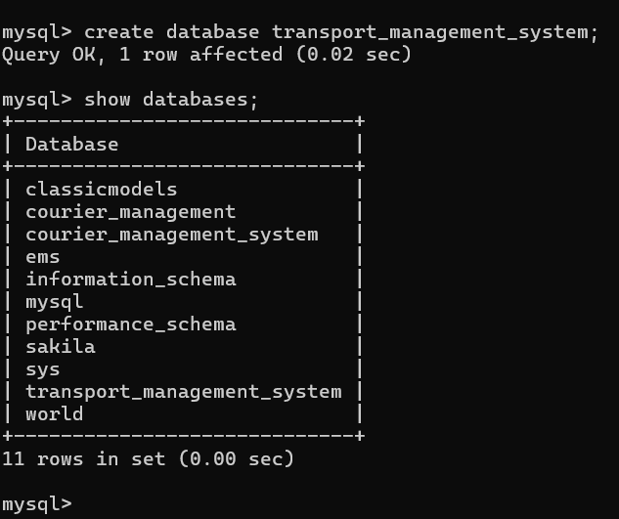

CREATE TABLE Vehicles (VehicleID INT AUTO_INCREMENT PRIMARY KEY, Model VARCHAR(255) NOT NULL, Capacity DECIMAL(10, 2) NOT NULL, Type VARCHAR(50) NOT NULL, Status VARCHAR(50) NOT NULL);

CREATE TABLE Routes (RouteID INT AUTO_INCREMENT PRIMARY KEY, StartDestination VARCHAR(255) NOT NULL, EndDestination VARCHAR(255) NOT NULL, Distance DECIMAL(10, 2) NOT NULL);

CREATE TABLE Trips (TripID INT AUTO_INCREMENT PRIMARY KEY, VehicleID INT, RouteID INT, DepartureDate DATETIME NOT NULL, ArrivalDate DATETIME NOT NULL, Status VARCHAR(50) NOT NULL, TripType VARCHAR(50) DEFAULT 'Freight', MaxPassengers INT, FOREIGN KEY (VehicleID) REFERENCES Vehicles(VehicleID), FOREIGN KEY (RouteID) REFERENCES Routes(RouteID));

CREATE TABLE Passengers (PassengerID INT AUTO_INCREMENT PRIMARY KEY, FirstName VARCHAR(255) NOT NULL, Gender VARCHAR(255) NOT NULL, Age INT NOT NULL, Email VARCHAR(255) UNIQUE NOT NULL, PhoneNumber VARCHAR(50) NOT NULL);

CREATE TABLE Bookings (BookingID INT AUTO_INCREMENT PRIMARY KEY, TripID INT, PassengerID INT, BookingDate DATETIME NOT NULL, Status VARCHAR(50) NOT NULL, FOREIGN KEY (TripID) REFERENCES Trips(TripID), FOREIGN KEY (PassengerID) REFERENCES Passengers(PassengerID));

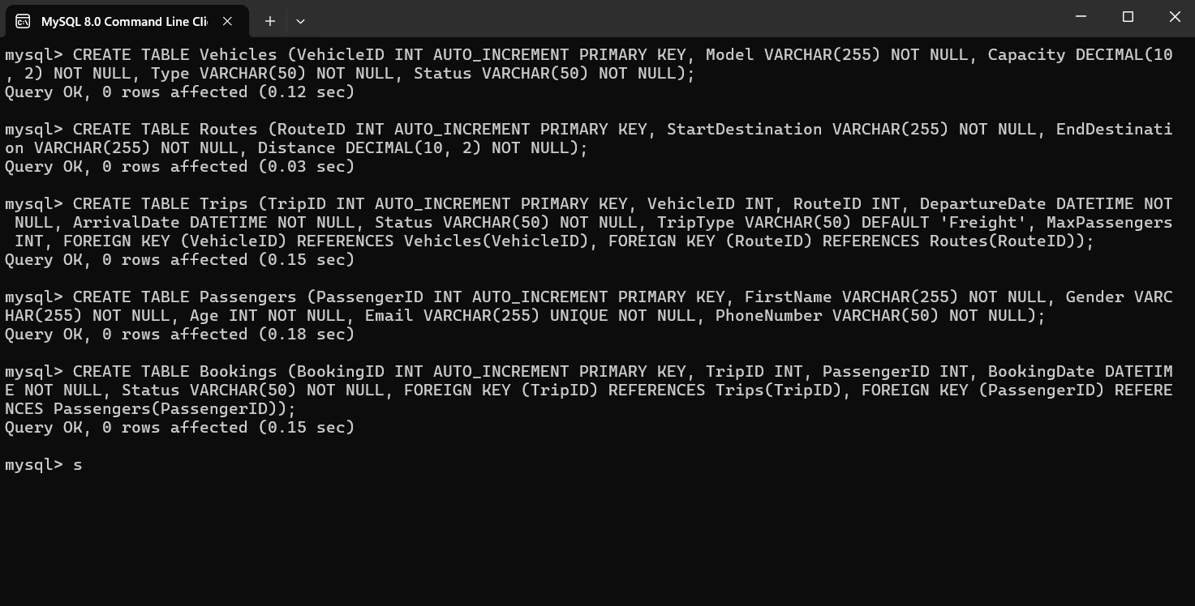

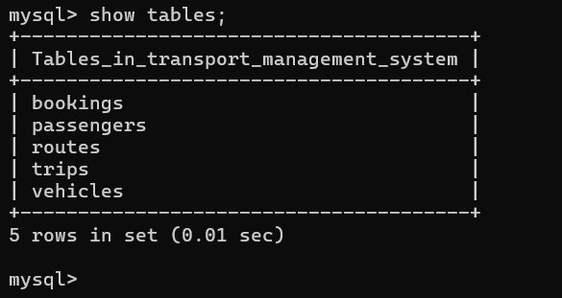

INSERT INTO Vehicles (Model, Capacity, Type, Status) VALUES ('Tata Ace', 1.00, 'Truck', 'Available'), ('Mahindra Bolero', 7.00, 'Van', 'On Trip'), ('Ashok Leyland 16', 16.00, 'Bus', 'Available'), ('Force Traveller', 12.00, 'Van', 'Maintenance'), ('Isuzu D-Max', 2.00, 'Truck', 'Available');

INSERT INTO Routes (StartDestination, EndDestination, Distance) VALUES ('Delhi', 'Mumbai', 1447.00), ('Bengaluru', 'Chennai', 348.00), ('Hyderabad', 'Pune', 590.00), ('Kolkata', 'Bhopal', 820.00), ('Jaipur', 'Ahmedabad', 650.00);

INSERT INTO Trips (VehicleID, RouteID, DepartureDate, ArrivalDate, Status, TripType, MaxPassengers) VALUES (1, 1, '2024-10-01 08:00:00', '2024-10-02 08:00:00', 'Scheduled', 'Freight', 0), (2, 2, '2024-10-03 09:00:00', '2024-10-03 20:00:00', 'In Progress', 'Passenger', 7), (3, 3, '2024-10-04 10:00:00', '2024-10-04 15:00:00', 'Scheduled', 'Passenger', 12), (4, 4, '2024-10-05 11:00:00', '2024-10-05 17:00:00', 'Completed', 'Passenger', 12), (5, 5, '2024-10-06 07:30:00', '2024-10-06 12:00:00', 'Cancelled', 'Freight', 0);

INSERT INTO Passengers (FirstName, Gender, Age, Email, PhoneNumber) VALUES ('Rahul Sharma', 'Male', 30, 'rahul.sharma@example.com', '9876543210'), ('Priya Gupta', 'Female', 28, 'priya.gupta@example.com', '9876543211'), ('Anita Verma', 'Female', 35, 'anita.verma@example.com', '9876543212'), ('Vikram Singh', 'Male', 40, 'vikram.singh@example.com', '9876543213'), ('Neha Rani', 'Female', 22, 'neha.rani@example.com', '9876543214');

INSERT INTO Bookings (TripID, PassengerID, BookingDate, Status) VALUES (1, 1, '2024-09-25 10:00:00', 'Confirmed'), (2, 2, '2024-09-26 11:00:00', 'Confirmed'), (3, 3, '2024-09-27 12:00:00', 'Cancelled'), (4, 4, '2024-09-28 09:30:00', 'Completed'), (5, 5, '2024-09-29 14:45:00', 'Confirmed');

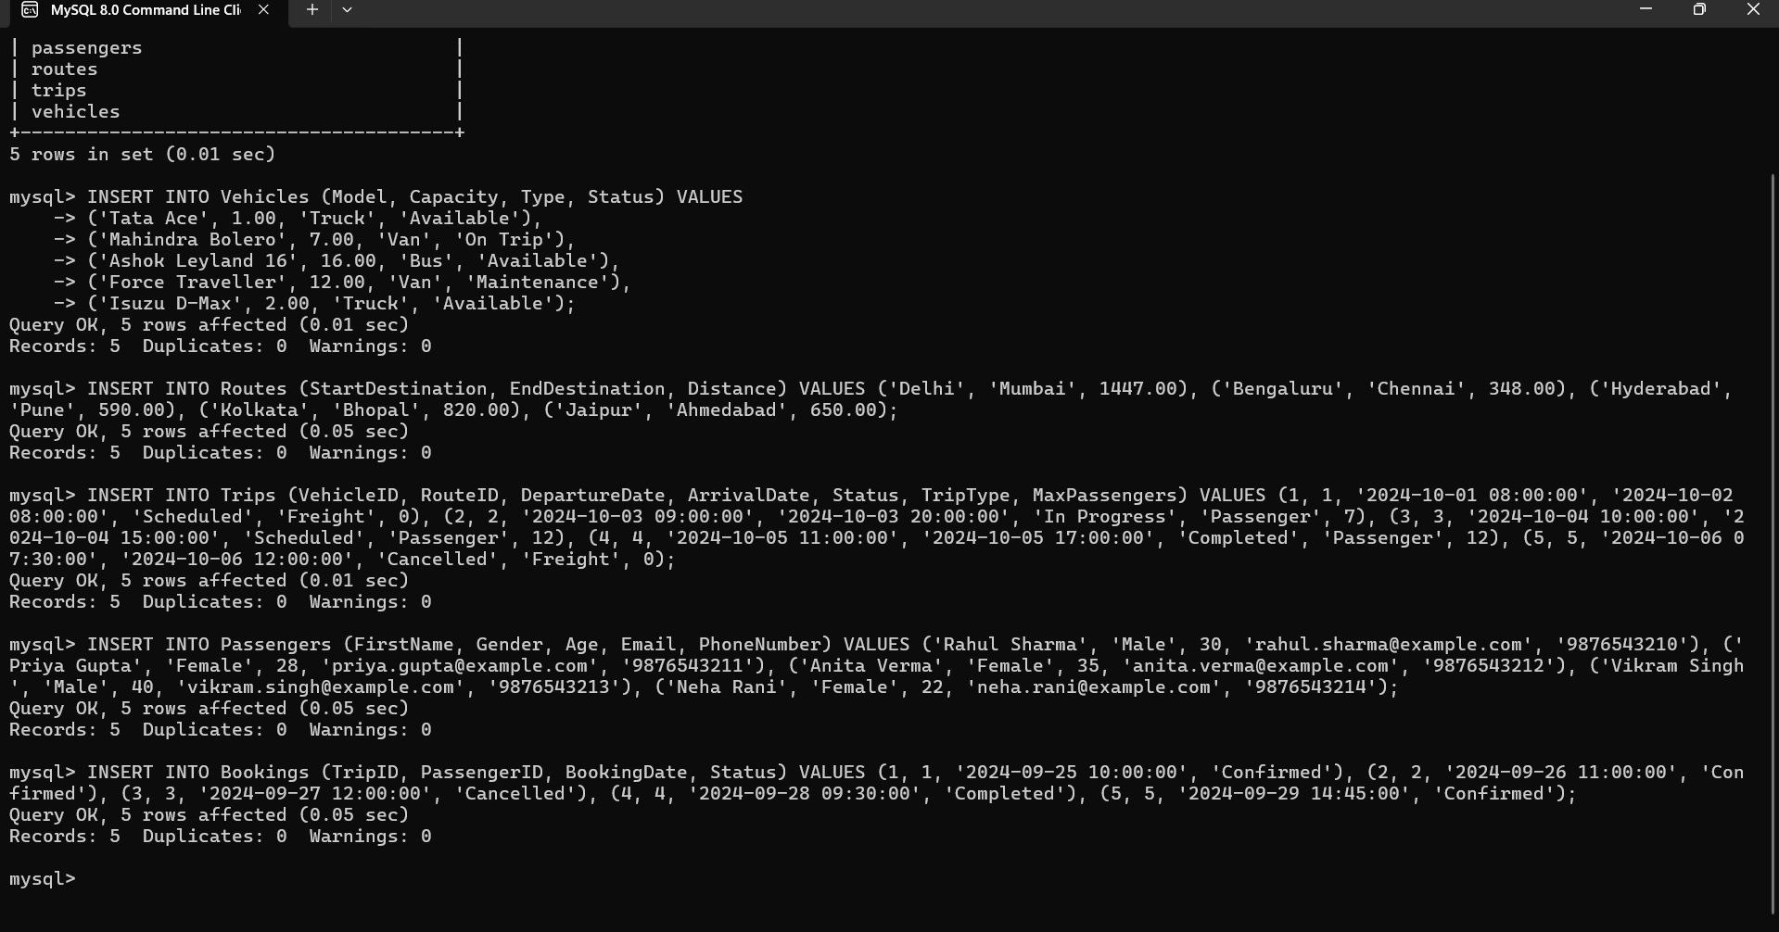

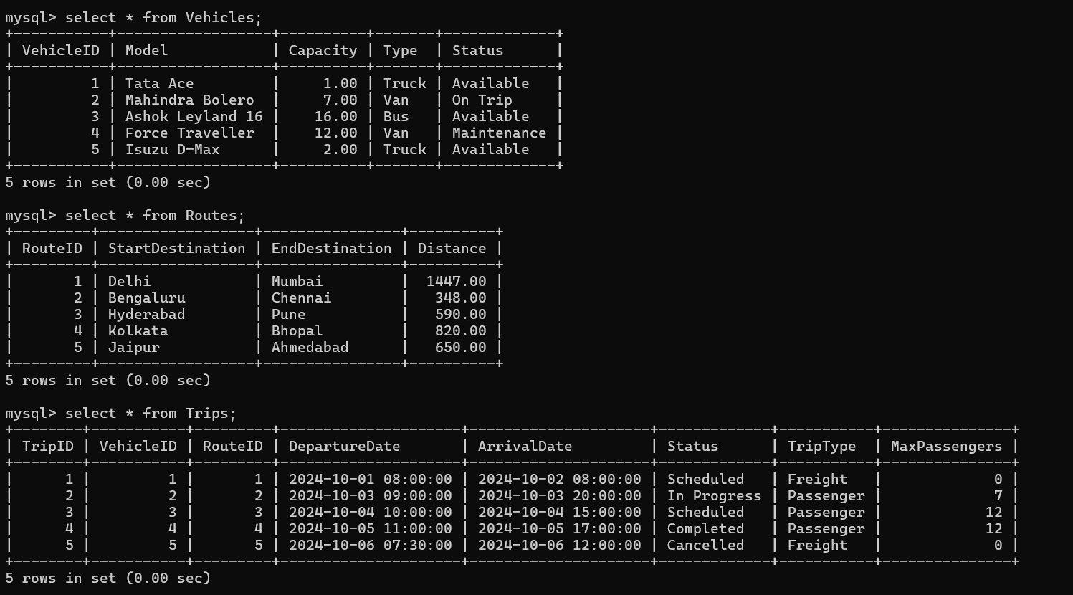

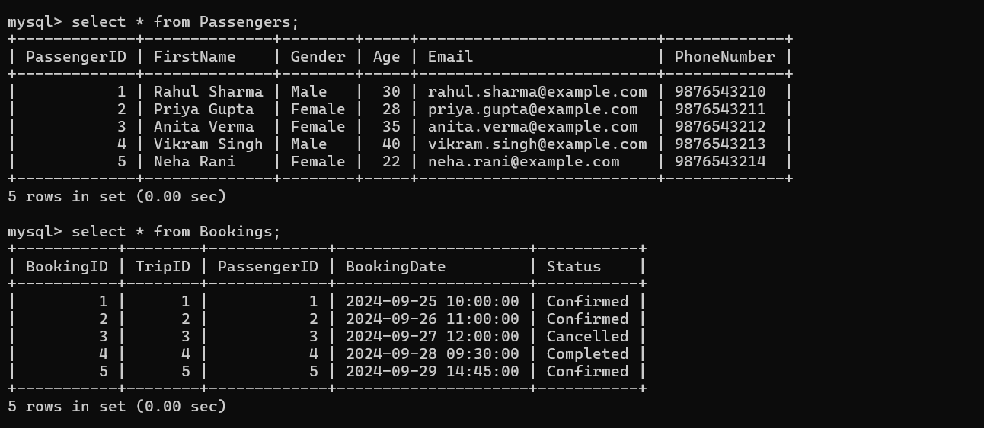

ER-Diagram

