AIR Quality ANALYSIS REPORT

Devanshu Tayal

Table of Contents

Problem Statement 2

WHO? KNOW YOUR AUDIENCE 3

WHAT ARE YOU TRYING TO COMMUNICATE? 4

The BIG IDEA 4

HOW? 4

Dataset: 4

Chart 1: Overall AQI Spread 5

Chart 2: Citywise AQI Trend 6

Chart 3: Citywise Major Pollutant Level 7

Dashboard 8

# Problem Statement

The air quality index (AQI) is an index for reporting air quality on a daily basis. It is a measure of how air pollution affects one's health within a short time period. The purpose of the AQI is to help people know how the local air quality impacts their health. The pollutants monitored are Sulphur Dioxide (SO2), Nitrogen Dioxide (NO2), Particulate Matter (PM10 and PM2.5), Carbon Monoxide (CO), Ozone(O3) etc.

**Central Pollution Control Board**is executing a nation-wide programme of ambient air quality monitoring known as National Air Quality Monitoring Programme (NAMP) and you are part of the project. As part of the programme, below data has been collected.

Source: This data has been published on Open Government Data platform India by the Ministry of Environment, Forest and Climate change, and is updated periodically.

You have been tasked to perform an analysis of the data and present the results to the **Chairman of** **CPCB**. With the given context, you need to create a dashboard using TABLEAU. (Use the concepts learned in the class).

# WHO? KNOW YOUR AUDIENCE

**List the primary groups or individuals to whom you’ll be communicating.**

* CPCB

**If you had to narrow that to a single person, who would that be?**

* CPCB CHAIRMAN

**What does your audience care about?**

* Our audience care about the air quality level of the city and what measures can be taken to improve the air quality.

**What action does your audience need to take?**

* Approve budget to increase green initiative projects to bring the AQI levels into control. There are different cities where AQI levels are in Poor, Very Poor and Severe states. Green projects need to be implemented based on the type of pollutant levels across these cities, in order to ensure AQI levels are brought under control.

**What is at stake? What is the benefit if the audience acts in the way you want them to?**

* Clean breathing matters to health. If we air quality is not improved then we would have both environmental and impact to health for the population, due to the bad air quality specified in these regions. If the Chairman is able to understand the impact, we can have the projects implemented to maintain the AQI levels, same as during the lockdown situation.

**What are the risks if they don’t?**

* If we air quality is not improved then the AQI levels would deteriorate to pre covid time and major population could be subjected to chronic respiratory diseases such as obstructive pulmonary disease (COPD), Asthma, Lung Cancer.

# WHAT ARE YOU TRYING TO COMMUNICATE?

**We are trying to get answers to these 3 questions:**

* Q1: How are all the cities performing w.r.t AQI levels across the country.
* Q2: How have the AQI levels performed during COVID time in comparison to a previous time period for a given city.
* Q3: What were the pollutant level / composition that were driving the AQI levels for a given city in this time period

# The BIG IDEA

We need budget approvals for execution of the mentioned green projects, that will help retain or better the AQI levels across the cities, as its evident from the comparison that there is a steady decline of AQI levels across all cities where lockdown were initiated, otherwise the AQI levels would reverse to the previous states and a large number of populations would end up with chronic respiratory disease, lung cancer and other disease.

# HOW?

## Dataset:

The following datasets have been used as part of this analysis:

1. Daily_Stationwise_Data.csv
2. Daily_Citywise_Data.csv
3. Stations_Data.csv

## Chart 1: Overall AQI Spread

**What type of viz did you create?**

We have used **maps** to display the AQI levels across cities using the Daily Station wise data and showcased the average AQI level at a country level.

**Why did you select the viz that you did?**

This is to give a good overview to the audience in terms of which are the cities where the AQI levels are good vs bad, that they would need to focus upon.

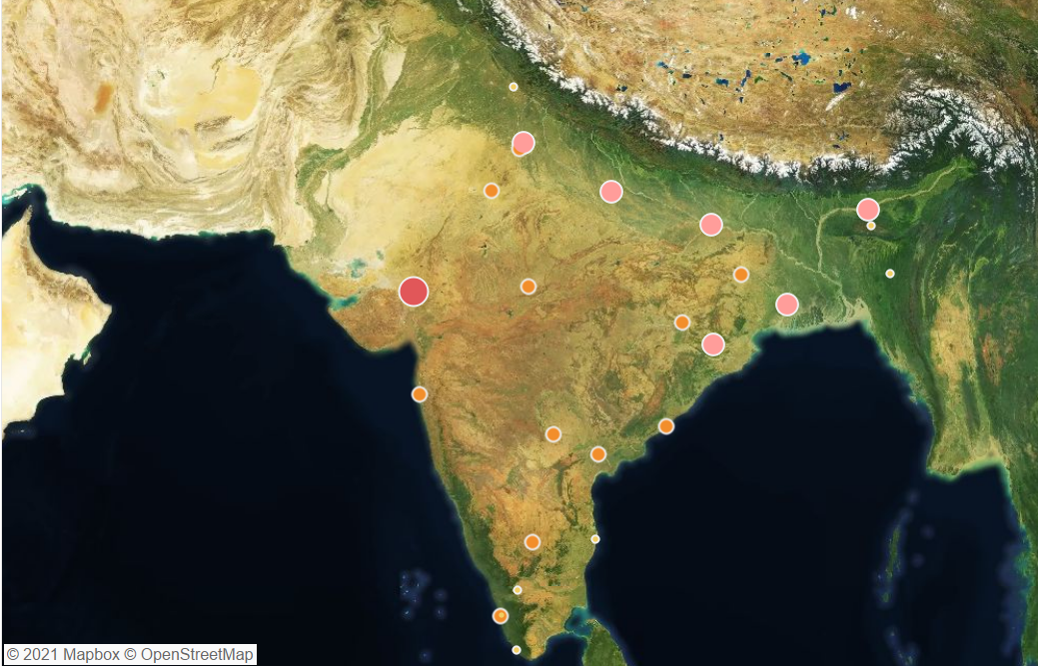

**Gestalt principles employed:**

1. Gestalt law of similarity to showcase the similar cities having the same AQI levels.
2. Gestalt law of proximity based on the labels displayed for each of the city. This is highlighted as part of selection of any given city.
3. Figure and Ground to showcase the level of AQI based on the size of the bubble.

**How you strategically used pre-attentive attributes to draw the audience's attention**

We have used the size and colour for the chairman to focus on the problem areas. For example – Ahmedabad falls into unhealthy zone – represented by the colour, and the size of the bubble indicates the AQI levels.

## Chart 2: City wise AQI Trend

**What type of viz did you create?**

We have created a **line chart** to show the trend between the AQI levels, for a given city.

**Why did you select the viz that you did?**

To showcase the trend of average AQI levels, post pandemic and pre pandemic.

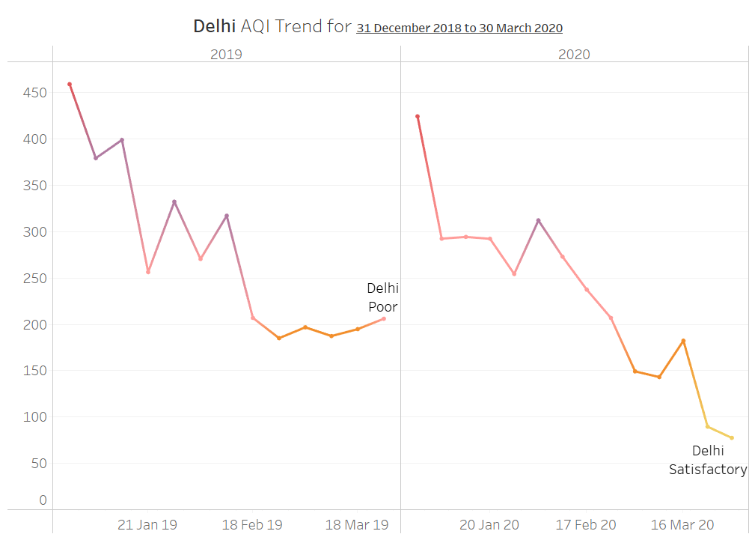

**Gestalt principles employed:**

1. Gestalt Law of Similarity – To showcase based on colour of the trend line
2. Gestalt Law of Proximity – Displaying the city against the trend line.
3. Gestalt Law of Continuity – This is to showcase the trends across years / quarters

**How you strategically used pre-attentive attributes to draw the audience's attention**

Based on the AQI levels – the colours in the trend line changes to indicate the severity levels.

## Chart 3: City wise Major Pollutant Level

**What type of viz did you create?**

We have created a **side-by-side bar chart** to indicate the different pollutant compositions.

**Why did you select the viz that you did?**

To showcase which pollutant levels were causing the AQI levels to move towards the Poor, Very Poor and Severe categories, and compare between the post pandemic period.

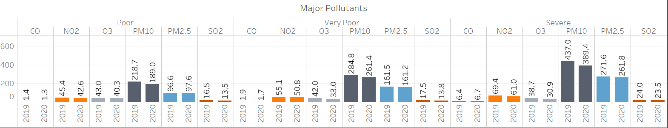

**Gestalt principles employed:**

1. Gestalt Law of Similarity – To showcase based on colour for each of the pollutants
2. Gestalt Law of Continuity – To showcase the pollutants across AQI bucket
3. Gestalt Law of Proximity – To signify the values of pollutants.

**How you strategically used pre-attentive attributes to draw the audience's attention**

Length of the bars to showcase the dip or increase in pollutant levels. Position of the values across years to help with comparison.

# Dashboard

