DS Lab 5 – Map-Reduce Programming using Python
-By Devanshu Singh

Sample Questions:-

Q1)
Mapper
import sys
# input comes from STDIN (standard input)
for line in sys.stdin:
# remove leading and trailing whitespace
line = line.strip()
# split the line into words
words = line.split()
# increase counters
for word in words:
# write the results to STDOUT (standard output);
# what we output here will be the input for the
# Reduce step, i.e. the input for reducer.py #
# tab-delimited; the trivial word count is 1
print("%s\t\t%s" %(word, 1))

Reducer
from operator import itemgetter
import sys
current_word = None
current_count = 0
word = None
# input comes from STDIN
for line in sys.stdin:
# remove leading and trailing whitespace
line = line.strip()
# parse the input we got from mapper.py
word, count = line.split('\t', 1)
# convert count (currently a string) to int
try:
count = int(count)
except ValueError:
# count was not a number, so silently
# ignore/discard this line
continue
# this IF-switch only works because Hadoop sorts map output
# by key (here: word) before it is passed to the reducer
if current_word == word:
current_count += count
else:
if current_word:
# write result to STDOUTprint('%s\t%s' % (current_word, current_count) )
current_count = count
current_word = word
# do not forget to output the last word if needed!
if current_word == word:
print('%s\t%s' % (current_word, current_count))

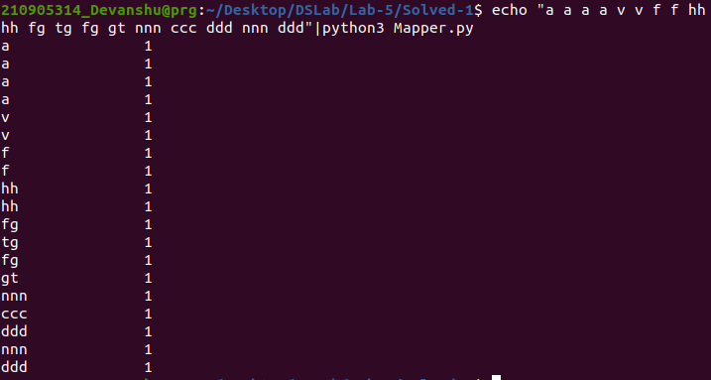
Q2)
Mapper

Reducer

Q3)
Mapper

Reducer

