LAB – 2
PYTHON BASIC PRACTICE - II
11-1-24
-Devanshu Singh

Q1.) Write a program to demonstrate while loop with else.

counter = 0
while counter < 3:
print("Inside loop")
counter = counter + 1
else:
print("Inside else")

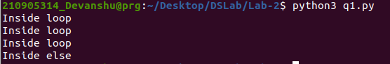

Q2.) Write a program to print negative Numbers in a List using while loop.

list1 = [-10, 21, -4, -45, -66, 93]
num = 0
# using while loop
while(num < len(list1)):
# checking condition
if list1[num] < 0:
print(list1[num], end = " ")
# increment num
num += 1

Q3.) Define a dictionary containing Students data {Name, Height, Qualification}.
a) Convert the dictionary into DataFrame
b) Declare a list that is to be converted into a new column (Address}
c) Using 'Address' as the column name and equate it to the list and display the result.

import pandas as pd
data = {'Name': ['Devanshu', 'Gauri', 'Mangla'],
'Height': [181, 155, 182],
'Qualification': ['BTech', 'BTech', 'BTech']}
df = pd.DataFrame.from_dict(data)
addr_list = ['Ahmedabad', 'Bareilly', 'Balabgarh']
df['Address'] = addr_list
print(df.head())

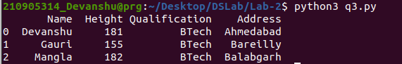

Q4.) Define a dictionary containing Students data {Name, Height, Qualification}.
a) Convert the dictionary into DataFrame
b) Use DataFrame.insert() to add a column and display the result.

import pandas as pd
data = {'Name': ['Devanshu', 'Gauri', 'Mangla'],
'Height': [181, 180, 179],
'Qualification': ['BTech', 'MS', 'PhD']}
# Convert the dictionary into DataFrame
df = pd.DataFrame(data)
# Using DataFrame.insert() to add a column
df.insert(2, "Age", [21, 23, 24], True)
print(df)

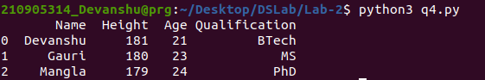

Q5.)a) Create two data frames df1 and df2. df1 contains one column ‘Name’ and df2 contains 4 columns ‘Maths’, ‘Physics’, ‘Chemistry’ and ‘Biology’ .
b) Concatenate two data frames df1 and df2. Now insert one column ‘Total’ to the new data frame df_new and find the sum of all marks.

import pandas as pd
df1_data = {'Name' : ['Ram','Diya','Chandan','James','Alice']}
df2_data = {'Maths':[80.0,90.0,77.5,87.5,86.5], 'Physics' : [81.0,94.0,74.5,83.0,82.5],'Chemistry' : [91.5,86.5,85.5,90.0,91.0],'Biology':[82.5,83.5,84.5,85.0,93.0]}
df1 = pd.DataFrame(df1_data)
df2 = pd.DataFrame(df2_data)
print(df1)
print()
print(df2)
print()
df_combined = pd.concat([df1,df2],axis=1)
print(df_combined)
print()
df_combined['Total'] = df_combined.loc[0:4, ['Maths','Physics','Chemistry','Biology']].sum(axis=1)
print(df_combined)

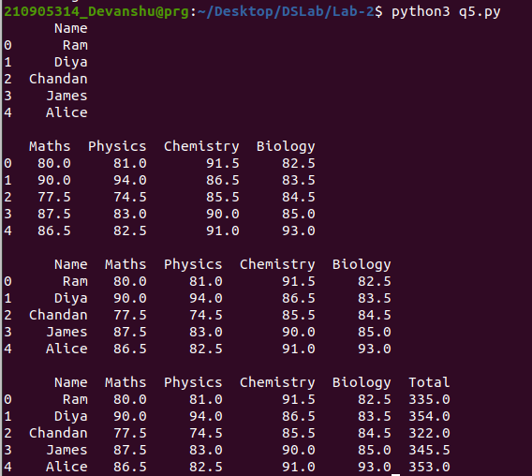

Q6.)Create a data frame with column- Name, Quiz_1 /10, In-Sem_1 /15, Quiz_2 /10 and
In-Sem_2 /15. Now insert a column Total and find the total and mean as given in the bellow table.

import pandas as pd
df_data = {
'Name':['Annie','Diya','Charles','James','Emily'],
'Quiz_1/10':[8.0,9.0,7.5,8.5,6.5],
'In-sem_1/15':[11.0,14.0,14.5,13.0,12.5],
'Quiz_2/10':[9.5,6.5,8.5,9.0,9.0],
'Insem_2/15':[12.5,13.5,14.5,15.0,13.0]
}
df = pd.DataFrame(df_data)
print(df)
print()
df['Total'] = df.loc[0:4, ['Quiz_1/10','In-sem_1/15','Quiz_2/10','Insem_2/15']].sum(axis=1)
print(df)
df_mean = df.select_dtypes(include=['float64', 'int64']).mean()
df_mean.name = 'Mean'
df_new = pd.concat([df, df_mean.to_frame().T])
print(df_new)

