LAB – 3
PYTHON BASIC PRACTICE - II
25-1-24
-Devanshu Singh
1. Write a program to find the factors of a given number (get input from user) using for loop.

def print_factors(n): # function to generate the factors.
for i in range (1, n+1):
if n % i == 0:
print(i)
number = int(input("Enter a number : "))
print("The factors for {} are : ".format(number))
print_factors(number)

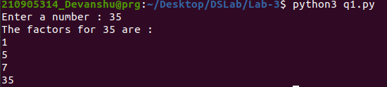

2. Find the sum of columns and rows using axis.

import numpy as np
import pandas as pd
df = pd.DataFrame(np.array([[33, 25, 55], [90, 53, 86], [67, 48, 29]]))
#df = pd.DataFrame(np.array([[1, 2, 3], [4, 5, 6], [7, 8, 9]]))
print(df)
a = df.sum(axis = 0) #axis = 0 represents column
b = df.sum(axis = 1) #axis = 0 represents column
print("The column sum is :")
print(a)
print("The row sum is :")
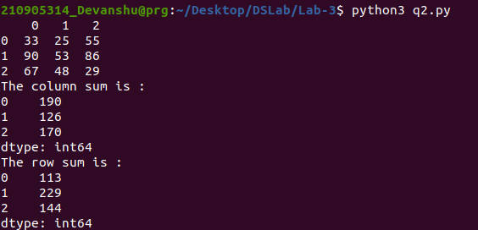
print(b)
3. Operations on Arrays (use numpy wherever required):
a) Create array from list with type float
b) Create array from tuple
c) Creating a 3X4 array with all zeros
d) Create a sequence of integers from 0 to 20 with steps of 5
e) Reshape 3X4 array to 2X2X3 array
f) Find maximum and minimum element of array, Row wise max and min, column wise max
and min and sum of elements. (Use functions max(), min(), sum())

import numpy as np
# a)
list = [76.33 , 58.449 , 354.3781 , 1000.0]
a = np.array(list)
print(a , end = "\n\n")
# b)
tuple = (43, 276, 35, 544)
a = np.array(tuple)
print(a , end = "\n\n")
# c)
a = np.zeros((3, 4))
print(a , end = "\n\n")
# d)
a = np.arange(0, 20, 5)
print(a , end = "\n\n")
# e)
a = np.arange(12).reshape((3, 4))
print(a , end = "\n")
a = np.reshape(a , (2, 2, 3))
print(a , end = "\n\n")
a = np.arange(9.0).reshape((3, 3))
# f)
print("Full array Max = " , a.max() , " Min = " , a.min() , " Sum = " , a.sum())
print("Rowwise array Max = " , a.max(axis = 1) , " Min = " , a.min(axis = 1) , " Sum= " , a.sum(axis = 1))
print("Rowwise array Max = " , a.max(axis = 0) , " Min = " , a.min(axis = 0) , " Sum= " , a.sum(axis = 0))
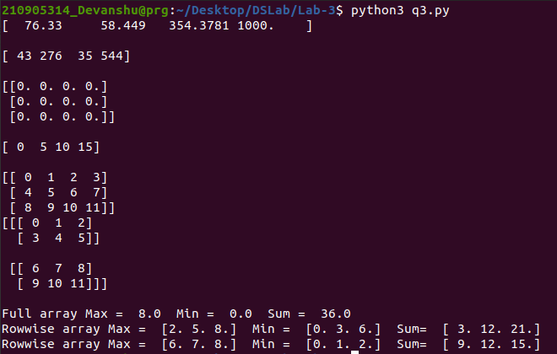

4. Write a program to transpose a given matrix.

X = [[100, 200],
[300, 400],
[500, 600]]
result = [[0,0,0],
[0,0,0]]
print("Before Transpose: ")
print(X)
print()
print("After Transpose : ")
for i in range(len(X)):
for j in range(len(X[0])):
result[j][i] = X[i][j]
for r in result:
print(result)

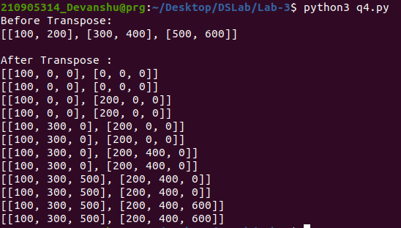

5. Write a program to add two matrices.

X = [[234,53,923],
[45, 432, 545],
[35, 724, 924]]
Y = [[540,814,121],
[68,247,453],
[435,365,925]]
result = [[0,0,0],
[0,0,0],
[0,0,0]]
for i in range(len(X)):
for j in range(len(X[0])):
result[i][j] = X[i][j] + Y[i][j]
for r in result:
print(r)

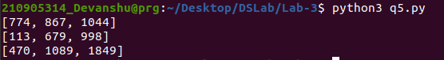

6. Write a program to find element wise product between two matrices.
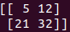
import numpy as np
a = np.matrix([[1,2], [3,4]])
b = np.matrix([[5,6], [7,8]])
result = np.array(a) * np.array(b)
print(result)

