DS8003 Project Report

Group Members
Devanshu Prajapati (SID: 501389606)
Nishi Patel (SID:501356244)
Avikumar Patel (SID: 501376903)

- Project Definition
Cancer research involves analyzing various cancer types and understanding how they relate to patients’ demographic background, cancer stages, preventive measures and possible treatment options. However, cancer is more complex disease with various types such as lung, breast, skin, bladder, and many more. Due to this, it becomes challenging for researchers and healthcare professionals to clearly identify patterns, classify its type and determine the most effective strategies. The complexity of cancer data can lead to difficulties to identify which cancer type cause the most cases and death, understand how cancer spread across tissues, uncover critical insights hidden in large datasets, and design the effective prevention strategies due to various cancer behavior and patients’ background.

- Data Description
The dataset used in this project is from Kaggle (Cancer database) (Sujay Kapadnis). It is in CSV file format and of 470.16 KB, containing 1453 records and 96 attributes that are related to cancer types, cancer centers, geographic information, classification systems and cancer incidence statistics.
It also integrates cancer taxonomy (OncoTree), geographical distribution, affected tissues, and U.S. cancer incidence data, making it suitable for pattern analysis and visualization across multiple cancer types.
- Attributes Description:
- title – Name of the cancer type or cancer center (e.g., Breast Cancer, Lung Cancer).
- type – Specifies whether the entry represents a cancer type or a cancer center.
- mainType – Broad category or classification of the cancer (e.g., Breast Cancer).
- oncoTreeId / parentOncoTreeId – Hierarchical identifiers used for cancer taxonomy in the OncoTree system.
- country, city – Geographic location of the cancer center.
- uscsCasesPerYear – Estimated annual cancer cases (U.S. Cancer Statistics).
- uscsDeathsPerYear – Estimated annual cancer deaths (U.S. Cancer Statistics).

- Statistics of the data:

- Work Distribution
All team members collaboratively designed the full data pipeline, interpreted insights and reviewed overall outputs together. Individually, Nishi Patel has helped in setting up NiFi, HDFS, HIVE and Spark environment. Also, she performed major data cleaning, merging and metric calculations. The major visualization part was done by her using Tableau and Power BI. Secondly, Devanshu Prajapati helped in building NiFi data flows and managed HDFS file. Along with this, he executed hive queries and created initial summary outputs and help in design charts and in analyzing findings and insights. Lastly, Avikumar Patel helped in assigning Hive tables, data validation and Pig Scripting. He also generated statistical summaries and helped to prepare dashboard visuals.

- Solution Description
This project is distributed into 6 phases. Starting from, Data Cleaning and preprocessing, Exploratory Data Analysis (EDA), Feature Engineering, Insights Generation and Evaluation and Visualization.
- Tools Used:
- Apache NiFi
- HDFS (Hadoop Distributed File System)
- Spark
- Pig
- Hive
- Tableau
- Power BI

- How they were Used:
- NiFi: Automatically ingested raw cancer datasets from various sources and transferred them to HDFS.
- HDFS: Provided distributed storage for both raw and cleaned datasets, enabling scalable and fault-tolerant data management.
- Hive: Performed data cleaning, transformation, and preprocessing using SQL-like queries for structured analysis.
- Pig & Spark: Conducted exploratory data analysis (EDA) to summarize key trends, generate statistics, and identify patterns in the datasets.
- Tableau & Power BI: Created interactive visualizations, dashboards, and heatmaps to communicate insights effectively.

- Why they were chosen for the problem space:
- NiFi: Simplifies the ingestion of large datasets from multiple sources with minimal manual intervention.
- HDFS: Handles large volumes of structured and unstructured data reliably in a distributed environment.
- Hive: Facilitates SQL-based preprocessing, which is familiar and efficient for data cleaning.
- Pig: Useful for procedural data transformations and batch processing of large datasets.
- Spark: Provides fast, in-memory computation for EDA and handling large-scale data efficiently.
- Tableau & Power BI: Allow easy creation of intuitive, interactive dashboards, supporting decision-making for medical professionals and researchers.

- Code snippets

- Insights
There is total 7 Insights that we have generated from the dataset.

- Top Cancer types by Annual Cases:

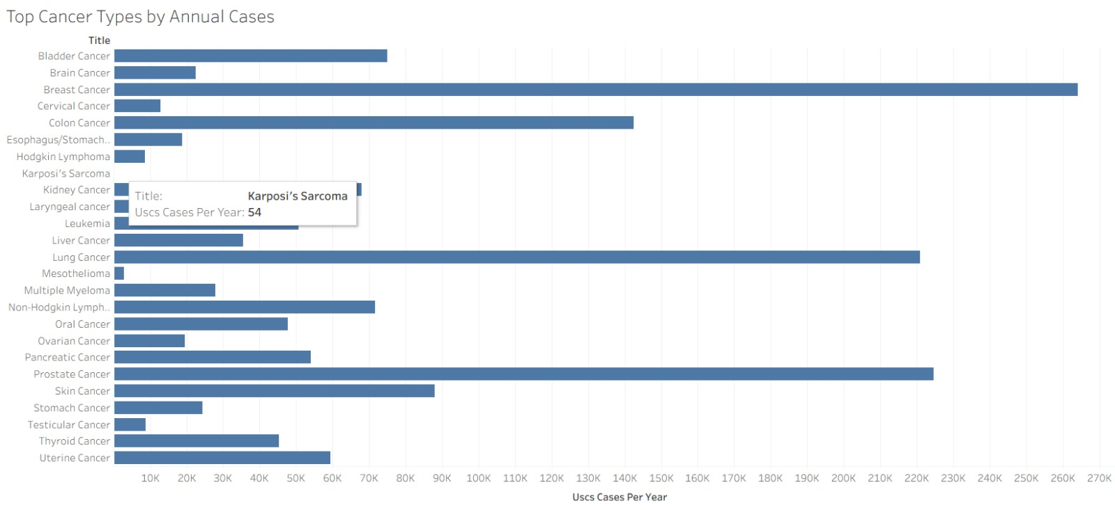
Here in this insight breast, lung, prostate, and colorectal cancers make up more than half of all annually reported cancer cases in the United States, making them the most significant contributors to overall cancer incidence. While a high number of cases does not always translate to higher mortality, it does indicate a substantial impact on public health systems. These cancers require large-scale screening programs, strong awareness campaigns, and considerable healthcare resources to ensure timely diagnosis and treatment.
Their dominance in national incidence highlights the critical need for targeted prevention and early detection strategies. By identifying these highly prevalent cancer types, governments and healthcare organizations can invest more effectively in early screening programs—such as mammography for breast cancer, colonoscopies for colorectal cancer, and low-dose CT scans for lung cancer. Focusing resources on these areas allows for earlier intervention, improved outcomes, and a more efficient allocation of medical and public health efforts.

- Highest-Volume Cancers
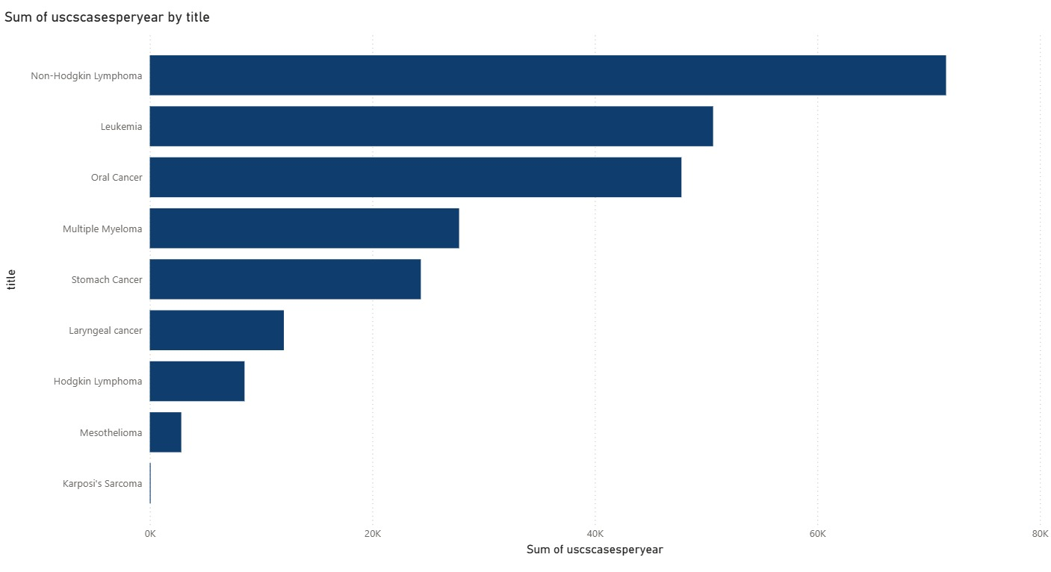
Non-Hodgkin Lymphoma emerges as one of the most common cancers in the dataset, with approximately 72,000 cases recorded annually. It is followed closely by Leukemia and Oral Cancer, which report around 51,000 and 48,000 cases per year respectively. These cancers collectively represent a major portion of the national cancer burden and highlight areas where healthcare systems must focus substantial attention.
The high incidence of these cancers indicates a strong demand for medical resources, including diagnostic facilities, oncology specialists, and long-term treatment infrastructure. It also emphasizes the importance of early screening and diagnostic programs, particularly for Non-Hodgkin Lymphoma and Leukemia, where early detection significantly improves treatment outcomes.
Additionally, understanding the incidence levels of these cancers helps hospitals, public health agencies, and research institutions better allocate funding, workforce, and clinical resources. By aligning resource distribution with actual patient volumes, healthcare organizations can improve service delivery, prioritize research efforts, and enhance overall patient outcomes.
This insight highlights which cancers impact the largest patient population, helping
prioritize screening, treatment resources, and research funding.

- Top 10 Deadliest Cancers
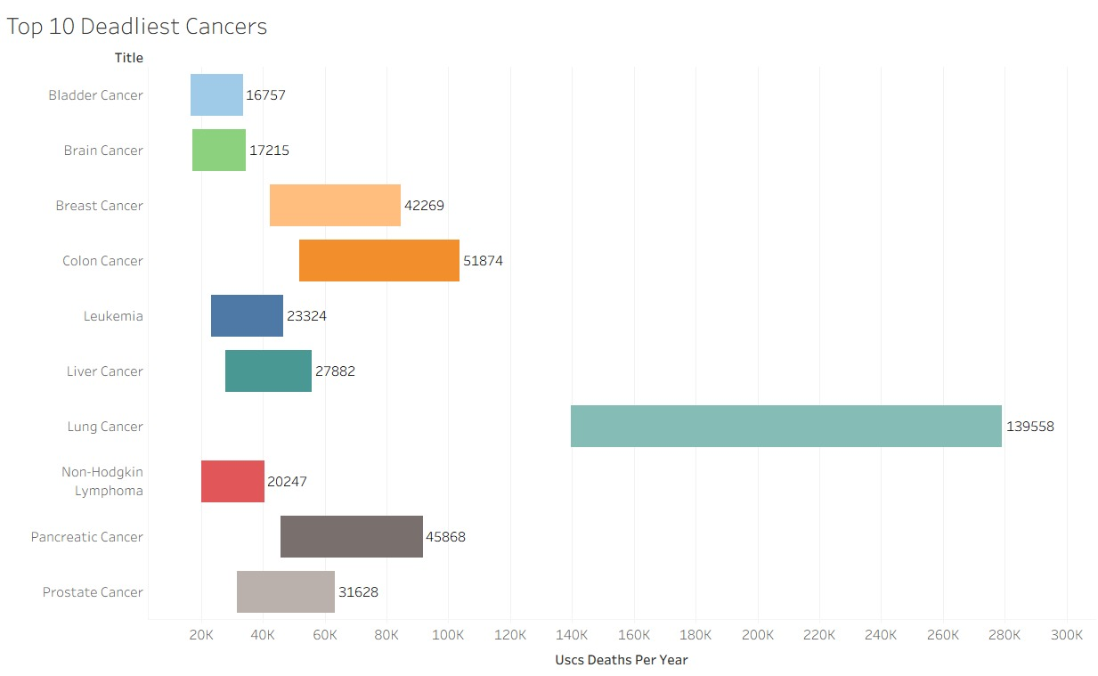
Lung cancer accounts for the highest number of cancer-related deaths each year, with approximately 140,000 fatalities, placing it significantly above all other cancer types. Although it is not always the most commonly diagnosed cancer, its exceptionally high mortality rate is largely due to late detection, as many patients are diagnosed at advanced stages when treatment options are limited.
Other cancers, including colorectal, breast, pancreatic, and liver cancers, also show substantial mortality levels. These cancers tend to be aggressive and often progress with minimal or non-specific symptoms, making early detection challenging. Consequently, they contribute heavily to overall cancer mortality.
Understanding which cancers result in the highest number of deaths is crucial for guiding public health priorities. This insight underscores the importance of promoting early screening, increasing public awareness of symptoms, and ensuring timely access to treatment. Targeted interventions in these high-mortality cancer types can significantly reduce the overall burden of cancer-related deaths.

- Mortality Share by Cancer Types
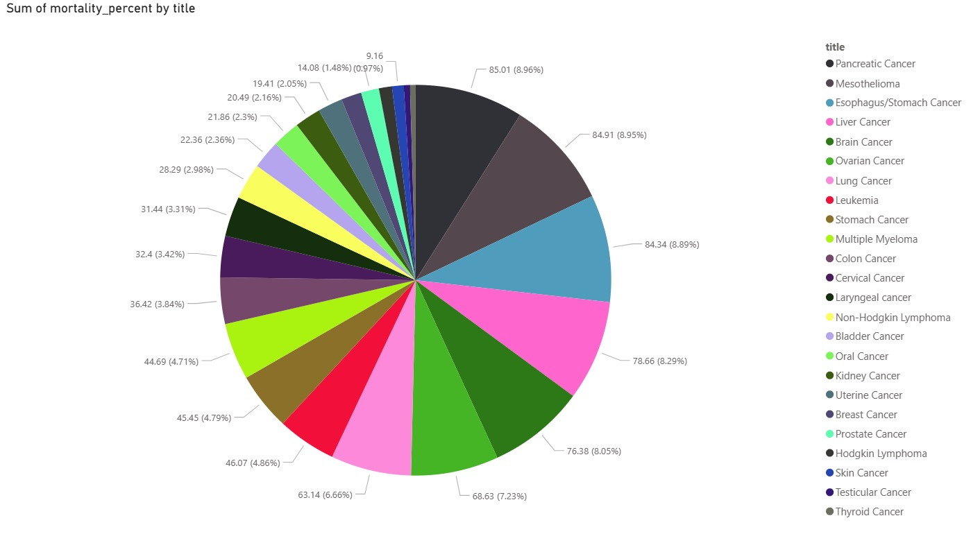
This section examines cancer from the perspective of mortality rates, highlighting not just the number of diagnosed cases but also the likelihood of survival. Mortality percentage is calculated as the ratio of annual deaths to total diagnosed cases.
The analysis shows that certain cancers, though less common, exhibit high mortality rates, indicating poor survival outcomes.
- Pancreatic cancer: Despite having fewer cases than lung or breast cancer, it has an extremely high mortality percentage.
- Mesothelioma: Cases are limited, but treatment options are few, resulting in poor outcomes.
- Liver and stomach cancers: Frequently diagnosed at later stages, contributing to higher mortality.
This approach emphasizes cancers that are the most difficult to survive and provides insights for prioritizing awareness, screening, and treatment resources.

- City-wise Cancer Centers & Geographic Distribution of Centers
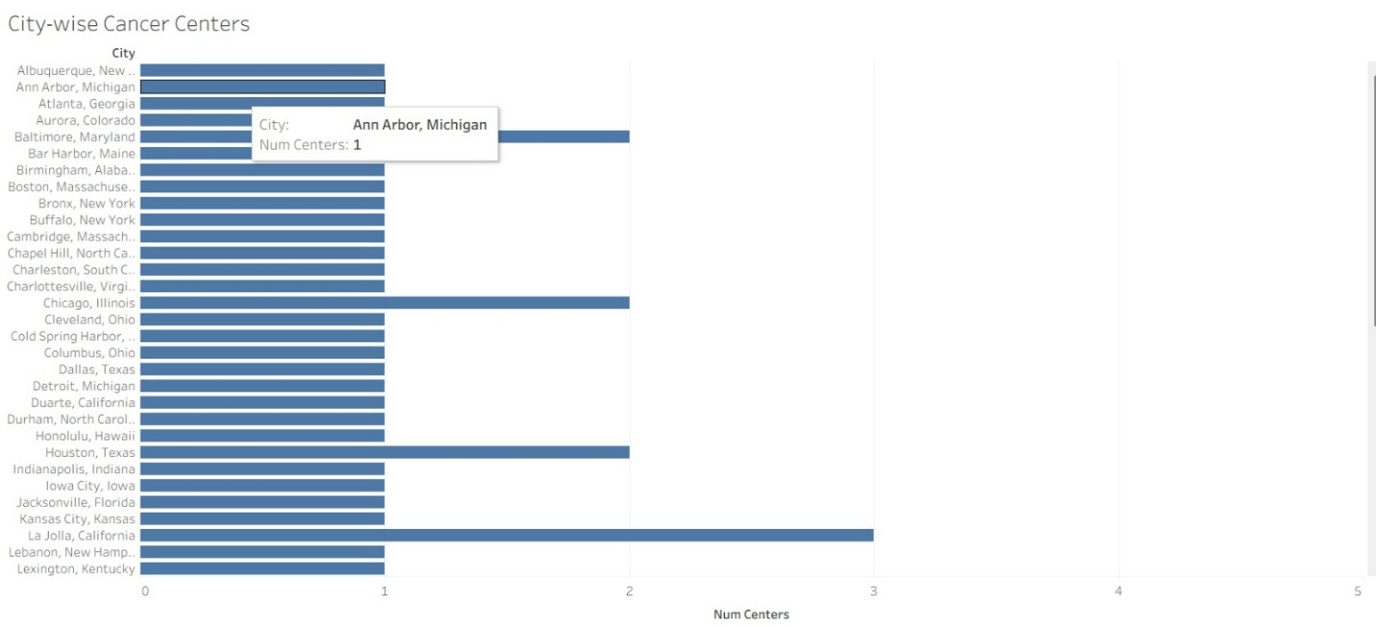
Here it presents, the distribution of NCI-designated cancer centers across different cities. Most cities host only one or two centers, which is the typical scenario.

- Certain cities, such as La Jolla, Houston, and Chicago, have multiple centers, making them major hubs for advanced cancer treatment, research, and clinical innovation.
- These cities provide more options for patients and attract researchers, specialists, and funding, contributing to the overall improvement in quality of care.

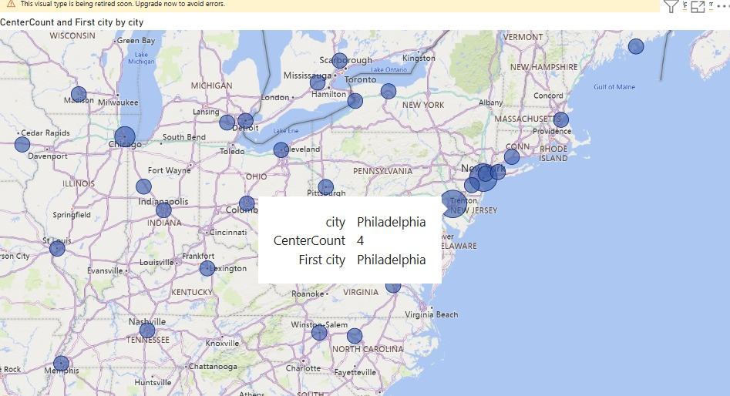

Mapping NCI-designated cancer centers across the country reveals a distinct spatial pattern. Most centers are concentrated along the East Coast, West Coast, and major metropolitan regions. In contrast, central and rural areas often have few or no specialized centers. This uneven distribution results in better and faster access to treatment for patients in large cities, while patients in rural regions may face delays in diagnosis and reduced opportunities for early detection.
Additionally, patients from remote areas frequently need to travel long distances for treatment, increasing physical, financial, and emotional burdens and potentially affecting the continuity of therapy.
These findings are critical for healthcare planners and policymakers, highlighting the need to expand cancer care infrastructure in underserved regions to ensure more equitable access to life-saving treatment.

- Cases vs Deaths Comparison
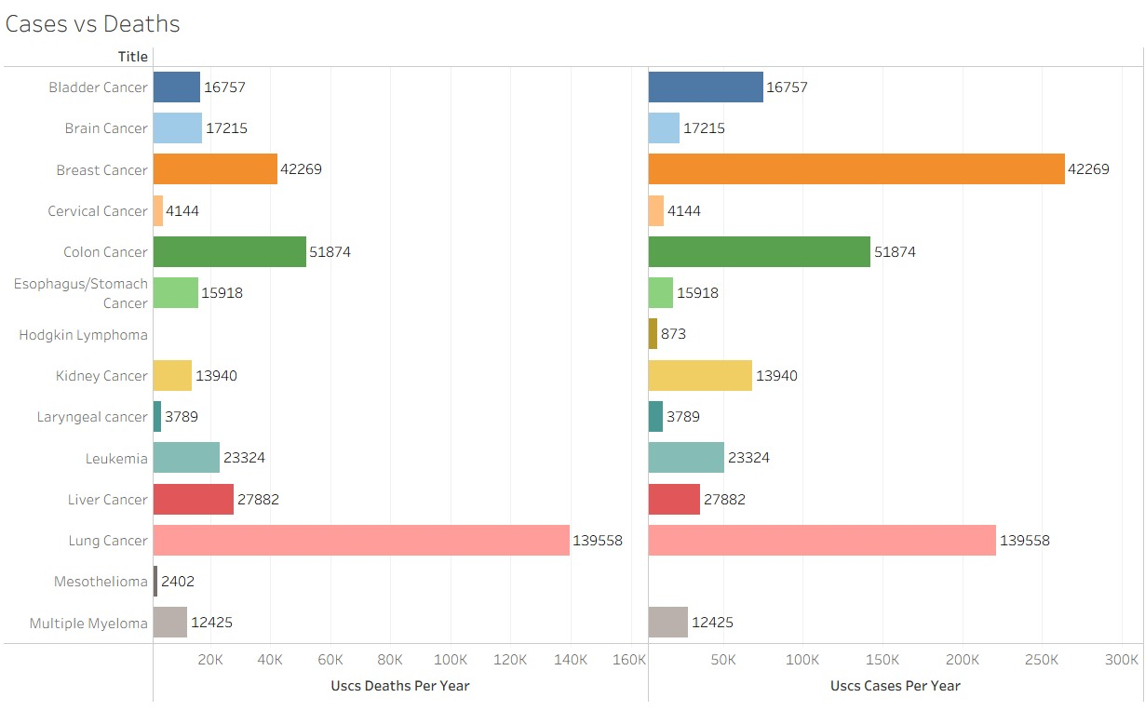
This visualization compares the number of diagnosed cases for each cancer with the corresponding number of deaths, highlighting both prevalence and lethality.
- Lung Cancer: Approximately 230,000 cases and 140,000 deaths, making it the deadliest major cancer.
- Colon Cancer: Around 150,000 cases and 55,000 deaths, reflecting high incidence and significant mortality.
- Breast Cancer: Very high cases (~260,000) but relatively lower deaths (~42,000), indicating effective treatment and early detection.
- Leukemia and Multiple Myeloma: Moderate number of cases but high death ratios, demonstrating poor survival outcomes.
- Thyroid, Skin, and Testicular Cancers: Low mortality despite cases, reflecting better survival rates.
This side-by-side comparison allows for easy identification of cancers that are both common and deadly, providing important insights for resource allocation and policymaking.

- Mortality Heatmap by Tissue
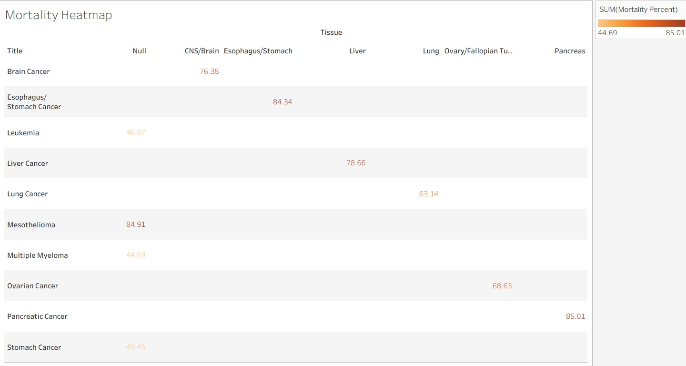
This heatmap links each cancer type to its corresponding tissue of origin and displays the mortality percentage.
- Tissues such as pancreas, liver, and gastrointestinal tract exhibit high mortality, indicated by darker colors.
- Tissues such as skin, thyroid, and breast show lighter colors, reflecting better survival rates.
This visualization highlights:
- Body systems associated with the most dangerous cancers
- Areas requiring improved diagnostic tools
- Regions where early detection can significantly improve survival
By analyzing cancer from a tissue-based perspective, it becomes easier to identify where the most aggressive cancers are concentrated and to prioritize research and healthcare interventions.

- Future Work
To further enhance the insights and impact of this project, the following things can be explored:
- Incorporate Patient Demographics and Risk Factors: Extend the dataset to include age, gender, lifestyle, and genetic predispositions to identify high-risk populations and enable targeted prevention strategies.
- Predictive Modeling for Early Detection: Develop machine learning models to predict cancer risk and survival outcomes, aiding in early intervention and personalized treatment planning.
- Optimize Healthcare Access: Use geospatial analysis to identify underserved regions and plan the expansion of cancer care infrastructure to ensure equitable access.
- Integrate Genomic and Clinical Data: Combine genomic and clinical trial data with existing datasets to uncover molecular markers and improve precision medicine approaches.

- References
- Sujay Kapadnis. Cancer Database.
Available at: https://www.kaggle.com/datasets/sujaykapadnis/cancer-database

