**What is version management?**

For example you are creating some design say UI design for your app or any website,, say that when designing the 1st time , We choose background color of screen purple and foreground in white we applied those changes to interface . Now after some break, I think nah I would be nicer if background in yellow and foreground in black, okay now removing the last interface we come up with this new interface , but when you discussed with your team mates they suggested the 1st one was a better option now , you can’t go back to that previous version .

Same way while working in software industries we undergoes many file version and keeping their track and control is called version management or version control .

Version management solve the problem like

**Multiple files Approach (**Creating multiple file and handling them separately**)**

**Single File Approach (**Creating a single file which contain all versions in it **)**

**Version management solves this by ->>** Inthis approach , though you have single file or you can say the latest codebase But you don’t loose any previous version all thanks to these management platform such as GitHub or GitLab .

**Git is all about Control* & tracking of code changes over time**

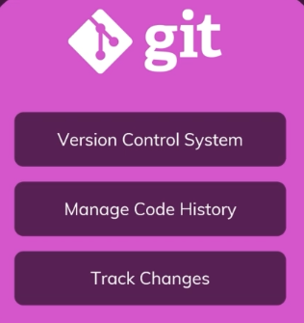So in nutshell Git helps in

Git has one disadvantages , Git is a local tool means git installed in my computer and system so only I can use those files and all locally , not from anywhere else remotely .

So Git is not useful in this type of scenarios ,, To overcome this **GitHub** comes in play .

**So what is GitHub?**

[On the website of GitHub](https://github.com/)  they stated it is the largest development platform , means developer all around the world use the GitHub for daily work from Development to collaboration , how this all is possible , It is due to its another Characteristic which is cloud hosting and collaboration provider. , which means where git is local , github makes code available in cloud in purpose to control and collaborate among developers . So in nutshell **GitHub is Git Repository** (git managed projects)**hosting provider .**

**So how we can make most out of this?**

By using Local capabilities of Git like code management , Tracking changes with capabilities of GitHub - To collaborate with others in cloud hosted environment and accessing code base anywhere We can make most out of both to do **Version control .**