Practical 9
Aim: Parser for ''FOR'' loop statements.
Theory: A parser is a program that checks whether a given input string follows the rules of a specific grammar. It is an essential part of a compiler, responsible for verifying the syntactic structure of the source code after lexical analysis. In this practical, we create a parser to recognize and validate FOR loop statements using LEX and YACC.
The lexical analyzer scans the input program and converts sequences of characters into tokens. Tokens represent meaningful units such as keywords (for), operators (=, ;), identifiers (variable names), and numbers.
LEX Code Role:
- Identifies and returns tokens like FOR, LPAREN, RPAREN, LBRACE, RBRACE, SEMICOLON, ASSIGN, IDENTIFIER, and NUMBER.
- Ignores whitespace.
- Prints an error message for invalid characters.
Thus, LEX acts as the scanner for the parser.
The parser generated by YACC takes the tokens from LEX and checks if they follow the grammar rules of a valid FOR loop. YACC is based on context-free grammar (CFG), which defines how tokens can be combined.
YACC Code Role:
- Defines grammar rules for a FOR loop of the form:
for(initialization; condition; update) {
body
}
- Uses productions like:
  - initialization → IDENTIFIER ASSIGN NUMBER
  - condition → IDENTIFIER
  - update → IDENTIFIER
  - body → /* empty */
- If the input matches the grammar, it prints "Valid FOR loop structure"; otherwise, it reports an error.
Code & Output:
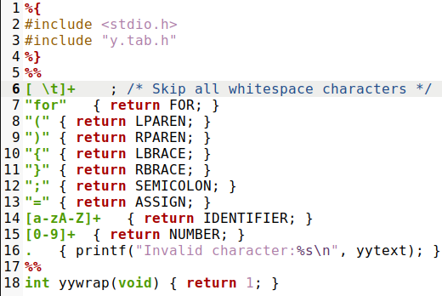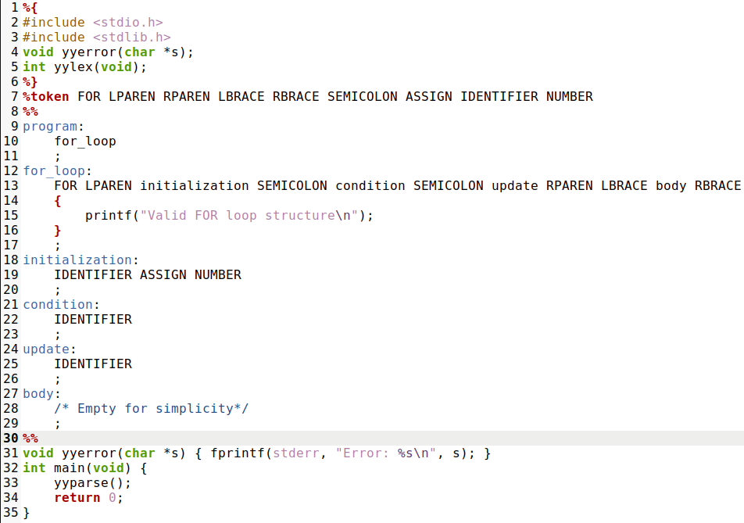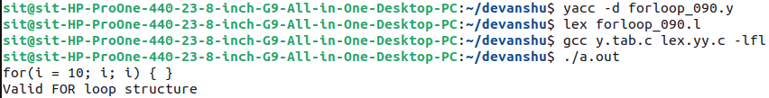
Conclusion: This practical demonstrates how to construct a parser for FOR loop statements using LEX and YACC. LEX performs lexical analysis by recognizing tokens, while YACC performs syntax analysis by applying grammar rules. Together, they validate the correctness of loop constructs in a structured and automated manner, forming the basis of real-world compilers.

