Practical 7
Aim: Postfix Expression Evaluation.
Theory:
- Postfix Expressions
- A postfix expression (also called Reverse Polish Notation, RPN) is a form of writing arithmetic expressions where operators follow their operands.
- Unlike infix expressions (e.g., A + B), postfix does not require parentheses or operator precedence rules, because the order of operations is explicitly defined.
Example:
- Infix: 3 + 4 * 5
- Postfix: 3 4 5 * +
Evaluation Rule:
- Scan the postfix expression from left to right.
- If the element is an operand → push it onto the stack.
- If the element is an operator → pop two operands from the stack, apply the operator, and push the result back onto the stack.
- After the entire expression is processed, the value at the top of the stack is the final result.
- Need for Postfix Evaluation
- Postfix eliminates ambiguity in operator precedence and associativity.
- It is easier for compilers and interpreters to evaluate expressions in postfix form using a stack-based approach.
- Many compilers internally convert infix expressions into postfix before evaluation.
- Role of LEX and YACC
- LEX (Lexical Analyzer):
  - Responsible for tokenizing the input string into meaningful tokens (numbers, operators, newline).
  - Converts sequences of digits into integers (token NUMBER).
  - Identifies operators +, -, *, /, and newline (\n).
- YACC (Yet Another Compiler Compiler):
  - Works as a parser and handles the grammar of postfix expressions.
  - Uses semantic actions (C code inside {}) to perform stack operations.
  - Defines how tokens (from LEX) are combined into valid expressions and evaluated.
- Working of the Program
- Input: The user enters a postfix expression, e.g.: 3 4 + 5 *
- Lexical Analysis (LEX):
- Splits input into tokens: 3, 4, +, 5, *.
- Numbers are returned as NUMBER with integer values in yylval.
- Operators are returned as their ASCII characters.
- Parsing and Evaluation (YACC):
- YACC grammar rules define how expressions are formed.
- Each NUMBER is pushed onto a stack.
- Each operator pops two operands from the stack, performs the operation, and pushes back the result.
- After processing the entire line (when \n is encountered), the result is printed.
- Stack Mechanism: Example: Expression → 3 4 + 5 *
Push(3) → Stack: [3]
Push(4) → Stack: [3, 4]
Operator +: Pop(4,3), Compute 3+4=7, Push(7) → Stack: [7]
Push(5) → Stack: [7, 5]
Operator *: Pop(5,7), Compute 7*5=35, Push(35) → Stack: [35]
Final result: 35
- Advantages of Using LEX and YACC
- Automation: LEX and YACC automatically generate lexical analyzers and parsers from rules.
- Error Handling: Simple error messages can be integrated for cases like division by zero or insufficient operands.
- Scalability: More operators (e.g., ^, %) or functionalities can be added easily.
- Practical Use: Provides a real-world compiler design approach where LEX handles tokens and YACC manages grammar + semantics.
Code & Output:
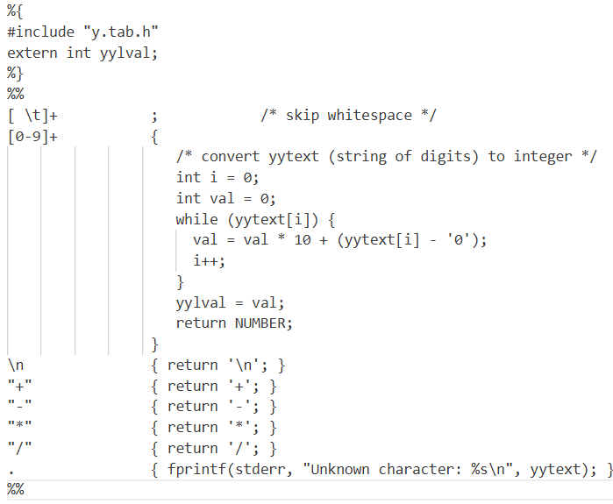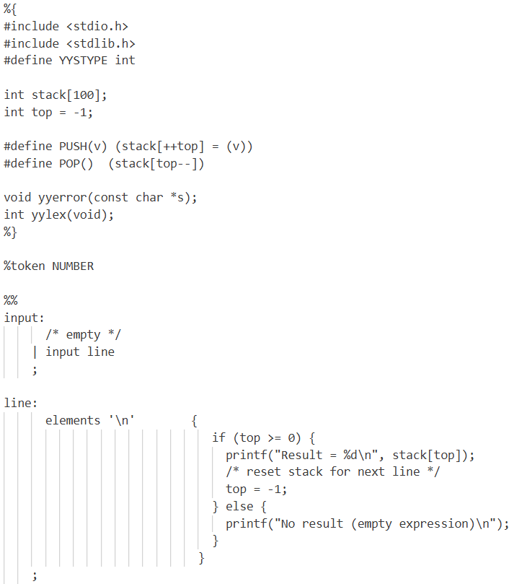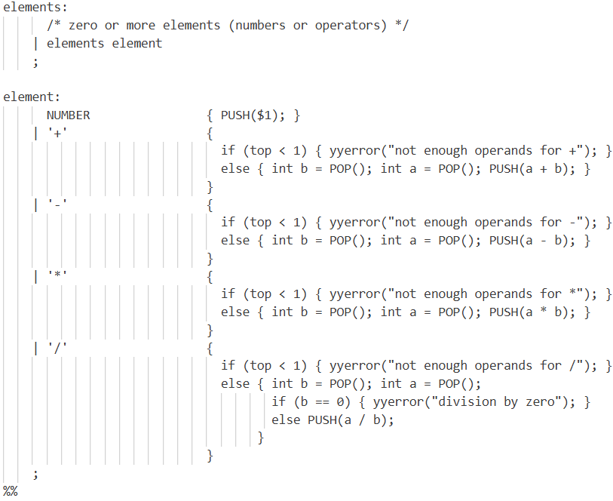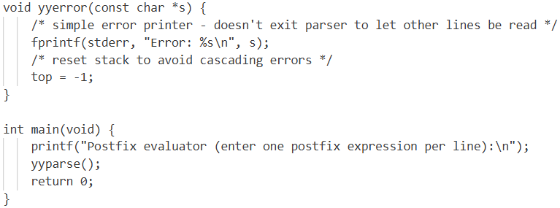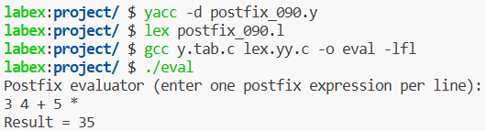
Conclusion: Postfix expression evaluation is an efficient and unambiguous method of expression computation. Using LEX and YACC, we can automatically build a scanner and parser that evaluate postfix expressions by using a stack mechanism. This practical demonstrates how compiler design concepts (lexical analysis, parsing, semantic actions) are applied to solve real problems like expression evaluation.

