Practical 10
Aim: Intermediate code (IC) generator for arithmetic expression.
Theory: In the process of compilation, the compiler converts a high-level source code into an equivalent low-level representation step by step. One of the most crucial stages is Intermediate Code Generation (ICG).
The Intermediate Code is a representation of the source code that lies between the high-level language and the machine code. It is independent of both the source and the target machine, making the compiler more portable and modular.
The Intermediate Code Generation (ICG) phase of a compiler translates a parsed source program into a machine-independent representation, which lies between the source code and the final machine code. This phase simplifies code optimization and target code generation.
This intermediate representation is used for optimization and final code generation. For arithmetic expressions, intermediate code is often represented in three-address code (TAC) form.
Intermediate Code for Arithmetic Expressions: Arithmetic expressions like “a + b * c – d” are decomposed into smaller operations using temporary variables. Each step corresponds to a single operation, forming Three Address Code (TAC), e.g.:
t0 = b * c
t1 = a + t0
t2 = t1 - d
Final Result in t2
Here, t0, t1, and t2 are temporary variables generated by the compiler during parsing.
Role of LEX: LEX performs tokenization, it reads the expression character by character and classifies them into tokens such as: Identifiers, Numbers, Operators and Parentheses. These tokens are then passed to YACC for syntax analysis.
Role of YACC: YACC defines grammar rules for arithmetic expressions and generates intermediate code during parsing. For each production rule like:
expr: expr PLUS expr
YACC creates a new temporary variable and prints a corresponding TAC line:
t0 = expr1 + expr2
This is achieved using a helper function such as newTemp() to dynamically create temporary variable names (t0, t1, t2, ...).
Code & Output:
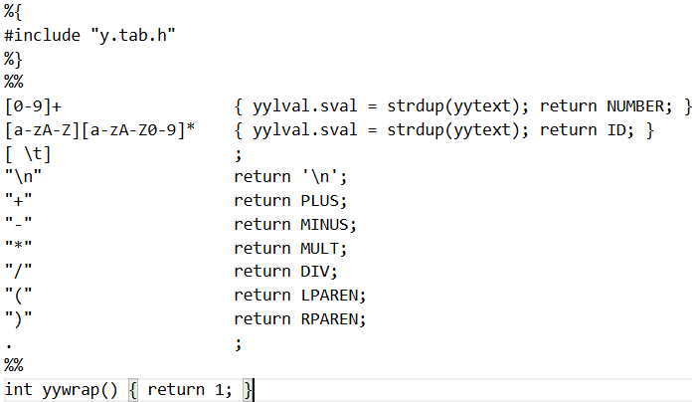
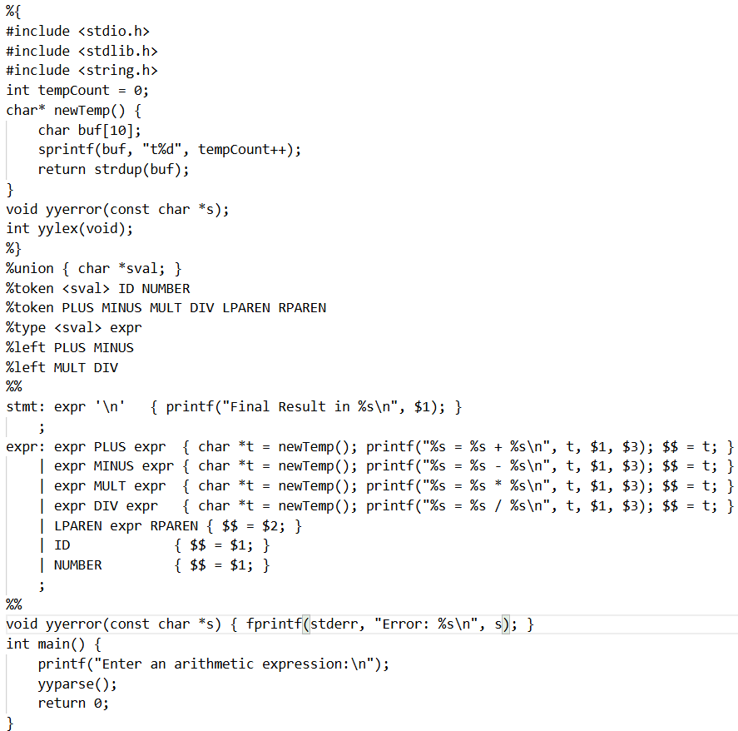
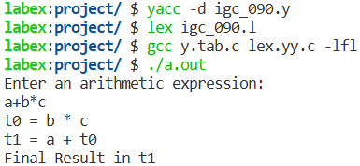
Conclusion: The program successfully generates intermediate code (three-address code) for arithmetic expressions using LEX and YACC. It demonstrates how the compiler converts high-level arithmetic expressions into an intermediate machine-independent form, which serves as a bridge for further optimization and target code generation.

