Practical 8
Aim: Desk calculator with error recovery
Theory: In compiler construction, parsers play a critical role in analysing the syntax of a given input based on grammar rules. Sometimes, the input may contain errors, and without proper handling, the parser may terminate abruptly. To ensure smooth execution, error recovery mechanisms are introduced. This practical demonstrates the use of LEX and YACC to build a simple desk calculator that can evaluate arithmetic expressions and handle errors gracefully.
Components:
- LEX Program (Lexical Analyzer):
- The LEX program is responsible for scanning the input and dividing it into meaningful tokens such as numbers, operators (+, -, *, /), and special characters like newline (\n).
- The lexical analyzer passes these tokens to the YACC parser.
- For example, a sequence like 25 + 10 will be tokenized into:
  - NUMBER (25)
  - PLUS (+)
  - NUMBER (10)
- YACC Program (Syntax Analyzer):
- The YACC program defines grammar rules to parse arithmetic expressions using the tokens provided by LEX.
- Operator precedence is defined using associativity rules (%left PLUS MINUS, %left MULT DIVIDE).
- Semantic actions are specified to compute the result of expressions (addition, subtraction, multiplication, division).
- Error handling is included using the error token and yyerrok for recovery, ensuring the parser continues processing after encountering invalid input.
- Error Recovery:
- If an invalid expression is encountered, instead of stopping execution, the parser reports an error message and continues with the next expression.
- Division by zero is also explicitly checked to prevent runtime errors.
Code & Output:
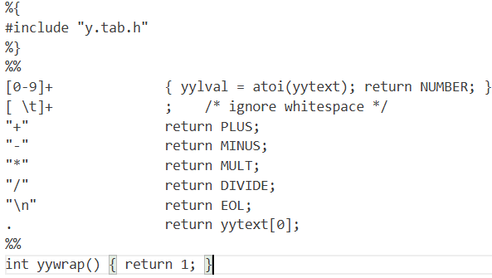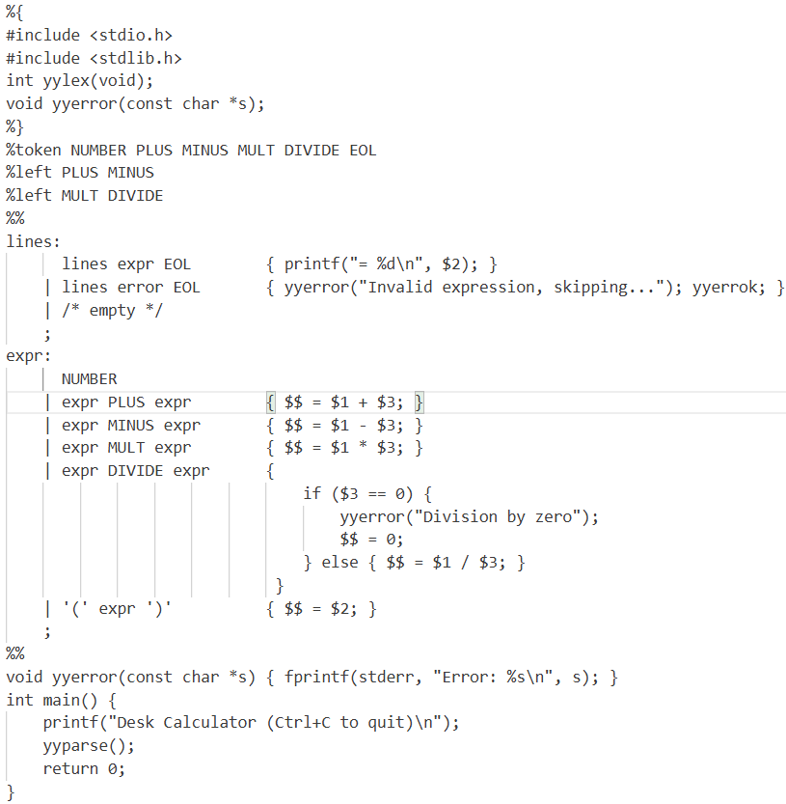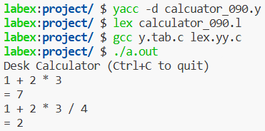
Conclusion: This practical successfully implements a Desk Calculator with Error Recovery using LEX and YACC. The calculator evaluates arithmetic expressions, respects operator precedence, and manages both syntactic and semantic errors effectively. It highlights the importance of error handling in compilers, ensuring robust and user-friendly systems.

