**Practical 6**

**Aim:** Test lines ending with ''com''.

**Theory:** In this practical, we aim to detect whether a given input line ends with the string "com". This can be useful in applications such as:

* Detecting domain extensions like .com in URLs.
* Pattern validation in data processing.
* Filtering specific text formats.

**Working of program:**

* .* → Matches zero or more occurrences of any character.
* com → Matches the exact string "com".
* $ → Anchors the match to the end of the line.

This ensures that only lines that end with "com" (and not those having "com" in the middle) are matched. If the input line matches this pattern, the program prints a message stating that the line ends with "com".

**Key Observations:**

* The $ symbol in regex is crucial for restricting the match to the end of the line.
* Without $, any line containing "com" anywhere would match.
* The .* ensures that any preceding characters (including none) are allowed.

**Code & Output:**

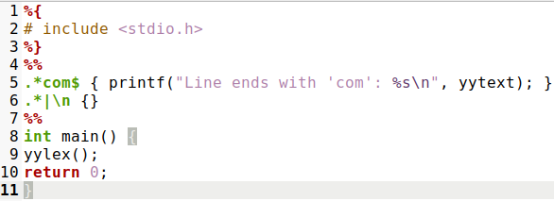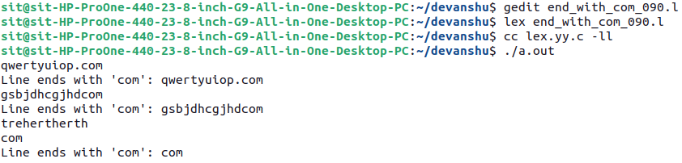

**Conclusion:** This practical demonstrates the integration of regular expressions within the LEX framework to detect text patterns—in this case, strings ending with "com". The approach is efficient, requires minimal manual parsing logic, and reflects how lexical analysis principles can be applied beyond compiler construction in real-world data filtering and validation tasks.