**Mini-project Report on**

**Apartment Visitor Management System**

**Submitted by:**

|  |  |
| --- | --- |
| Devanshu Surana  Pranav Pisal  Prachiti Kulkarni  Abhilash Kashid | PRN Number: 1032210755  PRN Number: 1032210794  PRN Number: 1032210844  PRN Number: 1032210826 |

**Under the Guidance of**

**Prof. Hanmant Magar**

**At**



An apartment visitor management system is a technology-based solution designed to improve security and enhance the overall experience for residents and visitors in apartment buildings. This system streamlines the visitor check-in process by digitizing visitor information, including their name, contact details, and purpose of the visit. With this information, building staff can verify visitor identities and ensure that only authorized individuals are allowed entry into the building.

The benefits of an apartment visitor management system include improved security, reduced wait times for visitors, and increased convenience for residents. Building staff can quickly and easily verify visitor information, and residents can receive notifications when their guests arrive. Additionally, the system can generate reports on visitor traffic and allow for the easy tracking of visitor data. Overall, an apartment visitor management system is a valuable tool for modern property management, providing enhanced security and a better experience for residents and their guests.

Table of Contents:

1. Introduction (Motivation and objectives)
2. Problem definition
3. System Flow Architecture with Database Design (ER diagram)
4. GUI (Screen Shots) with client side validations
5. Server-side database handling details
6. Conclusions.
7. Appendix :

a. Tools used  
b. References  
c. Plagiarism Report project report from any open source tool

**Introduction:**

In today's modern world, security has become a primary concern for apartment buildings, and the need for efficient and effective visitor management systems has grown significantly. An apartment visitor management system is an automated system designed to ensure the safety and security of residents and their guests by streamlining the visitor check-in process.

The primary motivation behind the development of an apartment visitor management system is to provide a secure, convenient, and streamlined approach to managing visitors. Traditional visitor management methods, such as sign-in sheets and manual logbooks, can be cumbersome and time-consuming, leading to long wait times and increased security risks. A digital system that can quickly and accurately identify and verify visitors can significantly enhance building security while also improving the visitor experience.

The objective of an apartment visitor management system is to provide a modern solution that simplifies the visitor check-in process while enhancing security measures. The system's primary aim is to minimize wait times and improve the overall experience for visitors and residents, providing a quick and seamless check-in process. Additionally, the system should have the ability to track visitor data, including their time and purpose of the visit, and generate useful reports that building management can use to make informed decisions. Ultimately, the goal is to provide a safer and more secure environment for residents and their guests.

**Problem Definition:**

The traditional approach to managing visitors in apartment buildings using paper-based sign-in sheets and manual logbooks can be slow, unreliable, and inefficient. These methods are prone to errors and inaccuracies, leading to potential security risks, especially in large buildings with a high volume of visitors. Visitors may also experience long wait times, leading to frustration and inconvenience.

Another challenge faced in managing visitors is the difficulty in tracking visitor data, such as their purpose of visit, time of arrival, and duration of the visit. This lack of tracking can make it difficult for building management to identify patterns or issues that may arise, leading to potential security concerns.

Moreover, the traditional approach does not provide any real-time alerts or notifications to residents when their guests arrive, leading to confusion and inconvenience for both residents and visitors.

Therefore, the problem definition of an apartment visitor management system is to provide a modern and efficient approach to manage visitors. The system should address the challenges faced in traditional approaches by providing a secure, reliable, and convenient way to manage visitors, minimizing wait times, and improving the overall visitor experience. It should also provide real-time alerts and notifications to residents when their guests arrive and enable building management to track visitor data for better security and decision-making.

**ER Diagram:**

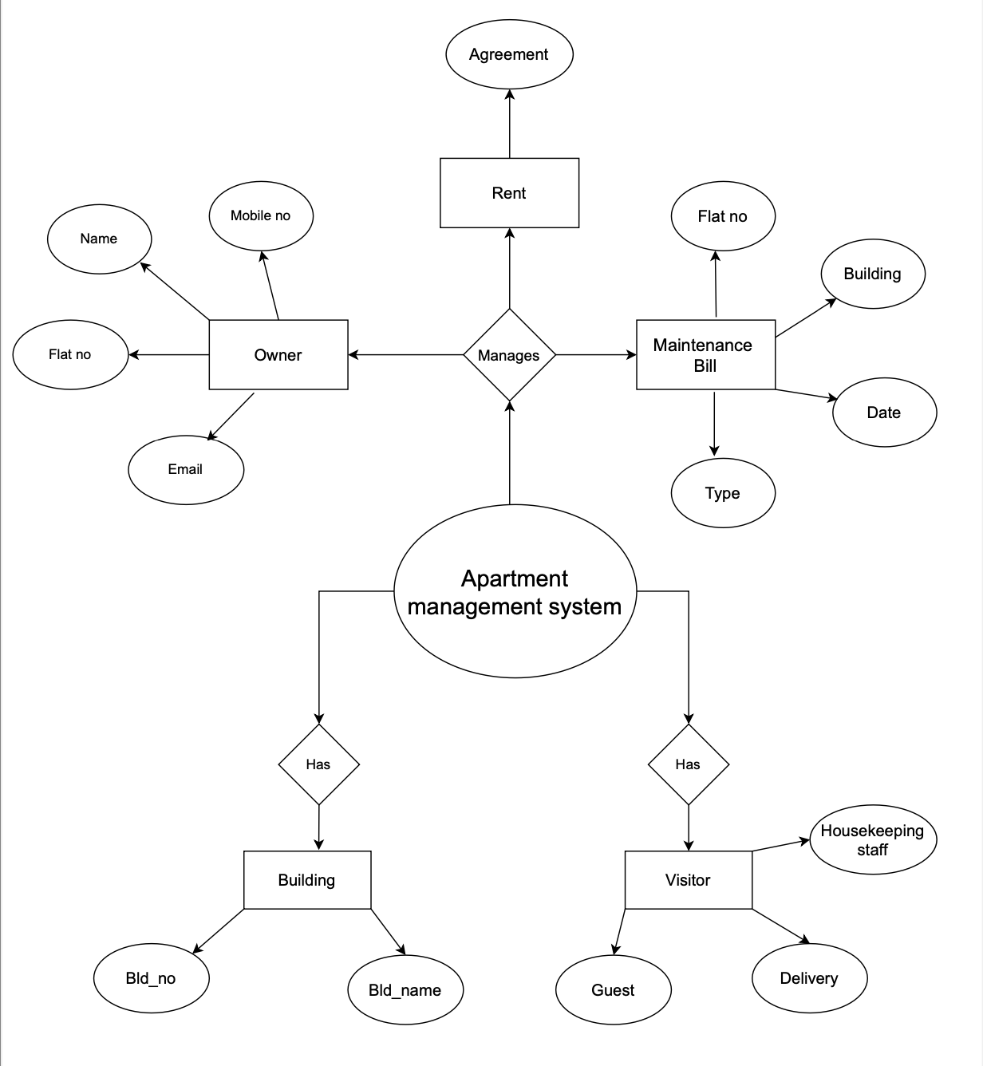

GUI ScreenShots:

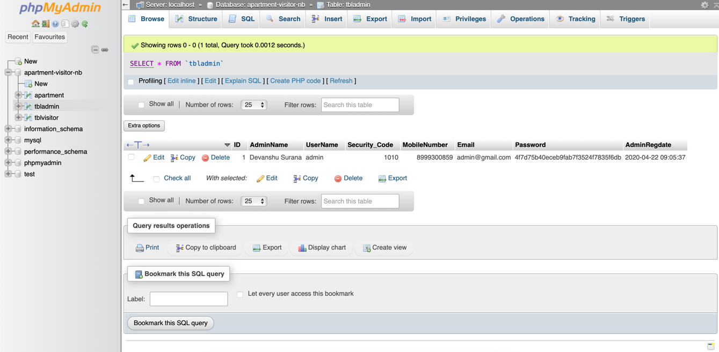

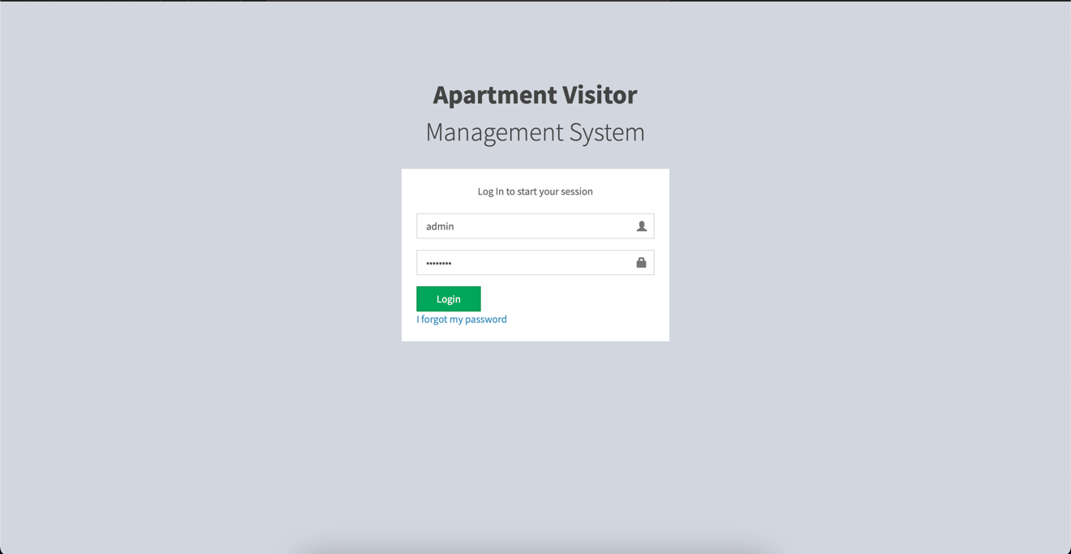

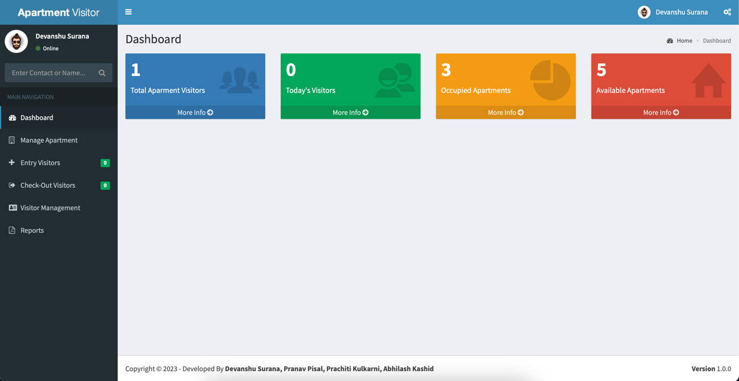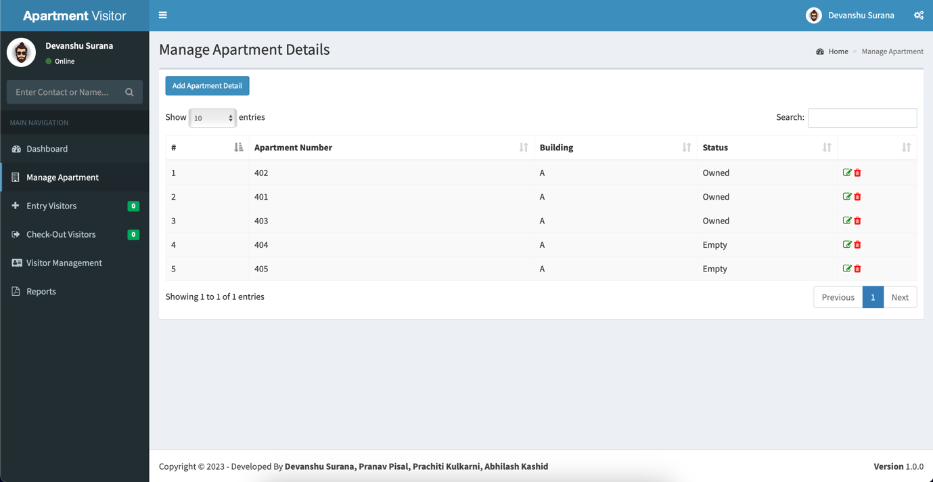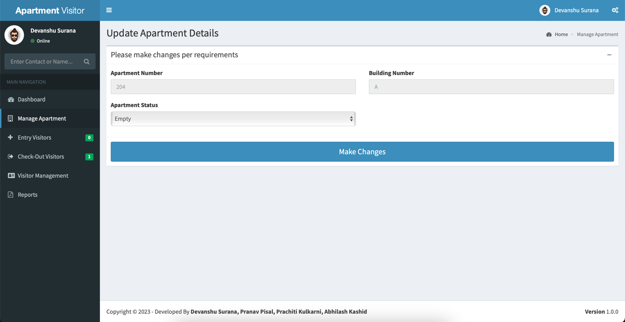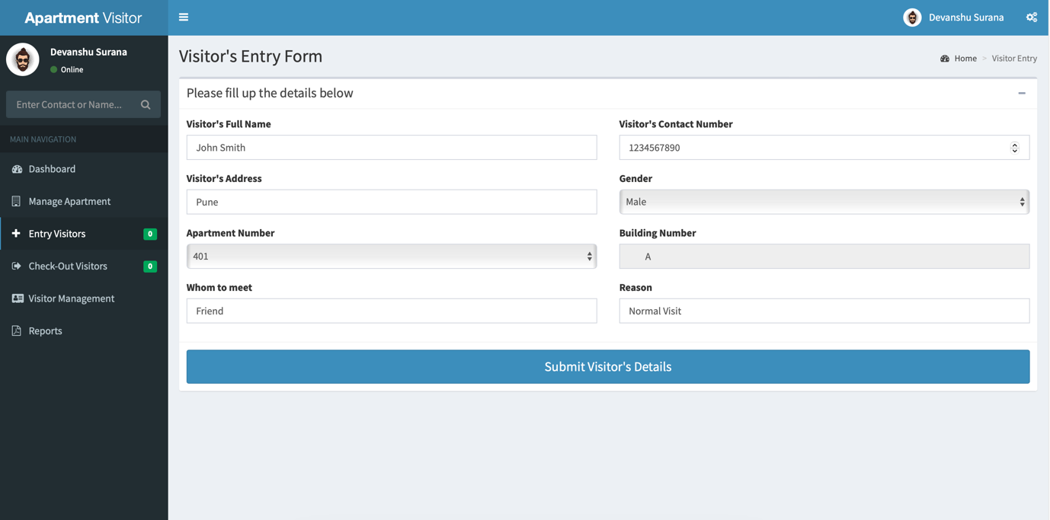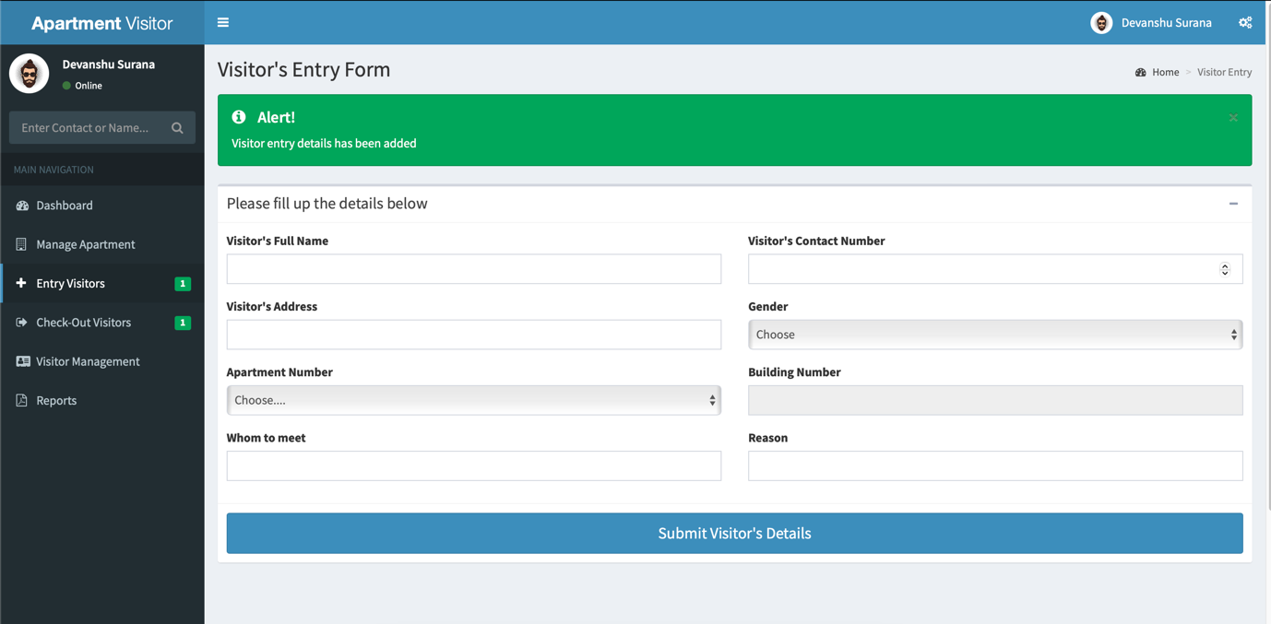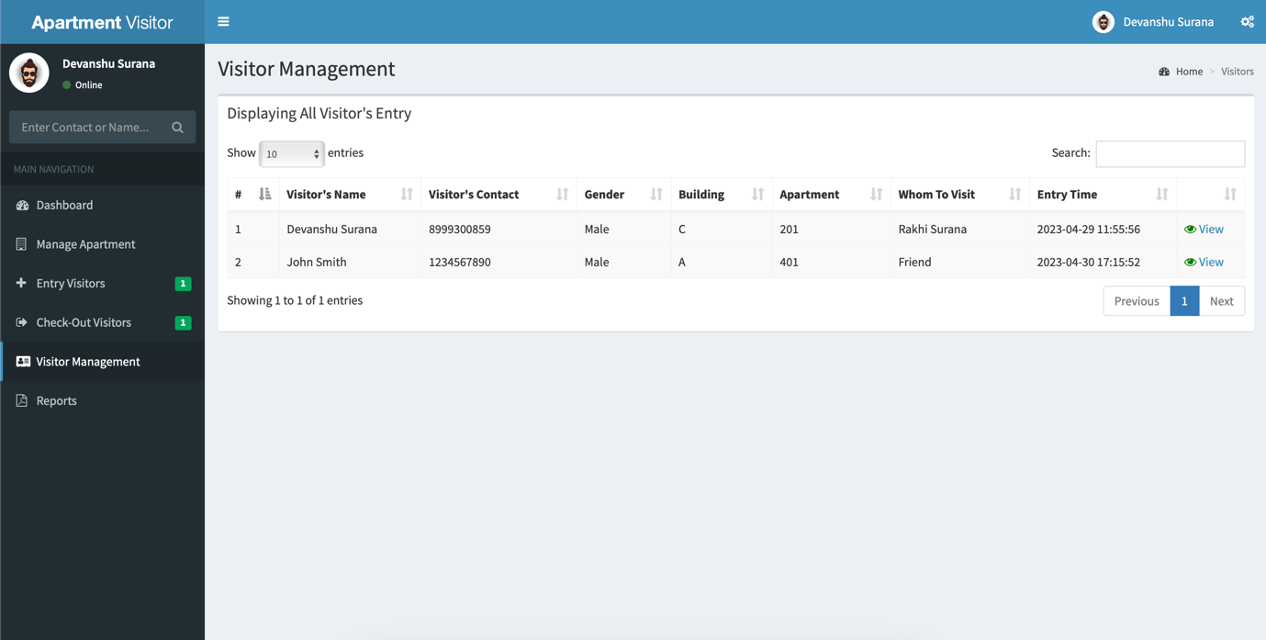

Conclusion:

Hence implemented the CRUD successfully.

Appendix:

Tools Used:

1. PHP
2. BOOTSTRAP
3. CSS
4. HTML
5. MYSQL

References:

1. Youtube