VARIABLES
In Python, a variable is a named storage location used to store data values. It's like a container that holds a specific piece of information. When you declare a variable, you specify its name and the type of data it will store.

Key Concepts:
- Name: The identifier you choose to refer to the variable. It should follow Python's naming conventions (e.g., start with a letter or underscore, use only letters, numbers, and underscores).
- Value: The data stored within the variable. It can be of various types, such as numbers (integers, floats), strings (text), lists, dictionaries, and more.
- Type: The kind of data the variable can hold. Python is dynamically typed, meaning you don't need to explicitly declare the type when creating a variable. The type is inferred based on the value assigned to it.

Assignment:
To assign a value to a variable, use the assignment operator (=). The variable name is placed on the left, and the value to be stored is placed on the right.

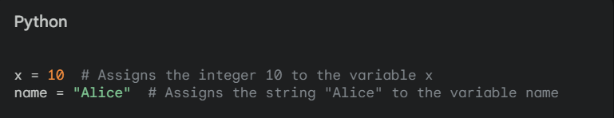

Variable Usage:
Once a variable is assigned a value, you can use it in expressions, calculations, and other operations.

Data Types:
Python supports various data types, each with its own characteristics and operations:
- Numbers:
  - int: Integers (e.g., 1, -2, 0)
  - float: Floating-point numbers (e.g., 3.14, -2.5)
  - complex: Complex numbers (e.g., 2+3j)
- Strings: Sequences of characters (e.g., "Hello", "world")
- Lists: Ordered collections of elements (e.g., [1, 2, 3], ["apple", "banana"])
- Tuples: Immutable ordered collections of elements (e.g., (1, 2, 3), ("apple", "banana"))
- Dictionaries: Unordered collections of key-value pairs (e.g., {"name": "Alice", "age": 30})
- Sets: Unordered collections of unique elements (e.g., {1, 2, 3}, {"apple", "banana"})
- Booleans: True or False values (e.g., True, False)

Best Practices:
- Use descriptive variable names that clearly indicate their purpose.
- Avoid using reserved words as variable names.
- Follow Python's naming conventions (e.g., snake_case for variables).
- Use appropriate data types for the values you're storing.
- Consider using type hints (PEP 484) for better code readability and maintainability, especially in larger projects.

DATATYPES:

Python is a dynamically typed language, meaning you don't need to explicitly declare the data type of a variable before assigning a value to it. The type of a variable is determined at runtime based on the value it holds.

Built-in Data Types:
- Numbers:
  - int: Integers (e.g., 1, -2, 0)
  - float: Floating-point numbers (e.g., 3.14, -2.5)
  - complex: Complex numbers (e.g., 2+3j)
- Strings: Sequences of characters (e.g., "Hello", "world")
- Lists: Ordered collections of elements (e.g., [1, 2, 3], ["apple", "banana"])
- Tuples: Immutable ordered collections of elements (e.g., (1, 2, 3), ("apple", "banana"))
- Dictionaries: Unordered collections of key-value pairs (e.g., {"name": "Alice", "age": 30})
- Sets: Unordered collections of unique elements (e.g., {1, 2, 3}, {"apple", "banana"})
- Booleans: True or False values (e.g., True, False)

Example:

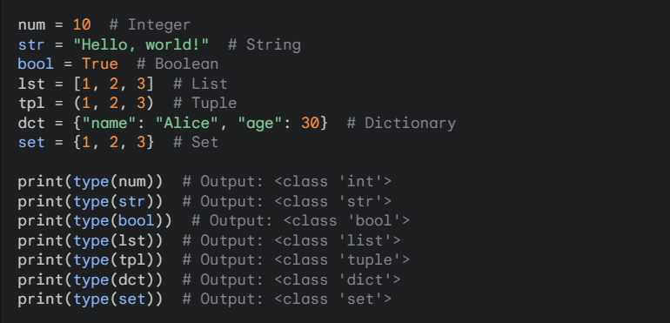
Strings

In Python, the string data type is a sequence of characters used to store and manipulate text data. Strings in Python are immutable sequences, meaning that once they are created, their contents cannot be altered. You can, however, create new strings based on operations performed on existing strings. Let's dive into the details of Python strings, covering their creation, properties, and the various methods for working with them.

1. Creating Strings
Strings in Python can be created using:
- Single quotes: 'Hello'
- Double quotes: "Hello"
- Triple quotes: '''Hello''' or """Hello"""

Example

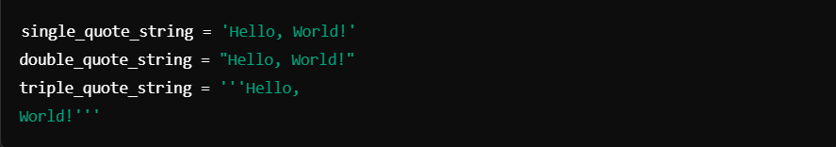

2. Characteristics of Strings
- Immutable: Strings cannot be modified once created. Any operation that changes a string’s content will produce a new string.
- Indexable and Slicable: Each character in a string can be accessed via an index (starting from 0), and substrings can be extracted through slicing.
- Unicode: Strings in Python are Unicode by default, allowing them to store international text and special characters.

3. Accessing Characters and Slicing
You can access individual characters or slices of characters from a string using indices.

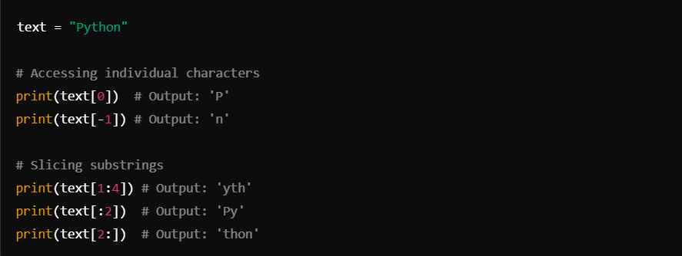

4. Common String Operations
Python provides many operations for manipulating strings.

a. Concatenation: Joining strings together with the + operator.

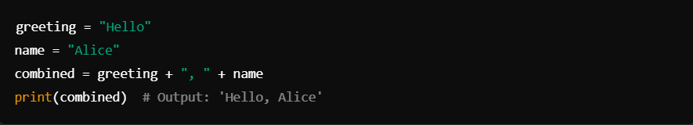

b. Repetition: Repeating a string a specified number of times with the * operator.

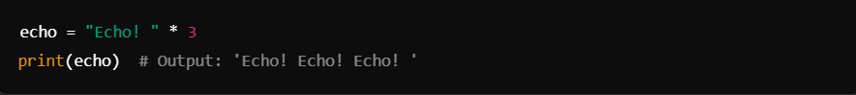

5. String Methods
Python strings come with many built-in methods that provide easy ways to perform common operations. Here are some frequently used methods:

a. Changing Case
- str.upper(): Converts all characters to uppercase.
- str.lower(): Converts all characters to lowercase.
- str.capitalize(): Capitalizes the first character of the string.
- str.title(): Converts the first character of each word to uppercase.

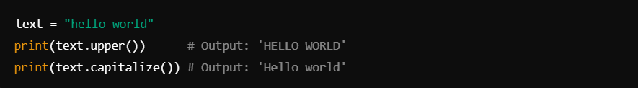

b. Searching and Replacing
- str.find(substring): Returns the index of the first occurrence of substring, or -1 if not found.
- str.replace(old, new): Replaces occurrences of a substring old with new.

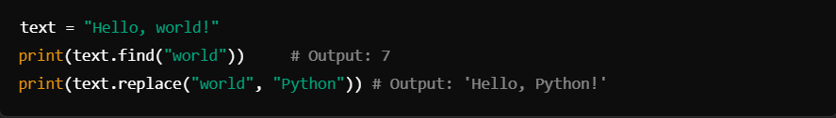

c. Splitting and Joining
- str.split(delimiter): Splits a string into a list of substrings based on the delimiter.
- delimiter.join(list): Joins a list of strings into a single string, with each element separated by delimiter.

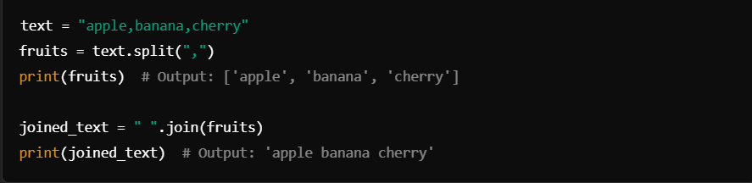

d. Trimming Whitespace
- str.strip(): Removes whitespace from the start and end of a string.
- str.lstrip() and str.rstrip(): Remove whitespace from the left or right side, respectively.

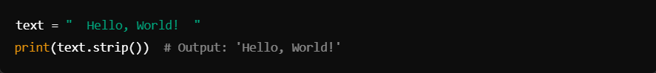

e. Checking String Contents
- str.isalpha(): Checks if all characters are alphabetic.
- str.isdigit(): Checks if all characters are digits.
- str.isspace(): Checks if all characters are whitespace.
- str.startswith(prefix): Checks if the string starts with prefix.
- str.endswith(suffix): Checks if the string ends with suffix.

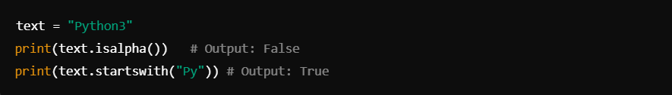

6. String Formatting
String formatting allows embedding variables or expressions within strings, with f-strings being the most modern approach.

a. f-strings (Python 3.6+)

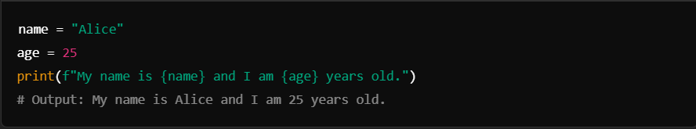

b. str.format()

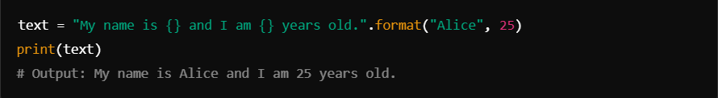

c. Old % formatting

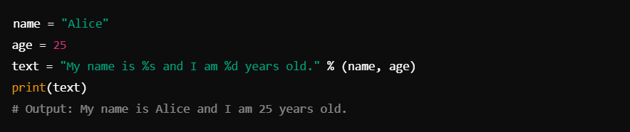

7. Escape Sequences
To include special characters in strings, you can use escape sequences.
- \' - Single quote
- \" - Double quote
- \\ - Backslash
- \n - Newline
- \t - Tab

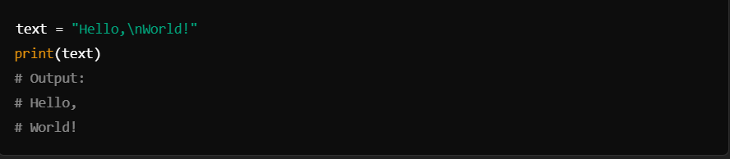

8. Multiline Strings
Using triple quotes (''' or """), you can create strings that span multiple lines.

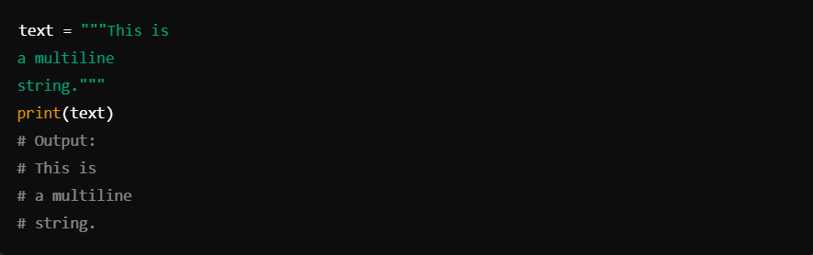

#f-string:

An f-string, or formatted string literal, is a concise and readable way to embed expressions inside string literals in Python. Introduced in Python 3.6, f-strings allow you to embed variables and expressions within curly braces {}, prefixed by the letter f before the string.

Basic Syntax
To use an f-string, prefix the string with f or F and place expressions inside curly braces {}. Python will evaluate these expressions and insert their values into the string.

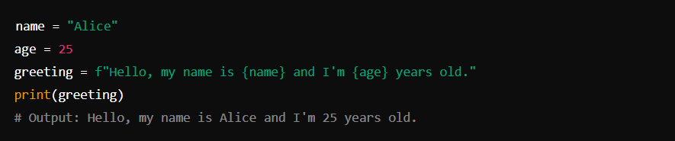

Advantages of f-strings
- Readability: Makes it easier to read and write strings with embedded variables or expressions.
- Performance: Generally faster than other formatting methods like str.format() and % formatting.
- Flexibility: You can include any valid Python expression inside {}, even function calls or arithmetic operations.

Example with Expressions

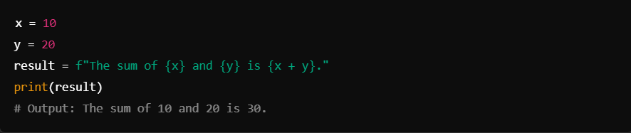

Formatting Output
F-strings also support formatting specifications, such as setting decimal places for floating-point numbers.

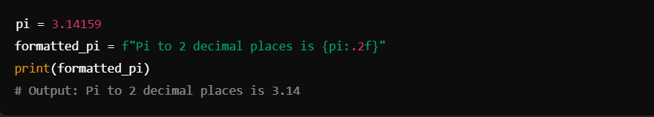

Modules:

In Python, modules are files containing Python code that define functions, classes, and variables or include runnable code. Modules are a way to organize and reuse code by dividing it into logical groups.

Key Points About Modules

- Structure:
  - A module is a single Python file with a .py extension.
  - The name of the file (without the .py extension) becomes the module's name when imported.
- Types of Modules:
  - Built-in Modules: Pre-installed modules like math, sys, and os.
  - Standard Library Modules: Part of Python's standard library, such as datetime, random, or re.
  - Third-Party Modules: Modules installed via package managers like pip (e.g., numpy, pandas).
  - User-Defined Modules: Custom modules created by users.
- Using Modules: To use a module, you import it in your Python code:

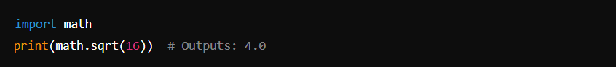

You can also import specific parts of a module:

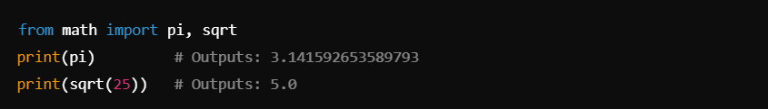

Or, rename a module using an alias:

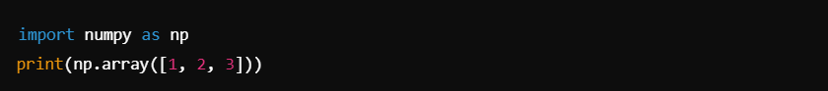

- Creating a Module: To create a module, simply write Python code in a .py file:

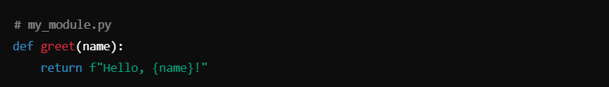

Use it in another file:

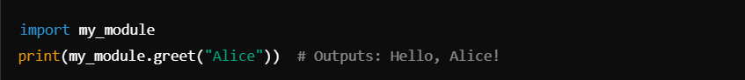

- Built-in Variables in Modules:
- __name__: Indicates the name of the module. If the module is run directly, __name__ is set to "__main__".

- Example:

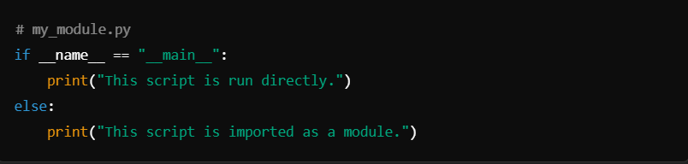

- Packages: Modules can be grouped into packages, which are directories containing an __init__.py file (this file can be empty in modern Python versions).

Advantages of Using Modules
- Code Reusability: Write once, reuse in multiple scripts.
- Code Organization: Makes large programs easier to manage.
- Namespace Management: Avoids name conflicts between different parts of a program.

Pip in Python:

pip stands for "Pip Installs Packages". It is the package manager for Python, allowing users to install, upgrade, and manage software packages or libraries written in Python. These packages are typically stored in the Python Package Index (PyPI), a vast repository of Python libraries.

Key Features of pip:
- Installation: Easily install Python packages from PyPI or other sources.
- Dependency Management: Automatically resolves and installs the dependencies a package requires.
- Upgrading: Update installed packages to their latest versions.
- Uninstallation: Remove packages that are no longer needed.
- Customization: Options for installing specific versions or even local/remote .whl (wheel) files.

How to Use pip:
1. Checking Installation
To verify if pip is installed:

If installed, this command shows the version of pip and Python it's associated with:

2. Installing a Package
To install a package, use the install command:

Example:

3. Installing a Specific Version
If a specific version of a package is required:

Example:

4. Upgrading a Package
To upgrade a package to the latest version:

Example:

5. Uninstalling a Package
To remove a package:

Example:

6. Listing Installed Packages
To see all installed packages:

7. Checking for Outdated Packages
To list outdated packages:

8. Saving and Recreating Environments
- Export Installed Packages to a File:

This creates a requirements.txt file containing a list of all installed packages and their versions.

- Install Packages from requirements.txt:

9. Installing from a Local or Remote Source
- Install a package from a local file:

- Install a package from a Git repository:

Configuring pip:
You can configure pip to use custom settings, such as a different repository or proxy. For example:
- Setting a Proxy:

- Using a Custom PyPI Repository:

Common Issues and Fixes:
- Permission Denied: Use --user to install packages locally for the current user:

- Upgrade pip Itself: Keep pip updated for compatibility with the latest packages:

- SSL Errors: These might occur due to outdated certificates. Fix with:

Advanced Features of pip:
- Install in Editable Mode: Use -e for developing a package locally:

- Search for Packages: Search PyPI for a package:

- Show Package Details: To see detailed information about an installed package:

- Install with Constraints: Install packages adhering to specific constraints:

Comments:

In Python, comments are used to explain code, make it more readable, or temporarily disable parts of the code during debugging. They are ignored by the Python interpreter and do not affect the program's execution.

Types of Comments in Python:
1. Single-Line Comments
Single-line comments begin with a # symbol and extend to the end of the line. They are used for brief explanations or annotations.

Example:

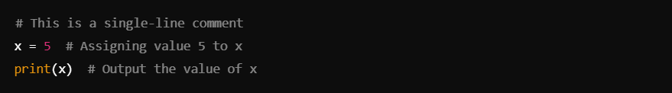

2. Multi-Line Comments (Block Comments)
Python does not have a specific syntax for multi-line comments, but you can create them using consecutive # symbols or triple-quoted strings (""" or ''').

Option 1: Using Consecutive # Symbols

Example:

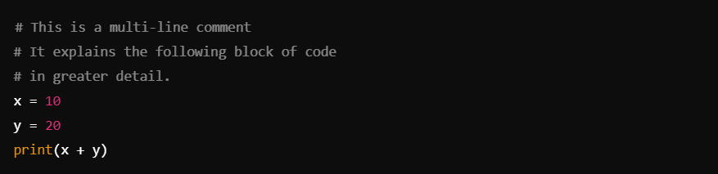

Option 2: Using Triple-Quoted Strings
Although triple quotes are primarily used for docstrings, they can also serve as comments when not assigned to a variable or function.

Example:

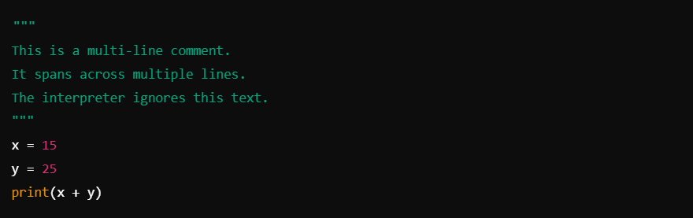

Comments vs. Docstrings
- Comments: Used to explain or annotate the code. Ignored by the Python interpreter.
- Docstrings: Special string literals (""" """") used to document the purpose of a function, class, or module. They are accessible at runtime via __doc__.

Example:

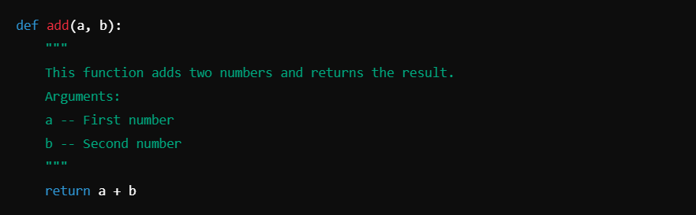

Operators

1. Arithmetic Operators
Used for basic mathematical operations.

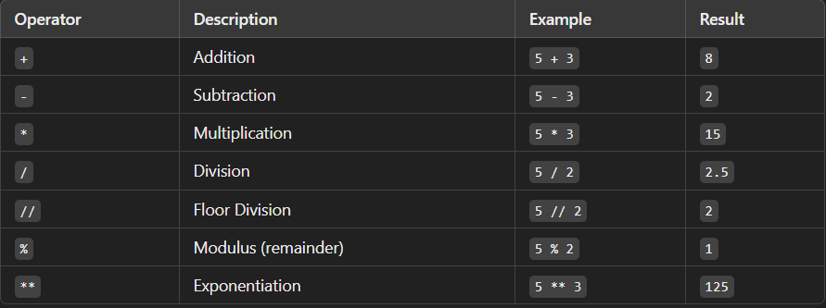

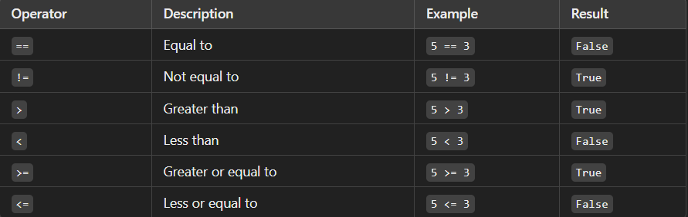

3. Logical Operators
Used to perform logical operations.

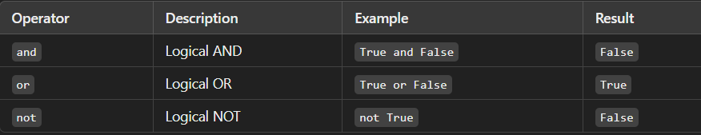

4. Bitwise Operators
Operate on binary representations of integers.

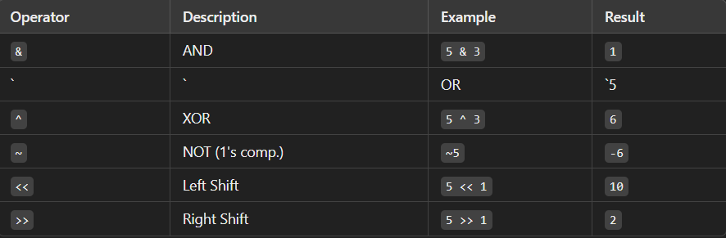

5. Assignment Operators
Used to assign values to variables.

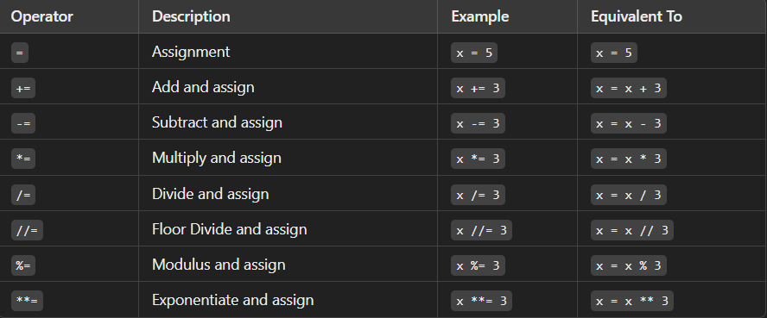

6. Membership Operators
Check for membership in sequences like strings, lists, or tuples.

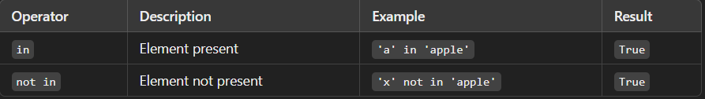

7. Identity Operators
Check if two objects share the same memory location.

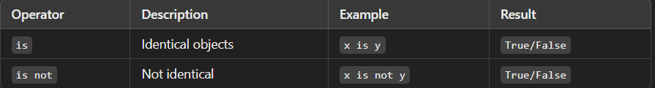

Conditional Statements

Conditional statements allow a program to execute certain pieces of code based on specific conditions. Python supports several types of conditional statements, including if, else, elif, and nested conditionals.

1. The if Statement
The if statement checks a condition. If the condition is True, the code block inside it executes.

Syntax:

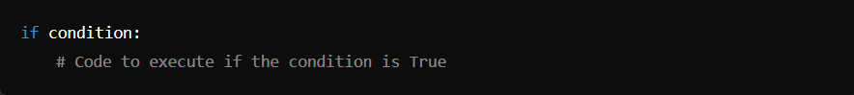

Example:

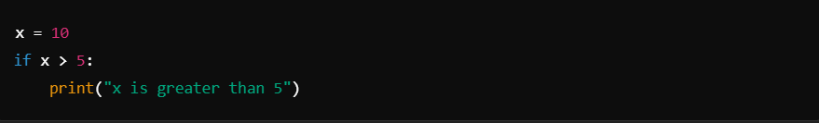

Output:
x is greater than 5

2. The else Statement
The else block executes when the if condition is False.

Syntax:

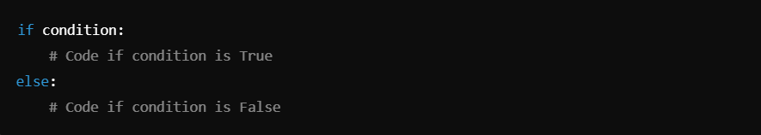
Example:

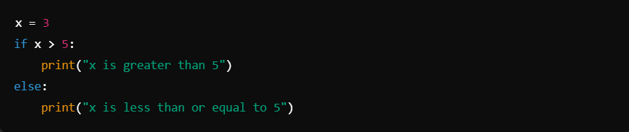

Output:
x is less than or equal to 5

3. The elif Statement
The elif (short for "else if") allows checking multiple conditions sequentially.

Syntax:

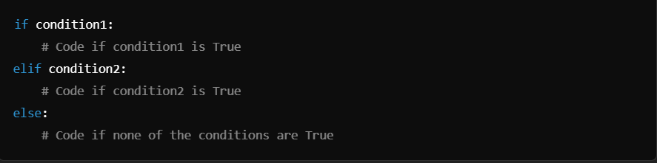

Example:

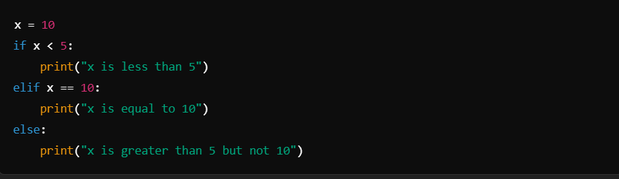

Output:
x is equal to 10

4. Nested if Statements
An if statement can be nested inside another if or else block.

Syntax:

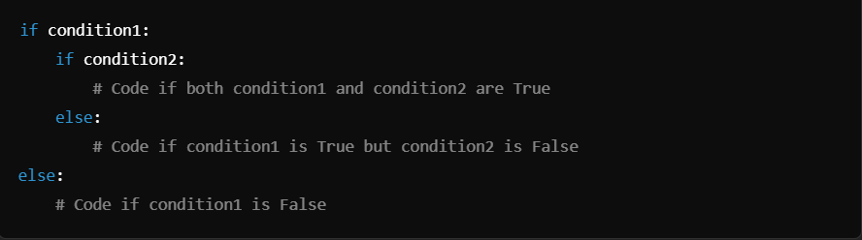

Example:

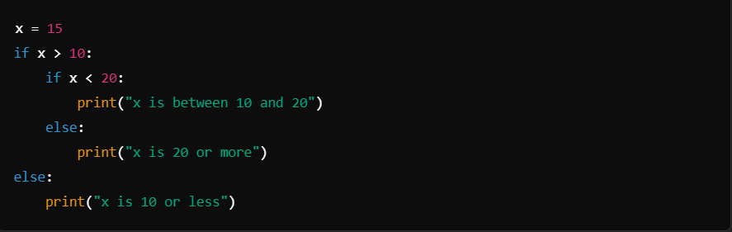

Output:
x is between 10 and 20

5. Using Logical Operators
Python’s logical operators and, or, and not allow combining multiple conditions.

Example with and:

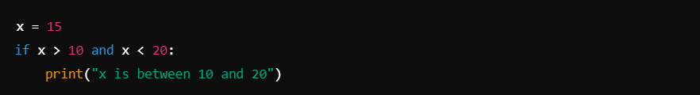

Output:
x is between 10 and 20

Example with or:

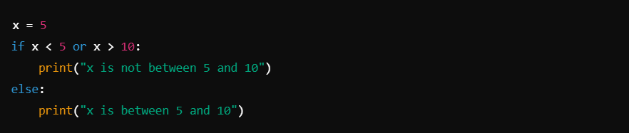

Output:
x is not between 5 and 10

Example with not:

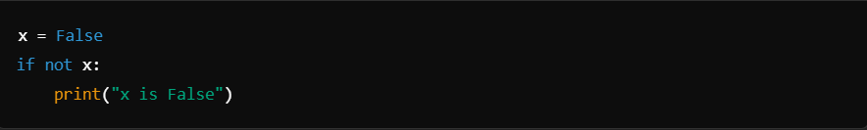

Output:
x is False

6. Ternary Conditional Operator (Inline if)
Python allows a shorthand way to write conditional statements using a ternary operator.

Syntax:

Example:

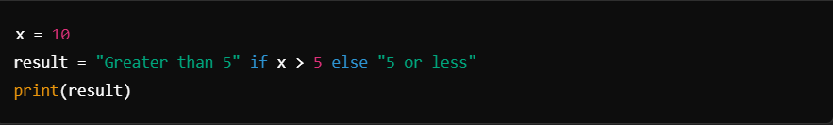

Output:
Greater than 5

7. Common Mistakes
- Indentation Errors: Python uses indentation to define blocks, so consistent indentation is crucial.

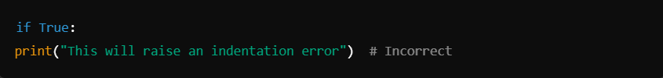

- Missing Colons: A colon (:) is required at the end of each if, elif, and else line.

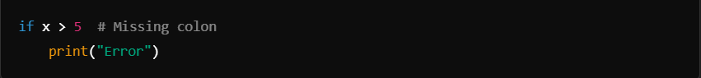

List

A list in Python is a built-in data structure that is mutable, ordered, and capable of storing heterogeneous elements. It is one of the most commonly used data structures due to its flexibility and ease of use.

Key Features of a List:
- Ordered:
  - The elements in a list have a defined order, and this order is maintained unless explicitly changed.
  - You can access elements using their index.
- Mutable:
  - Elements of a list can be modified after the list is created. For example, you can change, add, or delete elements.
- Heterogeneous:
  - A list can contain elements of different data types such as integers, floats, strings, or even other lists.
- Dynamic:
  - Lists can grow or shrink as needed. You don’t need to specify their size during creation.

Creating a List:
You can create a list using square brackets [] or the list() constructor.

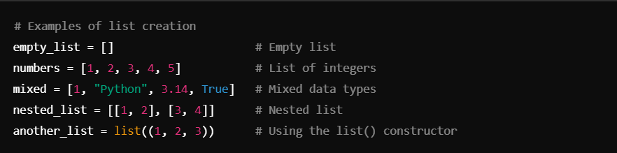

Accessing Elements:
- Indexing:
  - Access elements using their index (starting from 0).
  - Negative indices can be used to access elements from the end.

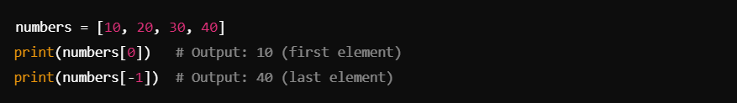

- Slicing:
  - Retrieve a subset of the list using slicing.

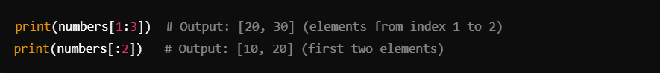

Common Operations on Lists:
Adding Elements:
- append():
  - Adds an element to the end of the list.

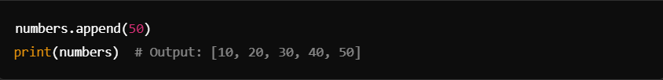

- insert():
  - Adds an element at a specified index.

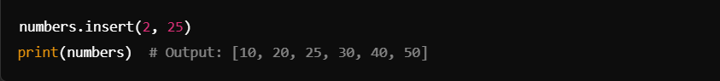

- extend():
  - Appends elements of another iterable to the end of the list.

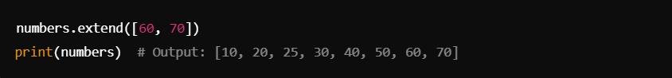

Removing Elements:
- remove():
  - Removes the first occurrence of the specified value.

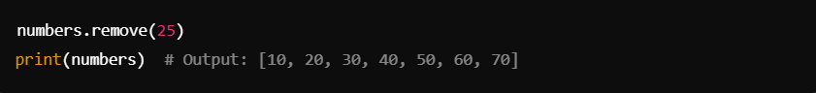

- pop():
  - Removes and returns an element at a specified index (default is the last element).

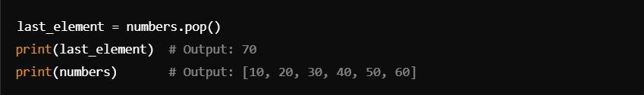

- clear():
  - Removes all elements from the list.

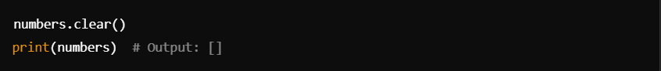

Other Operations:
- len():
  - Returns the number of elements in the list.

- sort():
  - Sorts the list in ascending order (can specify descending with reverse=True).

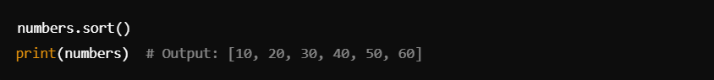

- reverse():
  - Reverses the elements in place.

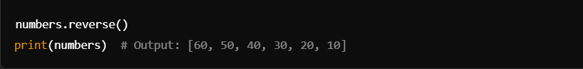

- index():
  - Returns the index of the first occurrence of the specified value.

- count():
  - Returns the number of occurrences of a specific value in the list

Iterating Over a List:
- Using a for loop:

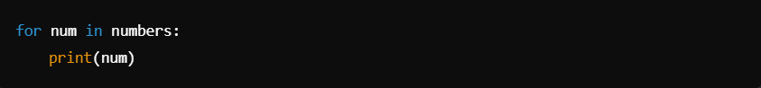

- Using enumerate() for indices:

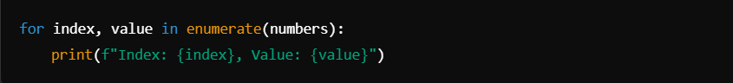

Nested Lists:
Lists can contain other lists, creating a multi-dimensional structure.

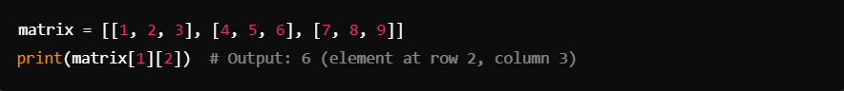

List Comprehensions:
A concise way to create lists.

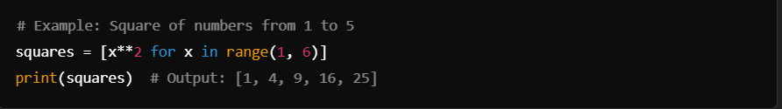

Tuple

Tuples are a built-in data structure in Python that allow you to store multiple items in a single variable. They are very similar to lists but have some key differences.

Key Characteristics of Tuples
- Ordered:
  - Tuples maintain the order of their elements. The order in which you add elements to a tuple is preserved.
- Immutable:
  - Once a tuple is created, you cannot modify its contents (i.e., no addition, deletion, or modification of elements).
- Heterogeneous:
  - A tuple can store elements of different data types, such as integers, strings, floats, or even other tuples.
- Indexed:
  - Elements in a tuple can be accessed using their index (0-based indexing).
- Allow Duplicates:
  - A tuple can have duplicate elements.
- Hashable:
  - Tuples are hashable if all their elements are hashable, meaning they can be used as keys in dictionaries or elements of sets.

Syntax of Tuples
Tuples are defined using parentheses () or the tuple() constructor.

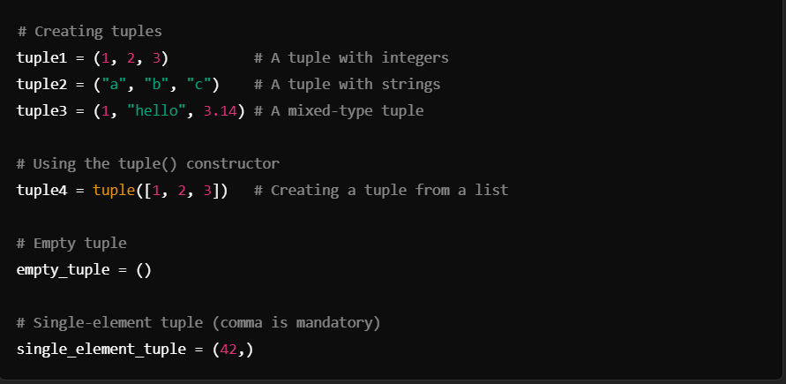

Accessing Tuple Elements
You can access elements of a tuple using indexing and slicing.

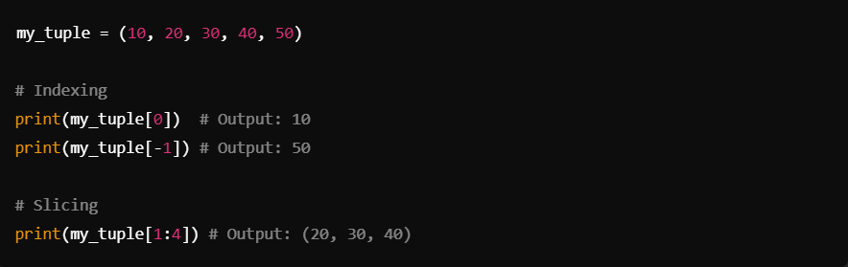

Operations on Tuples
Although tuples are immutable, there are several operations you can perform on them:
1. Concatenation

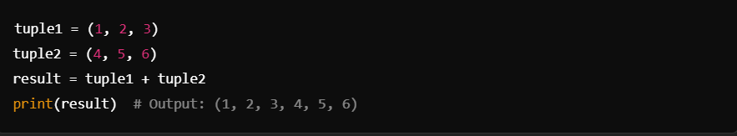

2. Repetition

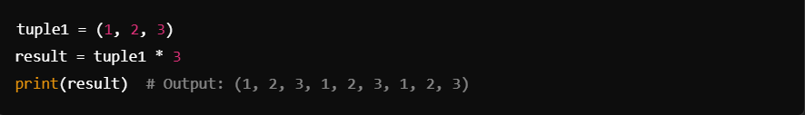

3. Membership Testing

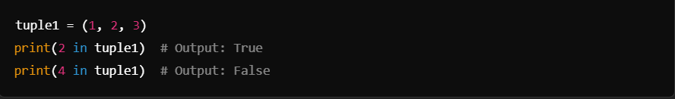

4. Iteration

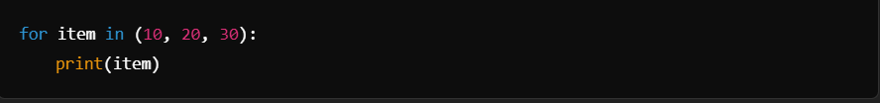

Tuple Methods
Tuples have limited built-in methods due to their immutability:
- count(x):
  - Returns the number of times x appears in the tuple.

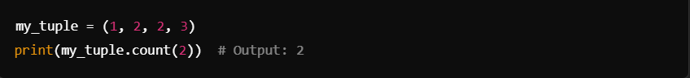

- index(x):
  - Returns the index of the first occurrence of x.

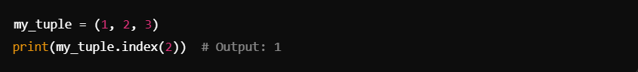

Immutability and Workarounds
Tuples cannot be changed directly, but you can:
- Create a new tuple by concatenation.
- Convert a tuple to a list, modify the list, and convert it back to a tuple.

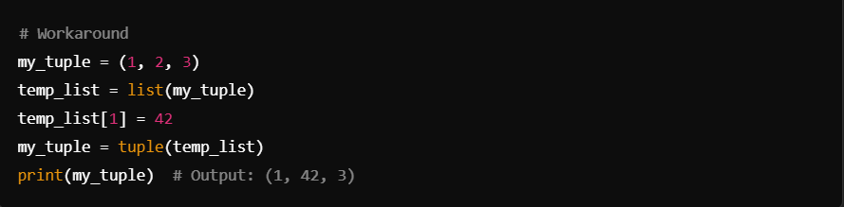

Advantages of Tuples
- Efficiency:
  - Tuples consume less memory and are faster than lists.
- Safety:
  - Immutability ensures that data cannot be accidentally changed.
- Hashability:
  - Tuples can be used as dictionary keys or stored in sets.

Use Cases of Tuples
- Returning Multiple Values from a Function:

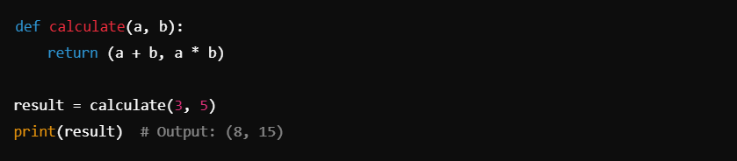

- Storing Related Data:

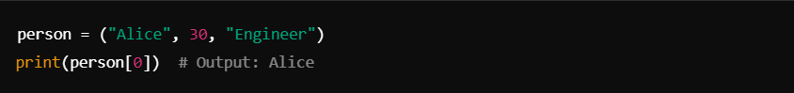

- Unpacking:

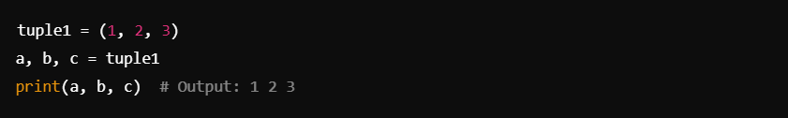

Dictionary:

A dictionary in Python is an unordered, mutable, and indexed collection that stores data in key-value pairs. Dictionaries are a powerful tool for organizing and retrieving data efficiently.

Key Features:
- Key-Value Pairs:
  - Data is stored in the form of {key: value} pairs.
  - Keys must be unique, immutable (strings, numbers, or tuples), and hashable.
  - Values can be of any data type and can be duplicated.
- Unordered:
  - Until Python 3.7, dictionaries were unordered collections.
  - From Python 3.7 onward, dictionaries maintain the insertion order of keys.
- Mutable:
  - Dictionaries can be modified (add, update, or remove items) after creation.
- Efficient:
  - Dictionaries offer fast lookups, insertions, and deletions due to their implementation as hash tables.

Creating a Dictionary

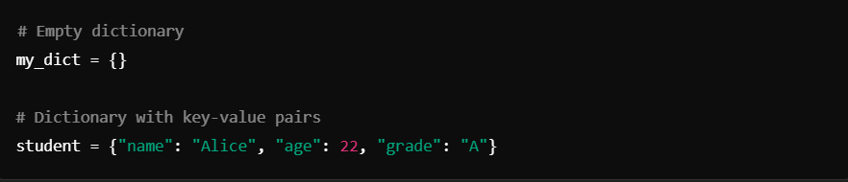

- Use the get() method to avoid errors if the key is not found:

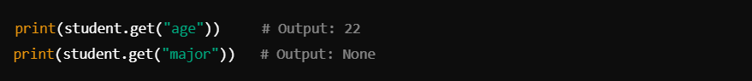

Modifying a Dictionary
- Add an Item:

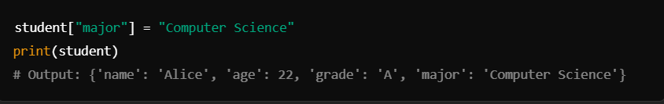

- Update an Item:

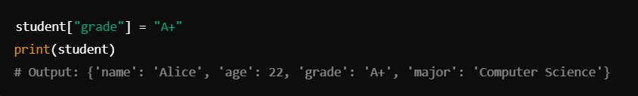

- Remove an Item:

- Using del:

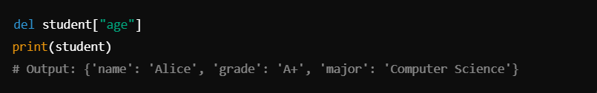

- Using pop():

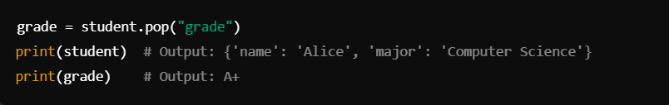

Dictionary Methods

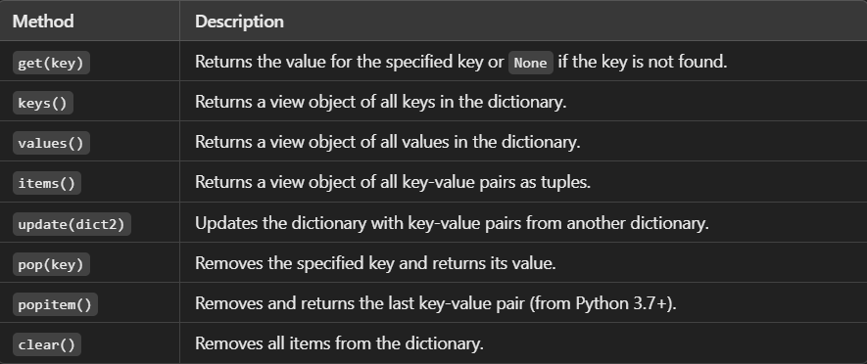

Iterating Through a Dictionary

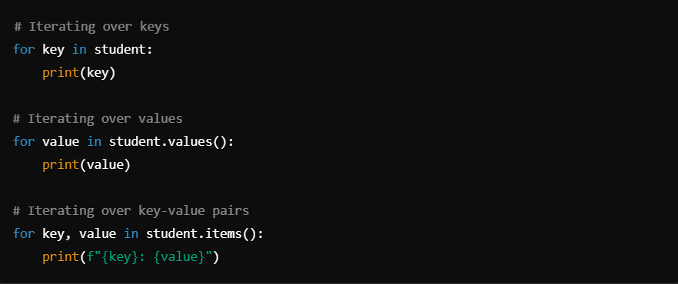

Nesting Dictionaries
Dictionaries can contain other dictionaries, allowing you to create complex data structures.

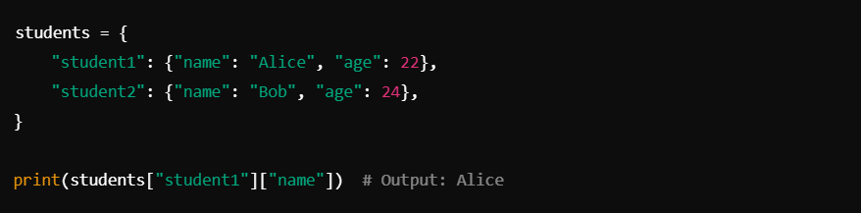

Common Use Cases
- Counting Occurrences:

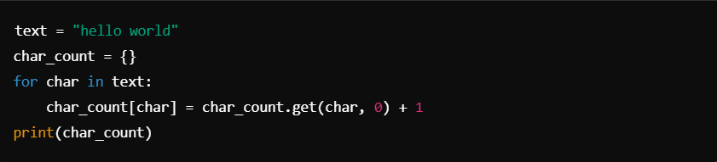

- Mapping Relationships:

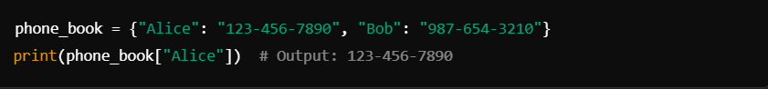

Set

A set in Python is a built-in data structure that stores unordered, unique, and immutable elements. Sets are similar to mathematical sets and are highly useful when you need to perform set operations such as union, intersection, difference, etc.

Key Features of Sets
- Unordered: The elements in a set do not have a fixed order.
- Unique: A set does not allow duplicate values.
- Immutable Elements: All elements in a set must be hashable (e.g., integers, strings, tuples). Mutable elements like lists or dictionaries cannot be added to a set.
- Dynamic: Sets are mutable; you can add or remove elements.

Creating Sets
Sets can be created using:
- Curly Braces ({})

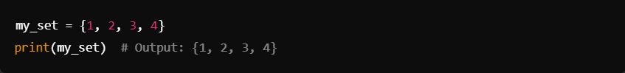

- set() Constructor:

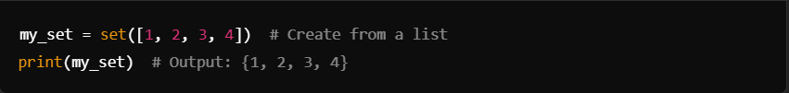
Note: An empty set must be created using set(), as {} creates an empty dictionary.

Basic Operations on Sets

1. Adding Elements
- Use the add() method:

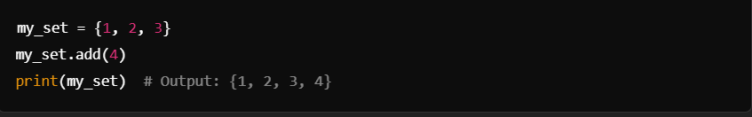

2. Removing Elements
- remove(item): Removes a specific element. Raises KeyError if the element is not found.

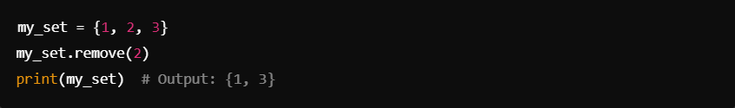

- discard(item): Removes a specific element but does not raise an error if the element is not found.

- pop(): Removes and returns an arbitrary element.

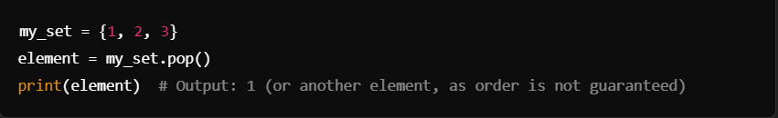

3. Checking Membership
- Use the in keyword:

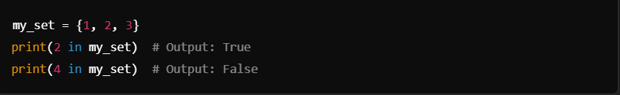

4. Length of a Set
- Use the len() function:

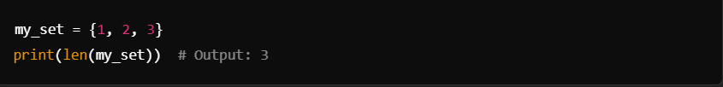

Set Operations
1. Union (| or union())
Combines elements from two sets, removing duplicates.

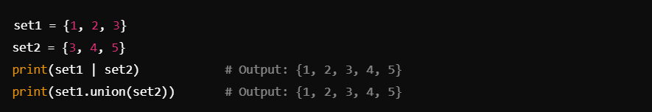

2. Intersection (& or intersection())
Returns common elements from both sets.

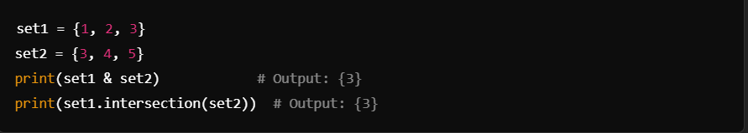

3. Difference (- or difference())
Returns elements in the first set but not in the second.

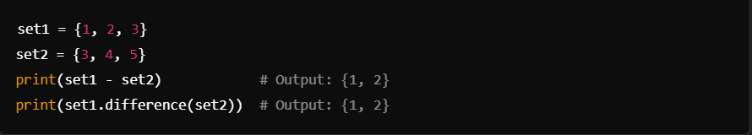

4. Symmetric Difference (^ or symmetric_difference())
Returns elements that are in either of the sets but not in both.

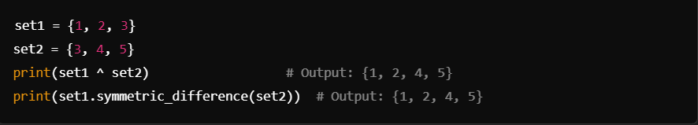

Other Set Methods
- Copy a Set:

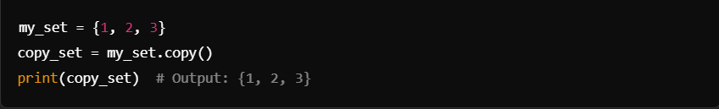

- Clear a Set:

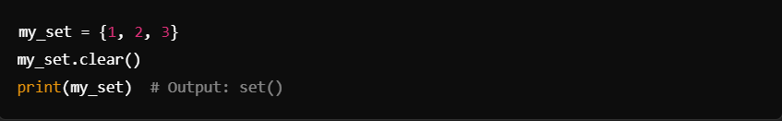

- Check Subset and Superset:

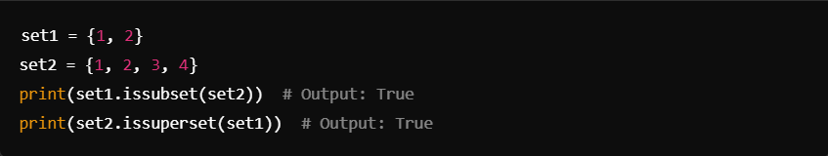

Frozen Sets
A frozenset is an immutable version of a set. It is hashable and can be used as a key in dictionaries.

Example:

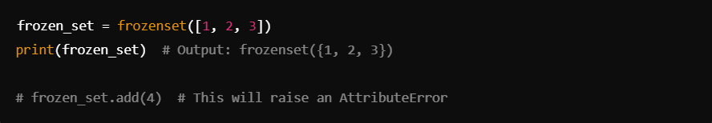

Use Cases of Sets
- Removing duplicates from a list:

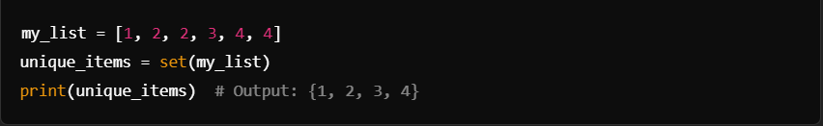

- Performing set operations like finding common or distinct elements.
- Checking membership efficiently (faster than lists).

Loops

Loops are used to execute a block of code repeatedly as long as a condition is met. Python supports two main types of loops: for and while.

1. for Loop
The for loop is used to iterate over sequences like lists, tuples, strings, or ranges.

Syntax:

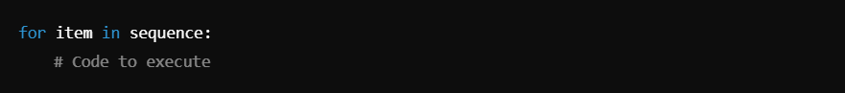

Example 1: Iterating Over a List

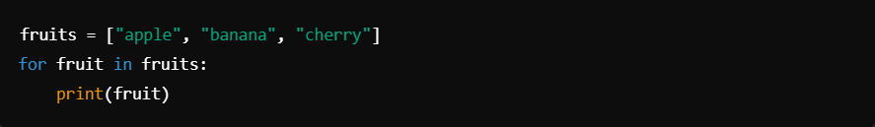

Example 2: Iterating Over a String

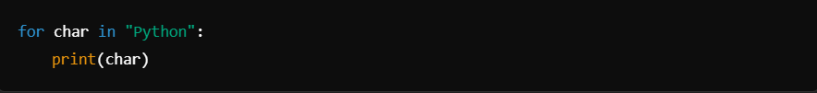

Example 3: Using range() Function

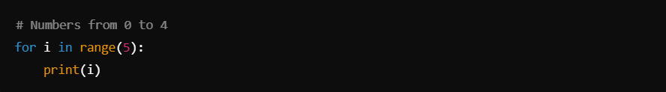

Example 4: Using range() with Start, Stop, and Step

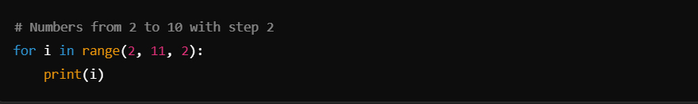

else Clause in for Loop
The else block runs if the loop completes without encountering a break.

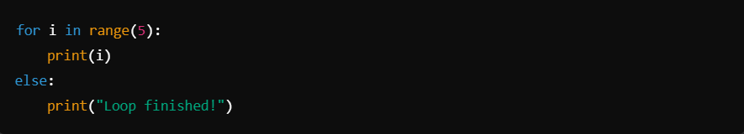

2. while Loop
The while loop runs as long as a specified condition is True.

Syntax:

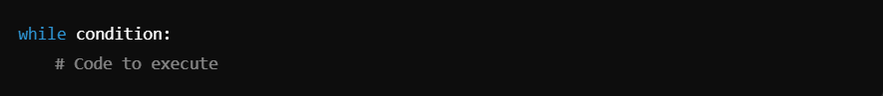

Example 1: Basic while Loop

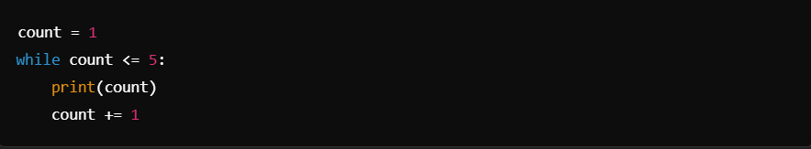

Example 2: Infinite Loop (Use break to Stop)

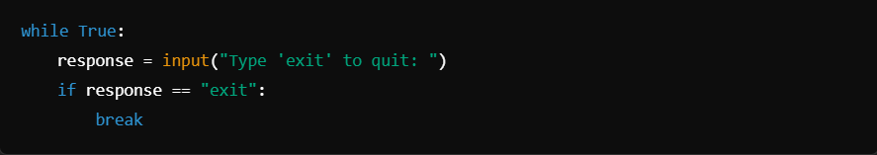

else Clause in while Loop
The else block runs if the while loop exits normally (not by break).

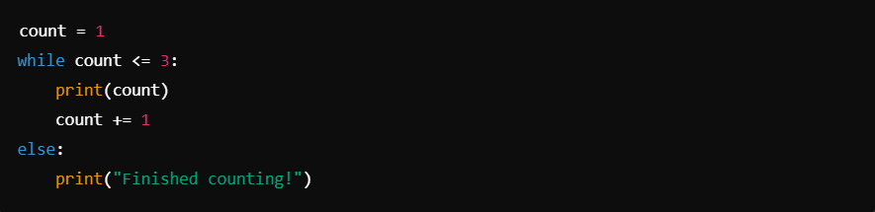

Control Statements in Loops
1. break Statement

Exits the loop prematurely.

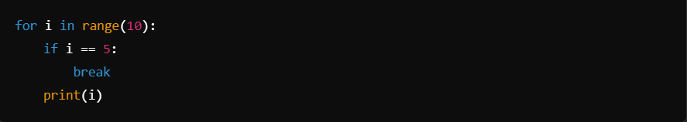

2. continue Statement
Skips the current iteration and proceeds to the next one.

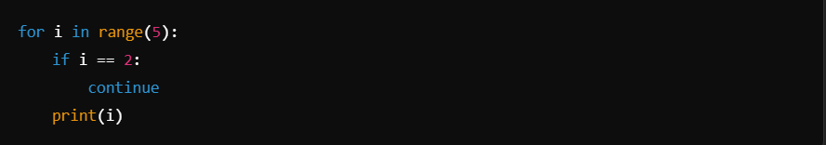

3. pass Statement
Acts as a placeholder, doing nothing.

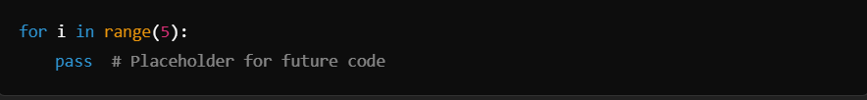

Nested Loops
You can nest loops inside each other.

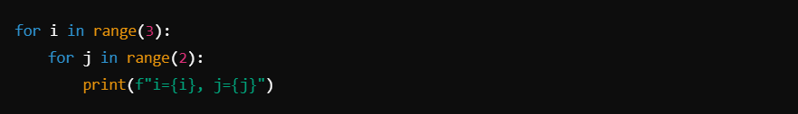

Functions

Functions in Python are reusable blocks of code that perform specific tasks. They help organize code, reduce redundancy, and improve readability.

1. Defining a Function
You define a function using the def keyword, followed by the function name and parentheses. Inside the parentheses, you can specify parameters.

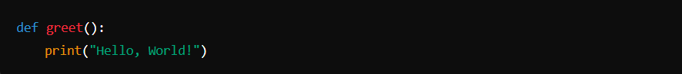

2. Calling a Function
To execute a function, use its name followed by parentheses.

3. Function Parameters
Functions can accept arguments (inputs).

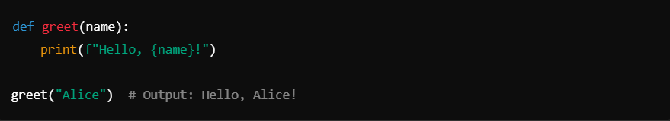

Default Parameters
You can set default values for parameters.

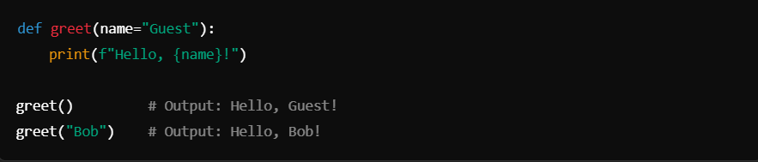

4. Return Statement
Functions can return values using the return keyword.

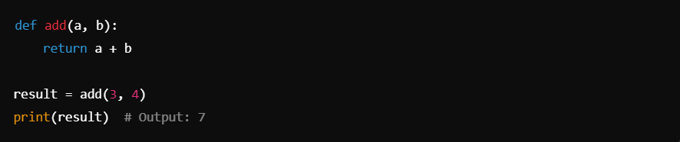

5. Types of Functions
- Built-in Functions: Predefined (e.g., print(), len(), max()).
- User-defined Functions: Functions created by the user.

6. Variable Scope
- Local Scope: Variables defined inside a function are accessible only within that function.

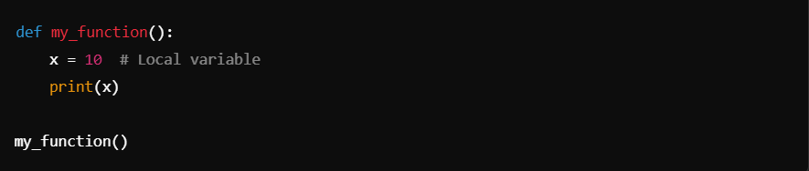

- Global Scope: Variables defined outside functions are accessible throughout the program.

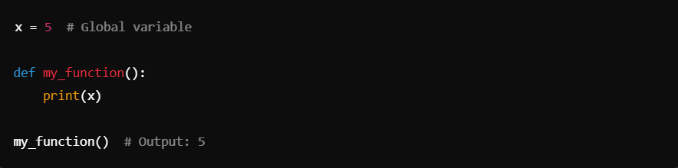

Modifying Global Variables
Use the global keyword to modify global variables inside a function.

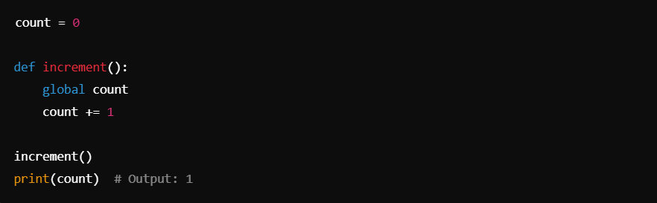

**7. *args and kwargs
*args: Allows a function to accept multiple positional arguments.

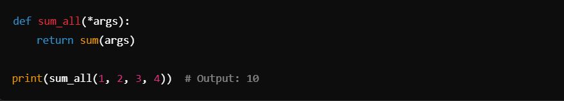

**kwargs: Allows a function to accept multiple keyword arguments.

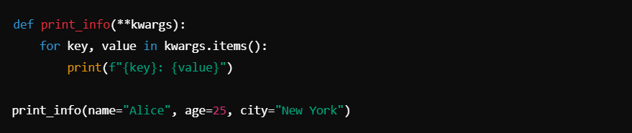

8. Lambda Functions
Lambda functions are anonymous, single-expression functions.

9. Function Annotations (Optional)
Python supports annotations for parameters and return types.

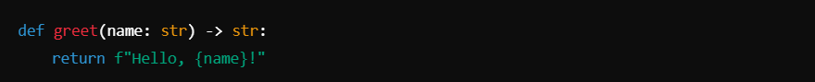

Recursion

Definition:
Recursion is a programming technique where a function calls itself in order to solve a problem. Each recursive call works on a smaller version of the problem until a base case is reached, which stops further recursion.

How Recursion Works:
- Recursive Case: The function calls itself with modified arguments, moving closer to the base case.
- Base Case: The condition where the function stops calling itself, preventing infinite recursion.

Syntax of a Recursive Function:

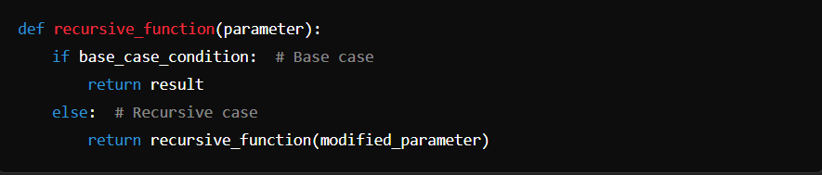

Example 1: Factorial Calculation
The factorial of a number nnn is n!=n×(n−1)!n! = n \times (n-1)!n!=n×(n−1)!.

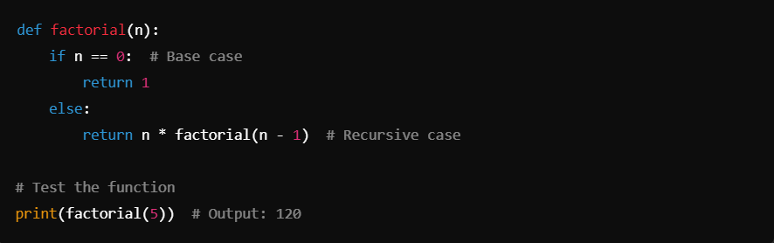
Example 2: Fibonacci Sequence
The Fibonacci sequence is a series where each number is the sum of the two preceding ones.

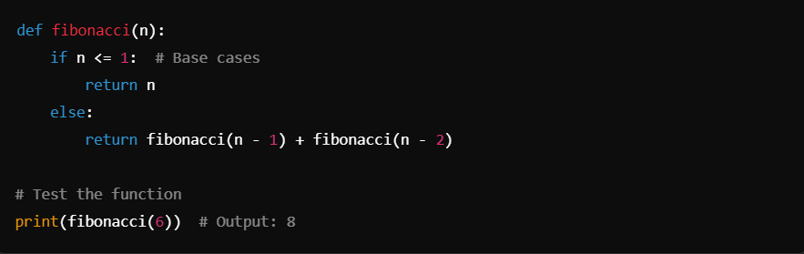

Understanding the Call Stack:
When a recursive function is called, each call is pushed onto the call stack. When the base case is reached, the calls are resolved in reverse order.

Benefits of Recursion:
- Simplifies complex problems by breaking them into smaller sub-problems.
- Useful for tasks like searching, sorting, and traversing data structures (trees, graphs).

Limitations of Recursion:
- Stack Overflow: Too many recursive calls can exceed Python's maximum recursion depth, causing a RecursionError.
- Performance: Recursive solutions can be less efficient due to repeated calculations.

Improving Recursive Functions:
- Memoization: Caching results of function calls to avoid redundant calculations.
- Tail Recursion (not supported natively in Python): A special form of recursion where the recursive call is the last operation in the function.

Example with Memoization:

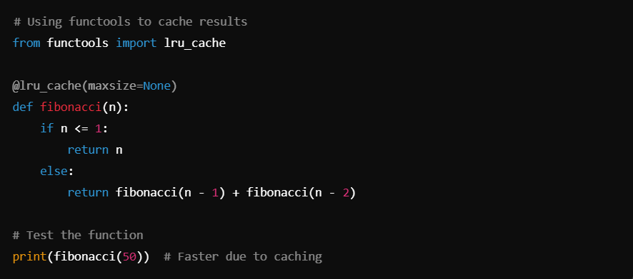

When to Use Recursion:
- Problems with repetitive sub-problems.
- When the solution can be expressed in terms of smaller sub-problems (divide-and-conquer approach).

File I/O

File I/O (Input/Output) in Python refers to reading from and writing to files. It enables persistent data storage, making information available even after the program ends.

1. Opening a File
To work with files, use the built-in open() function:

File Modes:
- 'r' - Read (default): Opens a file for reading.
- 'w' - Write: Opens a file for writing (overwrites if it exists).
- 'x' - Create: Creates a file, fails if it already exists.
- 'a' - Append: Opens a file for writing, appending to the end if it exists.
- 'b' - Binary mode: Reads/writes binary files.
- 't' - Text mode (default): Reads/writes text files.
- '+' - Read and write: Combines read and write modes.

2. Reading Files
Reading Methods:
- read(size): Reads the specified number of characters.
- readline(): Reads one line from the file.
- readlines(): Reads all lines into a list.

Example:

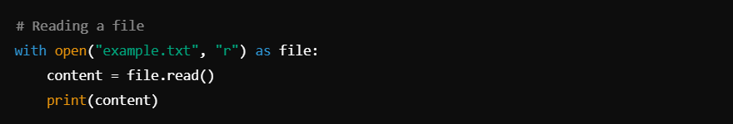

3. Writing to Files
Writing Methods:
- write(string): Writes a string to the file.
- writelines(list_of_strings): Writes multiple lines from a list.

Example:

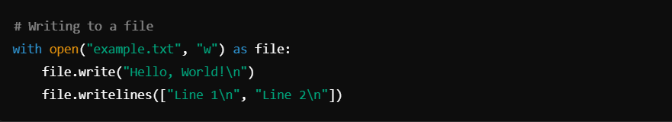

4. Appending to Files

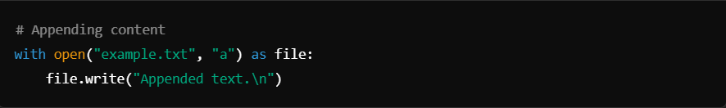

5. Closing a File
Always close files using close() or by using with to manage files automatically.

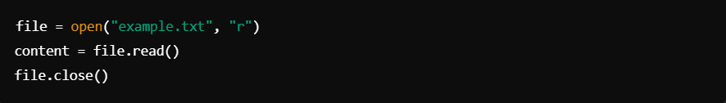

6. File Position
- tell(): Returns the current file cursor position.
- seek(offset, whence): Moves the file cursor.

Example:

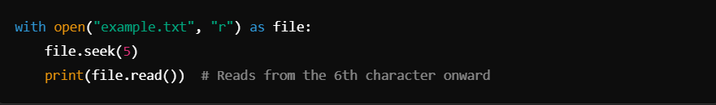

7. Working with Binary Files

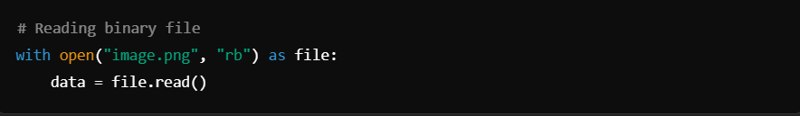

8.Handling File Exceptions

- Use try-except to avoid file operation errors:

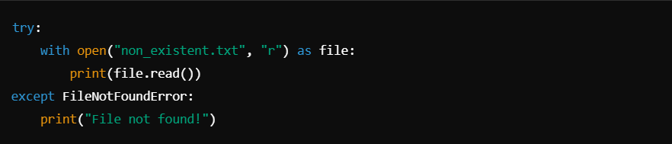

- Handling File Not Found Errors:
  - Use Case: When attempting to open a file that may not exist.
  - Example:

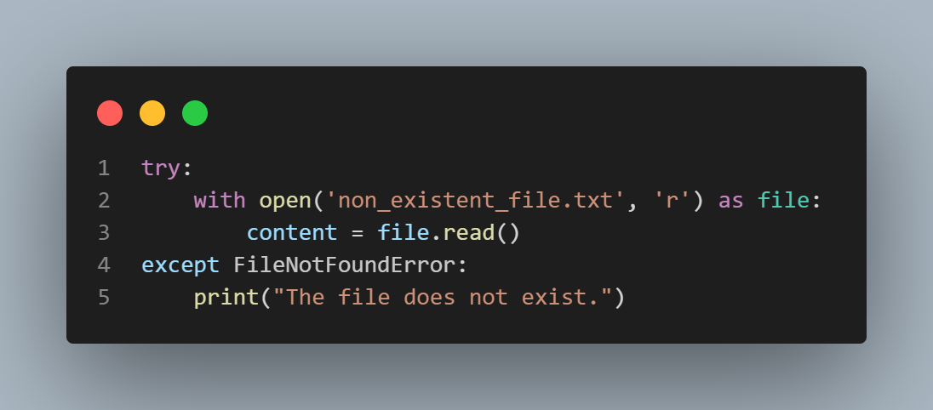

- PermissionError
  - Description: Raised when there is a permission issue while trying to open a file.
  - Example:

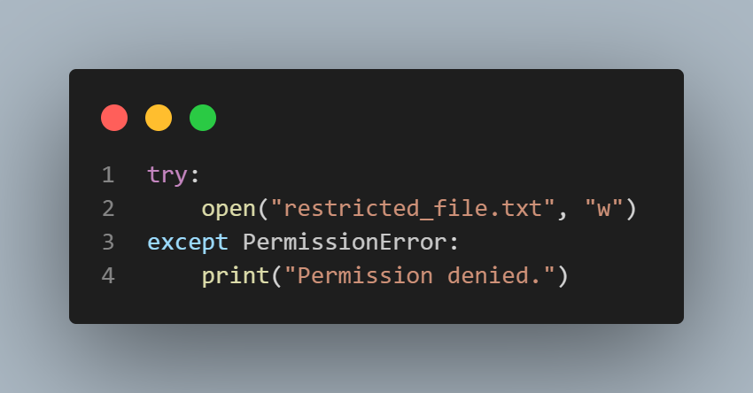

- IsADirectoryError
  - Description: Raised when a directory is expected but a file is found.
  - Example:



- NotADirectoryError
  - Description: Raised when a file is expected but a directory is found in a path.
  - Example:



Other I/O Operations

Combination file I/O operations involve reading and writing in the same file session using file modes like 'r+', 'w+', 'a+', and 'x+'. These modes enable reading and writing simultaneously.

1. File Modes for Combination Operations

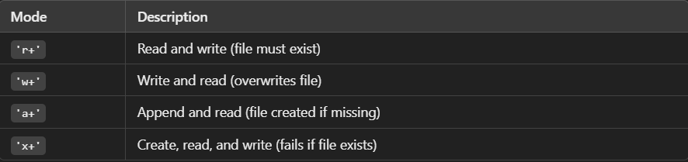

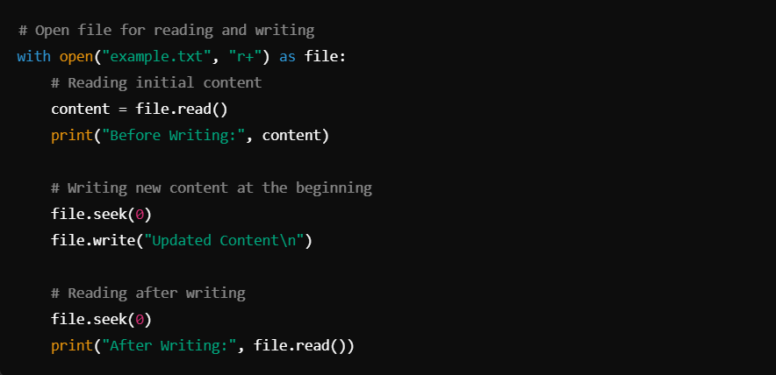

Example 2: Writing and Reading ('w+')

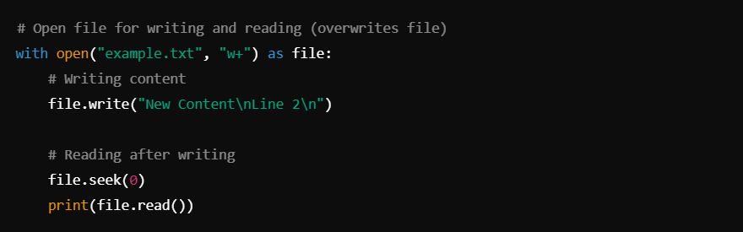

Example 3: Appending and Reading ('a+')

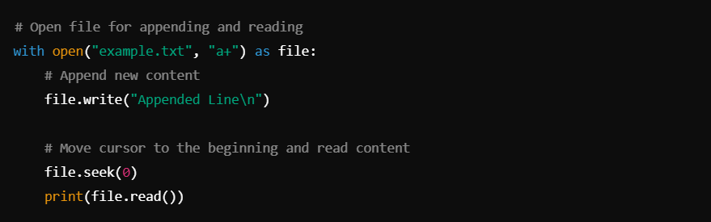

Example 4: Creating, Reading, and Writing ('x+')

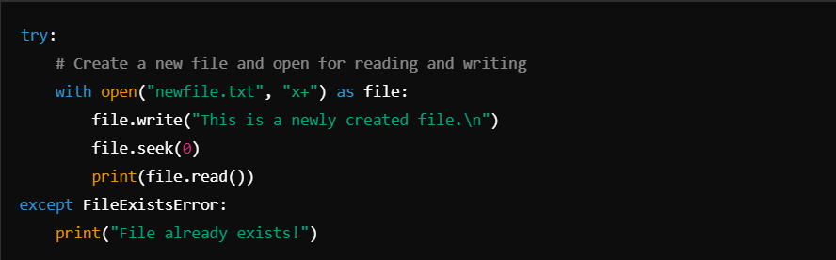

Key Considerations
- Always use file.seek(0) when switching between reading and writing to reset the file pointer.
- Use with open() to avoid manual file closure.
- Handle exceptions like FileNotFoundError or FileExistsError as needed.

Object Oriented Programming (00PS):

1. What are Classes and Objects?
Class
- A class is a blueprint or template for creating objects. It defines a structure to hold attributes (data) and methods (functions) that define the behavior of objects.
- In Python, a class is defined using the class keyword.
Object
- An object is an instance of a class. It represents a specific implementation of the blueprint (class) with real data.
- Multiple objects can be created from the same class, each with its own unique data.

2. How to Define a Class
The syntax for defining a class in Python:

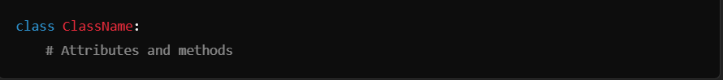

Example:

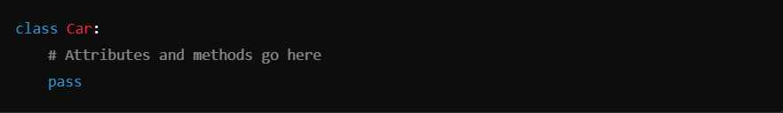

3. Creating an Object
To create an object of a class, use the following syntax:

Example:

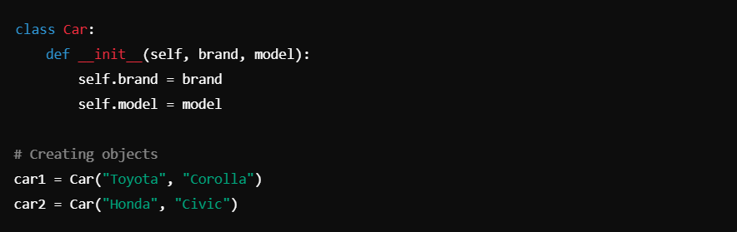

4. Instance Variables and Class Variables
Instance Variables
- Defined inside methods (usually __init__) and are unique to each object.
- Represent the data specific to each instance.

Example:

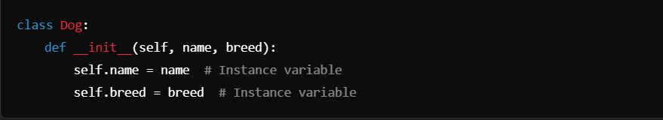

Class Variables
- Defined outside all methods within the class and are shared across all objects of the class.
- Represent properties common to all instances of the class.

Example:

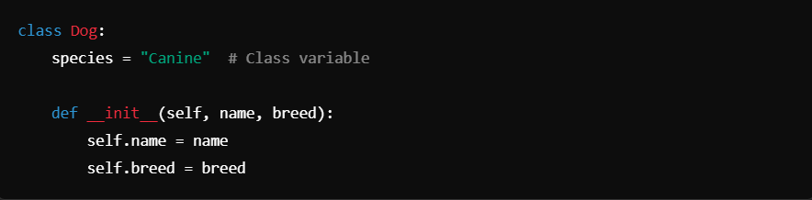

5. Methods in a Class
a. Instance Methods
- Operate on an instance of the class and can access instance variables via self.

Example:

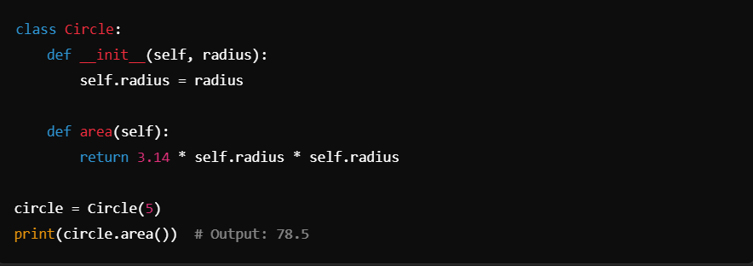

b. Class Methods
- Operate on the class itself, not on an instance. Defined using the @classmethod decorator.
- Use cls as the first parameter instead of self.

Example:

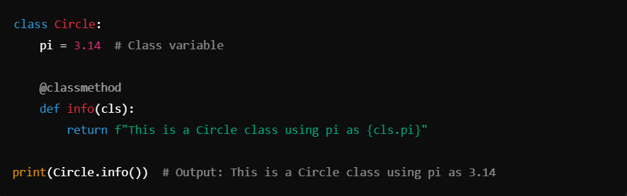

c. Static Methods
- Defined using the @staticmethod decorator.
- Do not operate on instance or class variables. They are independent utility methods.

Example:

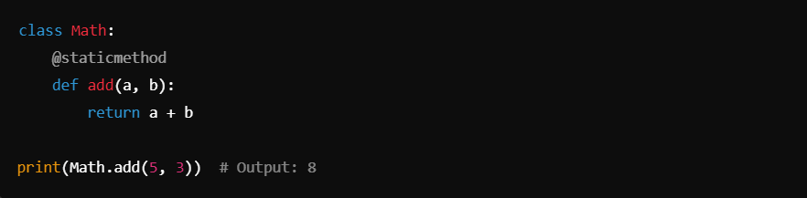

6. The __init__ Constructor
- A special method in Python called when an object is created.
- Used to initialize the object's attributes.

Example:

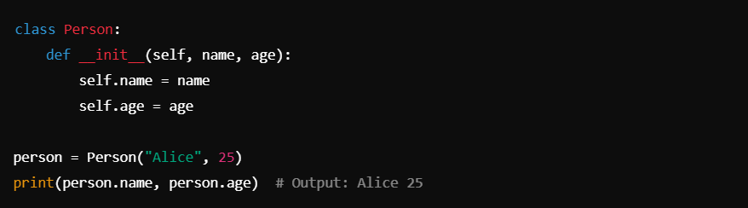

7. Accessing Attributes and Methods
Accessing Attributes
Attributes of an object can be accessed using the . operator.

Example:

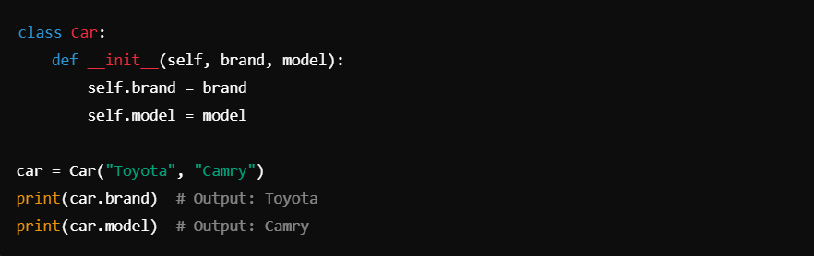

Accessing Methods
Methods of an object can also be called using the . operator.

Example:

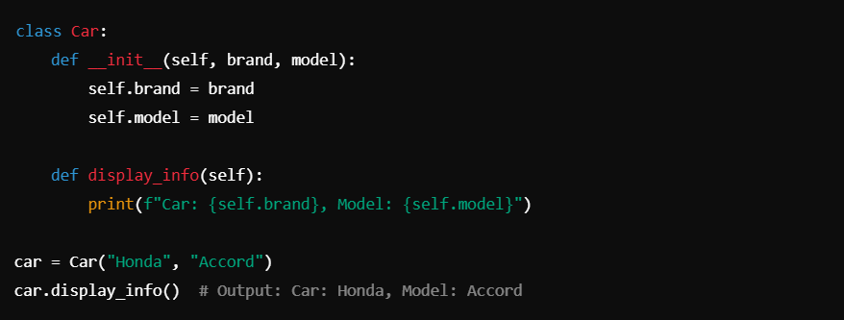

8. self Keyword
- self is a reference to the current instance of the class.
- It must be the first parameter of instance methods.
- Used to access attributes and methods within the class.

Example:

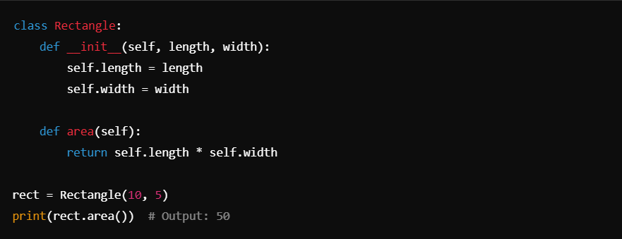

9. del Keyword
- Objects can be deleted using the del keyword.
- If needed, you can define a __del__ method (destructor) to perform cleanup before the object is destroyed.

Example:

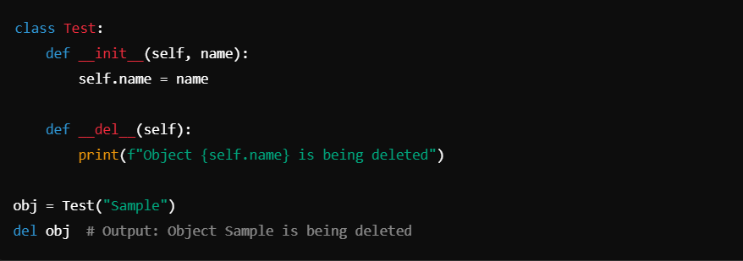

10. Example: Combining All Concepts

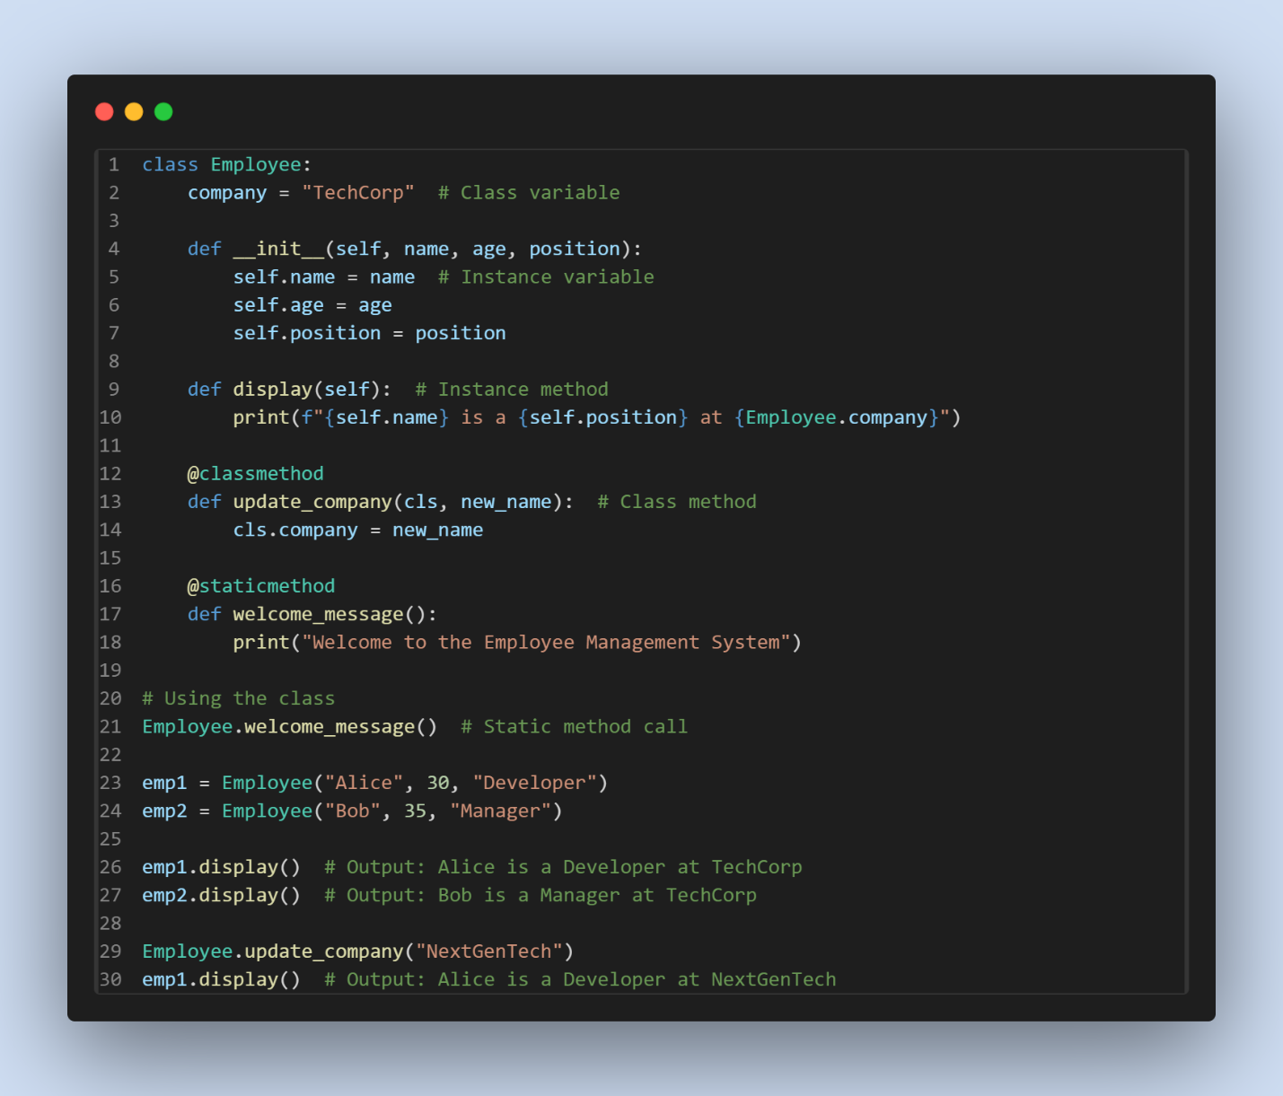

Abstraction:

Definition of Abstraction
Abstraction is a fundamental concept of Object-Oriented Programming (OOP) that focuses on hiding the implementation details of a class and showing only the essential features to the user.
In Python, abstraction allows us to create classes and objects that provide only relevant data and methods, while the internal implementation details remain hidden. This makes the code cleaner, more understandable, and easier to maintain.

Key Characteristics of Abstraction
- Hides Implementation Details: Only the functionality is exposed, not how it is implemented.
- Reduces Complexity: Focuses on what an object does rather than how it does it.
- Enhances Security: Encapsulation works with abstraction to restrict access to sensitive data.
- Improves Maintainability: Simplifies updates or changes by isolating the implementation.

How Abstraction Works in Python
Python uses abstract classes and interfaces to implement abstraction. Abstract classes in Python are created using the abc module (short for "Abstract Base Classes").

Abstract Class
An abstract class is a blueprint for other classes. It cannot be instantiated directly and must be subclassed. Abstract classes can have:
- Abstract methods: Methods declared but not implemented.
- Concrete methods: Fully implemented methods.

Syntax of Abstract Class
- Import the abc module:

- Define an abstract class using inheritance:

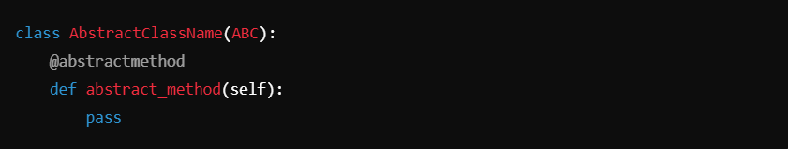

- Create subclasses to implement abstract methods:

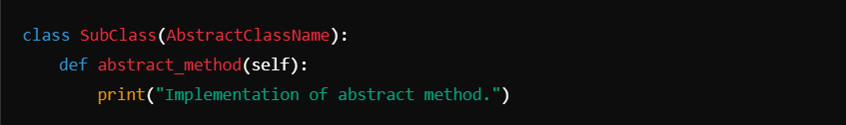

Example of Abstraction in Python

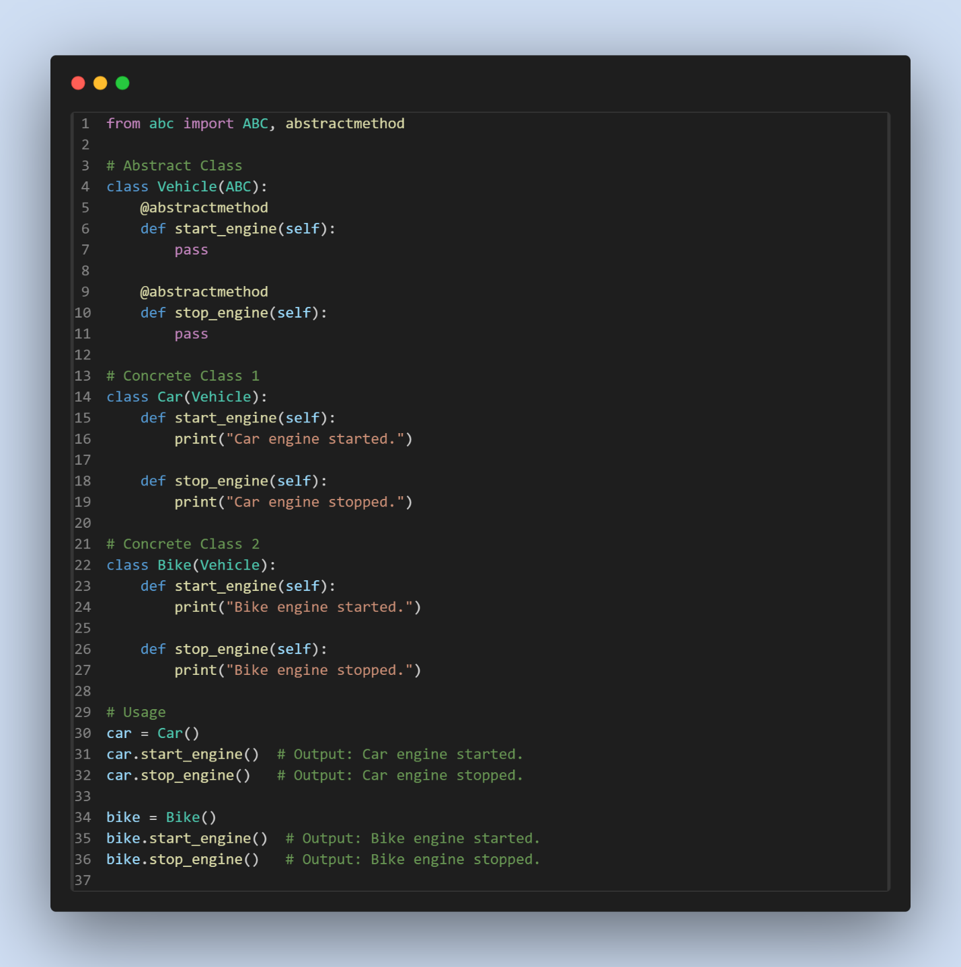

Explanation of the Example
- The Vehicle class is abstract and defines the structure with two abstract methods: start_engine and stop_engine.
- Concrete classes (Car and Bike) inherit from Vehicle and provide their own implementations for these methods.
- This ensures every subclass of Vehicle adheres to a common interface while allowing specific behavior.

Advantages of Abstraction
- Focus on Essential Features: Provides a clear and simplified interface.
- Code Reusability: Abstract classes can define reusable behaviors.
- Improved Security: Hides sensitive or unnecessary details from the end-user.
- Enhanced Flexibility: Allows for easier implementation changes without affecting the interface.

Real-Life Analogy
Think of a TV remote:
- You can use buttons like "Power," "Volume Up," and "Channel Down" without knowing the internal circuitry.
- The remote abstracts the complexity and provides a simple interface for the user.

Practical Use Cases
- Software Development Frameworks: Abstract classes define the skeleton of application workflows.
- API Design: Exposing only necessary endpoints to users while hiding internal mechanisms.
- Device Drivers: Ensuring all devices adhere to a standard interface.

Difference Between Abstraction and Encapsulation

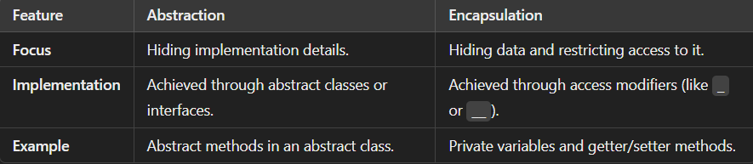

Common Mistakes
- Direct Instantiation of Abstract Classes: Attempting to create an object of an abstract class will result in an error:

- Omitting Abstract Method Implementation: If a subclass fails to implement all abstract
methods, it will also become abstract and cannot be instantiated.

Encapsulation:

Encapsulation is one of the fundamental principles of Object-Oriented Programming (OOP). It refers to bundling the data (attributes) and the methods (functions) that operate on that data into a single unit, typically a class. Encapsulation helps protect the data from unauthorized access and provides controlled ways to manipulate it.

Key Concepts of Encapsulation
- Data Hiding:
  - Encapsulation allows restricting direct access to some of the class components, keeping sensitive data safe from unintended interference and misuse.
  - This is achieved using access modifiers.
- Access Modifiers in Python: Python provides three types of access specifiers:
  - Public: Accessible from anywhere.
  - Protected: Accessible within the class and its subclasses (denoted by a single underscore _).
  - Private: Accessible only within the class (denoted by a double underscore __).
- Getter and Setter Methods:
  - These methods allow controlled access to private/protected attributes.
  - Getters retrieve the value of an attribute.
  - Setters modify the value of an attribute while ensuring proper validation.

Implementation of Encapsulation in Python
1. Public Access Modifier
Public attributes and methods are accessible from anywhere in the program.

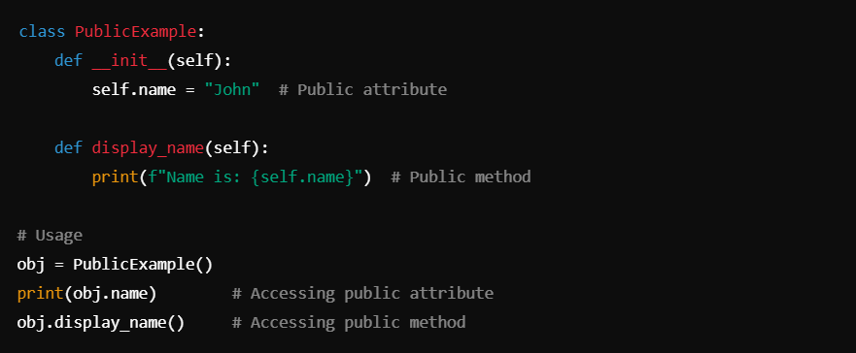

2. Protected Access Modifier
Protected attributes and methods are accessible within the class and its subclasses.

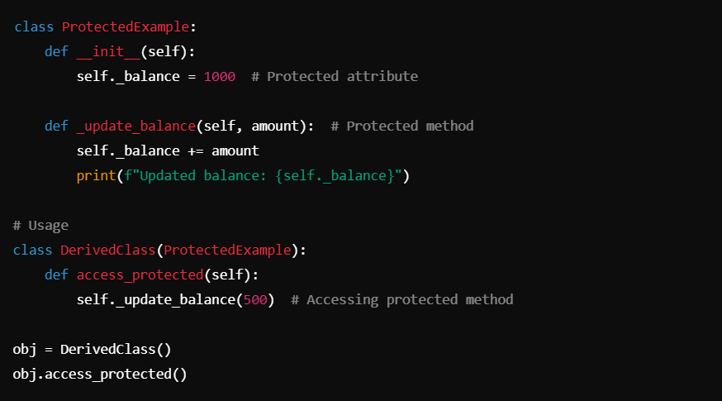

3. Private Access Modifier
Private attributes and methods are accessible only within the class. They are declared using double underscores (__).

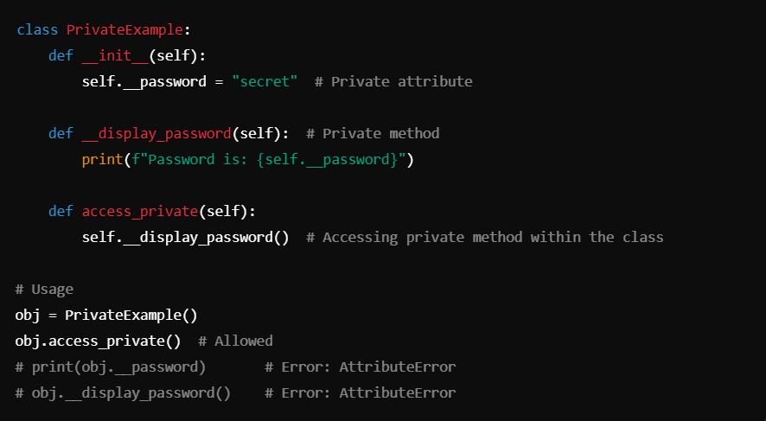

Using Getters and Setters for Encapsulation

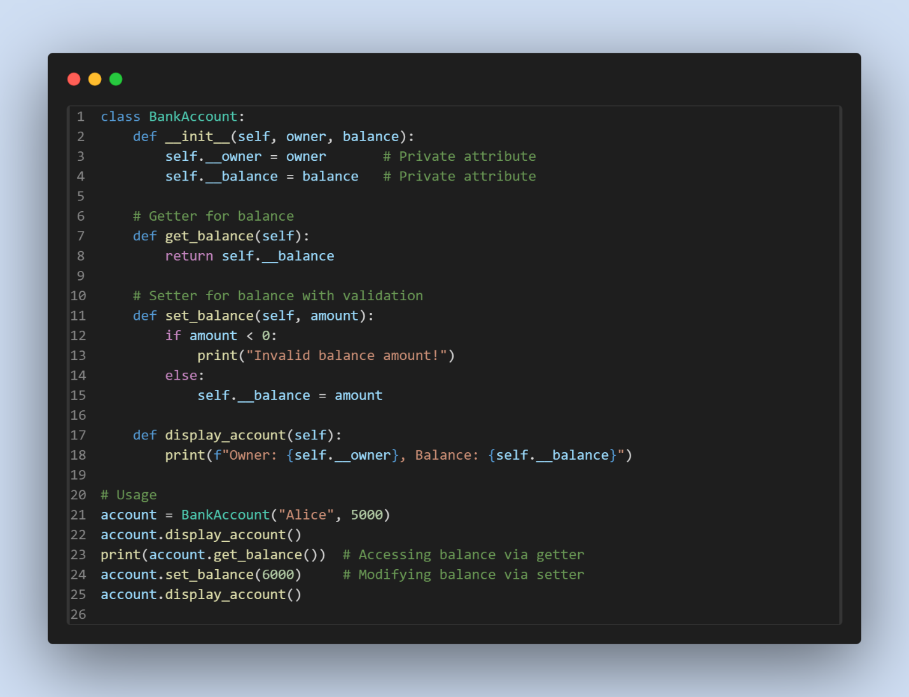

Advantages of Encapsulation
- Data Security: Sensitive data is hidden, preventing accidental or malicious modification.
- Controlled Access: Access to class data is managed through getters and setters.
- Code Maintainability: Changes in data implementation do not affect external code interacting with the class.
- Modularity: Encapsulation promotes modular programming by keeping data and methods together.
- Improved Flexibility: Validation and logic can be added when accessing or modifying data.
Real-Life Example of Encapsulation
Encapsulation in a Student Management System

