**Working with Directories**

1. Enter the command **cd /** and then **ls** and then hit **Enter** key

cd / - This command changes the directory to root directory

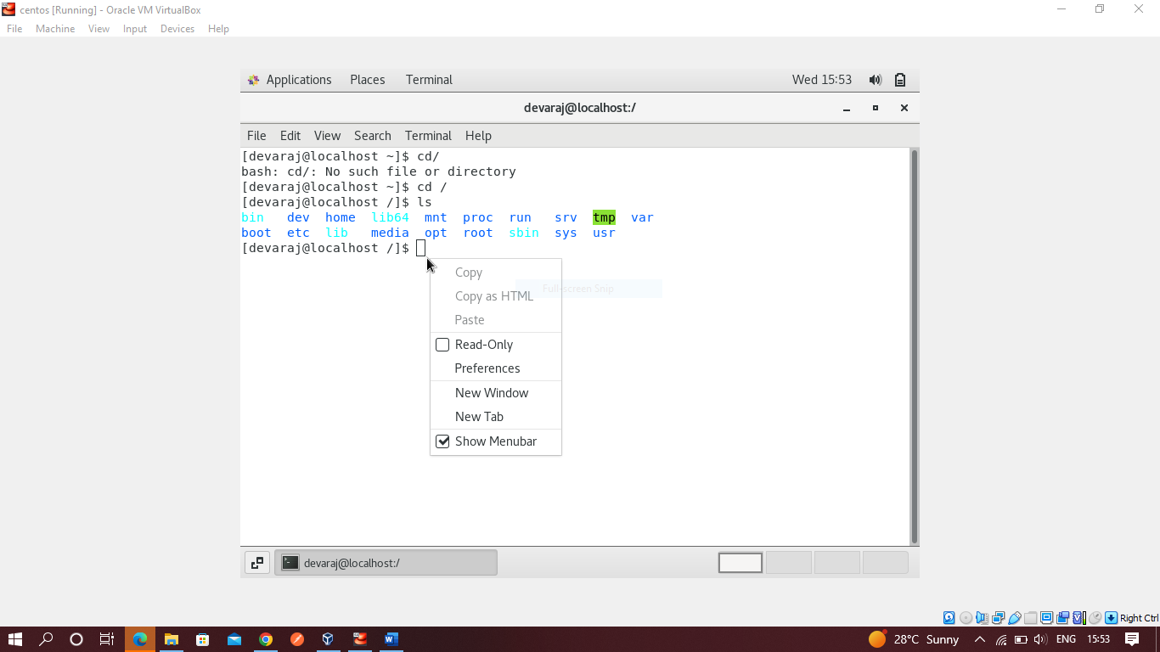

1. Enter the command now **cd /home** and then hit **Enter** key.

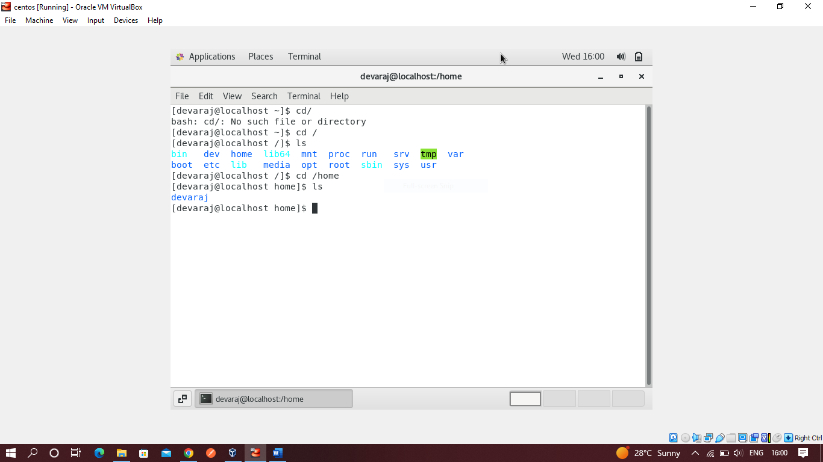

It enters in home directory where there is folder called Devaraj

1. Enter **cd ..** and hit **Enter** key

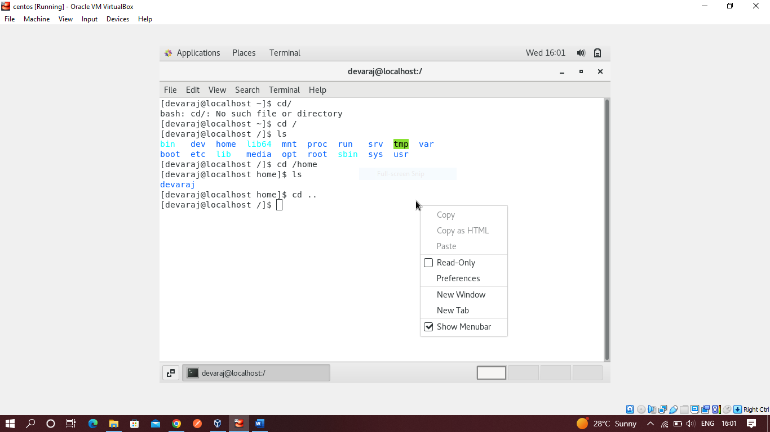

cd .. – It goes back one directory

1. Now enter **cd /var/www/html** and then type **cd** and hit **Enter** key

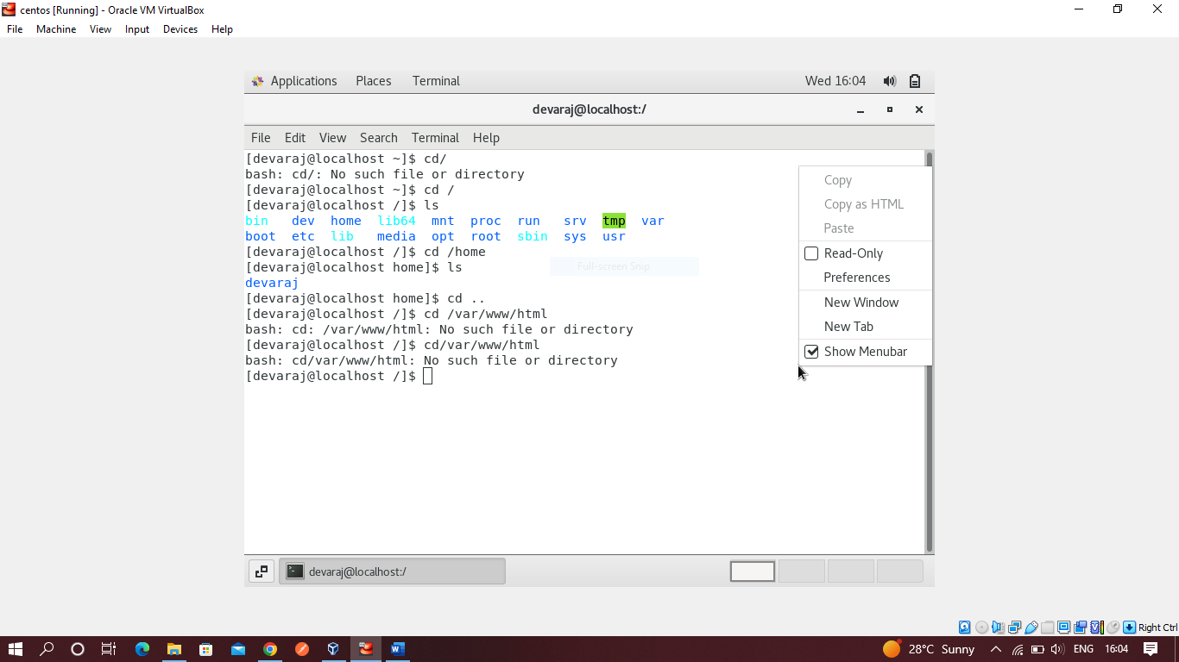

1. Now type **cd /root** and then hit **Enter** key

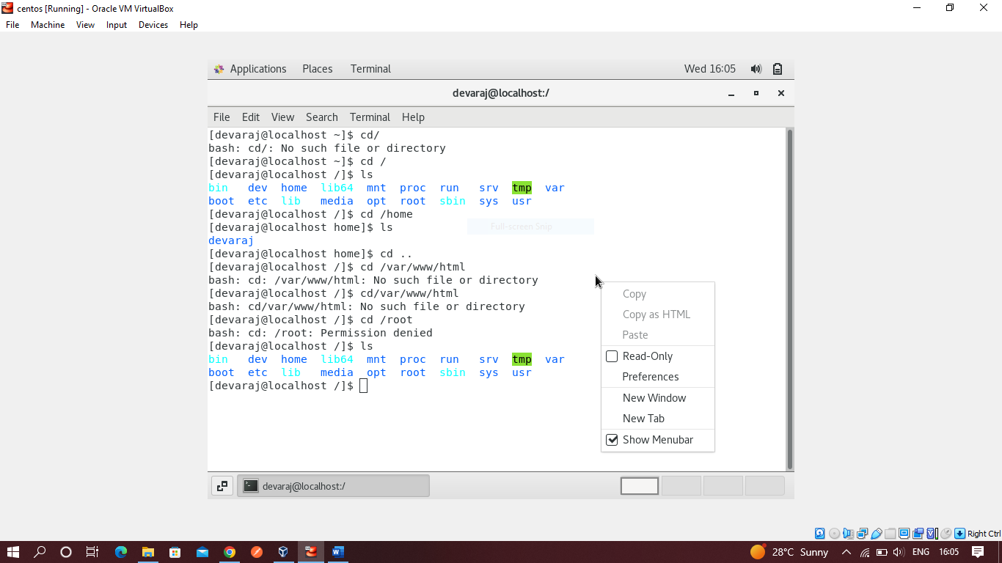

Iam getting permission denied as user do not have execute power

**Working with File Listing**

1. Go to **cd /etc** and type **ls**

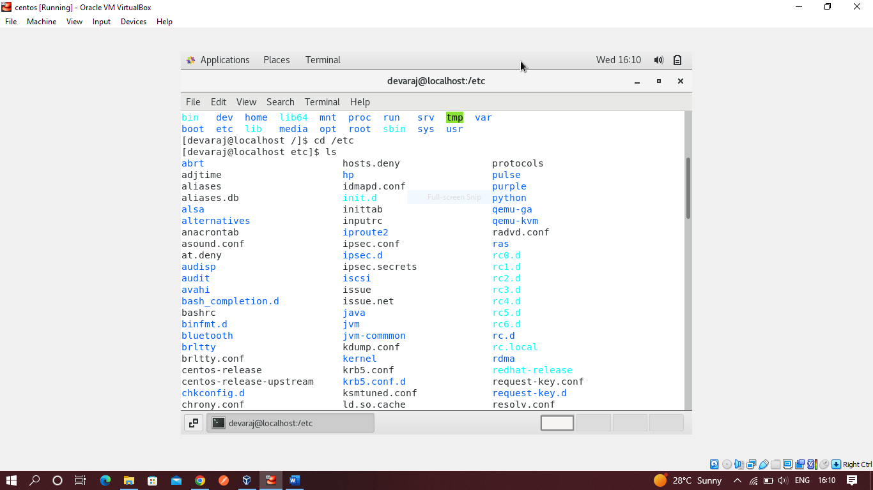

1. Then type **ls -al** and hit **Enter** key

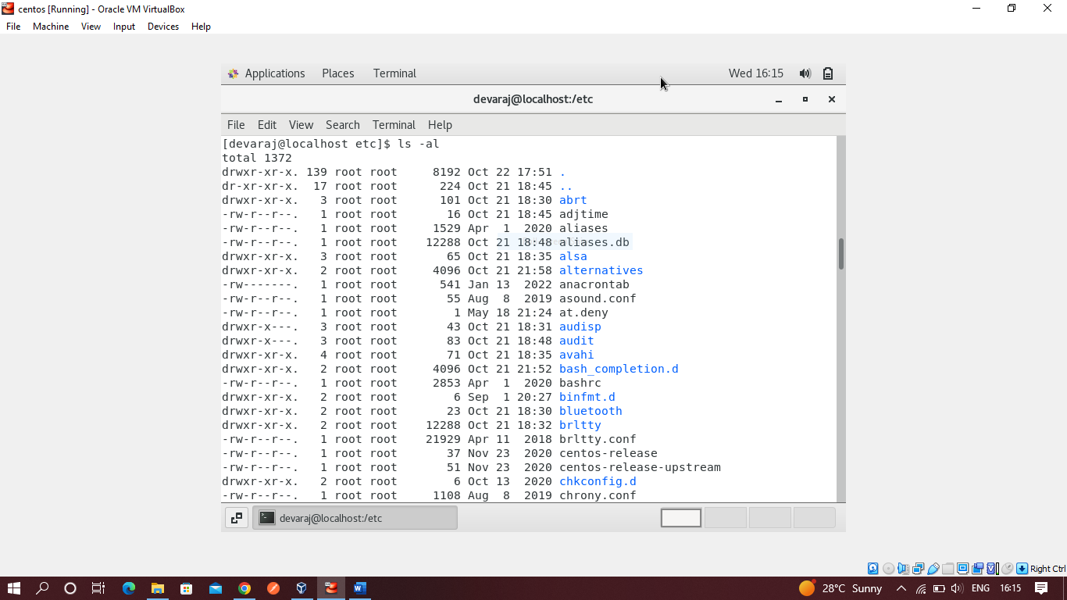

It displays all root files and names, size of them with date and permissions of file whether there are read-only, write-only or executable files.

1. Then use **ls -i** and hit **Enter** key

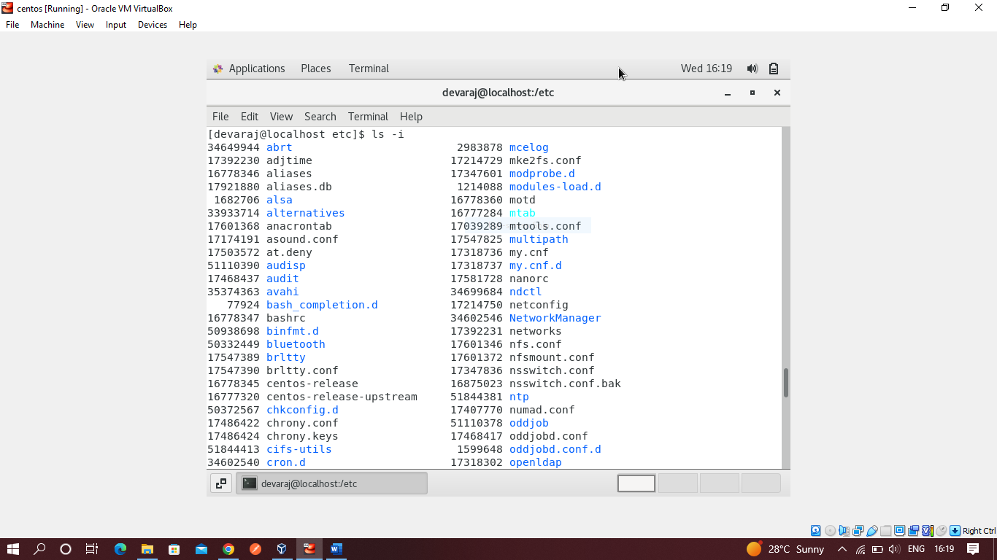

It displays inode number of files and directories.

1. Then use **ls –help** and see other options about **ls** command

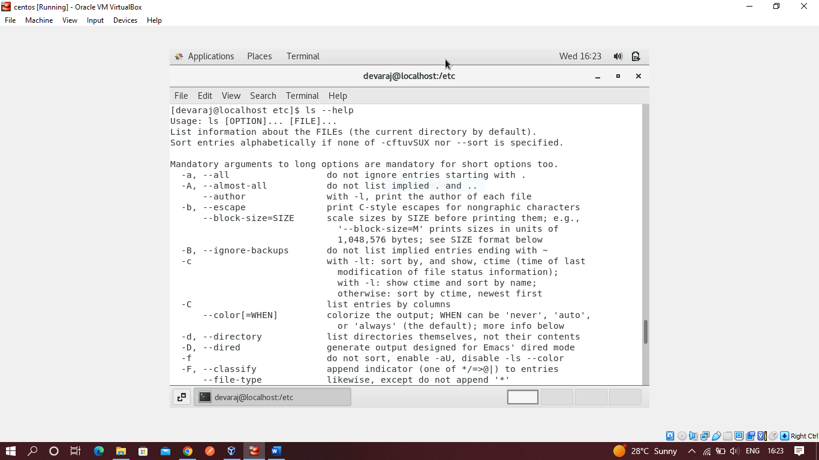

It displays all the commands like what else we can do with ls.

**Know where you are and where you working**

1. Open terminal after restart the linux

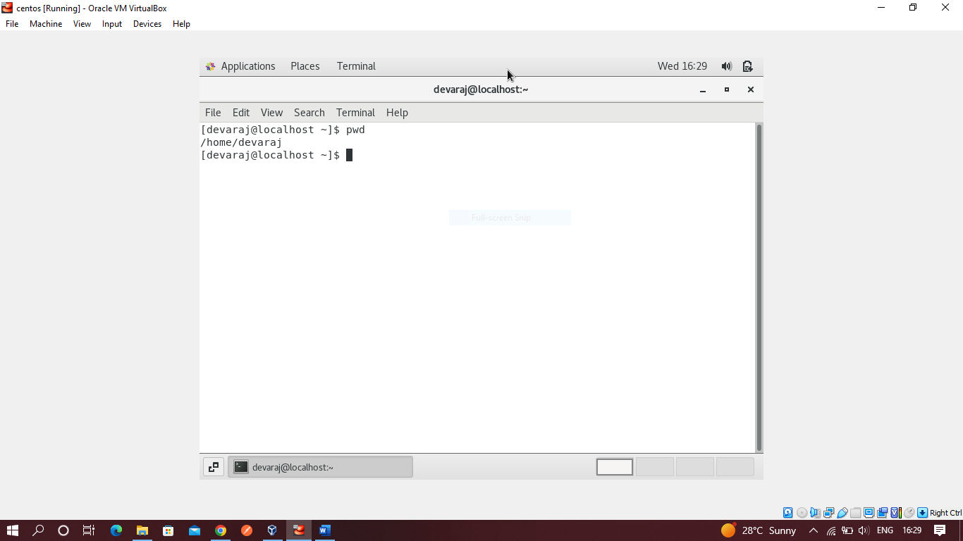

1. Now use **cd /var** and hit **Enter** key

