Getting Started with Azure Logic Apps

Task 1: HTTP Request-Response Demo
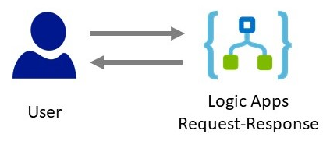

Task 2: Store Data into Storage Account
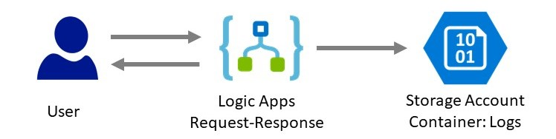

Task 3: Trigger Email when Data Inserted into Storage Account
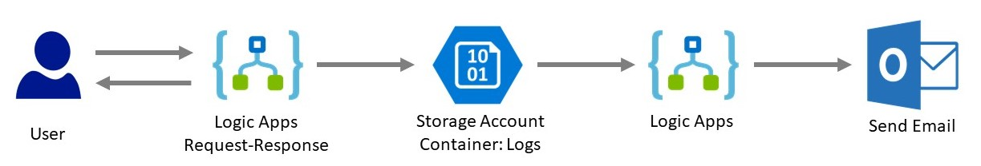

Task 1: HTTP Request-Response Demo
Step 1: Open Microsoft Azure Portal
https://portal.azure.com/

Step 2: Create Logic Apps
+ Create a resource -> Integration -> Logic App
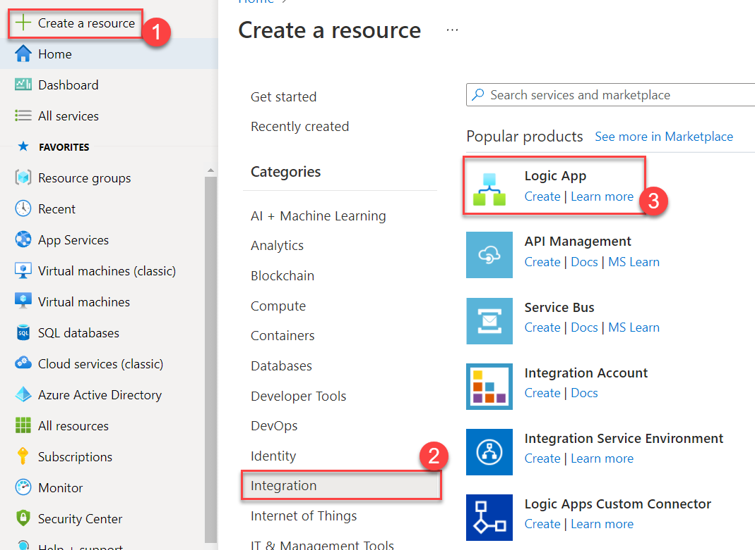

Step 3: Create New Logic Apps
Subscription: Choose any active Subscription
Resource Group: Create New Ex. LogicAppDemoRG
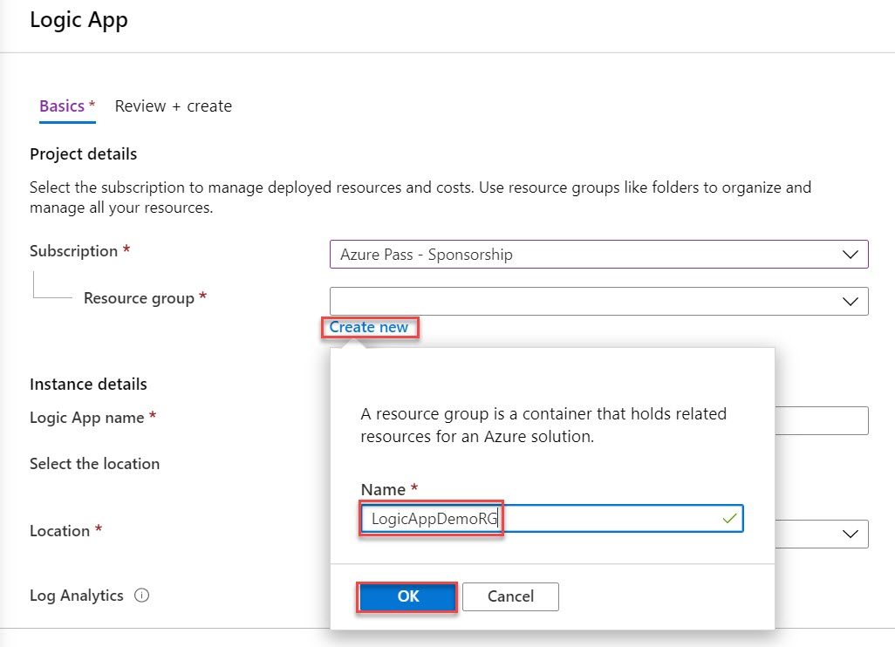

Type: Consumption
Logic App Name: enter any logic app name Ex. request-response-logicapp
Location: Choose nearest location Ex. Southeast Asia
Enable Log Analytics: No
Click on Review + Create button

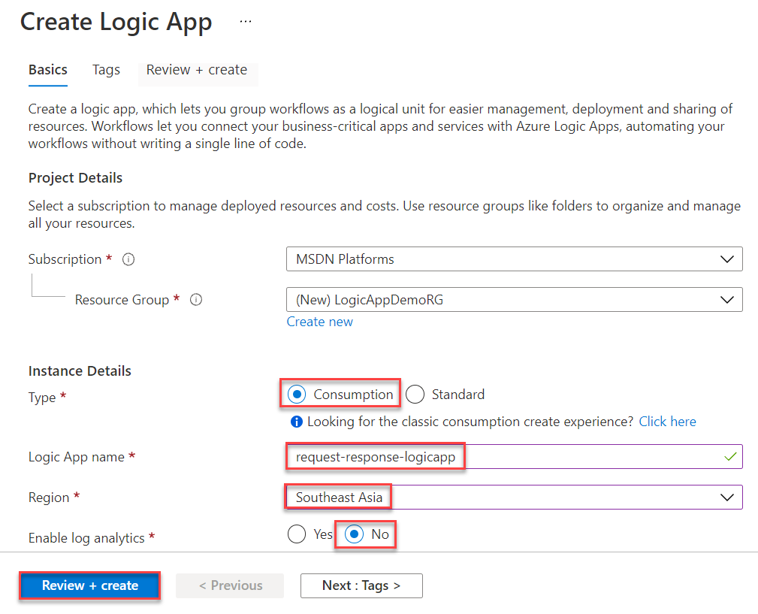

Step 4: Review all and click on Create button
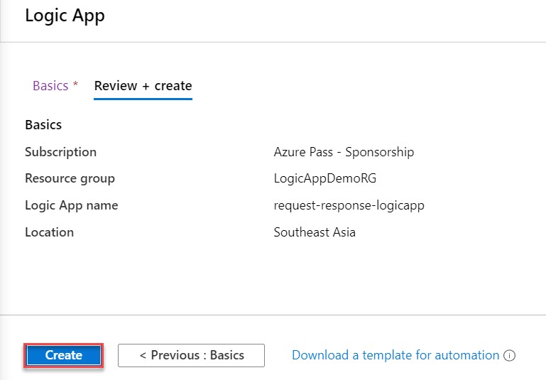

Wait for couple of seconds to deploy logic apps on Azure.
Click on Go to resource button.
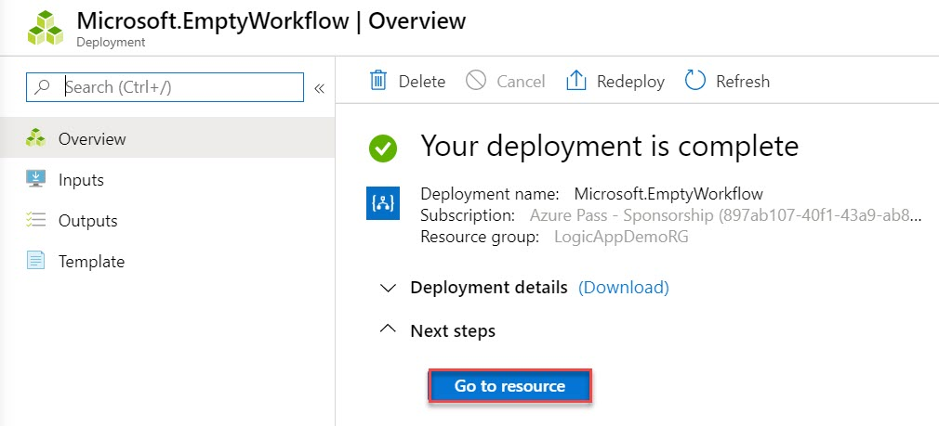
Step 5: Select Blank Logic App option
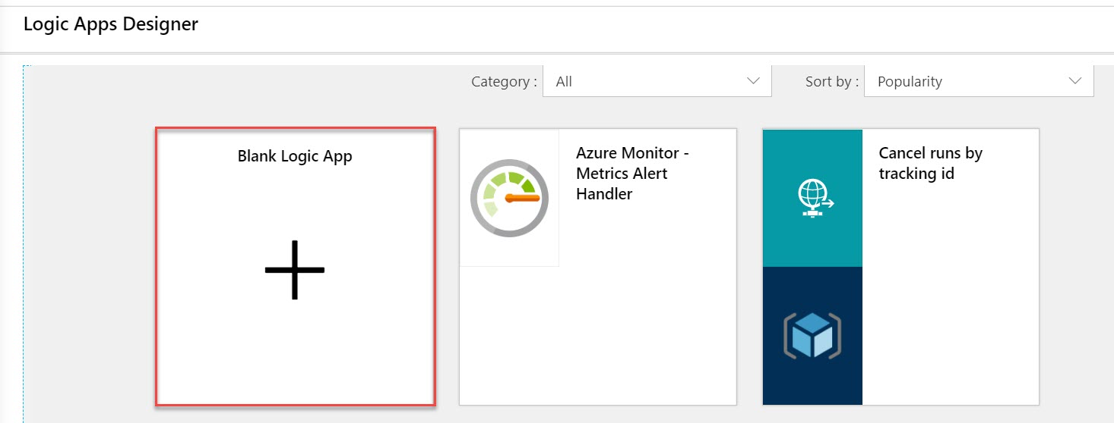

Step 6: Select All tab and select Request connector from list
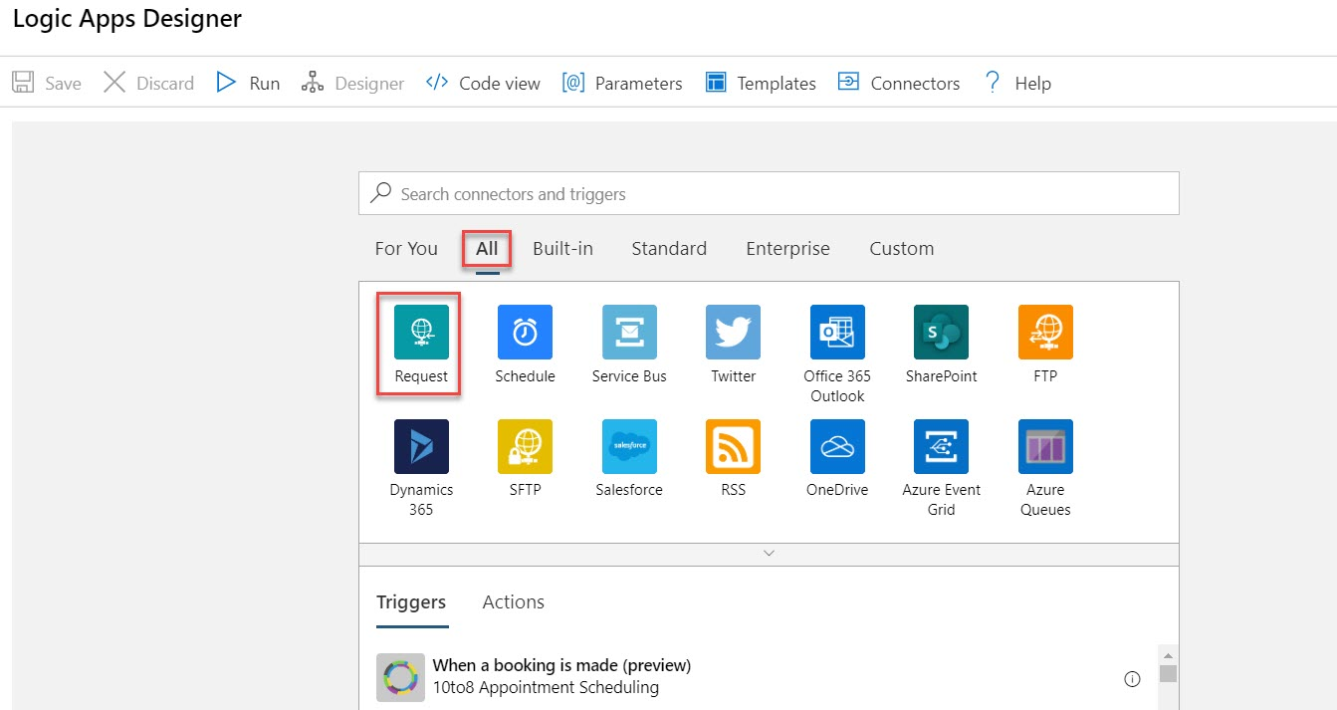

Select When a HTTP request is received under Triggers.
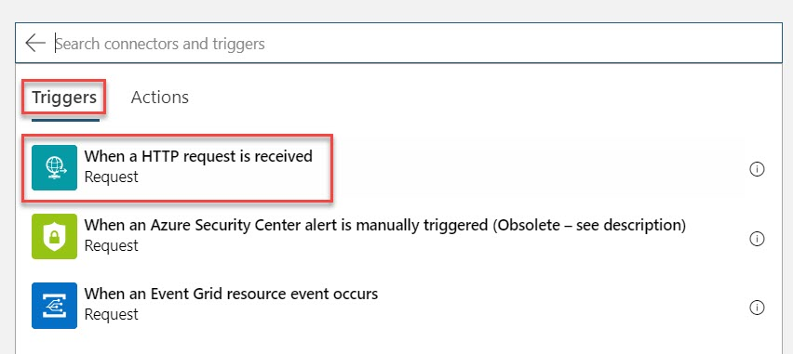

Select drop-down menu and select Method option
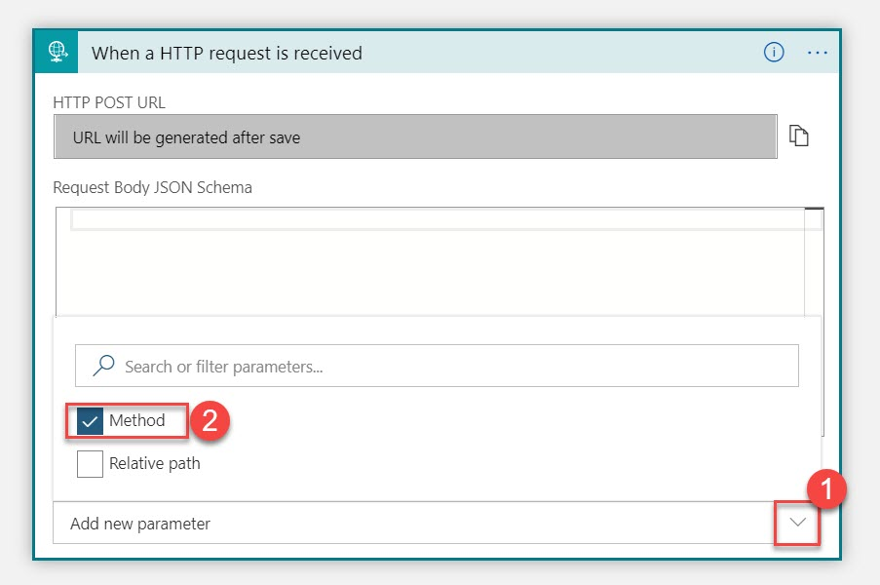

Choose Method: GET
Click on Save button
Note: it’s a good practice to save every time when we will add any new connector.
Click on + Next step button
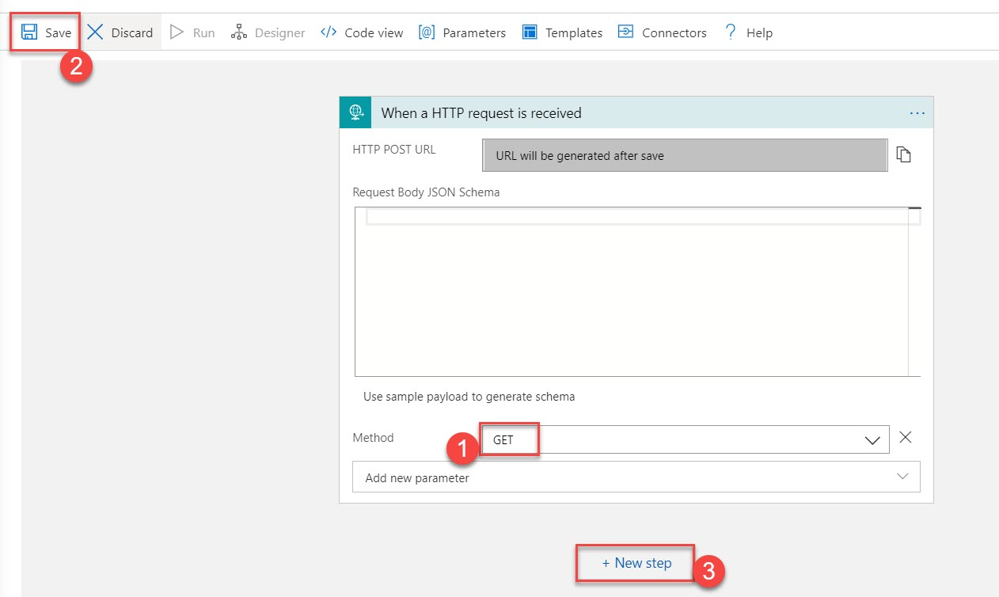

Step 7: After that add Actions
Select All tab -> Actions -> Select Response
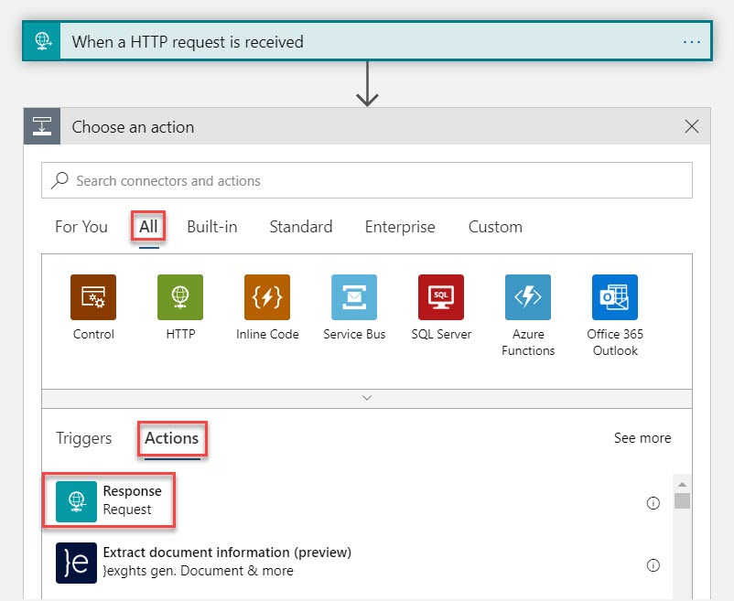

Enter Body: Hello World!!!
Click on Save button
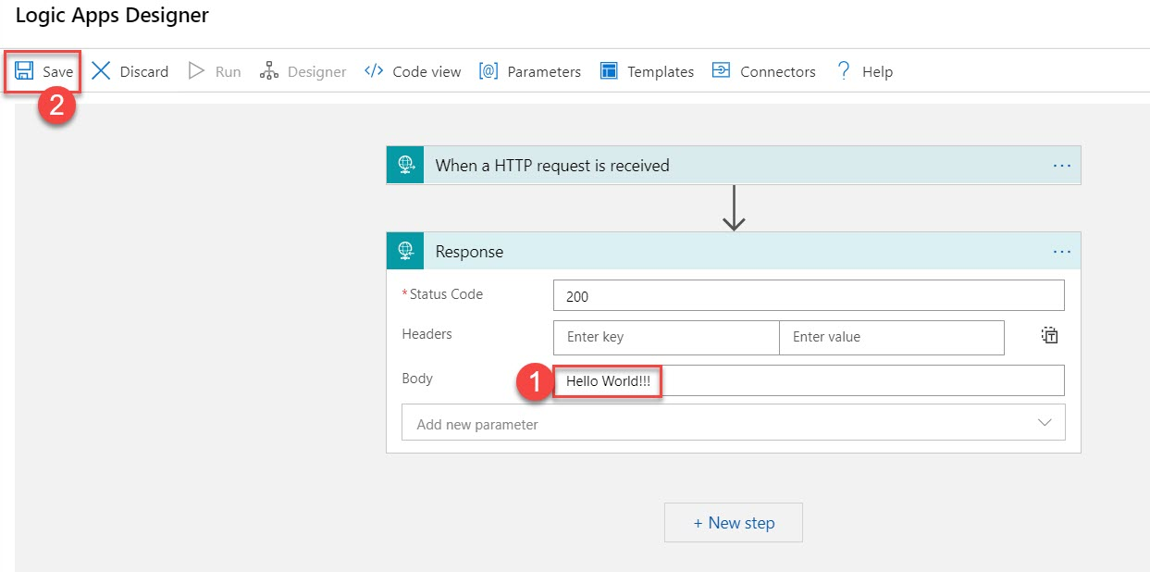

Step 8: Again, click on Trigger: When a HTTP request is received
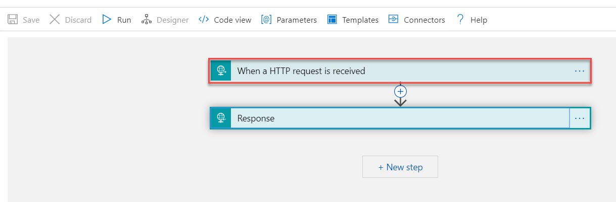

After clicking on Save button automatic URL will generate. Click on Copy button
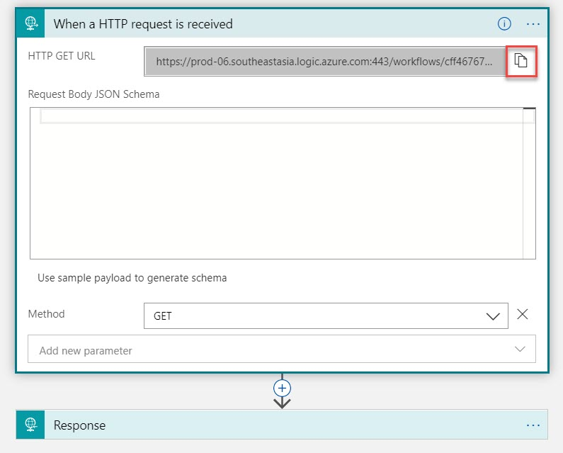

Step 9: Open another tab in browser and paste that link.
Output will be Hello World!!!
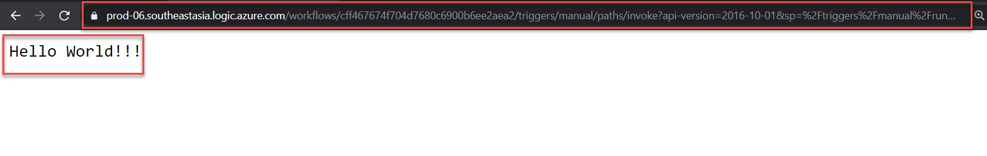

Step 10: Navigate to Logic Apps
Select Runs History tab and click on Refresh button
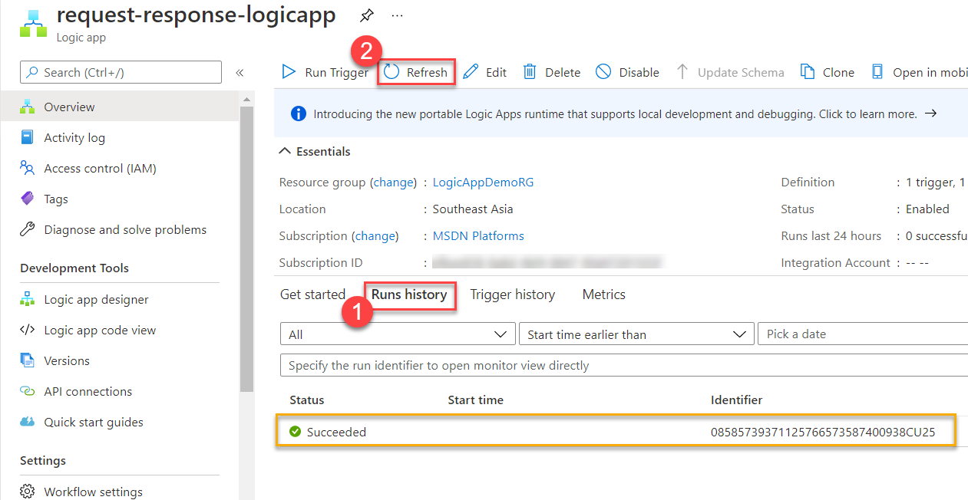

Verify Input and Output
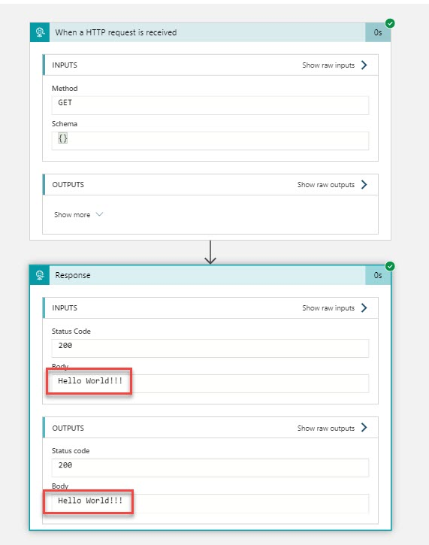

Step 11: Click on Edit option
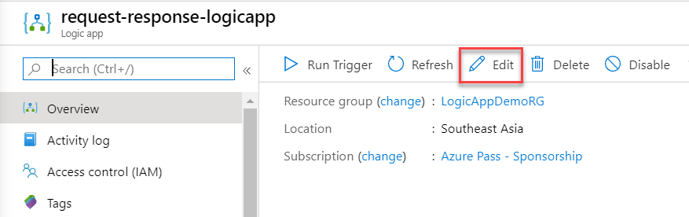

Step 12: Select When a HTTP request is received Trigger
Again, select drop-down option
Select Relative Path option
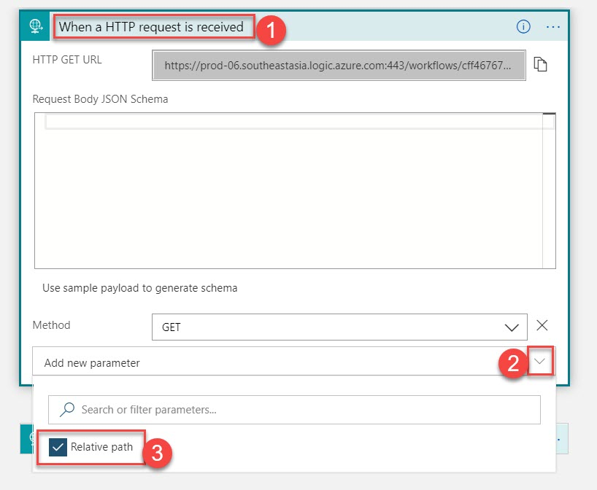

Add Relative Path: /{name}
So dynamic name can submit
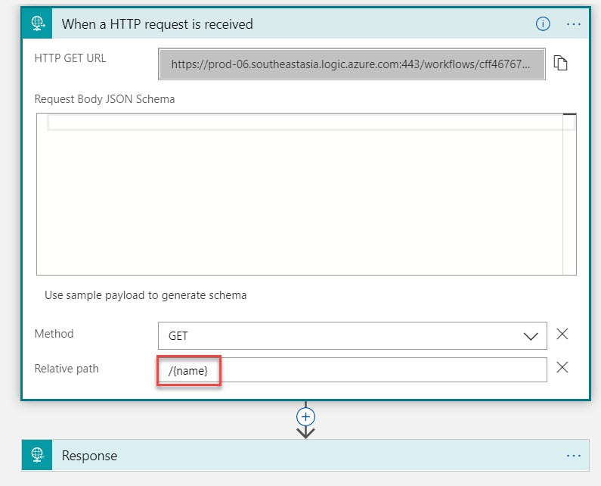

Step 13: Select Response action and modify Body section
Remove World and update with name as below:
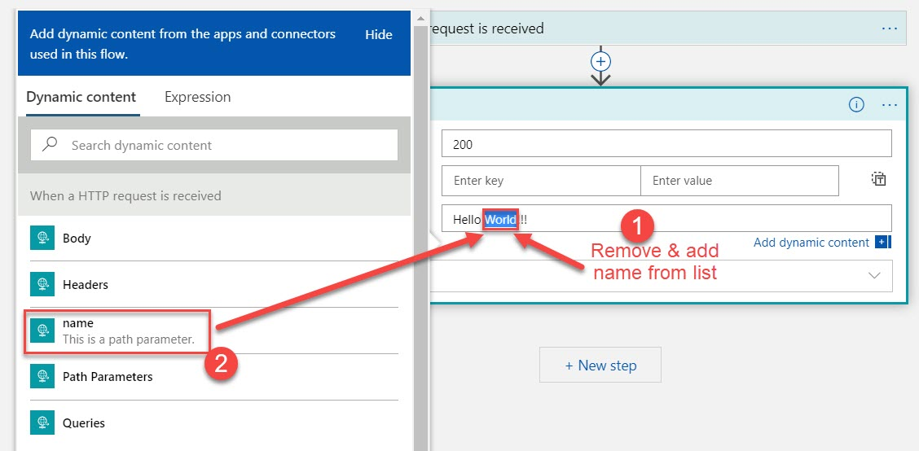

After updating Body section, click on Save option
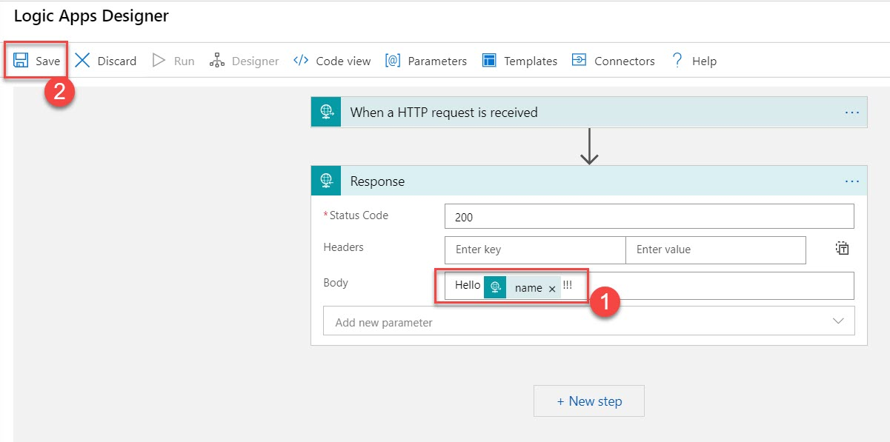

Step 14: Again, Select HTTP Request trigger and copy updated HTTP GET URL
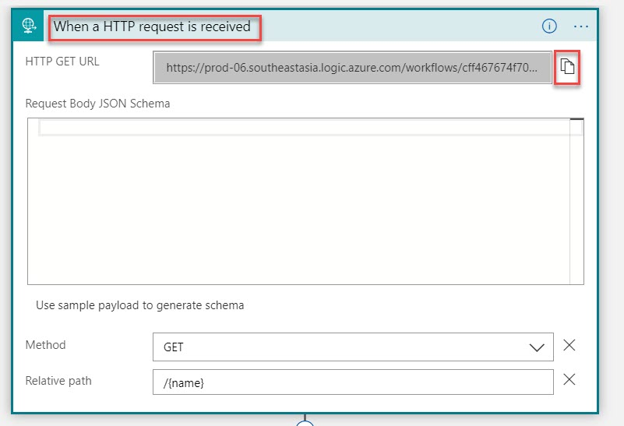
Step 15: Navigate to {name} parameter
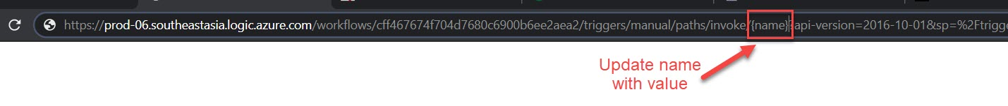

Update value with any text Ex. LogicApps
Press Enter key to get updated output or to start logic app workflow
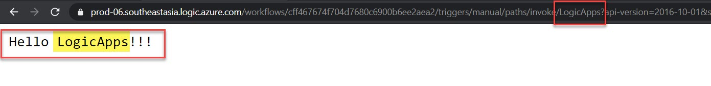

Task 2: Store Data into Storage Account
Step 16: Create New Storage account
Open another tab in your browser and open https://portal.azure.com/
+ Create a resource -> Get Started -> Storage account
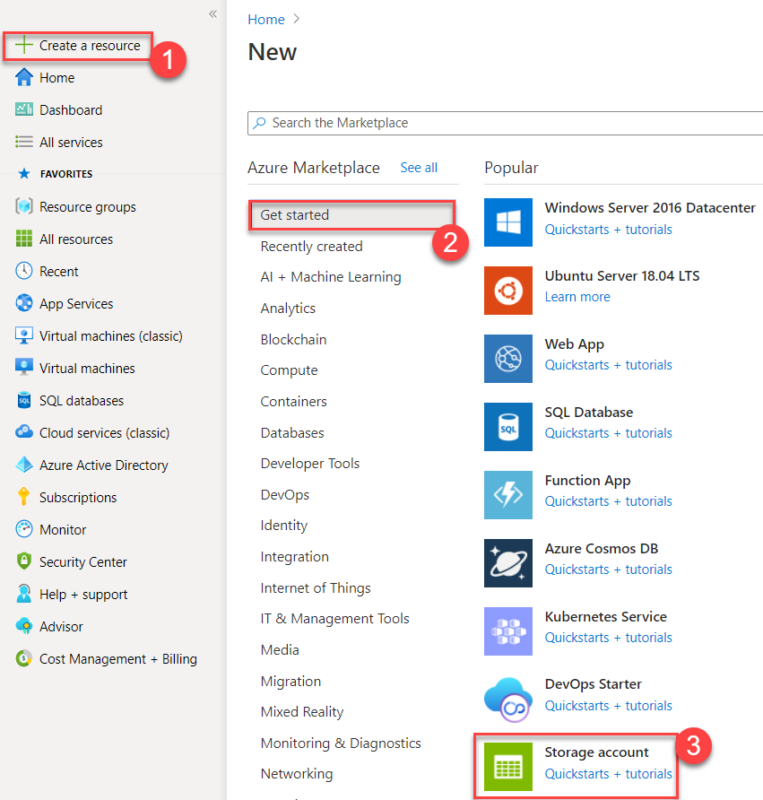

Step 17: Subscription: Choose same subscription where you have deployed Logic Apps
Resource Group: Choose Existing Resource Group Ex. LogicAppDemoRG
Storage Account Name: Enter unique name Ex. logicappstrg
Location: Choose logic app location Ex. (Asia Pacific) Southeast Asia
Performance: Standard
Replication: Locally-redundant storage (LRS)
Click on Review + Create button

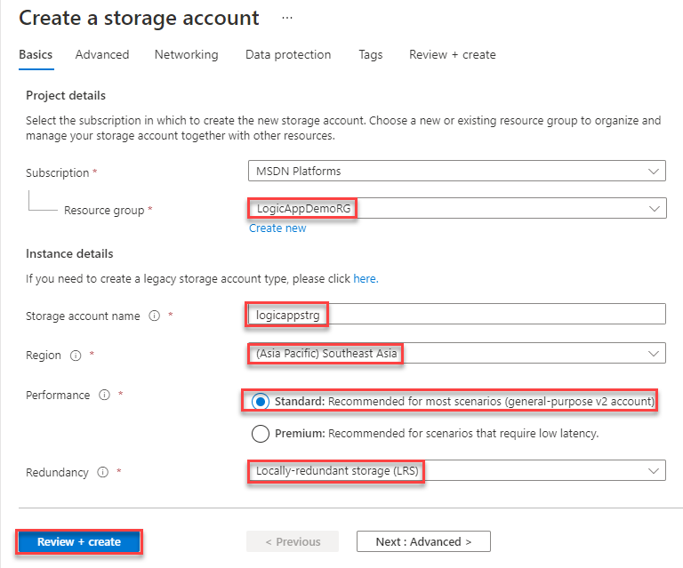

Step 18: Click on Create button to deploy storage account on Azure
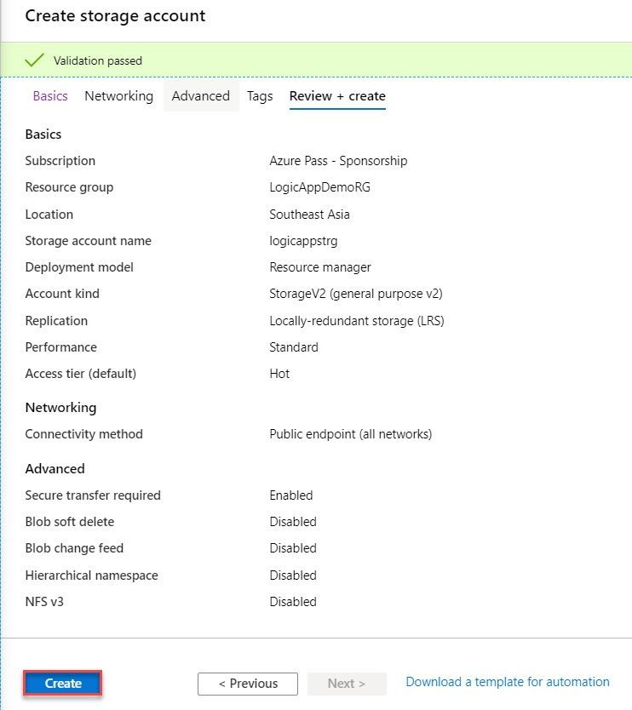
Click on Go to resource button
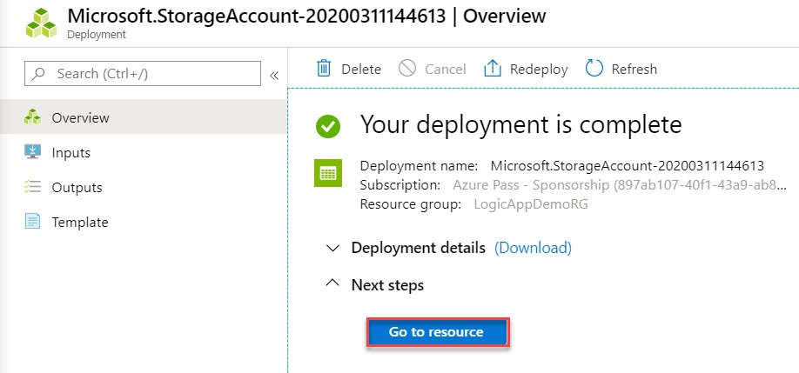
Step 19: Create New Container
Select Containers under Data Storage and click on + Container option
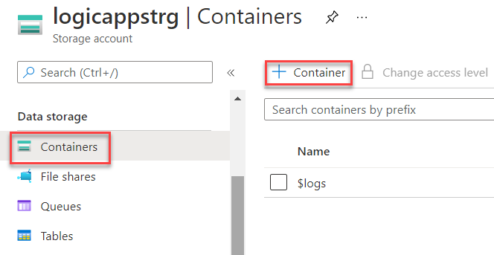

Container Name: logicapplogs
Public access level: Private (no anonymous access)
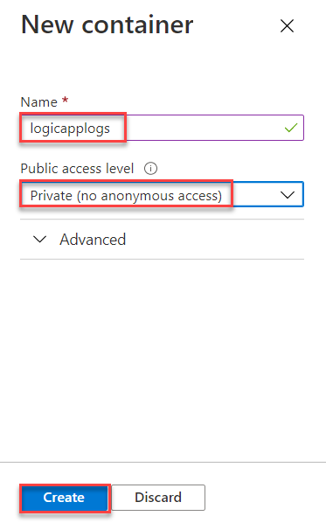

Step 20: Navigate to Logic App tab and modify Logic App Workflow
Click on + icon between Request (Trigger) and Response (Action)
Select Add an action option
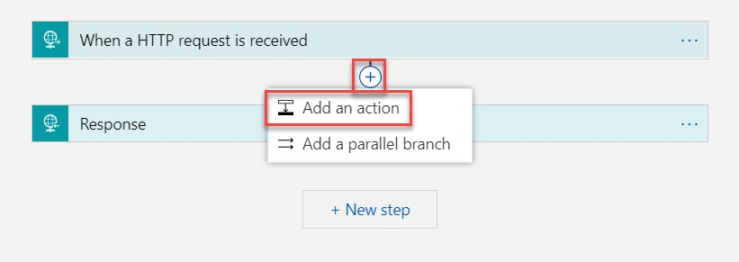

Step 21: Search for “storage” and select Create blob Action
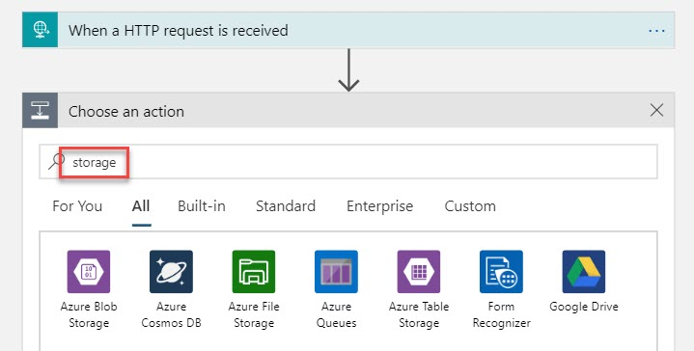
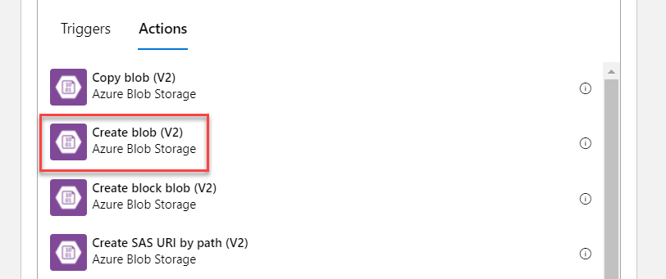
Connection Name: Enter any connection name Ex. MyBlobConnection
Authentication Type: Access Key
Azure Storage Account Name: Update Storage Account Name
Azure Storage Account Access Key: Update Storage Key
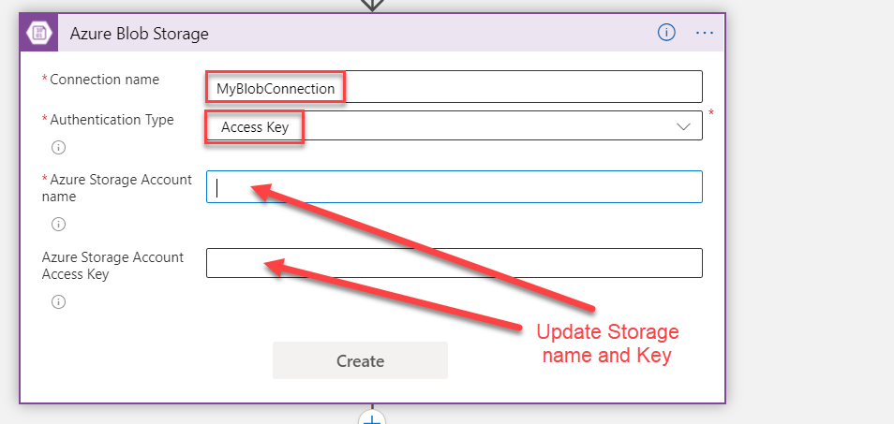

Open Azure Portal in different tab or navigate to Azure Storage Account
Select Access keys -> Copy Storage Account Name & Key
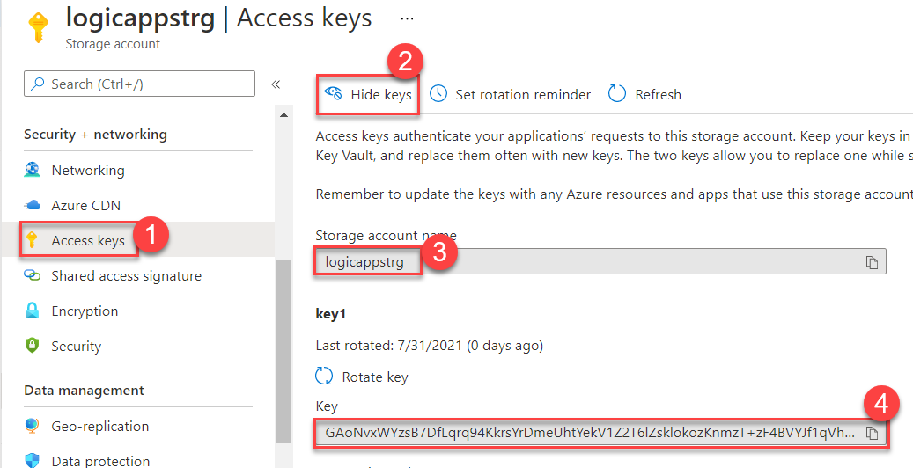

Paste Azure Storage Account Name & Key
Click on Create button
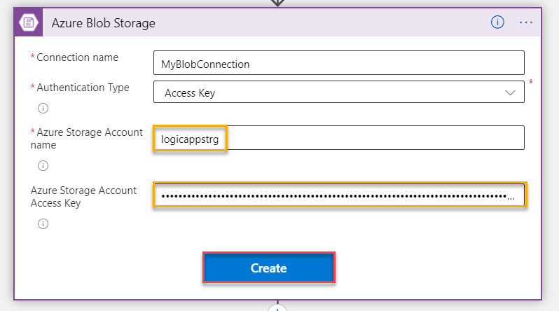

Storage account name: Select Storage account name from list
Ex. Use connection settings (logicappstrg)
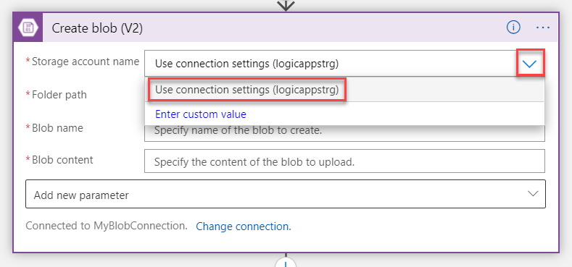

First Select Folder path in Create blob
Choose Azure Blob Storage Container Ex. logicapplogs
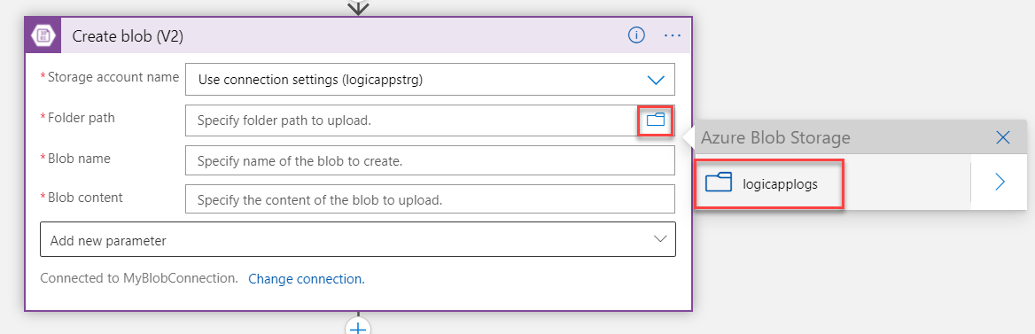

Blob name: Choose name and add .txt so it will save as .txt file Ex. test.txt
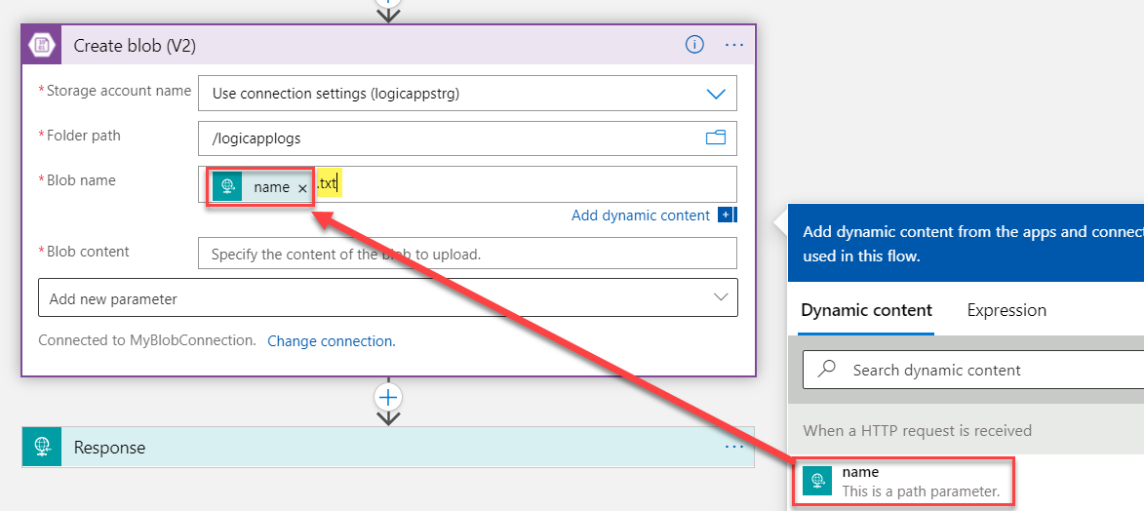

Blob content: Enter Blob Content. Ex. Hello
If it’s not loading click on See more option
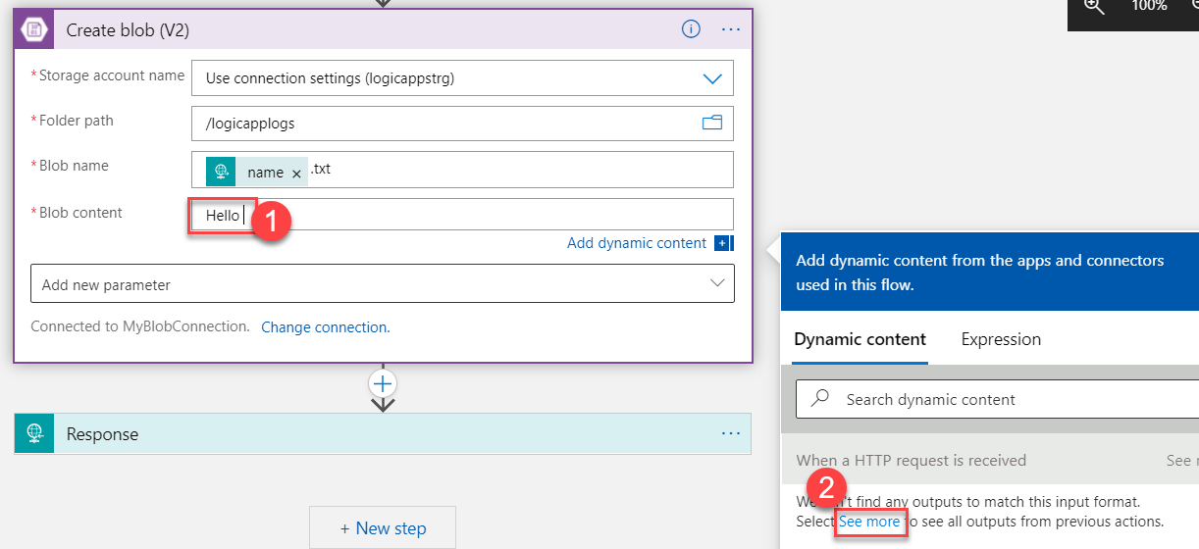

Blob Content: Hello [name]
Click on Save button
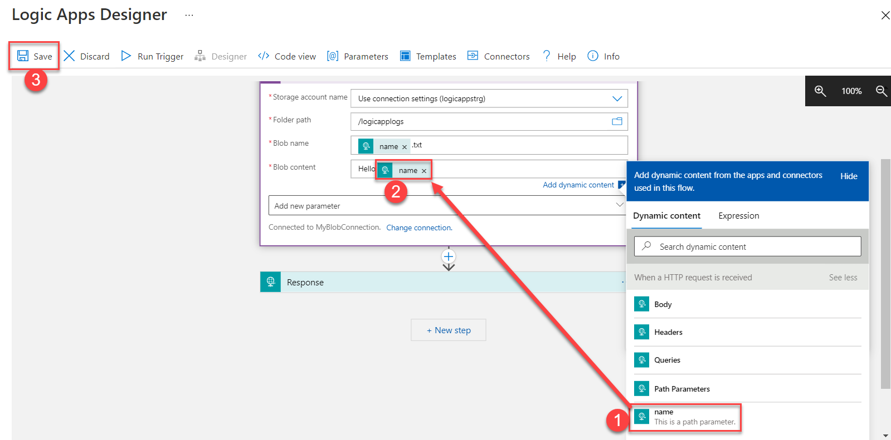

Step 22: Back to Logic App HTTP GET URL tab and refresh that link to start workflow

Step 23: Navigate to Logic App and check the Run History
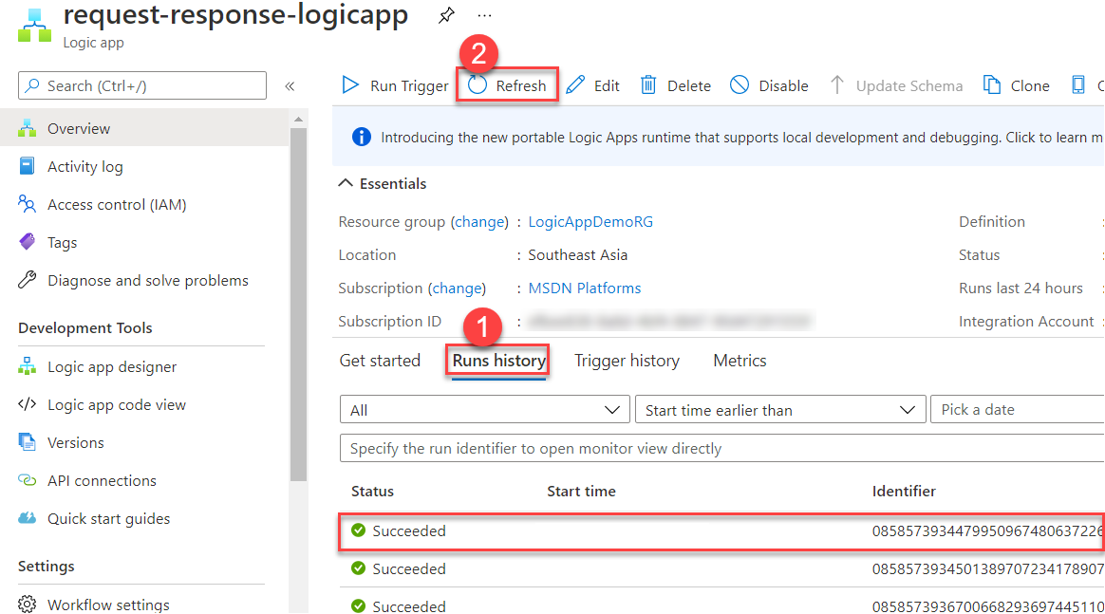

Trigger and Action executed successfully. Click on Create blob
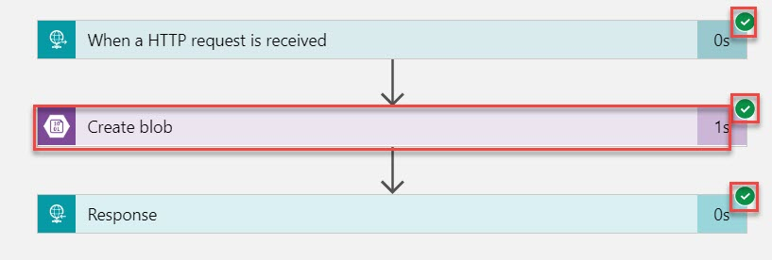

Verify all details like Folder path, Blob Name, Blob Content for Input and Output.
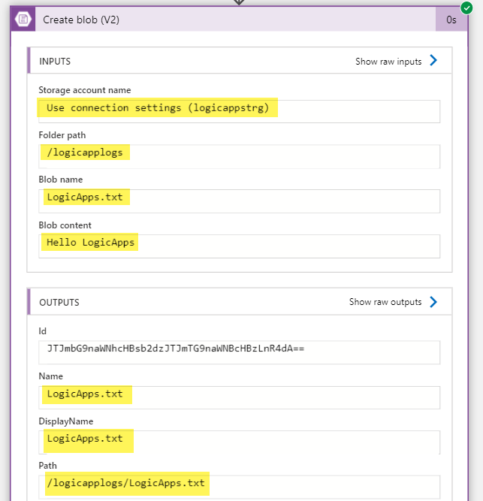

Step 24: Navigate to Storage account and open logicapplogs container
Based on name it will generate text file Ex. LogicApps.txt
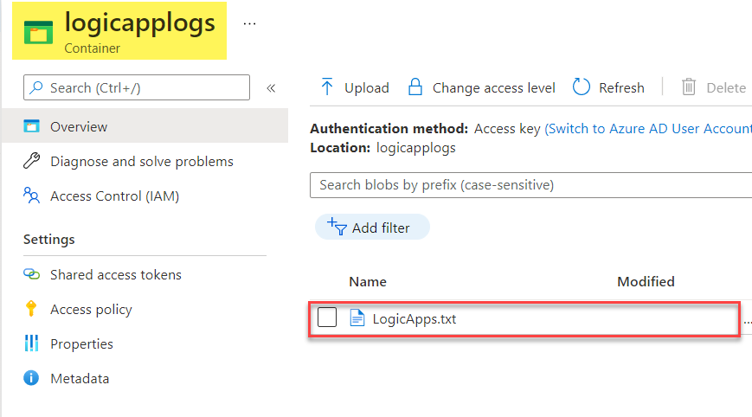

Click on Edit tab to see Blob Content
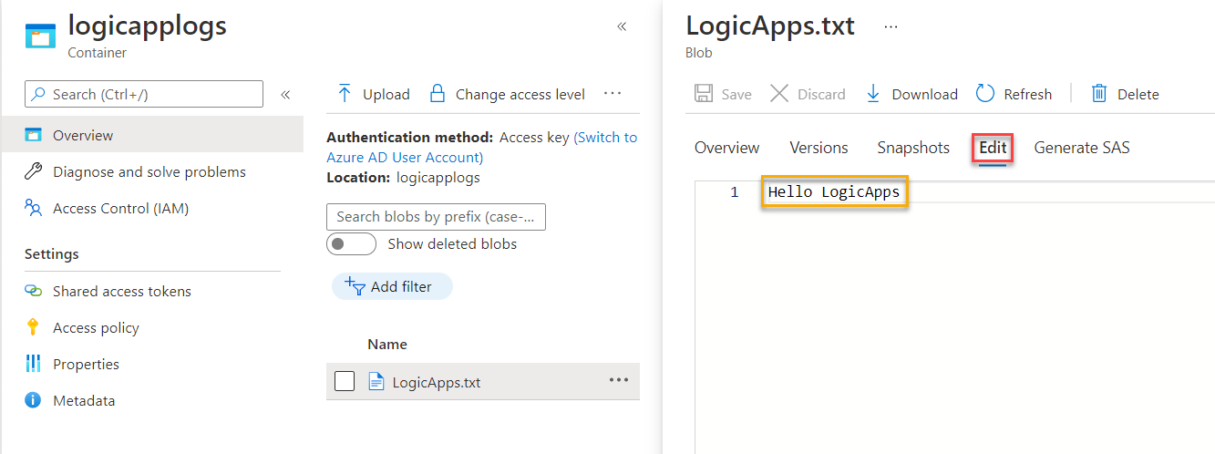

Step 25: For testing update one more time name Ex. Microsoft Azure and press enter key.
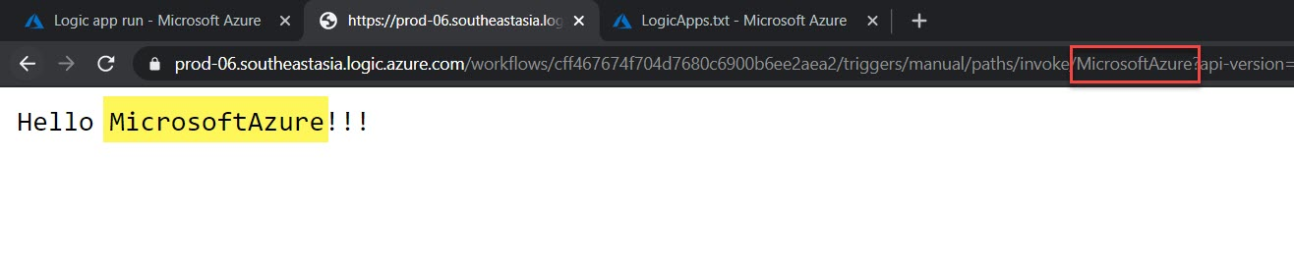

Check Storage Container
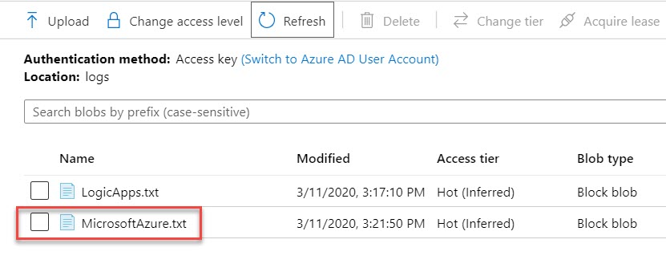
Click on Edit tab
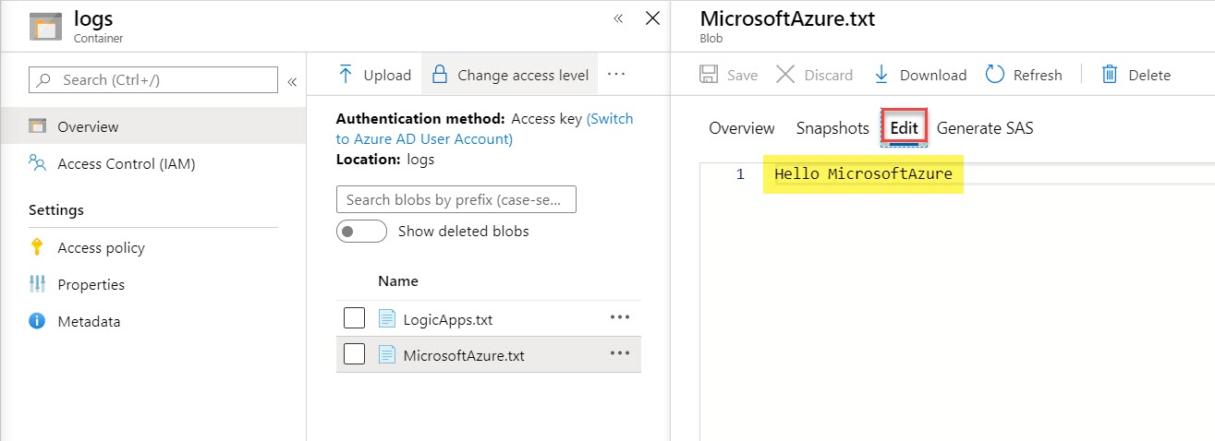

Task 3: Trigger Email when Data Inserted into Storage Account
Step 26: Create another Logic App
+ Create a resource -> Integration -> Logic App

Step 27: Subscription: Choose same subscription
Resource Group: Choose existing resource group Ex. LogicAppDemoRG
Type: Consumption
Logic App Name: Enter logic App Name Ex. logicapp-strg-email
Region: Choose same location Ex. (Asia Pacific) Southeast Asia
Click on Review + Create button

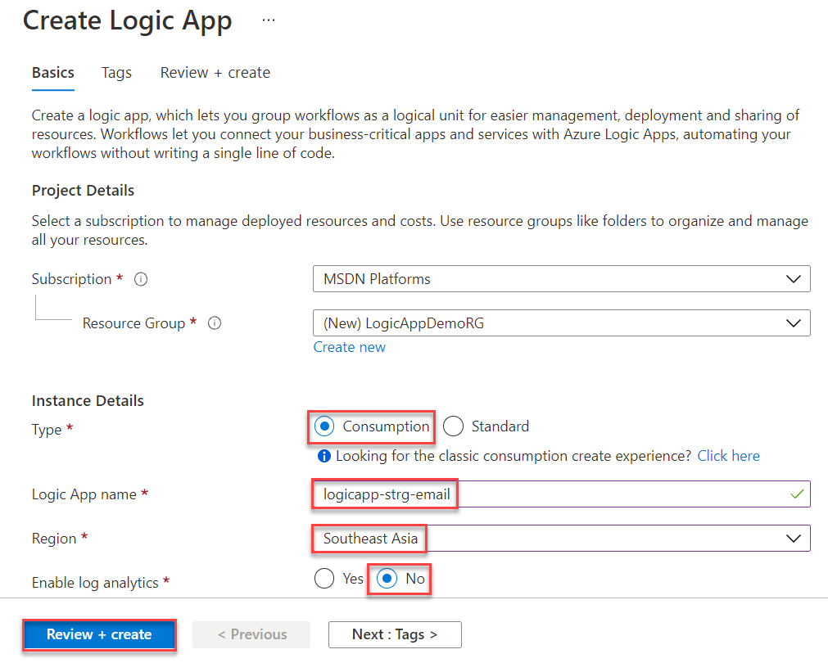

Step 28: Click on Create button
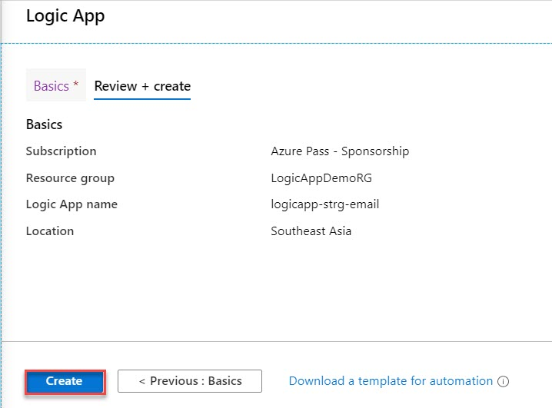

It will task couple of seconds to deploy Logic App on Azure
Click on Go to resource button
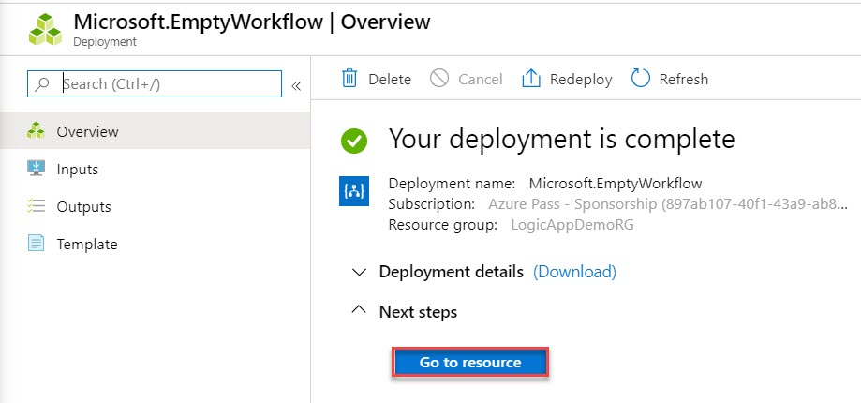
Step 29: Select Blank Logic App
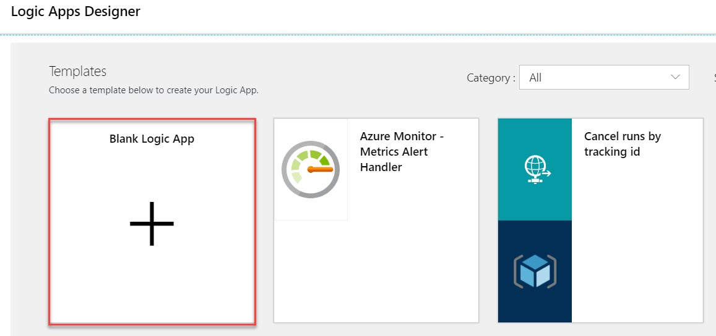

Step 30: Search for “Storage”
Select When a blob is added or modified (properties only) trigger
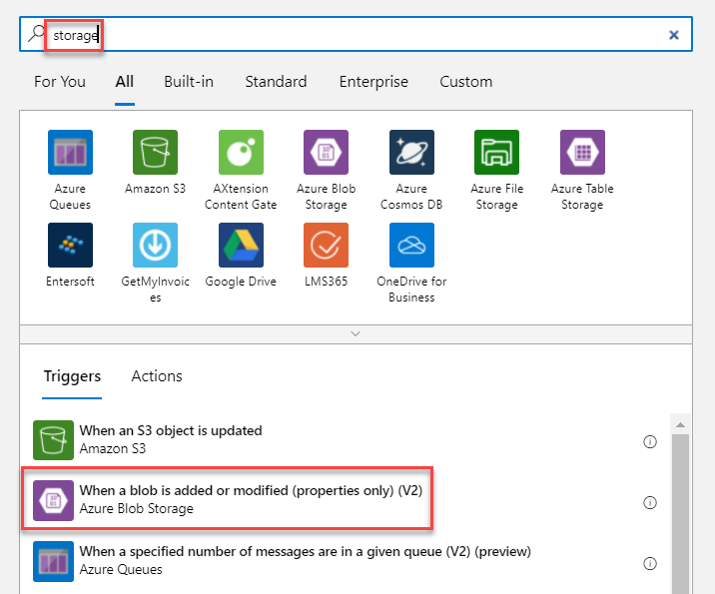

Automatic Storage Connection configured.
Storage account name: Select Storage account name from drop-down menu
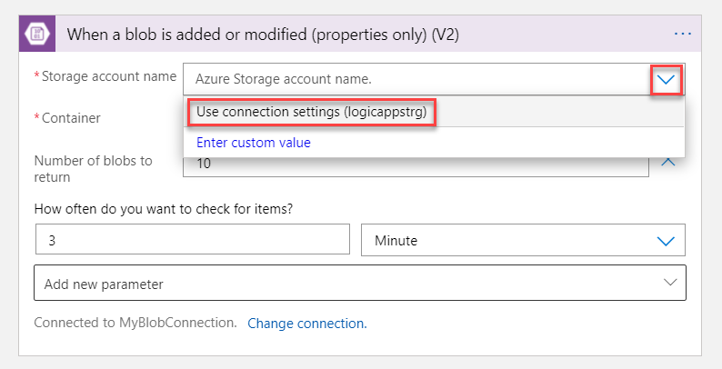

Container: Select Container Ex. logicapplogs
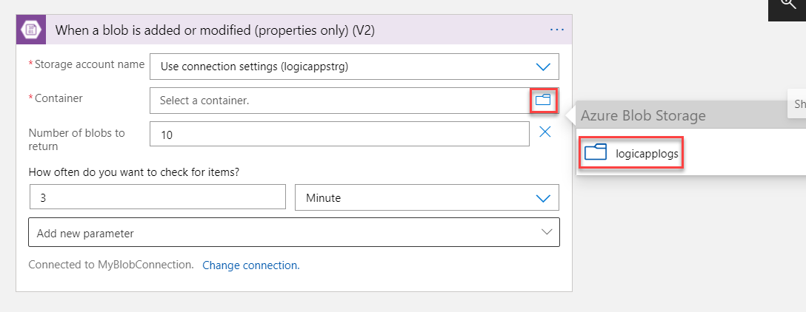

Interval: 3 (if you wish you can change as per your requirement)
Frequency: Second (if you wish you can change as per your requirement)
Click on Save button
Now add new step by click on + New step button
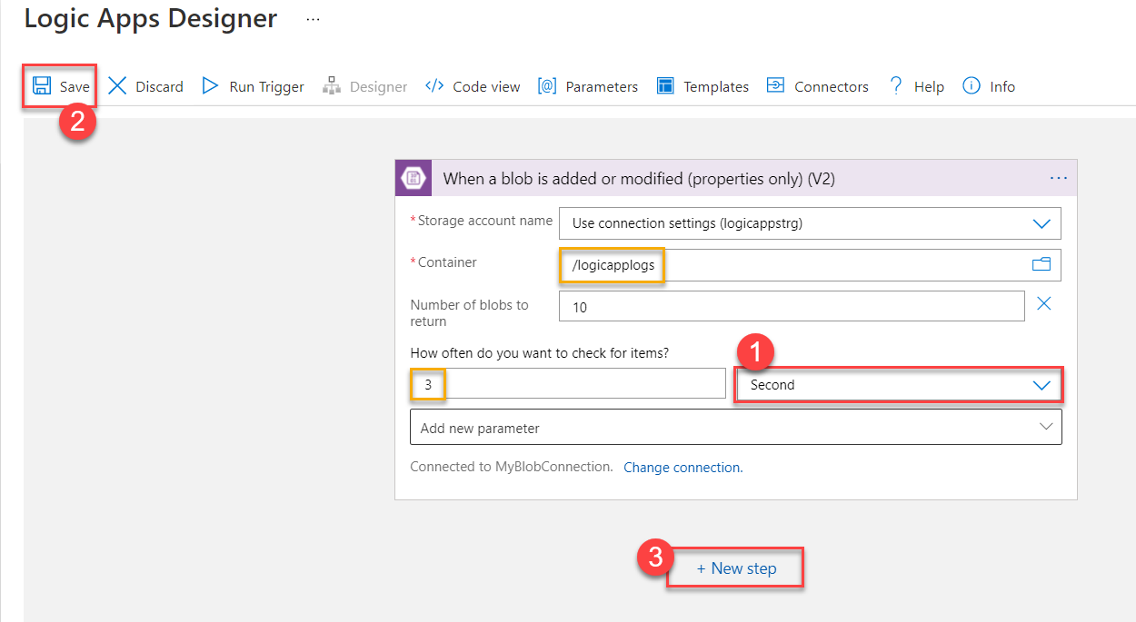

Step 31: Search for any mail option ex. Outlook, office365, Gmail, etc
For this demo we are going with outlook and Select Outlook.com
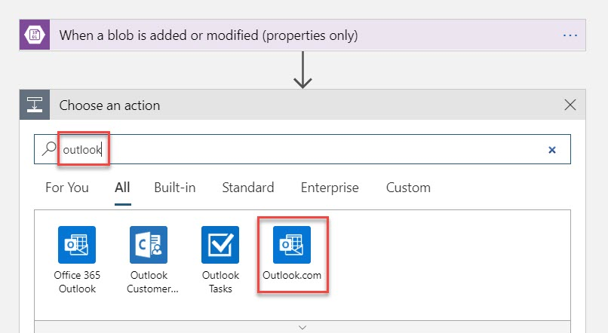
Note: if you are using organization email use Office 365
Select Send an email (V2) action from list.
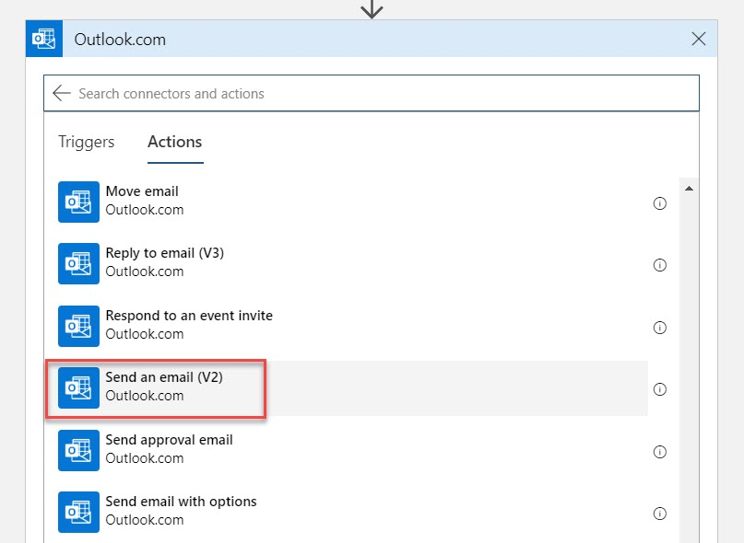

Click on Sign In button
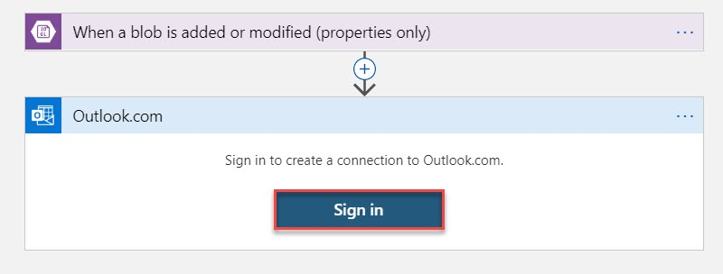

Enter email id and click on Yes button to give permission
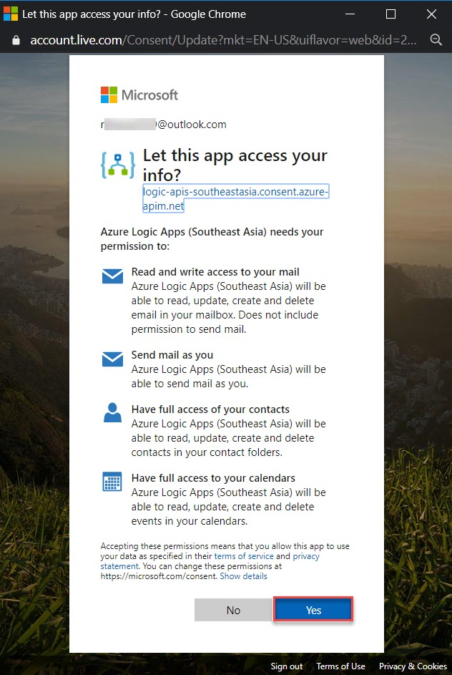

To: Enter another email id of yours
Subject: New file called [List of Files Name]
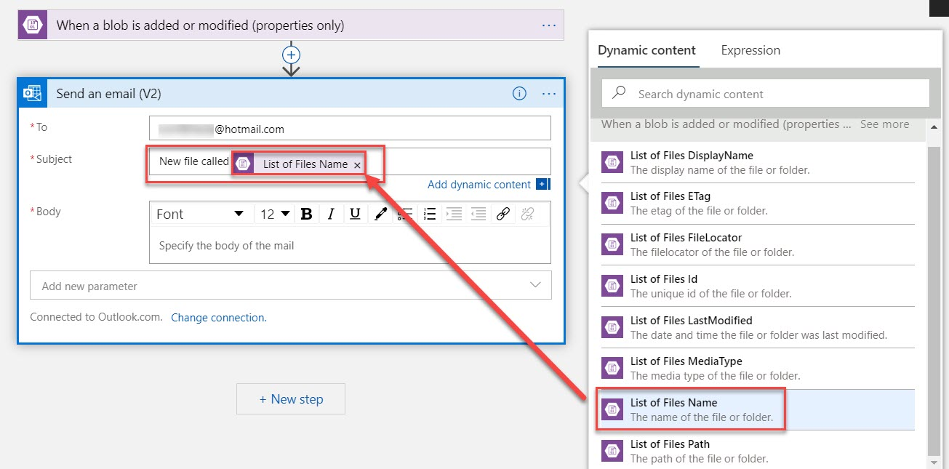

Body: File at [List of Files Path]
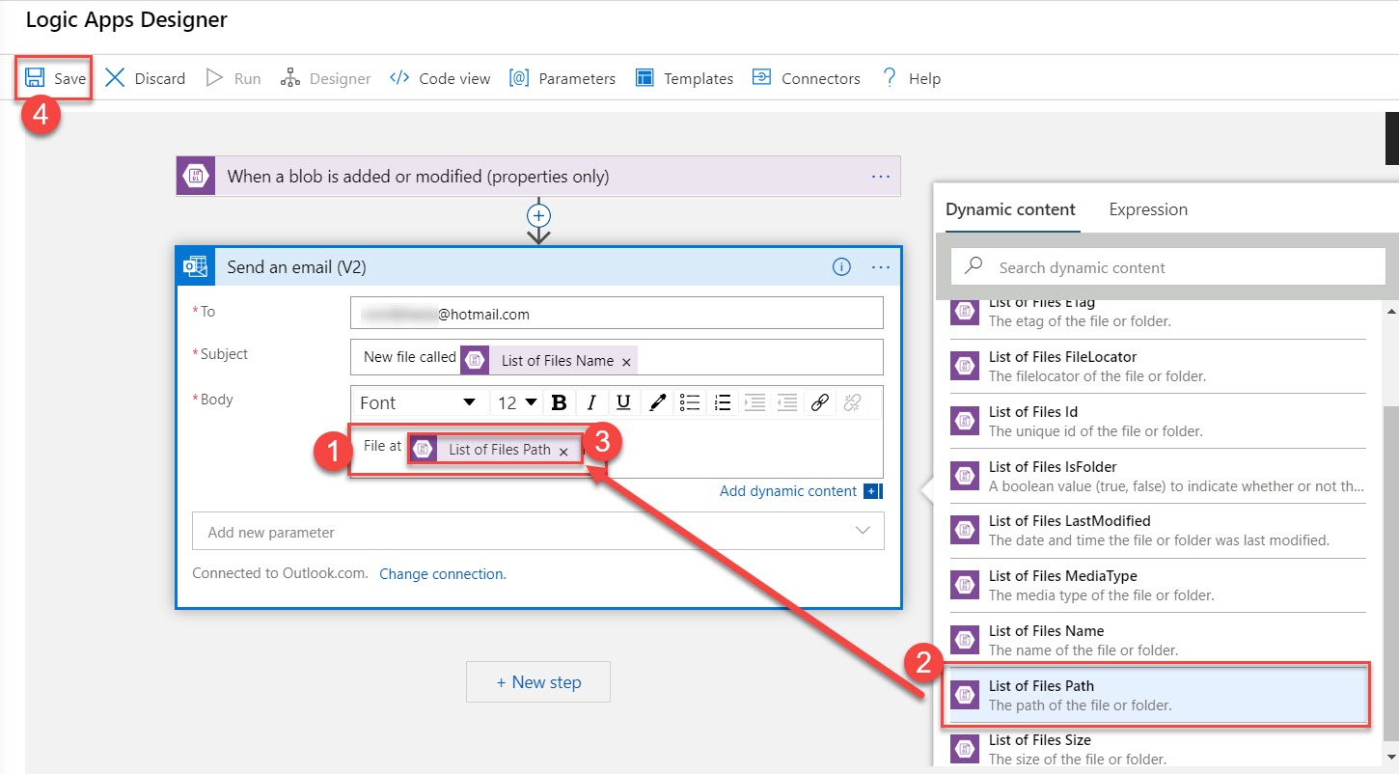
Click Save button.

Step 32: Now once again navigate to Logic App HTTP GET URL and click on Refresh button
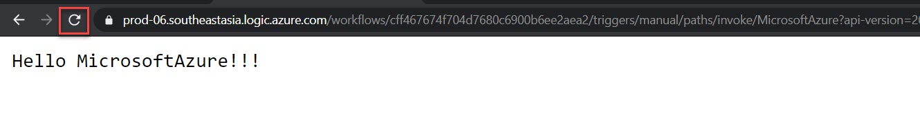

Now verify workflow and check your email id.
You will receive mail as below:
