Create API Management
Azure API Management (APIM) helps organizations publish APIs to external, partner, and internal developers to unlock the potential of their data and services. API Management provides the core competencies to ensure a successful API program through developer engagement, business insights, analytics, security, and protection. APIM enables you to create and manage modern API gateways for existing backend services hosted anywhere.

Step 1: Open Microsoft Azure Portal
https://portal.azure.com/

Step 2: Create API Management
+ Create a resource -> Integration -> API Management
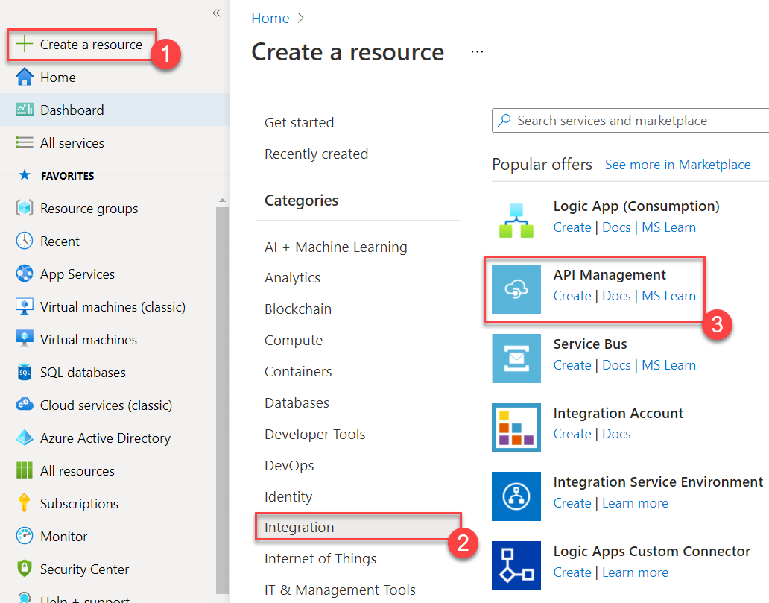

Step 3: Create API Management
Subscription: Choose any active Subscription
Resource Group: Create New Resource Group Ex. APIMRG
Click on OK button
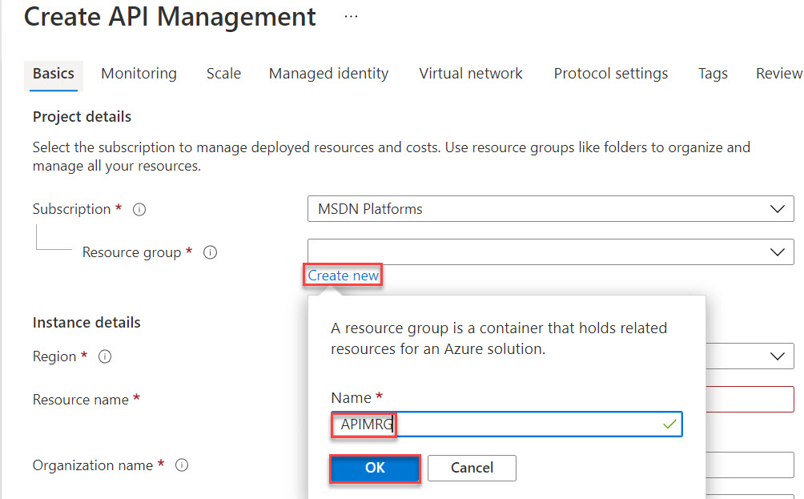

Region: Choose any region Ex. Southeast Asia
Resource name: Enter unique name Ex. testapim
Organization name: My Org
Administrator Email: Enter your email address
Pricing tier: Developer (no SLA)
Click on Review + create button

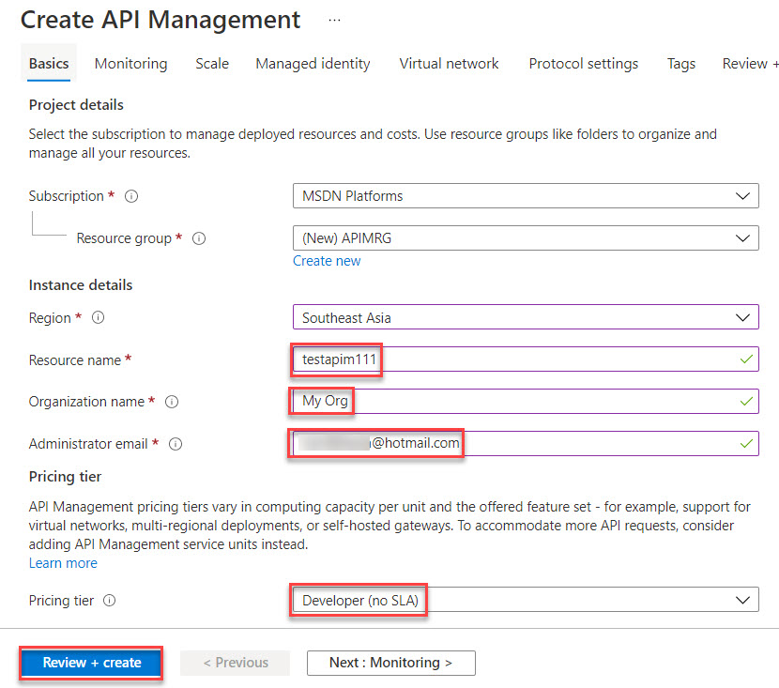

Step 4: Click on Create button
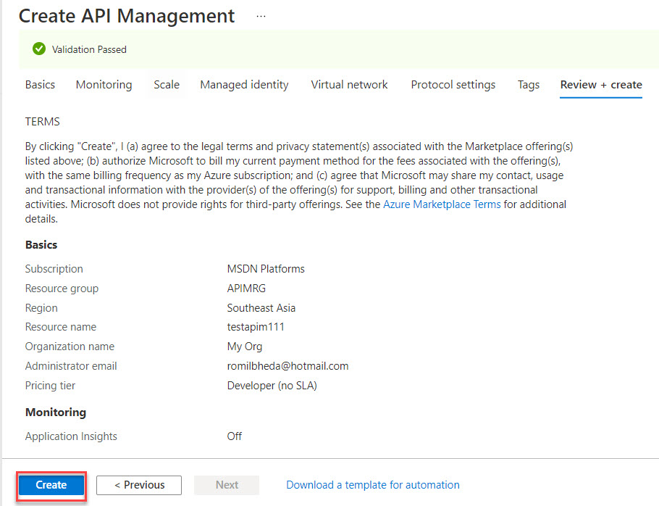

Note: Approx. it will take 30 to 40 minutes.
When Service ready you will receive email.

API App
Step 1: Open another tab in browser and open Microsoft Azure Portal
https://portal.azure.com

Step 2: Click on + Create a resource -> Search for “API App”
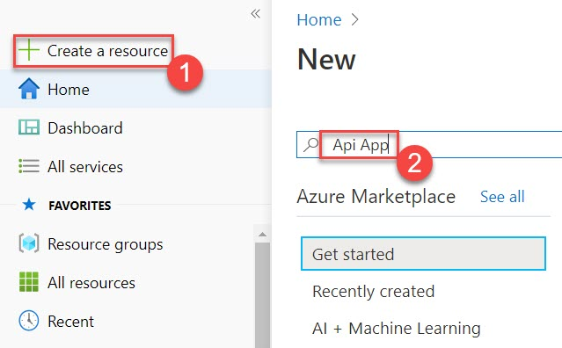

Click on Create button
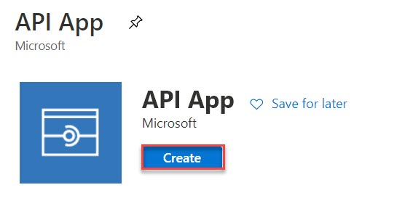

Step 3: Create API App
App Name: Enter unique name Ex. testapiapp
Resource Group: Choose Existing Resource Group Ex. APIMRG
Click on App Service plan/location
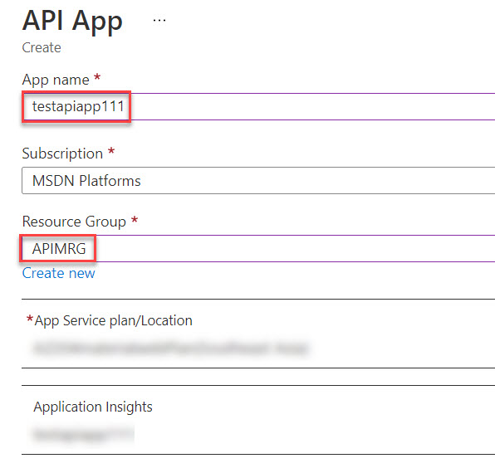

Create New Plan
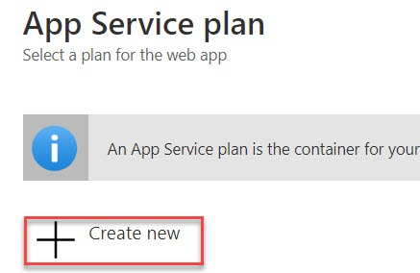

App Service Plan: ApiAppPlan
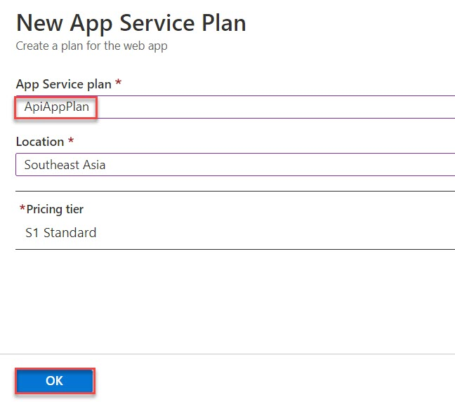
Click on Application Insights option
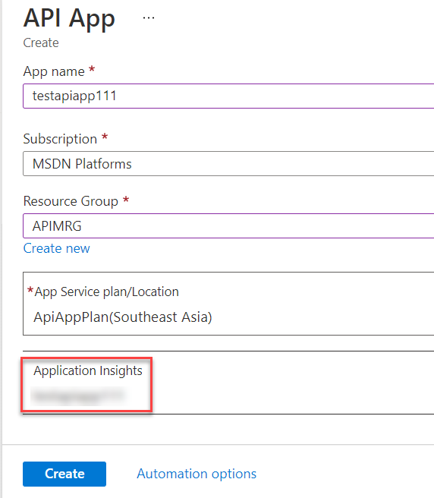

Application Insights: Disable
Click on Apply button
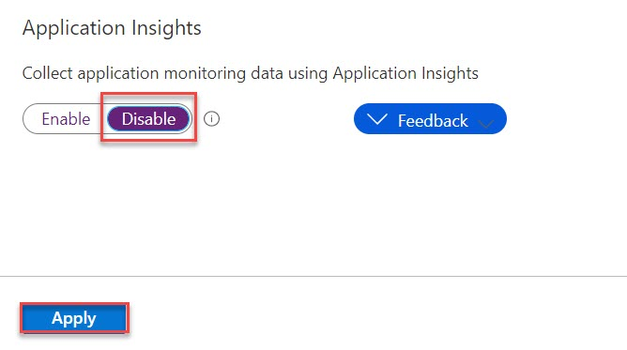

Click on Create button
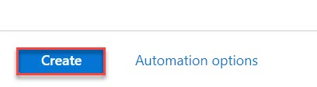
Step 4: Create Sample App
Start Visual Studio
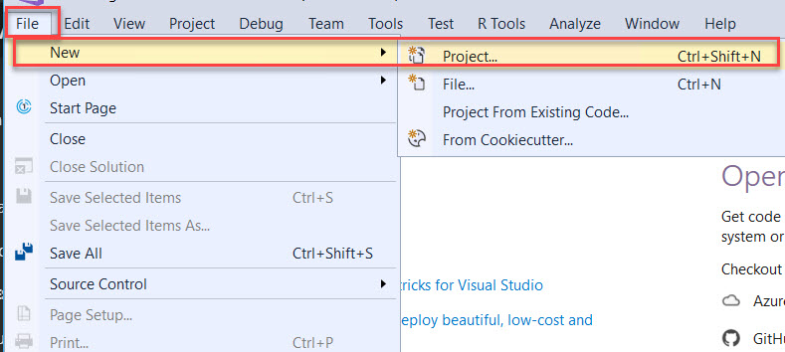

Step 5: Create ASP.NET Application (.Net Framework)
C# -> Web Application -> Select ASP.NET Web Application (.NET Framework)
Click on Next button

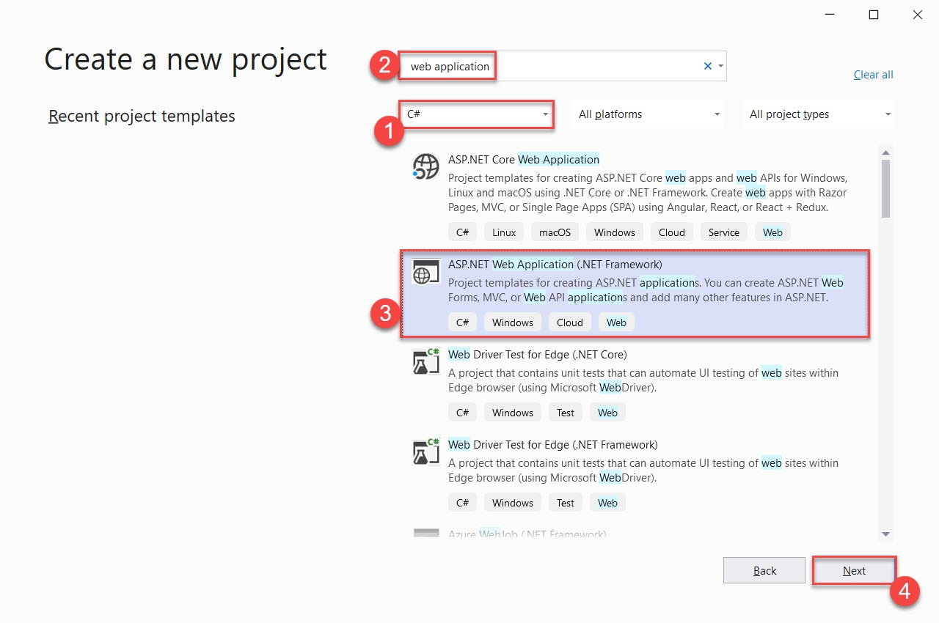

Project Name: ApiAppLab
Click on Create button
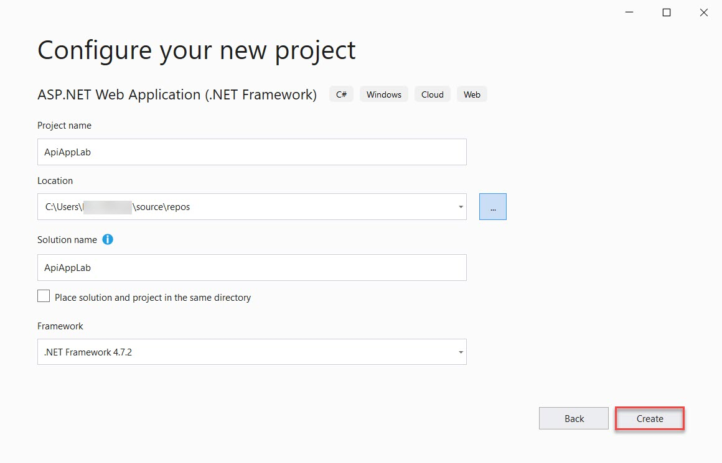

Select Empty project and select Web API option
Click on Create button
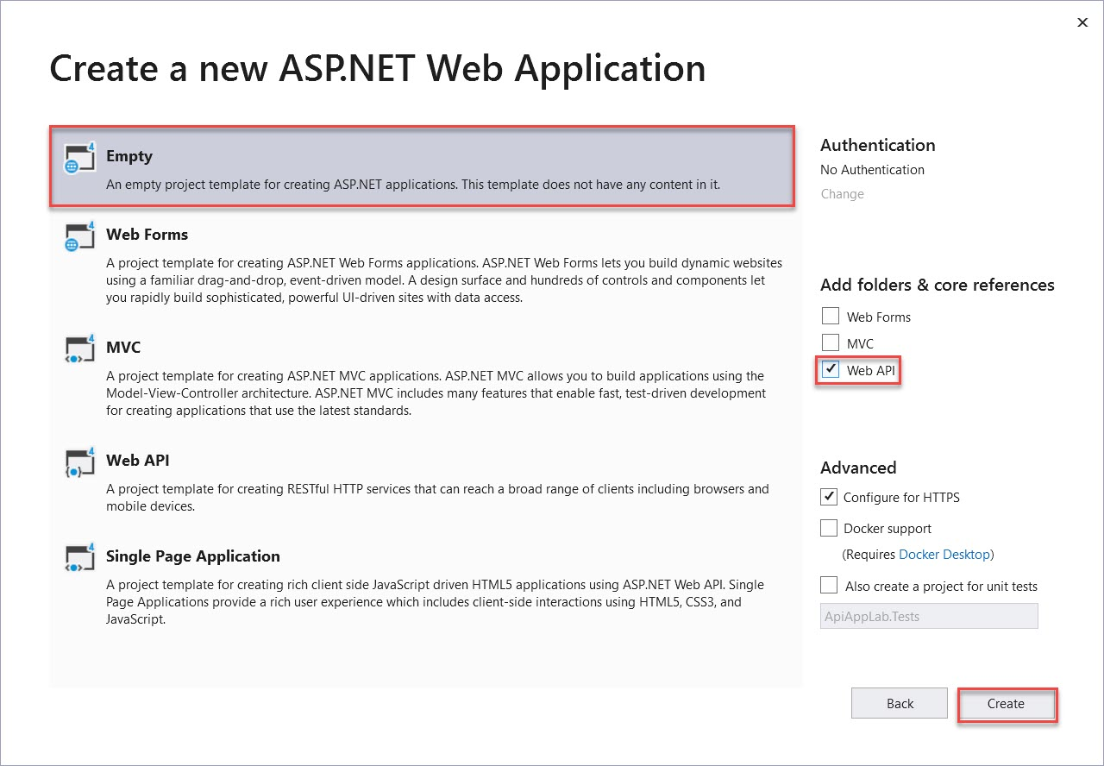

Step 6: Right click on Models -> Add -> Class
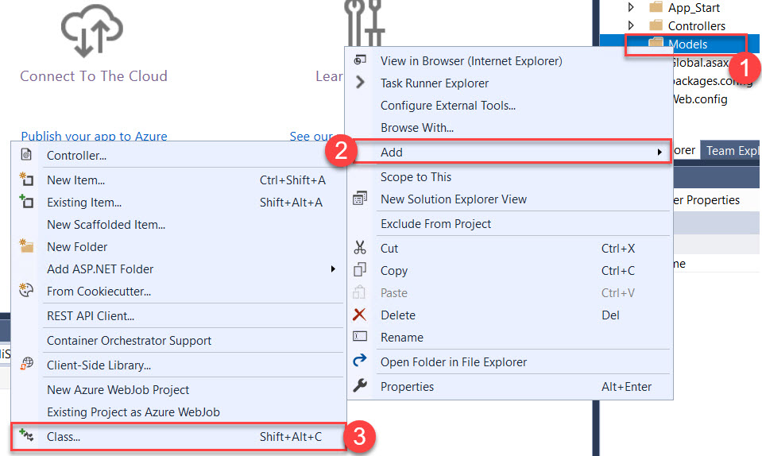

Class Name: Contact.cs
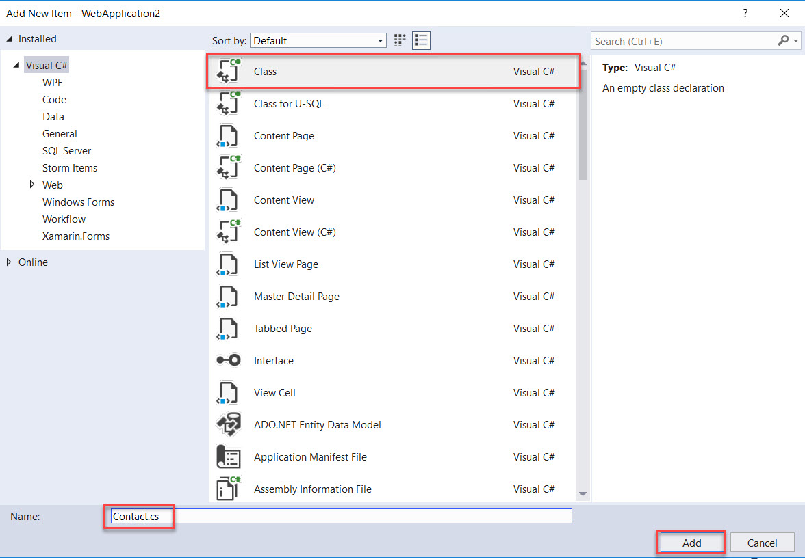

Step 7: Add below code
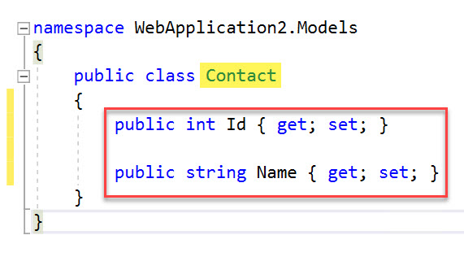

namespace WebApplication2.Models
{
public class Contact
{
public int Id { get; set; }

public string Name { get; set; }
}
}

Step 8: Right Click on Controllers -> Add -> Controller
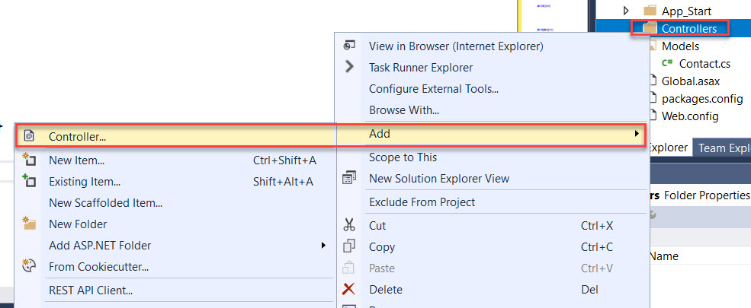

Step 9: Select Web API 2 Controller - Empty
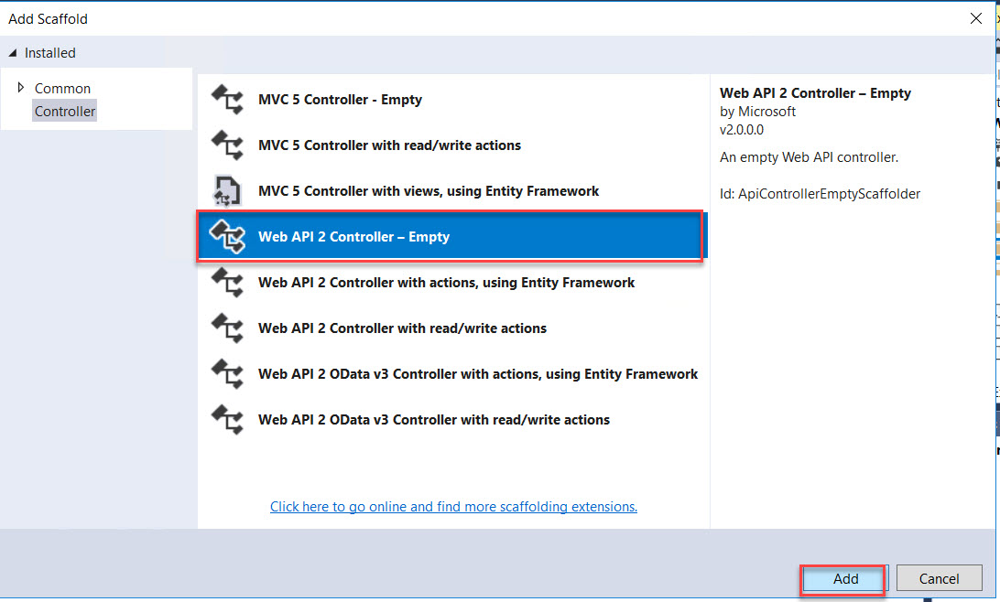

Enter Controller Name: ContactController
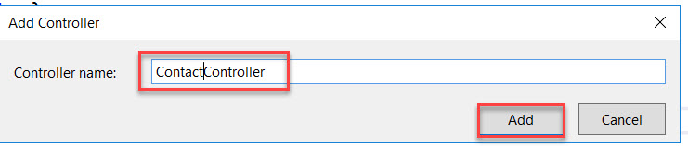
Step 10: Add below reference & code
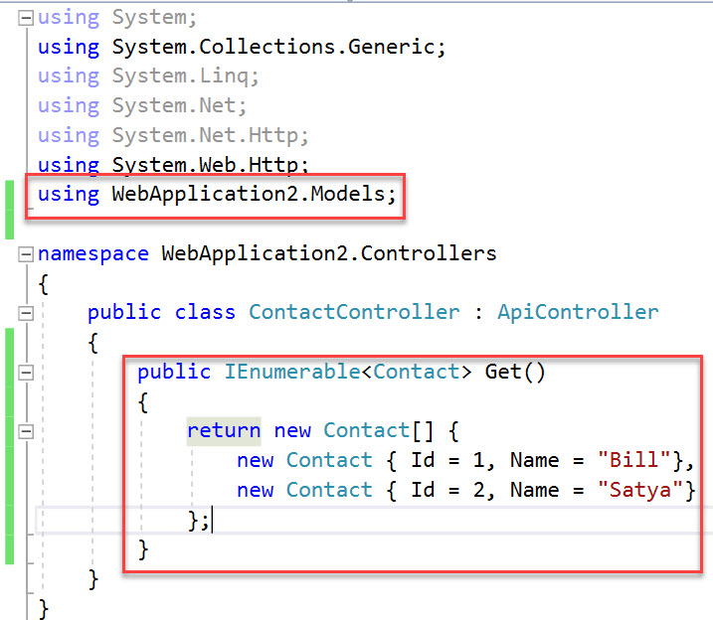

Reference:
using ApiAppLab.Models;

Code:
namespace WebApplication2.Controllers
{
public class ContactController : ApiController
{
public IEnumerable<Contact> Get()
{
return new Contact[] {
new Contact { Id = 1, Name = "Bill"},
new Contact { Id = 2, Name = "Satya"}
};
}
}
}

Step 11: Now run application
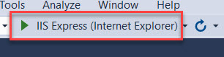

Step 12: Error page will display but Add api/Contact after localhost url
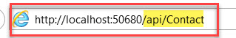

Output of Internet Explorer
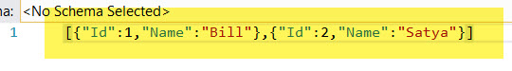

Output of Chrome browser
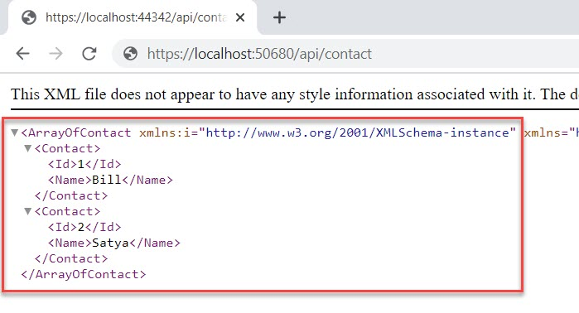

Step 13: Stop the Project. Right Click on Project -> Publish
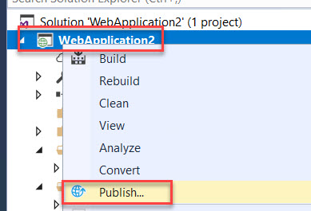

Target: Azure
Click on Next button
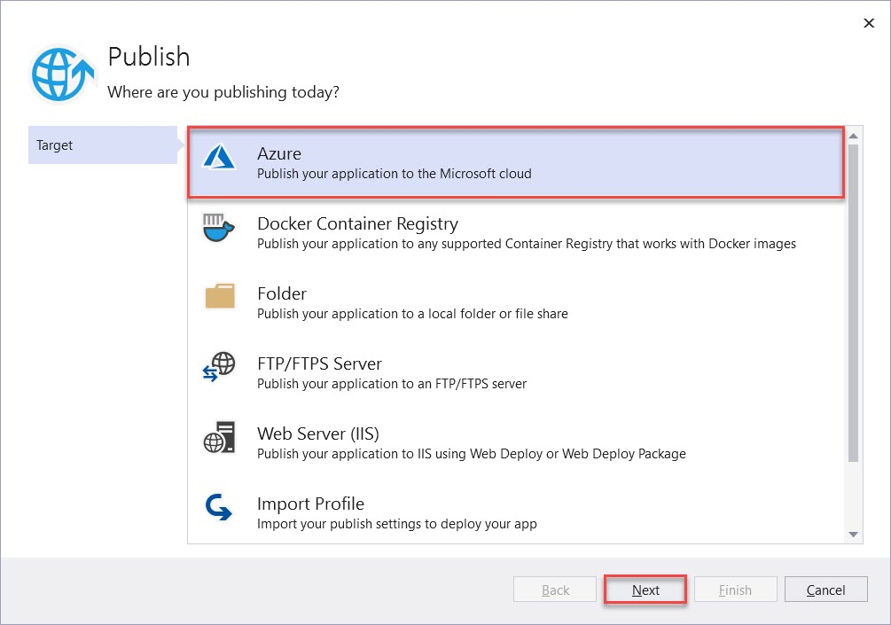

Select Azure App Service (Windows)
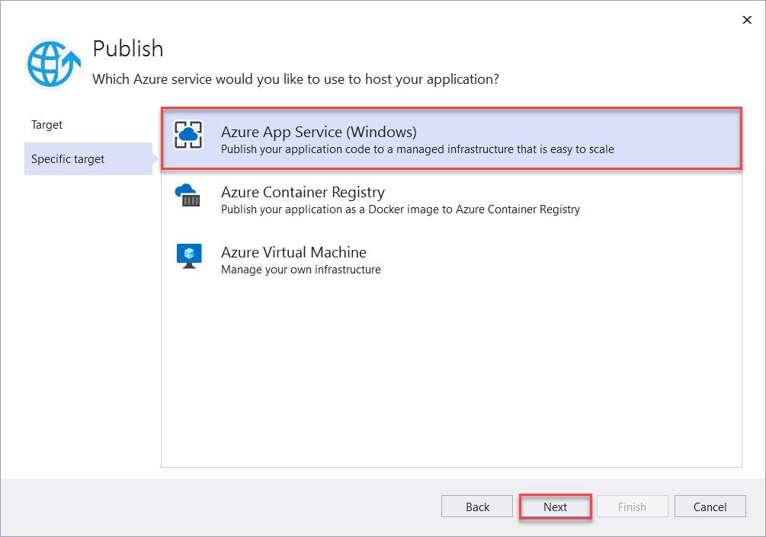

Select Api App from list and click on Finish button
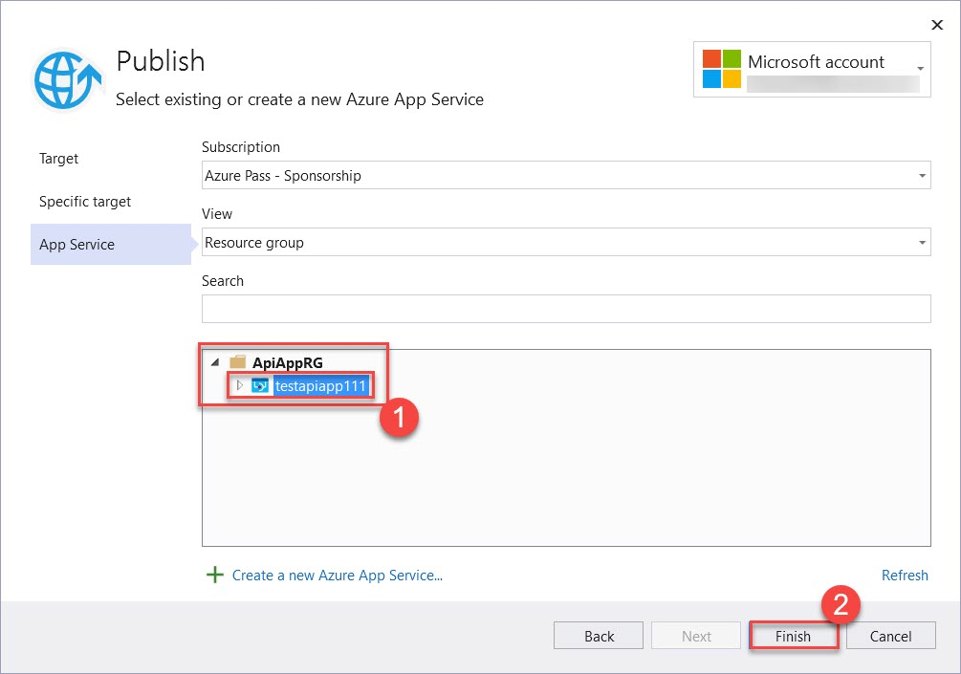

Click on Publish button
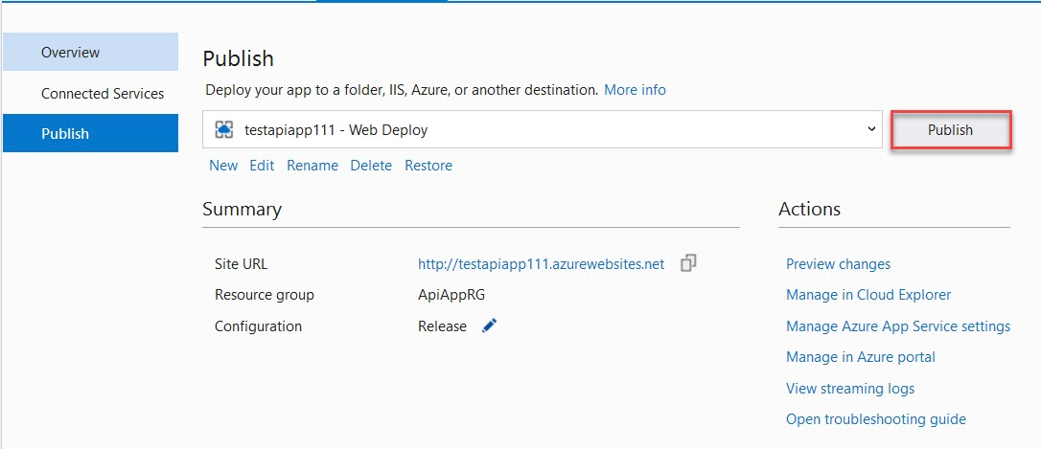

Step 14: Within few second it will publish. Also add api/Contact
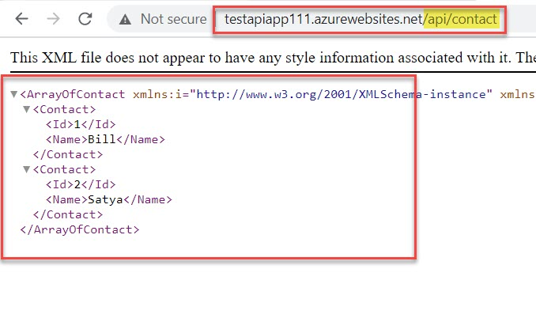

Client for API App
Step 15: Right on Solution -> Add -> New Project
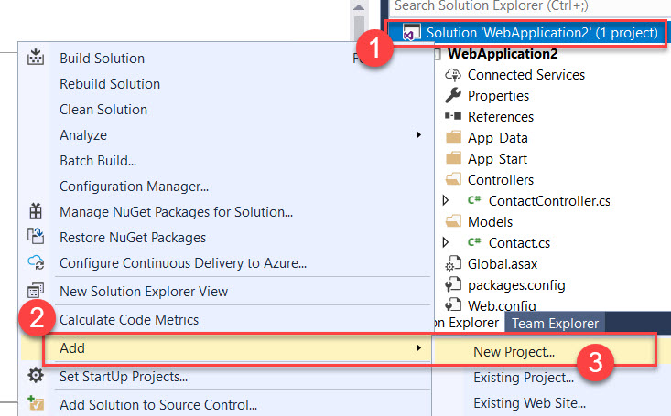

Step 16: Add Console App
C# -> Console App -> Console App (.Net Framework)
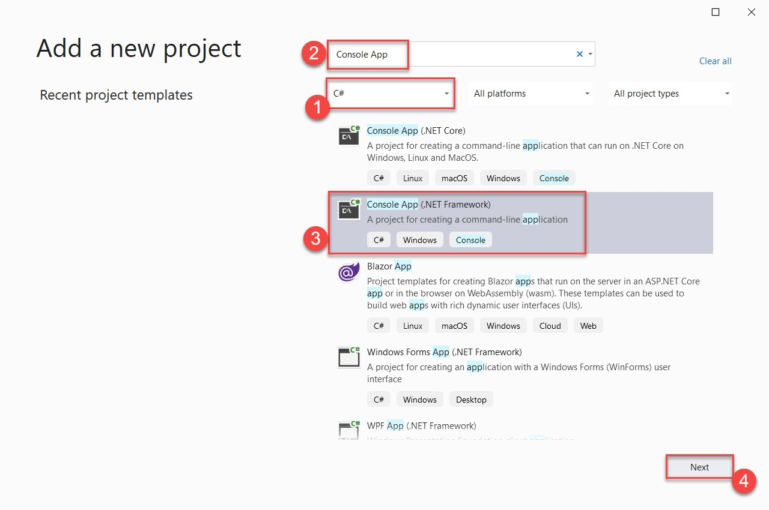

Project Name: ApiAppClientApp
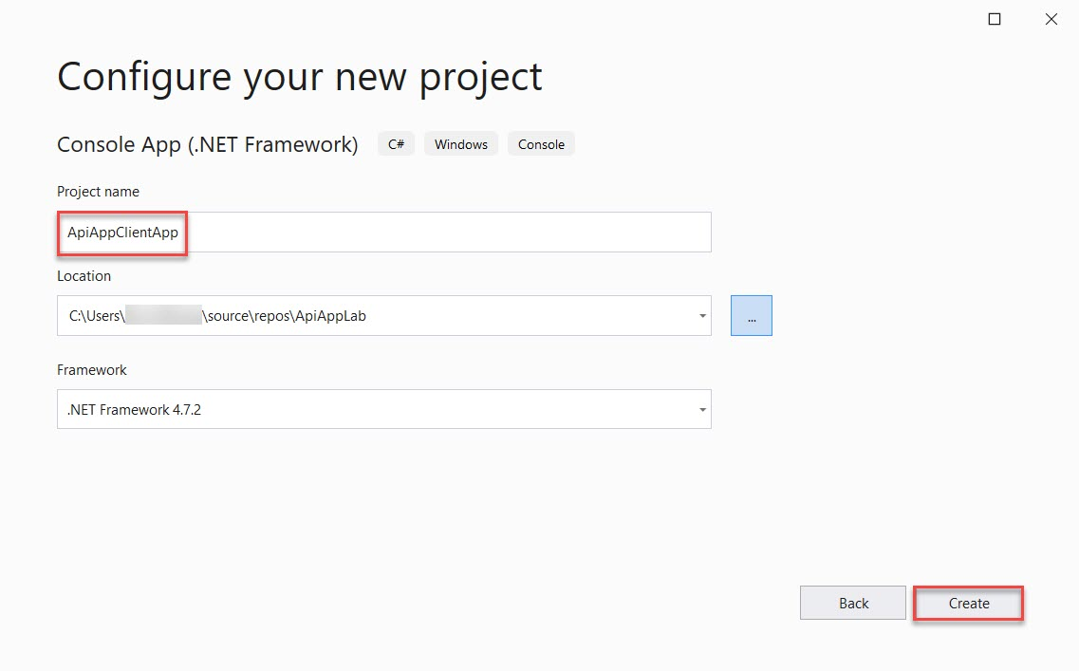

Step 17: Right Click on Project -> Manage NuGet Packages…
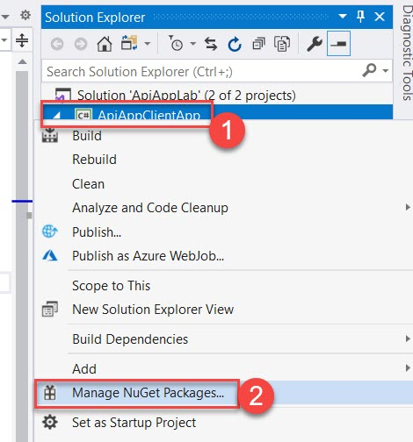

Select Browse option and Select Newtonsoft.Json
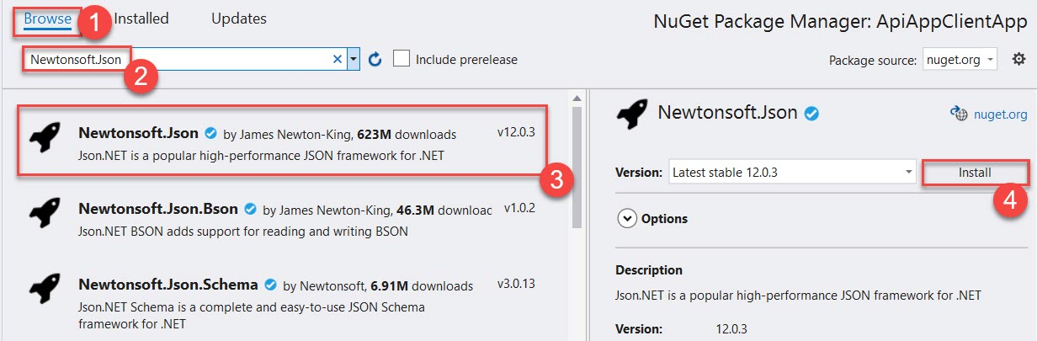

Step 18: Open Program.cs file
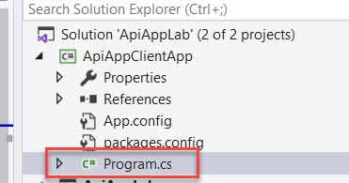

Step 19: Add references and code
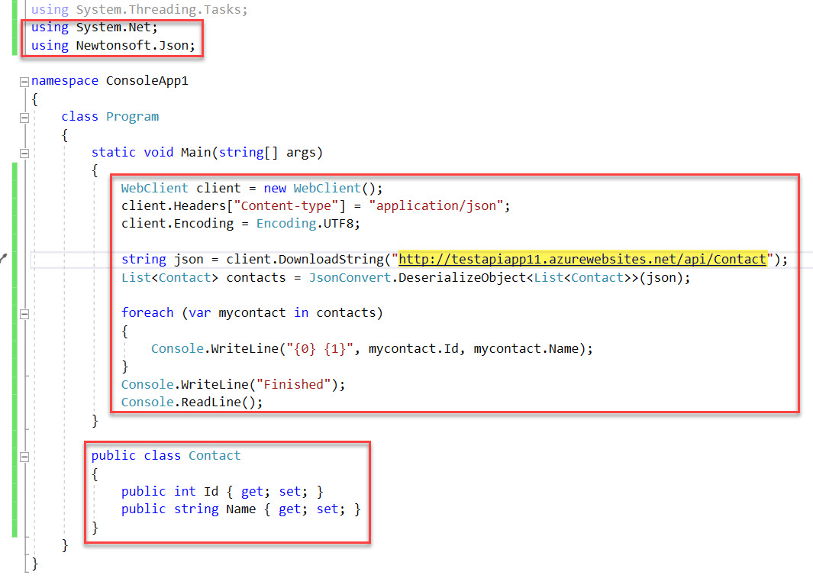
using System;
using System.Collections.Generic;
using System.Linq;
using System.Text;
using System.Threading.Tasks;
using System.Net;
using Newtonsoft.Json;

namespace ConsoleApp1
{
class Program
{
static void Main(string[] args)
{
WebClient client = new WebClient();
client.Headers["Content-type"] = "application/json";
client.Encoding = Encoding.UTF8;

string json = client.DownloadString("http://testapiapp11.azurewebsites.net/api/Contact");
List<Contact> contacts = JsonConvert.DeserializeObject<List<Contact>>(json);

foreach (var mycontact in contacts)
{
Console.WriteLine("{0} {1}", mycontact.Id, mycontact.Name);
}
Console.WriteLine("Finished");
Console.ReadLine();
}

public class Contact
{
public int Id { get; set; }
public string Name { get; set; }
}
}
}

Step 20: Right Click on Project Name -> Set as StartUp Project
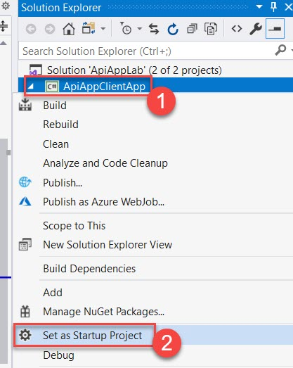

Step 21: Now run the Project
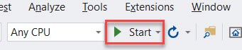

Sample Data available in Client application from Api App.
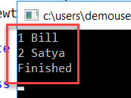
Step 3: Select APIs -> Click on Add API -> App Service (scroll down to select App Service)
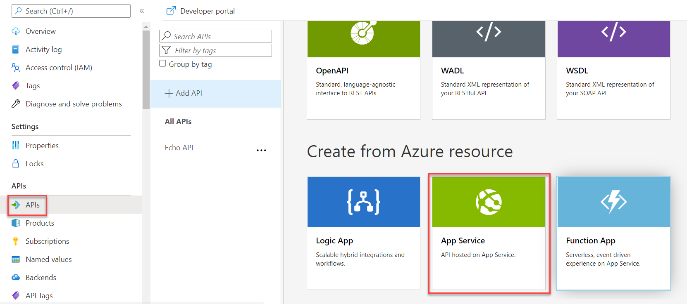

Step 4: Click on Browse option
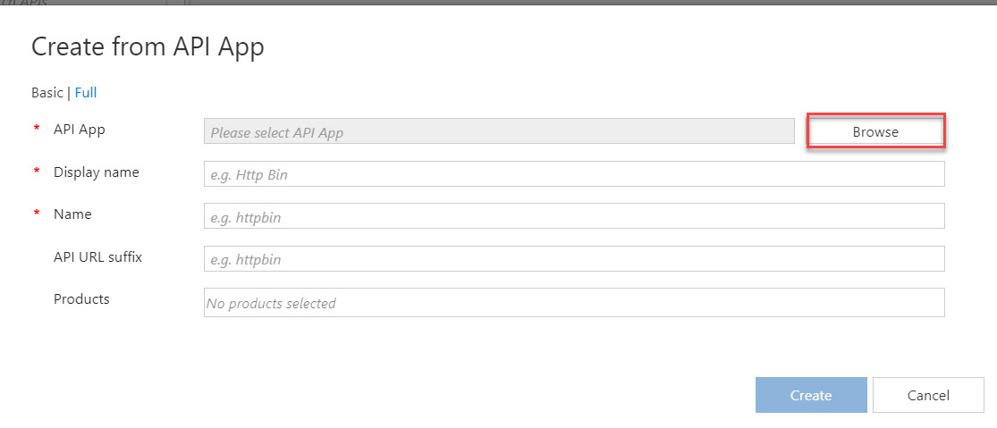

Step 5: Select API App from the list
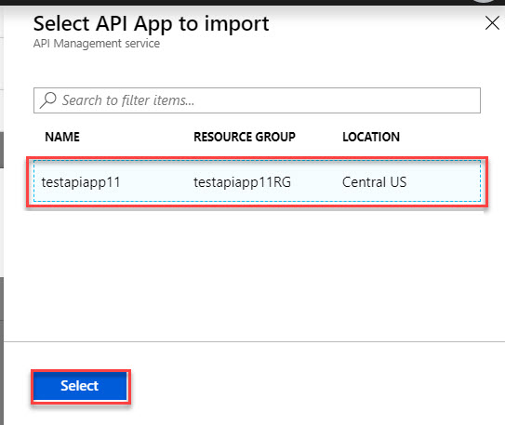

Step 6: Enter Display Name: Sample API, Products: Starter
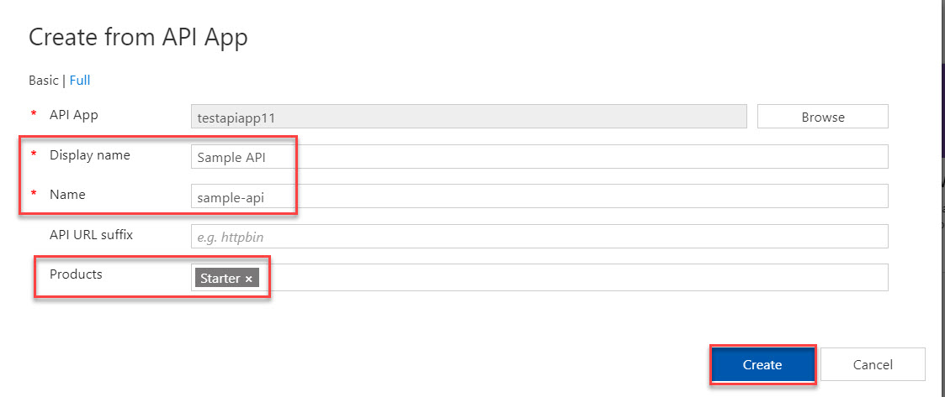

Step 7: Select Get Operations -> Click on Edit
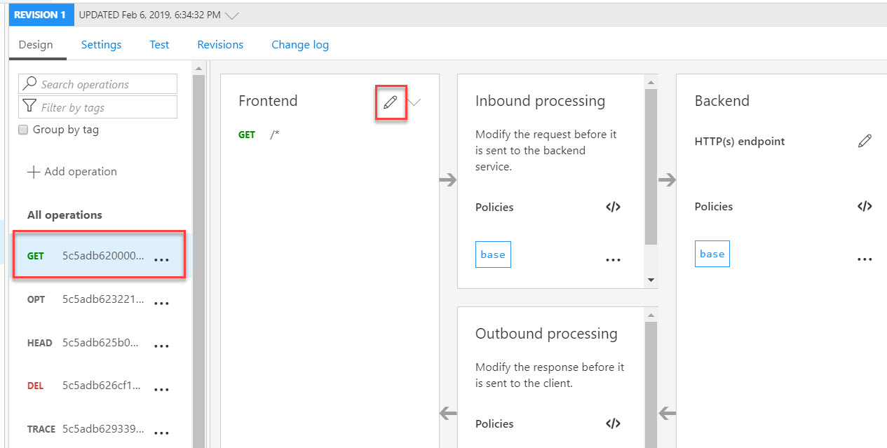

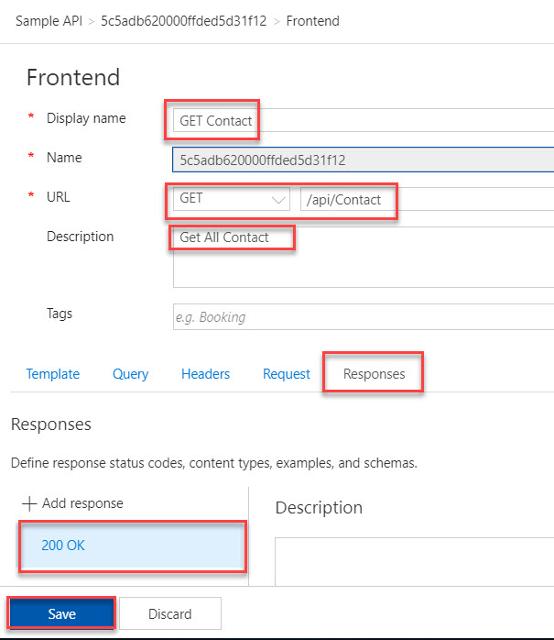
Display Name: GET Contact
URL: GET /api/Contact
Responses: 200 OK

Step 8: Select Test tab and click on Send button
