Role-Based Access Control and Azure Policy

Scenario
Adatum Corporation wants to use Azure Role Based Access Control and Azure Policy to control provisioning and management of their Azure resources. It also wants to be able to automate and track provisioning and management tasks.

Objectives
After completing this lab, you will be able to:
- Configure delegation of provisioning and management of Azure resources by using built-in Role-Based Access Control (RBAC) roles and built-in Azure policies
- Verify delegation by provisioning Azure resources as a delegated admin and auditing provisioning events

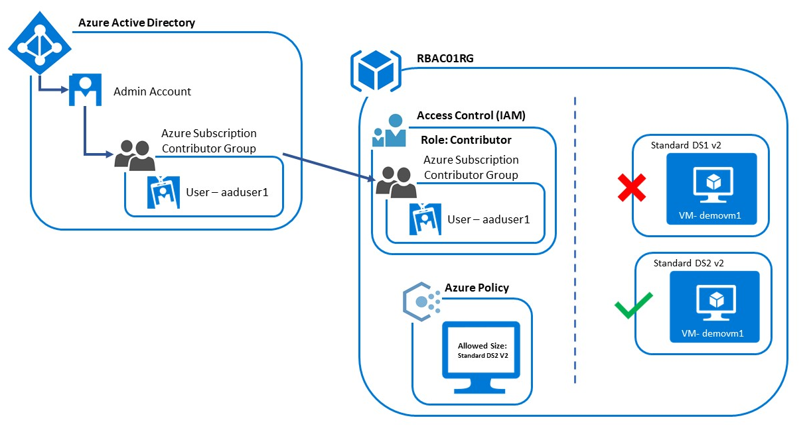

Lab:
Step 1: Open Azure Portal (https://portal.azure.com)

Step 2: Click on Azure Active Directory from favorites
Select Users
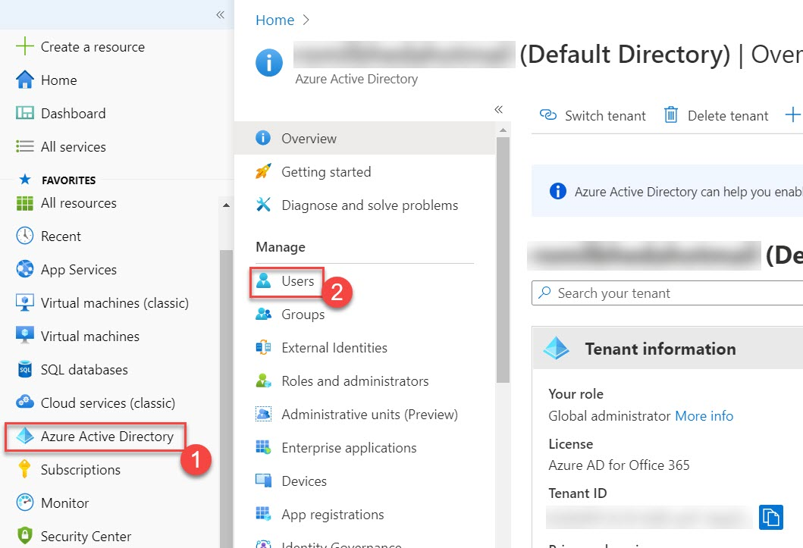

Step 3: Create New User
All users -> + New user
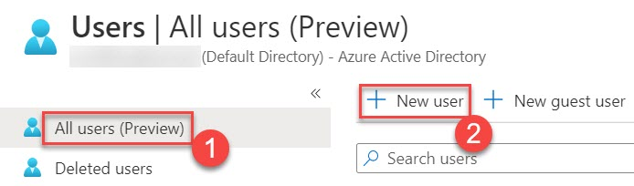

Step 4: Enter below details to create new user
Create user option
User name: aaduser1
Note: Click on Copy icon and paste username into notepad
Ex. aaduser1@training.onmicrosoft.com
Name: aaduser1

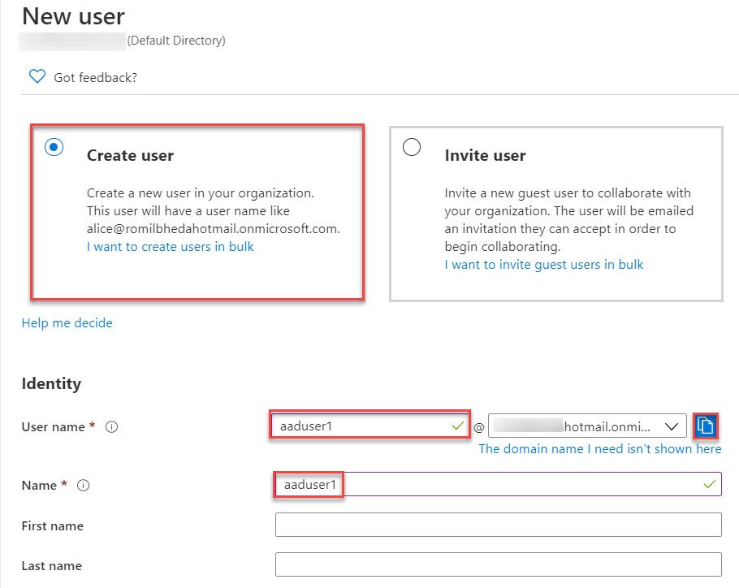

Password: Auto-generate password
Initial password: First select Show Password and click on Copy option
Note: Paste into Notepad where username or email collected in previous step
Roles: User
Click on Create button
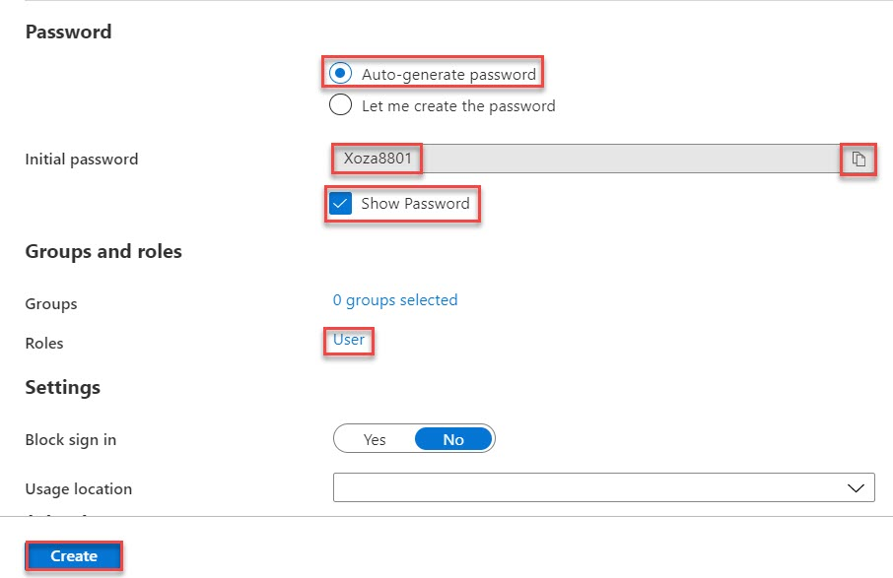

User will available as below:
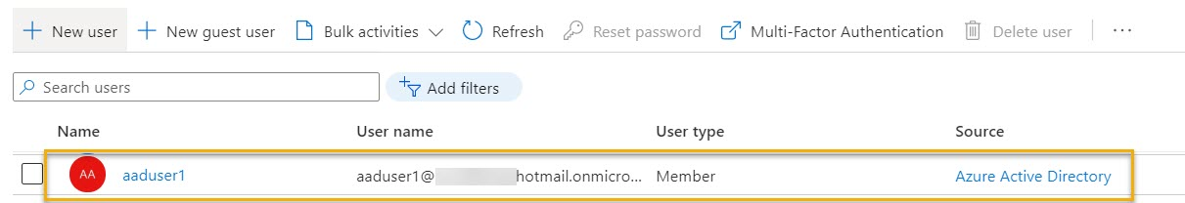

Step 5: Create New Group
Once again Click on Azure Active Directory and click on Groups
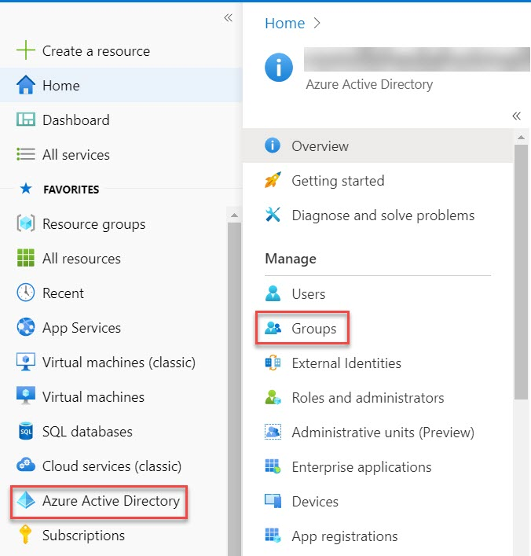

Step 6: All groups -> + New group
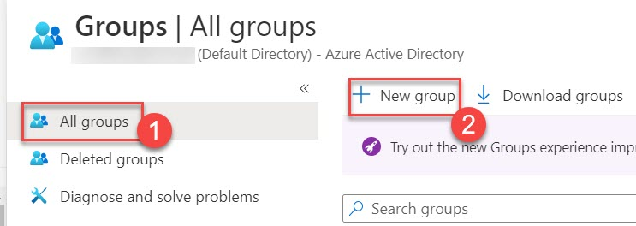

Step 7: Enter New Group Details
Group type: Security
Group name: Azure Subscription Contributor Group
Group description: Azure Subscription Contributor Group
Members: Click on that and search for aaduser1
Select aaduser1 and click on Select button.

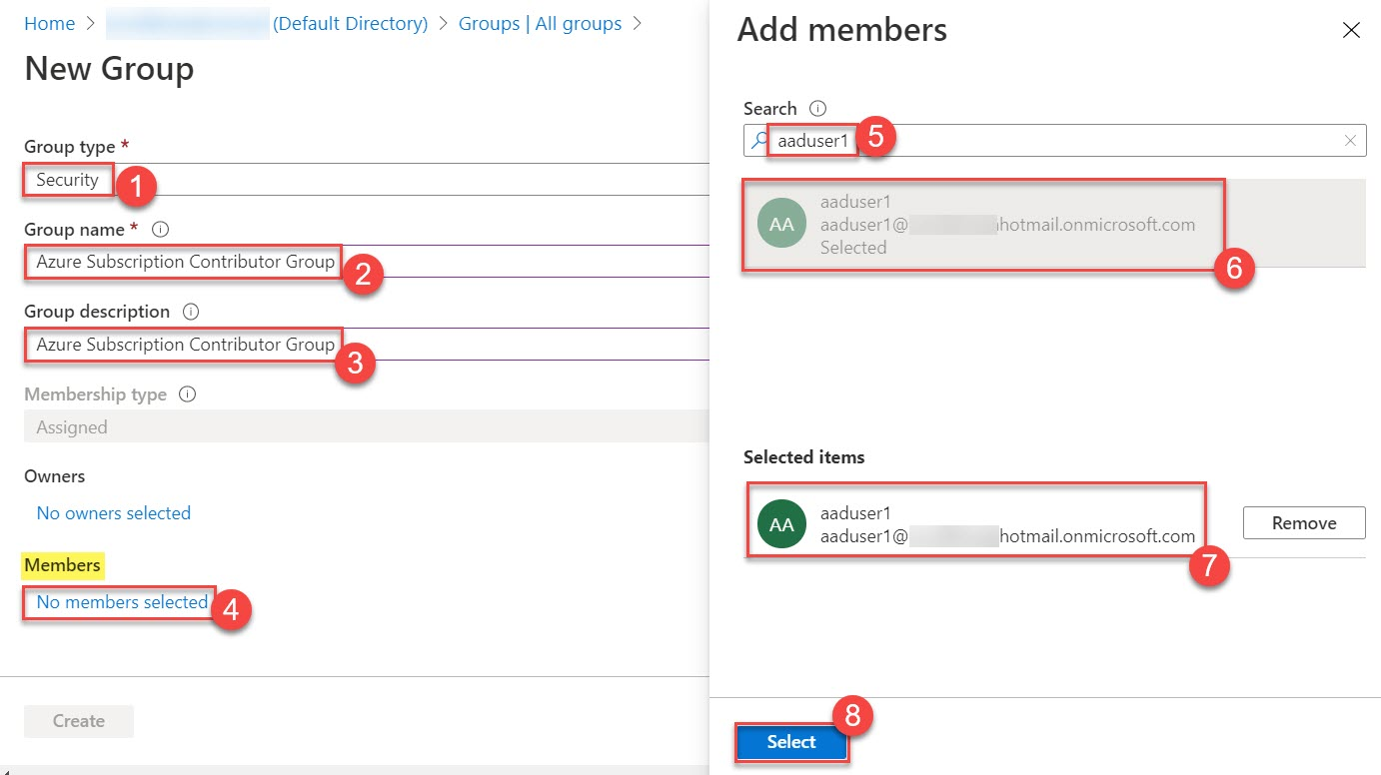

1 member will be there.
Click on Create button.

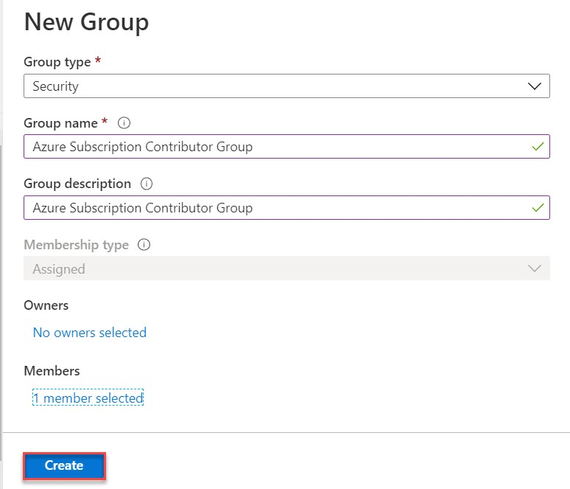

Group will load as below:
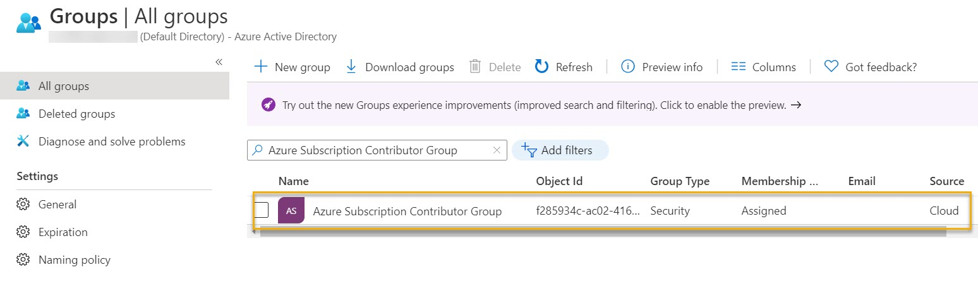

Step 8: Create New Resource Group
Click on Resource Groups -> + Add
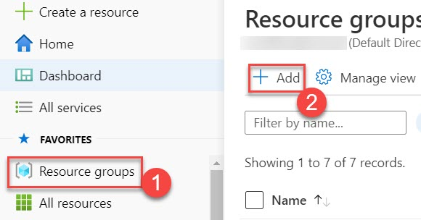

Step 9: Create resource group
Subscription: Choose active subscription
Resource Group: RBAC01RG
Region: (Asia Pacific) Southeast Asia
Click on Review + Create button.
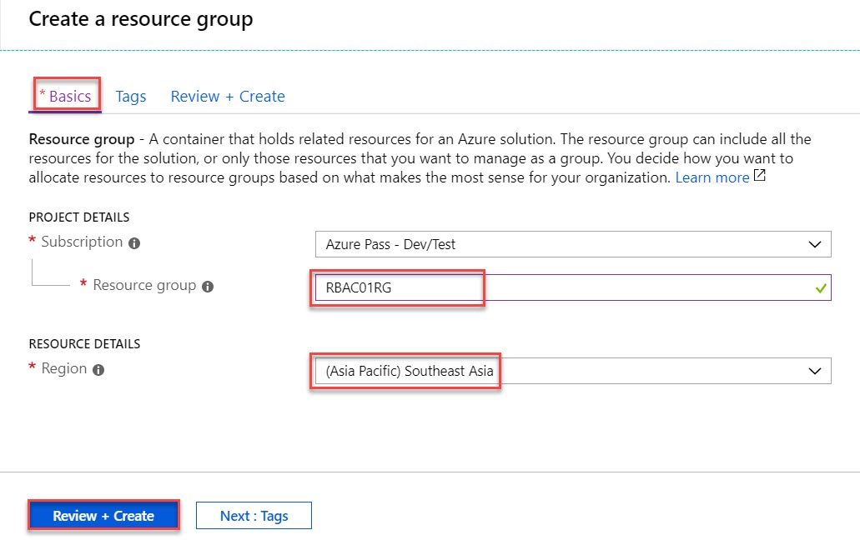

Step 10: Review + Create tab will open so click on Create button.
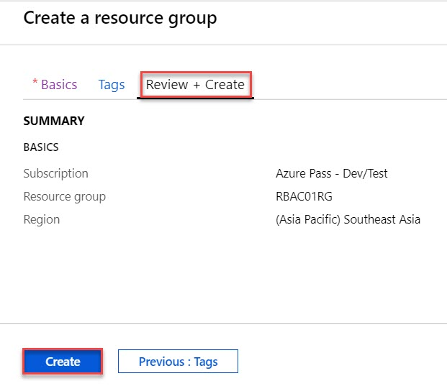

Within next second RBAC01RG resource group will create.
Click on that
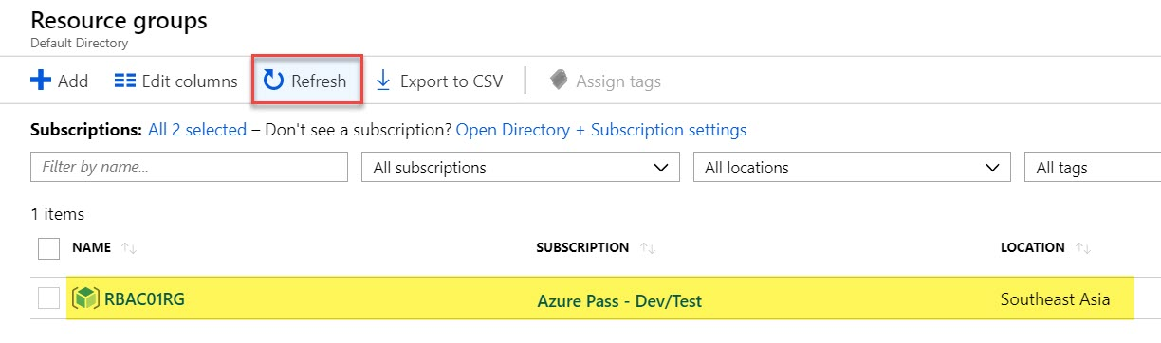

Step 11: Select Access Control (IAM) option.
Click on + Add -> Add role assignment
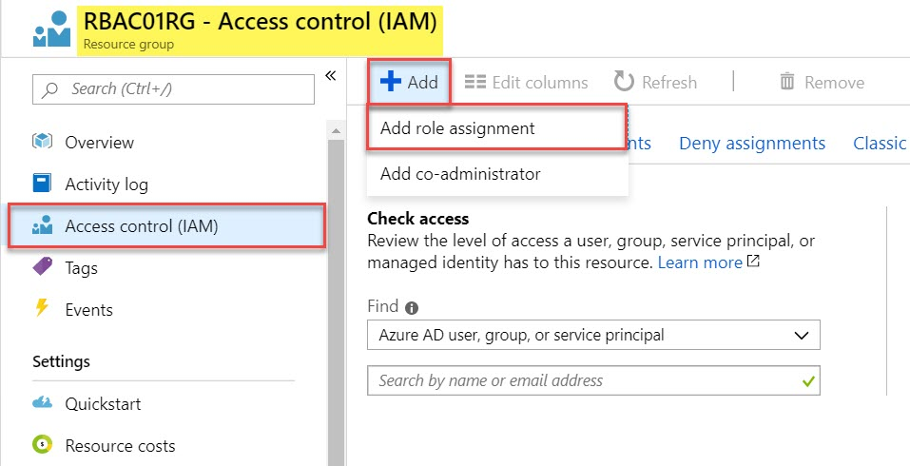

Step 12: Add Role Assignment
Role: Contributor
Assign access to: Azure AD user, group or service principal
Select: search for azure subscription and select from the result.
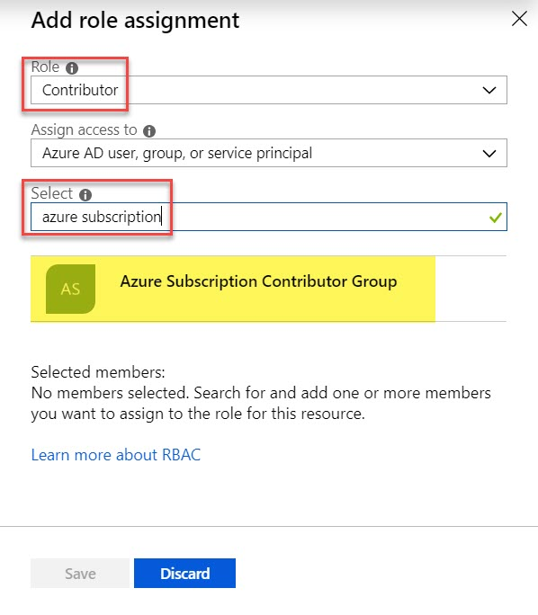
It will show under Selected Members and click on Save button.
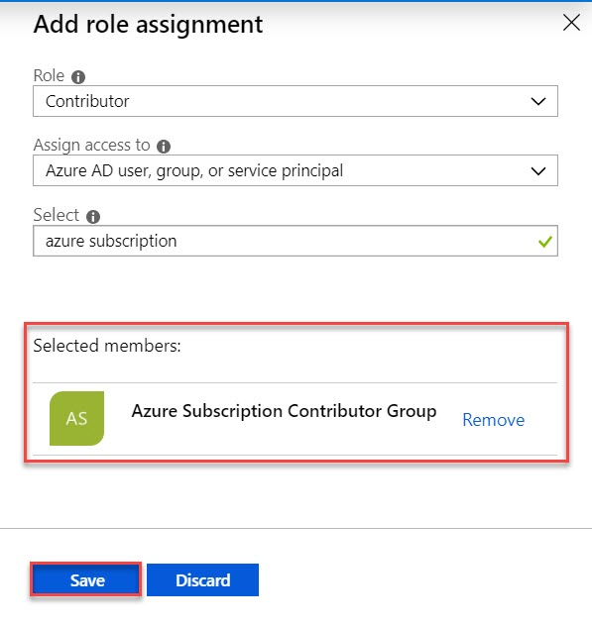
Step 13: Select Policies of RBAC01RG resource group
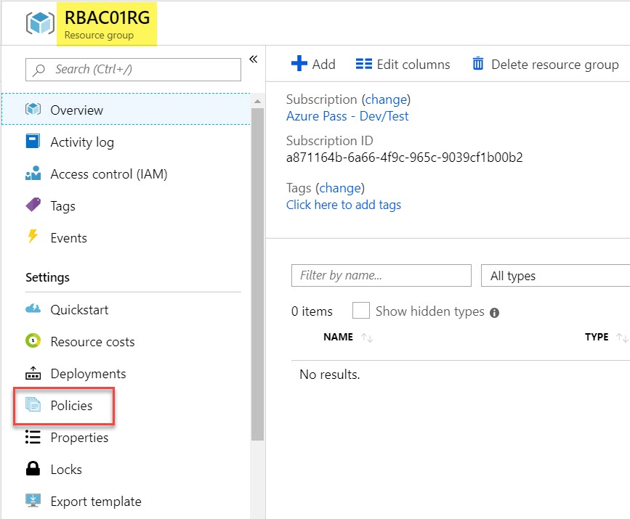

Step 14: Select built-in Definitions
Definitions -> search for SKUs and click on Allowed virtual machine size SKUs definition
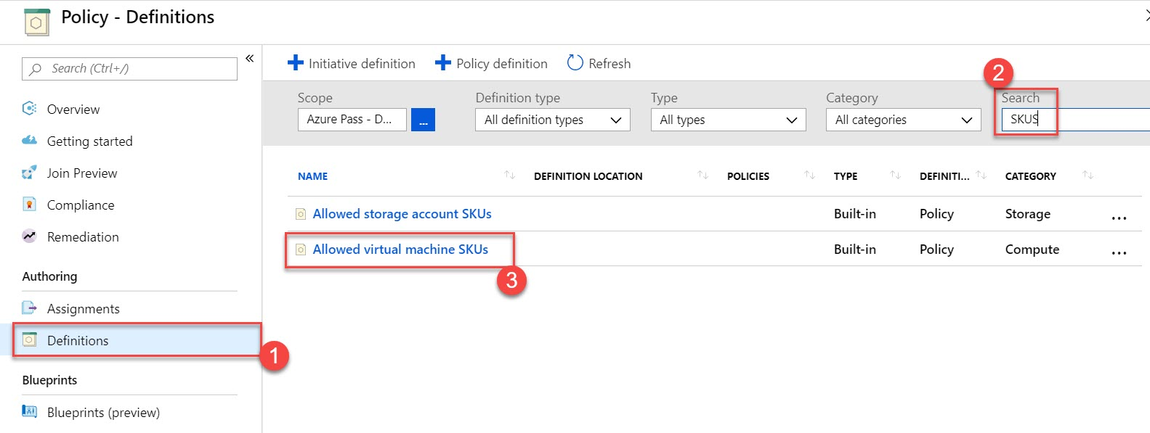

Step 15: Click on Assign option to Assign this policy on RBAC01RG resource group.
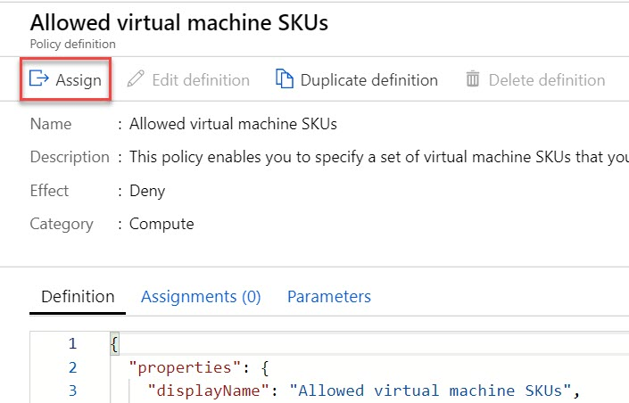

Step 16: Assign Policy option will open. Click on Browse option.
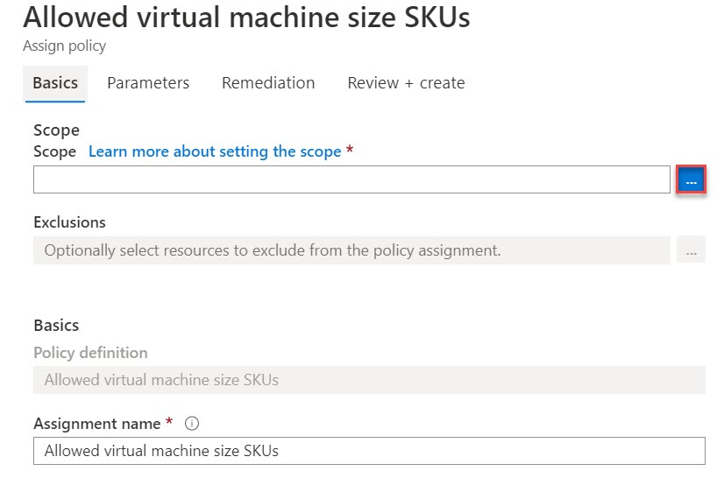

Step 17: Select Subscription and Resource Group. Click on Select button.
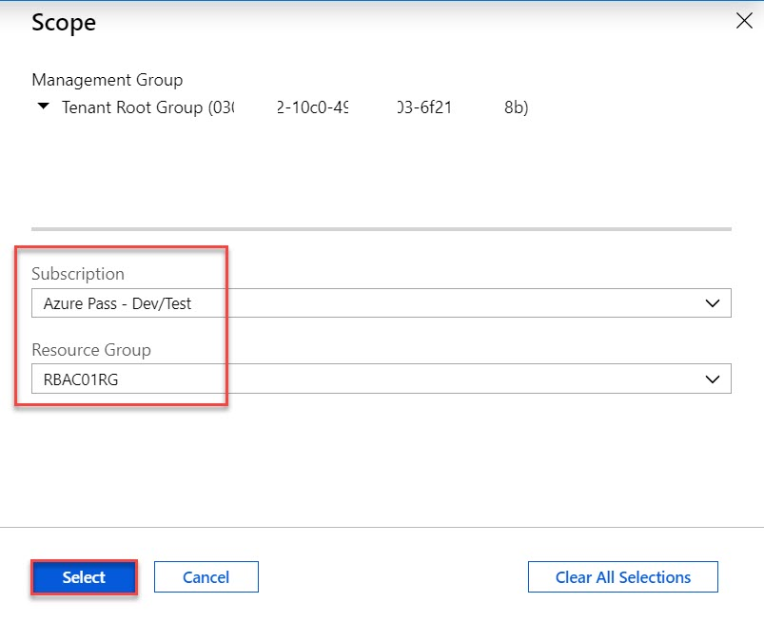
Step 18: Enter Assign Policy Description: Allowed selected virtual machine SKUs (Standard_DS2_v2)
Click on Next button
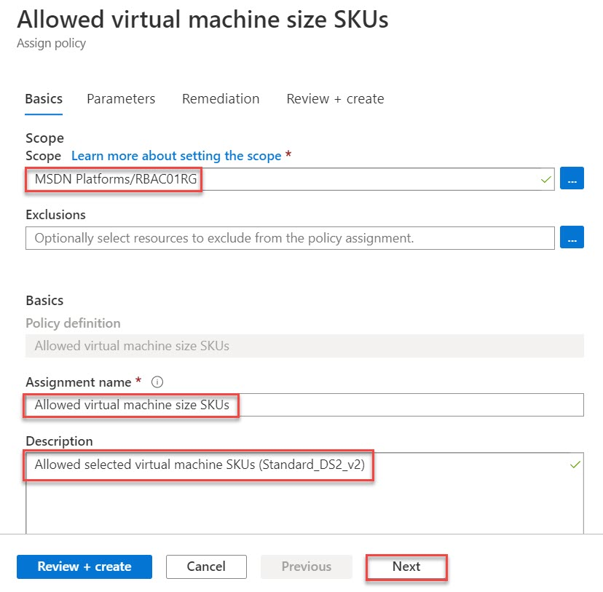

Select Allowed SKUs: Standard_D2s_v2 or v3 or Standard_DS2_v2 or search for any specific
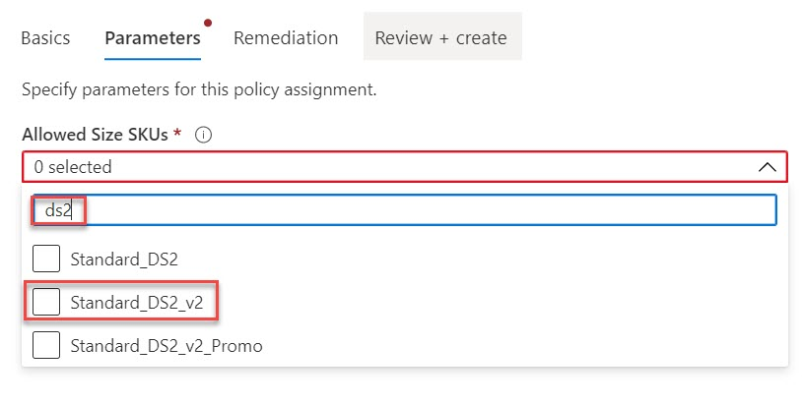

Click on Review + create button.
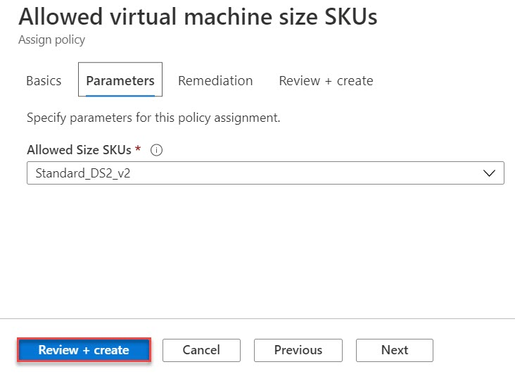

Click on Create button to Assign Policy

Step 19: Also, can verify from Assignments option and Allowed Virtual Machine size SKUs available
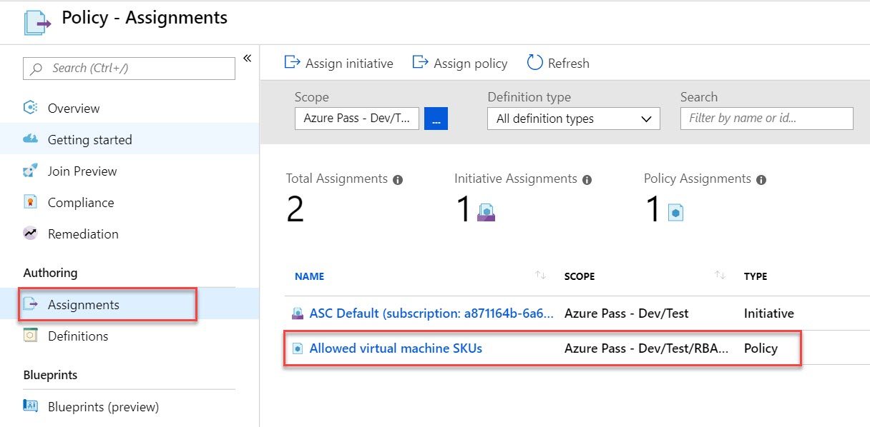

Step 20: Open another browser or open private browsing.
Open http://portal.azure.com and enter new user email: aaduser1@<dns-domain-name>
Ex. aaduser1@training.onmicrosoft.com (Step No. 4)
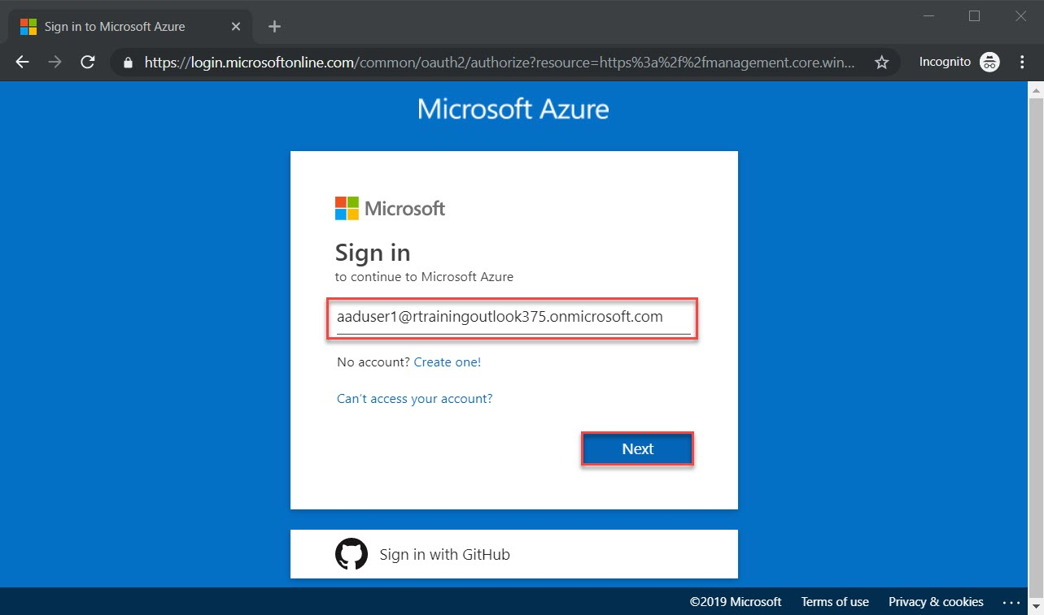
Step 21: When first time login with user it will show update password option
Enter Default password & new password.
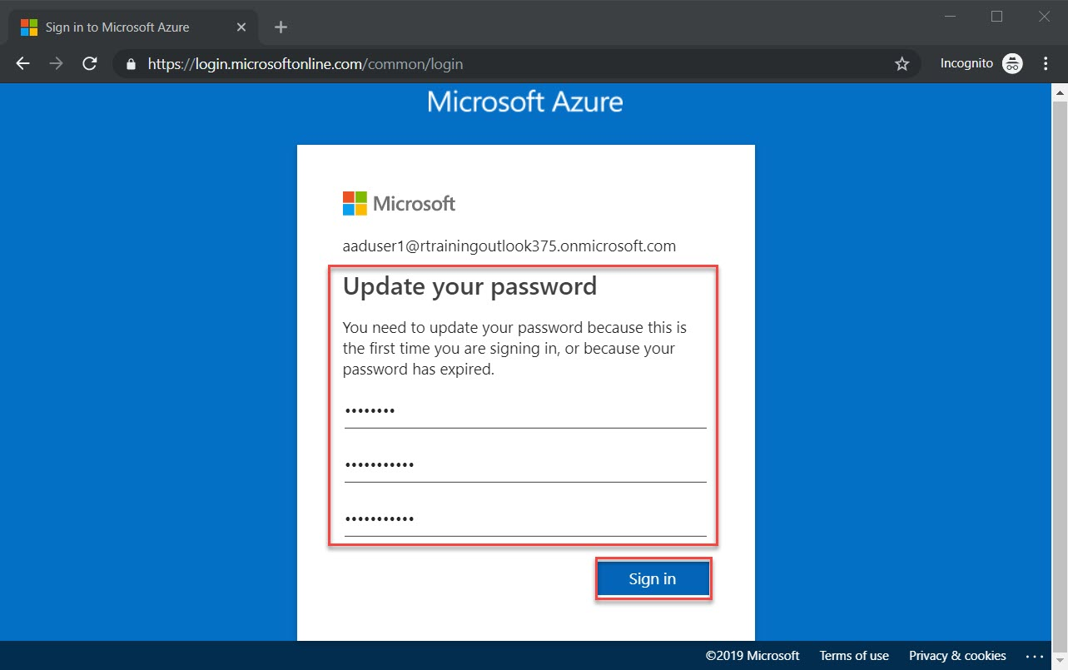

Step 22: Click on Resource Group and you can see RBAC01RG resource group available in this user as well.
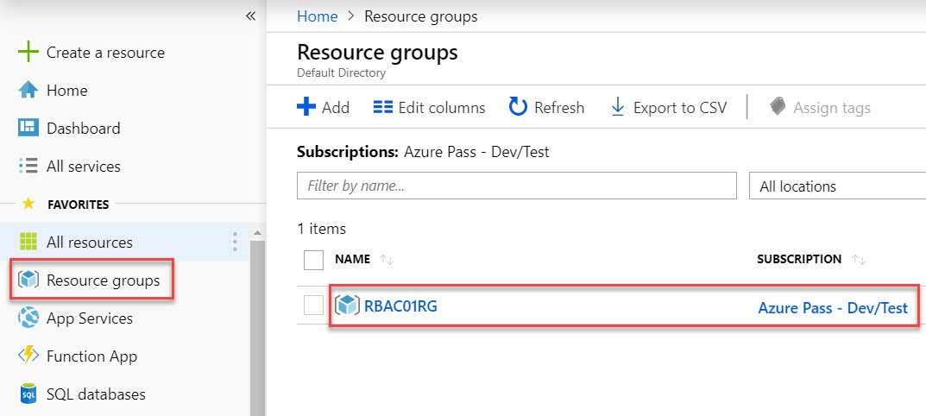

Step 23: Time to Test Policy
Note: from aaduser1 we are creating Virtual Machine not admin account.
+ Create a resource -> Get Started -> Windows Server 2019 VM
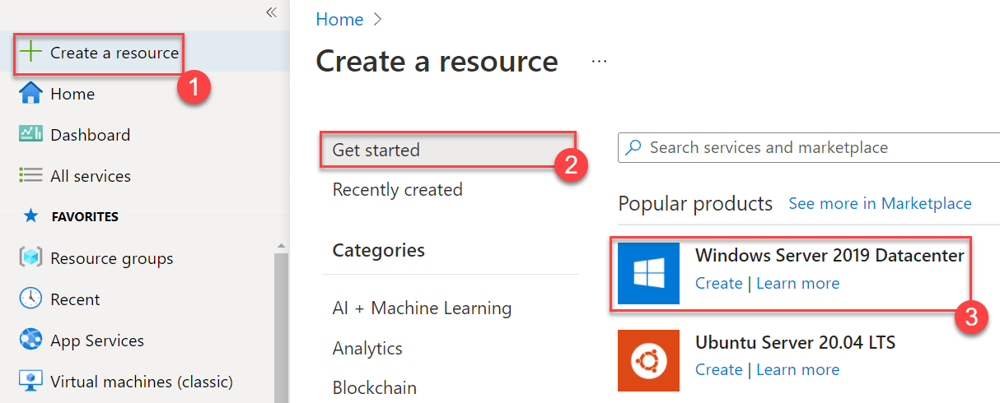

Step 24: Create a virtual machine

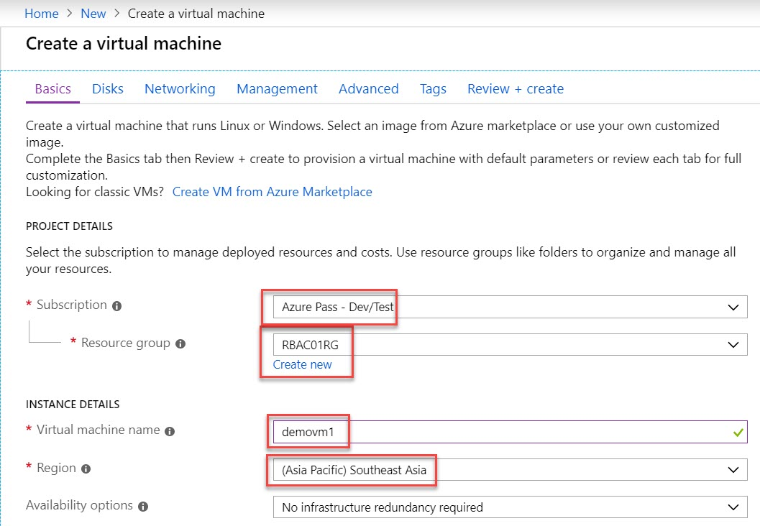
Subscription: Choose Azure Subscription
Resource Group: RBAC01RG
Virtual machine name: demovm1
Region: (Asia Pacific) Southeast Asia

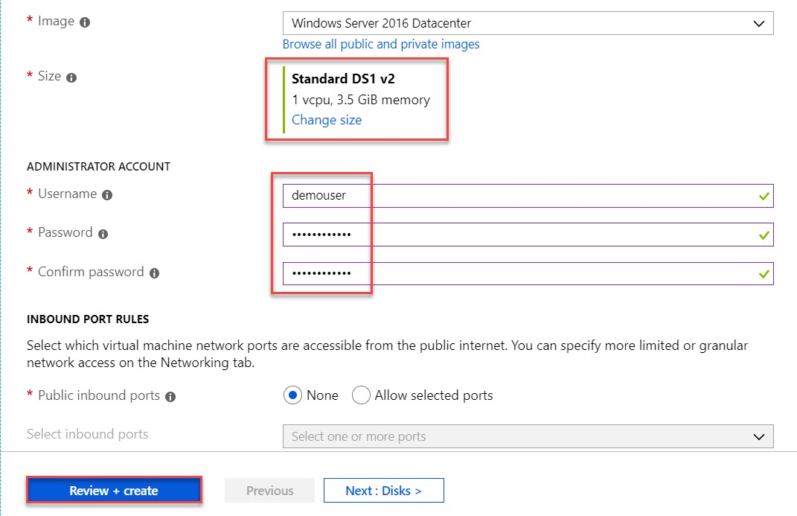
Size: Continue with default size. Ex. Standard DS1 v2
Username: demouser
Password: demo@pass123

Click on Review + Create button

Within next second you will receive Validation failed.
Click on that and under Error detail: Resource was disallowed by Policy because we have just allowed Standard_DS2_v2.
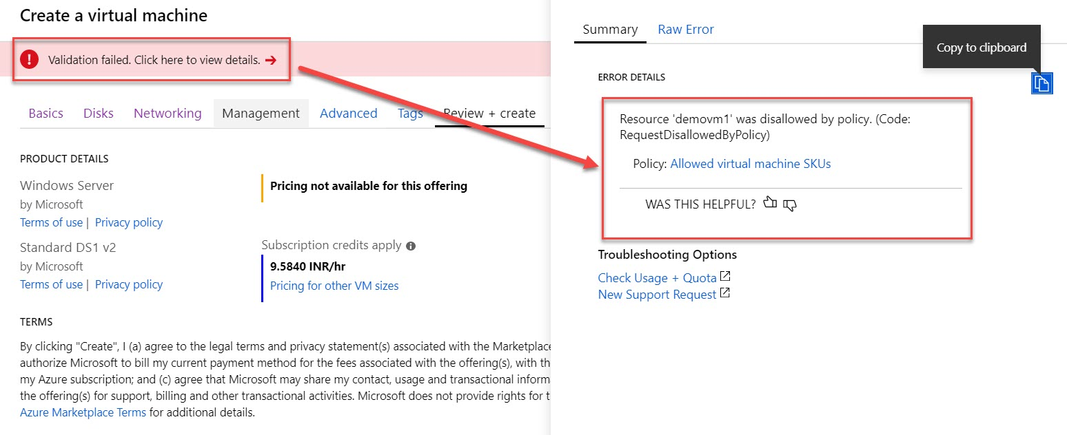

Step 25: Now back to first tab: Basics
Change Size to Standard DS2 v2 and click on Review + Create button.
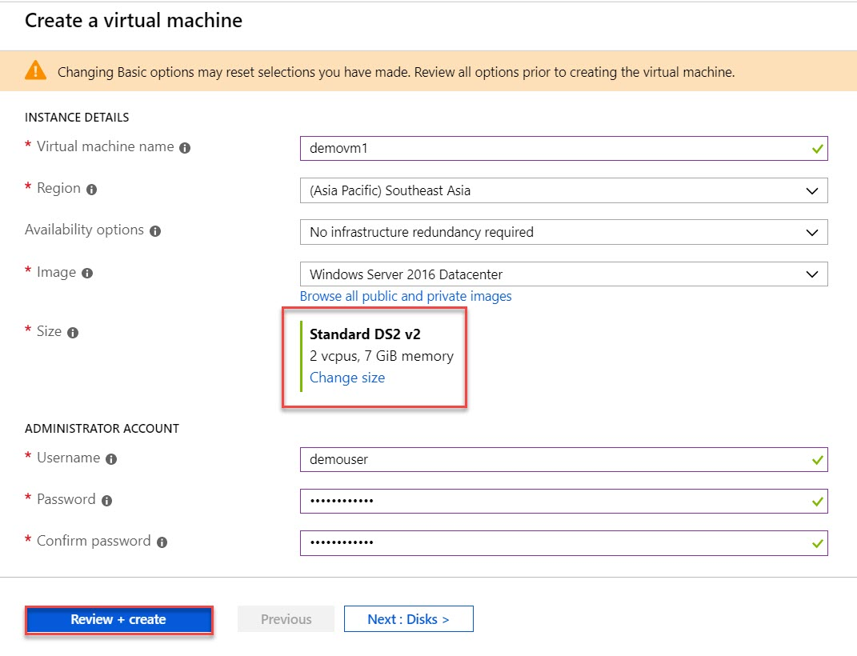
Step 26: Now you can see Validation Passed and click on Create button.
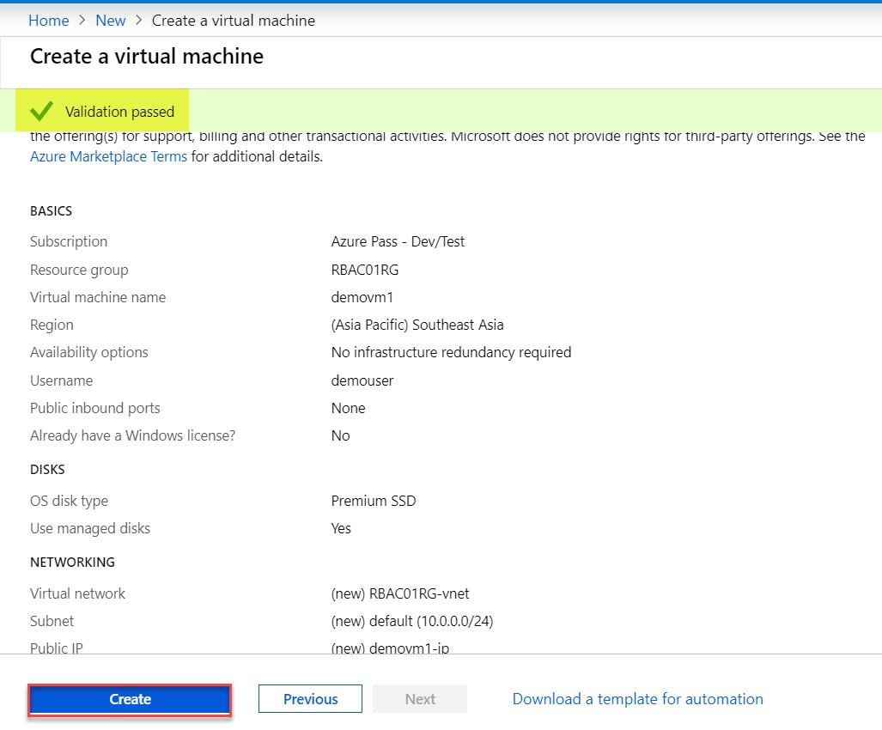

Step 27: Wait for few minutes to deploy Virtual Machine.
Click on Go to Resource button.
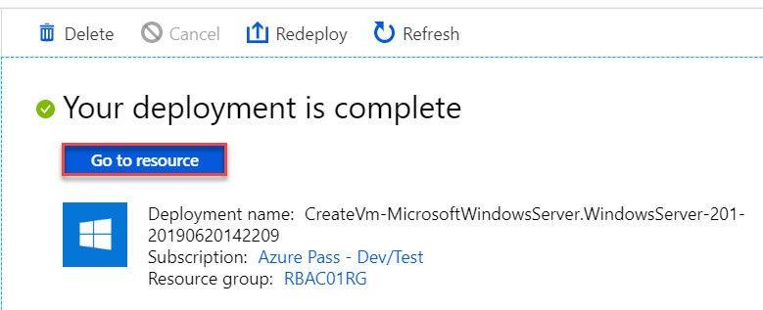

Step 28: Navigate to Activity log of RBAC01RG
Right side you can see all the activity log available of this resource group
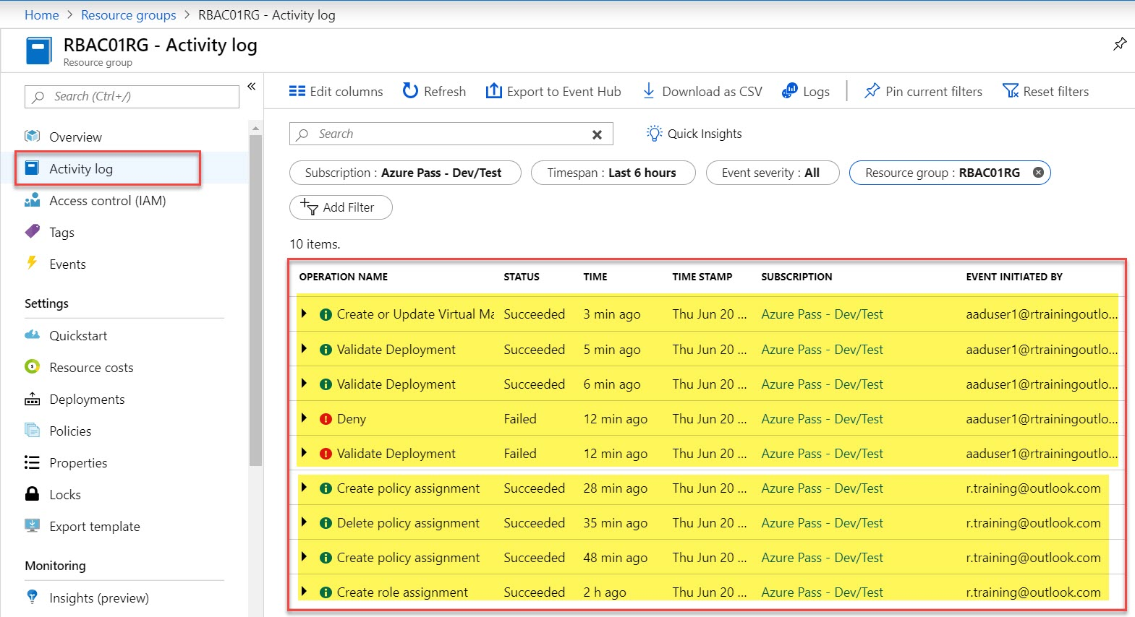

Step 29: Also navigate to Policy of RBAC01RG resource group
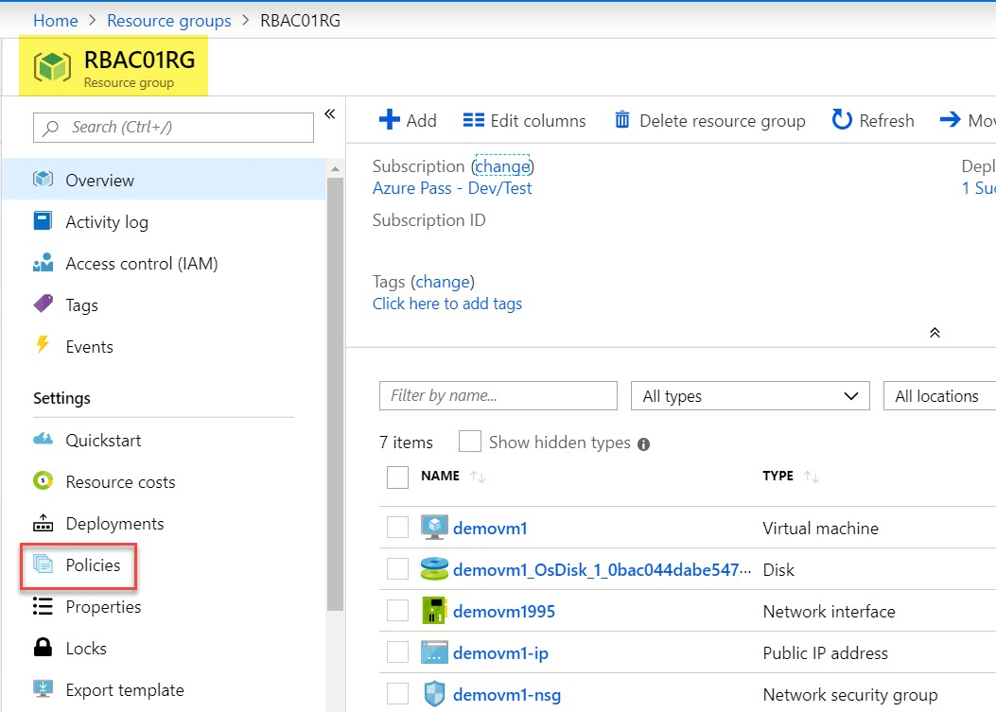
Step 30: This user has Contributor Role so does not allowed to delete policy
Assignments -> Allowed virtual machine SKUs -> Click on … -> Delete assignment disabled
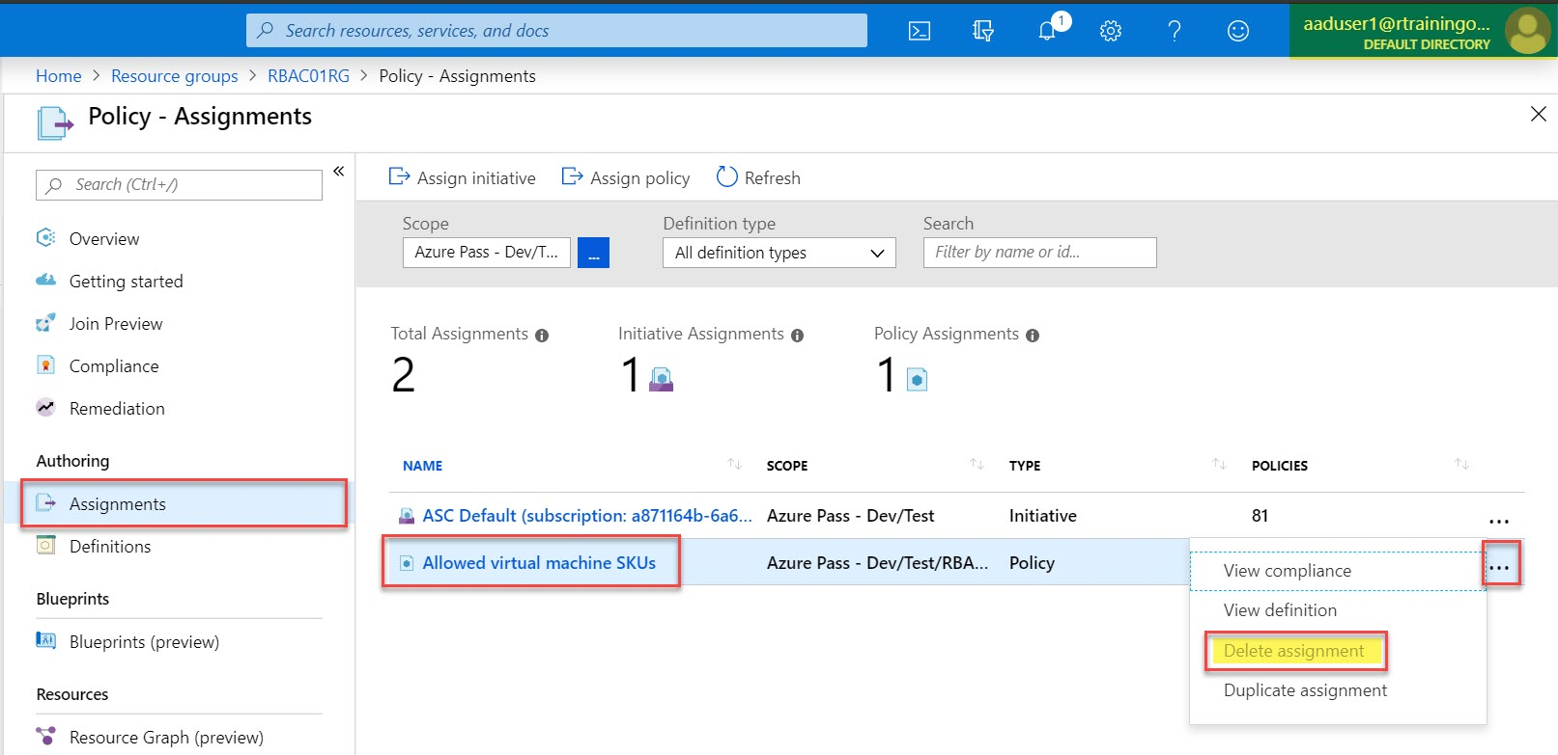

Step 31: Now delete Resource Group
Navigate to Resource Group: RBAC01RG and click on Delete Resource Group.
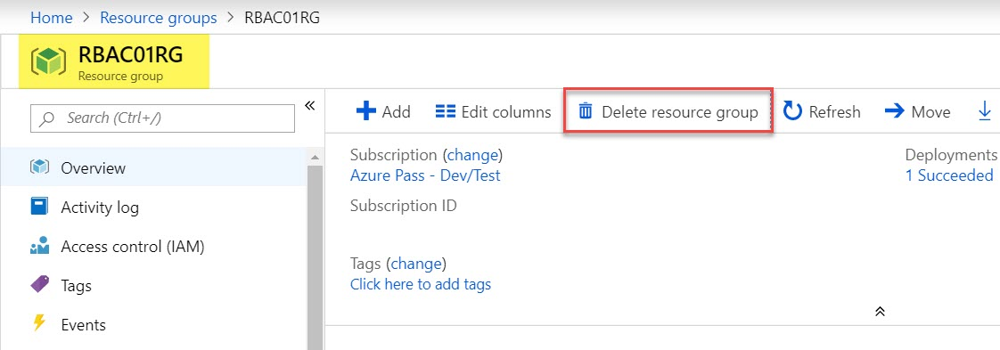

Enter Resource Group Name: RBAC01RG and click on Delete button.
