Attach Data Disk to Windows Server VM

Step 1: Open Microsoft Azure Portal
https://portal.azure.com

Step 2: Use existing Windows Server VM

Step 3: Add Disk
Click on Disks option
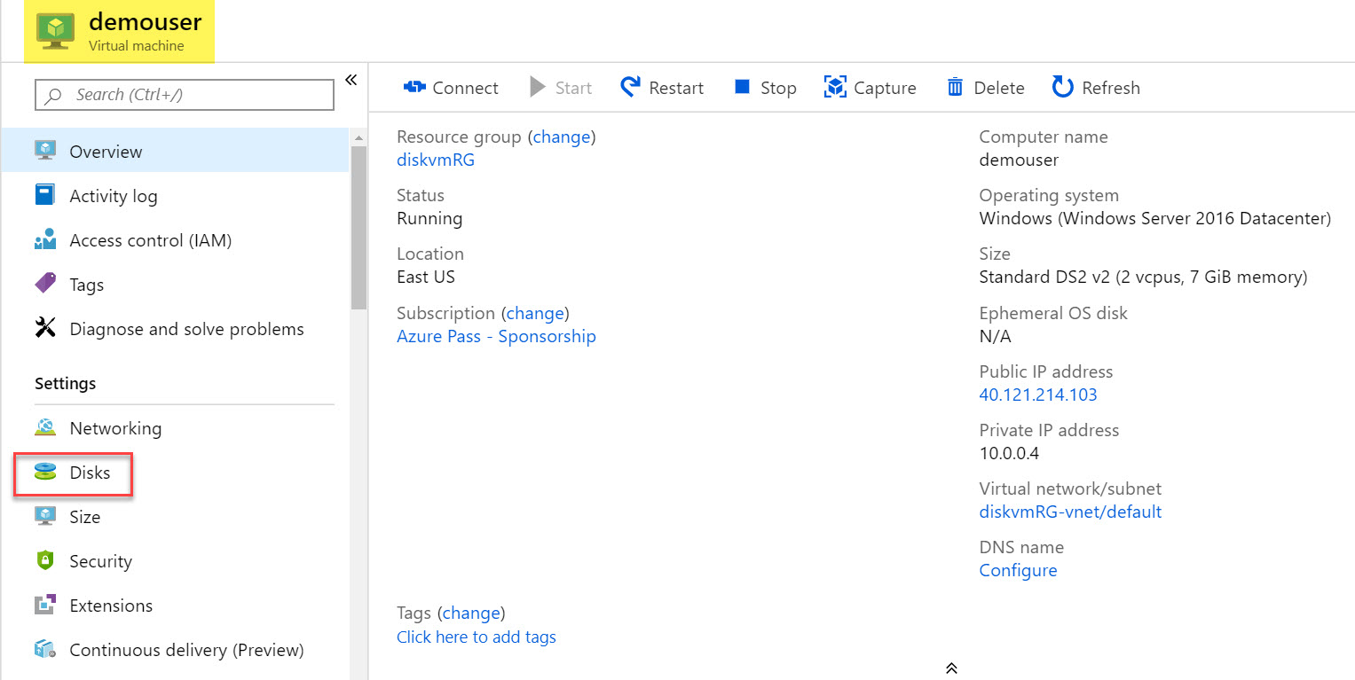

Step 4: Click on + Create and attach a new disk option
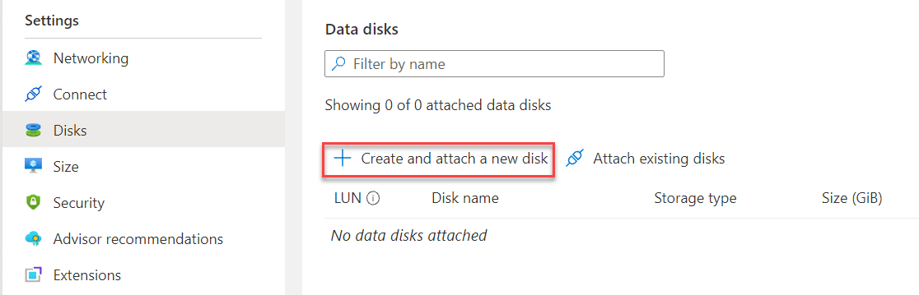

Step 5: Select below details
Diskname: vmdatadisk01
Storage type: Standard HDD
Size (GiB): 32 or more
Click on Save button
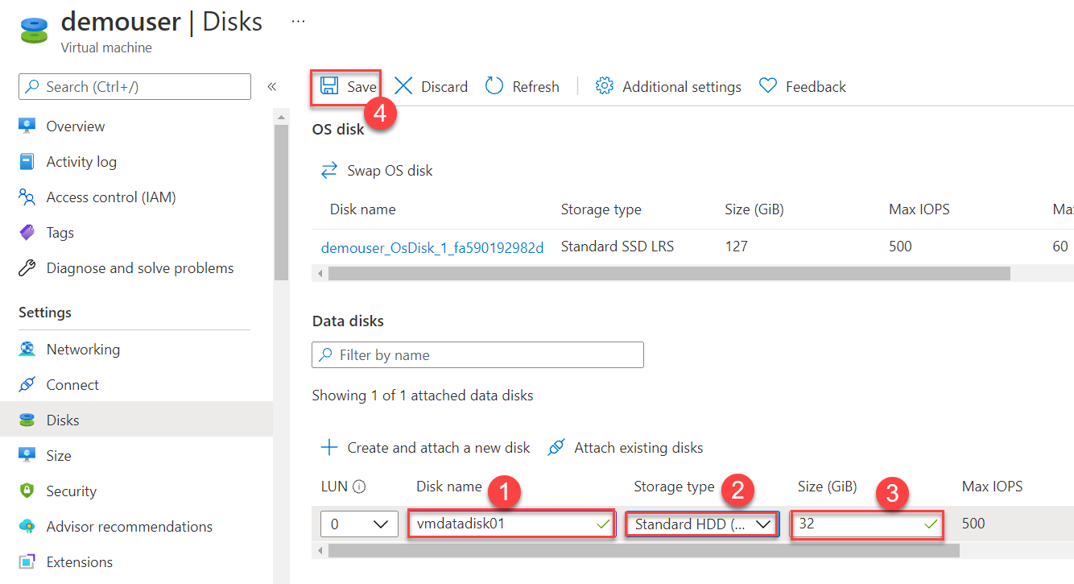

Note: if Virtual Machine already remotely connected skip step 6 to 11. Direct continue with Step No. 12
Step 6: Now Connect Windows Server VM via RDP. Click on Connect button.
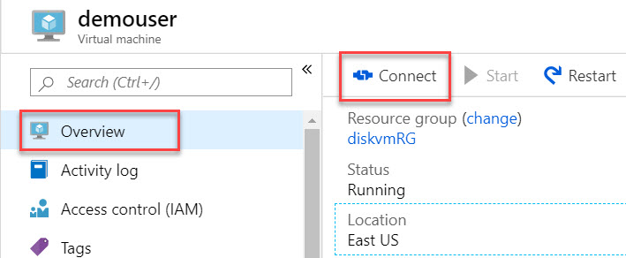

Step 7: Click on Download RDP File.
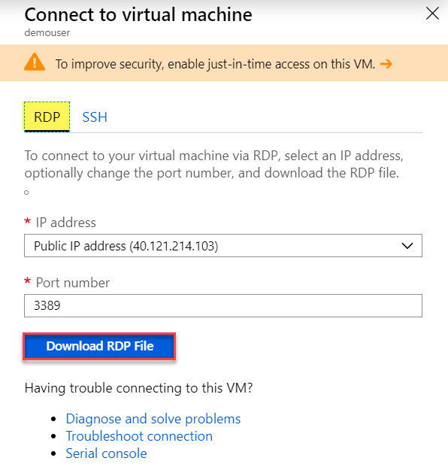

Step 8: Click on downloaded RDP file
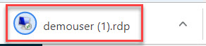

Step 9: Click on Connect button
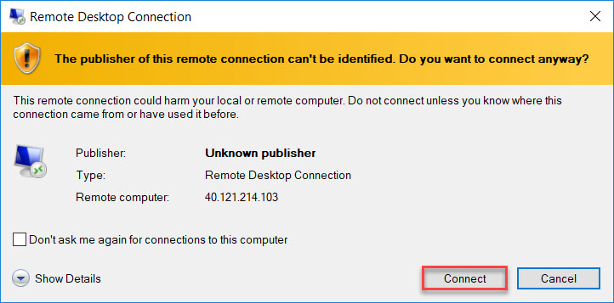

Step 10: Enter VM credentials
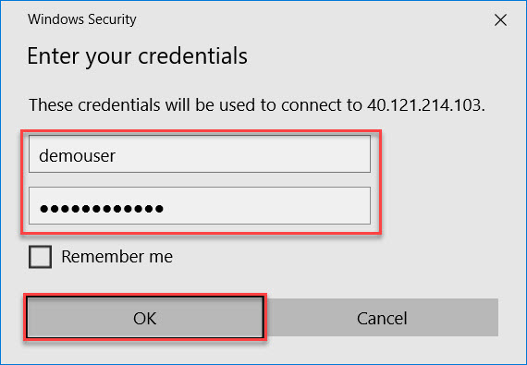
Step 11: Certificate error window will be there. Click on Yes button.
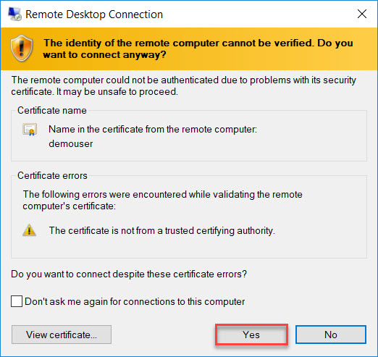

Step 12: Windows Server 2019 Datacenter will start.
Open File Explorer and verify Drives: Windows (C:) and Temporary Storage (D:) available
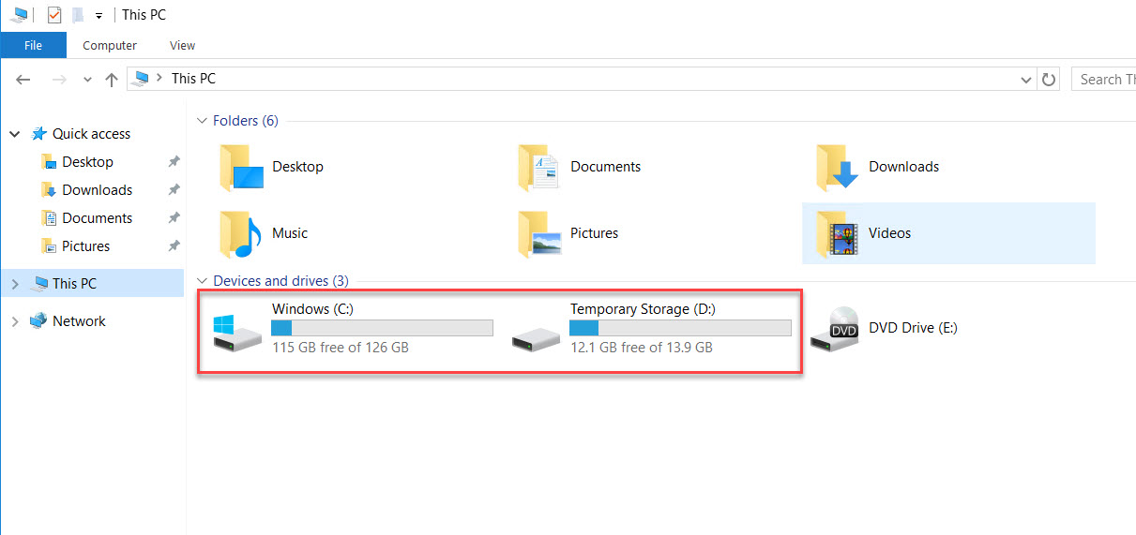

Step 13: Click on Windows button and search for “disk”
Stat Create and format hard disk partitions option
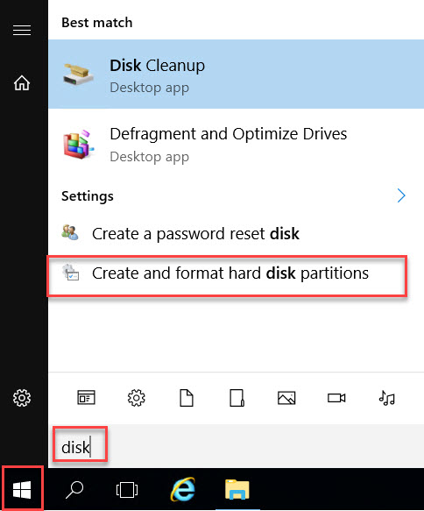

Step 14: When Disk Management will start, Initialize disk wizard will pop-up.
Check Disk 2 and click on OK button.
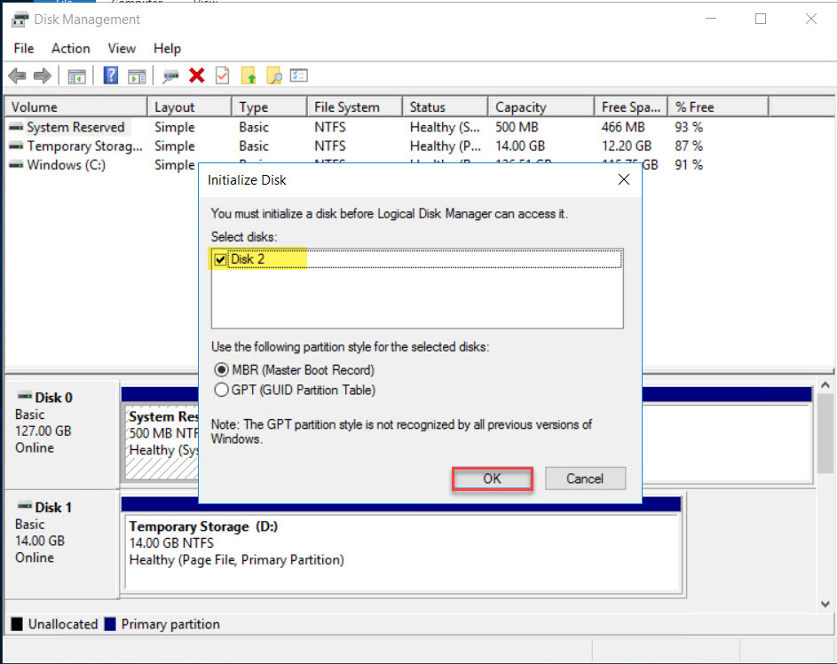

Step 15: Right-Click on Unallocated drive and select New Simple Volume… option
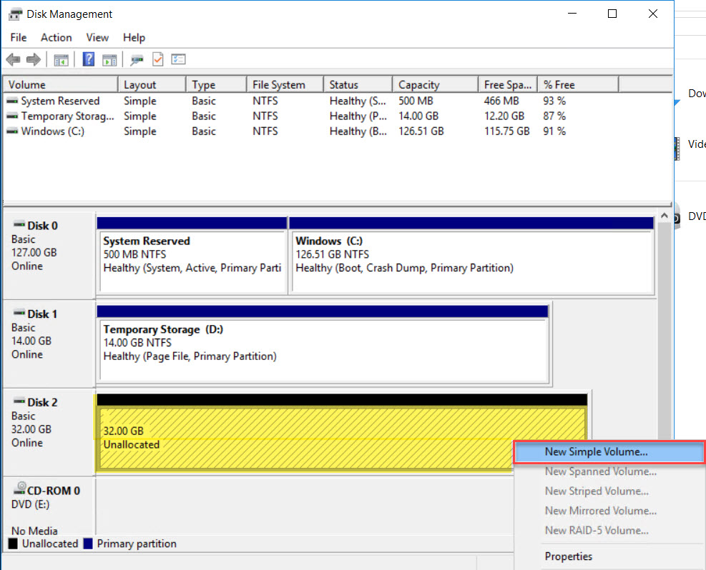

Step 16: New Simple Volume Wizard Will Start. Click on Next button
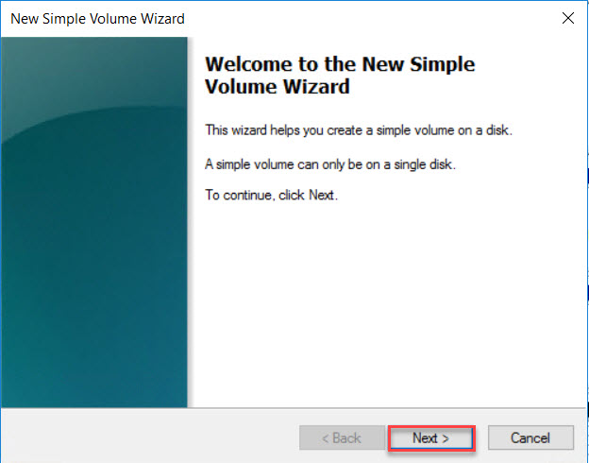
Step 17: Check Volume size and click on Next button.
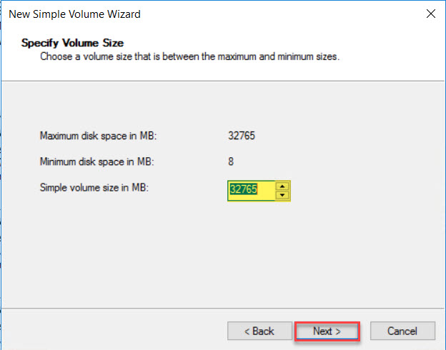

Step 18: Assign Drive Letter and click on Next button.
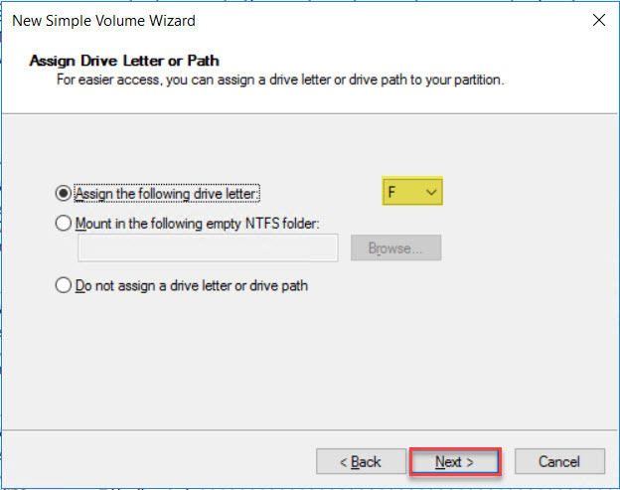
Step 19: Format Partition options
File System: NTFS
Allocation unit size: Default
Volume label: DataDisk1
Check on Perform a quick format
Click on Next button

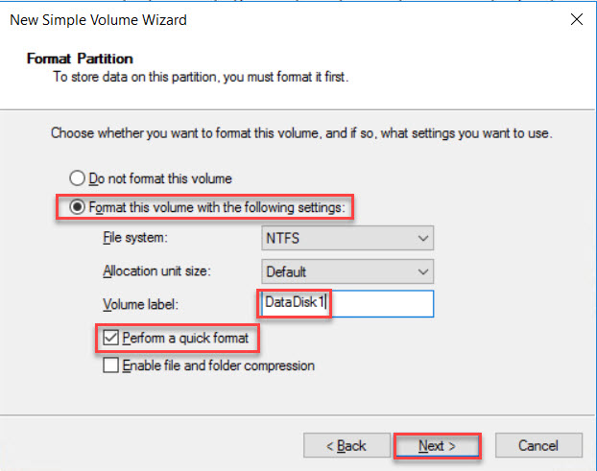

Step 20: Click on Finish button.
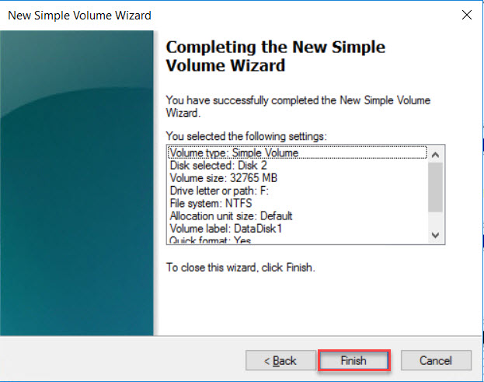

Step 21: Open File Explorer and check DataDisk1(F:) drive available
