Azure Service Bus – Topics

Step 1: Open Microsoft Azure Portal
https://portal.azure.com/

Step 2: Click on + Create a resource -> Integration -> Service Bus
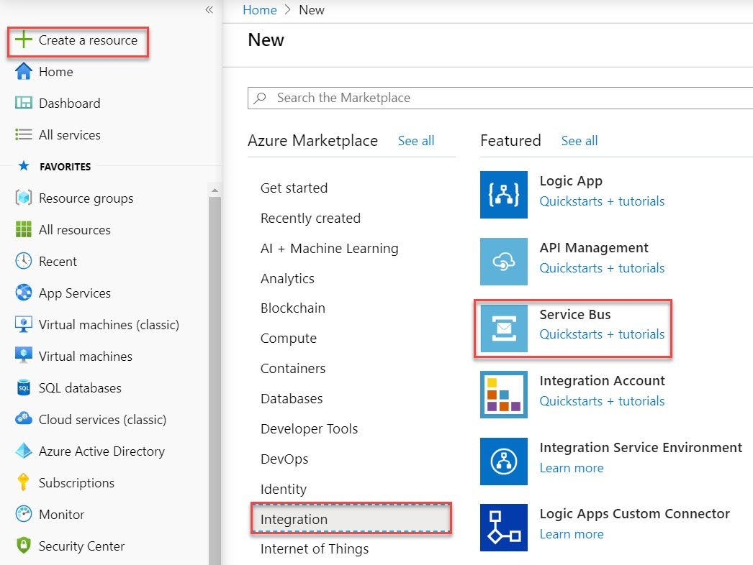

Step 3: Enter Service Bus Namespace
Subscription: Choose active Subscription
Resource Group: Create New Resource Group Ex. ServiceBusDemoRG
Namespace name: Enter unique name Ex. myservicebus
Location: Choose nearest location
Pricing tier: Standard

Click on Review + Create button
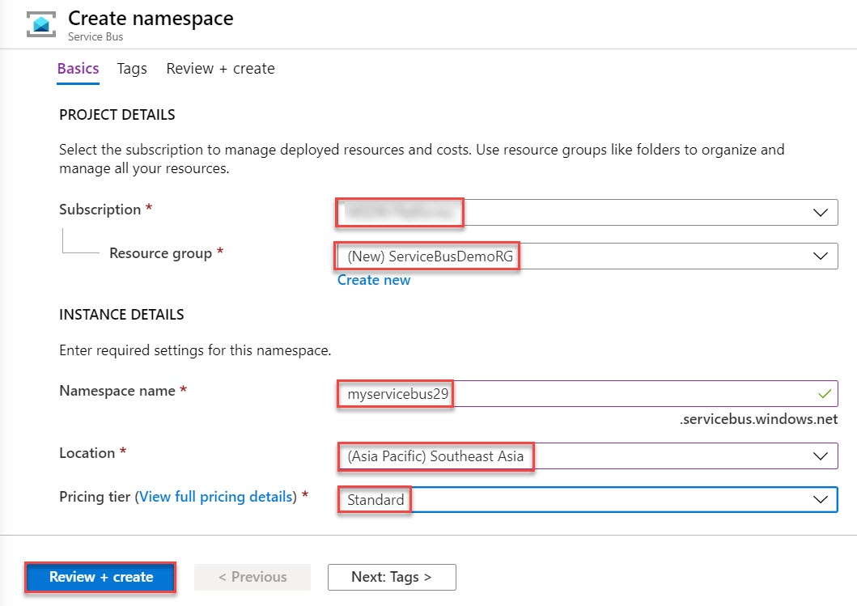

Click on Create button
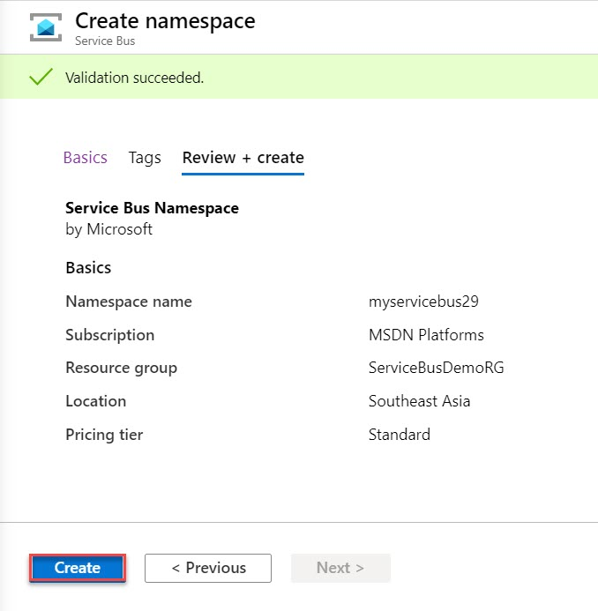

Click on Go to resource button
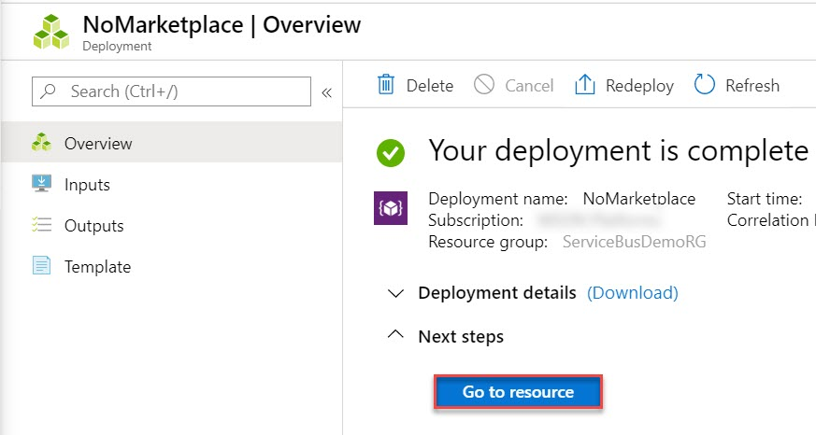
Step 4: Click on + Topics to create new Topics
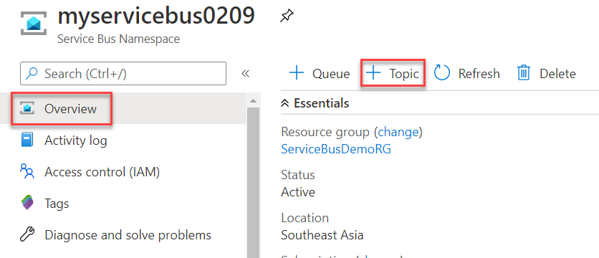

Enter Topics Name: sbtopics
Click on Create button
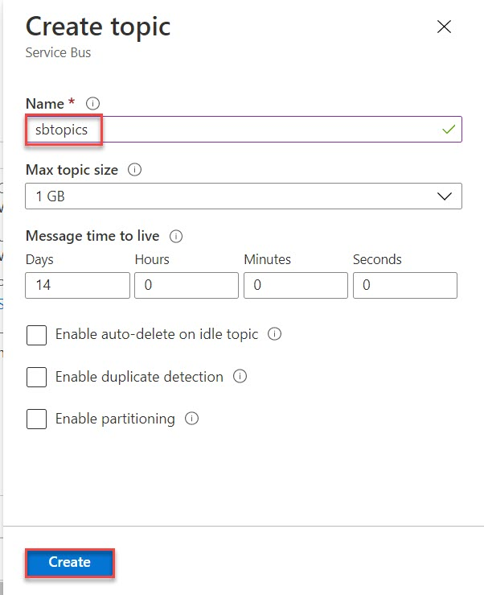

Step 5: Click on Shared access policies and Select RoorManageSharedAccessKey
Copy Primary Connection String into Notepad for further use
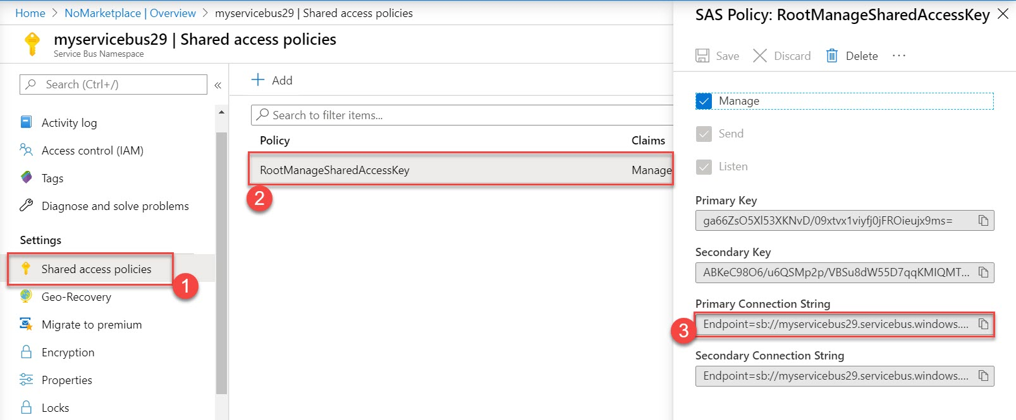

Step 6: Start Visual Studio and Create a new project
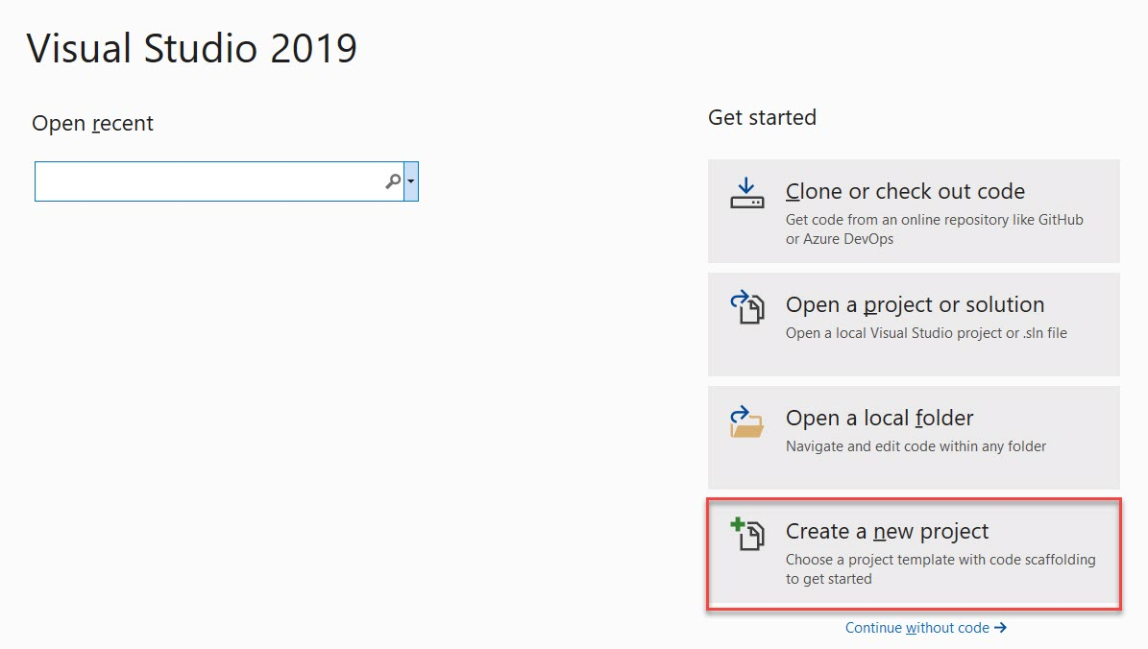

Choose Console App (.NET Framework)
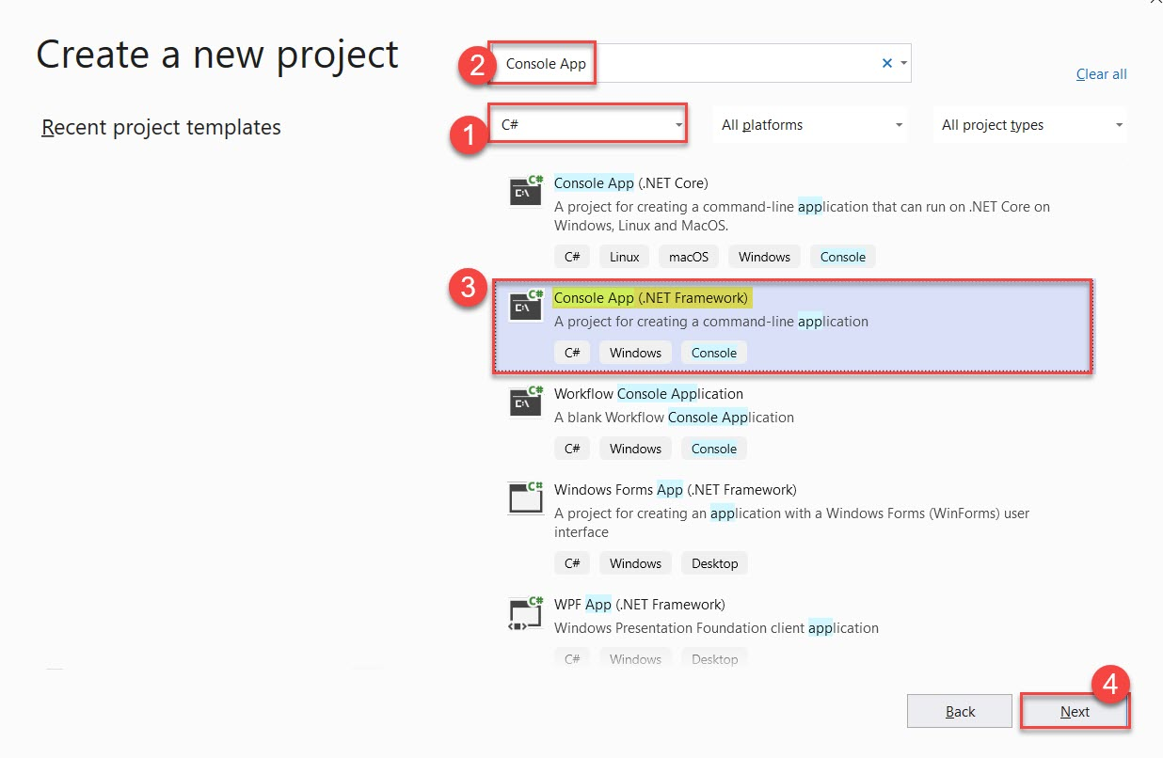

Project Name: SBTopicsChatApp
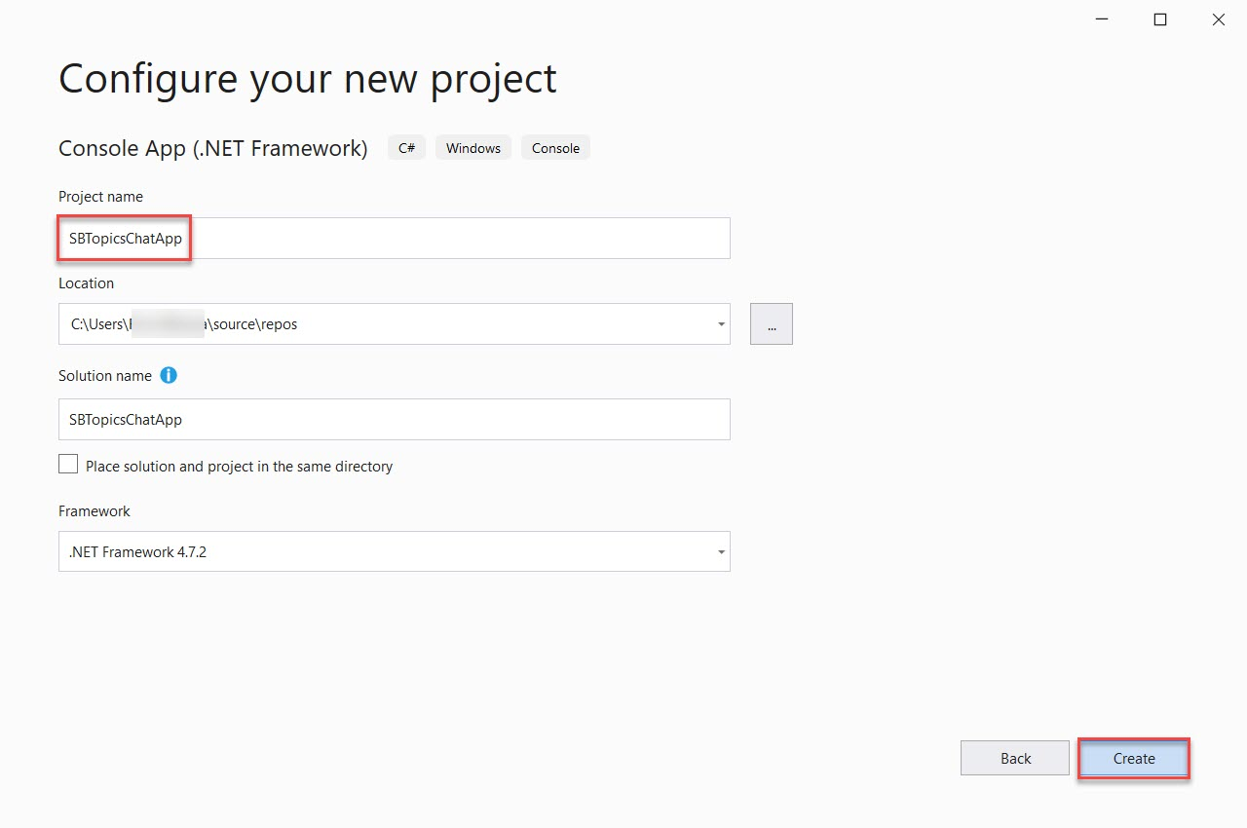

Step 7: Right click on Project Name & select “Manage NuGet Packages…”
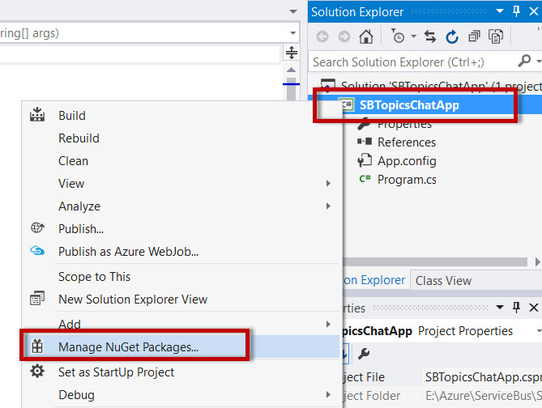

Search for “WindowsAzure.ServiceBus” & install packages.
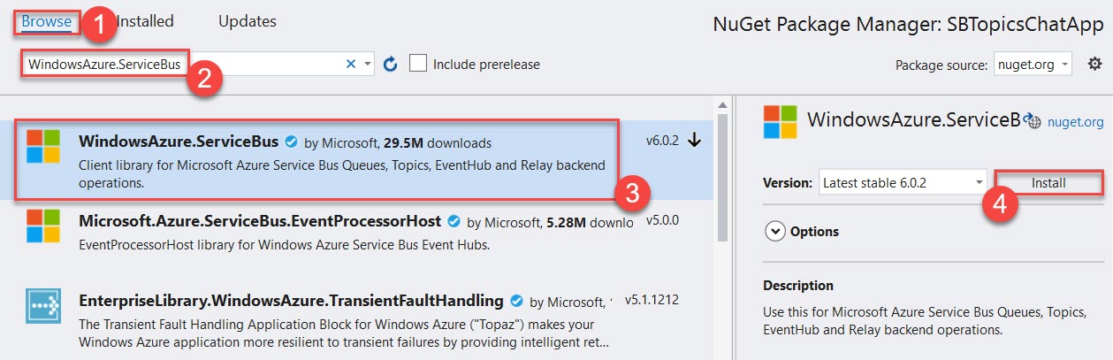

Step 8: Open Program.cs file
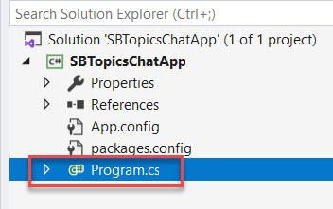
Step 9: Add Service Bus Namespace & update Connection String from Notepad or Azure Portal

using Microsoft.ServiceBus;
using Microsoft.ServiceBus.Messaging;

namespace SBTopicsChatApp
{
class Program
{
static string ConnectionString = "Endpoint=sb://azureservicebus.servicebus.windows.net/;SharedAccessKeyName=RootManageSharedAccessKey;SharedAccessKey=<copy-servicebus-sharedkey-from-azure-portal>";
static string TopicPath = "sbtopics";

static void Main(string[] args)
{
Console.WriteLine("Enter Name - ");
var username = Console.ReadLine();

var manager = NamespaceManager.CreateFromConnectionString(ConnectionString);
if (!manager.TopicExists(TopicPath))
{
manager.CreateTopic(TopicPath);
}
var description = new SubscriptionDescription(TopicPath, username);
{
description.AutoDeleteOnIdle = TimeSpan.FromMinutes(5);
}
manager.CreateSubscription(description);

var factory = MessagingFactory.CreateFromConnectionString(ConnectionString);
var topicClient = factory.CreateTopicClient(TopicPath);
var subscriptionClient = factory.CreateSubscriptionClient(TopicPath, username);

subscriptionClient.OnMessage(msg => ProcessMessage(msg));
var hellomessage = new BrokeredMessage("Has entered the Room...");
hellomessage.Label = username;
topicClient.Send(hellomessage);
while (true)
{
string text = Console.ReadLine();
if (text.Equals("exit")) break;
var chatMessage = new BrokeredMessage(text);
chatMessage.Label = username;
topicClient.Send(chatMessage);
}

var goodbyeMessage = new BrokeredMessage("Has left the building.....");
goodbyeMessage.Label = username;
topicClient.Send(goodbyeMessage);
factory.Close();
}

static void ProcessMessage(BrokeredMessage message)
{
string user = message.Label;
string text = message.GetBody<string>();
Console.WriteLine(user + ">" + text);
}
}
}

Step 10: Now run the project
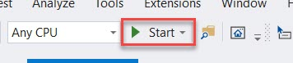

Enter Name Ex. User1
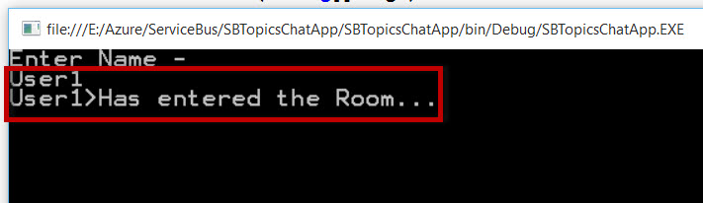
Step 11: Don’t Stop the project & right-click on project name -> Debug -> Start new instance
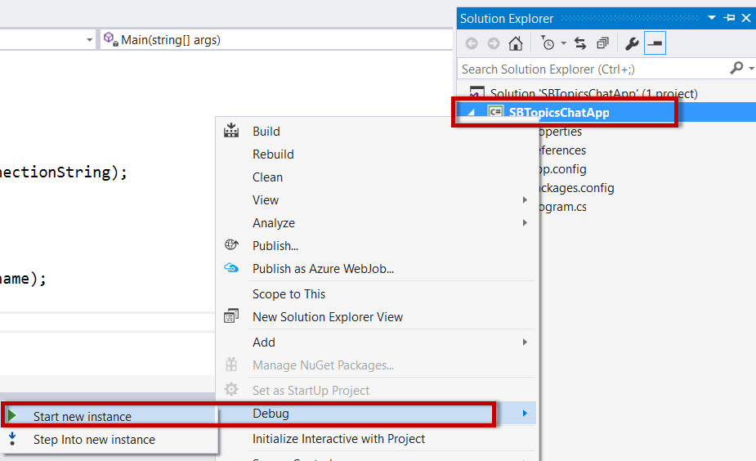
Enter another Name Ex. User2
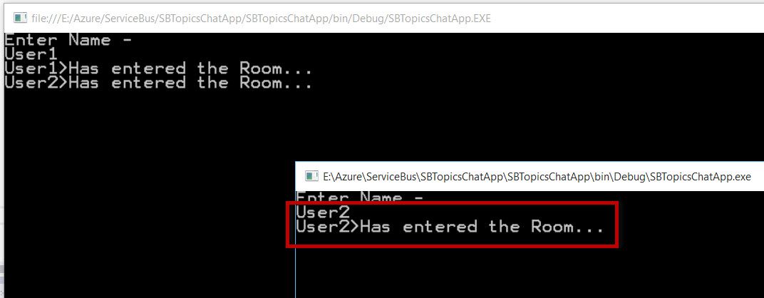

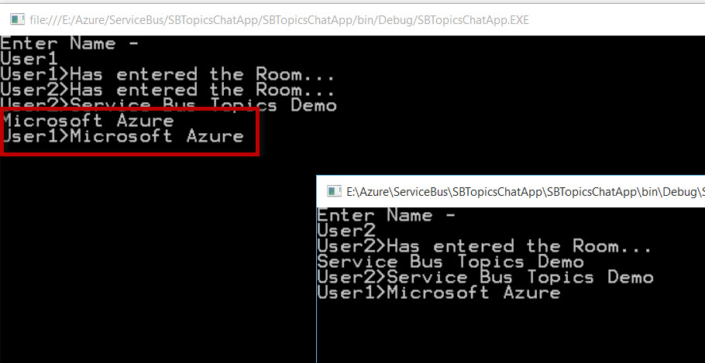

Step 12: Navigate to Service Bus Topics on Azure Portal
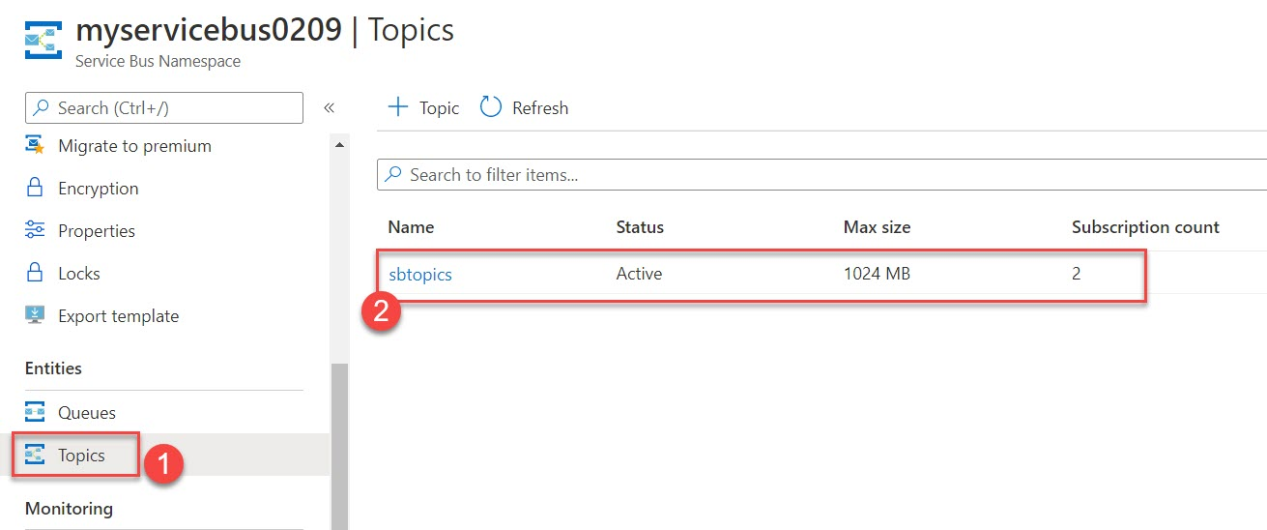

Select Subscriptions – User 1 & User 2 available
