Azure Storage – File Share
Note: Continue with Storage Blob demo or if you don’t have storage account so create new.
Step 1: Select Filer shares under Data storage
Click on + File share option
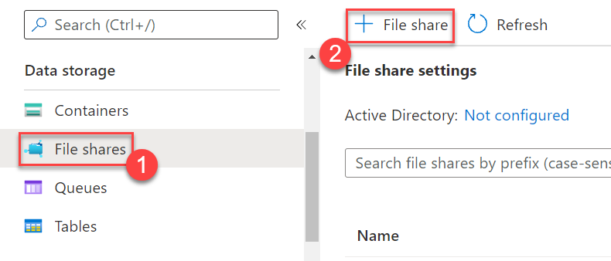

Step 2: New file share
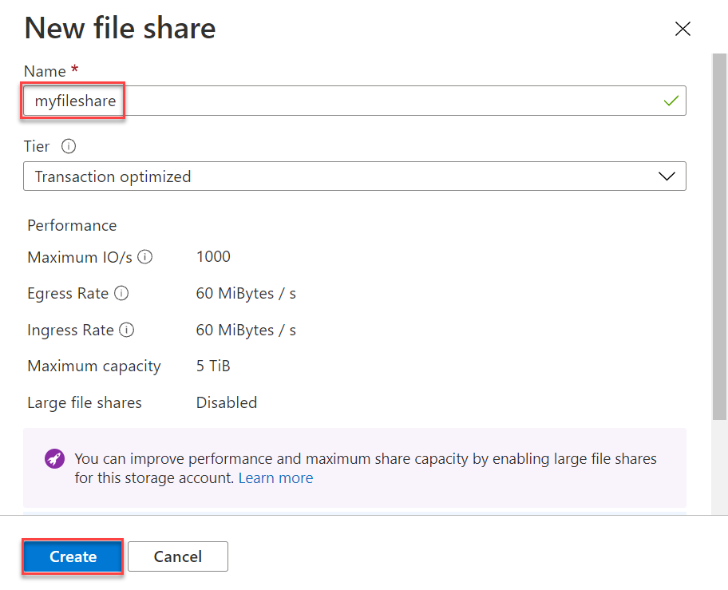
Name: myfileshare
Click on Create button

Step 3: Click on myfileshare
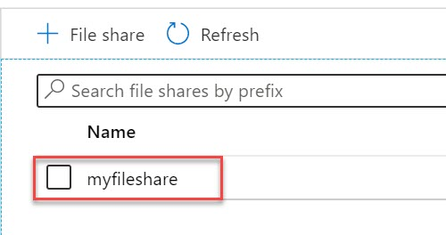

Step 4: Create New directory under file share
Click on + Add directory
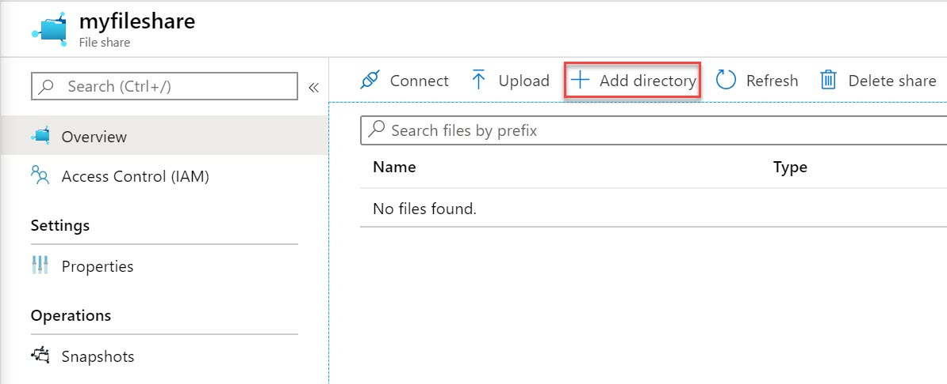

Step 5: Name: myfiles
Click on OK button
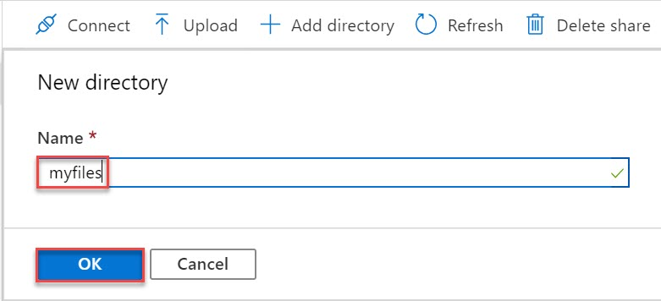

Step 6: Click on new directory
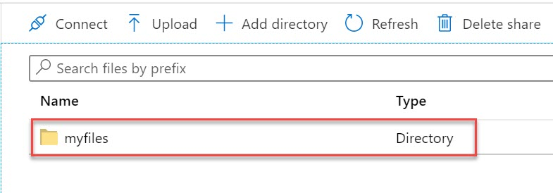

Step 7: Click on Upload option
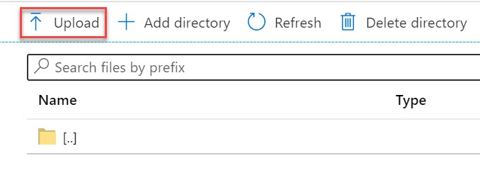

Step 8: Click on Browse option
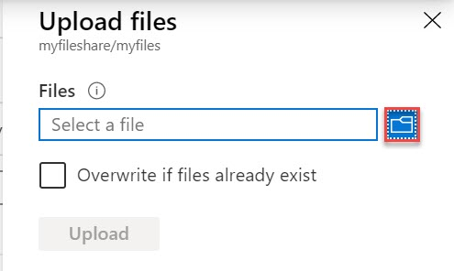

Step 9: Choose any file from system and click on Upload button
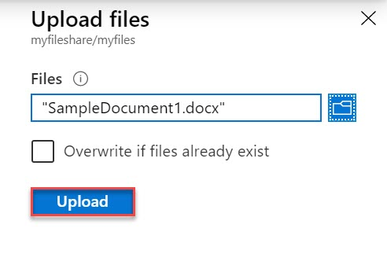
Step 10: File successfully uploaded and click on back option or navigate to root directory
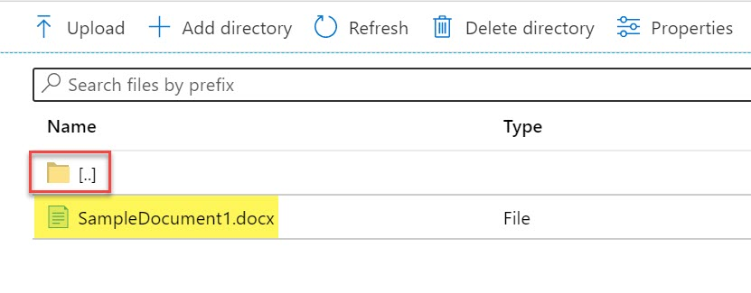
Step 11: Click on Connect option
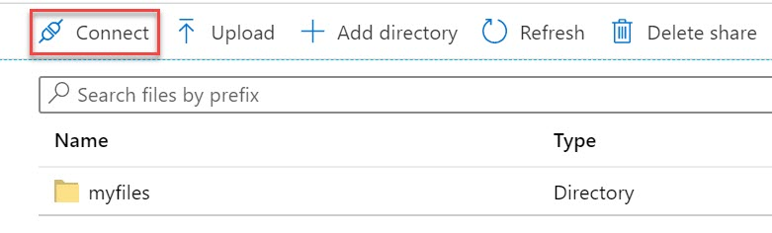

Step 12: Choose Operating and Drive letter
Copy complete script
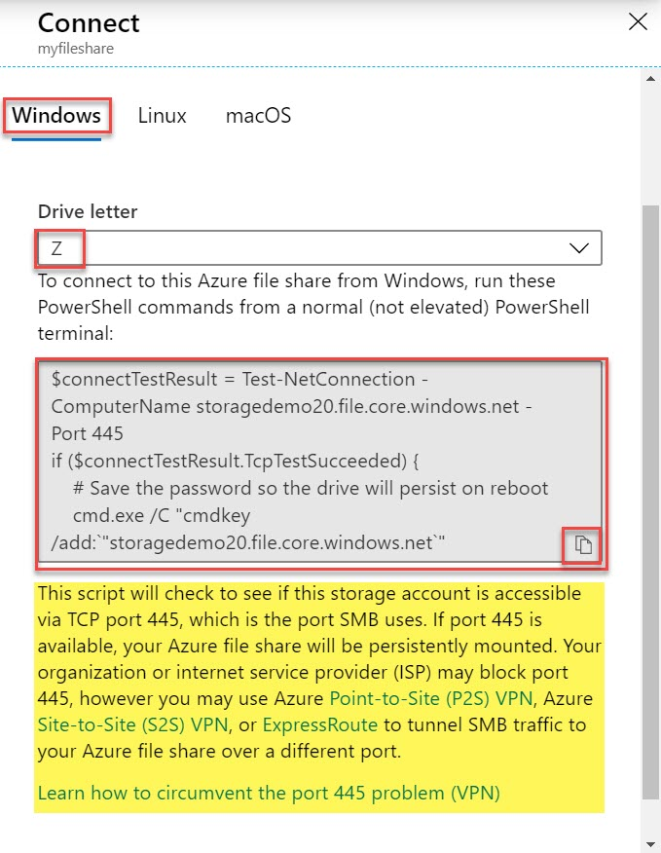
Step 13: Navigate to Azure Virtual Machine and Open Run (Windows + R)
Type powershell and click on OK button
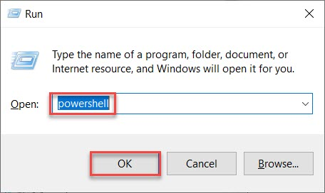

Step 14: Paste Storage File Share script
Within couple of seconds output will prompt
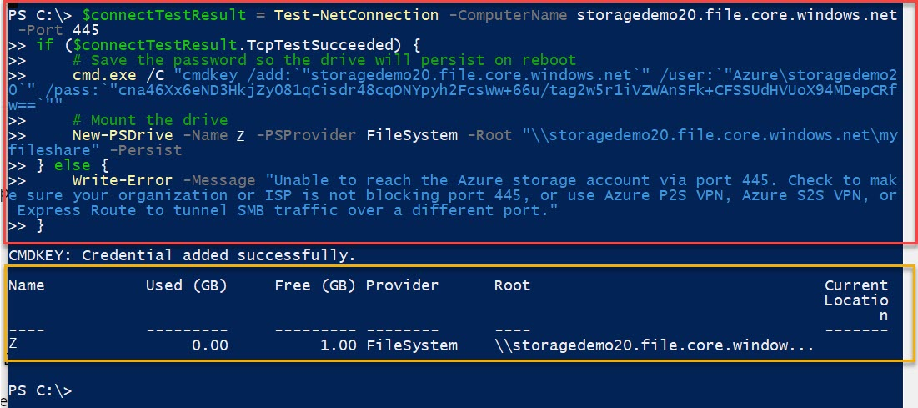

Step 15: Open This PC or computer and check one extra drive available
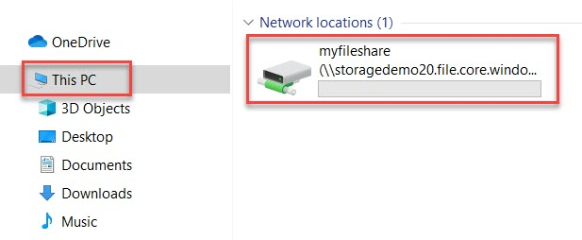
Step 16: Verify sample document
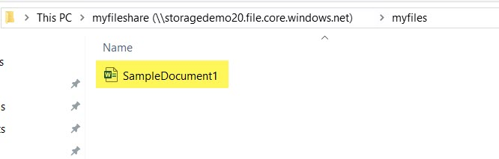

Step 17: Add few more files from system to current drive
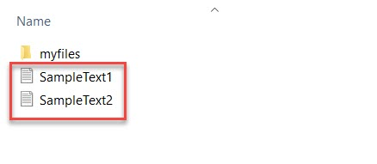
Step 18: Navigate to Azure Portal
Check File Share and click on Refresh button. Sample files also update here.
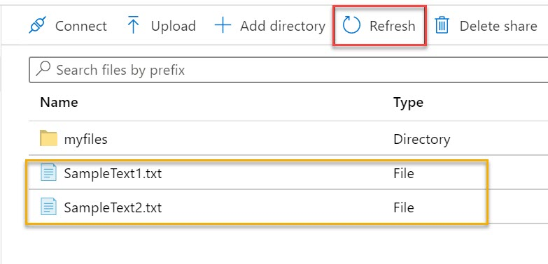

For unmount drive run below command:
Remove-PSDrive -Name <drive-letter>
Ex. Remove-PSDrive -Name Z

