Step 1: Create a new ASP.NET Core MVC application
- Open Visual Studio and select Create a new project.
- In Create a new project, find and search for ASP.NET Core Web App for C#.
- Choose ASP.NET Core Web App (Model-View-Controller). Select Create to continue. Visual Studio creates an empty MVC application.
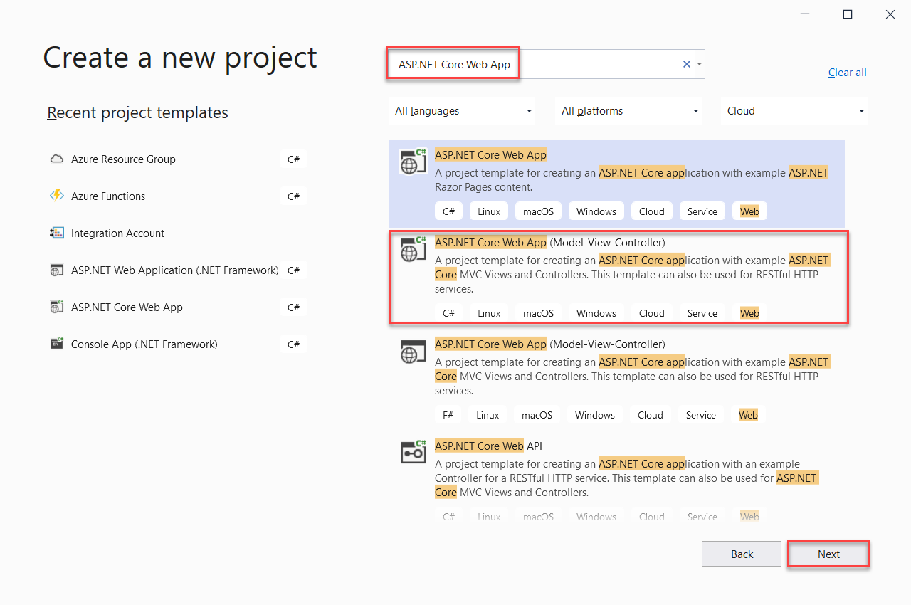

- Select Debug > Start Debugging or F5 to run your ASP.NET application locally.

Step 2: Add Azure Cosmos DB NuGet package to the project
Now that we have most of the ASP.NET Core MVC framework code that we need for this solution, let's add the NuGet packages required to connect to Azure Cosmos DB.
- In Solution Explorer, right-click your project and select Manage NuGet Packages.
- In the NuGet Package Manager, search for and select Microsoft.Azure.Cosmos. Select Install.
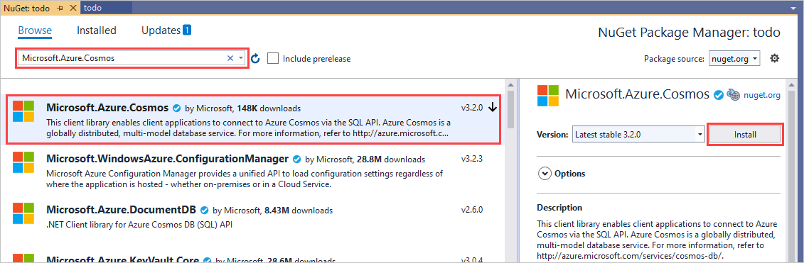
Visual Studio downloads and installs the Azure Cosmos DB package and its dependencies.
You can also use Package Manager Console to install the NuGet package. To do so, select Tools > NuGet Package Manager > Package Manager Console. At the prompt, type the following command:

Install-Package Microsoft.Azure.Cosmos

Step 3: Set up the ASP.NET Core MVC application
Now let's add the models, the views, and the controllers to this MVC application.

Add a model
- In Solution Explorer, right-click the Models folder, select Add > Class.
- In Add New Item, name your new class Item.cs and select Add.
- Replace the contents of Item.cs class with the following code:
namespace todo.Models
{
using Newtonsoft.Json;

public class Item
{
[JsonProperty(PropertyName = "id")]
public string Id { get; set; }

[JsonProperty(PropertyName = "name")]
public string Name { get; set; }

[JsonProperty(PropertyName = "description")]
public string Description { get; set; }

[JsonProperty(PropertyName = "isComplete")]
public bool Completed { get; set; }
}
}
Azure Cosmos DB uses JSON to move and store data. You can use the JsonProperty attribute to control how JSON serializes and deserializes objects. The Item class demonstrates the JsonProperty attribute. This code controls the format of the property name that goes into JSON. It also renames the .NET property Completed.

Add views
Next, let's add the following views.
- A create item view
- A delete item view
- A view to get an item details
- An edit item view
- A view to list all the items

Create item view
- In Solution Explorer, right-click the Views folder and select Add > New Folder. Name the folder Item.
- Right-click the empty Item folder, then select Add > View.
- In Add MVC View, make the following changes:
  - In View name, enter Create.
  - In Template, select Create.
  - In Model class, select Item (todo.Models).
  - Select Use a layout page and enter ~/Views/Shared/_Layout.cshtml.
  - Select Add.
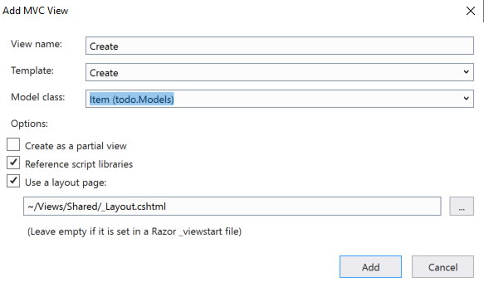

- Next select Add and let Visual Studio create a new template view. Replace the code in the generated file with the following contents:
@model todo.Models.Item

@{
ViewBag.Title = "Create";
Layout = "~/Views/Shared/_Layout.cshtml";
}

<h2>Create a new To-Do Item</h2>

@using (Html.BeginForm())
{
@Html.AntiForgeryToken()

<div class="form-horizontal">
<hr />
@Html.ValidationSummary(true, "", new { @class = "text-danger" })
<div class="form-group">
@Html.LabelFor(model => model.Name, htmlAttributes: new { @class = "control-label col-md-2" })
<div class="col-md-10">
@Html.EditorFor(model => model.Name, new { htmlAttributes = new { @class = "form-control" } })
@Html.ValidationMessageFor(model => model.Name, "", new { @class = "text-danger" })
</div>
</div>

<div class="form-group">
@Html.LabelFor(model => model.Description, htmlAttributes: new { @class = "control-label col-md-2" })
<div class="col-md-10">
@Html.EditorFor(model => model.Description, new { htmlAttributes = new { @class = "form-control" } })
@Html.ValidationMessageFor(model => model.Description, "", new { @class = "text-danger" })
</div>
</div>

<div class="form-group">
@Html.LabelFor(model => model.Completed, htmlAttributes: new { @class = "control-label col-md-2" })
<div class="col-md-10">
<div class="checkbox">
@Html.EditorFor(model => model.Completed)
@Html.ValidationMessageFor(model => model.Completed, "", new { @class = "text-danger" })
</div>
</div>
</div>

<div class="form-group">
<div class="col-md-offset-2 col-md-10">
<input type="submit" value="Create" class="btn btn-default" />
</div>
</div>
</div>
}

<div>
@Html.ActionLink("Back to List", "Index")
</div>
<script src="~/bundles/jqueryval"></script>

Delete item view
- From the Solution Explorer, right-click the Item folder again, select Add > View.
- In Add MVC View, make the following changes:
  - In the View name box, type Delete.
  - In the Template box, select Delete.
  - In the Model class box, select Item (todo.Models).
  - Select Use a layout page and enter ~/Views/Shared/_Layout.cshtml.
  - Select Add.
- Next select Add and let Visual Studio create a new template view. Replace the code in the generated file with the following contents:
@model todo.Models.Item

@{
ViewBag.Title = "Delete";
Layout = "~/Views/Shared/_Layout.cshtml";
}

<h2>Delete a To-Do Item</h2>

<h3>Are you sure you want to delete this?</h3>
<div>
<hr />
<dl class="dl-horizontal">
<dt>
@Html.DisplayNameFor(model => model.Name)
</dt>

<dd>
@Html.DisplayFor(model => model.Name)
</dd>

<dt>
@Html.DisplayNameFor(model => model.Description)
</dt>

<dd>
@Html.DisplayFor(model => model.Description)
</dd>

<dt>
@Html.DisplayNameFor(model => model.Completed)
</dt>

<dd>
@Html.DisplayFor(model => model.Completed)
</dd>
</dl>

@using (Html.BeginForm()) {
@Html.AntiForgeryToken()

<div class="form-actions no-color">
<input type="submit" value="Delete" class="btn btn-default" /> |
@Html.ActionLink("Back to List", "Index")
</div>
}
</div>

Add a view to get an item details
- In Solution Explorer, right-click the Item folder again, select Add > View.
- In Add MVC View, provide the following values:
  - In View name, enter Details.
  - In Template, select Details.
  - In Model class, select Item (todo.Models).
  - Select Use a layout page and enter ~/Views/Shared/_Layout.cshtml.
- Next select Add and let Visual Studio create a new template view. Replace the code in the generated file with the following contents:
@model todo.Models.Item

<h2>View To-Do Item Details</h2>

<div>
<h4>Item</h4>
<hr />
<dl class="dl-horizontal">
<dt>
@Html.DisplayNameFor(model => model.Name)
</dt>

<dd>
@Html.DisplayFor(model => model.Name)
</dd>

<dt>
@Html.DisplayNameFor(model => model.Description)
</dt>

<dd>
@Html.DisplayFor(model => model.Description)
</dd>

<dt>
@Html.DisplayNameFor(model => model.Completed)
</dt>

<dd>
@Html.DisplayFor(model => model.Completed)
</dd>

</dl>
</div>
<p>
@Html.ActionLink("Edit", "Edit", new { id = Model.Id }) |
@Html.ActionLink("Back to List", "Index")
</p>

Add an edit item view
- From the Solution Explorer, right-click the Item folder again, select Add > View.
- In Add MVC View, make the following changes:
  - In the View name box, type Edit.
  - In the Template box, select Edit.
  - In the Model class box, select Item (todo.Models).
  - Select Use a layout page and enter ~/Views/Shared/_Layout.cshtml.
  - Select Add.
- Next select Add and let Visual Studio create a new template view. Replace the code in the generated file with the following contents:
@model todo.Models.Item

<h2>Edit a To-Do Item</h2>

@using (Html.BeginForm())
{
@Html.AntiForgeryToken()

<div class="form-horizontal">
<h4>Item</h4>
<hr />
@Html.ValidationSummary(true, "", new { @class = "text-danger" })
@Html.HiddenFor(model => model.Id)

<div class="form-group">
@Html.LabelFor(model => model.Name, htmlAttributes: new { @class = "control-label col-md-2" })
<div class="col-md-10">
@Html.EditorFor(model => model.Name, new { htmlAttributes = new { @class = "form-control" } })
@Html.ValidationMessageFor(model => model.Name, "", new { @class = "text-danger" })
</div>
</div>

<div class="form-group">
@Html.LabelFor(model => model.Description, htmlAttributes: new { @class = "control-label col-md-2" })
<div class="col-md-10">
@Html.EditorFor(model => model.Description, new { htmlAttributes = new { @class = "form-control" } })
@Html.ValidationMessageFor(model => model.Description, "", new { @class = "text-danger" })
</div>
</div>

<div class="form-group">
@Html.LabelFor(model => model.Completed, htmlAttributes: new { @class = "control-label col-md-2" })
<div class="col-md-10">
<div class="checkbox">
@Html.EditorFor(model => model.Completed)
@Html.ValidationMessageFor(model => model.Completed, "", new { @class = "text-danger" })
</div>
</div>
</div>

<div class="form-group">
<div class="col-md-offset-2 col-md-10">
<input type="submit" value="Save" class="btn btn-default" />
</div>
</div>
</div>
}

<div>
@Html.ActionLink("Back to List", "Index")
</div>

<script src="~/bundles/jqueryval"></script>

Add a view to list all the items
And finally, add a view to get all the items with the following steps:
- From the Solution Explorer, right-click the Item folder again, select Add > View.
- In Add MVC View, make the following changes:
  - In the View name box, type Index.
  - In the Template box, select List.
  - In the Model class box, select Item (todo.Models).
  - Select Use a layout page and enter ~/Views/Shared/_Layout.cshtml.
  - Select Add.
- Next select Add and let Visual Studio create a new template view. Replace the code in the generated file with the following contents:
@model IEnumerable<todo.Models.Item>

@{
ViewBag.Title = "List of To-Do Items";
Layout = "~/Views/Shared/_Layout.cshtml";
}

<h2>List of To-Do Items</h2>

<table class="table">
<tr>
<th>
@Html.DisplayNameFor(model => model.Name)
</th>
<th>
@Html.DisplayNameFor(model => model.Description)
</th>
<th>
@Html.DisplayNameFor(model => model.Completed)
</th>
<th></th>
</tr>

@foreach (var item in Model) {
<tr>
<td>
@Html.DisplayFor(modelItem => item.Name)
</td>
<td>
@Html.DisplayFor(modelItem => item.Description)
</td>
<td>
@Html.DisplayFor(modelItem => item.Completed)
</td>
<td>
@Html.ActionLink("Edit", "Edit", new { id=item.Id }) |
@Html.ActionLink("Details", "Details", new { id=item.Id }) |
@Html.ActionLink("Delete", "Delete", new { id=item.Id })
</td>
</tr>
}

</table>

<p>
@Html.ActionLink("Create New", "Create")
</p>
Once you complete these steps, close all the cshtml documents in Visual Studio.

Declare and initialize services
First, we'll add a class that contains the logic to connect to and use Azure Cosmos DB. For this tutorial, we'll encapsulate this logic into a class called CosmosDbService and an interface called ICosmosDbService. This service does the CRUD operations. It also does read feed operations such as listing incomplete items, creating, editing, and deleting the items.
- In Solution Explorer, right-click your project and select Add > New Folder. Name the folder Services.
- Right-click the Services folder, select Add > Class. Name the new class CosmosDbService and select Add.
- Replace the contents of CosmosDbService.cs with the following code:
namespace todo
{
using System.Collections.Generic;
using System.Linq;
using System.Threading.Tasks;
using todo.Models;
using Microsoft.Azure.Cosmos;
using Microsoft.Azure.Cosmos.Fluent;
using Microsoft.Extensions.Configuration;

public class CosmosDbService : ICosmosDbService
{
private Container _container;

public CosmosDbService(
CosmosClient dbClient,
string databaseName,
string containerName)
{
this._container = dbClient.GetContainer(databaseName, containerName);
}

public async Task AddItemAsync(Item item)
{
await this._container.CreateItemAsync<Item>(item, new PartitionKey(item.Id));
}

public async Task DeleteItemAsync(string id)
{
await this._container.DeleteItemAsync<Item>(id, new PartitionKey(id));
}

public async Task<Item> GetItemAsync(string id)
{
try
{
ItemResponse<Item> response = await this._container.ReadItemAsync<Item>(id, new PartitionKey(id));
return response.Resource;
}
catch(CosmosException ex) when (ex.StatusCode == System.Net.HttpStatusCode.NotFound)
{
return null;
}

}

public async Task<IEnumerable<Item>> GetItemsAsync(string queryString)
{
var query = this._container.GetItemQueryIterator<Item>(new QueryDefinition(queryString));
List<Item> results = new List<Item>();
while (query.HasMoreResults)
{
var response = await query.ReadNextAsync();

results.AddRange(response.ToList());
}

return results;
}

public async Task UpdateItemAsync(string id, Item item)
{
await this._container.UpsertItemAsync<Item>(item, new PartitionKey(id));
}
}
}
- Right-click the Services folder, select Add > Class. Name the new class ICosmosDbService and select Add.
- Add the following code to ICosmosDbService class:
namespace todo
{
using System.Collections.Generic;
using System.Threading.Tasks;
using todo.Models;

public interface ICosmosDbService
{
Task<IEnumerable<Item>> GetItemsAsync(string query);
Task<Item> GetItemAsync(string id);
Task AddItemAsync(Item item);
Task UpdateItemAsync(string id, Item item);
Task DeleteItemAsync(string id);
}
}
- Open the Startup.cs file in your solution and add the following method InitializeCosmosClientInstanceAsync, which reads the configuration and initializes the client.
/// <summary>
/// Creates a Cosmos DB database and a container with the specified partition key.
/// </summary>
/// <returns></returns>
private static async Task<CosmosDbService> InitializeCosmosClientInstanceAsync(IConfigurationSection configurationSection)
{
string databaseName = configurationSection.GetSection("DatabaseName").Value;
string containerName = configurationSection.GetSection("ContainerName").Value;
string account = configurationSection.GetSection("Account").Value;
string key = configurationSection.GetSection("Key").Value;
Microsoft.Azure.Cosmos.CosmosClient client = new Microsoft.Azure.Cosmos.CosmosClient(account, key);
CosmosDbService cosmosDbService = new CosmosDbService(client, databaseName, containerName);
Microsoft.Azure.Cosmos.DatabaseResponse database = await client.CreateDatabaseIfNotExistsAsync(databaseName);
await database.Database.CreateContainerIfNotExistsAsync(containerName, "/id");

return cosmosDbService;
}
- On that same file, replace the ConfigureServices method with:
public void ConfigureServices(IServiceCollection services)
{
services.AddControllersWithViews();
services.AddSingleton<ICosmosDbService>(InitializeCosmosClientInstanceAsync(Configuration.GetSection("CosmosDb")).GetAwaiter().GetResult());
}
The code in this step initializes the client based on the configuration as a singleton instance to be injected through Dependency injection in ASP.NET Core.
And make sure to change the default MVC Controller to Item by editing the routes in the Configure method of the same file:
app.UseEndpoints(endpoints =>
{
endpoints.MapControllerRoute(
name: "default",
pattern: "{controller=Item}/{action=Index}/{id?}");
});
- Define the configuration in the project's appsettings.json file as shown in the following snippet:
{
"Logging": {
"LogLevel": {
"Default": "Warning"
}
},
"AllowedHosts": "*",
"CosmosDb": {
"Account": "<Endpoint URI of your Azure Cosmos account>",
"Key": "<PRIMARY KEY of your Azure Cosmos account>",
"DatabaseName": "Tasks",
"ContainerName": "Item"
}
}

Add a controller
- In Solution Explorer, right-click the Controllers folder, select Add > Controller.
- In Add Scaffold, select MVC Controller - Empty and select Add.
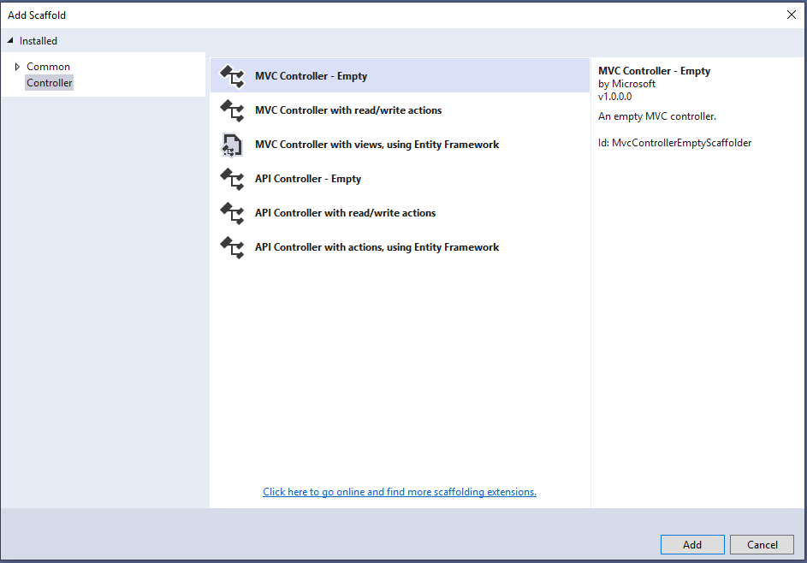

- Name your new controller ItemController.
- Replace the contents of ItemController.cs with the following code:
namespace todo.Controllers
{
using System;
using System.Threading.Tasks;
using Microsoft.AspNetCore.Mvc;
using todo.Models;

public class ItemController : Controller
{
private readonly ICosmosDbService _cosmosDbService;
public ItemController(ICosmosDbService cosmosDbService)
{
_cosmosDbService = cosmosDbService;
}

[ActionName("Index")]
public async Task<IActionResult> Index()
{
return View(await _cosmosDbService.GetItemsAsync("SELECT * FROM c"));
}

[ActionName("Create")]
public IActionResult Create()
{
return View();
}

[HttpPost]
[ActionName("Create")]
[ValidateAntiForgeryToken]
public async Task<ActionResult> CreateAsync([Bind("Id,Name,Description,Completed")] Item item)
{
if (ModelState.IsValid)
{
item.Id = Guid.NewGuid().ToString();
await _cosmosDbService.AddItemAsync(item);
return RedirectToAction("Index");
}

return View(item);
}

[HttpPost]
[ActionName("Edit")]
[ValidateAntiForgeryToken]
public async Task<ActionResult> EditAsync([Bind("Id,Name,Description,Completed")] Item item)
{
if (ModelState.IsValid)
{
await _cosmosDbService.UpdateItemAsync(item.Id, item);
return RedirectToAction("Index");
}

return View(item);
}

[ActionName("Edit")]
public async Task<ActionResult> EditAsync(string id)
{
if (id == null)
{
return BadRequest();
}

Item item = await _cosmosDbService.GetItemAsync(id);
if (item == null)
{
return NotFound();
}

return View(item);
}

[ActionName("Delete")]
public async Task<ActionResult> DeleteAsync(string id)
{
if (id == null)
{
return BadRequest();
}

Item item = await _cosmosDbService.GetItemAsync(id);
if (item == null)
{
return NotFound();
}

return View(item);
}

[HttpPost]
[ActionName("Delete")]
[ValidateAntiForgeryToken]
public async Task<ActionResult> DeleteConfirmedAsync([Bind("Id")] string id)
{
await _cosmosDbService.DeleteItemAsync(id);
return RedirectToAction("Index");
}

[ActionName("Details")]
public async Task<ActionResult> DetailsAsync(string id)
{
return View(await _cosmosDbService.GetItemAsync(id));
}
}
}

Step 4: Run the application locally
To test the application on your local computer, use the following steps:
- Press F5 in Visual Studio to build the application in debug mode. It should build the application and launch a browser with the empty grid page we saw before:
