Create Azure Cosmos DB using Azure Portal

Step 1: Open Microsoft Azure Portal
http://portal.azure.com/

Step 2: Create Cosmos DB Account
+ Create a resource -> Get started -> Azure Cosmos DB
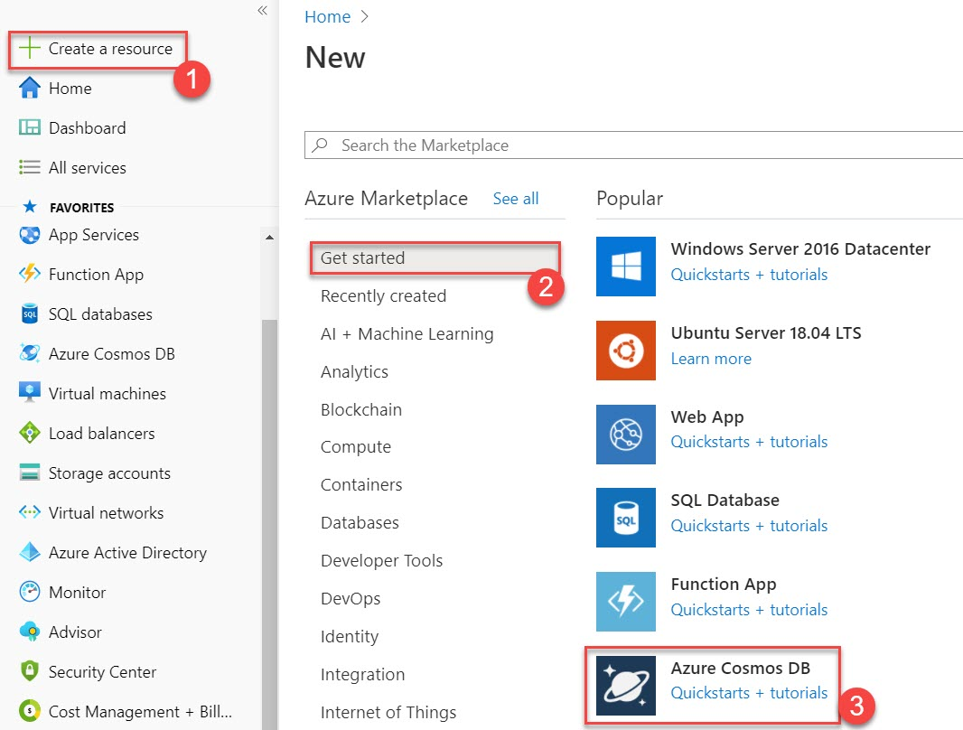

Select Core (SQL) – Recommended
Click on Create button
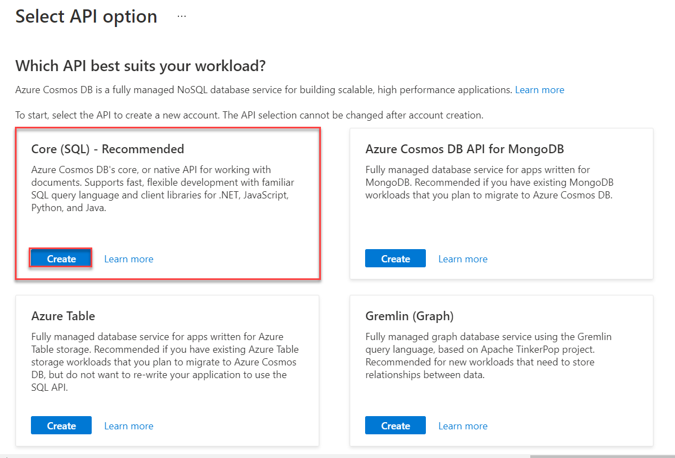

Step 3: Create Cosmos DB Account
Subscription: Choose any active Subscription
Resource Group: Create New Resource Group Ex. CosmosDBDemoRG

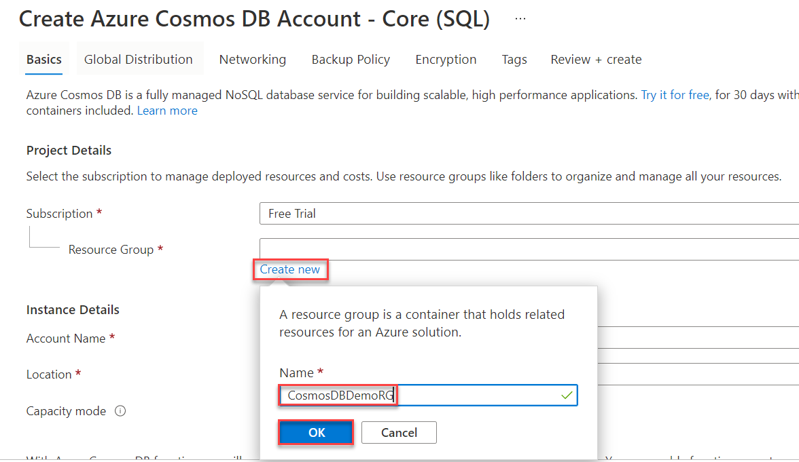

Account Name: Enter unique name of Cosmos DB Account Ex. mycosmosdbdemo
Location: Choose location Ex. East US
Capacity mode: Provisioned throughput
Apply Free Tier Discount: Do Not Apply
Click on Next: Global Distribution button

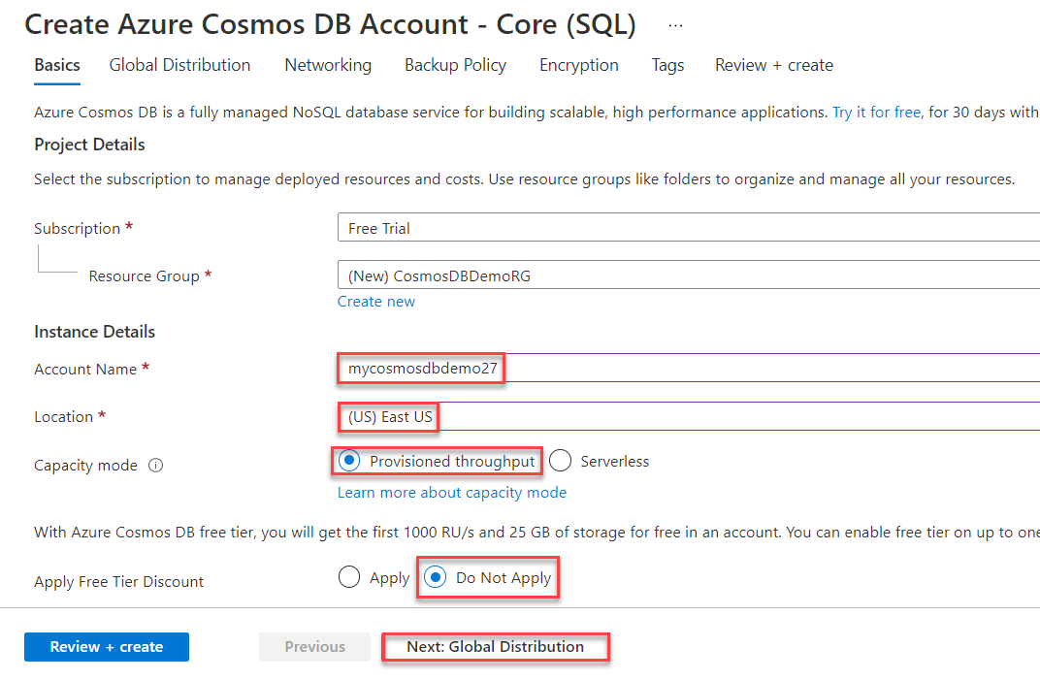

Click on Review + Create button
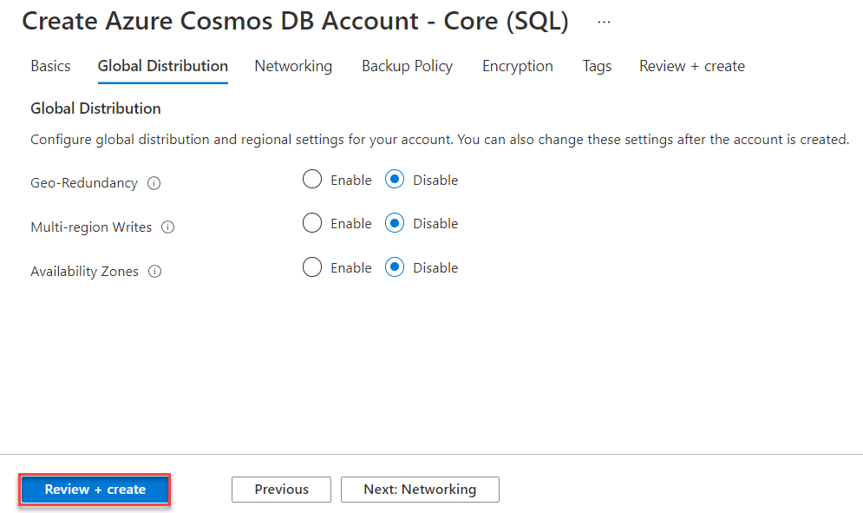

Step 4: Click on Create button.
Note: based on location it will time to deploy on Azure
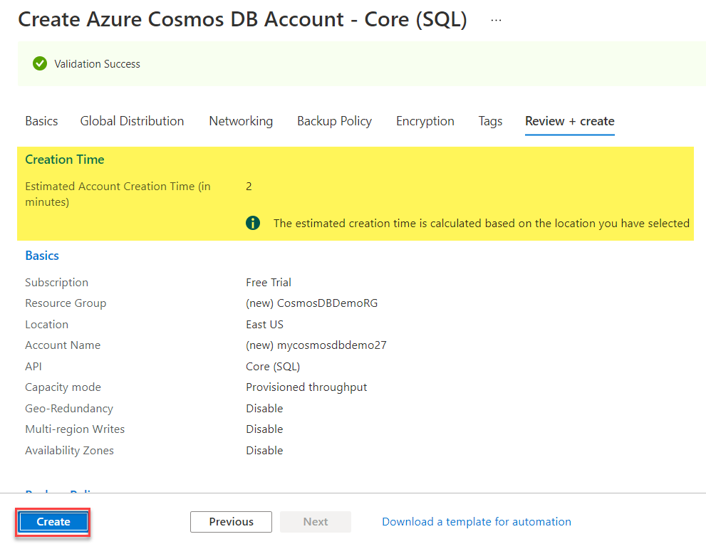

Step 5: Click on Go to resource button
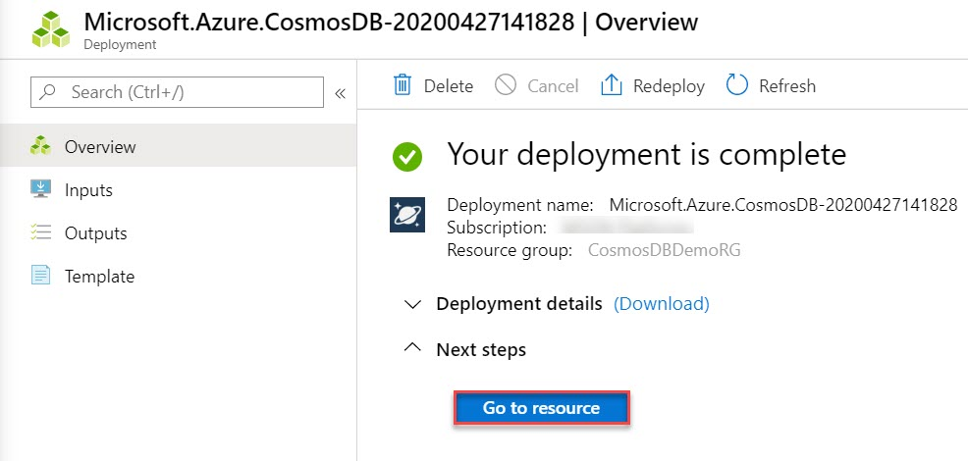
Step 6: Create New Container & Database
Select Data Explorer and click on New Container option
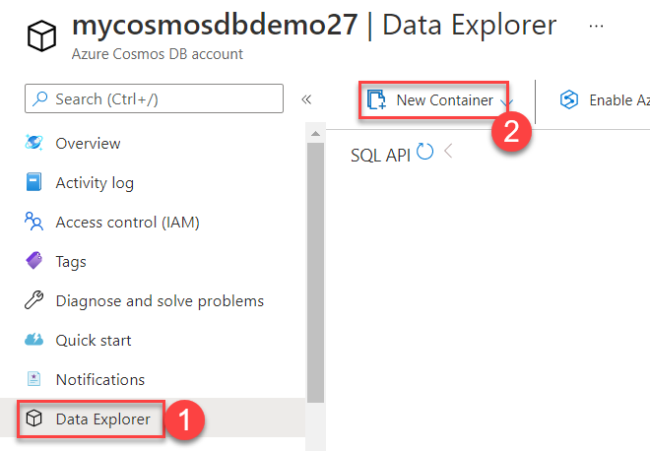

Step 7: Add Container
Database id: Create New Ex. ToDoList
Database throughput: Manual
Throughput: 400
Container id: Items
Partition key: /category
Note: Don't add Unique keys for this example. Unique keys let you add a layer of data integrity to the database by ensuring the uniqueness of one or more values per partition key.
Click on OK button
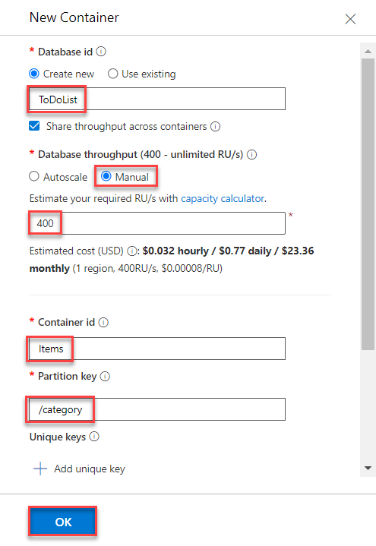

Add data to your database
Step 8: Select Items and Click on New Item option
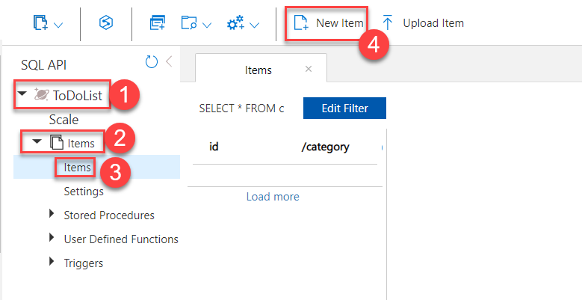

Step 9: Update the following structure to the document and click on Save button
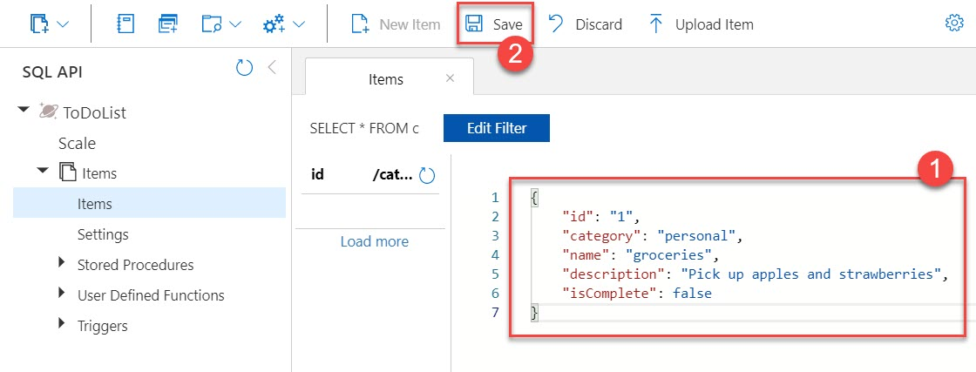
{
"id": "1",
"category": "personal",
"name": "groceries",
"description": "Pick up apples and strawberries",
"isComplete": false
}

Click on 1st document and view the document
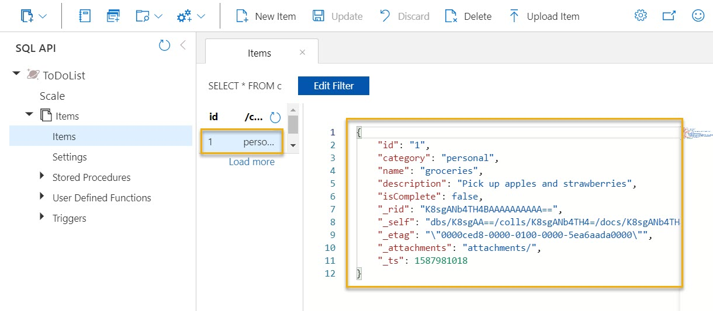

Step 10: Update one more document
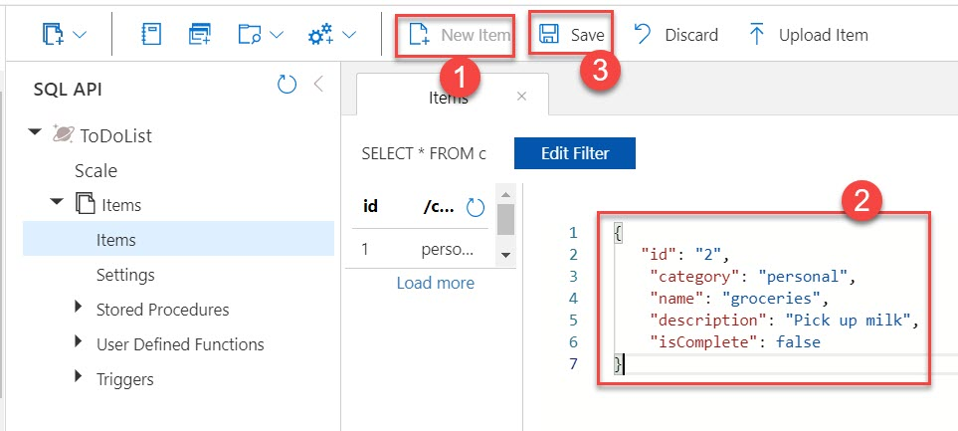
{
"id": "2",
"category": "personal",
"name": "groceries",
"description": "Pick up milk",
"isComplete": false
}

Click on 2nd document to view details
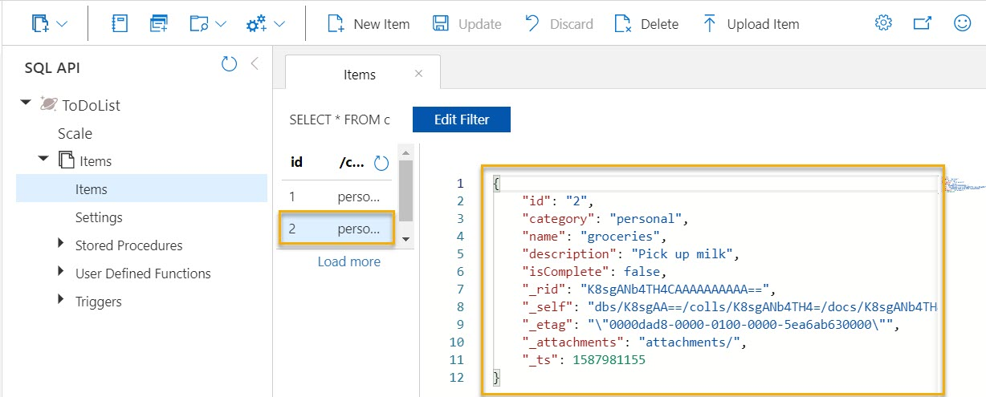

Step 11: Now update one more document
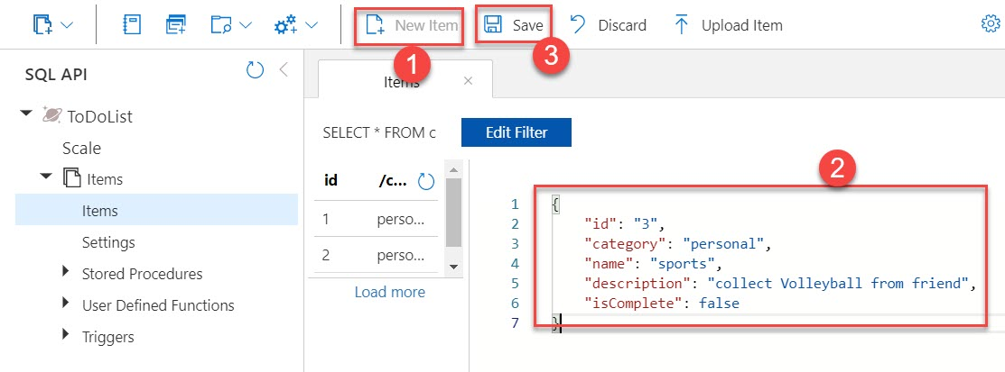

{
"id": "3",
"category": "personal",
"name": "sports",
"description": "collect Volleyball from friend",
"isComplete": false
}

Click on 3rd document to view all details
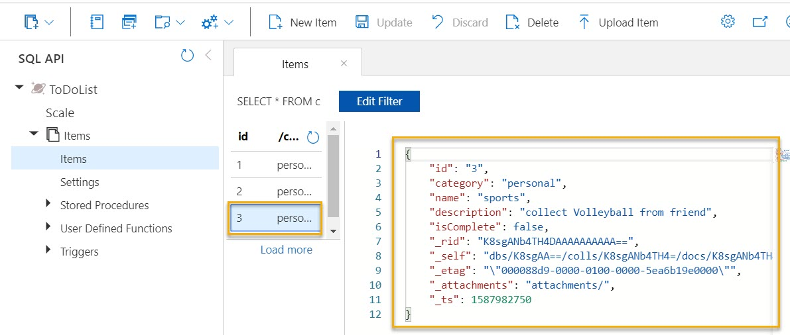

Step 12: Create New Query option
Go with default query and click on Execute Query button
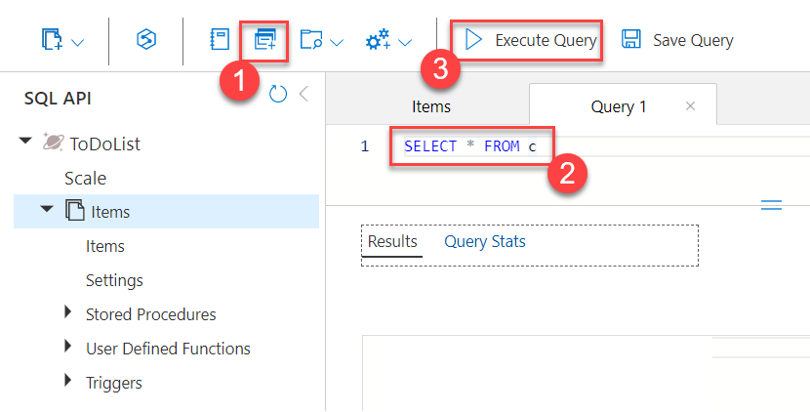

All documents loaded
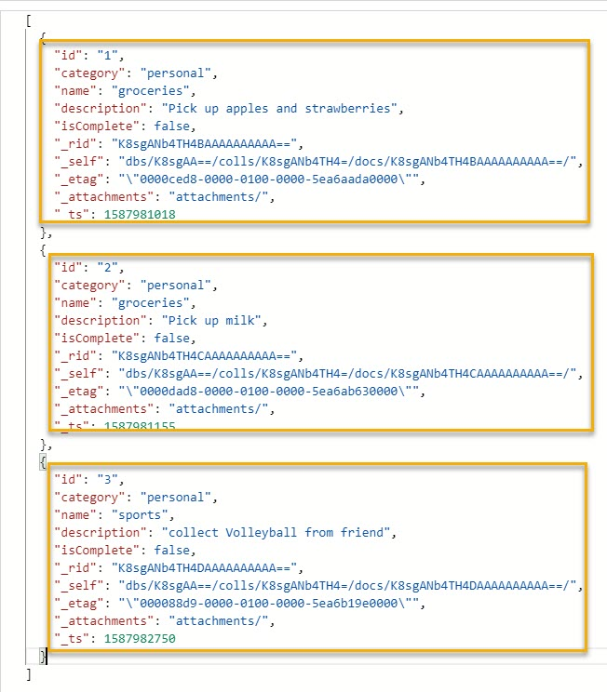

Step 13: create new query and run below query
SELECT * FROM c where c.name = "sports"

