Create and Manage WebApp using PowerShell – Cloud Shell

Step 1: Open Microsoft Azure Portal
https://portal.azure.com/

Step 2: Start Azure Cloud Shell


Step 3: Choose Subscription and click on Create Storage button
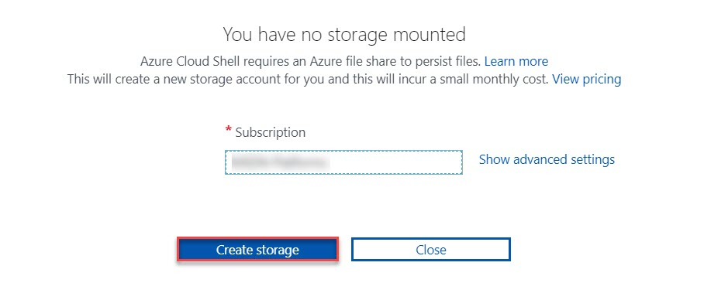

Step 4: Choose PowerShell from drop-down menu
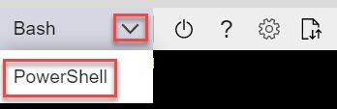

Step 5: By default, Bash started so switch to PowerShell by clicking on Confirm button
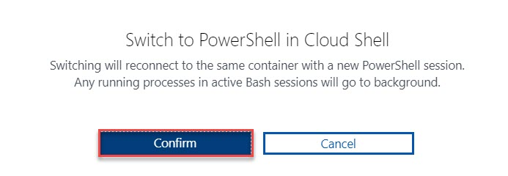

Step 6: Create New Resource Group
New-AzResourceGroup -Name WebAppDemoPSRG -Location "East US"
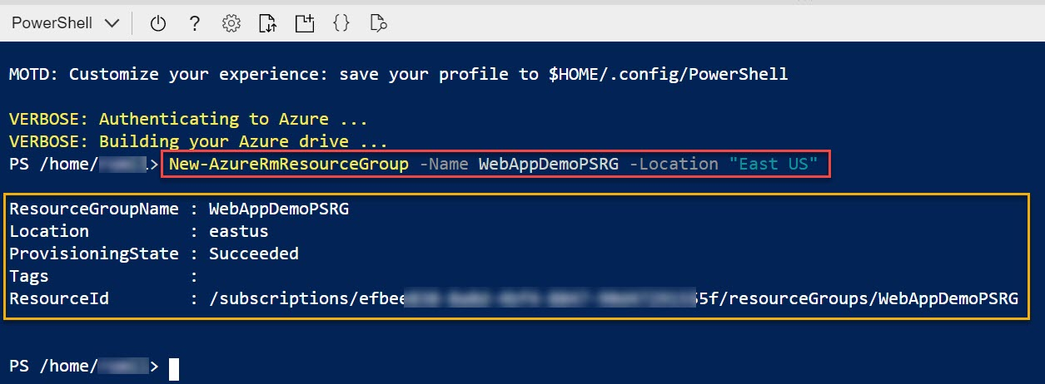

Step 7: Create New App Service Plan
New-AzAppServicePlan -Name MyAppServicePlan -Location "East US" -ResourceGroupName WebAppDemoPSRG -Tier Standard
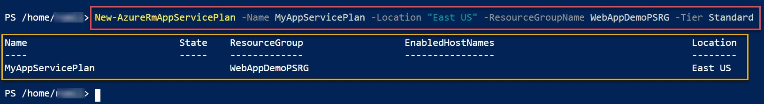

Step 8: List created App Service Plan
Get-AzAppServicePlan
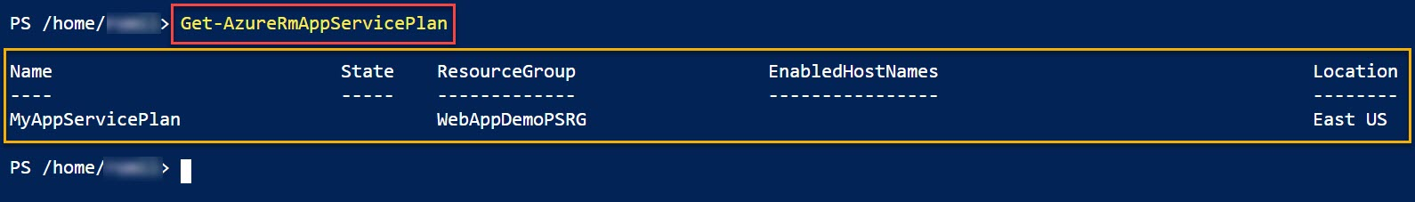

Step 9: Create New WebApp
New-AzWebApp -Name "WebAppDemo$(Get-Random)" -AppServicePlan MyAppServicePlan -ResourceGroupName WebAppDemoPSRG -Location "East US"
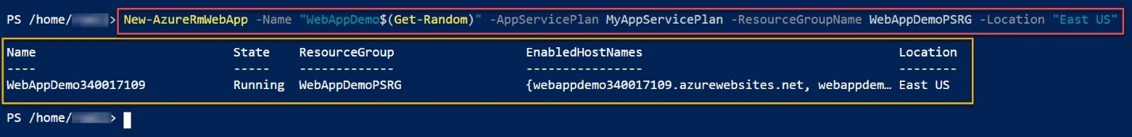

Step 10: List All WebApp
Get-AzWebApp | foreach-object {$_} | select-object DefaultHostName, ResourceGroup, Location
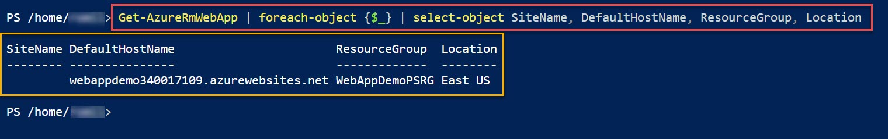

Step 11: temporary save information of Resource Group, Web App, etc
$webapp = Get-AzWebApp -ResourceGroupName "WebAppDemoPSRG"

Step 12: Get Web App URL and click on URL
"https://" + $webapp.DefaultHostName
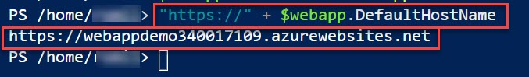

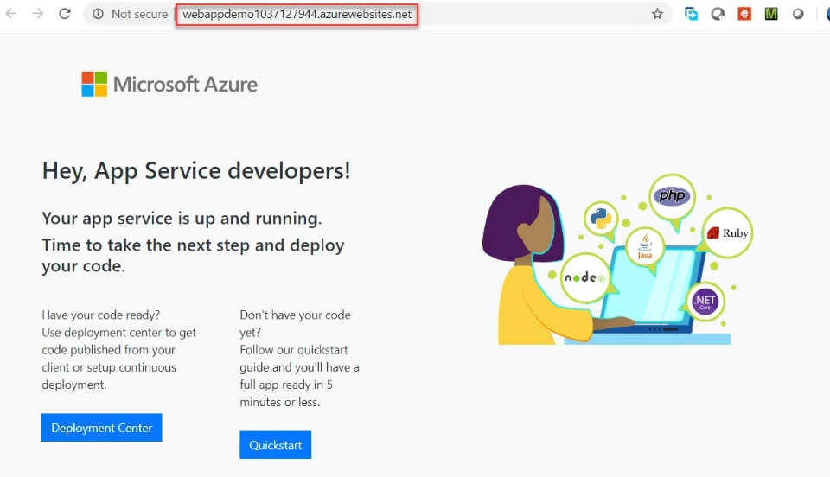

Step 13: Display Publish Profile File of WebApp
Get-AzWebAppPublishingProfile -ResourceGroupName "WebAppDemoPSRG" -Name $webapp.Name
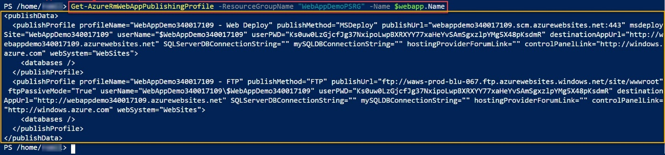

Stop Azure WebApp (optional)
Stop-AzWebapp -Name $webapp.Name -ResourceGroupName WebAppDemoPSRG
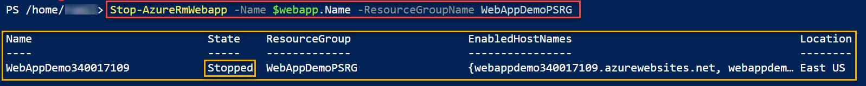

Start Azure WebApp (optional)
Start-AzWebapp -Name $webapp.Name -ResourceGroupName WebAppDemoPSRG
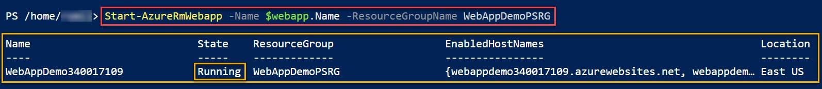

Restart Azure WebApp (optional)
Restart-AzWebapp -Name $webapp.Name -ResourceGroupName WebAppDemoPSRG
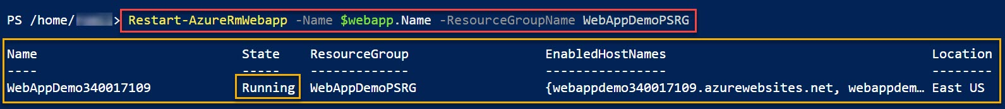

Delete Azure WebApp (optional)
Remove-AzWebApp -Name $webapp.Name -ResourceGroupName WebAppDemoPSRG
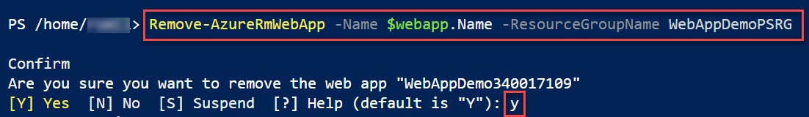

Step 14: Delete Resource Group
Remove-AzResourceGroup -Name "WebAppDemoPSRG"
