Deploy ARM Template using Portal

Step 1: Open Microsoft Azure Portal
https://portal.azure.com/

Step 2: Create Template Deployment
+ Create a resource -> search for “template”
Select Template deployment (deploy using custom templates)
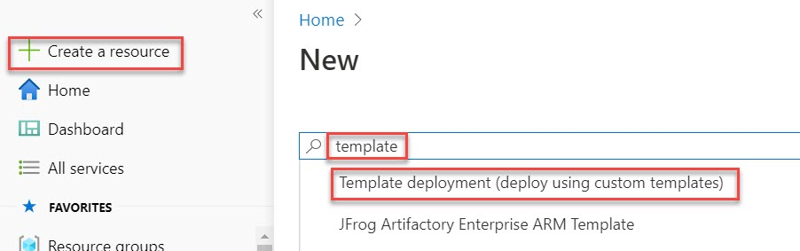

Step 3: Click on Create button
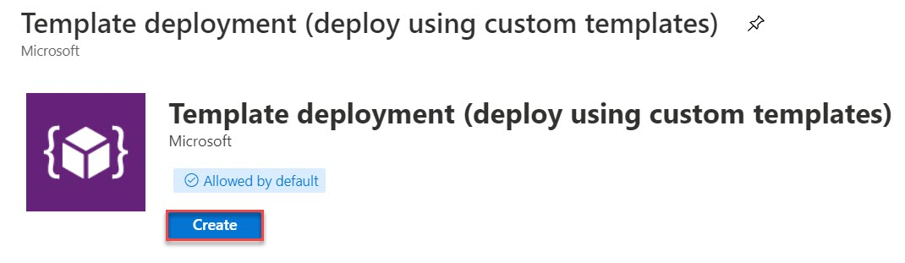

Step 4: Click on Build your own template in the editor option
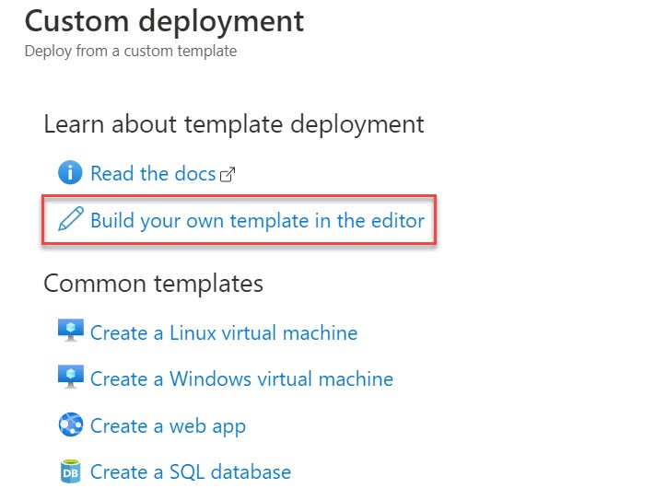

Step 5: Remove default and update with new code as below:
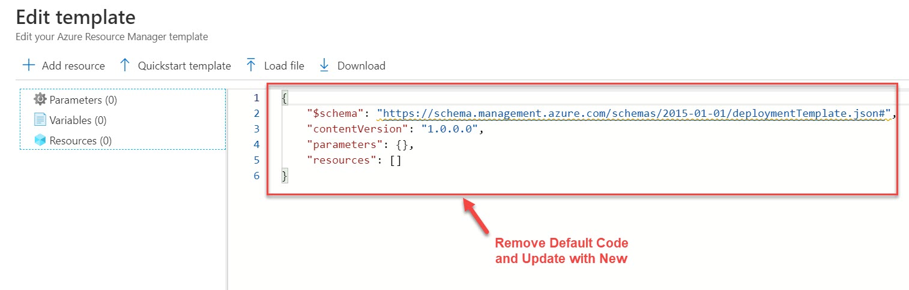

Step 6: Update with New code and Click on Save button
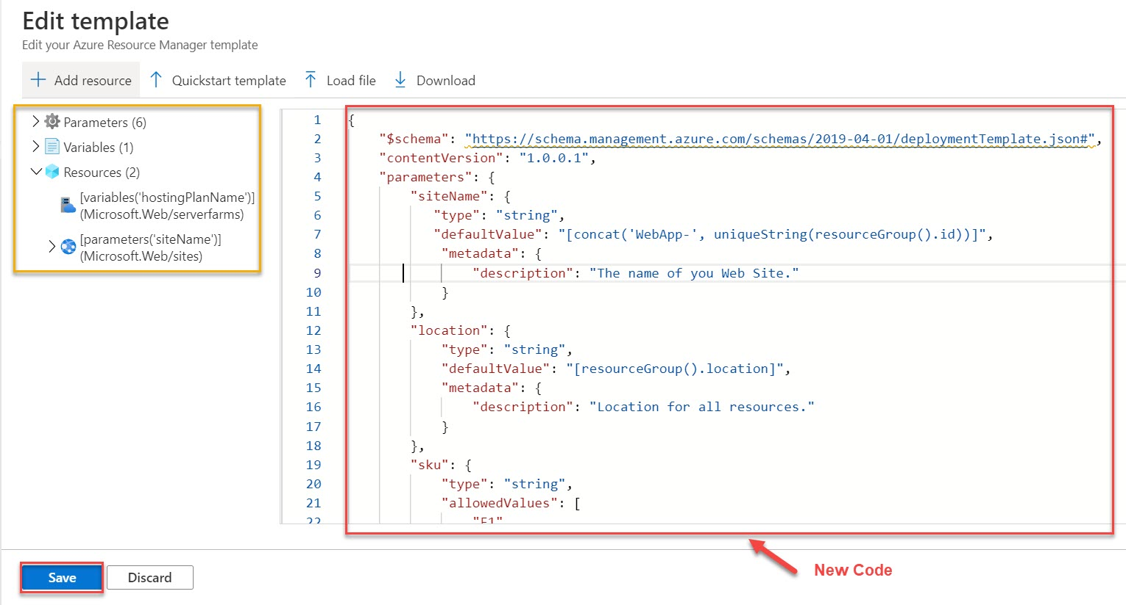

{
"$schema": "https://schema.management.azure.com/schemas/2019-04-01/deploymentTemplate.json#",
"contentVersion": "1.0.0.1",
"parameters": {
"siteName": {
"type": "string",
"defaultValue": "[concat('WebApp-', uniqueString(resourceGroup().id))]",
"metadata": {
"description": "The name of you Web Site."
}
},
"location": {
"type": "string",
"defaultValue": "[resourceGroup().location]",
"metadata": {
"description": "Location for all resources."
}
},
"sku": {
"type": "string",
"allowedValues": [
"F1",
"D1",
"B1",
"B2",
"B3",
"S1",
"S2",
"S3",
"P1",
"P2",
"P3",
"P4"
],
"defaultValue": "F1",
"metadata": {
"description": "The pricing tier for the hosting plan."
}
},
"workerSize": {
"type": "string",
"allowedValues": [
"0",
"1",
"2"
],
"defaultValue": "0",
"metadata": {
"description": "The instance size of the hosting plan (small, medium, or large)."
}
},
"repoURL": {
"type": "string",
"defaultValue": "https://github.com/Azure-Samples/app-service-web-html-get-started.git",
"metadata": {
"description": "The URL for the GitHub repository that contains the project to deploy."
}
},
"branch": {
"type": "string",
"defaultValue": "master",
"metadata": {
"description": "The branch of the GitHub repository to use."
}
}
},
"variables": {
"hostingPlanName": "[concat('hpn-', resourceGroup().name)]"
},
"resources": [
{
"type": "Microsoft.Web/serverfarms",
"apiVersion": "2018-02-01",
"name": "[variables('hostingPlanName')]",
"location": "[parameters('location')]",
"sku": {
"name": "[parameters('sku')]",
"capacity": "[parameters('workerSize')]"
},
"properties": {
"name": "[variables('hostingPlanName')]"
}
},
{
"type": "Microsoft.Web/sites",
"apiVersion": "2018-02-01",
"name": "[parameters('siteName')]",
"location": "[parameters('location')]",
"dependsOn": [
"[resourceId('Microsoft.Web/serverfarms', variables('hostingPlanName'))]"
],
"properties": {
"serverFarmId": "[variables('hostingPlanName')]"
},
"resources": [
{
"type": "sourcecontrols",
"apiVersion": "2018-02-01",
"name": "web",
"location": "[parameters('location')]",
"dependsOn": [
"[resourceId('Microsoft.Web/sites', parameters('siteName'))]"
],
"properties": {
"repoUrl": "[parameters('repoURL')]",
"branch": "[parameters('branch')]",
"isManualIntegration": true
}
}
]
}
]
}

Step 7: Custom deployment screen will open
Create New Resource Group Ex. WebAppGitRG
Leave with default settings
Click on Review + Create button
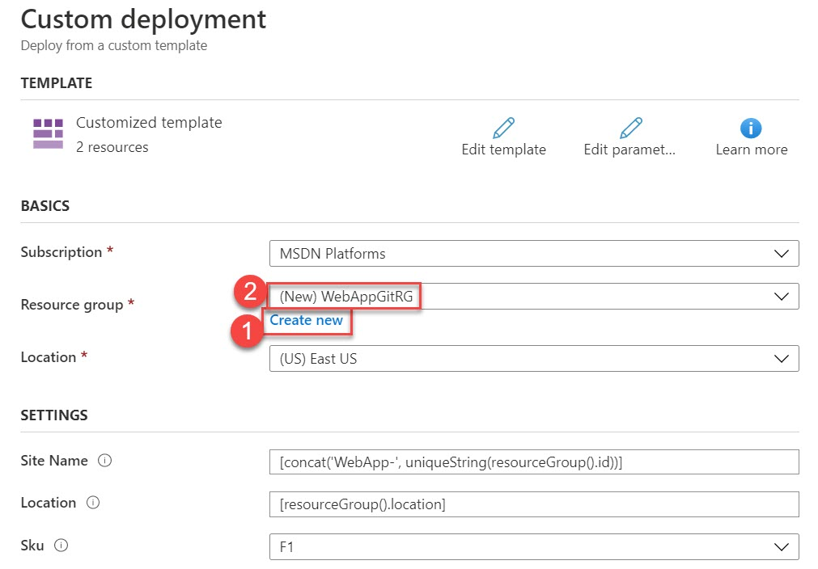
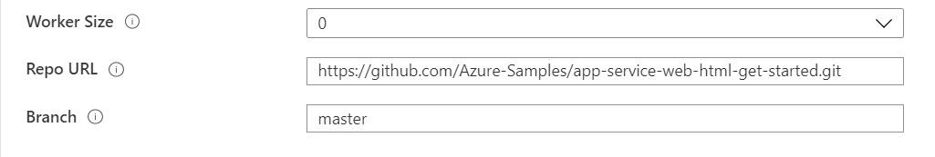

Step 8: Click on Notification icon
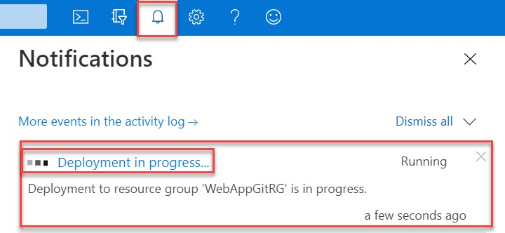

Step 9: Click on Go to resource group button
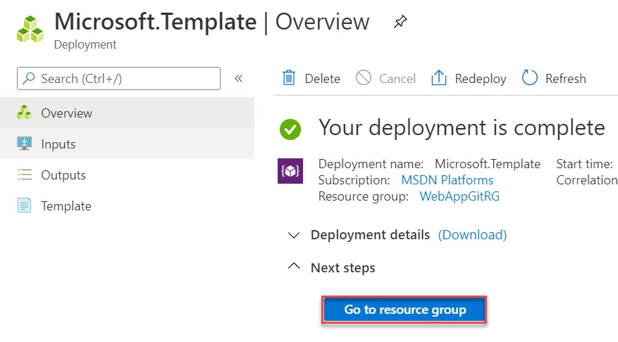

Step 10: Click on WebApp-xxxxxxx App Service
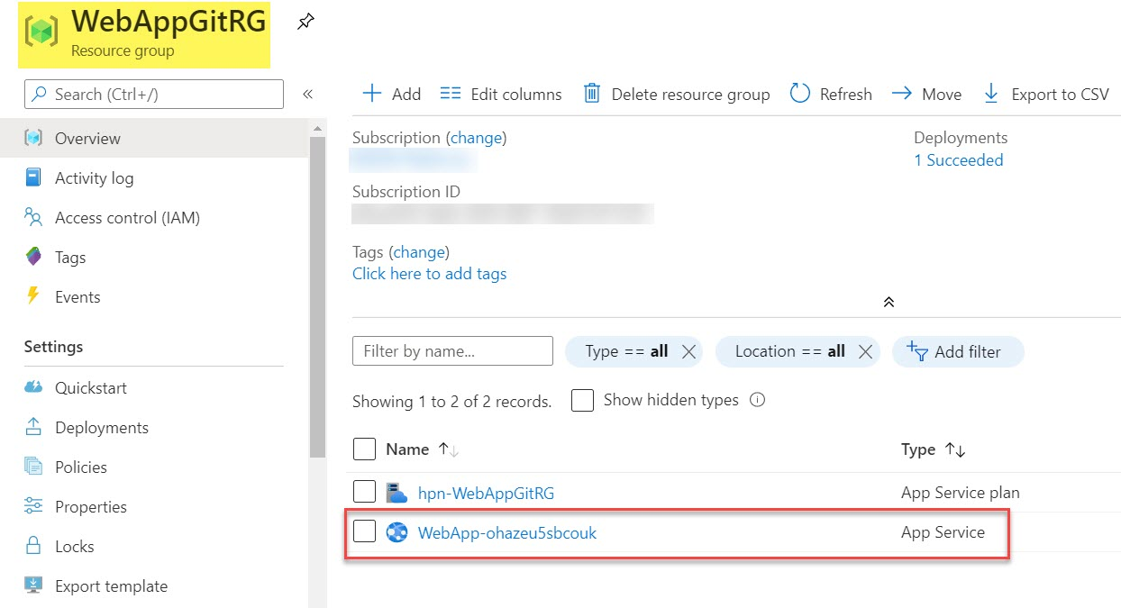

Step 11: Click on Browse option
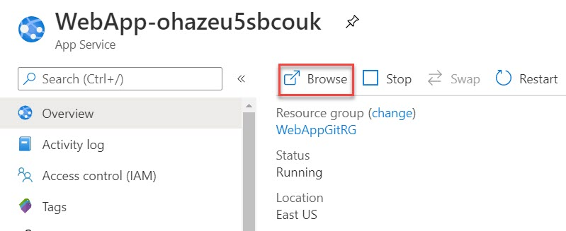

Step 12: Now Web App is deployed and sample application available on Github
