Create Windows Server 2019 Virtual Machine

Step 1: Open Azure Portal and enter credentials
https://portal.azure.com

Step 2: Click on + Create a resource -> Get started -> Windows Server 2019 Datacenter
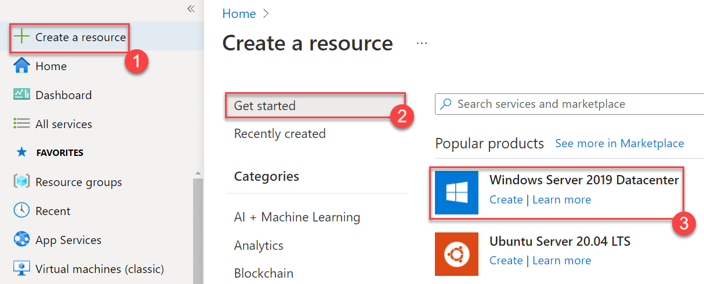

Step 3: Enter Virtual Machine Basics details
Subscription: Choose your Subscription
Resource Group: Create New -> WinVMRG
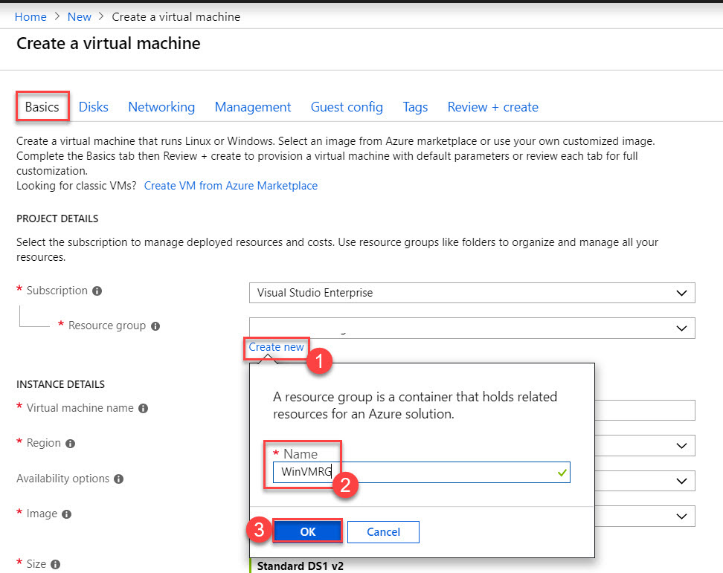

Virtual Machine Name: WindowsServerVM
Region: Choose any nearest region Ex. East US
Image: Windows Server 2019 Datacenter

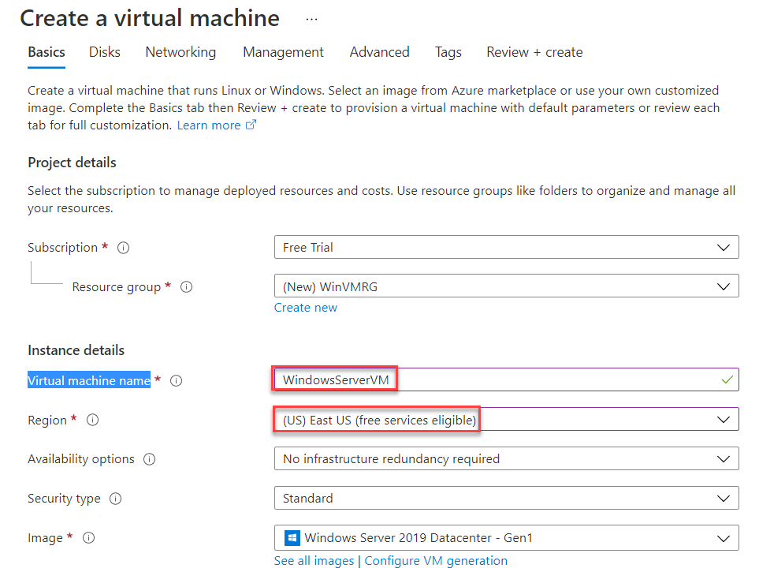

Size: Standard_D2s_v3 – 2 vcpus, 8 GiB memory or select any 2 vcpus
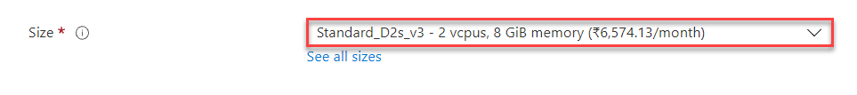
Administrator Username: demouser
Administrator Password: demo@pass123
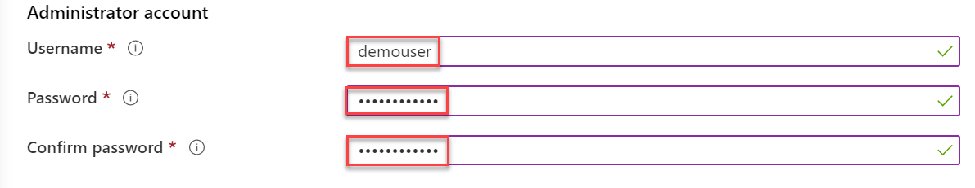

Public inbound ports: Allow selected ports
Select inbound ports: HTTP (80), RDP (3389)
Click on Next: Disks > button
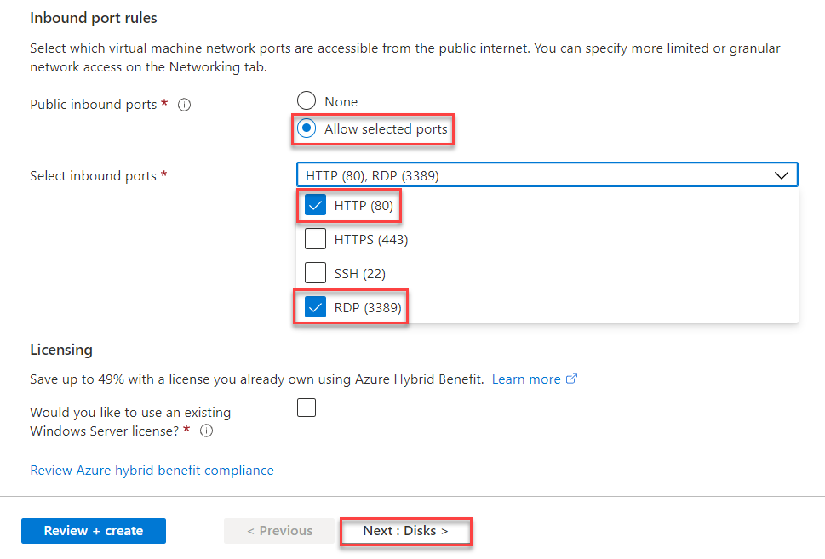

Step 4: Disks tab
OS disk type: Standard HDD
Click on Review + create button
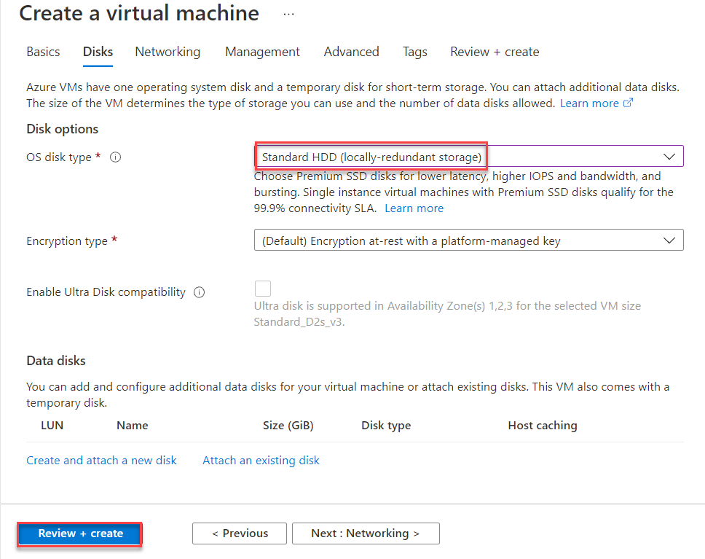
Step 5: Review + create tab
Validation passed means all settings are right and create virtual machine. If validation failed so verify all the settings.
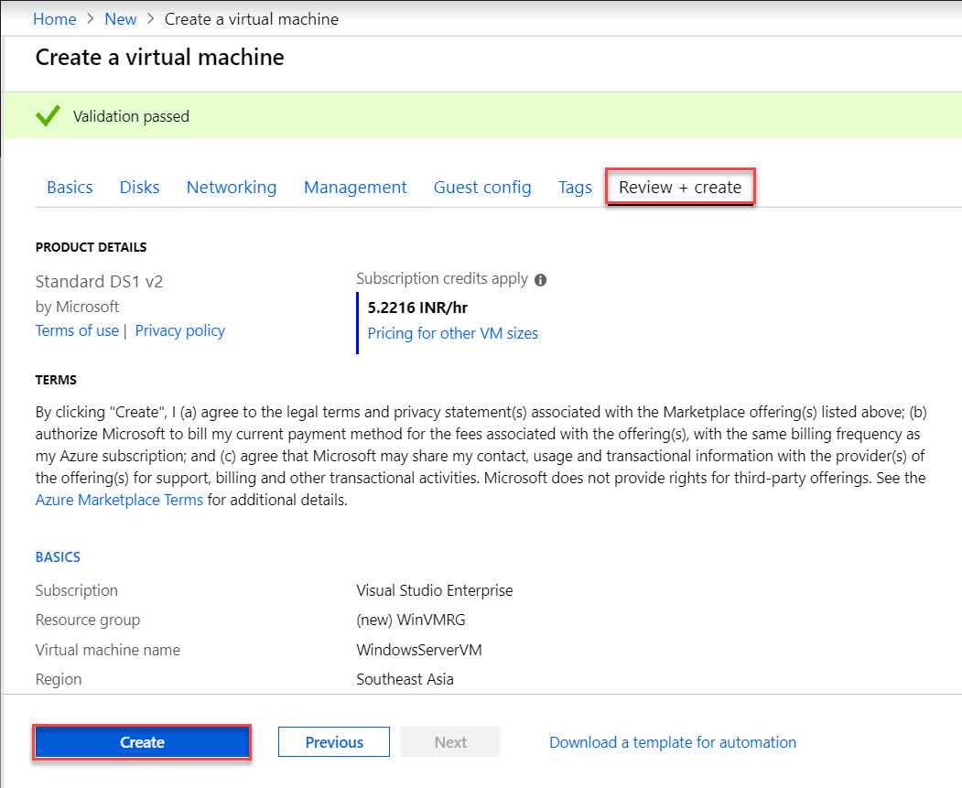

Virtual Machine deployment is underway. Wait for few minutes to complete
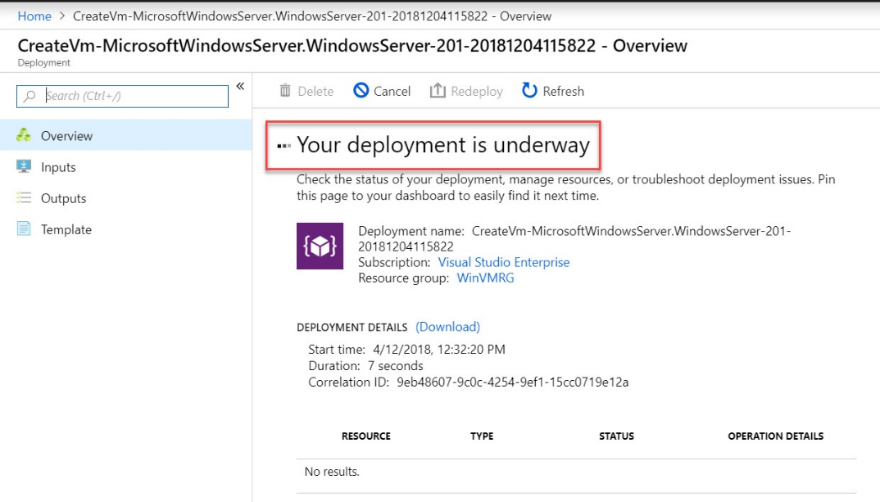

When deployment complete so click on Go to resource
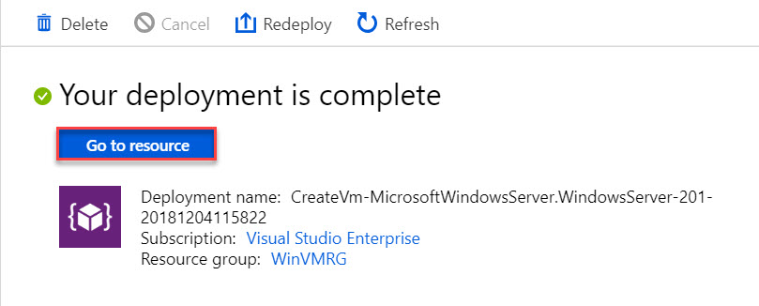

Step 6: Click on “Connect” button to download RDP file
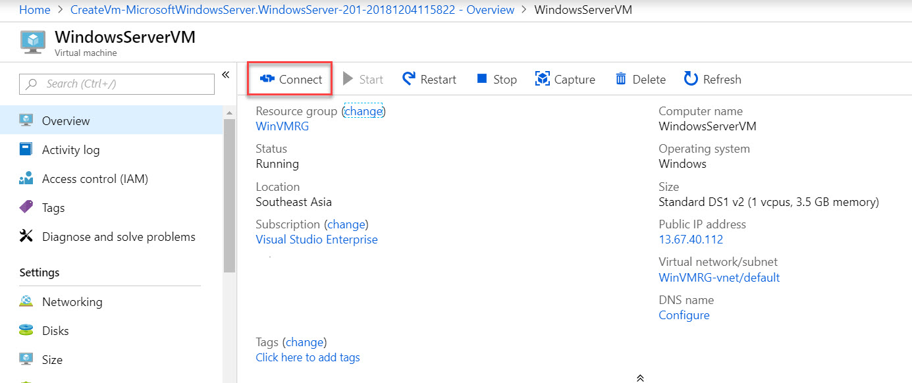
Click on Download RDP File
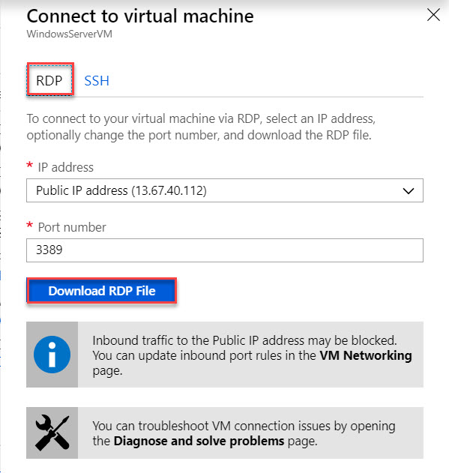
Step 7: Double click on RDP file
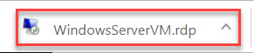

Remote Desktop Connection wizard will open & again click on “Connect” button
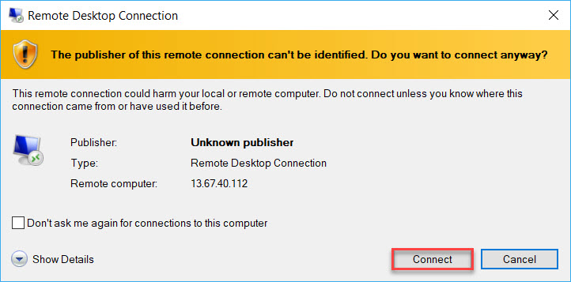

Enter Virtual Machine
Username: demouser
Password: demo@pass123
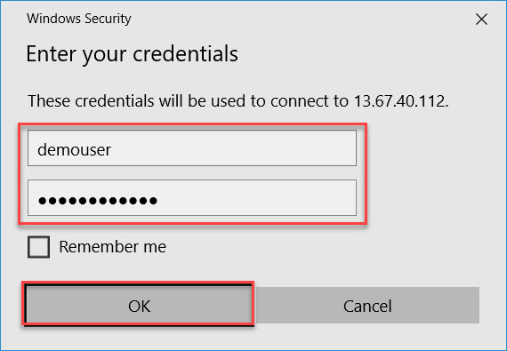
Note: if you have connected with any VPN please disconnect.
Also, in username add .\
Ex. Username: .\demouser
Password: demo@pass123
Click on “Yes” button to start remote connection
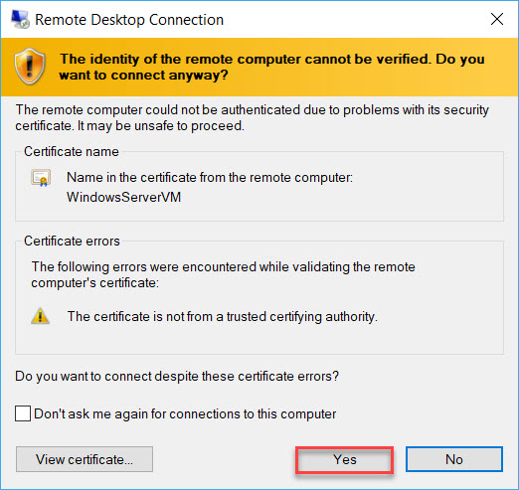

Wait for few seconds to start Windows Server 2016 Datacenter
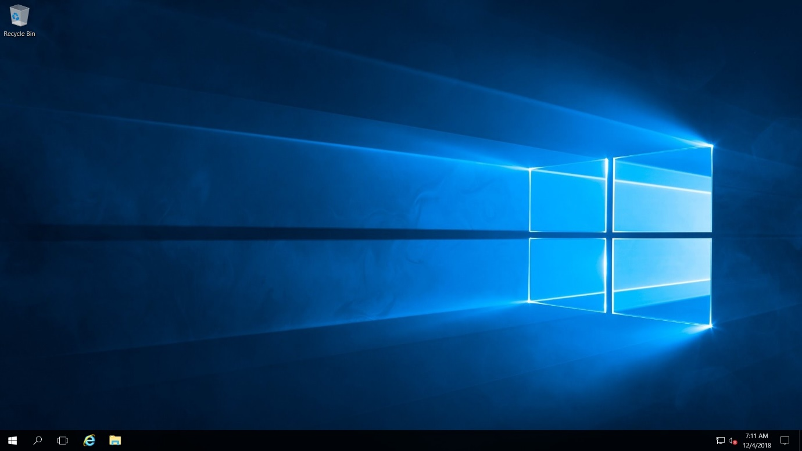

Step 8: Click on “No” button regarding Network option.
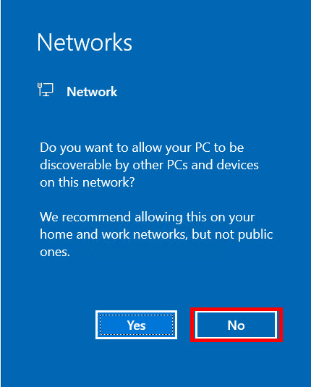

Step 9: Automatic Server Manager will start. Turn off IE Enhanced Security configuration
Local Server -> IE Enhanced Security Configuration
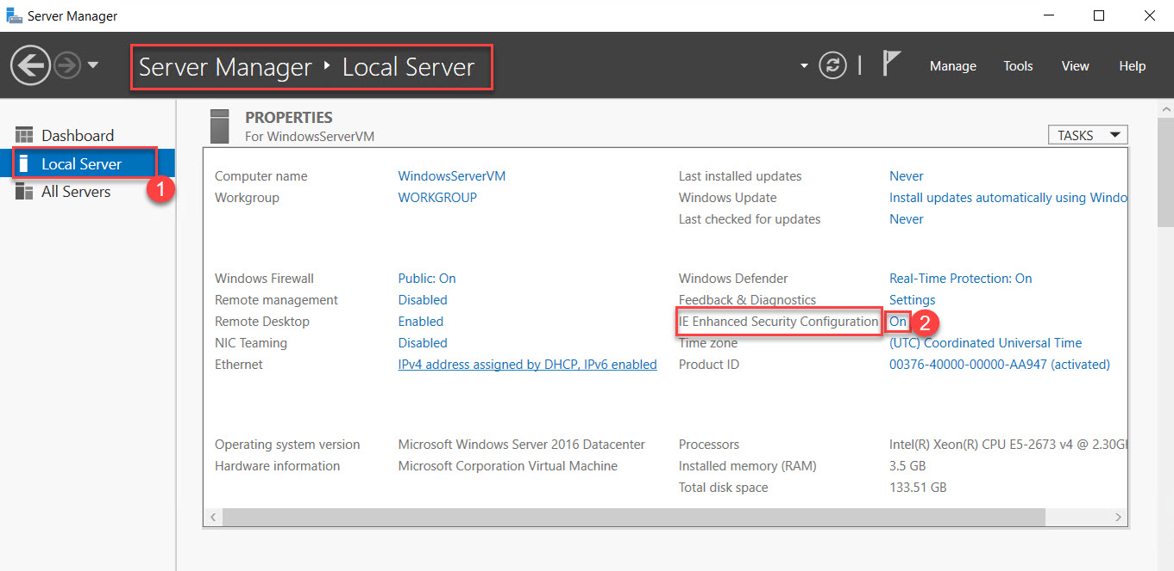

Choose “Off” option of Administrators & Users.
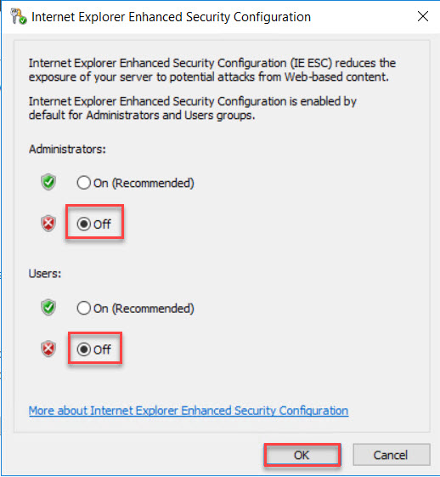

Click on close button of Server Manager.
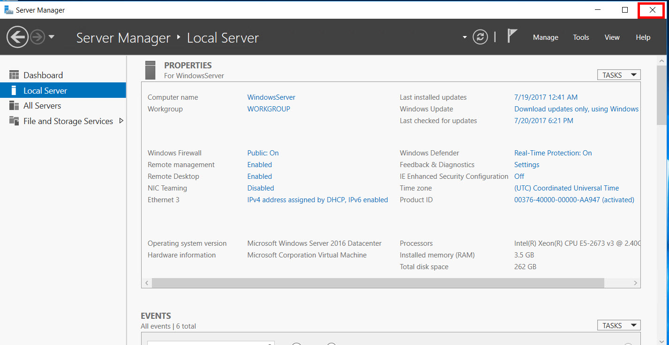

For this demo we are using PowerShell command to install IIS on Windows Server 2016,
Step 10: Click on Start Menu -> Right click on “Windows PowerShell” -> More -> Run as administrator
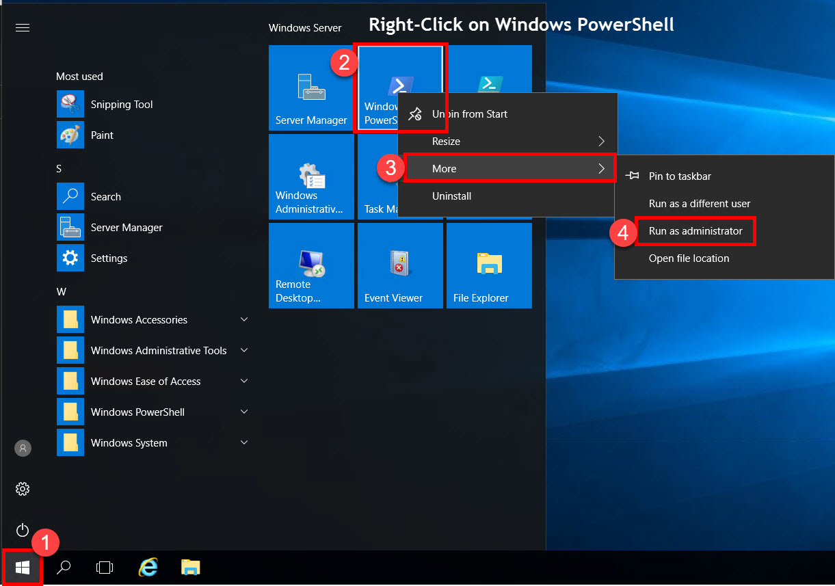

Step 11: Windows PowerShell will start.
Type below command:
Install-WindowsFeature -name Web-Server -IncludeManagementTools
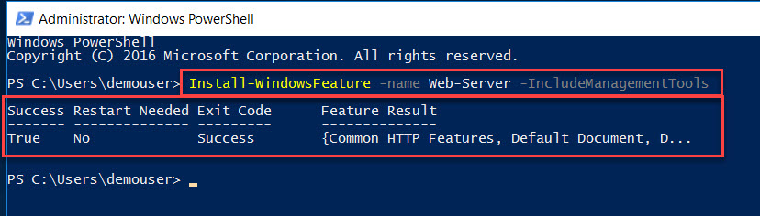
Note: it will take few minutes to install Web Server Feature.

Step 12: Press Windows + R button or start Run.
Type notepad & hit enter button
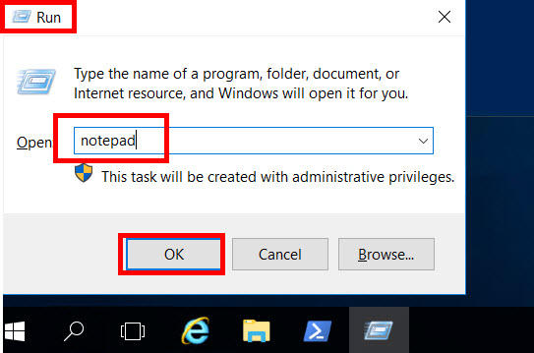

Step 13: Create basic HTML page like as below:
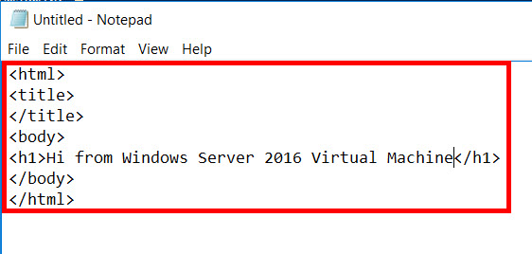

<html>
<title>
</title>
<body>
<h1>Hi from Windows Server Virtual Machine</h1>
</body>
</html>

Step 14: Select Save option.
Navigate to This PC > Local Disk (C:) > inetpub > wwwroot
File Name: index.html
Save as type: All Files
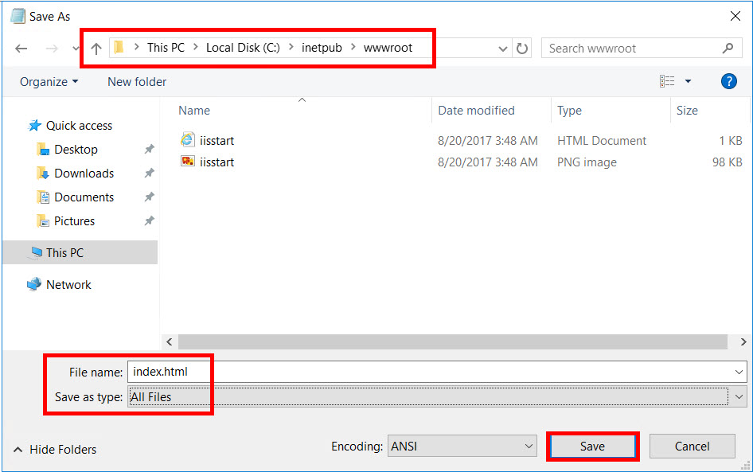
Note: if it will not allow to save file on this location, so save in desktop. After that copy-paste file into wwwroot folder.

Step 15: Now minimize the Virtual Machine & Navigate to Azure Portal.
Click on Resource Group (left side) -> “WinVMRG”
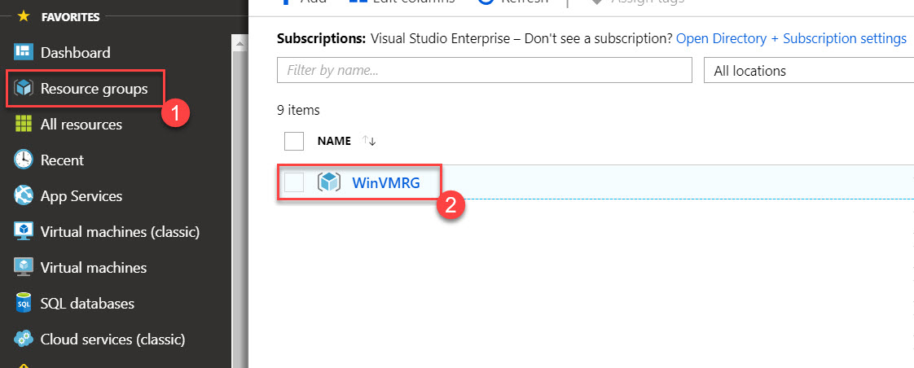

Select Virtual Machine Ex. WindowsServerVM
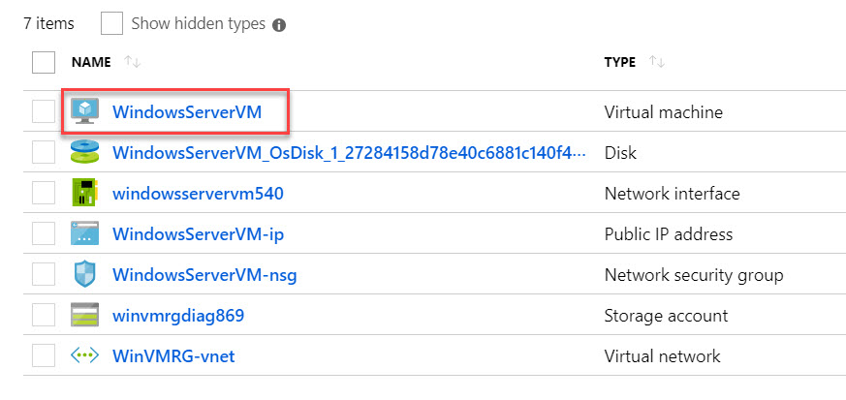
Step 16: Copy “Public IP Address”
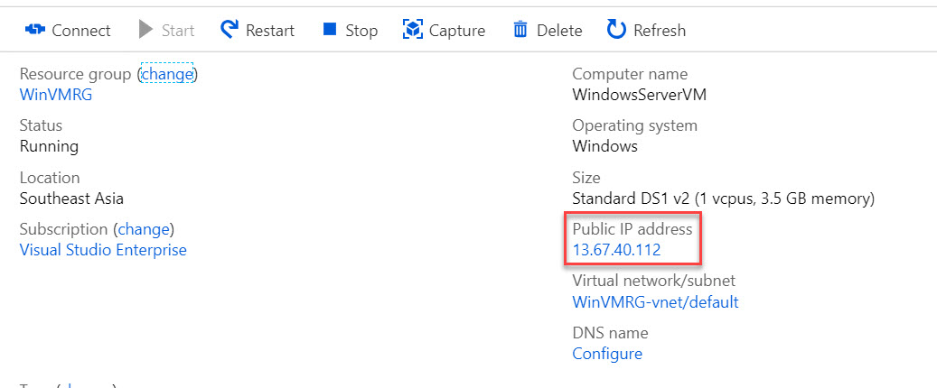

Step 17: Open any browser and paste IP address. Website will load
