Integrating Azure CDN with Web Apps

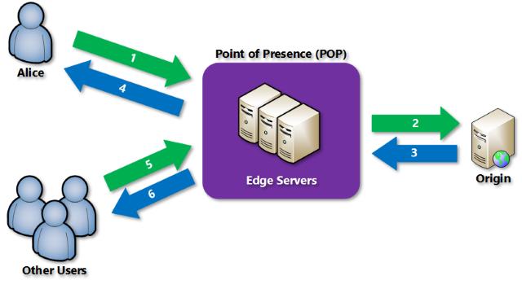

Task 1: Create Web App
Task 2: Configure Azure CDN with Web App
Task 3: Purge the CDN
Task 4: Restrict Azure CDN Content by Country/Region
Task 1: Create Web App
Step 1: Create CDN from Azure Portal
+ Create a resource -> search for “cdn” -> Click on CDN
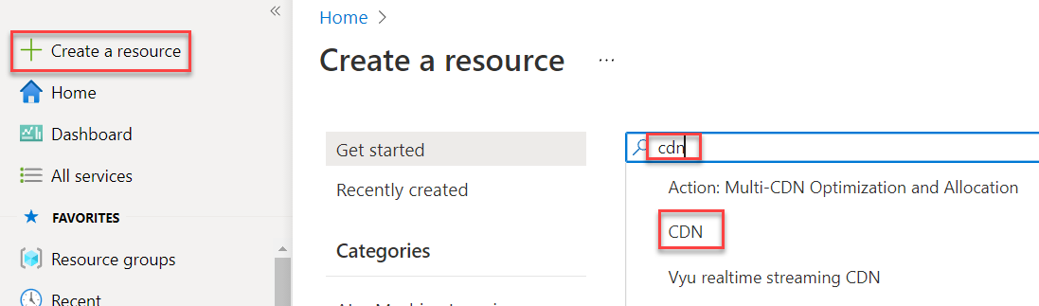

Step 2: Click on Create button
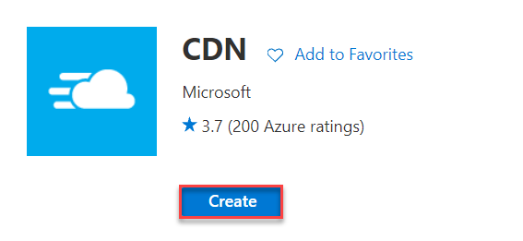
Step 3: Create CDN Profile
Subscription: Choose any Subscription
Resource Group: Create New Ex. CDNWebRG
Region: Choose region Ex. East US or any other
Name: Enter any name ex. cdnwebprofile
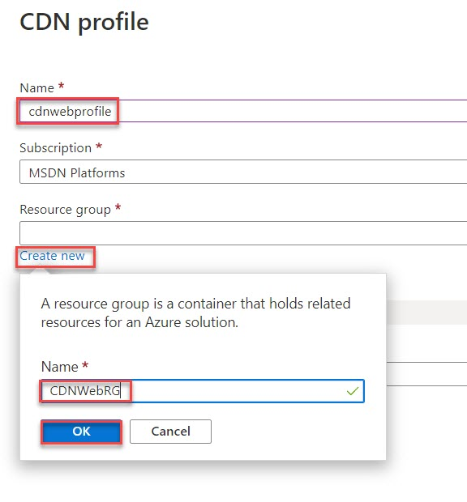
Step 4: Pricing tier: Standard Microsoft
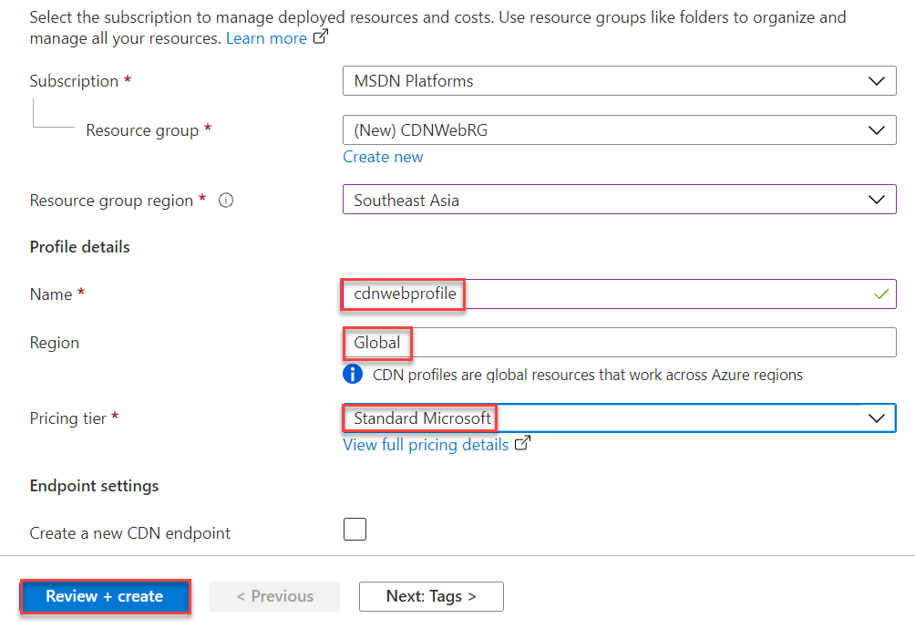
Check status of resource from Notification
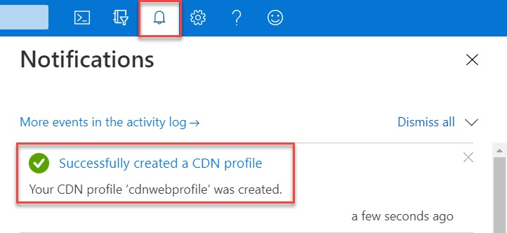

CDN Profile will deployed as below:
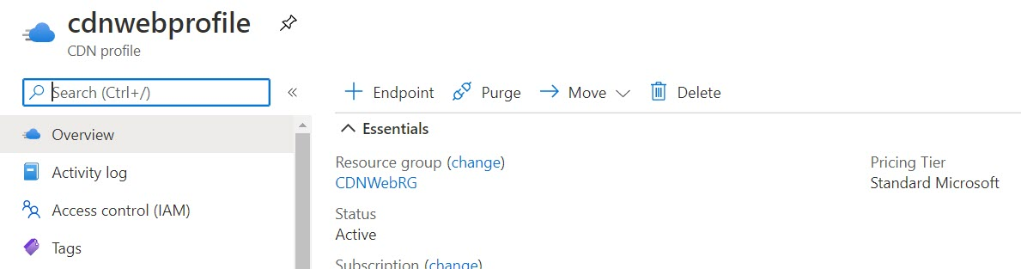

Step 5: Create Web App
+ Create a resource -> Get started -> Web App
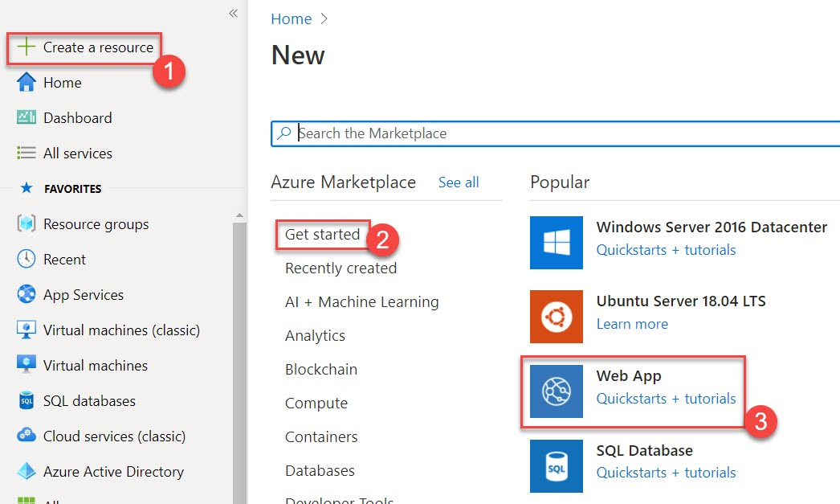
Resource Group: Choose existing Resource Group Ex. CDNWebRG
Name: Enter unique name Ex. cdnwebdemo
Publish: Code
Runtime stack: ASP.NET V4.8
Operating System: Windows
Region: Choose same region where deployed other resources Ex. East US

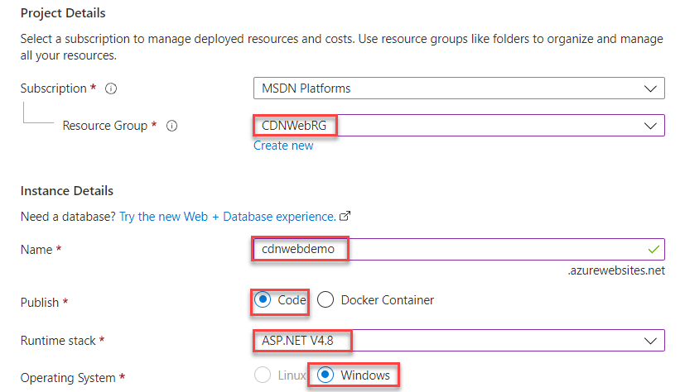

App Service Plan: Create New Ex. CDNWebPlan
Click on Review + create button
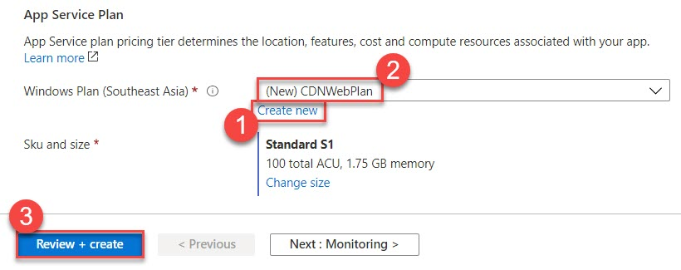

Step 6: Click on Create button
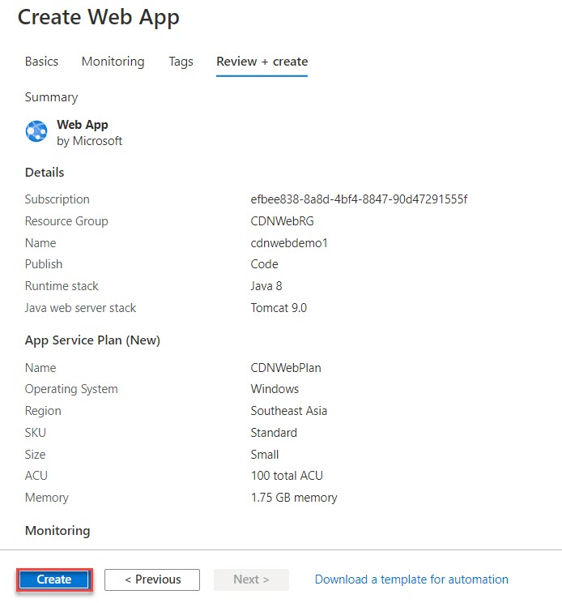
Step 7: Click on Go to resource button
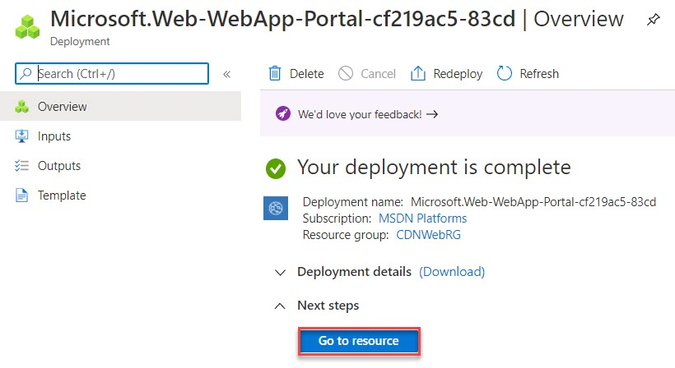

Step 8: Check Web App by selecting Browse option
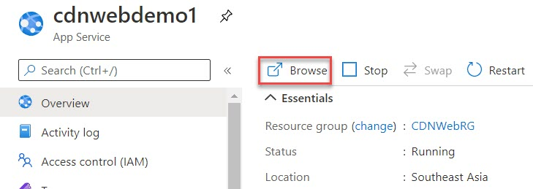

Sample page will load as below:
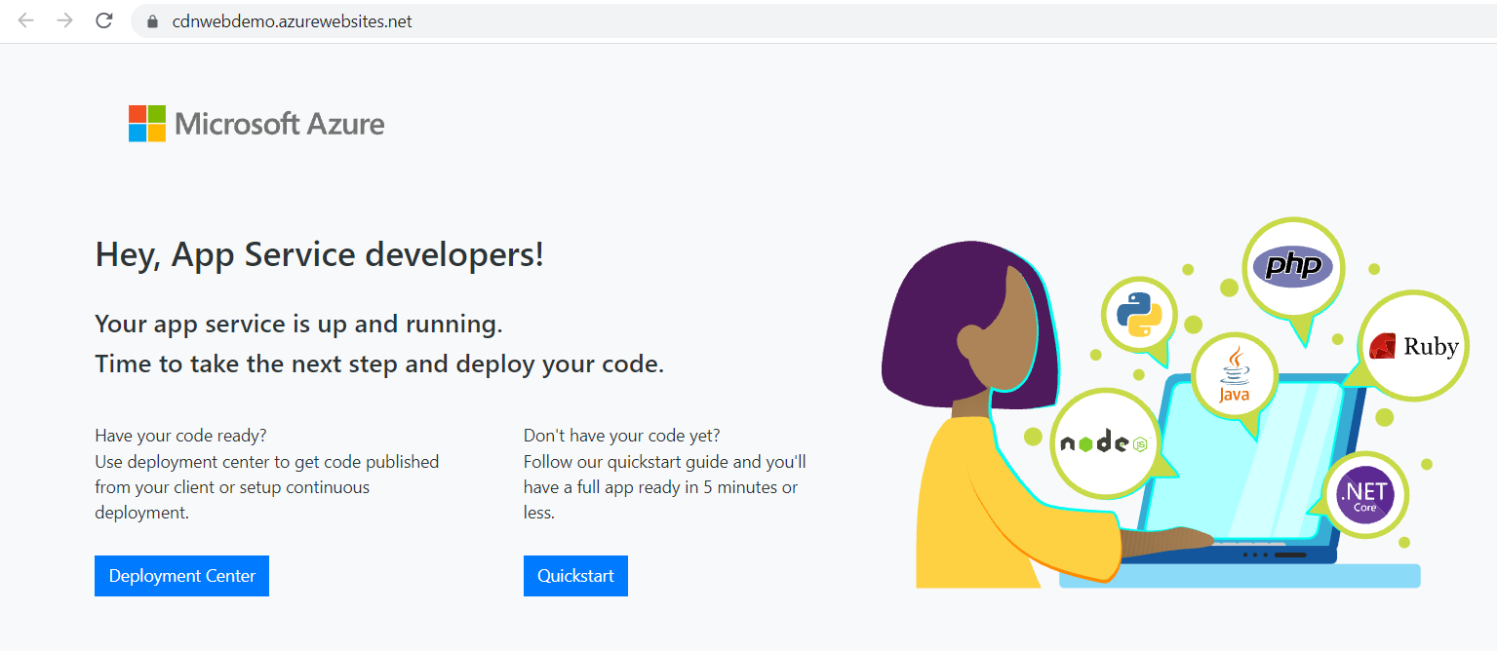

Task 2: Configure Azure CDN with Web App
Step 9: Select Networking -> Click on Azure CDN
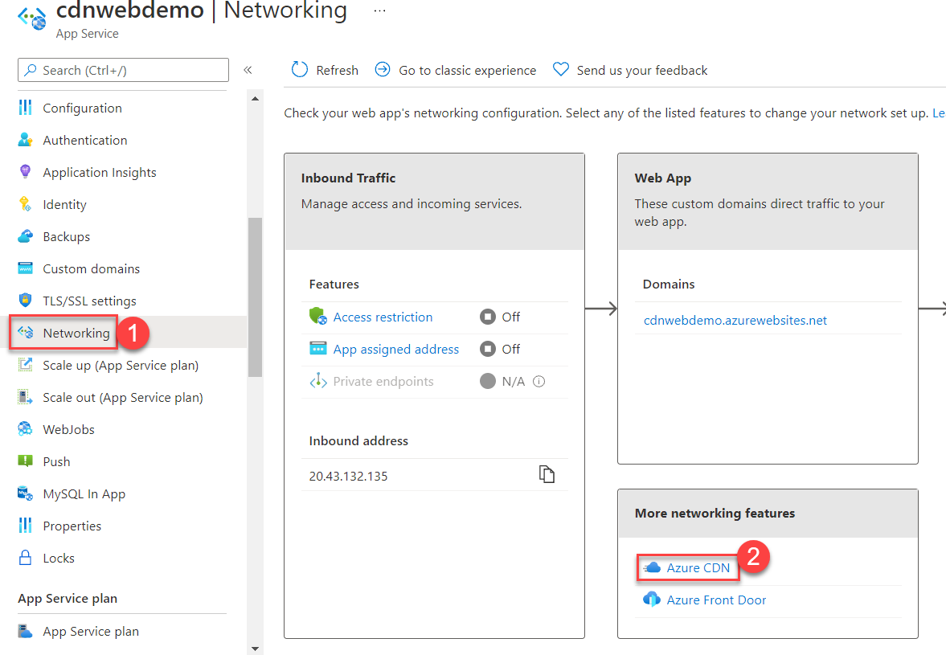

Step 10: CDN Profile: Use existing
Choose profile created in previous step
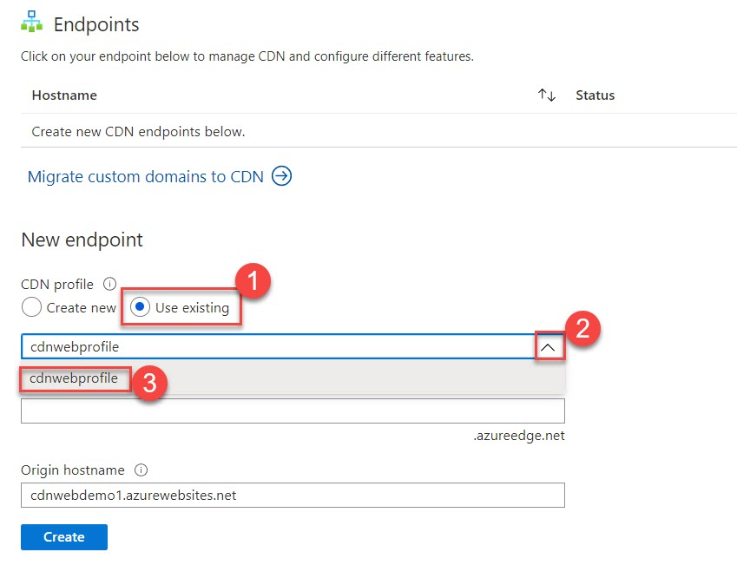

Step 11: CDN endpoint name: enter unique name ex. cdnwebendpoint1
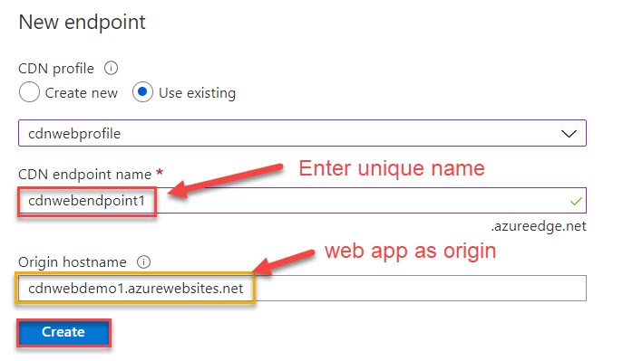

Wait for couple of duration to create
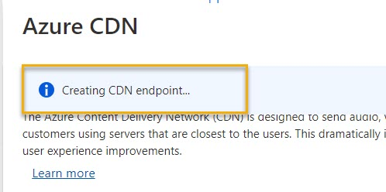

Check via Notification
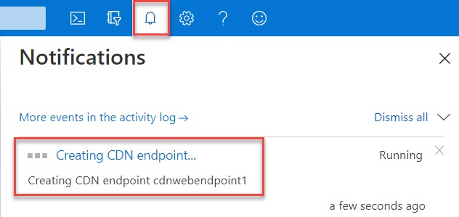

Successfully created and click on that notification
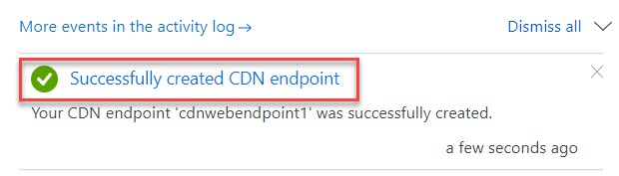

Step 12: Overview & run origin hostname in browser ex. http://webappname.azurewesites.net
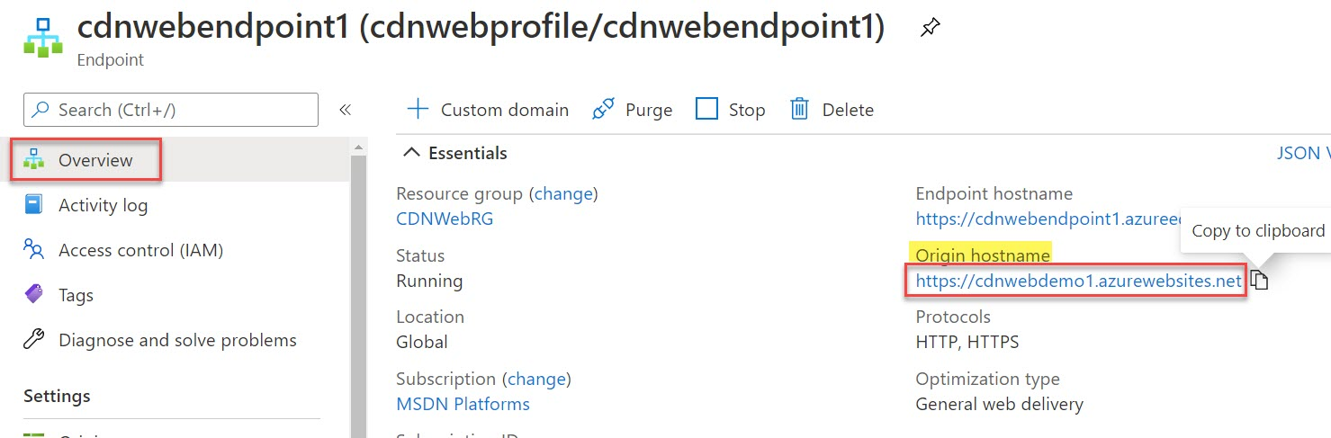

Step 13: App running from Web App URL
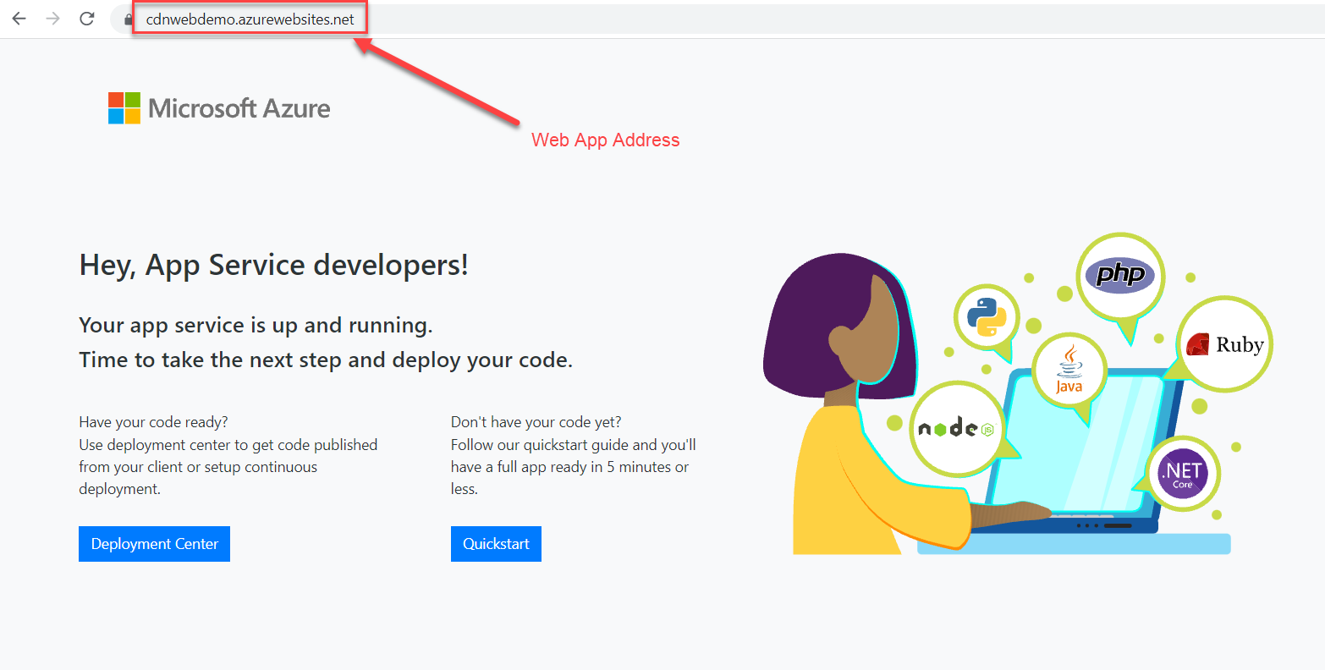

Step 14: Not collect CDN Endpoint hostname Ex. http://cdnaddress.azureedge.nets
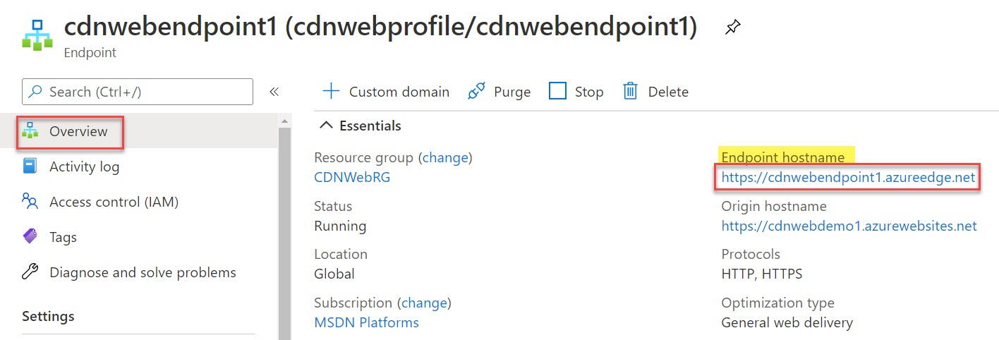

Wait for couple of duration to run sample page.
Note: might be it will take couple of minutes as we have selected Microsoft CDN.
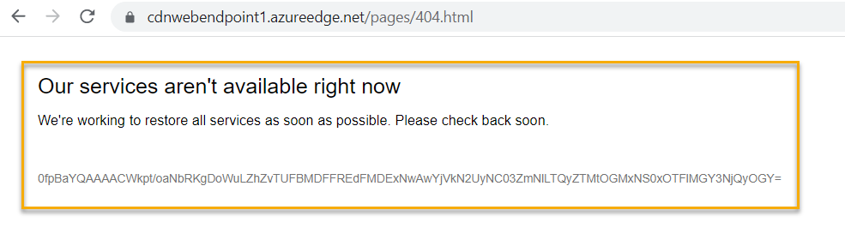
Refresh after some time
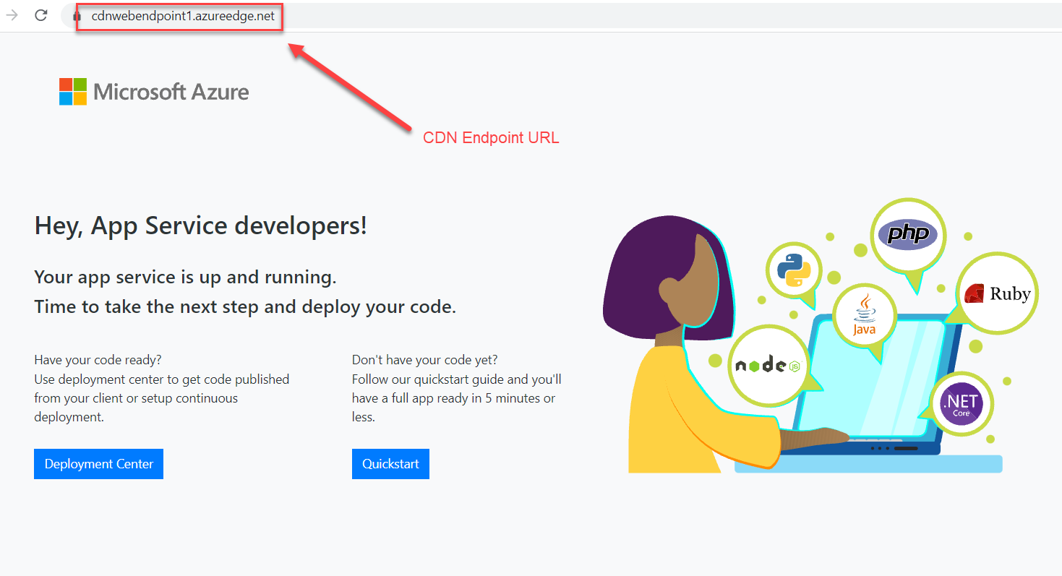

Step 15: Navigate to Resource Group -> CDNWebRG
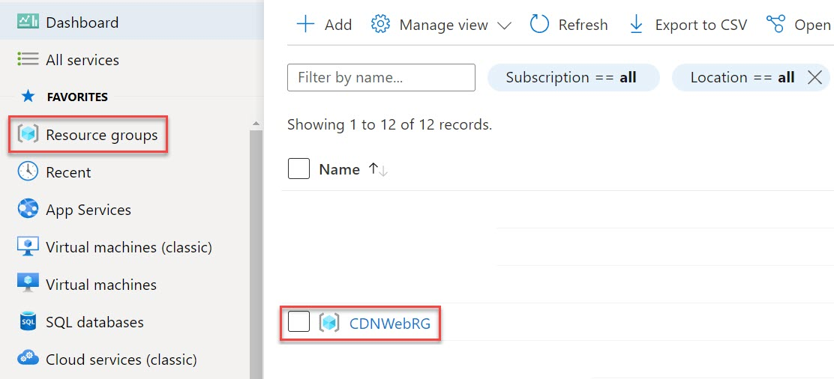

Step 16: Select Web App Ex. cdnwebdemo
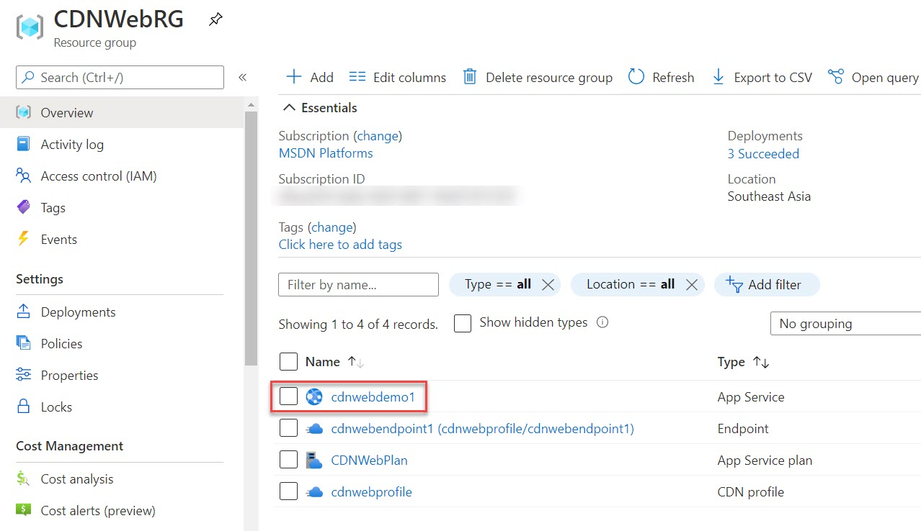

Step 17: Search for editor
Select App Service Editor & Click on Go option
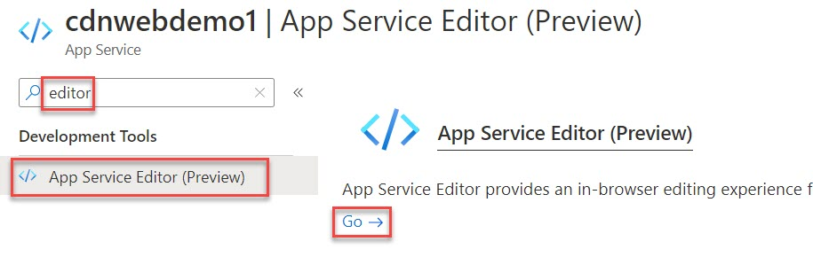

Step 18: Click on hostingstart.html file and update as below:
Hey, App Service developers! - CDN – V2
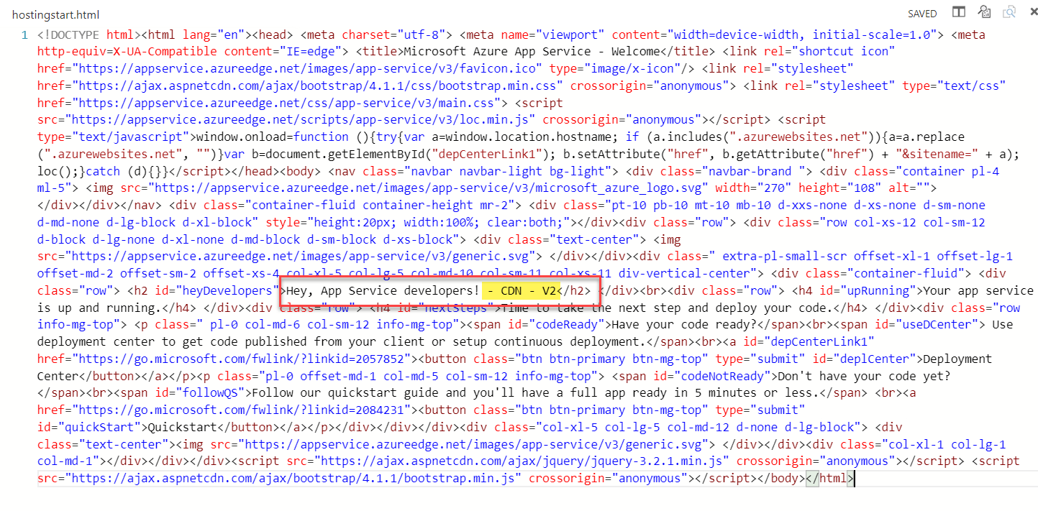

Step 19: Now run Web App ex. xxxx.azurewebsites.net
Site updated with CDN v2
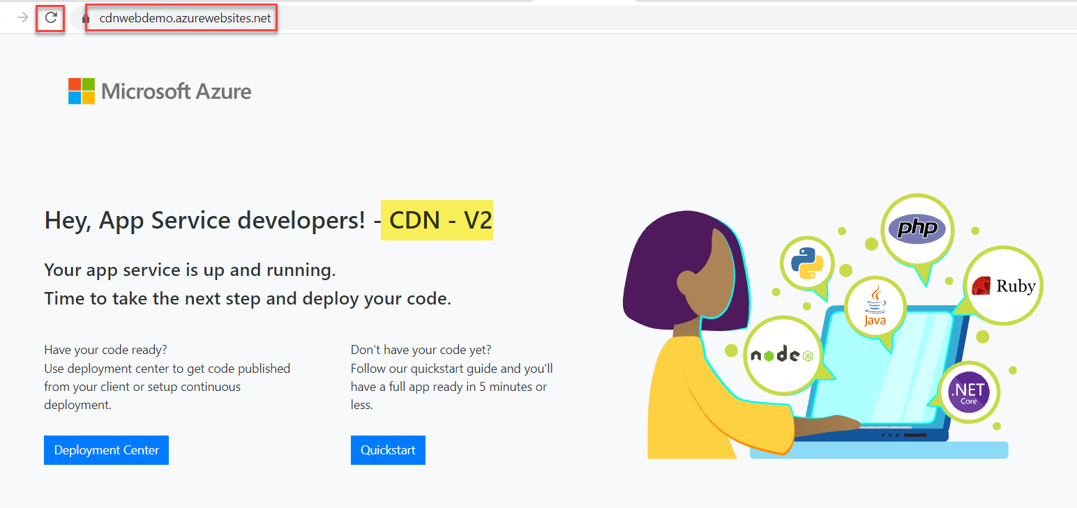

Step 20: Now refresh CDN Endpoint URL
Site not updated. Fetching from cache only
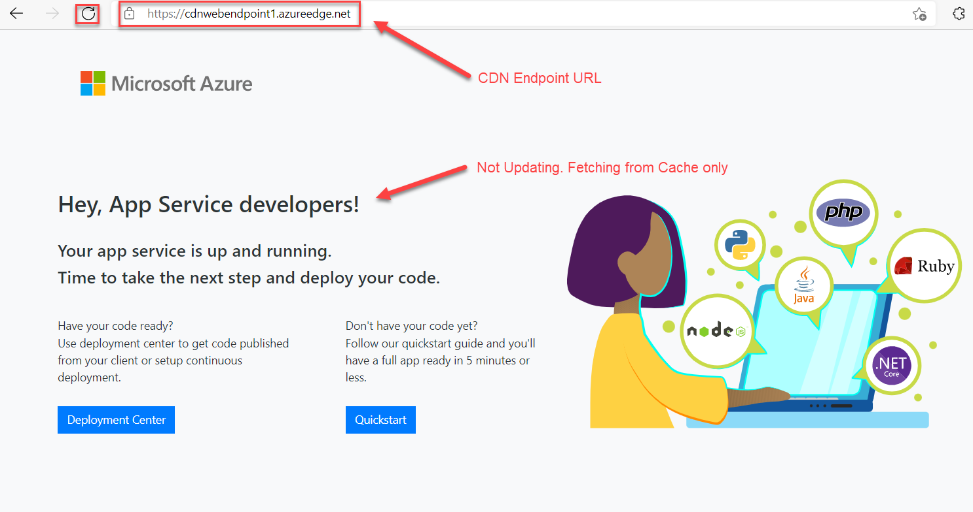

Step 21: Navigate to Resource Group -> CDNWebRG

Step 22: Select CDN Endpoint
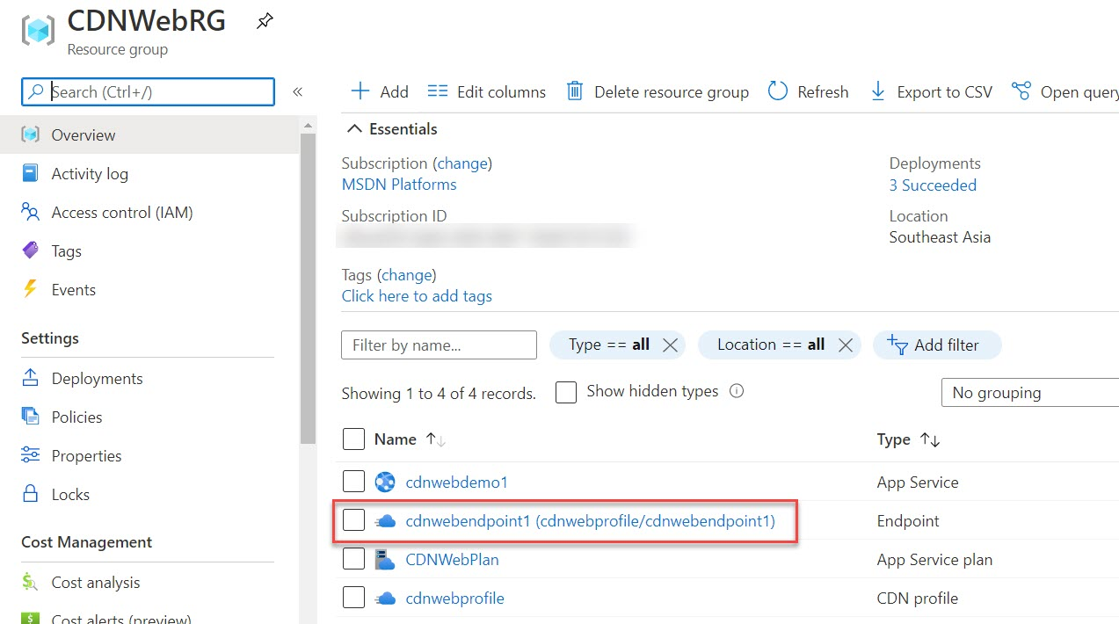

Task 3: Purge the CDN
Step 23: Click on Purge button
We can resolve this issue by below functionality
The CDN periodically refreshes its resources from the origin web app based on the time-to-live (TTL) configuration. The default TTL is seven days. At times you might need to refresh the CDN before the TTL expiration; for example, when you deploy updated content to the web app. To trigger a refresh, manually purge the CDN resources.
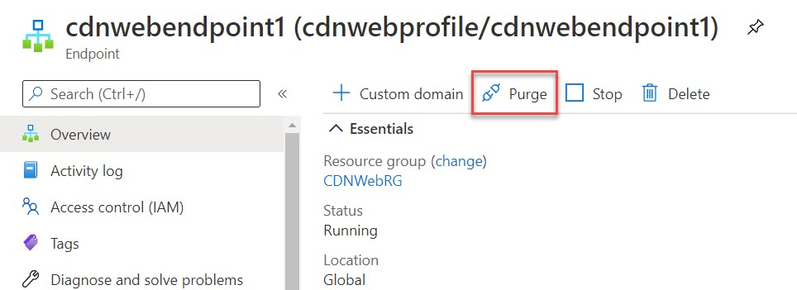

Step 24: Enter page name which page you require to get new content type /hostingstart.html
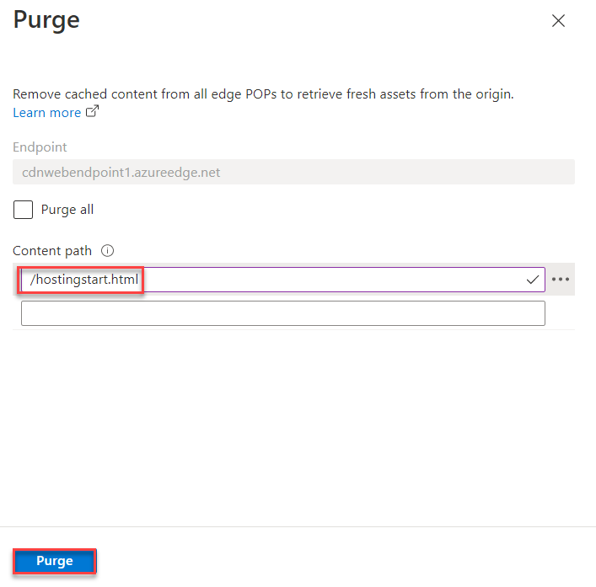
It will take couple of duration to update
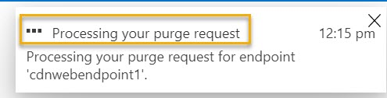

Check under notification
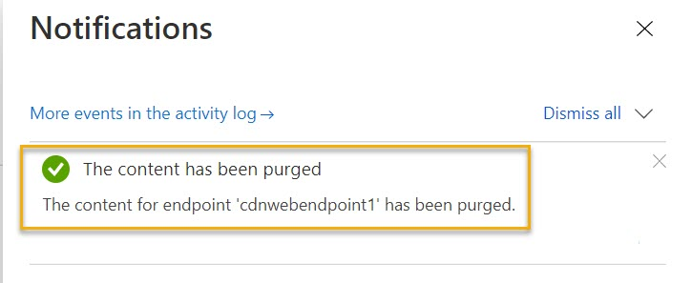

Step 25: Now refresh CDN Endpoint URL with adding /hostingstart.html
Its updated with new content Ex. CDN v2
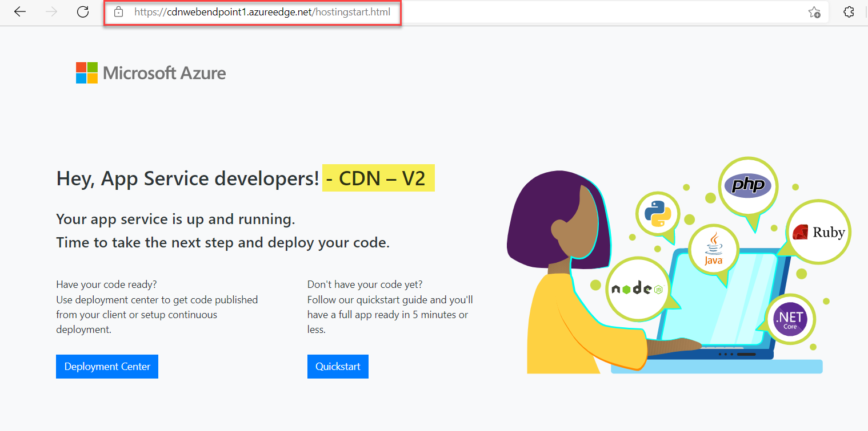

Task 4: Restrict Azure CDN Content by Country/Region
Step 26: Geo-filtering
Action: Block
Country: Choose your current country
Click on Save button
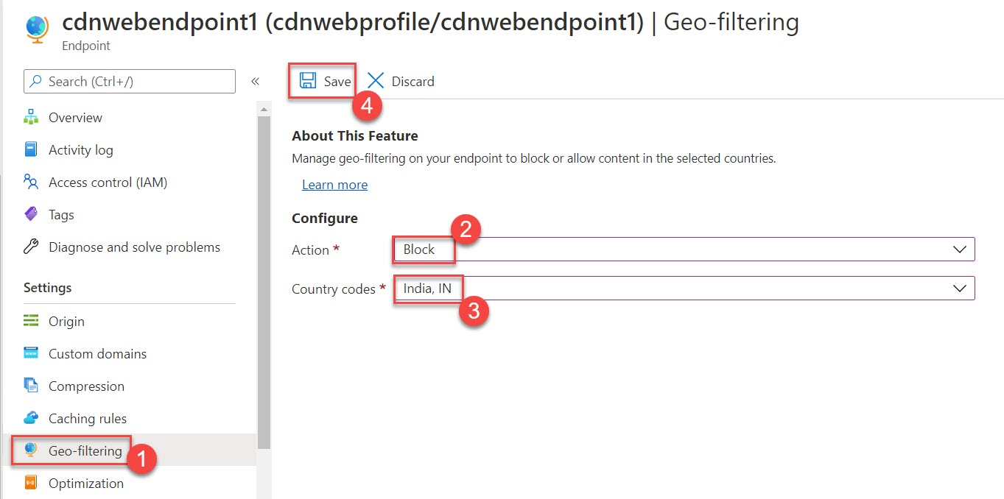

Wait for few duration & now refresh
Content is block as per geo-filtering option
