Azure Service Bus – Queue

Step 1: Open Microsoft Azure Portal
https://portal.azure.com/

Step 2: Click on + Create a resource -> Integration -> Service Bus
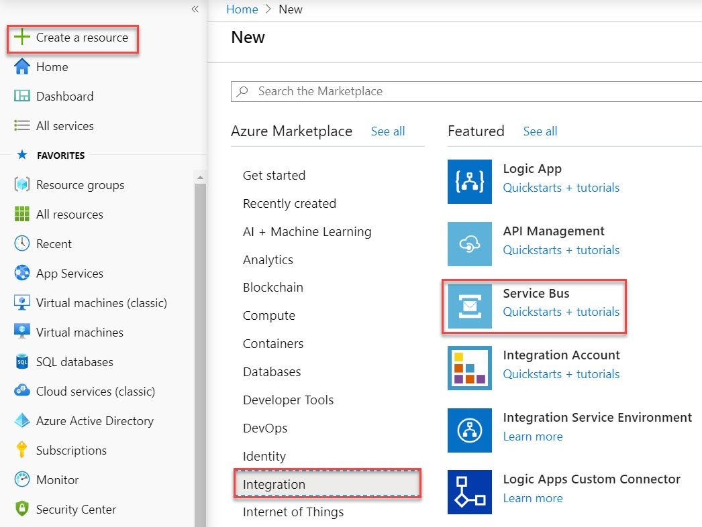

Step 3: Enter Service Bus Namespace
Subscription: Choose active Subscription
Resource Group: Create New Resource Group Ex. ServiceBusDemoRG
Namespace name: Enter unique name Ex. myservicebus
Location: Choose nearest location
Pricing tier: Standard

Click on Review + Create button
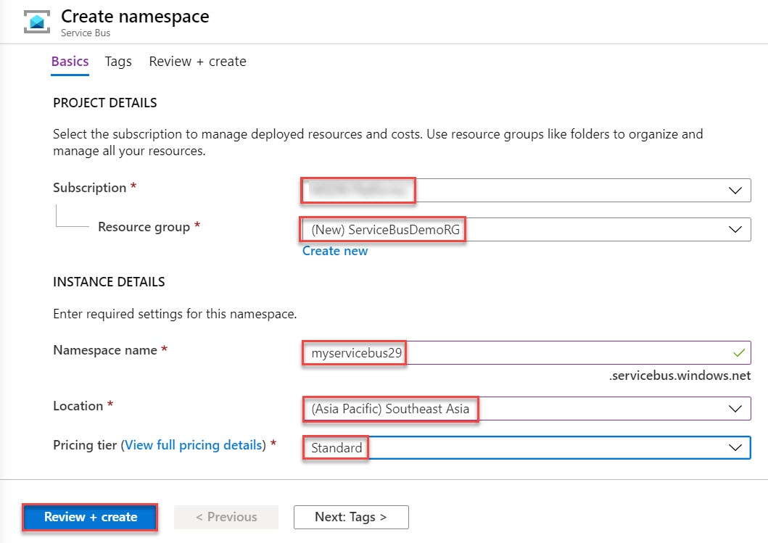

Click on Create button
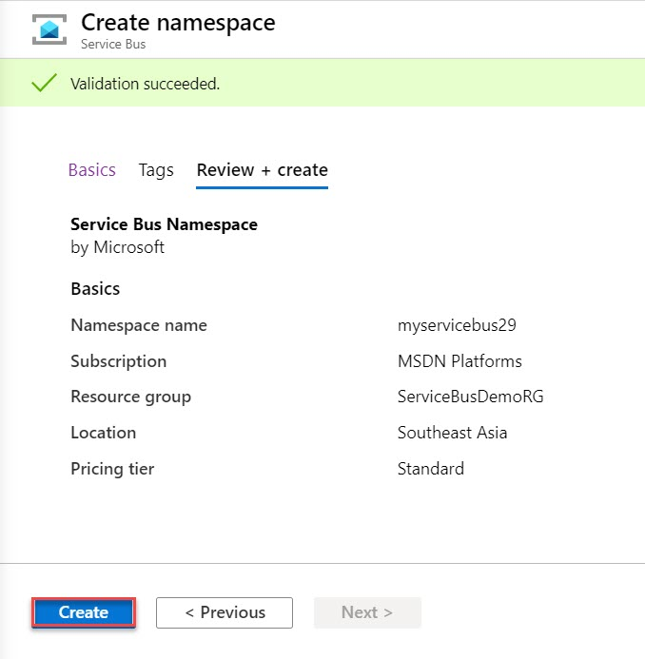

Click on Go to resource button
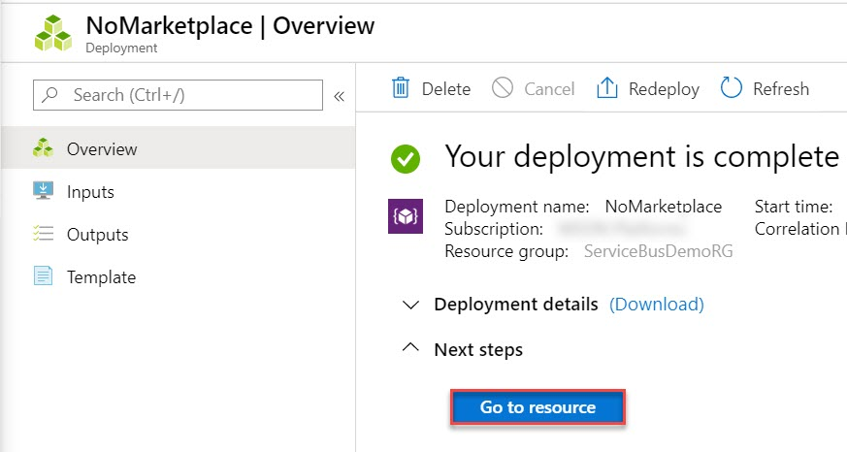
Step 4: Click on + Queue to create new Queue
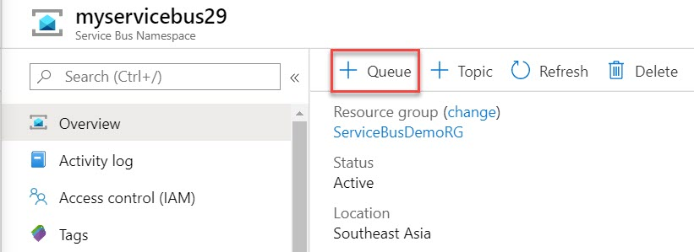

Step 5: Enter Queue Name: sbqueue
Go with default options of Max Size, Message time to live, Lock duration, etc.
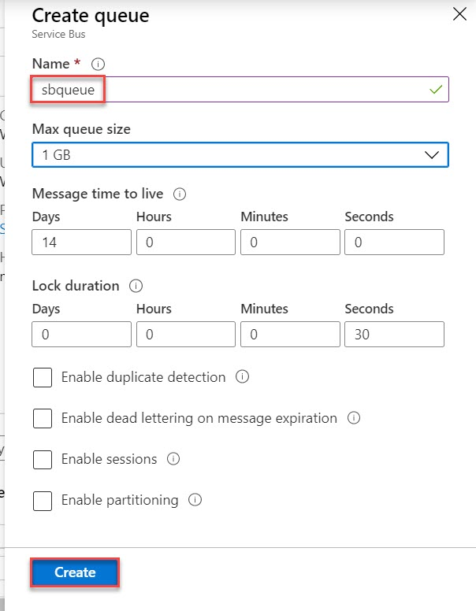
Queue created successfully.
Click on Shared access policies and Select RoorManageSharedAccessKey
Copy Primary Connection String into Notepad for further use
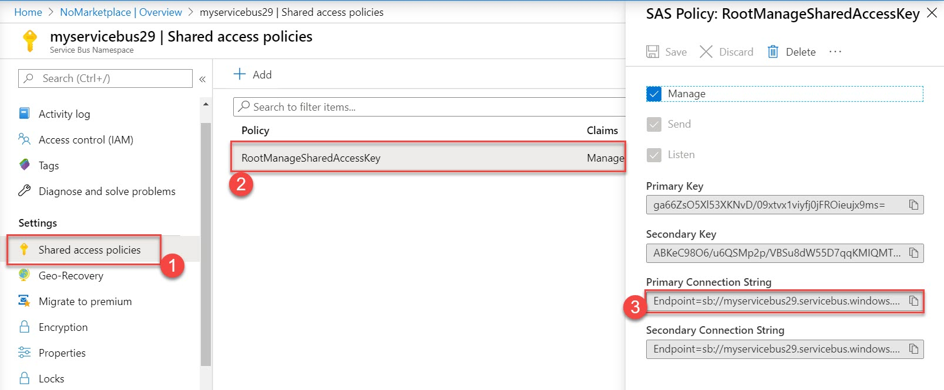

Step 6: Start Visual Studio and Create a new project
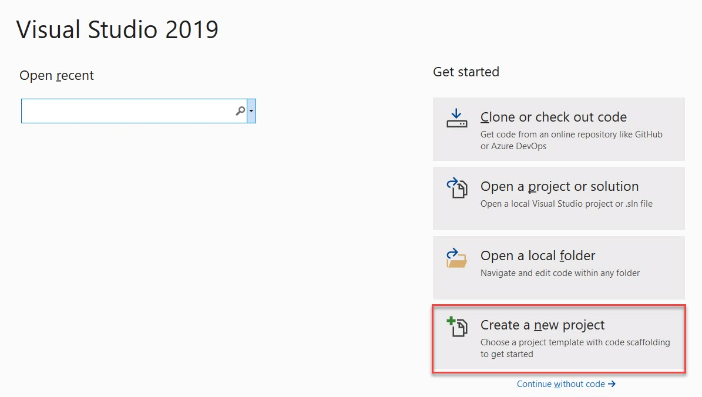

Choose Console App (.NET Framework)
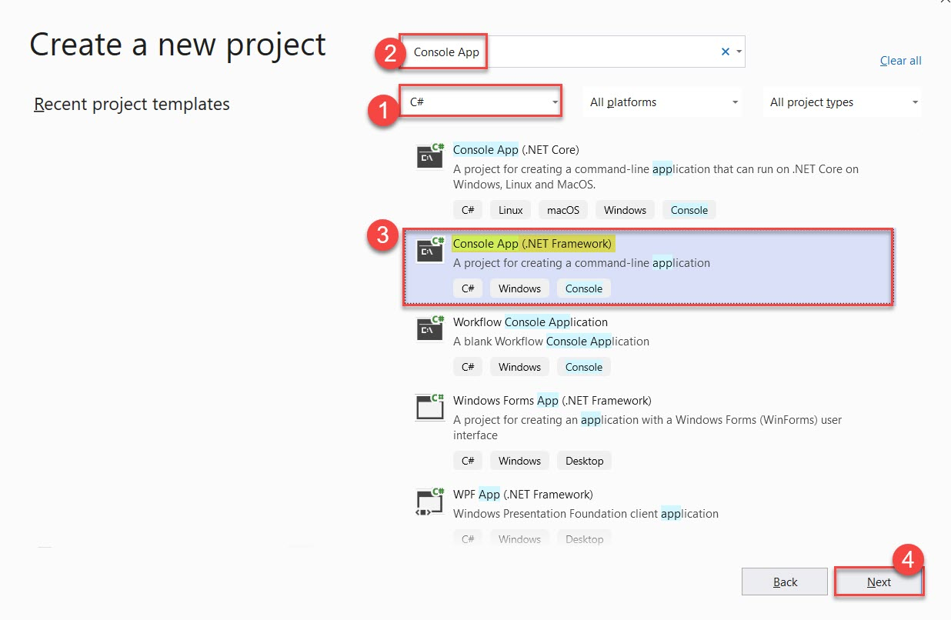

Project Name: SBQueueSender
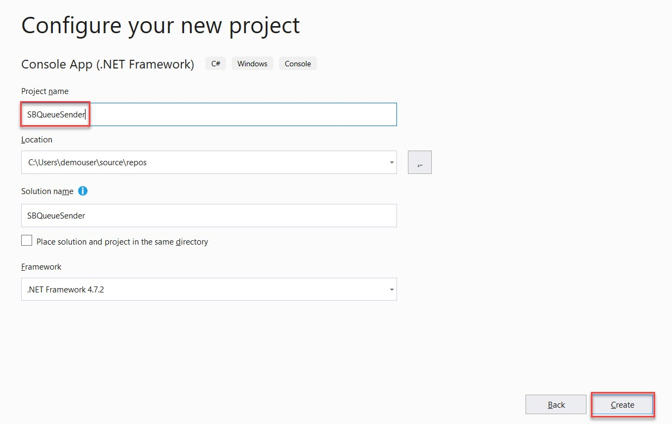
Step 7: Right click on Project Name & select “Manage NuGet Packages…”
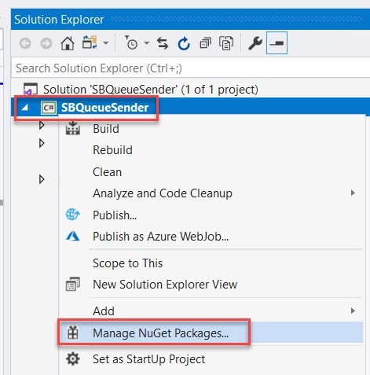

Step 8: Search for “WindowsAzure.ServiceBus” & install packages.
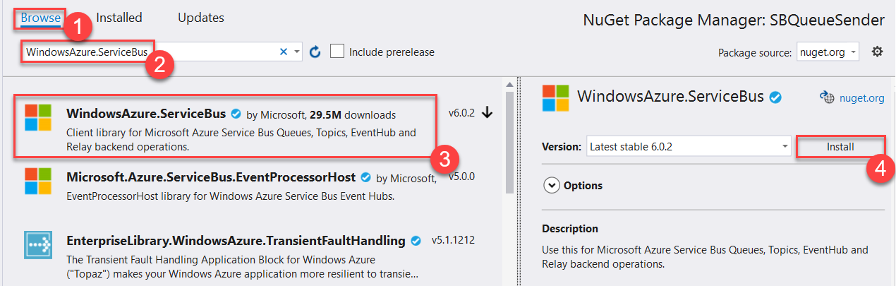

Step 9: Open Program.cs file
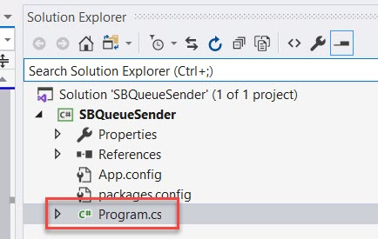

Step 10: Add below code:
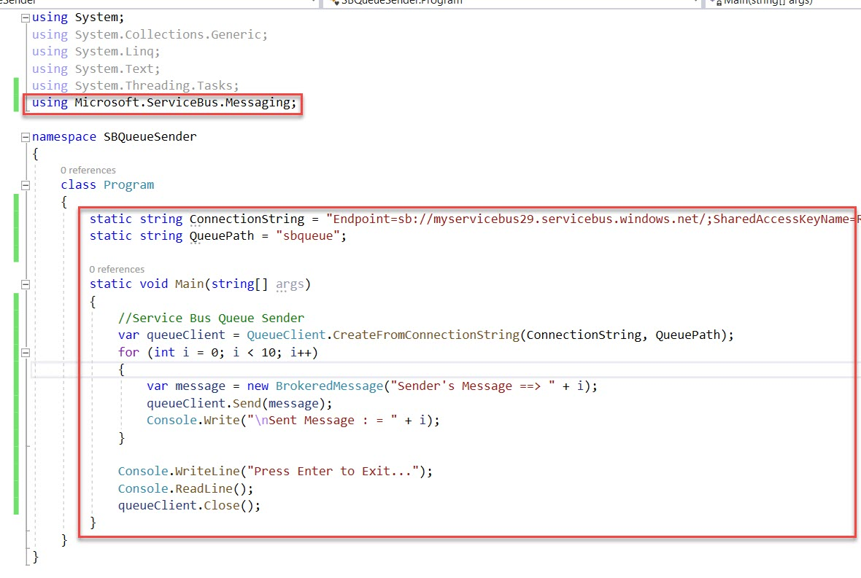

using Microsoft.ServiceBus.Messaging;

namespace SBQueueSender
{
class Program
{
static string ConnectionString = "Endpoint=sb://azureservicebus.servicebus.windows.net/;SharedAccessKeyName=RootManageSharedAccessKey;SharedAccessKey=<copy-servicebus-sharedkey-from-azure-portal>";
static string QueuePath = "sbqueue";

static void Main(string[] args)
{
//Service Bus Queue Sender
var queueClient = QueueClient.CreateFromConnectionString(ConnectionString, QueuePath);
for (int i = 0; i < 10; i++)
{
var message = new BrokeredMessage("Sender's Message ==> " + i);
queueClient.Send(message);
Console.Write("\nSent Message : = " + i );
}

Console.WriteLine("Press Enter to Exit...");
Console.ReadLine();
queueClient.Close();

}
}
}
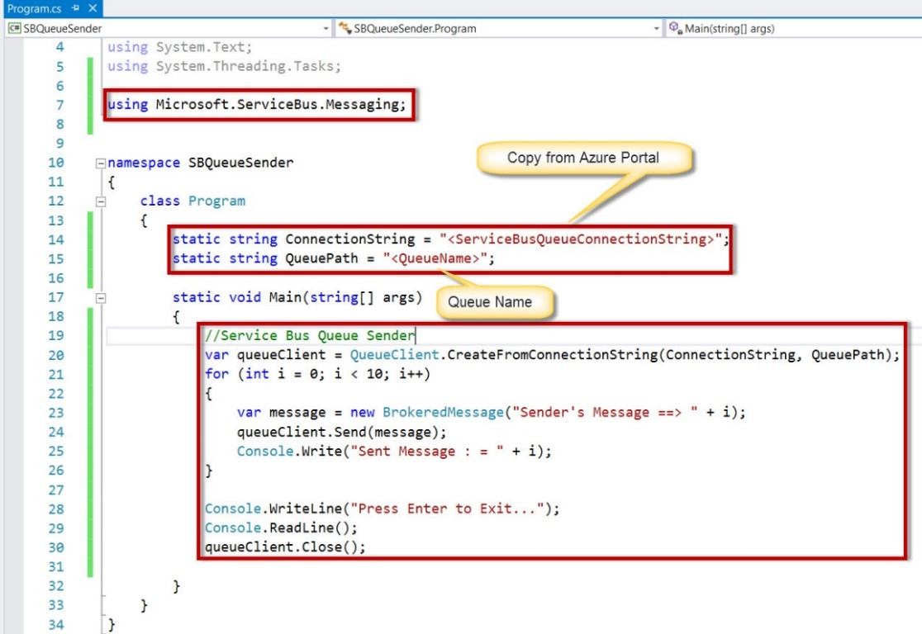
Step 11: Now run the Sender program
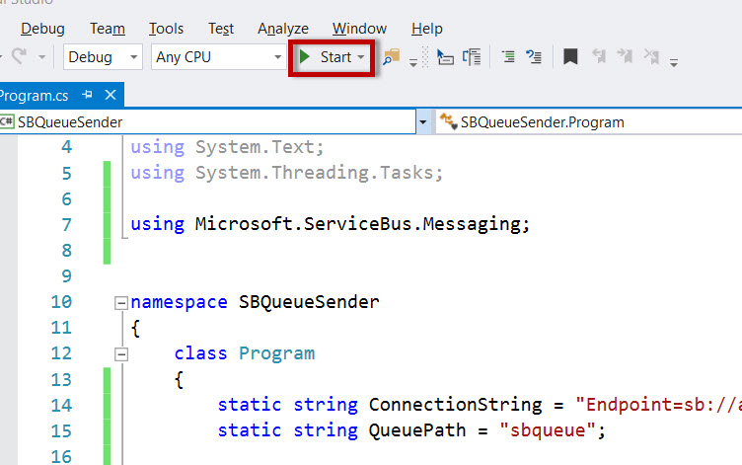

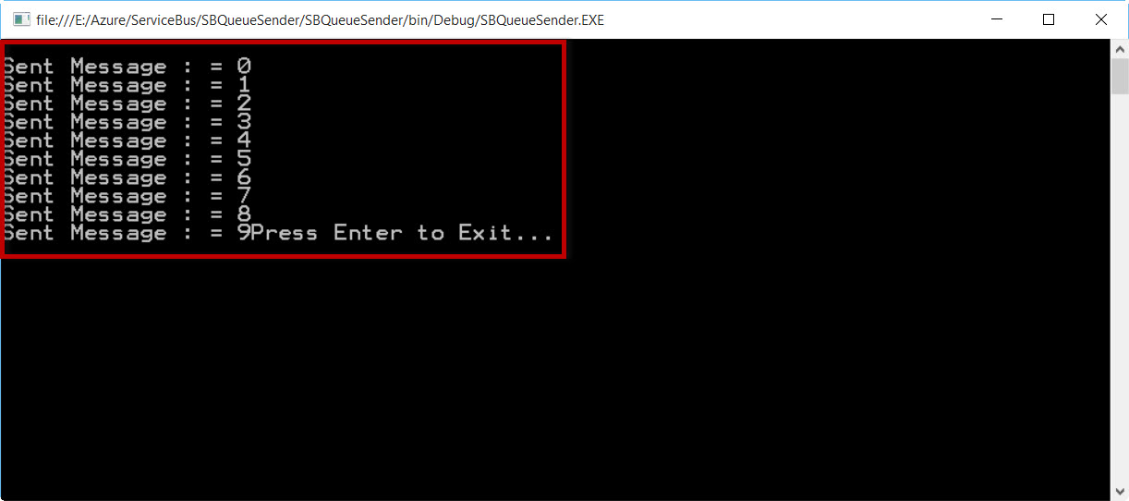

Again Navigate to Service Bus Queue option
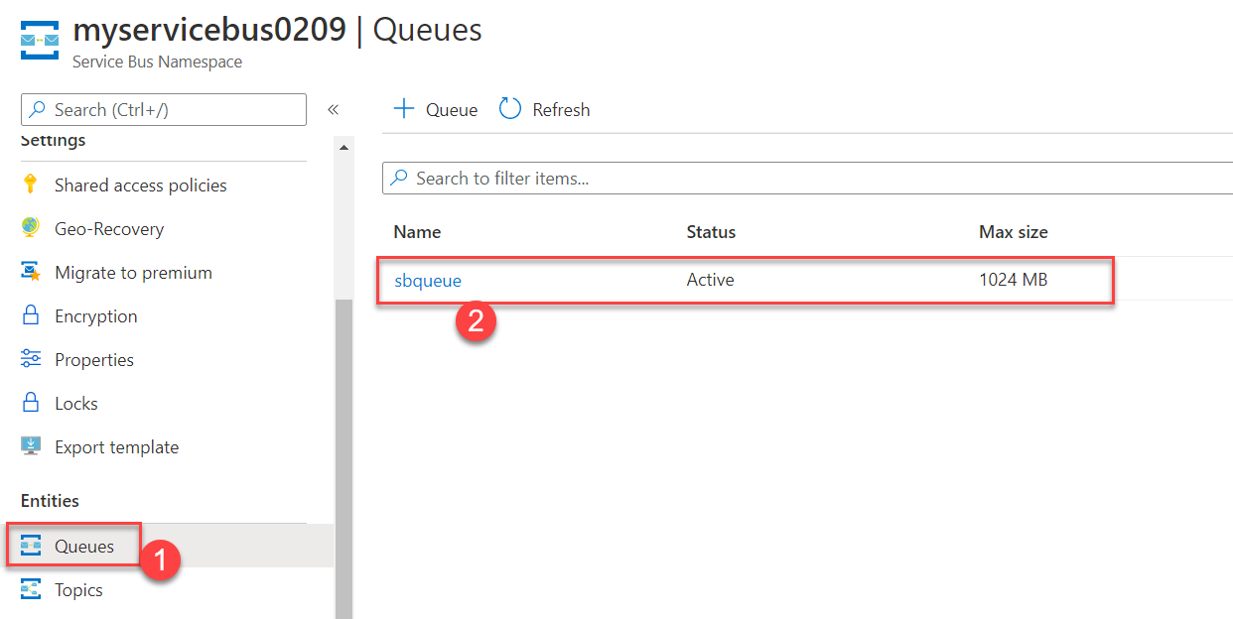

Verify 10 message count updated
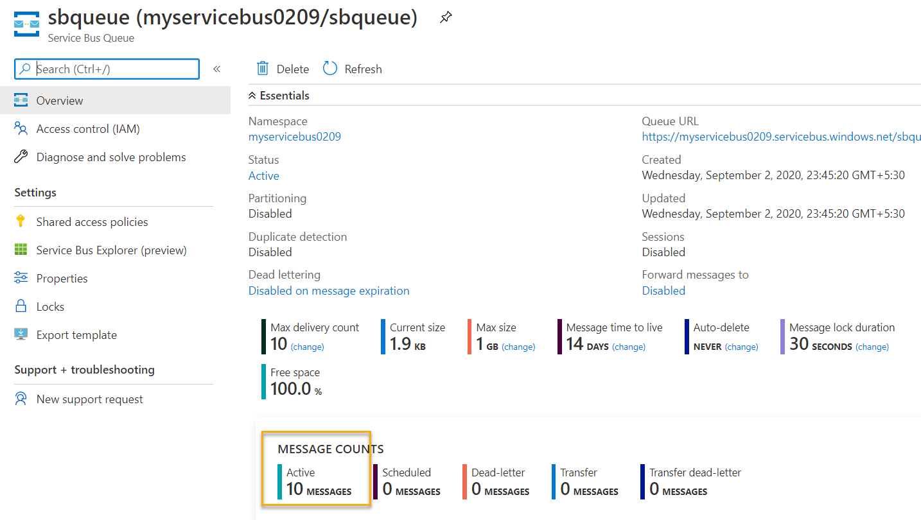

Step 12: Create one more project for Receiver using Visual Studio.
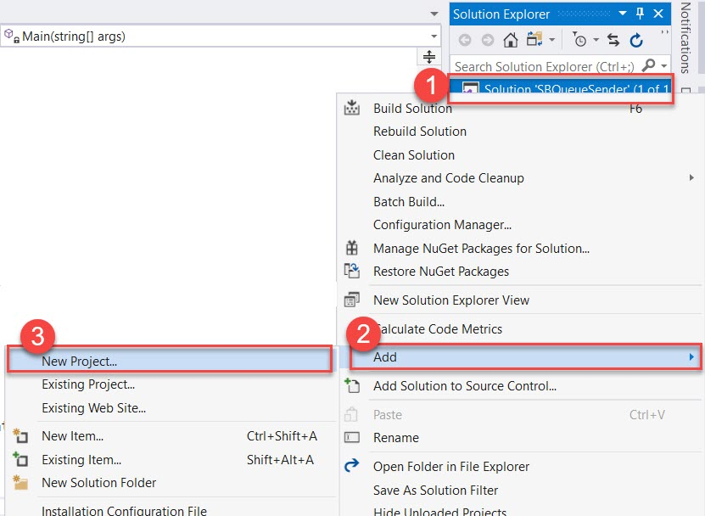

Create Console App (.NET Framework)
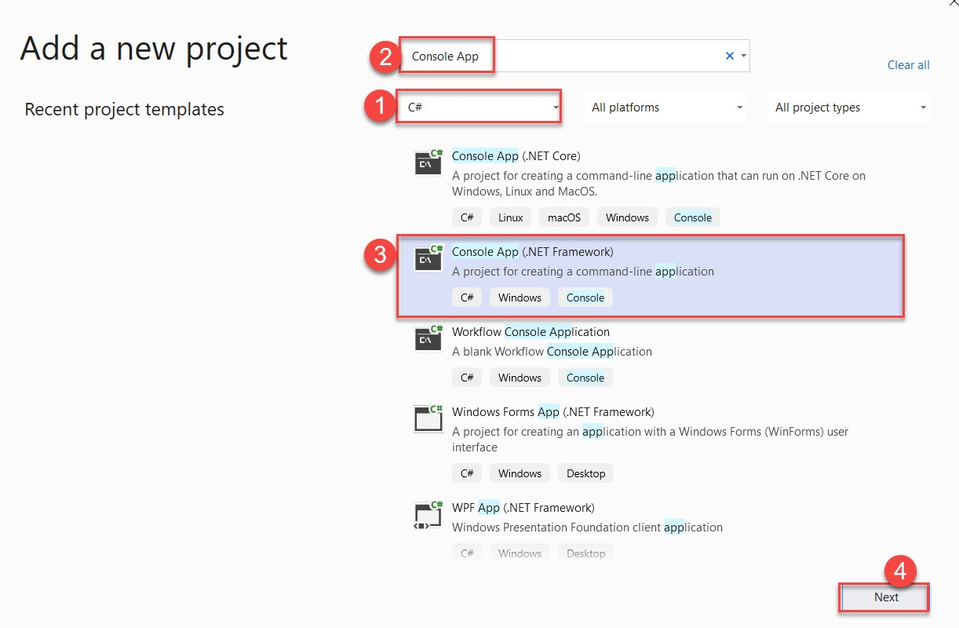
Project Name: SBQueueReceiver
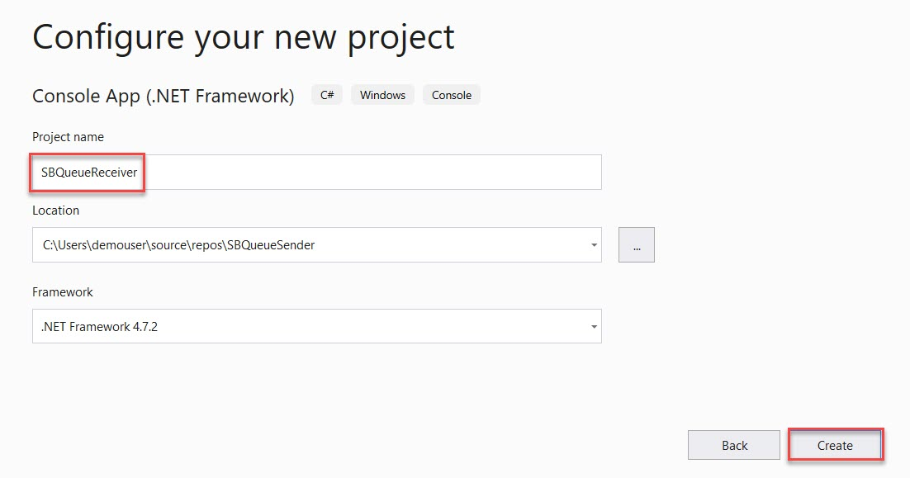

repeat the same steps to install NuGet Packages of Azure Service Bus.
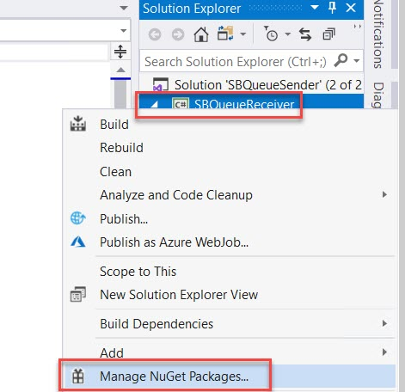

Search for “WindowsAzure.ServiceBus” & install packages.

Step 13: Open Program.cs file

Add Service Bus Namespace
using Microsoft.ServiceBus.Messaging;

Get ConnectionString & QueueName from Azure Portal or copy from Sender’s Project.
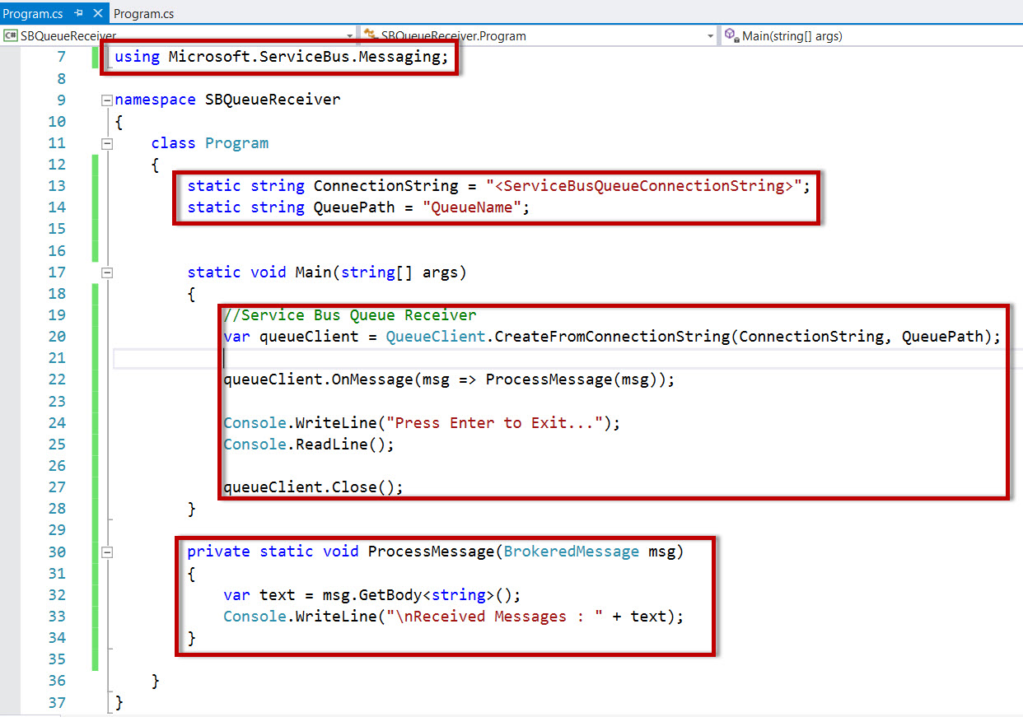

namespace SBQueueReceiver
{
class Program
{
static string ConnectionString = "Endpoint=sb://azureservicebus.servicebus.windows.net/;SharedAccessKeyName=RootManageSharedAccessKey;SharedAccessKey=<copy-servicebus-sharedkey-from-azure-portal>";
static string QueuePath = "sbqueue";

static void Main(string[] args)
{
//Service Bus Queue Receiver
var queueClient = QueueClient.CreateFromConnectionString(ConnectionString, QueuePath);

queueClient.OnMessage(msg => ProcessMessage(msg));

Console.WriteLine("Press Enter to Exit...");
Console.ReadLine();

queueClient.Close();
}

private static void ProcessMessage(BrokeredMessage msg)
{
var text = msg.GetBody<string>();
Console.WriteLine("\nReceived Messages : " + text);
}

}
}

Set SBQueueReceiver as a Startup project and run the project
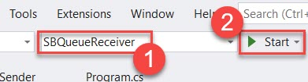
Step 14: Now run the Receiver project.
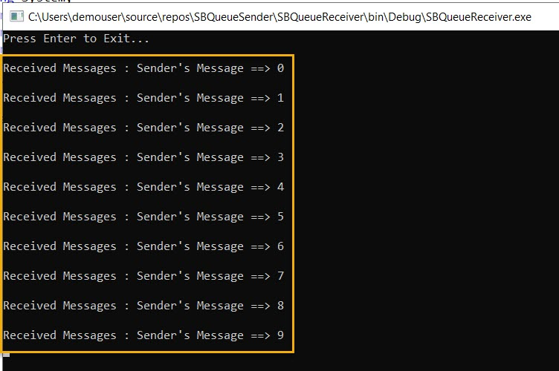

Navigate to Azure Portal and verify Queue
