NAME: DEVARASETTY KULDEEP
ROLL NO: CB.SC.U4CSE24712
EXPERIMENTAL-OS
STAGE1:
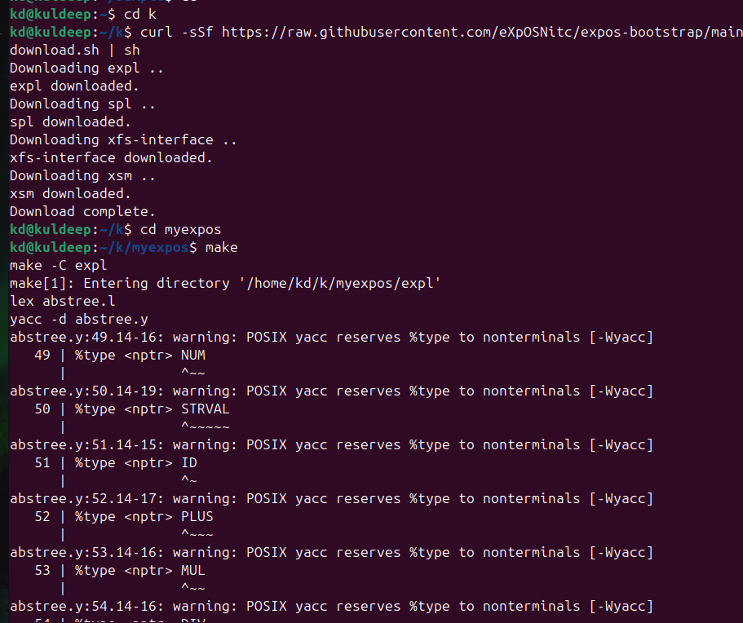

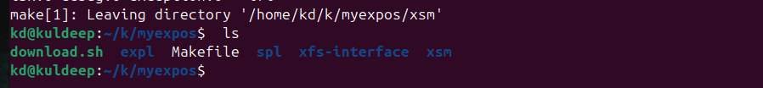

STAGE 2:
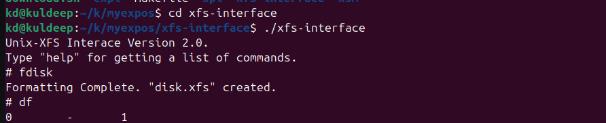

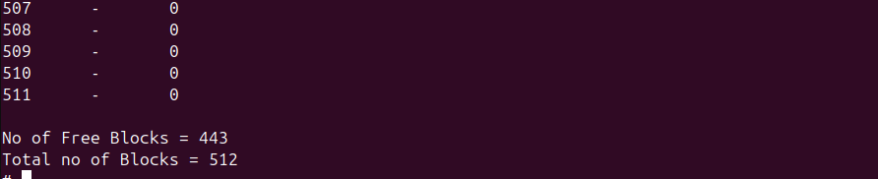
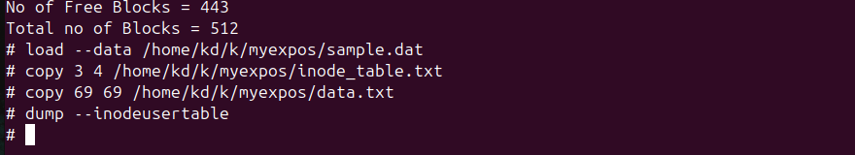
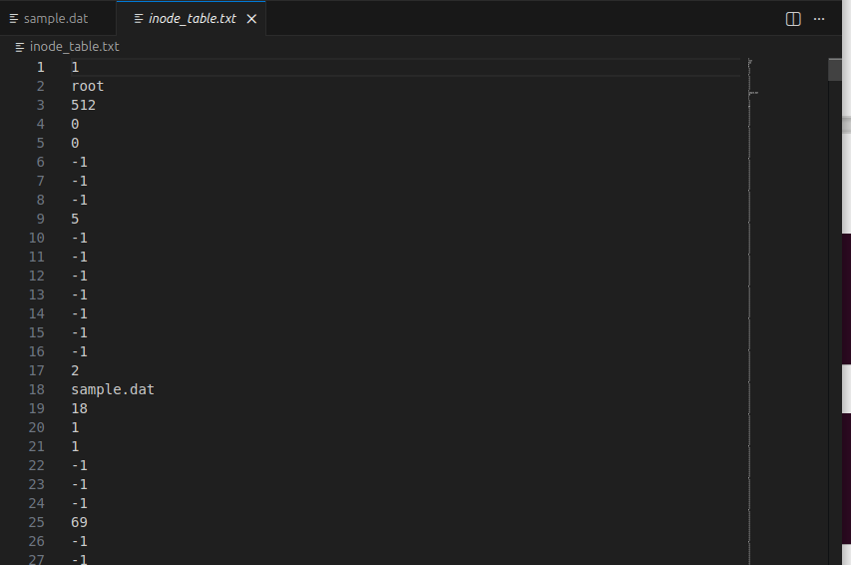

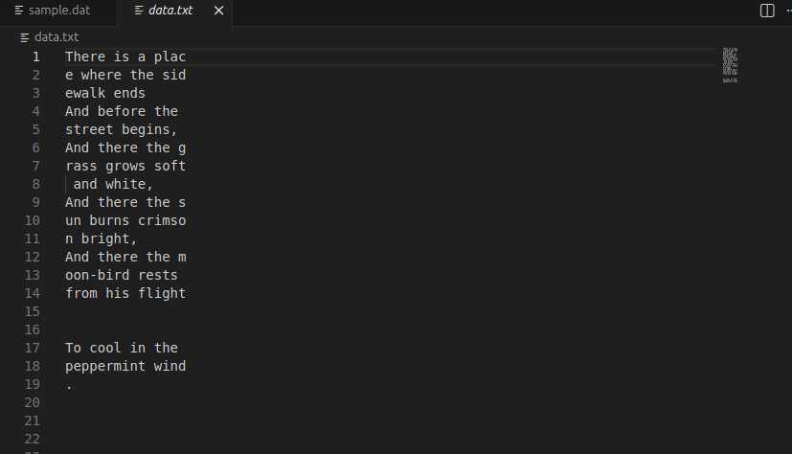
assignment1:
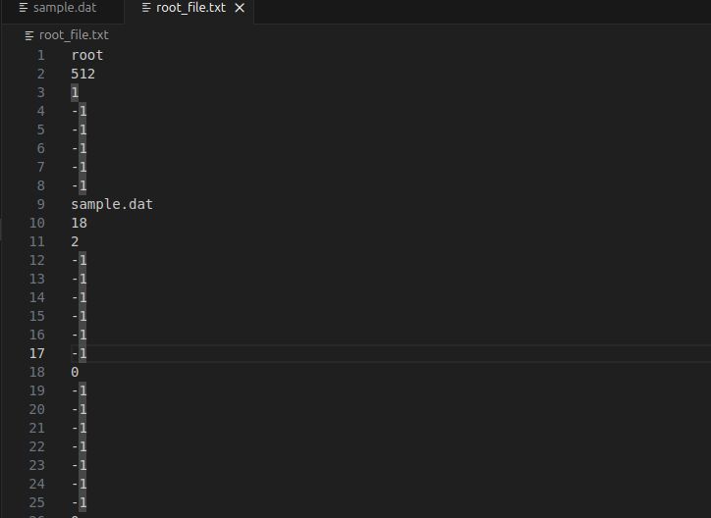
assignment2:
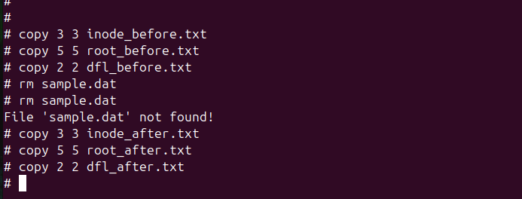

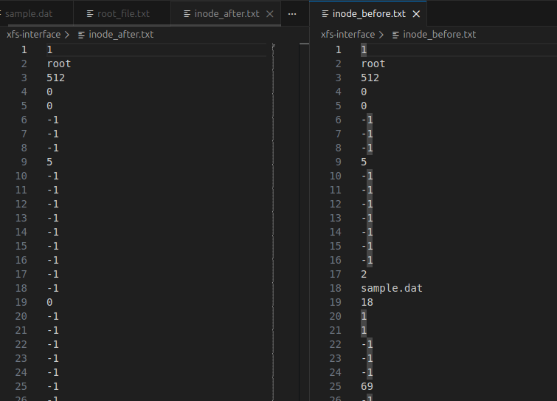
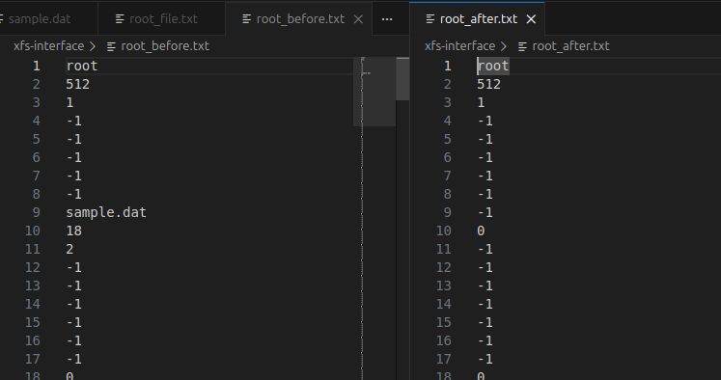
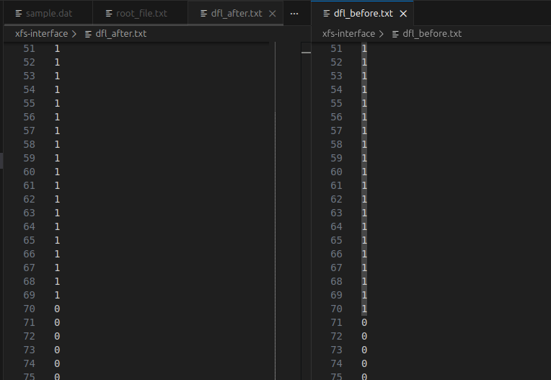

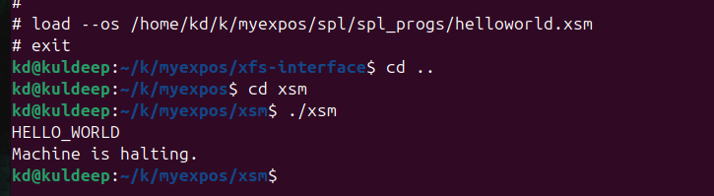
STAGE3 :
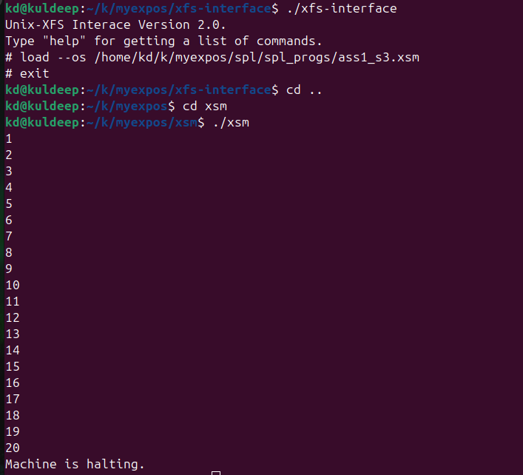
assignment:
MOV R0, 1
_L1:
MOV R16, 20
GE R16, R0
JZ R16, _L2
MOV R16, R0
PORT P1, R16
OUT
MOV R16, R0
ADD R16, 1
MOV R0, R16
JMP _L1
_L2:
HALT
HALT

STAGE 4:
alias counter R0;
counter = 0;
while(counter <= 20) do
if(counter%2 != 0) then
print counter;
endif;
counter = counter + 1;
endwhile;
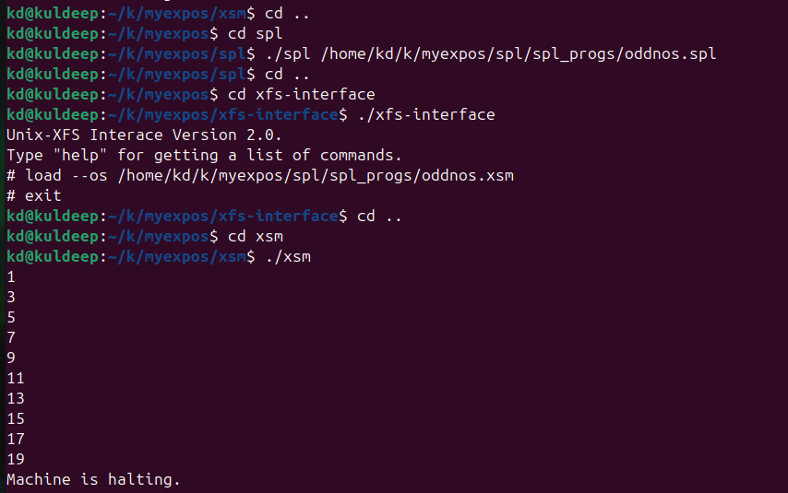
assignment1:
alias counter R0;
alias sum R1;
alias square R2;

counter = 1;
sum = 0;

while(counter <= 20) do
square = counter * counter;
sum = sum + square;
counter = counter + 1;
endwhile;

print sum;
halt;
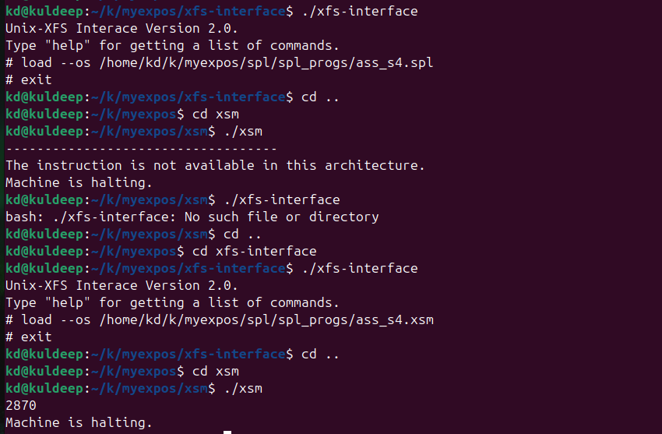

STAGE 5:
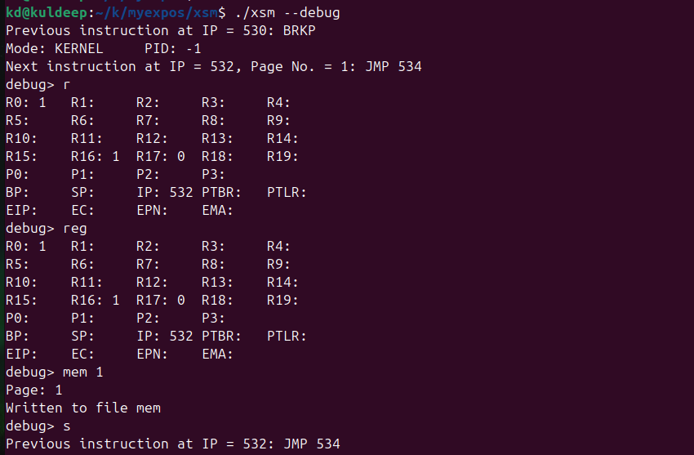

STAGE 6:
os_startup.spl:

loadi(65,7);
loadi(66,8);
loadi(22,35);
loadi(23,36);
loadi(2, 15);
loadi(3, 16);
PTBR = PAGE_TABLE_BASE;
PTLR = 3;
[PTBR+0] = 65;
[PTBR+1] = "0100";
[PTBR+2] = 66;
[PTBR+3] = "0100";
[PTBR+4] = 76;
[PTBR+5] = "0110";
[76*512] = 0;
SP = 2*512;
ireturn;

haltprog.spl:
halt;

squares.xsm:

MOV R0, 1
MOV R2, 5
GE R2, R0
JZ R2, 2066
MOV R1, R0
MUL R1, R0
BRKP
ADD R0, 1
JMP 2050
INT 10
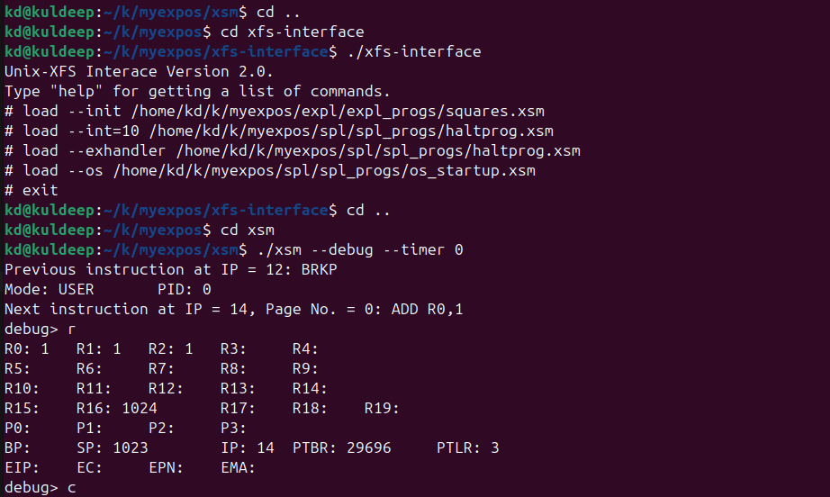
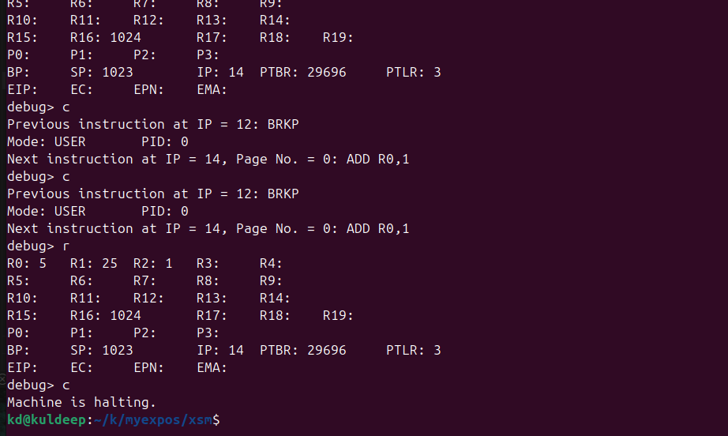
assignment6:

os_startup.spl:
loadi(65,7);
loadi(66,8);

loadi(22,35);
loadi(23,36);

loadi(2,15);
loadi(3,16);

PTBR = PAGE_TABLE_BASE;
PTLR = 9;

[PTBR+8] = 65;
[PTBR+9] = 4;

[PTBR+10] = 66;
[PTBR+11] = 4;

[PTBR+16] = 76;
[PTBR+17] = 6;

[76*512] = 2048;
SP = 8*512;

ireturn;

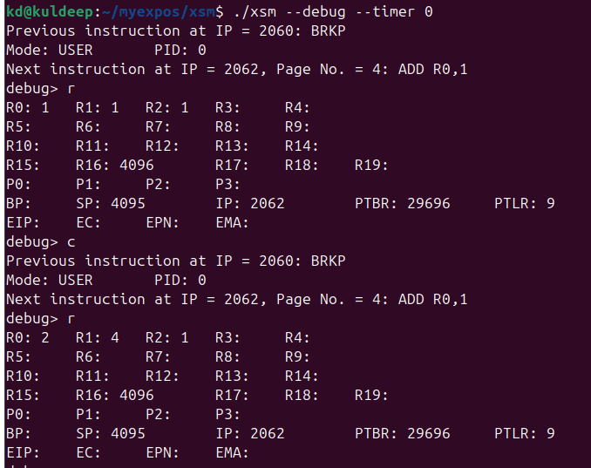

STAGE7:

os_startup.spl:
loadi(63, 13);
loadi(64, 14);
loadi(65, 7);
loadi(66, 8);
loadi(2, 17);
loadi(3, 18);
PTBR = PAGE_TABLE_BASE;
PTLR = 10;
[PTBR+0] = 63;
[PTBR+1] = "0100";
[PTBR+2] = 64;
[PTBR+3] = "0100";
[PTBR+4] = 78;
[PTBR+5] = "0110";
[PTBR+6] = 79;
[PTBR+7] = "0110";
[PTBR+8] = 65;
[PTBR+9] = "0100";
[PTBR+10] = 66;
[PTBR+11] = "0100";
[PTBR+12] = -1;
[PTBR+13] = "0000";
[PTBR+14] = -1;
[PTBR+15] = "0000";
[PTBR+16] = 76;
[PTBR+17] = "0110";
[PTBR+18] = 77;
[PTBR+19] = "0110";
SP = 8 * 512;
[76*512] = [65 * 512 + 1];
ireturn;

square.xsm:
0
2056
0
0
0
0
0
0

MOV R0, 1
MOV R2, 5
GE R2, R0
JZ R2, 2076
MOV R1, R0
MUL R1, R0
BRKP
ADD R0, 1
JMP 2058
INT 10

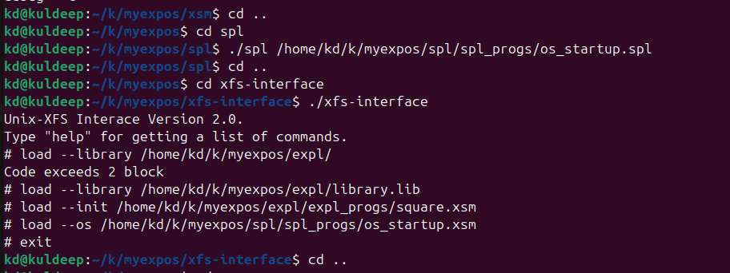

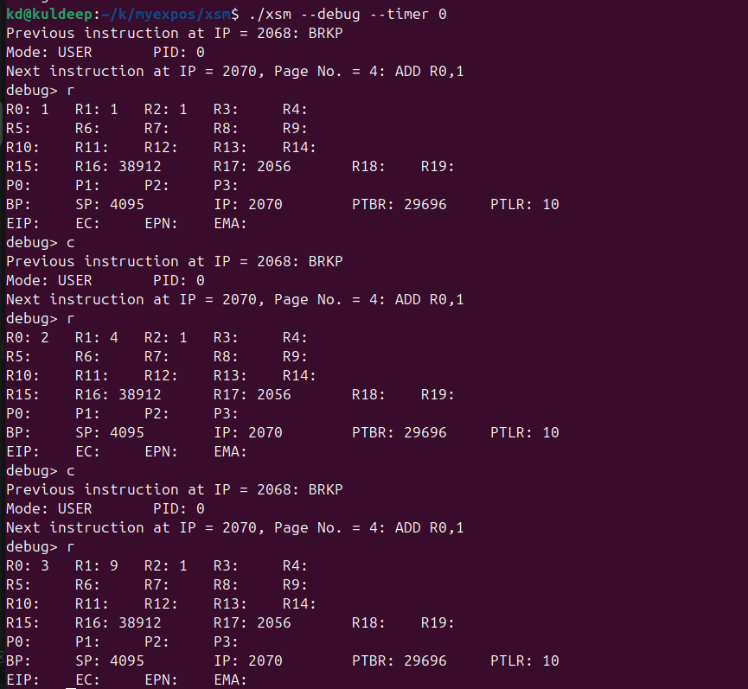
assignment(7):

os_startup.spl:
loadi(63, 13);
loadi(64, 14);
loadi(65, 7);
loadi(66, 8);
loadi(2, 17);
loadi(3, 18);
PTBR = PAGE_TABLE_BASE;
PTLR = 10;
[PTBR+0] = 63;
[PTBR+1] = "0100";
[PTBR+2] = 64;
[PTBR+3] = "0100";
[PTBR+4] = 78;
[PTBR+5] = "0110";
[PTBR+6] = 79;
[PTBR+7] = "0110";
[PTBR+8] = 65;
[PTBR+9] = "0100";
[PTBR+10] = 66;
[PTBR+11] = "0100";
[PTBR+12] = -1;
[PTBR+13] = "0000";
[PTBR+14] = -1;
[PTBR+15] = "0000";
[PTBR+16] = 76;
[PTBR+17] = "0110";
[PTBR+18] = 77;
[PTBR+19] = "0110";
SP = 8 * 512;
[76*512] = [65 * 512 + 1];
ireturn;
cubes.xsm:

0
2056
0
0
0
0
0
0

MOV R0, 1
MOV R2, 5
GE R2, R0
JZ R2, 2076
MOV R1, R0
MUL R1, R0
MUL R1, R0
BRKP
ADD R0, 1
JMP 2058
INT 10
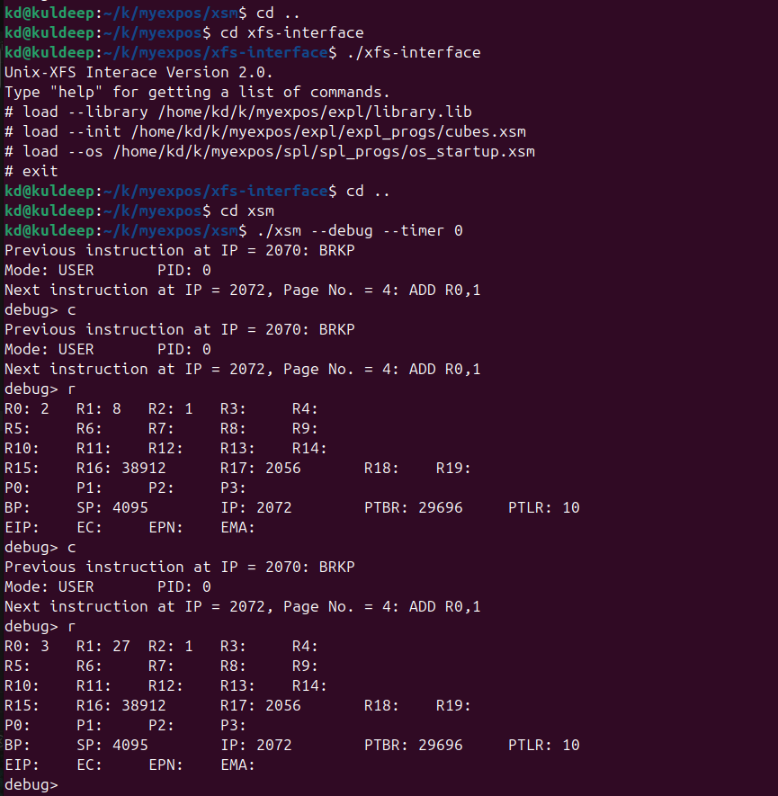

STAGE 8:

os_startup.spl:
loadi(63, 13);
loadi(64, 14);

loadi(65, 7);
loadi(66, 8);

loadi(4, 17);
loadi(5, 18);

loadi(2, 17);
loadi(3, 18);

PTBR = PAGE_TABLE_BASE;
PTLR = 10;

[PTBR+0] = 63;
[PTBR+1] = "0100";

[PTBR+2] = 64;
[PTBR+3] = "0100";

[PTBR+4] = 78;
[PTBR+5] = "0110";

[PTBR+6] = 79;
[PTBR+7] = "0110";

[PTBR+8] = 65;
[PTBR+9] = "0100";

[PTBR+10] = 66;
[PTBR+11] = "0100";

[PTBR+12] = -1;
[PTBR+13] = "0000";

[PTBR+14] = -1;
[PTBR+15] = "0000";

[PTBR+16] = 76;
[PTBR+17] = "0110";

[PTBR+18] = 77;
[PTBR+19] = "0110";

PTLR = 10;

SP = 8*512;

[76*512] = [65*512 + 1];

ireturn;

sample_timer.spl:

print "TIMER";
ireturn;
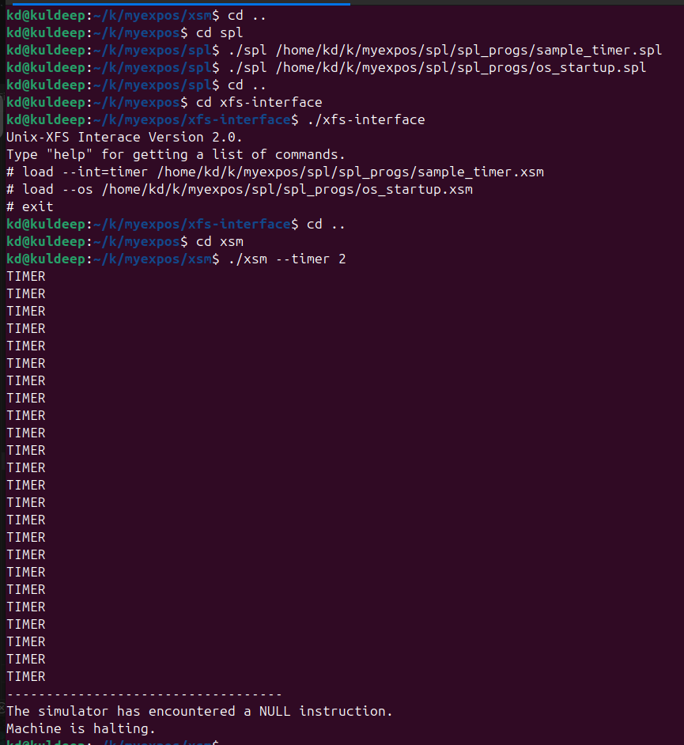

STAGE 9:
sample_timer.spl:

[PROCESS_TABLE + ( [SYSTEM_STATUS_TABLE + 1] * 16) + 13] = SP;
// Setting SP to UArea Page number * 512 - 1
SP = [PROCESS_TABLE + ([SYSTEM_STATUS_TABLE + 1] * 16) + 11] * 512 - 1;
backup;
print "TIMER";
restore;
SP = [PROCESS_TABLE + ( [SYSTEM_STATUS_TABLE + 1] * 16) + 13];
ireturn;

os_startup.spl:
[PROCESS_TABLE + 11] = 80;
[PROCESS_TABLE + 1] = 0;
[SYSTEM_STATUS_TABLE + 1] = 0;

loadi(63, 13);
loadi(64, 14);

loadi(65, 7);
loadi(66, 8);

loadi(4, 17);
loadi(5, 18);

loadi(2, 17);
loadi(3, 18);

PTBR = PAGE_TABLE_BASE;
PTLR = 10;

[PTBR+0] = 63;
[PTBR+1] = "0100";

[PTBR+2] = 64;
[PTBR+3] = "0100";

[PTBR+4] = 78;
[PTBR+5] = "0110";

[PTBR+6] = 79;
[PTBR+7] = "0110";

[PTBR+8] = 65;
[PTBR+9] = "0100";

[PTBR+10] = 66;
[PTBR+11] = "0100";

[PTBR+12] = -1;
[PTBR+13] = "0000";
[PTBR+14] = -1;
[PTBR+15] = "0000";

[PTBR+16] = 76;
[PTBR+17] = "0110";

[PTBR+18] = 77;
[PTBR+19] = "0110";

PTLR = 10;

SP = 8*512;

[76*512] = [65*512 + 1];

ireturn;

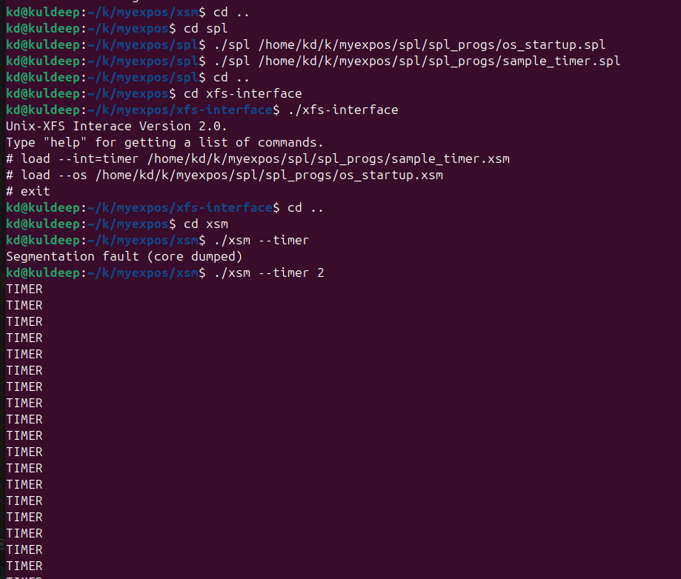

assignment(9):
sample_timer.spl:
[PROCESS_TABLE + ( [SYSTEM_STATUS_TABLE + 1] * 16) + 13] = SP;
// Setting SP to UArea Page number * 512 - 1
SP = [PROCESS_TABLE + ([SYSTEM_STATUS_TABLE + 1] * 16) + 11] * 512 - 1;
backup;
print [SYSTEM_STATUS_TABLE + 1];
restore;
SP = [PROCESS_TABLE + ( [SYSTEM_STATUS_TABLE + 1] * 16) + 13];
ireturn;

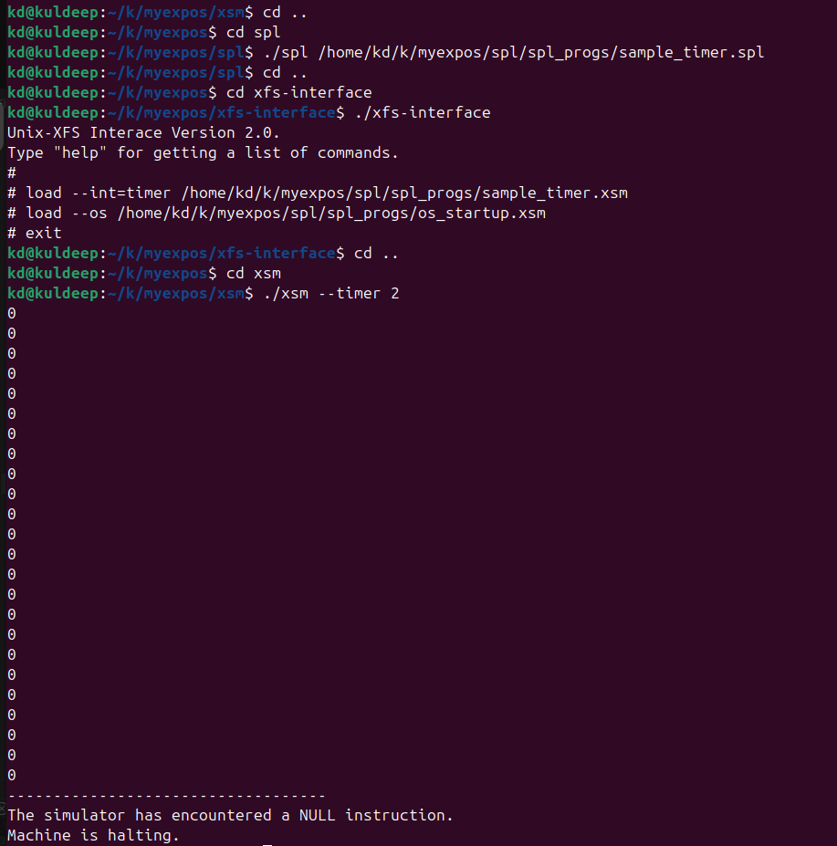

STAGE 10:
os_startup.spl:
loadi(65,7);
loadi(66,8);

loadi(16,29);
loadi(17,30);

loadi(22,35);
loadi(23,36);

loadi(2,15);
loadi(3,16);

PTBR = PAGE_TABLE_BASE;
PTLR = 10;

[PTBR+8] = 65; [PTBR+9] = "0100";
[PTBR+10] = 66; [PTBR+11] = "0100";

[PTBR+16] = 76; [PTBR+17] = "0110";
[PTBR+18] = 77; [PTBR+19] = "0110";

[76*512] = [65*512 + 1];
SP = 8 * 512;

ireturn;

square.xsm:
0
2056
0
0
0
0
0
0

MOV R0, 1

MOV R2, 5
GE R2, R0
JZ R2, 2110

MOV R1, R0
MUL R1, R0

PUSH R0
PUSH R1
PUSH R2

MOV R0, 5
MOV R2, -2
PUSH R0
PUSH R2
PUSH R1
PUSH R0
PUSH R0

INT 7

POP R1
POP R1
POP R1
POP R1
POP R1

POP R2
POP R1
POP R0

ADD R0, 1
JMP 2058

INT 10

sample_int7.spl:
alias userSP R0;
userSP = SP;

[PROCESS_TABLE + [SYSTEM_STATUS_TABLE + 1] * 16 + 13] = SP;
SP = [PROCESS_TABLE + [SYSTEM_STATUS_TABLE + 1] * 16 + 11] * 512 - 1;

alias word R1;
word = [[PTBR + 2 * ((userSP - 3) / 512)] * 512 + ((userSP - 3) % 512)];

print word;

alias retAddr R2;
retAddr = ([PTBR + 2 * ((userSP - 1) / 512)] * 512) + ((userSP - 1) % 512);
[retAddr] = 0;

SP = userSP;

ireturn;

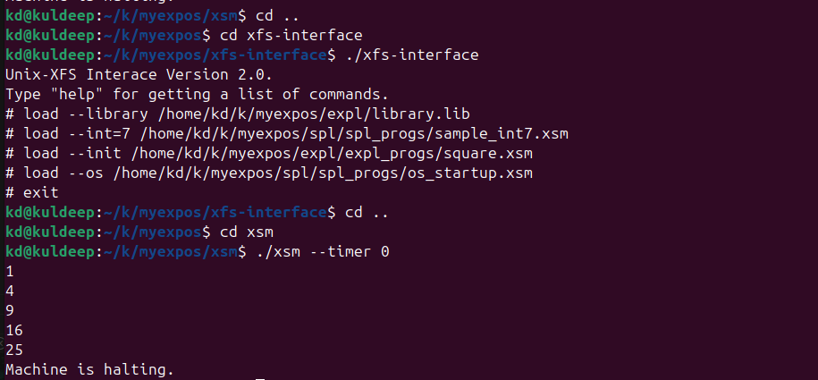

assignment:
ass_s10.xsm:
MOV R0, 1
MOV R2, 20
GE R2, R0
JZ R2, 2110
MOV R1, R0
PUSH R0
PUSH R1
PUSH R2
MOV R0, 5
MOV R2, -2
PUSH R0
PUSH R2
PUSH R1
PUSH R0
PUSH R0
INT 7
POP R1
POP R1
POP R1
POP R1
POP R1
POP R2
POP R1
POP R0
ADD R0, 1
JMP 2058
INT 10

