C Programming Practical - Complete Solution by
Devarsh Barevadiya

Lab – 3 : Introduction
- Write an algorithm and Draw Flowchart for following:
- Calculate addition of two numbers. (A)
Algorithm:
Step 1: Start
Step 2: Declare variables a, b, sum
Step 3: Initialize sum ← 0
Step 4: Calculate sum ← a + b
Step 5: Display the value of sum
Step 6: Stop

- Calculate average of three numbers. (A)
Algorithm:
Step 1: Start
Step 2: Declare variables num1, num2, num3, average
Step 3: Initialize average ← 0
Step 4: Calculate average ← (num1+num2+num3) / 3
Step 5: Display the value of average
Step 6: Stop

- Find area of circle. (pie*r*r). (A)
Algorithm:
Step 1: Start
Step 2: Declare variable radius and area
Step 3: Initialize area ← 0, pi ← 3.14
Step 4: Calculate area ← pi * radius * radius
Step 5: Display the value of area
Step 6: Stop

- Find area of triangle. ((height*base)/2). (A)
Algorithm:
Step 1: Start
Step 2: Declare variables base, height, area
Step 3: Initialize area ← 0
Step 4: Calculate area ← (base * height) / 2
Step 5: Display the value of area
Step 6: Stop

- Calculate simple interest. (principal*roi*time period)/100. (A)
Algorithm:
Step 1: Start
Step 2: Declare variables principal, rate, time, and SI
Step 3: Initialize SI ← 0
Step 4: SI ← (principal * rate * time) / 100
Step 5: Display the value of SI
Step 6: Stop

- Convert temperature from Fahrenheit to Celsius. (Formula: c=(((f-32)*5))/9). (A)
Algorithm:
Step 1: Start
Step 2: Declare variables fr, cs
Step 3: Set cs ← 0
Step 4: Calculate cs ← (fr - 32) * 5 / 9
Step 5: Display the value of cs
Step 6: Stop

_____________________________________________
Lab – 4 : Introduction
- Write an algorithm and Draw Flowchart for following:
- Convert given feet into inches. (feet*12). (A)
Algorithm:
Step 1: Start
Step 2: Input the length in feet
Step 3: Initialize inches ← 0
Step 4: Calculate inches: inches ← feet * 12
Step 5: Print the value of inches
Step 6: Stop

- Swap two numbers. (Using temporary variable and without using temporary variable). (A)
- Using temporary variable
Algorithm:
Step 1: Start
Step 2: Input two numbers: a and b
Step 3: Create a temporary variable temp
Step 4: Assign temp ← a
Step 5: Assign a ← b
Step 6: Assign b ← temp
Step 7: Print the swapped values of a and b
Step 8: Stop
- Without Using temporary variable
Algorithm:
Step 1: Start
Step 2: Input two numbers: a and b
Step 3: Assign a ← a + b
Step 4: Assign b ← a - b
Step 5: Assign a ← a - b
Step 6: Print the swapped values of a and b
Step 7: Stop

- Check whether given number is positive or negative. (A)
Algorithm:
Step 1: Start
Step 2: Input number n
Step 3: If n > 0, goto step 5
Step 4: Print n is negative, goto step 6
Step 5: Print n is positive
Step 6: Stop

- Check whether the given number is odd or even. (A)
Algorithm:
Step 1: Start
Step 2: Input number n
Step 3: If n % 2 = 0, goto step 5
Step 4: Print n is odd, goto step 6
Step 5: Print n is even
Step 6: Stop

- Find out largest number from given two numbers. (A)
Algorithm:
Step 1: Start
Step 2: Input two numbers: a and b
Step 3: If a > b, goto Step 5
Step 4: Print b is greater, goto Step 6
Step 5: Print a is greater
Step 6: Stop

- Find out largest number from given three numbers. (B)
Algorithm:
Step 1: Start
Step 2: Input three numbers a, b, and c
Step 3: If a > b, goto Step 6
Step 4: If b > c, goto Step 7
Step 5: Print c is maximum, goto Step 9
Step 6: If a > c, goto Step 8
Step 7: Print b is maximum, goto step 9
Step 8: Print a is maximum
Step 9: Stop

_____________________________________________
Lab – 5 : Introduction
- Write an algorithm and Draw Flowchart for following:
1. Display day name for the given number. (A)
Algorithm:
Step 1: Start
Step 2: Input a number → num
Step 3: If num = 1, Print Sunday, goto Step 10
Step 4: If num = 2, Print Monday, goto Step 10
Step 5: If num = 3, Print Tuesday, goto Step 10
Step 6: If num = 4, Print Wednesday, goto Step 10
Step 7: If num = 5, Print Thursday, goto Step 10
Step 8: If num = 6, Print Friday, goto Step 10
Step 9: If num = 7, Print Saturday, goto Step 10
Step 10: Print "Invalid Number"
Step 11: Stop

2. Accept three numbers from user and print them in ascending and descending order. (A)
Algorithm:
Step 1: Start
Step 2: Input three numbers: a, b, c
Step 3: If a <= b and b <= c
Print Ascending: a < b < c
Print Descending: c > b > a

Step 4: Else If a <= c and c <= b
Print Ascending: a < c < b
Print Descending: b > c > a

Step 5: Else If b <= a and a <= c
Print Ascending: b < a < c
Print Descending: c > a > b

Step 6: Else If b <= c and c <= a
Print Ascending: b < c < a
Print Descending: a > c > b

Step 7: Else If c <= a and a <= b
Print Ascending: c < a < b
Print Descending: b > a > c

Step 8: Else
Print Ascending: c < b < a
Print Descending: a > b > c

Step 9: Stop

3. Check whether the given year is leap year or not. [If a year can be divisible by 4 but not divisible by 100 then it is leap year but if it is divisible by 400 then it is leap year]. (A)
Algorithm:
Step 1: Start
Step 2: Input the year
Step 3: If year mod 400 = 0, goto Step 7
Step 4: If year mod 100 = 0, goto Step 8
Step 5: If year mod 4 = 0, goto Step 7
Step 6: goto Step 8
Step 7: Print "Year is a leap year"
goto Step 9

Step 8: Print "Year is not a leap year"
Step 9: Stop

4. Input electricity unit charge and calculate the total electricity bill according to the given condition:
• For first 50 units Rs. 0.50/unit
• For next 100 units Rs. 0.75/unit
• For next 100 units Rs. 1.20/unit
• For unit above 250 Rs. 1.50/unit
An additional surcharge of 20% is added to the bill. (B)
Algorithm:
Step 1: Start
Step 2: Input electricity units used
Step 3: Initialize
bill ← 0
surcharge ← 0
total_bill ← 0

Step 4: If units <= 50, goto Step 5
Step 5: bill ← units × 0.50
goto Step 12

Step 6: If units <= 150, goto Step 7
Step 7: bill ← 50 × 0.50 + (units - 50) × 0.75
goto Step 12

Step 8: If units <= 250, goto Step 9
Step 9: bill ← 50 × 0.50 + 100 × 0.75 +
(units - 150) × 1.20
goto Step 12

Step 10: bill ← 50 × 0.50 + 100 × 0.75 +
100 × 1.20 +
(units - 250) × 1.50

Step 11: surcharge ← 0.20 × bill
Step 12: Print total_bill
Step 13: Stop

_____________________________________________
Lab – 6 : Introduction
- Write an algorithm and Draw Flowchart for following:
1. Find factorial of given number. (A)
Algorithm:
Step 1: Start
Step 2: Input number n
Step 3: Initialize fact ← 1, i ← 1
Step 4: Repeat while i <= n
Step 5: fact = fact * i
Step 6: Increment i by 1, goto Step 4
Step 7: Print fact
Step 8: Stop

2. Print all factors of given number. (A)
Algorithm:
Step 1: Start
Step 2: Input number n
Step 3: Set i ← 1
Step 4: Repeat while i <= n
Step 5: If n % i = 0, goto Step 7
Step 6: Print i
Step 7: Increment i by 1, goto Step 4
Step 8: Stop

3. Print fibonacci series upto given numbers. (A)
Algorithm:
Step 1: Start
Step 2: Input number n
Step 3: Initialize a ← 0, b ← 1, i ← 0, c ← 0
Step 4: Print a and b
Step 5: Repeat while i < n - 1
Step 6: c ← a + b
Step 7: Print c
Step 8: a ← b, b ← c
Step 9: Increment i by 1, goto Step 5
Step 10: Stop

4. Print sum of digit of given number. (A)
Algorithm:
Step 1: Start
Step 2: Input number n
Step 3: Initialize sum ← 0, digit ← 0
Step 4: Repeat while n != 0
Step 5: digit ← n % 10
Step 6: sum ← sum + digit
Step 7: n ← n / 10, goto Step 4
Step 8: Print sum
Step 9: Stop

5. Check whether given number is prime or not. (B)
Algorithm:
Step 1: Start
Step 2: Input number n
Step 3: If n <= 1, goto Step 5
Step 4: Print Not a prime number and go to Step 9
Step 5: Set i ← 2
Step 6: Repeat while i <= √n,
Step 7: If n mod i = 0, goto Step 7
Step 8: Print Not a prime number, go to Step 9
Step 9: Increment i by 1, goto Step 6
Step 10: Print Prime number
Step 11: Stop

6. Check whether given number is palindrome or not. (C)
Algorithm:
Step 1: Start
Step 2: Input number n
Step 3: Set original ← n, rev ← 0, digit ← 0
Step 4: Repeat while n != 0
Step 5: digit ← n % 10
Step 6: rev ← rev * 10 + digit
Step 7: n ← n / 10, goto Step 4
Step 8: If rev = original, goto Step 10
Step 9: Print Palindrome number
Step 10: Print "Not a palindrome number"
Step 11: Stop

Flowcharts:
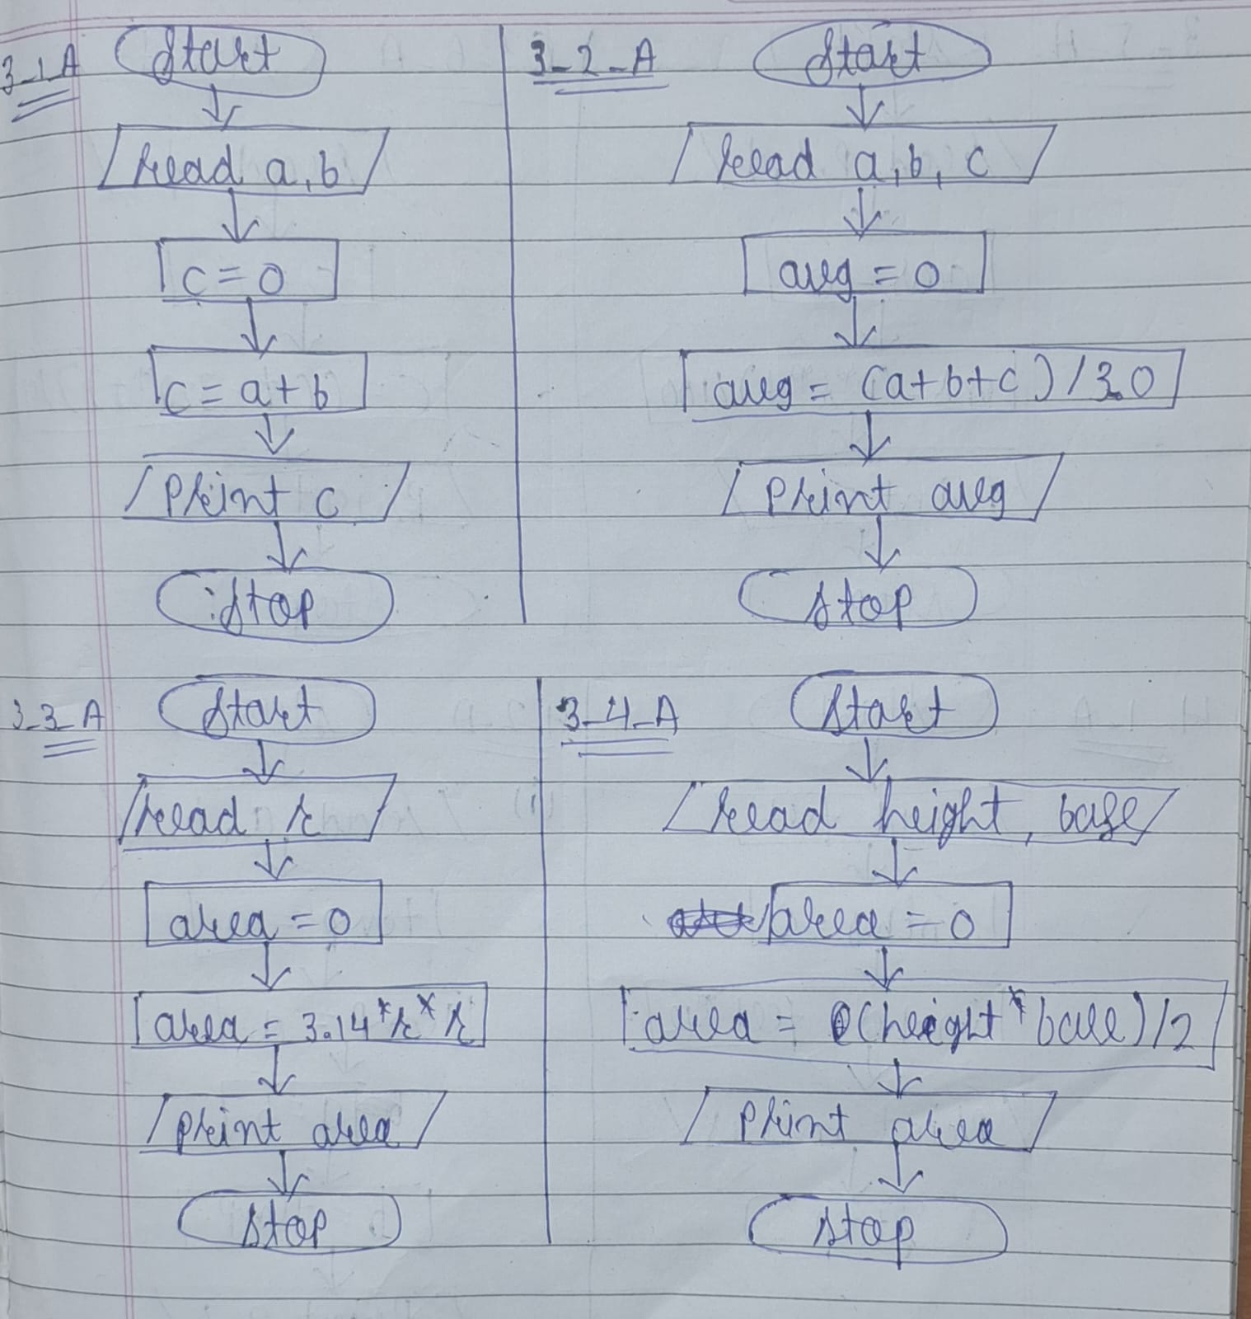

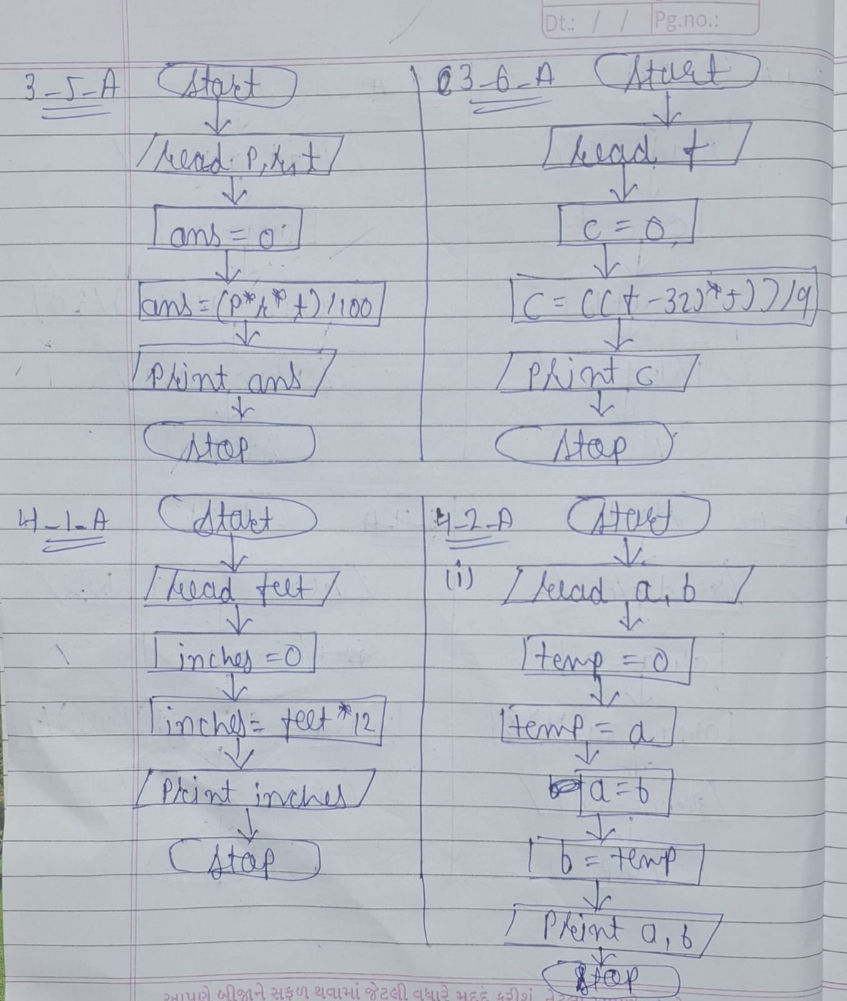

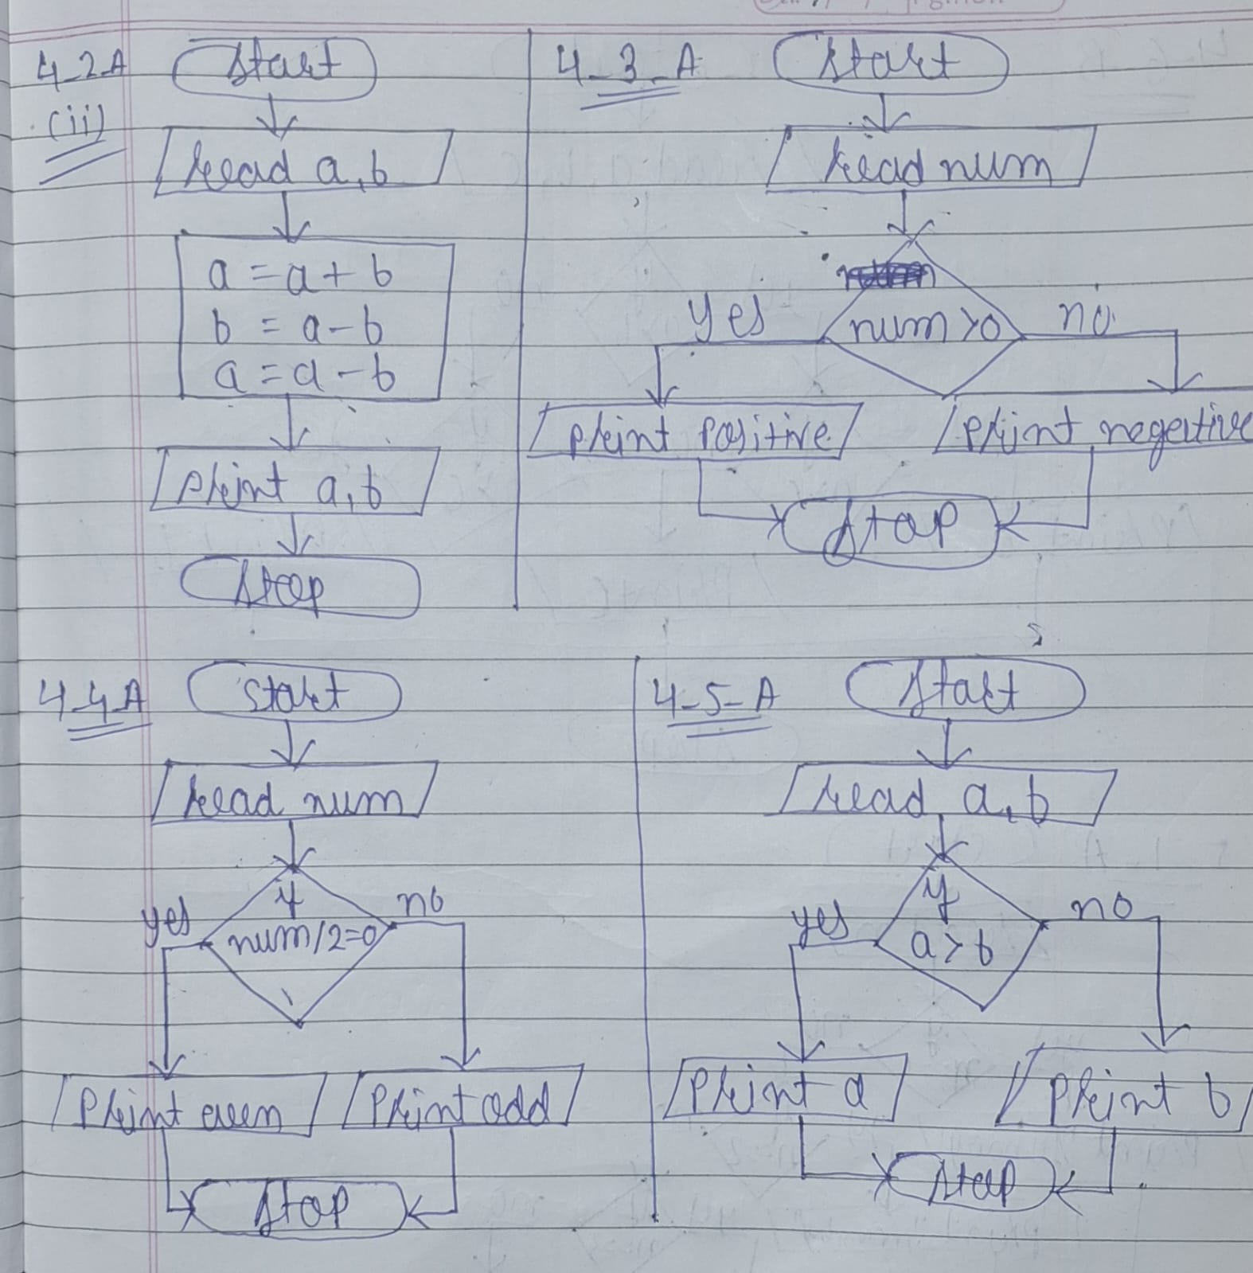

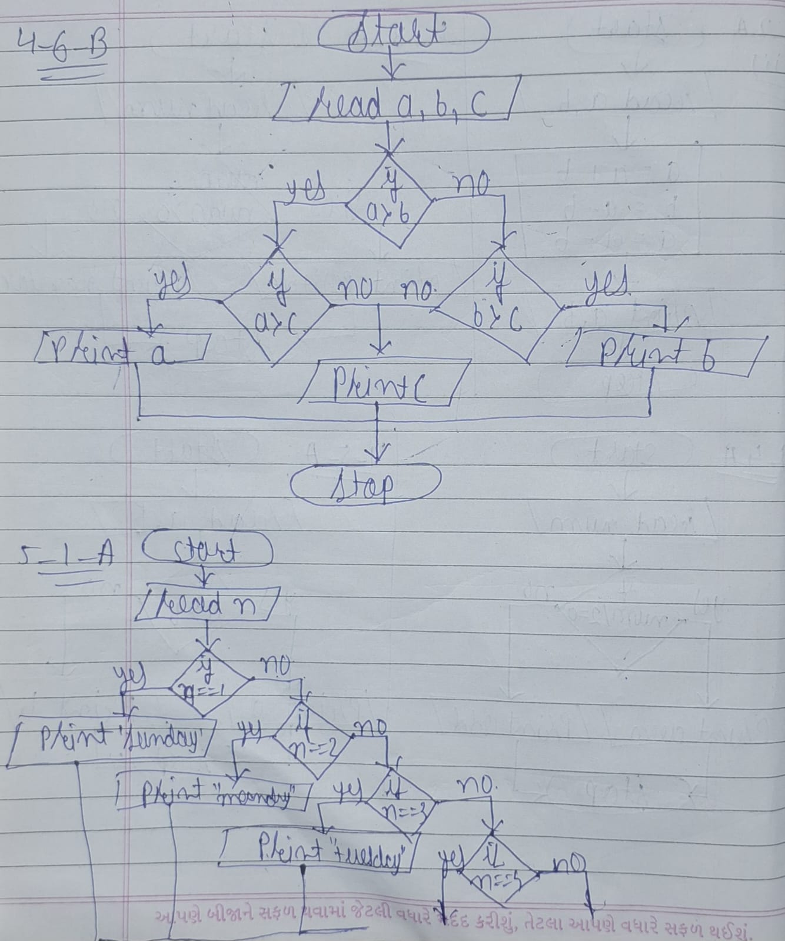

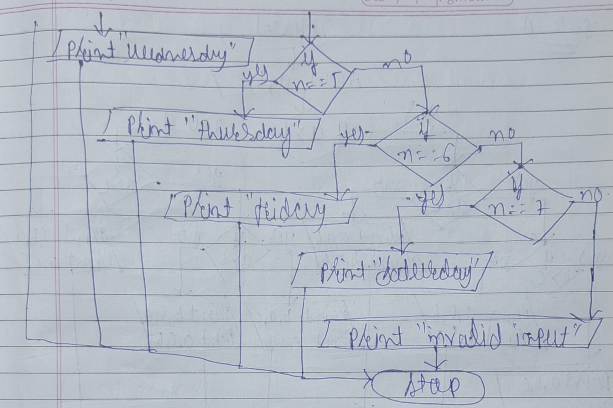

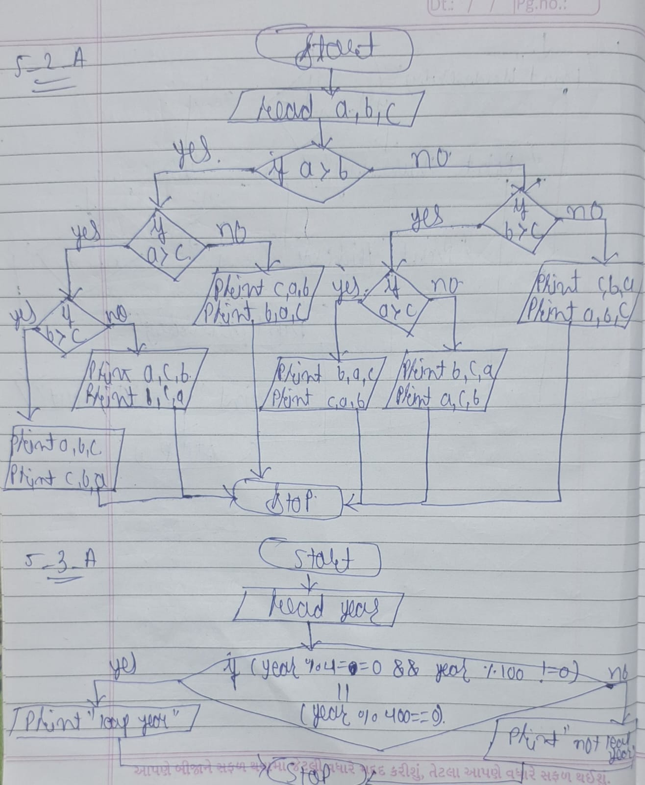

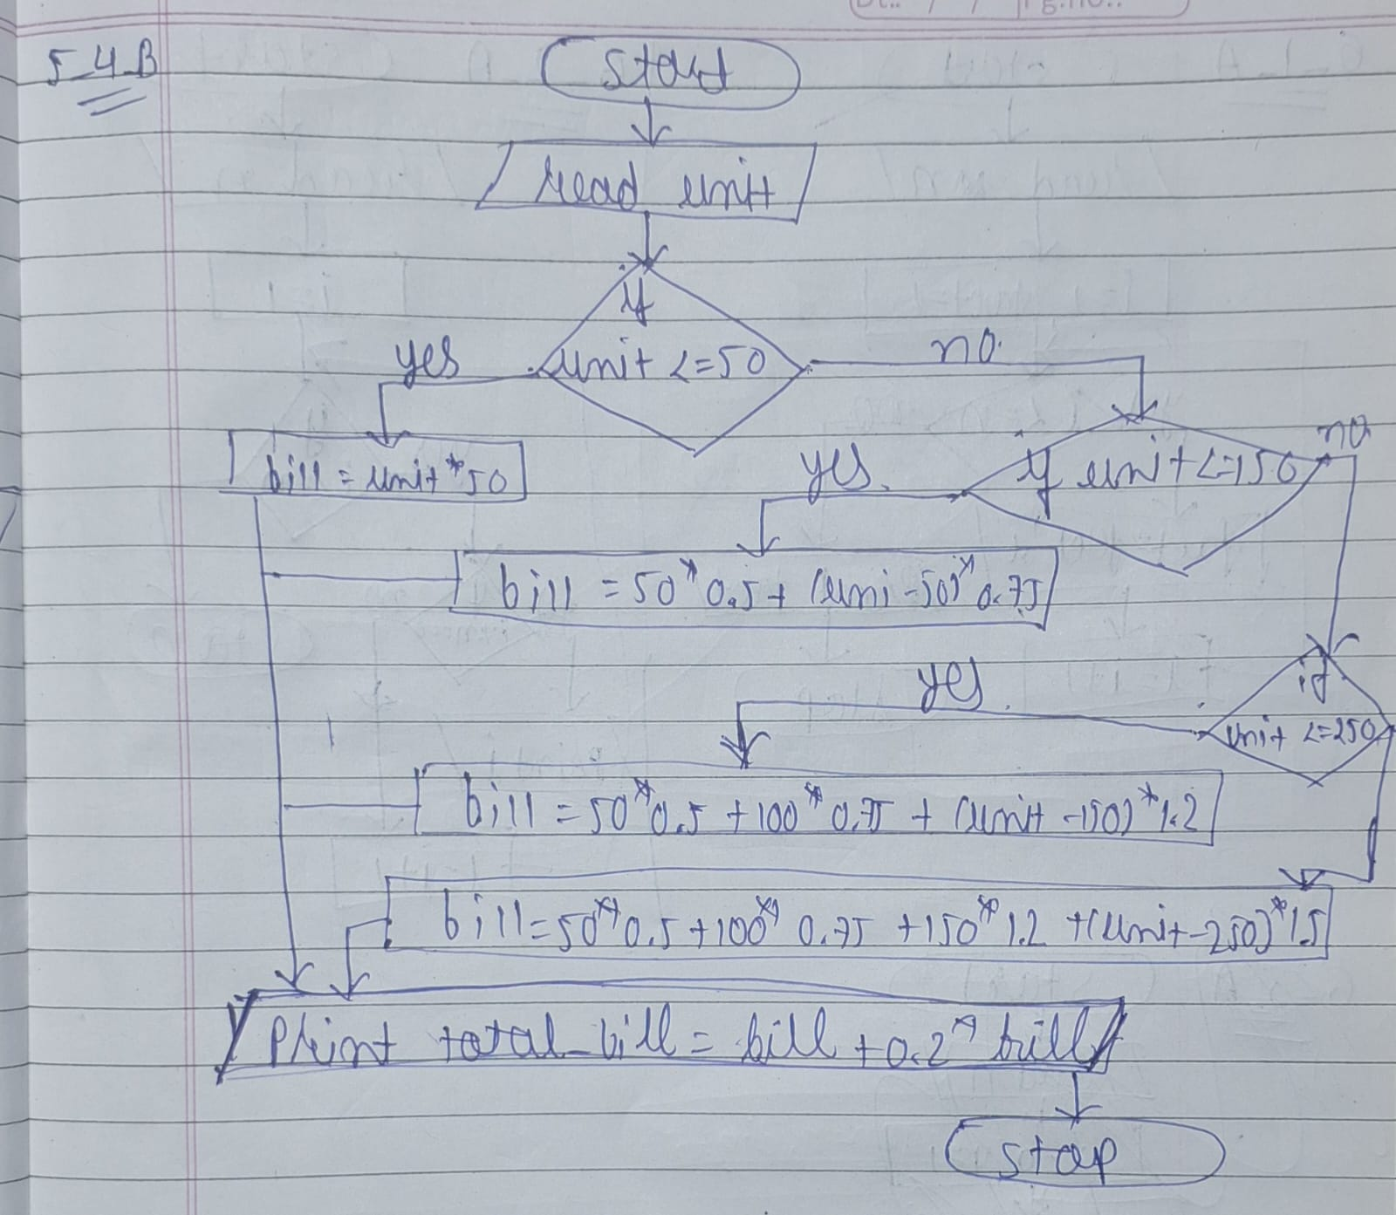

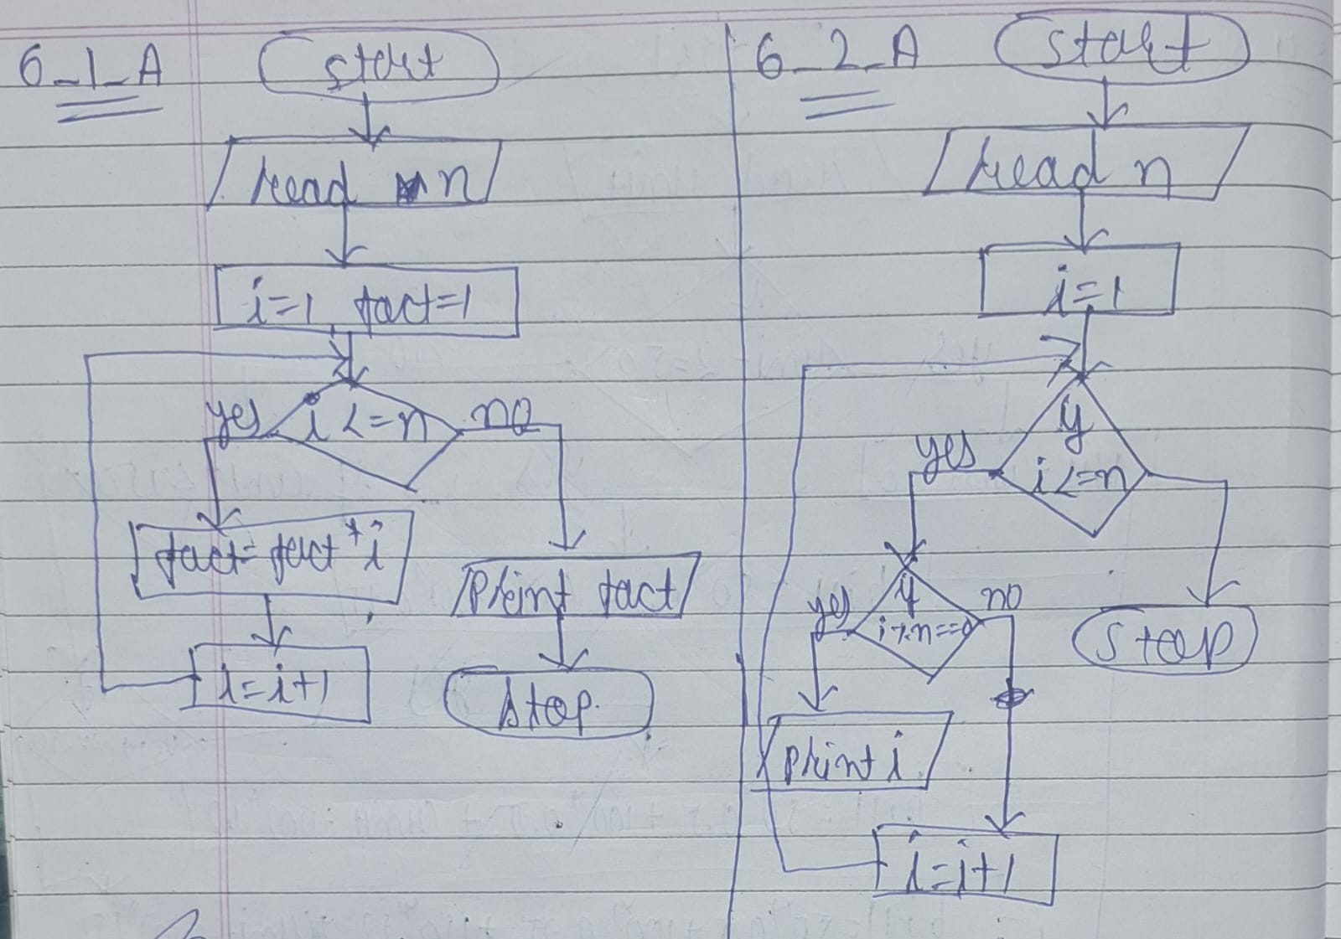

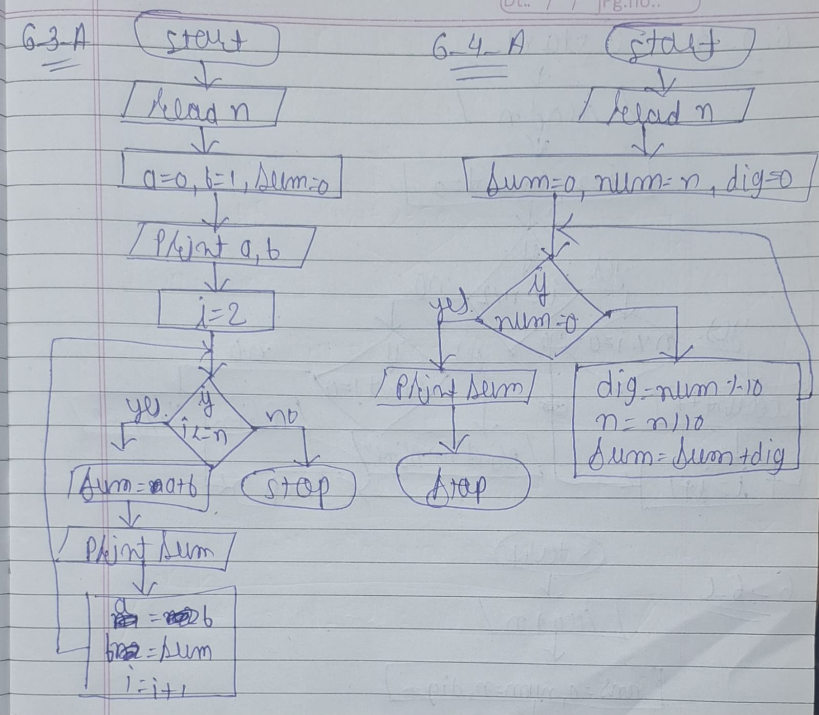

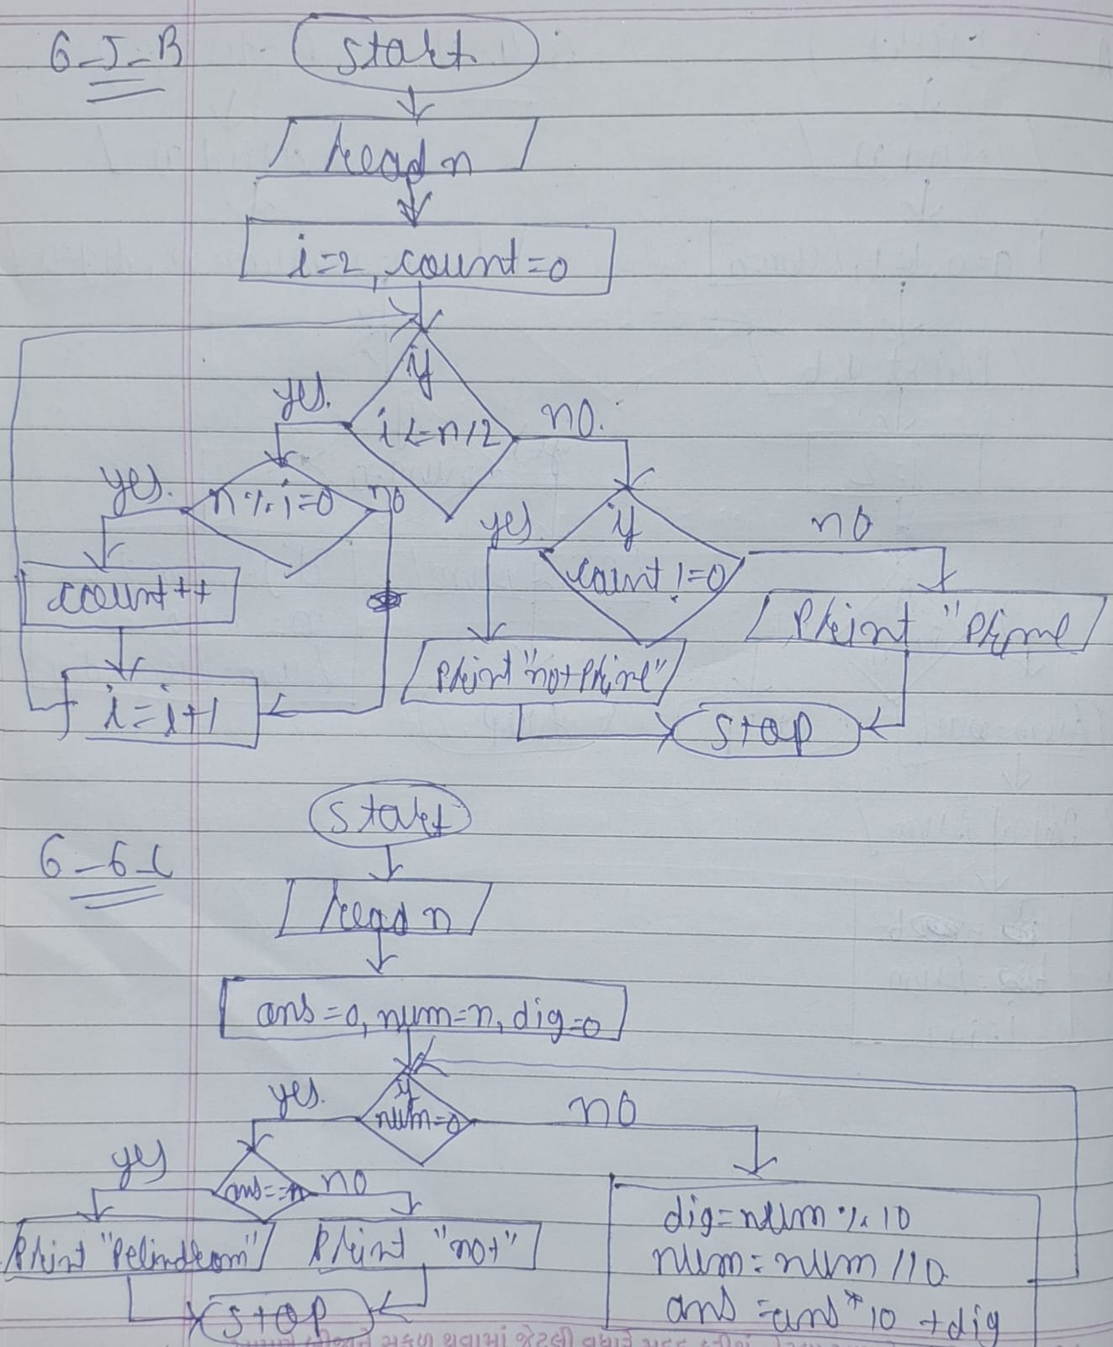

_____________________________________________

Lab – 7 : Introduction & C Operators & Decision-Making Statements
- Write following programs in C. (Basic)

- Print Hello World. (A)
#include<stdio.h>
int main() {
printf("Hello World :)");
return 0;
}

Output:
D:\B.TECH\TEST\C>cd ""d:\B.TECH\TEST\C\"" && gcc "ta.c" -o "ta.exe" && ""d:\B.TECH\TEST\C\"\ta.exe"

Hello World :)

- Print your address (A)
- using single printf
#include<stdio.h>
int main() {
printf("Darshan \nUniversity ");
return 0;
}

Output:
D:\B.TECH\TEST\C>cd ""d:\B.TECH\TEST\C\"" && gcc "ta.c" -o "ta.exe" && ""d:\B.TECH\TEST\C\"\ta.exe"

Darshan
University

- using multiple printf
#include<stdio.h>
int main() {
printf("Darshan \n");
Printf(“University”);
return 0;
}
Output:
D:\B.TECH\TEST\C>cd ""d:\B.TECH\TEST\C\"" && gcc "ta.c" -o "ta.exe" && ""d:\B.TECH\TEST\C\"\ta.exe"
Darshan
University

- Print addition of 2 numbers. (A)
- Without scanf
#include<stdio.h>
int main() {
int a = 10, b = 20, sum;
sum = a + b;
printf("Addition = %d", sum);
return 0;
}
Output:
D:\B.TECH\TEST\C>cd ""d:\B.TECH\TEST\C\"" && gcc "ta.c" -o "ta.exe" && ""d:\B.TECH\TEST\C\"\ta.exe"

Addition = 30

- With scanf
#include<stdio.h>
int main() {
int a, b, sum;
printf("Enter first number: ");
scanf("%d", &a);
printf("Enter second number: ");
scanf("%d", &b);
sum = a + b;
printf("Addition = %d", sum);
return 0;
}
Output:
D:\B.TECH\TEST\C>cd ""d:\B.TECH\TEST\C\"" && gcc "ta.c" -o "ta.exe" && ""d:\B.TECH\TEST\C\"\ta.exe"
Enter first number: 1
Enter second number: 2
Addition = 3
- Print average of three numbers. (A)
- Without Scanf
#include<stdio.h>
int main() {
int a = 10, b = 20, c = 30;
float avg;
avg = (a + b + c) / 3.0;
printf("Average = %.2f", avg);
return 0;
}

Output:
D:\B.TECH\TEST\C>cd ""d:\B.TECH\TEST\C\"" && gcc "ta.c" -o "ta.exe" && ""d:\B.TECH\TEST\C\"\ta.exe"
Average = 20.00

- With Scanf
#include<stdio.h>
int main() {
int a, b, c;
float avg;
printf("Enter three numbers: ");
scanf("%d %d %d", &a, &b, &c);
avg = (a + b + c) / 3.0;
printf("Average = %.2f", avg);
return 0;
}

Output:
D:\B.TECH\TEST\C>cd ""d:\B.TECH\TEST\C\"" && gcc "ta.c" -o "ta.exe" && ""d:\B.TECH\TEST\C\"\ta.exe"
Enter three numbers: 1
10
100
Average = 37.00

- Print area of circle. (pie*r*r). (A)
#include<stdio.h>
int main() {
float r, area;
float pie = 3.14;
printf("Enter radius: ");
scanf("%f", &r);
area = pie * r * r;
printf("Area of Circle = %.2f", area);
return 0;
}

Output:
D:\B.TECH\TEST\C>cd ""d:\B.TECH\TEST\C\"" && gcc "ta.c" -o "ta.exe" && ""d:\B.TECH\TEST\C\"\ta.exe"

Enter radius: 10
Area of Circle = 314.00
_____________________________________________
Lab – 8 : C Operators & Decision-Making Statements

- Write following programs in C. (Type casting and Constant)
- Calculate average of 2 integers and show result in float. (A)
#include<stdio.h>
int main() {
int a, b;
float avg;
printf("Enter two integers: ");
scanf("%d %d", &a, &b);
avg = (a + b) / 2.0;
printf("Average = %.2f", avg);
return 0;
}

Output:
D:\B.TECH\TEST\C>cd ""d:\B.TECH\TEST\C\"" && gcc "ta.c" -o "ta.exe" && ""d:\B.TECH\TEST\C\"\ta.exe"

Enter two integers: 2
7
Average = 4.50

- Demonstrate const keyword. (A)
#include<stdio.h>
int main() {
const float PI = 3.14;
float radius, area;
printf("Enter radius: ");
scanf("%f", &radius);
area = PI * radius * radius;
printf("Area of Circle = %.2f", area);
return 0;
}
Output:
D:\B.TECH\TEST\C>cd ""d:\B.TECH\TEST\C\"" && gcc "ta.c" -o "ta.exe" && ""d:\B.TECH\TEST\C\"\ta.exe"

Enter radius: 100
Area of Circle = 31400.00

- ASCII value of character using type casting. (A)
#include <stdio.h>

int main() {
char ch;

printf("Enter a character: ");
scanf("%c", &ch);

printf("ASCII value of %c = %d", ch, (int)ch);

return 0;
}

Output:
D:\B.TECH\TEST\C>cd ""d:\B.TECH\TEST\C\"" && gcc "ta.c" -o "ta.exe" && ""d:\B.TECH\TEST\C\"\ta.exe"

Enter a character: X
ASCII value of X = 88

- Demonstrate while converting float data into integer data and observe data lose during conversion. (A)
#include<stdio.h>
int main() {
float num;
int x;
printf("Enter a float number: ");
scanf("%f", &num);
x = (int)num;
printf("Float value = %.2f\n", num);
printf("Integer value after conversion = %d", x);
return 0;
}

Output:
D:\B.TECH\TEST\C>cd ""d:\B.TECH\TEST\C\"" && gcc "ta.c" -o "ta.exe" && ""d:\B.TECH\TEST\C\"\ta.exe"

Enter a float number: 3.14
Float value = 3.14
Integer value after conversion = 3

- Convert a character into lowercase and uppercase using ASCII code. (A)
#include<stdio.h>
int main() {
char ch;
printf("Enter a character: ");
scanf("%c", &ch);
printf("Uppercase = %c\n", ch - 32);
printf("Lowercase = %c", ch + 32);
return 0;
}

Output:
D:\B.TECH\TEST\C>cd ""d:\B.TECH\TEST\C\"" && gcc "ta.c" -o "ta.exe" && ""d:\B.TECH\TEST\C\"\ta.exe"

Enter a character: x
Uppercase = X
Lowercase = ÿ

- Take value from user of a product price and tax in % and print the amount of tax in float. (B)
#include<stdio.h>
int main() {
float price, tax, taxAmount;
printf("Enter product price: ");
scanf("%f", &price);
printf("Enter tax percentage: ");
scanf("%f", &tax);
taxAmount = (price * tax) / 100;
printf("Tax Amount = %.2f", taxAmount);
return 0;
}

Output:
D:\B.TECH\TEST\C>cd ""d:\B.TECH\TEST\C\"" && gcc "ta.c" -o "ta.exe" && ""d:\B.TECH\TEST\C\"\ta.exe"
Enter product price: 400
Enter tax percentage: 3
Tax Amount = 12.00

_____________________________________________
Lab – 9 : C Operators & Decision-Making Statements
- Write following programs in C. (Basic)

- Calculate average of 2 integers and show result in float. (A)
#include<stdio.h>
int main() {
float base, height, area;
printf("Enter base and height: ");
scanf("%f %f", &base, &height);
area = (base * height) / 2;
printf("Area of Triangle = %.2f", area);
return 0;
}
Output:
D:\B.TECH\TEST\C>cd ""d:\B.TECH\TEST\C\"" && gcc "ta.c" -o "ta.exe" && ""d:\B.TECH\TEST\C\"\ta.exe"

Enter base and height: 20
10
Area of Triangle = 100.00

- Print simple interest. (principal*roi*time period)/100. (A)
#include<stdio.h>
int main() {
float p, r, t, si;
printf("Enter principal, rate and time: ");
scanf("%f %f %f", &p, &r, &t);
si = (p * r * t) / 100;
printf("Simple Interest = %.2f", si);
return 0;
}

Output:
D:\B.TECH\TEST\C>cd ""d:\B.TECH\TEST\C\"" && gcc "ta.c" -o "ta.exe" && ""d:\B.TECH\TEST\C\"\ta.exe"

Enter principal, rate and time: 10
12
10
Simple Interest = 12.00

- Print temperature from Fahrenheit to Celsius. (Formula: c=(((f-32)*5))/9). (A)
#include<stdio.h>
int main() {
float f, c;
printf("Enter temperature in Fahrenheit: ");
scanf("%f", &f);
c = ((f - 32) * 5) / 9;
printf("Temperature in Celsius = %.2f", c);
return 0;
}
Output:
D:\B.TECH\TEST\C>cd ""d:\B.TECH\TEST\C\"" && gcc "ta.c" -o "ta.exe" && ""d:\B.TECH\TEST\C\"\ta.exe"

Enter temperature in Fahrenheit: 100
Temperature in Celsius = 37.78

- Convert seconds into hours, minutes & seconds and print in HH:MM:SS. [e.g. 10000 seconds = 02:46:40)]. (B)

#include<stdio.h>
int main() {
int sec, h, m, s;
printf("Enter seconds: ");
scanf("%d", &sec);
h = sec / 3600;
m = (sec % 3600) / 60;
s = sec % 60;
printf("%02d:%02d:%02d", h, m, s);
return 0;
}
Output:
D:\B.TECH\TEST\C>cd ""d:\B.TECH\TEST\C\"" && gcc "ta.c" -o "ta.exe" && ""d:\B.TECH\TEST\C\"\ta.exe"

Enter seconds: 150
00:02:30

- Convert number of days into year, week & days. [e.g. 375 days mean 1 year, 1 week and 3 days]. (B)
#include<stdio.h>
int main() {
int days, years, months, remdays;
printf("Enter number of days: ");
scanf("%d", &days);
years = days / 365;
months = (days % 365) / 30;
remdays = (days % 365) % 30;
printf("Years = %d\n", years);
printf("Months = %d\n", months);
printf("Days = %d", remdays);
return 0;
}

Output:
D:\B.TECH\TEST\C>cd ""d:\B.TECH\TEST\C\"" && gcc "ta.c" -o "ta.exe" && ""d:\B.TECH\TEST\C\"\ta.exe"

Enter number of days: 405
Years = 1
Months = 1
Days = 10

__________________________________________________
Lab – 10 : C Operators & Decision-Making Statements
- Write following programs in C. (Basic)
- Calculate perimeter of a Rectangle. (A)
#include<stdio.h>
int main() {
float length, width, perimeter;
printf("Enter length and width: ");
scanf("%f %f", &length, &width);
perimeter = 2 * (length + width);
printf("Perimeter of Rectangle = %.2f", perimeter);
return 0;
}
Output:
D:\B.TECH\TEST\C>cd ""d:\B.TECH\TEST\C\"" && gcc "ta.c" -o "ta.exe" && ""d:\B.TECH\TEST\C\"\ta.exe"

Enter length and width: 40
60
Perimeter of Rectangle = 200.00

- Calculate BMI by taking values of weight and height from user. (Formula: BMI = weight / (height*height)). (A)
#include<stdio.h>
int main() {
float weight, height, bmi;
printf("Enter weight (in kg): ");
scanf("%f", &weight);
printf("Enter height (in meters): ");
scanf("%f", &height);
bmi = weight / (height * height);
printf("BMI = %.2f\n", bmi);
return 0;
}
Output:
D:\B.TECH\TEST\C>cd ""d:\B.TECH\TEST\C\"" && gcc "ta.c" -o "ta.exe" && ""d:\B.TECH\TEST\C\"\ta.exe"

Enter weight (in kg): 60
Enter height (in meters): 1.80
BMI = 18.52

- Calculate electricity bill based on the no. of units consumed and rate. (A)
#include<stdio.h>
int main() {
float units, rate, bill;
printf("Enter units consumed: ");
scanf("%f", &units);
printf("Enter rate per unit: ");
scanf("%f", &rate);
bill = units * rate;
printf("Electricity Bill = %.2f", bill);
return 0;
}
Output:
D:\B.TECH\TEST\C>cd ""d:\B.TECH\TEST\C\"" && gcc "ta.c" -o "ta.exe" && ""d:\B.TECH\TEST\C\"\ta.exe"

Enter units consumed: 40
Enter rate per unit: 7
Electricity Bill = 280.00

- Calculate total salary after adding a bonus percentage (%). (A)
#include<stdio.h>
int main() {
float salary, bonusPercent, totalSalary;
printf("Enter salary: ");
scanf("%f", &salary);
printf("Enter bonus percentage: ");
scanf("%f", &bonusPercent);
totalSalary = salary + (salary * bonusPercent / 100);
printf("Total Salary = %.2f", totalSalary);
return 0;
}
Output:
D:\B.TECH\TEST\C>cd ""d:\B.TECH\TEST\C\"" && gcc "ta.c" -o "ta.exe" && ""d:\B.TECH\TEST\C\"\ta.exe"

Enter salary: 50000
Enter bonus percentage: 20
Total Salary = 60000.00

- Calculate total cost of fuel based on distance, milage and fuel price. (Formula: ((distance/milage)*price_per_liter). (A)
#include<stdio.h>
int main() {
float distance, mileage, pricePerLiter, totalCost;
printf("Enter distance: ");
scanf("%f", &distance);
printf("Enter mileage: ");
scanf("%f", &mileage);
printf("Enter fuel price per liter: ");
scanf("%f", &pricePerLiter);
totalCost = (distance / mileage) * pricePerLiter;
printf("Total Fuel Cost = %.2f", totalCost);
return 0;
}
Output:
D:\B.TECH\TEST\C>cd ""d:\B.TECH\TEST\C\"" && gcc "ta.c" -o "ta.exe" && ""d:\B.TECH\TEST\C\"\ta.exe"

Enter distance: 1100
Enter mileage: 30
Enter fuel price per liter: 90
Total Fuel Cost = 3300.00

- Calculate profit % by taking selling price and cost price from user. (B)
#include<stdio.h>
int main() {
float sp, cp, profit, profitPercent;
printf("Enter selling price and cost price: ");
scanf("%f %f", &sp, &cp);
profit = sp - cp;
profitPercent = (profit / cp) * 100;
printf("Profit Percentage = %.2f%%", profitPercent);
return 0;
}
Output:
D:\B.TECH\TEST\C>cd ""d:\B.TECH\TEST\C\"" && gcc "ta.c" -o "ta.exe" && ""d:\B.TECH\TEST\C\"\ta.exe"

Enter selling price and cost price: 1500
1200
Profit Percentage = 25.00%

- Calculate final cost of product after taking total cost and discount in % from user. (B)
#include<stdio.h>
int main() {
float totalCost, discount, finalCost;
printf("Enter total cost: ");
scanf("%f", &totalCost);
printf("Enter discount percentage: ");
scanf("%f", &discount);
finalCost = totalCost - (totalCost * discount / 100);
printf("Final Cost = %.2f", finalCost);
return 0;
}
Output:
D:\B.TECH\TEST\C>cd ""d:\B.TECH\TEST\C\"" && gcc "ta.c" -o "ta.exe" && ""d:\B.TECH\TEST\C\"\ta.exe"

Enter total cost: 1200
Enter discount percentage: 30
Final Cost = 840.00

Lab – 11 : C Operators & Decision-Making Statements
- Write following programs in C. (Decision Making: if, else)

- Swap two numbers. (Using temporary variable and without using temporary variable). (A)
- Using temporary variable
#include<stdio.h>
int main() {
int a, b, temp;
printf("Enter two numbers: ");
scanf("%d %d", &a, &b);
temp = a;
a = b;
b = temp;
printf("After Swapping:\n");
printf("a = %d\nb = %d", a, b);
return 0;
}
Output:
D:\B.TECH\TEST\C>cd ""d:\B.TECH\TEST\C\"" && gcc "ta.c" -o "ta.exe" && ""d:\B.TECH\TEST\C\"\ta.exe"

Enter two numbers: 10
20
After Swapping:
a = 20
b = 10

- Without using temporary variable
#include<stdio.h>
int main() {
int a, b;
printf("Enter two numbers: ");
scanf("%d %d", &a, &b);
a = a + b;
b = a - b;
a = a - b;
printf("After Swapping:\n");
printf("a = %d\nb = %d", a, b);
return 0;
}

Output:
D:\B.TECH\TEST\C>cd ""d:\B.TECH\TEST\C\"" && gcc "ta.c" -o "ta.exe" && ""d:\B.TECH\TEST\C\"\ta.exe"

Enter two numbers: 100
200
After Swapping:
a = 200
b = 100

- Check whether given number is positive or negative. (A)
#include<stdio.h>
int main() {
int num;
printf("Enter a number: ");
scanf("%d", &num);
if(num >= 0)
printf("Positive Number");
else
printf("Negative Number");
return 0;
}
Output:
D:\B.TECH\TEST\C>cd ""d:\B.TECH\TEST\C\"" && gcc "ta.c" -o "ta.exe" && ""d:\B.TECH\TEST\C\"\ta.exe"

Enter a number: -20
Negative Number
- Check whether the given number is odd or even. (A)
#include<stdio.h>
int main() {
int num;
printf("Enter a number: ");
scanf("%d", &num);
if(num % 2 == 0)
printf("Even Number");
else
printf("Odd Number");
return 0;
}

Output:
D:\B.TECH\TEST\C>cd ""d:\B.TECH\TEST\C\"" && gcc "ta.c" -o "ta.exe" && ""d:\B.TECH\TEST\C\"\ta.exe"

Enter a number: 20
Even Number

- Check whether the given number is odd or even. (A)
#include<stdio.h>
int main() {
int a, b, c;
printf("Enter three numbers: ");
scanf("%d %d %d", &a, &b, &c);
if(a > b && a > c)
printf("Largest Number = %d", a);
else if(b > c)
printf("Largest Number = %d", b);
else
printf("Largest Number = %d", c);
return 0;
}
Output:
D:\B.TECH\TEST\C>cd ""d:\B.TECH\TEST\C\"" && gcc "ta.c" -o "ta.exe" && ""d:\B.TECH\TEST\C\"\ta.exe"

Enter three numbers: 10
20
30
Largest Number = 30

- Check whether given character is vowel or consonant. (Using single if only). (B)
#include<stdio.h>
int main() {
char ch;
printf("Enter a character: ");
scanf("%c", &ch);
if(ch=='a'||ch=='e'||ch=='i'||ch=='o'||ch=='u'||
ch=='A'||ch=='E'||ch=='I'||ch=='O'||ch=='U')
printf("Vowel");
else
printf("Consonant");
return 0;
}
Output:
D:\B.TECH\TEST\C>cd ""d:\B.TECH\TEST\C\"" && gcc "ta.c" -o "ta.exe" && ""d:\B.TECH\TEST\C\"\ta.exe"

Enter a character: w
Consonant

Lab – 12 : C Operators & Decision-Making Statements
- Write following programs in C. (Decision Making: Nested and Ladder if)

- Perform Addition, Subtraction, Multiplication and Division of 2 numbers as per users choice. (A)
#include<stdio.h>
int main() {
int a, b, choice;
printf("Enter two numbers: ");
scanf("%d %d", &a, &b);
printf("1.Addition\n2.Subtraction\n3.Multiplication\n4.Division\n");
printf("Enter your choice: ");
scanf("%d", &choice);
if(choice == 1)
printf("Addition = %d", a + b);
else if(choice == 2)
printf("Subtraction = %d", a - b);
else if(choice == 3)
printf("Multiplication = %d", a * b);
else if(choice == 4)
printf("Division = %.2f", (float)a / b);
else
printf("Invalid Choice");
return 0;
}
Output:
D:\B.TECH\TEST\C>cd ""d:\B.TECH\TEST\C\"" && gcc "ta.c" -o "ta.exe" && ""d:\B.TECH\TEST\C\"\ta.exe"

Enter two numbers: 20
44
1.Addition
2.Subtraction
3.Multiplication
4.Division
Enter your choice: 1
Addition = 64

- Enter basic salary of an employee and calculate Gross salary according to given conditions: (A)
• Basic Salary >= 10000 : HRA = 20% of basic, DA = 80% of basic
• Basic Salary >= 20000 : HRA = 25% of basic, DA = 90% of basic
• Basic Salary >= 30000 : HRA = 30% of basic, DA = 95% of basic
#include<stdio.h>
int main() {
float basic, hra, da, gross;
printf("Enter Basic Salary: ");
scanf("%f", &basic);
if(basic >= 30000) {
hra = basic * 0.30;
da = basic * 0.95;
}
else if(basic >= 20000) {
hra = basic * 0.25;
da = basic * 0.90;
}
else if(basic >= 10000) {
hra = basic * 0.20;
da = basic * 0.80;
}
else {
hra = 0;
da = 0;
}
gross = basic + hra + da;
printf("Gross Salary = %.2f", gross);
return 0;
}

Output:
D:\B.TECH\TEST\C>cd ""d:\B.TECH\TEST\C\"" && gcc "ta.c" -o "ta.exe" && ""d:\B.TECH\TEST\C\"\ta.exe"

Enter Basic Salary: 50000
Gross Salary = 112500.00

- Check whether the entered character is upper case, lower case, digit or any special character. (A)
#include<stdio.h>
int main() {
char ch;
printf("Enter a character: ");
scanf("%c", &ch);
if(ch >= 'A' && ch <= 'Z')
printf("Uppercase Character");
else if(ch >= 'a' && ch <= 'z')
printf("Lowercase Character");
else if(ch >= '0' && ch <= '9')
printf("Digit");
else
printf("Special Character");
return 0;
}
Output:
D:\B.TECH\TEST\C>cd ""d:\B.TECH\TEST\C\"" && gcc "ta.c" -o "ta.exe" && ""d:\B.TECH\TEST\C\"\ta.exe"

Enter a character: $
Special Character

- Input an integer number and check the last digit of number is even or odd. (A)
#include<stdio.h>
int main() {
int num, lastDigit;
printf("Enter a number: ");
scanf("%d", &num);
lastDigit = num % 10;
if(lastDigit % 2 == 0)
printf("Last Digit is Even");
else
printf("Last Digit is Odd");
return 0;
}

Output:
D:\B.TECH\TEST\C>cd ""d:\B.TECH\TEST\C\"" && gcc "ta.c" -o "ta.exe" && ""d:\B.TECH\TEST\C\"\ta.exe"

Enter a number: 38
Last Digit is Even

- Read marks of five subjects. Calculate percentage and print class accordingly. Fail below 35, Pass Class between 36 to 45, Second Class between 46 to 60, First Class between 61 to 70, Distinction if more than 70. (B)
#include<stdio.h>
int main() {
float s1, s2, s3, s4, s5, percentage;
printf("Enter marks of 5 subjects: ");
scanf("%f %f %f %f %f", &s1, &s2, &s3, &s4, &s5);
percentage = (s1 + s2 + s3 + s4 + s5) / 5;
printf("Percentage = %.2f\n", percentage);
if(percentage < 35)
printf("Fail");
else if(percentage <= 45)
printf("Pass Class");
else if(percentage <= 60)
printf("Second Class");
else if(percentage <= 70)
printf("First Class");
else
printf("Distinction");
return 0;
}
Output:
D:\B.TECH\TEST\C>cd ""d:\B.TECH\TEST\C\"" && gcc "ta.c" -o "ta.exe" && ""d:\B.TECH\TEST\C\"\ta.exe"

Enter marks of 5 subjects: 100
90
88
77
62
Percentage = 83.40
Distinction

Lab – 13 : C Operators & Decision-Making Statements
- Write following programs in C. (Decision Making: Nested and Ladder if)

- Print weekday based on given number. (A)
#include<stdio.h>
int main() {
int day;
printf("Enter weekday number (1-7): ");
scanf("%d", &day);
if(day == 1)
printf("Sunday");
else if(day == 2)
printf("Monday");
else if(day == 3)
printf("Tuesday");
else if(day == 4)
printf("Wednesday");
else if(day == 5)
printf("Thursday");
else if(day == 6)
printf("Friday");
else if(day == 7)
printf("Saturday");
else
printf("Invalid Number");
return 0;
}

Output:
D:\B.TECH\TEST\C>cd ""d:\B.TECH\TEST\C\"" && gcc "ta.c" -o "ta.exe" && ""d:\B.TECH\TEST\C\"\ta.exe"

Enter weekday number (1-7): 6
Friday

- Print month name based on given number. (A)
#include<stdio.h>
int main() {
int month;
printf("Enter month number (1-12): ");
scanf("%d", &month);
if(month == 1)
printf("January");
else if(month == 2)
printf("February");
else if(month == 3)
printf("March");
else if(month == 4)
printf("April");
else if(month == 5)
printf("May");
else if(month == 6)
printf("June");
else if(month == 7)
printf("July");
else if(month == 8)
printf("August");
else if(month == 9)
printf("September");
else if(month == 10)
printf("October");
else if(month == 11)
printf("November");
else if(month == 12)
printf("December");
else
printf("Invalid Number");
return 0;
}

Output:
D:\B.TECH\TEST\C>cd ""d:\B.TECH\TEST\C\"" && gcc "ta.c" -o "ta.exe" && ""d:\B.TECH\TEST\C\"\ta.exe"

Enter month number (1-12): 6
June

- Input electricity unit charge and calculate the total electricity bill according to the given condition: (A) • For first 50 units Rs. 0.50/unit
• For next 100 units Rs. 0.75/unit
• For next 100 units Rs. 1.20/unit
• For unit above 250 Rs. 1.50/unit
An additional surcharge of 20% is added to the bill.
#include<stdio.h>
int main() {
float units, bill;
printf("Enter electricity units: ");
scanf("%f", &units);
if(units <= 50)
bill = units * 0.50;
else if(units <= 150)
bill = 25 + (units - 50) * 0.75;
else if(units <= 250)
bill = 100 + (units - 150) * 1.20;
else
bill = 220 + (units - 250) * 1.50;
bill = bill + (bill * 0.20);
printf("Total Electricity Bill = %.2f", bill);
return 0;
}

Output:
D:\B.TECH\TEST\C>cd ""d:\B.TECH\TEST\C\"" && gcc "ta.c" -o "ta.exe" && ""d:\B.TECH\TEST\C\"\ta.exe"

Enter electricity units: 50
Total Electricity Bill = 30.00

- Determine the roots of the equation ax2+bx+c=0. (B)
#include<stdio.h>
int main() {
float a, b, c, d, root1, root2;
printf("Enter values of a, b and c: ");
scanf("%f %f %f", &a, &b, &c);
d = (b * b) - (4 * a * c);
if(d > 0) {
root1 = (-b + sqrt(d)) / (2 * a);
root2 = (-b - sqrt(d)) / (2 * a);
printf("Roots are Real and Different\n");
printf("Root1 = %.2f\nRoot2 = %.2f", root1, root2);
}
else if(d == 0) {
root1 = -b / (2 * a);
printf("Roots are Real and Equal\n");
printf("Root = %.2f", root1);
}
else
printf("Roots are Imaginary");
return 0;
}

Output:
D:\B.TECH\TEST\C>cd ""d:\B.TECH\TEST\C\"" && gcc "ta.c" -o "ta.exe" && ""d:\B.TECH\TEST\C\"\ta.exe"

Enter values of a, b and c: 20
30
50
Roots are Imaginary

- Three sides of a triangle are entered through the keyboard, WAP to check whether the triangle is isosceles, equilateral, scalene or right-angled triangle. (B)
#include<stdio.h>
int main() {
int a, b, c;
printf("Enter three sides of triangle: ");
scanf("%d %d %d", &a, &b, &c);
if(a == b && b == c)
printf("Equilateral Triangle");
else if(a == b || b == c || a == c)
printf("Isosceles Triangle");
else if((a*a + b*b == c*c) ||
(a*a + c*c == b*b) ||
(b*b + c*c == a*a))
printf("Right Angled Triangle");
else
printf("Scalene Triangle");
return 0;
}

Output:
D:\B.TECH\TEST\C>cd ""d:\B.TECH\TEST\C\"" && gcc "ta.c" -o "ta.exe" && ""d:\B.TECH\TEST\C\"\ta.exe"

Enter three sides of triangle: 4
5
6
Scalene Triangle

- Find the second largest number among three user input numbers. (C)
#include<stdio.h>
int main() {
int a, b, c;
printf("Enter three numbers: ");
scanf("%d %d %d", &a, &b, &c);
if((a > b && a < c) || (a > c && a < b))
printf("Second Largest = %d", a);
else if((b > a && b < c) || (b > c && b < a))
printf("Second Largest = %d", b);
else
printf("Second Largest = %d", c);
return 0;
}

Output:
D:\B.TECH\TEST\C>cd ""d:\B.TECH\TEST\C\"" && gcc "ta.c" -o "ta.exe" && ""d:\B.TECH\TEST\C\"\ta.exe"

Enter three numbers: 67
69
30
Second Largest = 67

Lab – 14 : C Operators & Decision-Making Statements
- Write following programs in C. (Decision Making: Switch Case, Conditional Operator)

- Print weekday based on given number. (A)
#include<stdio.h>
int main() {
int day;
printf("Enter weekday number (1-7): ");
scanf("%d", &day);
switch(day) {
case 1: printf("Sunday"); break;
case 2: printf("Monday"); break;
case 3: printf("Tuesday"); break;
case 4: printf("Wednesday"); break;
case 5: printf("Thursday"); break;
case 6: printf("Friday"); break;
case 7: printf("Saturday"); break;
default: printf("Invalid Number");
}
return 0;
}

Output:
D:\B.TECH\TEST\C>cd ""d:\B.TECH\TEST\C\"" && gcc "ta.c" -o "ta.exe" && ""d:\B.TECH\TEST\C\"\ta.exe"

Enter weekday number (1-7): 7
Saturday

- Print month name based on given number. (A)
#include<stdio.h>
int main() {
int month;
printf("Enter month number (1-12): ");
scanf("%d", &month);
switch(month) {
case 1: printf("January"); break;
case 2: printf("February"); break;
case 3: printf("March"); break;
case 4: printf("April"); break;
case 5: printf("May"); break;
case 6: printf("June"); break;
case 7: printf("July"); break;
case 8: printf("August"); break;
case 9: printf("September"); break;
case 10: printf("October"); break;
case 11: printf("November"); break;
case 12: printf("December"); break;
default: printf("Invalid Number");
}
return 0;
}

Output:
D:\B.TECH\TEST\C>cd ""d:\B.TECH\TEST\C\"" && gcc "ta.c" -o "ta.exe" && ""d:\B.TECH\TEST\C\"\ta.exe"

Enter month number (1-12): 4
April

- Perform Addition, Subtraction, Multiplication and Division of 2 numbers as per user’s choice using switch. (A)
#include<stdio.h>
int main() {
int a, b, choice;
printf("Enter two numbers: ");
scanf("%d %d", &a, &b);
printf("1.Addition\n2.Subtraction\n3.Multiplication\n4.Division\n");
printf("Enter your choice: ");
scanf("%d", &choice);
switch(choice) {
case 1:
printf("Addition = %d", a + b);
break;
case 2:
printf("Subtraction = %d", a - b);
break;
case 3:
printf("Multiplication = %d", a * b);
break;
case 4:
printf("Division = %.2f", (float)a / b);
break;
default:
printf("Invalid Choice");
}
return 0;
}

Output:
D:\B.TECH\TEST\C>cd ""d:\B.TECH\TEST\C\"" && gcc "ta.c" -o "ta.exe" && ""d:\B.TECH\TEST\C\"\ta.exe"

Enter two numbers: 38
65
1.Addition
2.Subtraction
3.Multiplication
4.Division

Enter your choice: 4
Division = 0.58

- Read 3 numbers, multiply largest number from first two numbers to third one using switch. (B)
#include<stdio.h>
int main() {
int a, b, c, largest;
printf("Enter three numbers: ");
scanf("%d %d %d", &a, &b, &c);
largest = (a > b) ? a : b;
switch(largest) {
case 0:
break;
default:
printf("Result = %d", largest * c);
}
return 0;
}
Output:
D:\B.TECH\TEST\C>cd ""d:\B.TECH\TEST\C\"" && gcc "ta.c" -o "ta.exe" && ""d:\B.TECH\TEST\C\"\ta.exe"

Enter three numbers: 33
44
55
Result = 2420

- Check whether character is an alphabet or not using conditional operator. (B)
#include<stdio.h>
int main() {
char ch;
printf("Enter a character: ");
scanf("%c", &ch);
((ch >= 'A' && ch <= 'Z') || (ch >= 'a' && ch <= 'z'))
? printf("Alphabet")
: printf("Not an Alphabet");
return 0;
}

Output:
D:\B.TECH\TEST\C>cd ""d:\B.TECH\TEST\C\"" && gcc "ta.c" -o "ta.exe" && ""d:\B.TECH\TEST\C\"\ta.exe"
Enter a character: k
Alphabet

- Print number of days in a month considering leap year using switch. (C)
#include<stdio.h>
int main() {
int month, year;
printf("Enter month number and year: ");
scanf("%d %d", &month, &year);
switch(month) {
case 1:
case 3:
case 5:
case 7:
case 8:
case 10:
case 12:
printf("31 Days");
break;
case 4:
case 6:
case 9:
case 11:
printf("30 Days");
break;
case 2:
if((year % 4 == 0 && year % 100 != 0) || (year % 400 == 0))
printf("29 Days");
else
printf("28 Days");
break;
default:
printf("Invalid Month");
}
return 0;
}
Output:
D:\B.TECH\TEST\C>cd ""d:\B.TECH\TEST\C\"" && gcc "ta.c" -o "ta.exe" && ""d:\B.TECH\TEST\C\"\ta.exe"

Enter month number and year: 2
2024
29 Days

Lab – 15 : C Operators & Decision-Making Statements
- Write following programs in C. (Decision Making: Switch Case, Conditional Operator)

- Demonstrate the behaviour of switch case without break. (A)
#include<stdio.h>
int main() {
int num;
printf("Enter a number: ");
scanf("%d", &num);
switch(num) {
case 1:
printf("One\n");
case 2:
printf("Two\n");
case 3:
printf("Three\n");
default:
printf("End");
}
return 0;
}
Output:
D:\B.TECH\TEST\C>cd ""d:\B.TECH\TEST\C\"" && gcc "ta.c" -o "ta.exe" && ""d:\B.TECH\TEST\C\"\ta.exe"

Enter a number: 2
Two
Three
End

- Check whether given number is positive or negative using conditional operator. (A)
#include<stdio.h>
int main() {
int num;
printf("Enter a number: ");
scanf("%d", &num);
(num >= 0) ? printf("Positive Number")
: printf("Negative Number");
return 0;
}

Output:
D:\B.TECH\TEST\C>cd ""d:\B.TECH\TEST\C\"" && gcc "ta.c" -o "ta.exe" && ""d:\B.TECH\TEST\C\"\ta.exe"

Enter a number: 89
Positive Number

- Find out largest number from given 3 numbers using conditional operator. (A)
#include<stdio.h>
int main() {
int a, b, c, largest;
printf("Enter three numbers: ");
scanf("%d %d %d", &a, &b, &c);
largest = (a > b)? ((a > c) ? a : c): ((b > c) ? b : c);
printf("Largest Number = %d", largest);
return 0;
}

Output:
D:\B.TECH\TEST\C>cd ""d:\B.TECH\TEST\C\"" && gcc "ta.c" -o "ta.exe" && ""d:\B.TECH\TEST\C\"\ta.exe"

Enter three numbers: 999
555
29
Largest Number = 999

- Check whether number is even number or odd number using conditional operator. (A)
#include<stdio.h>
int main() {
int num;
printf("Enter a number: ");
scanf("%d", &num);
(num % 2 == 0) ? printf("Even Number")
: printf("Odd Number");
return 0;
}
Output:
D:\B.TECH\TEST\C>cd ""d:\B.TECH\TEST\C\"" && gcc "ta.c" -o "ta.exe" && ""d:\B.TECH\TEST\C\"\ta.exe"

Enter a number: 55
Odd Number

Lab – 16 : C Loops
- Write following programs in C. (While Loop)

- Print 1 to 10 using While loop. (A)
#include<stdio.h>
int main() {
int i = 1;
while(i <= 10) {
printf("%d\n", i);
i++;
}
return 0;
}
Output:
D:\B.TECH\TEST\C>cd ""d:\B.TECH\TEST\C\"" && gcc "ta.c" -o "ta.exe" && ""d:\B.TECH\TEST\C\"\ta.exe"

1
2
3
4
5
6
7
8
9
10

- Print 1 to N using While loop. (A)
#include<stdio.h>
int main() {
int n, i = 1;
printf("Enter value of N: ");
scanf("%d", &n);
while(i <= n) {
printf("%d\n", i);
i++;
}
return 0;
}
Output:
D:\B.TECH\TEST\C>cd ""d:\B.TECH\TEST\C\"" && gcc "ta.c" -o "ta.exe" && ""d:\B.TECH\TEST\C\"\ta.exe"

Enter value of N: 5
1
2
3
4
5

- Print odd numbers between 1 to N. (A)
#include<stdio.h>
int main() {
int n, i = 1;
printf("Enter value of N: ");
scanf("%d", &n);
while(i <= n) {
if(i % 2 != 0)
printf("%d\n", i);
i++;
}
return 0;
}

Output:
D:\B.TECH\TEST\C>cd ""d:\B.TECH\TEST\C\"" && gcc "ta.c" -o "ta.exe" && ""d:\B.TECH\TEST\C\"\ta.exe"

Enter value of N: 5
1
3
5

- Print numbers between two given numbers which is divisible by 2. (A)
#include<stdio.h>
int main() {
int start, end;
printf("Enter starting and ending numbers: ");
scanf("%d %d", &start, &end);
while(start <= end) {
if(start % 2 == 0)
printf("%d\n", start);
start++;
}
return 0;
}

Output:
D:\B.TECH\TEST\C>cd ""d:\B.TECH\TEST\C\"" && gcc "ta.c" -o "ta.exe" && ""d:\B.TECH\TEST\C\"\ta.exe"

Enter starting and ending numbers: 2
18
2
4
6
8
10
12
14
16
18

- Print number and its square root for 0 to 9. (B)
#include<stdio.h>
#include <math.h>
int main() {
int i = 0;
while(i <= 9) {
printf("Number = %d\tSquare Root = %.2f\n", i, sqrt(i));
i++;
}
return 0;
}

Output:
D:\B.TECH\TEST\C>cd ""d:\B.TECH\TEST\C\"" && gcc "ta.c" -o "ta.exe" && ""d:\B.TECH\TEST\C\"\ta.exe"

Number = 0 Square Root = 0.00
Number = 1 Square Root = 1.00
Number = 2 Square Root = 1.41
Number = 3 Square Root = 1.73
Number = 4 Square Root = 2.00
Number = 5 Square Root = 2.24
Number = 6 Square Root = 2.45
Number = 7 Square Root = 2.65
Number = 8 Square Root = 2.83
Number = 9 Square Root = 3.00

- Calculate the square of integers 1 through 10. (C)
#include<stdio.h>
int main() {
int i = 1;
while(i <= 10) {
printf("Square of %d = %d\n", i, i * i);
i++;
}
return 0;
}
Output:
D:\B.TECH\TEST\C>cd ""d:\B.TECH\TEST\C\"" && gcc "ta.c" -o "ta.exe" && ""d:\B.TECH\TEST\C\"\ta.exe"

Square of 1 = 1
Square of 2 = 4
Square of 3 = 9
Square of 4 = 16
Square of 5 = 25
Square of 6 = 36
Square of 7 = 49
Square of 8 = 64
Square of 9 = 81
Square of 10 = 100

_________________________________________
Lab – 17 : C Loops
- Write following programs in C. (While Loop)

- Print sum of 1 to n numbers. (A)
#include<stdio.h>
int main() {
int n, i = 1, sum = 0;
printf("Enter value of N: ");
scanf("%d", &n);
while(i <= n) {
sum = sum + i;
i++;
}
printf("Sum = %d", sum);
return 0;
}

Output:
D:\B.TECH\TEST\C>cd ""d:\B.TECH\TEST\C\"" && gcc "ta.c" -o "ta.exe" && ""d:\B.TECH\TEST\C\"\ta.exe"

Enter value of N: 5
Sum = 15

- Get 10 numbers from user print count of odd, even numbers. (A)
#include<stdio.h>
int main() {
int num, i = 1, odd = 0, even = 0;
while(i <= 10) {
printf("Enter number: ");
scanf("%d", &num);
if(num % 2 == 0)
even++;
else
odd++;
i++;
}
printf("Even Numbers = %d\n", even);
printf("Odd Numbers = %d", odd);
return 0;
}

Output:
D:\B.TECH\TEST\C>cd ""d:\B.TECH\TEST\C\"" && gcc "ta.c" -o "ta.exe" && ""d:\B.TECH\TEST\C\"\ta.exe"

Enter number: 56
Enter number: 90
Enter number: 12
Enter number: 34
Enter number: 23
Enter number: 56
Enter number: 43
Enter number: 67
Enter number: 87
Enter number: 65
Even Numbers = 5
Odd Numbers = 5

- Print all integer greater than 100 and less than 200 that are divisible by 7 but not divisible by 5. (A)
#include<stdio.h>
int main() {
int i = 101;
while(i < 200) {
if(i % 7 == 0 && i % 5 != 0)
printf("%d\n", i);
i++;
}
return 0;
}

Output:
D:\B.TECH\TEST\C>cd ""d:\B.TECH\TEST\C\"" && gcc "ta.c" -o "ta.exe" && ""d:\B.TECH\TEST\C\"\ta.exe"

112
119
126
133
147
154
161
168
182
189
196

- Print multiplication table of a given number. (A)
#include<stdio.h>
int main() {
int num, i = 1;
printf("Enter a number: ");
scanf("%d", &num);
while(i <= 10) {
printf("%d x %d = %d\n", num, i, num * i);
i++;
}
return 0;
}

Output:
D:\B.TECH\TEST\C>cd ""d:\B.TECH\TEST\C\"" && gcc "ta.c" -o "ta.exe" && ""d:\B.TECH\TEST\C\"\ta.exe"

18 x 1 = 18
18 x 2 = 36
18 x 3 = 54
18 x 4 = 72
18 x 5 = 90
18 x 6 = 108
18 x 7 = 126
18 x 8 = 144
18 x 9 = 162
18 x 10 = 180

- Print first 50 numbers in series 1, 4, 7,10.. (B)
#include<stdio.h>
int main() {
int i = 1, count = 1;
while(count <= 50) {
printf("%d\n", i);
i = i + 3;
count++;
}
return 0;
}

Output:
D:\B.TECH\TEST\C>cd ""d:\B.TECH\TEST\C\"" && gcc "ta.c" -o "ta.exe" && ""d:\B.TECH\TEST\C\"\ta.exe"

1 4 7 10 13 16 19 22 25 28 31 34 37 40 43 46 49 52 55 58 61 64 67 70 73 76 79 82 85 88 91 94 97 100 103 106 109 112 115 118 121 124 127 130 133 136 139 142 145 148

- Print sum of series 1 + 4 + 9 + 16 + 25 + 36 + n. (C)
#include<stdio.h>
int main() {
int n, i = 1, sum = 0;
printf("Enter value of N: ");
scanf("%d", &n);
while(i <= n) {
sum = sum + (i * i);
i++;
}
printf("Sum of Series = %d", sum);
return 0;
}
Output:
D:\B.TECH\TEST\C>cd ""d:\B.TECH\TEST\C\"" && gcc "ta.c" -o "ta.exe" && ""d:\B.TECH\TEST\C\"\ta.exe"

Enter value of N: 5
Sum of Series = 55

_________________________________________
Lab – 18 : C Loops
- Write following programs in C. (While Loop)

- Find out sum of first and last digit of a given number. (A)
#include<stdio.h>
int main() {
int num, first, last;
printf("Enter a number: ");
scanf("%d", &num);
last = num % 10;
while(num >= 10) {
num = num / 10;
}
first = num;
printf("Sum = %d", first + last);
return 0;
}

Output:
D:\B.TECH\TEST\C>cd ""d:\B.TECH\TEST\C\"" && gcc "ta.c" -o "ta.exe" && ""d:\B.TECH\TEST\C\"\ta.exe"

Enter a number: 1234
Sum = 5

- Find the sum and average of different numbers which are accepted by user as many as user wants. (A)
#include<stdio.h>
int main() {
int num, sum = 0, count = 0, choice;
float avg;
do {
printf("Enter a number: ");
scanf("%d", &num);
sum = sum + num;
count++;
printf("Press 1 to continue and 0 to stop: ");
scanf("%d", &choice);
} while(choice == 1);
avg = (float)sum / count;
printf("Sum = %d\n", sum);
printf("Average = %.2f", avg);
return 0;
}

Output:
D:\B.TECH\TEST\C>cd ""d:\B.TECH\TEST\C\"" && gcc "ta.c" -o "ta.exe" && ""d:\B.TECH\TEST\C\"\ta.exe"

Enter a number: 10
Press 1 to continue and 0 to stop: 1
Enter a number: 12
Press 1 to continue and 0 to stop: 1
Enter a number: 80
Press 1 to continue and 0 to stop: 0
Sum = 102
Average = 34.00

- Find whether the given number is prime or not. (A)
#include<stdio.h>
int main() {
int num, i = 2;
printf("Enter a number: ");
scanf("%d", &num);
while(i < num) {
if(num % i == 0) {
printf("Not Prime");
return 0;
}
i++;
}
printf("Prime Number");
return 0;
}

Output:
D:\B.TECH\TEST\C>cd ""d:\B.TECH\TEST\C\"" && gcc "ta.c" -o "ta.exe" && ""d:\B.TECH\TEST\C\"\ta.exe"

Enter a number: 10
Press 1 to continue and 0 to stop: 1
Enter a number: 12
Press 1 to continue and 0 to stop: 1
Enter a number: 80
Press 1 to continue and 0 to stop: 0
Sum = 102
Average = 34.00

- Print digits of given number. (A)
#include<stdio.h>
int main() {
int num, digit;
printf("Enter a number: ");
scanf("%d", &num);
while(num > 0) {
digit = num % 10;
printf("%d\n", digit);
num = num / 10;
}
return 0;
}

Output:
D:\B.TECH\TEST\C>cd ""d:\B.TECH\TEST\C\"" && gcc "ta.c" -o "ta.exe" && ""d:\B.TECH\TEST\C\"\ta.exe"

Enter a number: 11254
4
5
2
1
1

- Check whether the given number is perfect or not. (B)
#include<stdio.h>
int main() {
int num, i = 1, sum = 0;
printf("Enter a number: ");
scanf("%d", &num);
while(i < num) {
if(num % i == 0)
sum = sum + i;
i++;
}
if(sum == num)
printf("Perfect Number");
else
printf("Not Perfect Number");
return 0;
}

Output:
D:\B.TECH\TEST\C>cd ""d:\B.TECH\TEST\C\"" && gcc "ta.c" -o "ta.exe" && ""d:\B.TECH\TEST\C\"\ta.exe"

Enter a number: 22
Not Perfect Number

- Find whether the given number is prime or not using flag. (B)
#include<stdio.h>
int main() {
int num, i = 2, flag = 0;
printf("Enter a number: ");
scanf("%d", &num);
while(i < num) {
if(num % i == 0) {
flag = 1;
break;
}
i++;
}
if(flag == 0)
printf("Prime Number");
else
printf("Not Prime Number");
return 0;
}

Output:
D:\B.TECH\TEST\C>cd ""d:\B.TECH\TEST\C\"" && gcc "ta.c" -o "ta.exe" && ""d:\B.TECH\TEST\C\"\ta.exe"

Enter a number: 7
Prime Number

- Check whether the given number is palindrome or not. (C)
#include<stdio.h>
int main() {
int num, rem, rev = 0, temp;
printf("Enter a number: ");
scanf("%d", &num);
temp = num;
while(num > 0) {
rem = num % 10;
rev = rev * 10 + rem;
num = num / 10;
}
if(temp == rev)
printf("Palindrome Number");
else
printf("Not Palindrome Number");
return 0;
}

Output:
D:\B.TECH\TEST\C>cd ""d:\B.TECH\TEST\C\"" && gcc "ta.c" -o "ta.exe" && ""d:\B.TECH\TEST\C\"\ta.exe"

Enter a number: 1551
Palindrome Number

- Check whether the given number is Armstrong or not. (C)
#include<stdio.h>
int main() {
int num, rem, sum = 0, temp;
printf("Enter a number: ");
scanf("%d", &num);
temp = num;
while(num > 0) {
rem = num % 10;
sum = sum + (rem * rem * rem);
num = num / 10;
}
if(temp == sum)
printf("Armstrong Number");
else
printf("Not Armstrong Number");
return 0;
}

Output:
D:\B.TECH\TEST\C>cd ""d:\B.TECH\TEST\C\"" && gcc "ta.c" -o "ta.exe" && ""d:\B.TECH\TEST\C\"\ta.exe"
Enter a number: 153
Armstrong Number
_________________________________________
Lab – 19 : C Loops
- Write following programs in C. (Do While Loop)

- Print sum of 1 to n numbers. (A)
#include<stdio.h>
int main() {
int n, i = 1, sum = 0;
printf("Enter value of N: ");
scanf("%d", &n);
do {
sum = sum + i;
i++;
} while(i <= n);
printf("Sum = %d", sum);
return 0;
}

Output:
D:\B.TECH\TEST\C>cd ""d:\B.TECH\TEST\C\"" && gcc "ta.c" -o "ta.exe" && ""d:\B.TECH\TEST\C\"\ta.exe"

Enter value of N: 30
Sum = 465

- Get 10 numbers from user print count of odd, even numbers. (A)
#include<stdio.h>
int main() {
int num, i = 1, odd = 0, even = 0;
do {
printf("Enter number: ");
scanf("%d", &num);
if(num % 2 == 0)
even++;
else
odd++;
i++;
} while(i <= 10);
printf("Even Numbers = %d\n", even);
printf("Odd Numbers = %d", odd);
return 0;
}
Output:
D:\B.TECH\TEST\C>cd ""d:\B.TECH\TEST\C\"" && gcc "ta.c" -o "ta.exe" && ""d:\B.TECH\TEST\C\"\ta.exe"

Enter number: 30
Enter number: 12
Enter number: 11
Enter number: 10
Enter number: 17
Enter number: 67
Enter number: 65
Enter number: 35
Enter number: 72
Enter number: 21
Even Numbers = 4
Odd Numbers = 6

- Print all integer greater than 100 and less than 200 that are divisible by 7 but not divisible by 5. (A)
#include<stdio.h>
int main() {
int i = 101;
do {
if(i % 7 == 0 && i % 5 != 0)
printf("%d\n", i);
i++;
} while(i < 200);
return 0;
}

Output:
D:\B.TECH\TEST\C>cd ""d:\B.TECH\TEST\C\"" && gcc "ta.c" -o "ta.exe" && ""d:\B.TECH\TEST\C\"\ta.exe"

112
119
126
133
147
154
161
168
182
189
196

- Print multiplication table of a given number. (A)
#include<stdio.h>
int main() {
int num, i = 1;
printf("Enter a number: ");
scanf("%d", &num);
do {
printf("%d x %d = %d\n", num, i, num * i);
i++;
} while(i <= 10);
return 0;
}

Output:
D:\B.TECH\TEST\C>cd ""d:\B.TECH\TEST\C\"" && gcc "ta.c" -o "ta.exe" && ""d:\B.TECH\TEST\C\"\ta.exe"

12 x 1 = 12
12 x 2 = 24
12 x 3 = 36
12 x 4 = 48
12 x 5 = 60
12 x 6 = 72
12 x 7 = 84
12 x 8 = 96
12 x 9 = 108
12 x 10 = 120

- Print first 50 numbers in series 1, 4, 7,10.. (B)
#include<stdio.h>
int main() {
int num = 1, count = 1;
do {
printf("%d\n", num);
num = num + 3;
count++;
} while(count <= 50);
return 0;
}

Output:
D:\B.TECH\TEST\C>cd ""d:\B.TECH\TEST\C\"" && gcc "ta.c" -o "ta.exe" && ""d:\B.TECH\TEST\C\"\ta.exe"

1 4 7 10 13 16 19 22 25 28 31 34 37 40 43 46 49 52 55 58 61 64 67 70 73 76 79 82 85 88 91 94 97 100 103 106 109 112 115 118 121 124 127 130 133 136 139 142 145 148

- Print sum of series 1 + 4 + 9 + 16 + 25 + 36 + n. (C)
#include<stdio.h>
int main() {
int n, i = 1, sum = 0;
printf("Enter value of N: ");
scanf("%d", &n);
do {
sum = sum + (i * i);
i++;
} while(i <= n);
printf("Sum of Series = %d", sum);
return 0;
}
Output:
D:\B.TECH\TEST\C>cd ""d:\B.TECH\TEST\C\"" && gcc "ta.c" -o "ta.exe" && ""d:\B.TECH\TEST\C\"\ta.exe"
Enter value of N: 33
Sum of Series = 12529
_________________________________________
Lab – 20 : C Loops
- Write following programs in C. (Do While Loop)

- Find out sum of first and last digit of a given number. (A)
#include<stdio.h>
int main() {
int num, first, last;
printf("Enter a number: ");
scanf("%d", &num);
last = num % 10;
do {
first = num % 10;
num = num / 10;
} while(num > 0);
printf("Sum = %d", first + last);
return 0;
}

Output:
D:\B.TECH\TEST\C>cd ""d:\B.TECH\TEST\C\"" && gcc "ta.c" -o "ta.exe" && ""d:\B.TECH\TEST\C\"\ta.exe"

Enter a number: 10
Sum = 1

- Find the sum and average of different numbers which are accepted by user as many as user wants. (A)
#include<stdio.h>
int main() {
int num, sum = 0, count = 0, choice;
float avg;
do {
printf("Enter a number: ");
scanf("%d", &num);
sum = sum + num;
count++;
printf("Press 1 to continue and 0 to stop: ");
scanf("%d", &choice);
} while(choice == 1);
avg = (float)sum / count;
printf("Sum = %d\n", sum);
printf("Average = %.2f", avg);
return 0;
}

Output:
D:\B.TECH\TEST\C>cd ""d:\B.TECH\TEST\C\"" && gcc "ta.c" -o "ta.exe" && ""d:\B.TECH\TEST\C\"\ta.exe"

Enter a number: 50
Press 1 to continue and 0 to stop: 1
Enter a number: 20
Press 1 to continue and 0 to stop: 0
Sum = 70
Average = 35.00

- Find whether the given number is prime or not. (A)
#include<stdio.h>
int main() {
int num, i = 2;
printf("Enter a number: ");
scanf("%d", &num);
do {
if(num % i == 0 && num != 2) {
printf("Not Prime Number");
return 0;
}
i++;
} while(i < num);
printf("Prime Number");
return 0;
}

Output:
D:\B.TECH\TEST\C>cd ""d:\B.TECH\TEST\C\"" && gcc "ta.c" -o "ta.exe" && ""d:\B.TECH\TEST\C\"\ta.exe"

Enter a number: 20
Not Prime Number

- Print digits of given number. (A)
#include<stdio.h>
int main() {
int num, digit;
printf("Enter a number: ");
scanf("%d", &num);
do {
digit = num % 10;
printf("%d\n", digit);
num = num / 10;
} while(num > 0);
return 0;
}

Output:
D:\B.TECH\TEST\C>cd ""d:\B.TECH\TEST\C\"" && gcc "ta.c" -o "ta.exe" && ""d:\B.TECH\TEST\C\"\ta.exe"

Enter a number: 20
0
2

- Check whether the given number is perfect or not. (B)
#include<stdio.h>
int main() {
int num, i = 1, sum = 0;
printf("Enter a number: ");
scanf("%d", &num);
do {
if(num % i == 0)
sum = sum + i;
i++;
} while(i < num);
if(sum == num)
printf("Perfect Number");
else
printf("Not Perfect Number");
return 0;
}

Output:
D:\B.TECH\TEST\C>cd ""d:\B.TECH\TEST\C\"" && gcc "ta.c" -o "ta.exe" && ""d:\B.TECH\TEST\C\"\ta.exe"

Enter a number: 20
Not Perfect Number

- Find whether the given number is prime or not using flag. (B)
#include<stdio.h>
int main() {
int num, i = 2, flag = 0;
printf("Enter a number: ");
scanf("%d", &num);
do {
if(num % i == 0 && num != 2) {
flag = 1;
break;
}
i++;
} while(i < num);
if(flag == 0)
printf("Prime Number");
else
printf("Not Prime Number");
return 0;
}

Output:
D:\B.TECH\TEST\C>cd ""d:\B.TECH\TEST\C\"" && gcc "ta.c" -o "ta.exe" && ""d:\B.TECH\TEST\C\"\ta.exe"

Enter a number: 17
Prime Number

- Check whether the given number is palindrome or not. (C)
#include<stdio.h>
int main() {
int num, rem, rev = 0, temp;
printf("Enter a number: ");
scanf("%d", &num);
temp = num;
do {
rem = num % 10;
rev = rev * 10 + rem;
num = num / 10;
} while(num > 0);
if(temp == rev)
printf("Palindrome Number");
else
printf("Not Palindrome Number");
return 0;
}

Output:
D:\B.TECH\TEST\C>cd ""d:\B.TECH\TEST\C\"" && gcc "ta.c" -o "ta.exe" && ""d:\B.TECH\TEST\C\"\ta.exe"

Enter a number: 1001
Palindrome Number

- Check whether the given number is Armstrong or not. (C)
#include<stdio.h>
int main() {
int num, rem, sum = 0, temp;
printf("Enter a number: ");
scanf("%d", &num);
temp = num;
do {
rem = num % 10;
sum = sum + (rem * rem * rem);
num = num / 10;
} while(num > 0);
if(temp == sum)
printf("Armstrong Number");
else
printf("Not Armstrong Number");
return 0;
}
Output:
D:\B.TECH\TEST\C>cd ""d:\B.TECH\TEST\C\"" && gcc "ta.c" -o "ta.exe" && ""d:\B.TECH\TEST\C\"\ta.exe"

Enter a number: 123
Not Armstrong Number

_________________________________________
Lab – 21 : C Loops
- Write following programs in C. (For Loop)

- Print 1 to 10 then modify program print 1 to n. (A)
#include<stdio.h>
int main() {
int n, i;
printf("Print 1 to 10:\n");
for(i = 1; i <= 10; i++) {
printf("%d\n", i);
}
printf("Enter value of N: ");
scanf("%d", &n);
printf("Print 1 to N:\n");
for(i = 1; i <= n; i++) {
printf("%d\n", i);
}
return 0;
}

Output:
D:\B.TECH\TEST\C>cd ""d:\B.TECH\TEST\C\"" && gcc "ta.c" -o "ta.exe" && ""d:\B.TECH\TEST\C\"\ta.exe"

Print 1 to 10:
1 2 3 4 5 6 7 8 9 10 Enter value of N: 5
Print 1 to N:
1 2 3 4 5

- Print sum of 1 to n numbers. (A)
#include<stdio.h>
int main() {
int n, i, sum = 0;
printf("Enter value of N: ");
scanf("%d", &n);
for(i = 1; i <= n; i++) {
sum = sum + i;
}
printf("Sum = %d", sum);
return 0;
}

Output:
D:\B.TECH\TEST\C>cd ""d:\B.TECH\TEST\C\"" && gcc "ta.c" -o "ta.exe" && ""d:\B.TECH\TEST\C\"\ta.exe"

Enter value of N: 45
Sum = 1035

- Print multiplication table of a given number. (A)
#include<stdio.h>
int main() {
int num, i;
printf("Enter a number: ");
scanf("%d", &num);
for(i = 1; i <= 10; i++) {
printf("%d x %d = %d\n", num, i, num * i);
}
return 0;
}

Output:
D:\B.TECH\TEST\C>cd ""d:\B.TECH\TEST\C\"" && gcc "ta.c" -o "ta.exe" && ""d:\B.TECH\TEST\C\"\ta.exe"
Enter a number: 100
100 x 1 = 100
100 x 2 = 200
100 x 3 = 300
100 x 4 = 400
100 x 5 = 500
100 x 6 = 600
100 x 7 = 700
100 x 8 = 800
100 x 9 = 900
100 x 10 = 1000

- Calculate x^y without using power function. (A)
#include<stdio.h>
int main() {
int x, y, i, power = 1;
printf("Enter value of x and y: ");
scanf("%d %d", &x, &y);
for(i = 1; i <= y; i++) {
power = power * x;
}
printf("Result = %d", power);
return 0;
}

Output:
D:\B.TECH\TEST\C>cd ""d:\B.TECH\TEST\C\"" && gcc "ta.c" -o "ta.exe" && ""d:\B.TECH\TEST\C\"\ta.exe"

Enter value of x and y: 2
5
Result = 32

- Find factorial of the given number. (A)
#include<stdio.h>
int main() {
int num, i;
long int fact = 1;
printf("Enter a number: ");
scanf("%d", &num);
for(i = 1; i <= num; i++) {
fact = fact * i;
}
printf("Factorial = %ld", fact);
return 0;
}

Output:
D:\B.TECH\TEST\C>cd ""d:\B.TECH\TEST\C\"" && gcc "ta.c" -o "ta.exe" && ""d:\B.TECH\TEST\C\"\ta.exe"

Enter a number: 5
Factorial = 120

- Print all factors of the given number. (B)
#include<stdio.h>
int main() {
int num, i;
printf("Enter a number: ");
scanf("%d", &num);
printf("Factors are:\n");
for(i = 1; i <= num; i++) {
if(num % i == 0)
printf("%d\n", i);
}
}
return 0;
}

Output:
D:\B.TECH\TEST\C>cd ""d:\B.TECH\TEST\C\"" && gcc "ta.c" -o "ta.exe" && ""d:\B.TECH\TEST\C\"\ta.exe"

Enter a number: 44
Factors are:
1
2
4
11
22
44

- Print the Fibonacci Series. (B)
#include<stdio.h>
int main() {
int n, a = 0, b = 1, c, i;
printf("Enter number of terms: ");
scanf("%d", &n);
printf("%d %d ", a, b);
for(i = 3; i <= n; i++) {
c = a + b;
printf("%d ", c);
a = b;
b = c;
}
return 0;
}

Output:
D:\B.TECH\TEST\C>cd ""d:\B.TECH\TEST\C\"" && gcc "ta.c" -o "ta.exe" && ""d:\B.TECH\TEST\C\"\ta.exe"

Enter number of terms: 10
0 1 1 2 3 5 8 13 21 34

- Count frequency of digits in an integer. (C)
#include<stdio.h>
int main() {
int num, digit, count[10] = {0};
printf("Enter a number: ");
scanf("%d", &num);
while(num > 0) {
digit = num % 10;
count[digit]++;
num = num / 10;
}
for(digit = 0; digit <= 9; digit++) {
if(count[digit] != 0)
printf("%d occurs %d times\n", digit, count[digit]);
}
return 0;
}

Output:
D:\B.TECH\TEST\C>cd ""d:\B.TECH\TEST\C\"" && gcc "ta.c" -o "ta.exe" && ""d:\B.TECH\TEST\C\"\ta.exe"

Enter a number: 127764512
1 occurs 2 times
2 occurs 2 times
4 occurs 1 times
5 occurs 1 times
6 occurs 1 times
7 occurs 2 times

- Print all ASCII character with their values. (C)
#include<stdio.h>
int main() {
int i;
for(i = 0; i <= 255; i++) {
printf("ASCII Value = %d\tCharacter = %c\n", i, i);
}
return 0;
}

Output:
D:\B.TECH\TEST\C>cd ""d:\B.TECH\TEST\C\"" && gcc "ta.c" -o "ta.exe" && ""d:\B.TECH\TEST\C\"\ta.exe"

ASCII Value = 0 Character =
ASCII Value = 1 Character =
ASCII Value = 2 Character =
ASCII Value = 3 Character =
ASCII Value = 4 Character =
ASCII Value = 5 Character =
ASCII Value = 6 Character =
ASCII Value = 7 Character =
ASCII Value = 8 Character =
ASCII Value = 9 Character =
ASCII Value = 10 Character =

ASCII Value = 11 Character =

ASCII Value = 12 Character =

ASCII Value = 13 Character =
ASCII Value = 14 Character =
ASCII Value = 15 Character =
ASCII Value = 16 Character =
ASCII Value = 17 Character =
ASCII Value = 18 Character =
ASCII Value = 19 Character =
ASCII Value = 20 Character =
ASCII Value = 21 Character =
ASCII Value = 22 Character =
ASCII Value = 23 Character =
ASCII Value = 24 Character =
ASCII Value = 25 Character =
ASCII Value = 26 Character =
ASCII Value = 27 Character =
SCII Value = 28 Character =
ASCII Value = 29 Character =
ASCII Value = 30 Character =
ASCII Value = 31 Character =
ASCII Value = 32 Character =
ASCII Value = 33 Character = !
ASCII Value = 34 Character = "
ASCII Value = 35 Character = #
ASCII Value = 36 Character = $
ASCII Value = 37 Character = %
ASCII Value = 38 Character = &
ASCII Value = 39 Character = '
ASCII Value = 40 Character = (
ASCII Value = 41 Character = )
ASCII Value = 42 Character = *
ASCII Value = 43 Character = +
ASCII Value = 44 Character = ,
ASCII Value = 45 Character = -
ASCII Value = 46 Character = .
ASCII Value = 47 Character = /
ASCII Value = 48 Character = 0
ASCII Value = 49 Character = 1
ASCII Value = 50 Character = 2
ASCII Value = 51 Character = 3
ASCII Value = 52 Character = 4
ASCII Value = 53 Character = 5
ASCII Value = 54 Character = 6
ASCII Value = 55 Character = 7
ASCII Value = 56 Character = 8
ASCII Value = 57 Character = 9
ASCII Value = 58 Character = :
ASCII Value = 59 Character = ;
ASCII Value = 60 Character = <
ASCII Value = 61 Character = =
ASCII Value = 62 Character = >
ASCII Value = 63 Character = ?
ASCII Value = 64 Character = @
ASCII Value = 65 Character = A
ASCII Value = 66 Character = B
ASCII Value = 67 Character = C
ASCII Value = 68 Character = D
ASCII Value = 69 Character = E
ASCII Value = 70 Character = F
ASCII Value = 71 Character = G
ASCII Value = 72 Character = H
ASCII Value = 73 Character = I
ASCII Value = 74 Character = J
ASCII Value = 75 Character = K
ASCII Value = 76 Character = L
ASCII Value = 77 Character = M
ASCII Value = 78 Character = N
ASCII Value = 79 Character = O
ASCII Value = 80 Character = P
ASCII Value = 81 Character = Q
ASCII Value = 82 Character = R
ASCII Value = 83 Character = S
ASCII Value = 84 Character = T
ASCII Value = 85 Character = U
ASCII Value = 86 Character = V
ASCII Value = 87 Character = W
ASCII Value = 88 Character = X
ASCII Value = 89 Character = Y
ASCII Value = 90 Character = Z
ASCII Value = 91 Character = [
ASCII Value = 92 Character = \
ASCII Value = 93 Character = ]
ASCII Value = 94 Character = ^
ASCII Value = 95 Character = _
ASCII Value = 96 Character = `
ASCII Value = 97 Character = a
ASCII Value = 98 Character = b
ASCII Value = 99 Character = c
ASCII Value = 100 Character = d
ASCII Value = 101 Character = e
ASCII Value = 102 Character = f
ASCII Value = 103 Character = g
ASCII Value = 104 Character = h
ASCII Value = 105 Character = i
ASCII Value = 106 Character = j
ASCII Value = 107 Character = k
ASCII Value = 108 Character = l
ASCII Value = 109 Character = m
ASCII Value = 110 Character = n
ASCII Value = 111 Character = o
ASCII Value = 112 Character = p
ASCII Value = 113 Character = q
ASCII Value = 114 Character = r
ASCII Value = 115 Character = s
ASCII Value = 116 Character = t
ASCII Value = 117 Character = u
ASCII Value = 118 Character = v
ASCII Value = 119 Character = w
ASCII Value = 120 Character = x
ASCII Value = 121 Character = y
ASCII Value = 122 Character = z
ASCII Value = 123 Character = {
ASCII Value = 124 Character = |
ASCII Value = 125 Character = }
ASCII Value = 126 Character = ~
ASCII Value = 127 Character =
ASCII Value = 128 Character = Ç
ASCII Value = 129 Character = ü
ASCII Value = 130 Character = é
ASCII Value = 131 Character = â
ASCII Value = 132 Character = ä
ASCII Value = 133 Character = à
ASCII Value = 134 Character = å
ASCII Value = 135 Character = ç
ASCII Value = 136 Character = ê
ASCII Value = 137 Character = ë
ASCII Value = 138 Character = è
ASCII Value = 139 Character = ï
ASCII Value = 140 Character = î
ASCII Value = 141 Character = ì
ASCII Value = 142 Character = Ä
ASCII Value = 143 Character = Å
ASCII Value = 144 Character = É
ASCII Value = 145 Character = æ
ASCII Value = 146 Character = Æ
ASCII Value = 147 Character = ô
ASCII Value = 148 Character = ö
ASCII Value = 149 Character = ò
ASCII Value = 150 Character = û
ASCII Value = 151 Character = ù
ASCII Value = 152 Character = ÿ
ASCII Value = 153 Character = Ö
ASCII Value = 154 Character = Ü
ASCII Value = 155 Character = ¢
ASCII Value = 156 Character = £
ASCII Value = 157 Character = ¥
ASCII Value = 158 Character = ₧
ASCII Value = 159 Character = ƒ
ASCII Value = 160 Character = á
ASCII Value = 161 Character = í
ASCII Value = 162 Character = ó
ASCII Value = 163 Character = ú
ASCII Value = 164 Character = ñ
ASCII Value = 165 Character = Ñ
ASCII Value = 166 Character = ª
ASCII Value = 167 Character = º
ASCII Value = 168 Character = ¿
ASCII Value = 169 Character = ⌐
ASCII Value = 170 Character = ¬
ASCII Value = 171 Character = ½
ASCII Value = 172 Character = ¼
ASCII Value = 173 Character = ¡
ASCII Value = 174 Character = «
ASCII Value = 175 Character = »
ASCII Value = 176 Character = ░
ASCII Value = 177 Character = ▒
ASCII Value = 178 Character = ▓
ASCII Value = 179 Character = │
ASCII Value = 180 Character = ┤
ASCII Value = 181 Character = ╡
ASCII Value = 182 Character = ╢
ASCII Value = 183 Character = ╖
ASCII Value = 184 Character = ╕
ASCII Value = 185 Character = ╣
ASCII Value = 186 Character = ║
ASCII Value = 187 Character = ╗
ASCII Value = 188 Character = ╝
ASCII Value = 189 Character = ╜
ASCII Value = 190 Character = ╛
ASCII Value = 191 Character = ┐
ASCII Value = 192 Character = └
ASCII Value = 193 Character = ┴
ASCII Value = 194 Character = ┬
ASCII Value = 195 Character = ├
ASCII Value = 196 Character = ─
ASCII Value = 197 Character = ┼
ASCII Value = 198 Character = ╞
ASCII Value = 199 Character = ╟
ASCII Value = 200 Character = ╚
ASCII Value = 201 Character = ╔
ASCII Value = 202 Character = ╩
ASCII Value = 203 Character = ╦
ASCII Value = 204 Character = ╠
ASCII Value = 205 Character = ═
ASCII Value = 206 Character = ╬
ASCII Value = 207 Character = ╧
ASCII Value = 208 Character = ╨
ASCII Value = 209 Character = ╤
ASCII Value = 210 Character = ╥
ASCII Value = 211 Character = ╙
ASCII Value = 212 Character = ╘
ASCII Value = 213 Character = ╒
ASCII Value = 214 Character = ╓
ASCII Value = 215 Character = ╫
ASCII Value = 216 Character = ╪
ASCII Value = 217 Character = ┘
ASCII Value = 218 Character = ┌
ASCII Value = 219 Character = █
ASCII Value = 220 Character = ▄
ASCII Value = 221 Character = ▌
ASCII Value = 222 Character = ▐
ASCII Value = 223 Character = ▀
ASCII Value = 224 Character = α
ASCII Value = 225 Character = ß
ASCII Value = 226 Character = Γ
ASCII Value = 227 Character = π
ASCII Value = 228 Character = Σ
ASCII Value = 229 Character = σ
ASCII Value = 230 Character = µ
ASCII Value = 231 Character = τ
ASCII Value = 232 Character = Φ
ASCII Value = 233 Character = Θ
ASCII Value = 234 Character = Ω
ASCII Value = 235 Character = δ
ASCII Value = 236 Character = ∞
ASCII Value = 237 Character = φ
ASCII Value = 238 Character = ε
ASCII Value = 239 Character = ∩
ASCII Value = 240 Character = ≡
ASCII Value = 241 Character = ±
ASCII Value = 242 Character = ≥
ASCII Value = 243 Character = ≤
ASCII Value = 244 Character = ⌠
ASCII Value = 245 Character = ⌡
ASCII Value = 246 Character = ÷
ASCII Value = 247 Character = ≈
ASCII Value = 248 Character = °
ASCII Value = 249 Character = ∙
ASCII Value = 250 Character = ·
ASCII Value = 251 Character = √
ASCII Value = 252 Character = ⁿ
ASCII Value = 253 Character = ²
ASCII Value = 254 Character = ■
ASCII Value = 255 Character =

_________________________________________
Lab – 22 : C Loops
- Write following programs in C. (Nested For Loop)

- Print following patterns (A)
*
**
***
****
*****
#include<stdio.h>
int main() {
for(int i = 1; i <= 5; i++) {
for(int j = 1; j <= i; j++) {
printf("*");
}
printf("\n");
}
return 0;
}

Output:
D:\B.TECH\TEST\C>cd ""d:\B.TECH\TEST\C\"" && gcc "ta.c" -o "ta.exe" && ""d:\B.TECH\TEST\C\"\ta.exe"

*
**
***
****
*****

_________________________________________________
1
12
123
1234
12345

#include<stdio.h>
int main() {
for(int i = 1; i <= 5; i++) {
for(int j = 1; j <= i; j++) {
printf("%d", j);
}
printf("\n");
}
return 0;
}

Output:
D:\B.TECH\TEST\C>cd ""d:\B.TECH\TEST\C\"" && gcc "ta.c" -o "ta.exe" && ""d:\B.TECH\TEST\C\"\ta.exe"

1
12
123
1234
12345

_________________________________________________
5
54
543
5432
54321

#include<stdio.h>
int main() {
for(int i = 5; i >= 1; i--) {
for(int j = 5; j >= i; j--) {
printf("%d", j);
}
printf("\n");
}
return 0;
}
Output:
D:\B.TECH\TEST\C>cd ""d:\B.TECH\TEST\C\"" && gcc "ta.c" -o "ta.exe" && ""d:\B.TECH\TEST\C\"\ta.exe"

5
54
543
5432
54321

_________________________________________________
*****
****
***
**
*

#include<stdio.h>
int main() {
for(int i = 5; i >= 1; i--) {
for(int j = 1; j <= i; j++) {
printf("*");
}
printf("\n");
}
return 0;
}

Output:
D:\B.TECH\TEST\C>cd ""d:\B.TECH\TEST\C\"" && gcc "ta.c" -o "ta.exe" && ""d:\B.TECH\TEST\C\"\ta.exe"

*****
****
***
**
*

_________________________________________________
12345
1234
123
12
1

#include<stdio.h>
int main() {
for(int i = 5; i >= 1; i--) {
for(int j = 1; j <= i; j++) {
printf("%d", j);
}
printf("\n");
}
return 0;
}

Output:
D:\B.TECH\TEST\C>cd ""d:\B.TECH\TEST\C\"" && gcc "ta.c" -o "ta.exe" && ""d:\B.TECH\TEST\C\"\ta.exe"
12345
1234
123
12
1

- Print following patterns. (B)

1
0 1
1 0 1
0 1 0 1
1 0 1 0 1

#include<stdio.h>
int main() {
for(int i = 1; i <= 5; i++) {
for(int j = 1; j <= i; j++) {
if((i + j) % 2 == 0)
printf("1 ");
else
printf("0 ");
}
printf("\n");
}
return 0;
}

Output:
D:\B.TECH\TEST\C>cd ""d:\B.TECH\TEST\C\"" && gcc "ta.c" -o "ta.exe" && ""d:\B.TECH\TEST\C\"\ta.exe"

1
0 1
1 0 1
0 1 0 1
1 0 1 0 1

_________________________________________________
1
2 3
4 5 6
7 8 9 10
11 12 13 14 15

#include<stdio.h>
int main() {
for(int i = 1; i <= 5; i++) {
for(int j = 1; j <= i; j++) {
printf("%d ", num);
num++;
}
printf("\n");
}
return 0;
}
Output:
D:\B.TECH\TEST\C>cd ""d:\B.TECH\TEST\C\"" && gcc "ta.c" - o "ta.exe" && ""d:\B.TECH\TEST\C\"\ta.exe"

1
2 3
4 5 6
7 8 9 10
11 12 13 14 15

_________________________________________
Lab – 23 : Introduction to array
- Write following programs in C. (Array)

- Read n numbers from user and print in normal and reverse order. (A)
#include<stdio.h>
int main() {
int a[100], n, i;
printf("Enter number of elements: ");
scanf("%d", &n);
for(i = 0; i < n; i++) {
scanf("%d", &a[i]);
}
printf("Normal Order:\n");
for(i = 0; i < n; i++) {
printf("%d ", a[i]);
}
printf("\nReverse Order:\n");
for(i = n - 1; i >= 0; i--) {
printf("%d ", a[i]);
}
return 0;
}

Output:
D:\B.TECH\TEST\C>cd ""d:\B.TECH\TEST\C\"" && gcc "ta.c" -o "ta.exe" && ""d:\B.TECH\TEST\C\"\ta.exe"

Enter number of elements: 5
1
2
3
4
5
Normal Order:
1 2 3 4 5
Reverse Order:
5 4 3 2 1

- Count number of positive or negative number from an array of n numbers. (A)
#include<stdio.h>
int main() {
int a[100], n, i;
int positive = 0, negative = 0;
printf("Enter number of elements: ");
scanf("%d", &n);
for(i = 0; i < n; i++) {
scanf("%d", &a[i]);
if(a[i] >= 0)
positive++;
else
negative++;
}
printf("Positive Numbers = %d\n", positive);
printf("Negative Numbers = %d", negative);
return 0;
}

Output:
D:\B.TECH\TEST\C>cd ""d:\B.TECH\TEST\C\"" && gcc "ta.c" -o "ta.exe" && ""d:\B.TECH\TEST\C\"\ta.exe"

Enter number of elements: 5
-1
2
-3
4
-5
Positive Numbers = 2
Negative Numbers = 3

- Count number of even or odd number from an array of n numbers. (A)
#include<stdio.h>
int main() {
int a[100], n, i;
int even = 0, odd = 0;
printf("Enter number of elements: ");
scanf("%d", &n);
for(i = 0; i < n; i++) {
scanf("%d", &a[i]);
if(a[i] % 2 == 0)
even++;
else
odd++;
}
printf("Even Numbers = %d\n", even);
printf("Odd Numbers = %d", odd);
return 0;
}

Output:
D:\B.TECH\TEST\C>cd ""d:\B.TECH\TEST\C\"" && gcc "ta.c" -o "ta.exe" && ""d:\B.TECH\TEST\C\"\ta.exe"

Enter number of elements: 5
1
2
3
4
5
Even Numbers = 2
Odd Numbers = 3

- Count numbers higher than the average of an array. (B)
#include<stdio.h>
int main() {
int a[100], n, i, count = 0;
float sum = 0, avg;
printf("Enter number of elements: ");
scanf("%d", &n);
for(i = 0; i < n; i++) {
scanf("%d", &a[i]);
sum = sum + a[i];
}
avg = sum / n;
for(i = 0; i < n; i++) {
if(a[i] > avg)
count++;
}
printf("Average = %.2f\n", avg);
printf("Numbers greater than average = %d", count);
return 0;
}

Output:
D:\B.TECH\TEST\C>cd ""d:\B.TECH\TEST\C\"" && gcc "ta.c" -o "ta.exe" && ""d:\B.TECH\TEST\C\"\ta.exe"

Enter number of elements: 5
1
2
3
4
5
Average = 3.00
Numbers greater than average = 2

- Calculate the average, geometric and harmonic mean of n elements in an array. (C)
#include<stdio.h>
int main() {
int a[100], n, i;
float sum = 0, avg, gm, hm;
float product = 1, reciprocalSum = 0;
printf("Enter number of elements: ");
scanf("%d", &n);
for(i = 0; i < n; i++) {
scanf("%d", &a[i]);
sum = sum + a[i];
product = product * a[i];
reciprocalSum = reciprocalSum + (1.0 / a[i]);
}
avg = sum / n;
gm = pow(product, 1.0 / n);
hm = n / reciprocalSum;
printf("Average = %.2f\n", avg);
printf("Geometric Mean = %.2f\n", gm);
printf("Harmonic Mean = %.2f", hm);
return 0;
}

Output:
D:\B.TECH\TEST\C>cd ""d:\B.TECH\TEST\C\"" && gcc "ta.c" -o "ta.exe" && ""d:\B.TECH\TEST\C\"\ta.exe"

Enter number of elements: 5
1
2
3
4
5
Average = 3.00
Geometric Mean = 2.61
Harmonic Mean = 2.19

_________________________________________
Lab – 24 : Introduction to array
- Write following programs in C. (Array)

- Find Max, Min, Sum, Avg. of given numbers from an array. (A)
#include<stdio.h>
int main() {
int a[100], n, i;
int max, min, sum = 0;
float avg;
printf("Enter number of elements: ");
scanf("%d", &n);
for(i = 0; i < n; i++) {
scanf("%d", &a[i]);
}
max = min = a[0];
for(i = 0; i < n; i++) {
if(a[i] > max)
max = a[i];
if(a[i] < min)
min = a[i];
sum = sum + a[i];
}
avg = (float)sum / n;
printf("Maximum = %d\n", max);
printf("Minimum = %d\n", min);
printf("Sum = %d\n", sum);
printf("Average = %.2f", avg);
return 0;
}

Output:
D:\B.TECH\TEST\C>cd ""d:\B.TECH\TEST\C\"" && gcc "ta.c" -o "ta.exe" && ""d:\B.TECH\TEST\C\"\ta.exe

Enter number of elements: 5
1
2
3
4
5
Maximum = 5
Minimum = 1
Sum = 15
Average = 3.00

- Read five person height and weight and count the number of person having height greater than 170 and weight less than 50. (A)
#include<stdio.h>
int main() {
int height[5], weight[5];
int i, count = 0;
for(i = 0; i < 5; i++) {
printf("Enter height and weight of person %d: ", i + 1);
scanf("%d %d", &height[i], &weight[i]);
if(height[i] > 170 && weight[i] < 50)
count++;
}
printf("Count = %d", count);
return 0;
}

Output:
D:\B.TECH\TEST\C>cd ""d:\B.TECH\TEST\C\"" && gcc "ta.c" -o "ta.exe" && ""d:\B.TECH\TEST\C\"\ta.exe"

Enter height and weight of person 1: 60
170
Enter height and weight of person 2: 55
180
Enter height and weight of person 3: 78
160
Enter height and weight of person 4: 44
185
Enter height and weight of person 5: 70
178
Count = 0

- Sort elements of an array in an ascending order. (A)
#include<stdio.h>
int main() {
int a[100], n, i, j, temp;
printf("Enter number of elements: ");
scanf("%d", &n);
for(i = 0; i < n; i++) {
scanf("%d", &a[i]);
}
for(i = 0; i < n - 1; i++) {
for(j = i + 1; j < n; j++) {
if(a[i] > a[j]) {
temp = a[i];
a[i] = a[j];
a[j] = temp;
}
}
}
printf("Ascending Order:\n");
for(i = 0; i < n; i++) {
printf("%d ", a[i]);
}
return 0;
}

Output:
D:\B.TECH\TEST\C>cd ""d:\B.TECH\TEST\C\"" && gcc "ta.c" -o "ta.exe" && ""d:\B.TECH\TEST\C\"\ta.exe"

Enter number of elements: 5
29384
234
2
756446
3453
Ascending Order:
2 234 3453 29384 756446

- Count total duplicate elements in an array. (B)
#include<stdio.h>
int main() {
int a[100], n, i, count = 0;
float sum = 0, avg;
printf("Enter number of elements: ");
scanf("%d", &n);
for(i = 0; i < n; i++) {
scanf("%d", &a[i]);
sum = sum + a[i];
}
avg = sum / n;
for(i = 0; i < n; i++) {
if(a[i] > avg)
count++;
}
printf("Average = %.2f\n", avg);
printf("Numbers greater than average = %d", count);
return 0;
}

Output:
D:\B.TECH\TEST\C>cd ""d:\B.TECH\TEST\C\"" && gcc "ta.c" -o "ta.exe" && ""d:\B.TECH\TEST\C\"\ta.exe"

20
49
324
21
12
Average = 85.20
Numbers greater than average = 1

- Find missing numbers of sequence using array.(in a sequence 1,2,4,5,7,8,10, Missing numbers are 3,6,9). (C)
#include<stdio.h>
int main() {
int a[100], n, i;
int expectedSum = 0, actualSum = 0, missing;
printf("Enter number of elements: ");
scanf("%d", &n);
printf("Enter elements:\n");
for(i = 0; i < n; i++) {
scanf("%d", &a[i]);
actualSum = actualSum + a[i];
}
expectedSum = ((n + 1) * (n + 2)) / 2;
missing = expectedSum - actualSum;
printf("Missing Number = %d", missing);
return 0;
}
Output:
D:\B.TECH\TEST\C>cd ""d:\B.TECH\TEST\C\"" && gcc "ta.c" -o "ta.exe" && ""d:\B.TECH\TEST\C\"\ta.exe
Enter number of elements: 7
Enter elements:
1
2
7
8
3
4
6
Missing Number = 5

_________________________________________
Lab – 25 : Introduction to array
- Write following programs in C. (Array)

- Copy all elements of one array to another. (A)
#include<stdio.h>
int main() {
int a[100], b[100], n, i;
printf("Enter number of elements: ");
scanf("%d", &n);
for(i = 0; i < n; i++) {
scanf("%d", &a[i]);
}
for(i = 0; i < n; i++) {
b[i] = a[i];
}
printf("Copied Array:\n");
for(i = 0; i < n; i++) {
printf("%d ", b[i]);
}
return 0;
}

Output:
D:\B.TECH\TEST\C>cd ""d:\B.TECH\TEST\C\"" && gcc "ta.c" -o "ta.exe" && ""d:\B.TECH\TEST\C\"\ta.exe"

Enter number of elements: 5
12
24
2435
43
43
Copied Array:
12 24 2435 43 43

- Count total number of negative elements in array. (A)
#include<stdio.h>
int main() {
int a[100], n, i, count = 0;
printf("Enter number of elements: ");
scanf("%d", &n);
for(i = 0; i < n; i++) {
scanf("%d", &a[i]);
if(a[i] < 0)
count++;
}
printf("Total Negative Elements = %d", count);
return 0;
}

Output:
D:\B.TECH\TEST\C>cd ""d:\B.TECH\TEST\C\"" && gcc "ta.c" -o "ta.exe" && ""d:\B.TECH\TEST\C\"\ta.exe"

Enter number of elements: 5
-1
2
-3
4
5
Total Negative Elements = 2

- Count number of elements divisible by 3 in array. (A)
#include<stdio.h>
int main() {
int a[100], n, i, count = 0;
printf("Enter number of elements: ");
scanf("%d", &n);
for(i = 0; i < n; i++) {
scanf("%d", &a[i]);
if(a[i] % 3 == 0)
count++;
}
printf("Elements divisible by 3 = %d", count);
return 0;
}

Output:
D:\B.TECH\TEST\C>cd ""d:\B.TECH\TEST\C\"" && gcc "ta.c" -o "ta.exe" && ""d:\B.TECH\TEST\C\"\ta.exe"

Enter number of elements: 5
1
3
6
8
9
Elements divisible by 3 = 3

- Delete all duplicate elements from an array. (B)
#include<stdio.h>
int main() {
int a[100], n, i, j, k;
printf("Enter number of elements: ");
scanf("%d", &n);
for(i = 0; i < n; i++) {
scanf("%d", &a[i]);
}
for(i = 0; i < n; i++) {
for(j = i + 1; j < n; ) {
if(a[i] == a[j]) {
for(k = j; k < n - 1; k++) {
a[k] = a[k + 1];
}
n--;
}
else {
j++;
}
}
}
printf("Array after deleting duplicates:\n");
for(i = 0; i < n; i++) {
printf("%d ", a[i]);
}
return 0;
}

Output:
D:\B.TECH\TEST\C>cd ""d:\B.TECH\TEST\C\"" && gcc "ta.c" -o "ta.exe" && ""d:\B.TECH\TEST\C\"\ta.exe"

Enter number of elements: 5
1
1
3
1
5
Array after deleting duplicates:
1 3 5

- Reverse elements of an array without using second array. (B)
#include<stdio.h>
int main() {
int a[100], n, i, temp;
printf("Enter number of elements: ");
scanf("%d", &n);
for(i = 0; i < n; i++) {
scanf("%d", &a[i]);
}
for(i = 0; i < n / 2; i++) {
temp = a[i];
a[i] = a[n - i - 1];
a[n - i - 1] = temp;
}
printf("Reversed Array:\n");
for(i = 0; i < n; i++) {
printf("%d ", a[i]);
}
return 0;
}

Output:
D:\B.TECH\TEST\C>cd ""d:\B.TECH\TEST\C\"" && gcc "ta.c" -o "ta.exe" && ""d:\B.TECH\TEST\C\"\ta.exe"

Enter number of elements: 5
1
2
3
4
5
Reversed Array:
5 4 3 2 1

- Find two largest elements in a one dimensional array. (C)
#include<stdio.h>
int main() {
int a[100], n, i;
int largest, secondLargest;
printf("Enter number of elements: ");
scanf("%d", &n);
for(i = 0; i < n; i++) {
scanf("%d", &a[i]);
}
largest = secondLargest = a[0];
for(i = 1; i < n; i++) {
if(a[i] > largest) {
secondLargest = largest;
largest = a[i];
}
else if(a[i] > secondLargest && a[i] != largest) {
secondLargest = a[i];
}
}
printf("Largest = %d\n", largest);
printf("Second Largest = %d", secondLargest);
return 0;
}
Output:
D:\B.TECH\TEST\C>cd ""d:\B.TECH\TEST\C\"" && gcc "ta.c" -o "ta.exe" && ""d:\B.TECH\TEST\C\"\ta.exe"

Enter number of elements: 5
123
324
35
45
222
Largest = 324
Second Largest = 222

_________________________________________
Lab – 26 : Introduction to array
- Write following programs in C. (Array)

- Search element in array. (A)
#include<stdio.h>
int main() {
int a[100], n, i, search, flag = 0;
printf("Enter number of elements: ");
scanf("%d", &n);
for(i = 0; i < n; i++) {
scanf("%d", &a[i]);
}
printf("Enter element to search: ");
scanf("%d", &search);
for(i = 0; i < n; i++) {
if(a[i] == search) {
flag = 1;
break;
}
}
if(flag == 1)
printf("Element Found at position %d", i + 1);
else
printf("Element Not Found");
return 0;
}

Output:
D:\B.TECH\TEST\C>cd ""d:\B.TECH\TEST\C\"" && gcc "ta.c" -o "ta.exe" && ""d:\B.TECH\TEST\C\"\ta.exe"

Enter number of elements: 5
1
34
532
2
43
Enter element to search: 532
Element Found at position 3

- Find maximum and minimum value from array. (A)
#include<stdio.h>
int main() {
int a[100], n, i;
int max, min;
printf("Enter number of elements: ");
scanf("%d", &n);
for(i = 0; i < n; i++) {
scanf("%d", &a[i]);
}
max = min = a[0];
for(i = 1; i < n; i++) {
if(a[i] > max)
max = a[i];
if(a[i] < min)
min = a[i];
}
printf("Maximum = %d\n", max);
printf("Minimum = %d", min);
return 0;
}

Output:
D:\B.TECH\TEST\C>cd ""d:\B.TECH\TEST\C\"" && gcc "ta.c" -o "ta.exe" && ""d:\B.TECH\TEST\C\"\ta.exe"

Enter number of elements: 5
213
1324
12
324
68
Maximum = 1324
Minimum = 12

- Input a string in character array and print string and length of string. (A)
#include<stdio.h>
int main() {
char str[100];
printf("Enter a string: ");
scanf("%s", str);
printf("String = %s\n", str);
printf("Length = %d", strlen(str));
return 0;
}

Output:
D:\B.TECH\TEST\C>cd ""d:\B.TECH\TEST\C\"" && gcc "ta.c" -o "ta.exe" && ""d:\B.TECH\TEST\C\"\ta.exe"

Enter a string: Hy
String = Hy
Length = 2

- Swap first element with last, second to second last and so on. (B)
#include<stdio.h>
int main() {
int a[100], n, i, temp;
printf("Enter number of elements: ");
scanf("%d", &n);
for(i = 0; i < n; i++) {
scanf("%d", &a[i]);
}
for(i = 0; i < n / 2; i++) {
temp = a[i];
a[i] = a[n - 1 - i];
a[n - 1 - i] = temp;
}
printf("Array after swapping:\n");
for(i = 0; i < n; i++) {
printf("%d ", a[i]);
}
return 0;
}

Output:
D:\B.TECH\TEST\C>cd ""d:\B.TECH\TEST\C\"" && gcc "ta.c" -o "ta.exe" && ""d:\B.TECH\TEST\C\"\ta.exe"
Enter number of elements: 5
123
231
22
33
546
Array after swapping:
546 33 22 231 123

- Insert new value in the sorted array. (C)
#include<stdio.h>
int main() {
int a[100], n, i, value, pos;
printf("Enter number of elements: ");
scanf("%d", &n);
printf("Enter sorted array elements:\n");
for(i = 0; i < n; i++) {
scanf("%d", &a[i]);
}
printf("Enter new value to insert: ");
scanf("%d", &value);
for(i = 0; i < n; i++) {
if(value < a[i]) {
pos = i;
break;
}
}
for(i = n; i > pos; i--) {
a[i] = a[i - 1];
}
a[pos] = value;
n++;
printf("Array after insertion:\n");
for(i = 0; i < n; i++) {
printf("%d ", a[i]);
}
return 0;
}

Output:
D:\B.TECH\TEST\C>cd ""d:\B.TECH\TEST\C\"" && gcc "ta.c" -o "ta.exe" && ""d:\B.TECH\TEST\C\"\ta.exe"

Enter sorted array elements:
123
234
687
65
898
Enter new value to insert: 34
Array after insertion:
34 123 234 687 65 898

_________________________________________
Lab – 27 : 2-D array and String
- Write following programs in C. (2D Array)

- Read values in two-dimensional array and print them in matrix form. (A)
#include<stdio.h>
int main() {
int a[3][3], i, j;
printf("Enter elements of matrix:\n");
for(i = 0; i < 3; i++) {
for(j = 0; j < 3; j++) {
scanf("%d", &a[i][j]);
}
}
printf("Matrix Form:\n");
for(i = 0; i < 3; i++) {
for(j = 0; j < 3; j++) {
printf("%d ", a[i][j]);
}
printf("\n");
}
return 0;
}

Output:
D:\B.TECH\TEST\C>cd ""d:\B.TECH\TEST\C\"" && gcc "ta.c" -o "ta.exe" && ""d:\B.TECH\TEST\C\"\ta.exe"

Enter elements of matrix:
1
2
3
4
5
6
7
8
9
Matrix Form:
1 2 3
4 5 6
7 8 9

- Count number of positive, negative and zero elements from 3 X 3 matrix. (A)
#include<stdio.h>
int main() {
int a[3][3], i, j;
int positive = 0, negative = 0, zero = 0;
printf("Enter elements of matrix:\n");
for(i = 0; i < 3; i++) {
for(j = 0; j < 3; j++) {
scanf("%d", &a[i][j]);
if(a[i][j] > 0)
positive++;
else if(a[i][j] < 0)
negative++;
else
zero++;
}
}
printf("Positive Elements = %d\n", positive);
printf("Negative Elements = %d\n", negative);
printf("Zero Elements = %d", zero);
return 0;
}
Output:
d:\B.TECH\TEST\C\"" && gcc "ta.c" -o "ta.exe" && ""d:\B.TECH\TEST\C\"\ta.exe"

Positive Elements = 5
Negative Elements = 4
Zero Elements = 0

- Read and store the roll no and marks of 20 students using 2D array. (A)
#include<stdio.h>
int main() {
int student[20][2];
int i;
printf("Enter Roll Number and Marks:\n");
for(i = 0; i < 20; i++) {
printf("Student %d: ", i + 1);
scanf("%d %d", &student[i][0], &student[i][1]);
}
printf("\nRoll No\tMarks\n");
for(i = 0; i < 20; i++) {
printf("%d\t%d\n", student[i][0], student[i][1]);
}

return 0;
}

Output:
D:\B.TECH\TEST\C>cd ""d:\B.TECH\TEST\C\"" && gcc "ta.c" -o "ta.exe" && ""d:\B.TECH\TEST\C\"\ta.exe"

Enter Roll No and Marks of student 1: 101 85
Enter Roll No and Marks of student 2: 102 78
Enter Roll No and Marks of student 3: 103 92
Enter Roll No and Marks of student 4: 104 67
Enter Roll No and Marks of student 5: 105 88
Enter Roll No and Marks of student 6: 106 75
Enter Roll No and Marks of student 7: 107 81
Enter Roll No and Marks of student 8: 108 90
Enter Roll No and Marks of student 9: 109 72
Enter Roll No and Marks of student 10: 110 86
Enter Roll No and Marks of student 11: 111 79
Enter Roll No and Marks of student 12: 112 84
Enter Roll No and Marks of student 13: 113 91
Enter Roll No and Marks of student 14: 114 69
Enter Roll No and Marks of student 15: 115 87
Enter Roll No and Marks of student 16: 116 76
Enter Roll No and Marks of student 17: 117 82
Enter Roll No and Marks of student 18: 118 94
Enter Roll No and Marks of student 19: 119 73
Enter Roll No and Marks of student 20: 120 89
Roll No Marks
101 85
102 78
103 92
104 67
105 88
106 75
107 81
108 90
109 72
110 86
111 79
112 84
113 91
114 69
115 87
116 76
117 82
118 94
119 73
120 89

- Print Transpose of a matrix. (B)
#include<stdio.h>
int main() {
int a[3][3], i, j;
printf("Enter elements of matrix:\n");
for(i = 0; i < 3; i++) {
for(j = 0; j < 3; j++) {
scanf("%d", &a[i][j]);
}
}
printf("Transpose Matrix:\n");
for(i = 0; i < 3; i++) {
for(j = 0; j < 3; j++) {
printf("%d ", a[j][i]);
}
printf("\n");
}
return 0;
}

Output:
D:\B.TECH\TEST\C>cd ""d:\B.TECH\TEST\C\"" && gcc "ta.c" -o "ta.exe" && ""d:\B.TECH\TEST\C\"\ta.exe"

Enter elements of matrix:
1
2
3
4
5
6
7
8
9
Transpose Matrix:
1 4 7
2 5 8
3 6 9

- Perform Multiplication of two matrices. (B)
#include<stdio.h>
int main() {
int a[3][3], b[3][3], c[3][3];
int i, j, k;
printf("Enter elements of first matrix:\n");
for(i = 0; i < 3; i++) {
for(j = 0; j < 3; j++) {
scanf("%d", &a[i][j]);
}
}
printf("Enter elements of second matrix:\n");
for(i = 0; i < 3; i++) {
for(j = 0; j < 3; j++) {
scanf("%d", &b[i][j]);
}
}
for(i = 0; i < 3; i++) {
for(j = 0; j < 3; j++) {
c[i][j] = 0;
for(k = 0; k < 3; k++) {
c[i][j] = c[i][j] + (a[i][k] * b[k][j]);
}
}
}
printf("Multiplication Matrix:\n");
for(i = 0; i < 3; i++) {
for(j = 0; j < 3; j++) {
printf("%d ", c[i][j]);
}
printf("\n");
}
return 0;
}
Output:
D:\B.TECH\TEST\C>cd ""d:\B.TECH\TEST\C\"" && gcc "ta.c" -o "ta.exe" && ""d:\B.TECH\TEST\C\"\ta.exe"

Enter elements of first matrix:
1
2
3
4
5
6
7
8
9
Enter elements of second matrix:
9
8
7
6
5
4
3
2
1
Multiplication Matrix:
30 24 18
84 69 54
138 114 90

_________________________________________
Lab – 28 : 2-D array and String
- Write following programs in C. (2D Array)

- Count number of odd and even elements from N X N matrix. (A)
#include<stdio.h>
int main() {
int a[10][10], n, i, j;
int even = 0, odd = 0;
printf("Enter order of matrix: ");
scanf("%d", &n);
printf("Enter matrix elements:\n");
for(i = 0; i < n; i++) {
for(j = 0; j < n; j++) {
scanf("%d", &a[i][j]);
if(a[i][j] % 2 == 0)
even++;
else
odd++;
}
}
printf("Even Elements = %d\n", even);
printf("Odd Elements = %d", odd);
return 0;
}
Output:
D:\B.TECH\TEST\C>cd ""d:\B.TECH\TEST\C\"" && gcc "ta.c" -o "ta.exe" && ""d:\B.TECH\TEST\C\"\ta.exe"

Enter order of matrix: 3
Enter matrix elements:
1
2
3
4
5
6
7
8
0
Even Elements = 5
Odd Elements = 4

- Check given two matrices are identical or not. (A)
#include<stdio.h>
int main() {
int a[3][3], b[3][3];
int i, j, flag = 1;
printf("Enter first matrix:\n");
for(i = 0; i < 3; i++) {
for(j = 0; j < 3; j++) {
scanf("%d", &a[i][j]);
}
}
printf("Enter second matrix:\n");
for(i = 0; i < 3; i++) {
for(j = 0; j < 3; j++) {
scanf("%d", &b[i][j]);
if(a[i][j] != b[i][j])
flag = 0;
}
}
if(flag == 1)
printf("Matrices are Identical");
else
printf("Matrices are Not Identical");
return 0;
}

Output:
D:\B.TECH\TEST\C>cd ""d:\B.TECH\TEST\C\"" && gcc "ta.c" -o "ta.exe" && ""d:\B.TECH\TEST\C\"\ta.exe"

Enter first matrix:
1
2
3
4
5
6
7
8
9
Enter second matrix:
9
8
7
6
5
4
3
2
1
Matrices are Not Identical

- Read a matrix and print diagonal elements and its sum. (B)
#include<stdio.h>
int main() {
int a[10][10], n, i, j, sum = 0;
printf("Enter order of matrix: ");
scanf("%d", &n);
printf("Enter matrix elements:\n");
for(i = 0; i < n; i++) {
for(j = 0; j < n; j++) {
scanf("%d", &a[i][j]);
}
}
printf("Diagonal Elements:\n");
for(i = 0; i < n; i++) {
for(j = 0; j < n; j++) {
if(i == j) {
printf("%d ", a[i][j]);
sum = sum + a[i][j];
}
}
}
printf("\nSum = %d", sum);

return 0;
}

Output:
D:\B.TECH\TEST\C>cd ""d:\B.TECH\TEST\C\"" && gcc "ta.c" -o "ta.exe" && ""d:\B.TECH\TEST\C\"\ta.exe"

Enter order of matrix: 3
Enter matrix elements:
1
1
1
2
2
2
3
3
3
Diagonal Elements:
1 2 3
Sum = 6

- Check a given matrix is a sparse matrix or not. (B)
#include<stdio.h>
int main() {
int a[10][10], n, i, j;
int zero = 0, total;
printf("Enter order of matrix: ");
scanf("%d", &n);
total = n * n;
printf("Enter matrix elements:\n");
for(i = 0; i < n; i++) {
for(j = 0; j < n; j++) {
scanf("%d", &a[i][j]);
if(a[i][j] == 0)
zero++;
}
}
if(zero > total / 2)
printf("Sparse Matrix");
else
printf("Not Sparse Matrix");
return 0;
}

Output:
D:\B.TECH\TEST\C>cd ""d:\B.TECH\TEST\C\"" && gcc "ta.c" -o "ta.exe" && ""d:\B.TECH\TEST\C\"\ta.exe"

Enter order of matrix: 3
Enter matrix elements:
1
1
1
1
1
1
1
1
1
Not Sparse Matrix

- Print the upper triangular matrix. (C)
#include<stdio.h>
int main() {
int a[10][10], n, i, j;
printf("Enter order of matrix: ");
scanf("%d", &n);
printf("Enter matrix elements:\n");
for(i = 0; i < n; i++) {
for(j = 0; j < n; j++) {
scanf("%d", &a[i][j]);
}
}
printf("Upper Triangular Matrix:\n");
for(i = 0; i < n; i++) {
for(j = 0; j < n; j++) {
if(i <= j)
printf("%d ", a[i][j]);
else
printf("0 ");
}
printf("\n");
}
return 0;
}

Output:
D:\B.TECH\TEST\C>cd ""d:\B.TECH\TEST\C\"" && gcc "ta.c" -o "ta.exe" && ""d:\B.TECH\TEST\C\"\ta.exe"

Enter order of matrix: 3
Enter matrix elements:
1
2
3
4
5
6
7
8
9
Upper Triangular Matrix:
1 2 3
0 5 6
0 0 9

_________________________________________
Lab – 29 : 2-D array and String
- Write following programs in C. (String)

- Use string handling functions strlen(), strcmp(), strcpy(), strcat(), strrev(), strlwr() and strupr() (A)
#include<stdio.h>
int main() {
char str1[100], str2[100];
printf("Enter first string: ");
gets(str1);
printf("Enter second string: ");
gets(str2);
printf("Length of str1 = %d\n", strlen(str1));
printf("Comparison = %d\n", strcmp(str1, str2));
strcpy(str2, str1);
printf("After Copy = %s\n", str2);
strcat(str1, str2);
printf("After Concatenation = %s\n", str1);
printf("Reverse String = %s\n", strrev(str1));
printf("Lowercase = %s\n", strlwr(str1));
printf("Uppercase = %s\n", strupr(str1));
return 0;
}

Output:
D:\B.TECH\TEST\C>cd ""d:\B.TECH\TEST\C\"" && gcc "ta.c" -o "ta.exe" && ""d:\B.TECH\TEST\C\"\ta.exe"

Enter first string: Hello
Enter second string: World
Length of str1 = 5
Comparison = -1
After Copy = hello
After Concatenation = hellohello
Reverse String = olleholleh
Lowercase = olleholleh
Uppercase = OLLEHOLLEH

- Print all character of given string. (A)
#include<stdio.h>
int main() {
char str[100];
int i = 0;
printf("Enter a string: ");
gets(str);
while(str[i] != '\0') {
printf("%c\n", str[i]);
i++;
}
return 0;
}

Output:
D:\B.TECH\TEST\C>cd ""d:\B.TECH\TEST\C\"" && gcc "ta.c" -o "ta.exe" && ""d:\B.TECH\TEST\C\"\ta.exe"

Enter a string: Hello
H
e
l
l
o

- Find a character from given string. (A)
#include<stdio.h>
int main() {
char str[100], ch;
int i = 0, flag = 0;
printf("Enter a string: ");
gets(str);
printf("Enter character to search: ");
scanf("%c", &ch);
while(str[i] != '\0') {
if(str[i] == ch) {
flag = 1;
break;
}
i++;
}
if(flag == 1)
printf("Character Found");
else
printf("Character Not Found");

return 0;
}

Output:
D:\B.TECH\TEST\C>cd ""d:\B.TECH\TEST\C\"" && gcc "ta.c" -o "ta.exe" && ""d:\B.TECH\TEST\C\"\ta.exe"

Enter a string: World!
Enter character to search: !
Character Found

- Replace a character in given string. (A)
#include<stdio.h>
int main() {
char str[100], oldChar, newChar;
int i = 0;
printf("Enter a string: ");
gets(str);
printf("Enter character to replace: ");
scanf("%c", &oldChar);
getchar();
printf("Enter new character: ");
scanf("%c", &newChar);
while(str[i] != '\0') {
if(str[i] == oldChar)
str[i] = newChar;
i++;
}
printf("Modified String = %s", str);
return 0;
}

Output:
D:\B.TECH\TEST\C>cd ""d:\B.TECH\TEST\C\"" && gcc "ta.c" -o "ta.exe" && ""d:\B.TECH\TEST\C\"\ta.exe"

Enter a string: Hello;World!
Enter character to replace: ;
Enter new character: _
Modified String = Hello_World!

_________________________________________
Lab – 30 : 2-D array and String
- Write following programs in C. (String)

- Find length of given string without using built-in function. (A)
#include<stdio.h>
int main() {
char str[100];
int i = 0, length = 0;
printf("Enter a string: ");
gets(str);
while(str[i] != '\0') {
length++;
i++;
}
printf("Length of String = %d", length);
return 0;
}

Output:
D:\B.TECH\TEST\C>cd ""d:\B.TECH\TEST\C\"" && gcc "ta.c" -o "ta.exe" && ""d:\B.TECH\TEST\C\"\ta.exe"

Enter a string: Hello_World!
Length of String = 12

- Convert a string into upper case and lower case string without using built-in function. (A)
#include<stdio.h>
int main() {
char str[100];
int i = 0;
printf("Enter a string: ");
gets(str);
while(str[i] != '\0') {
if(str[i] >= 'a' && str[i] <= 'z')
str[i] = str[i] - 32;
i++;
}
printf("Uppercase String = %s\n", str);
i = 0;
while(str[i] != '\0') {
if(str[i] >= 'A' && str[i] <= 'Z')
str[i] = str[i] + 32;
i++;
}
printf("Lowercase String = %s", str);
return 0;
}

Output:
D:\B.TECH\TEST\C>cd ""d:\B.TECH\TEST\C\"" && gcc "ta.c" -o "ta.exe" && ""d:\B.TECH\TEST\C\"\ta.exe"

Enter a string: How_are_you?
Uppercase String = HOW_ARE_YOU?
Lowercase String = how_are_you?

- Copy given string into another string without using built-in function. (A)
#include<stdio.h>
int main() {
char str1[100], str2[100];
int i = 0;
printf("Enter a string: ");
gets(str1);
while(str1[i] != '\0') {
str2[i] = str1[i];
i++;
}
str2[i] = '\0';
printf("Copied String = %s", str2);

return 0;
}

Output:
D:\B.TECH\TEST\C>cd ""d:\B.TECH\TEST\C\"" && gcc "ta.c" -o "ta.exe" && ""d:\B.TECH\TEST\C\"\ta.exe"

Enter a string: I_am_fine!
Copied String = I_am_fine!

- Read two string from user and merge second string into first string without using built-in function. (B)
#include<stdio.h>
int main() {
char str1[200], str2[100];
int i = 0, j = 0;
printf("Enter first string: ");
gets(str1);
printf("Enter second string: ");
gets(str2);
while(str1[i] != '\0') {
i++;
}
while(str2[j] != '\0') {
str1[i] = str2[j];
i++;
j++;
}
str1[i] = '\0';
printf("Merged String = %s", str1);
return 0;
}

Output:
D:\B.TECH\TEST\C>cd ""d:\B.TECH\TEST\C\"" && gcc "ta.c" -o "ta.exe" && ""d:\B.TECH\TEST\C\"\ta.exe"

Enter first string: Hey_there...
Enter second string: Hyy
Merged String = Hey_there...Hyy

- Count occurrence of a given character in a string. (B)
#include<stdio.h>
int main() {
char str[100], ch;
int i = 0, count = 0;
printf("Enter a string: ");
gets(str);
printf("Enter character to count: ");
scanf("%c", &ch);
while(str[i] != '\0') {
if(str[i] == ch)
count++;
i++;
}
printf("Occurrence of %c = %d", ch, count);
return 0;
}
Output:
D:\B.TECH\TEST\C>cd ""d:\B.TECH\TEST\C\"" && gcc "ta.c" -o "ta.exe" && ""d:\B.TECH\TEST\C\"\ta.exe"

Enter a string: Farewell...!
Enter character to count: .
Occurrence of . = 3

